Aaron Dancer – IT-FP3215 – Assessment 5

Website URL:
https://fp3215.vercel.app/a5/registration.html

Chrome Validation:
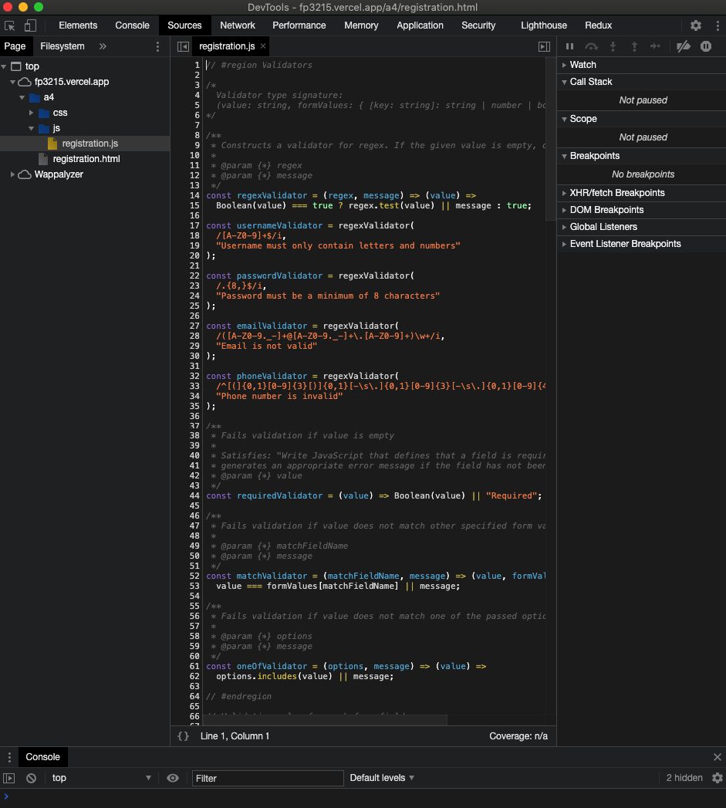

Firefox Validation:
