Aaron Dancer – IT-FP3215 – Assessment 2

Website URL:
https://aarondancer.github.io/fp3215/a2-2/invitation.html

Chrome Validation:
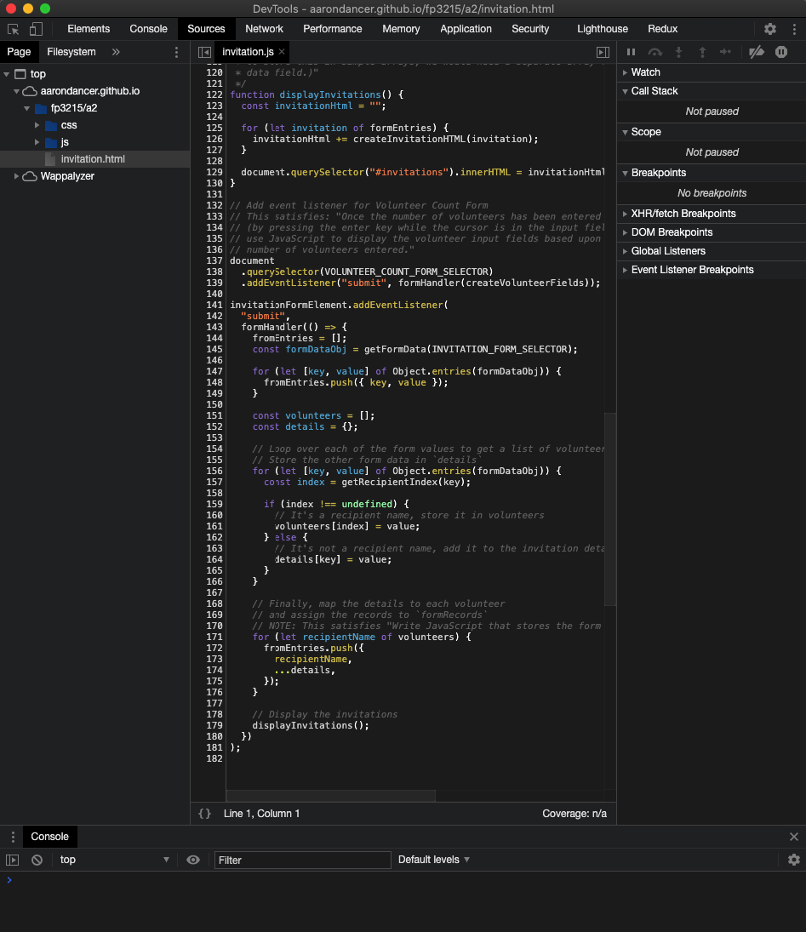
Firefox Validation:
