Assignment 10 - HuffmanTree QA document

Aaron Dressler

12/4/2015

Huffman Tree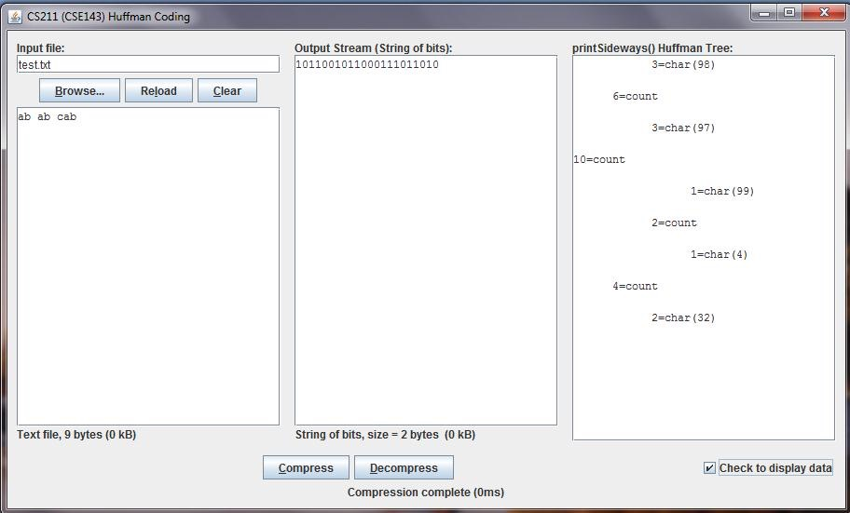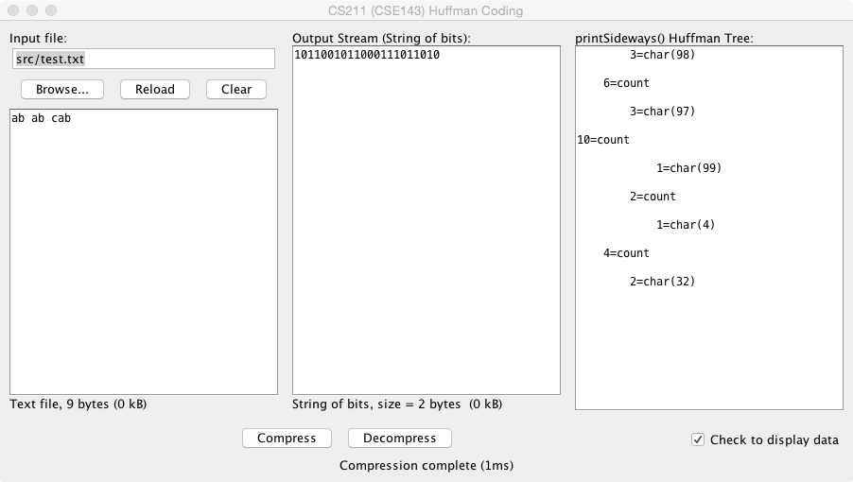

### The compressed file results should match the supplied screenshot:

My results:

### The decoded results should match the provided screenshot, and should be exactly the same as before the encoding

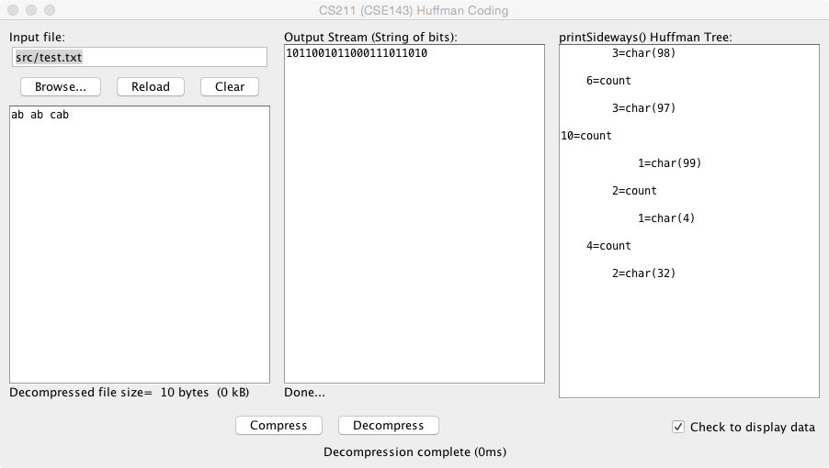

My results: