Active Directory Home Lab
Active Directory Practical Project Report

Author: Aaron Erickson
Date: October 2026
Project Type: Cybersecurity / Active Directory Lab
Platform: Windows

Based on the East Charmer Active Directory Project (Home Lab) playlist, with independent testing, tuning and documentation.

Overview
This report documents a small Active Directory lab built with virtual machines. The work covers creating a domain, setting up users and groups, applying Group Policy, joining a client computer to the domain, configuring shared folders and storage controls, and testing access changes for joiners, movers and leavers. The screenshots are included as evidence of the configuration and tests carried out.
Note: The screenshots contain both AaronE.local and AaronTech.local for the domain name. This report keeps those names where they appeared during original write-up, the project had to be restarted partway through due to an error with the virtual machine being used.

1. Installing the Server and Creating the Domain

a) Installing Windows Server in a Virtual Machine
Installed Windows Server in a virtual machine to use as the domain controller for the lab.
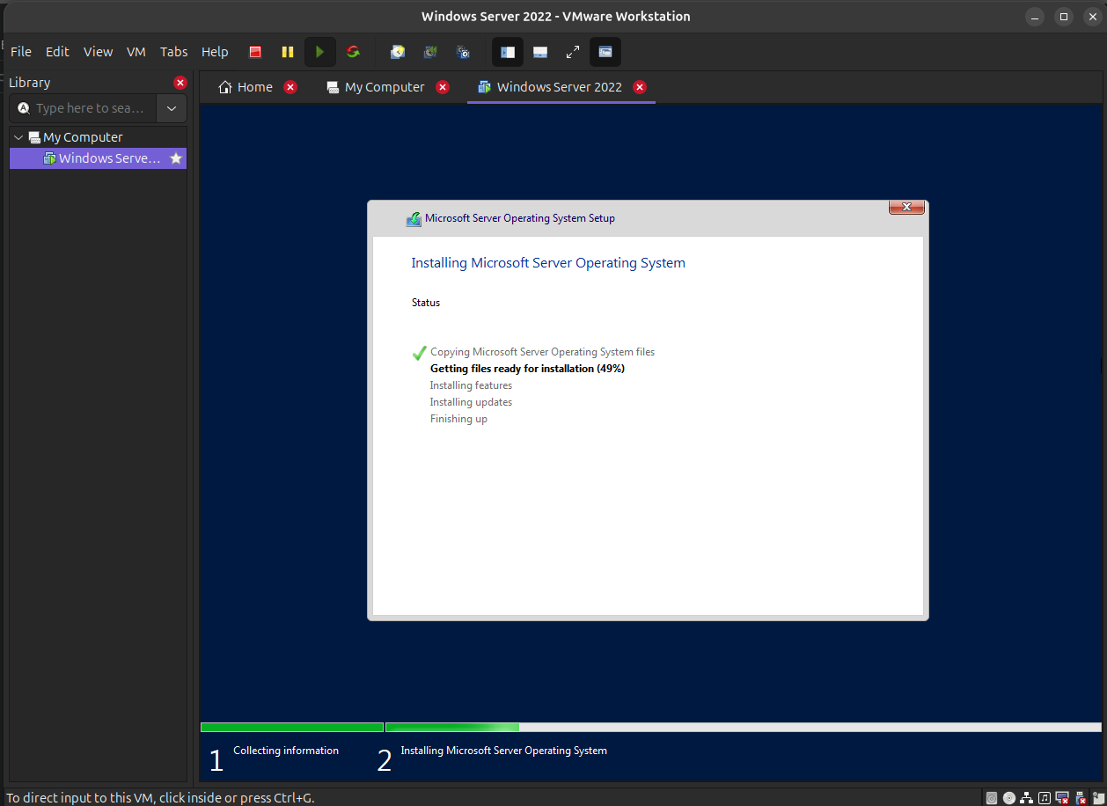

b) Creating the Active Directory Domain
Created the Active Directory domain. The original notes refer to the domain as AaronE.local at this stage.
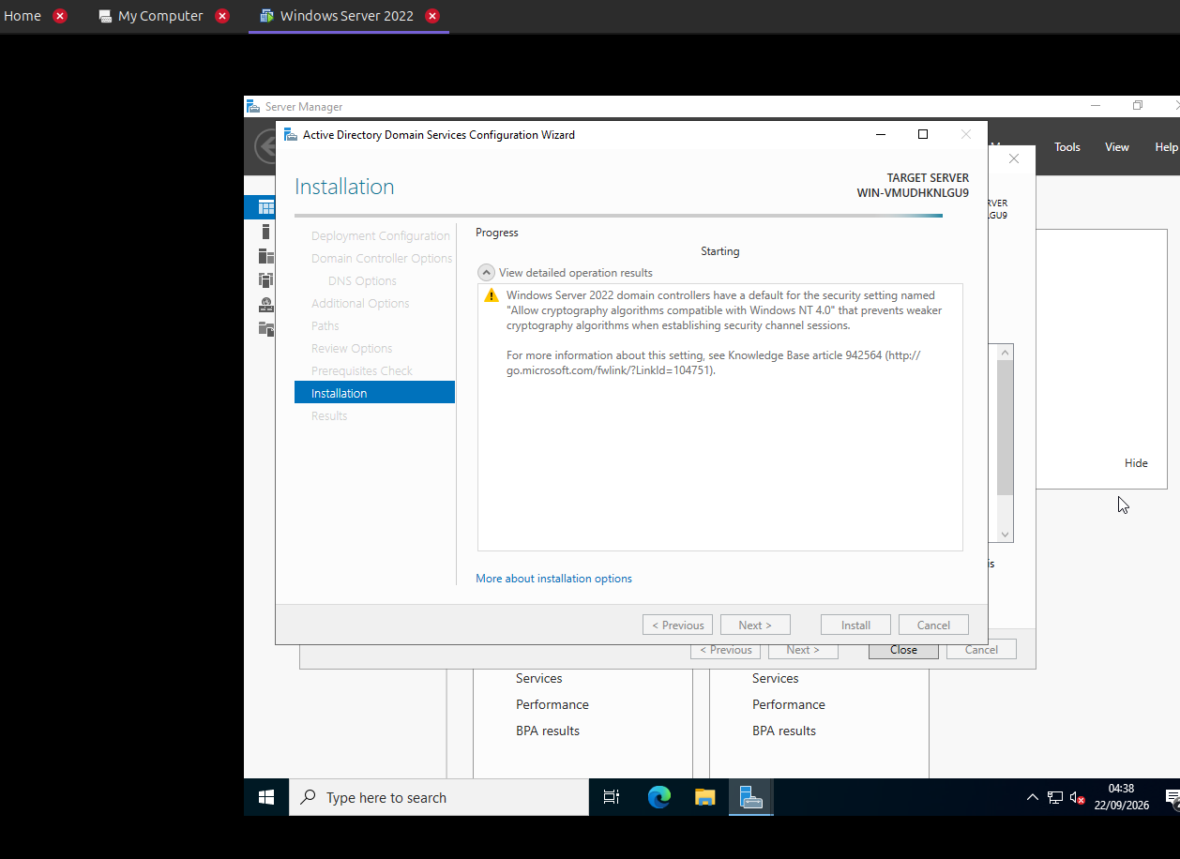

2. Creating Users, Groups and Group Policies

a) Creating an Active Directory Group
Created a new group and selected the appropriate group scope and group type.
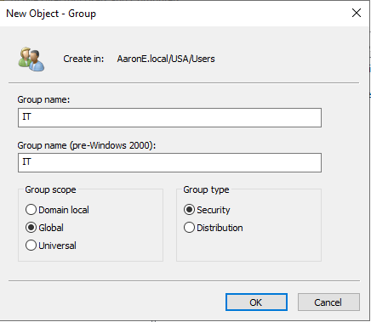

b) Creating Users and Department Groups
Created three user accounts, department distribution groups for email, and security groups to manage access.
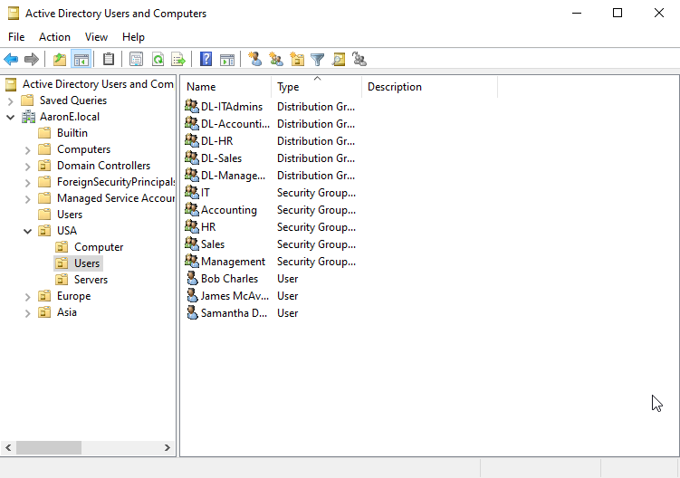

c) Configuring a Password Policy
Configured the password policy through Computer Configuration so it applies at computer/domain policy level rather than as an individual user setting.
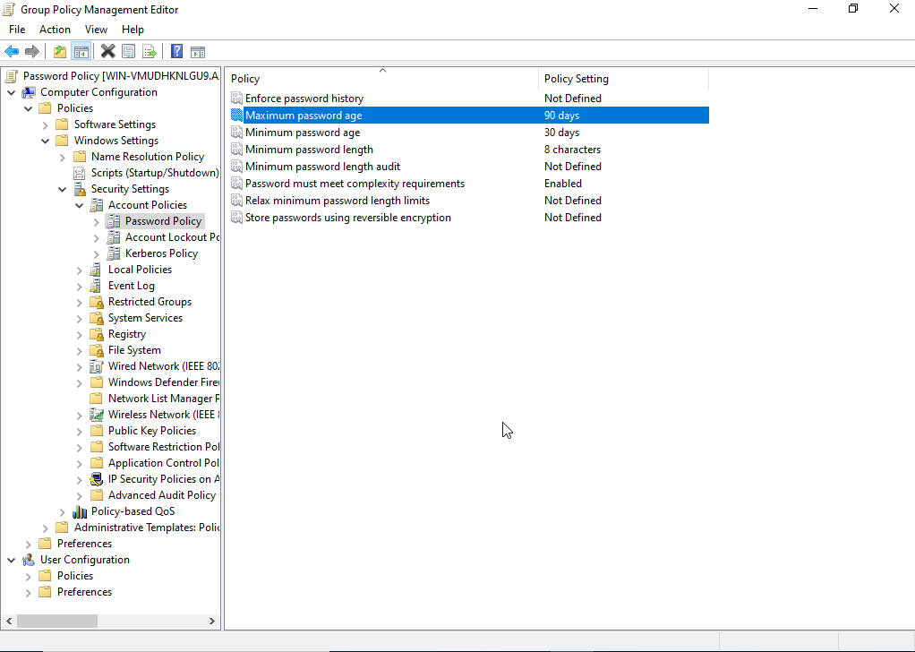

d) Configuring a Mapped Drive Preference
Created a Group Policy Preference for mapping a shared network drive for users.
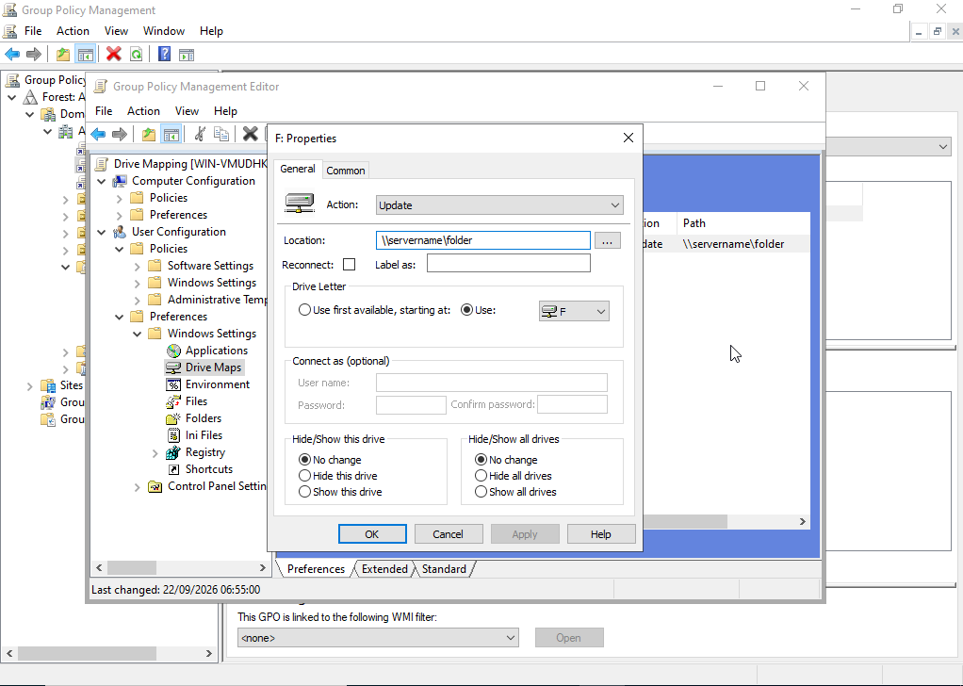

e) Applying a Desktop Wallpaper Policy
Configured a user policy to apply a desktop wallpaper consistently.
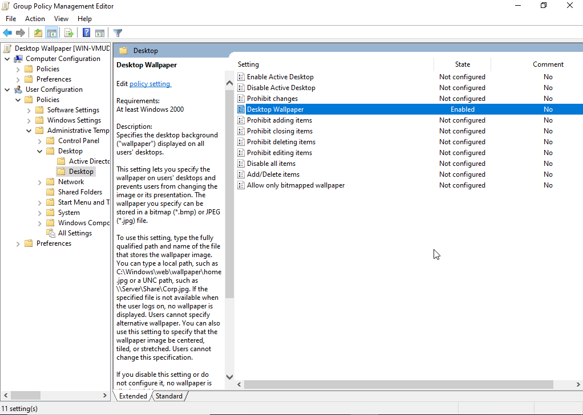

f) Blocking Control Panel Access
Configured a user policy to prevent users from opening Control Panel.
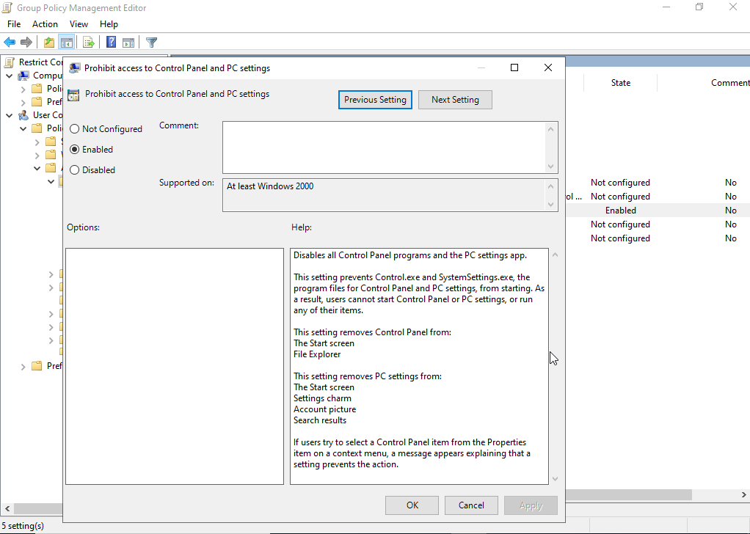

g) Blocking Removable Storage
Configured a computer policy to deny access to removable storage devices.
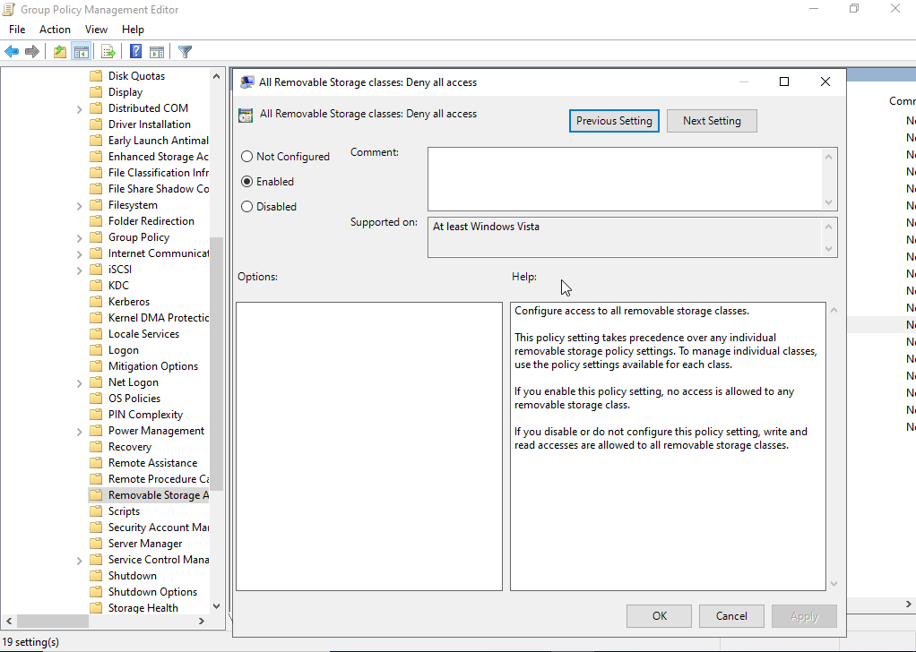

h) Configuring Account Lockout
Set the account lockout duration, failed-attempt threshold, and reset interval.
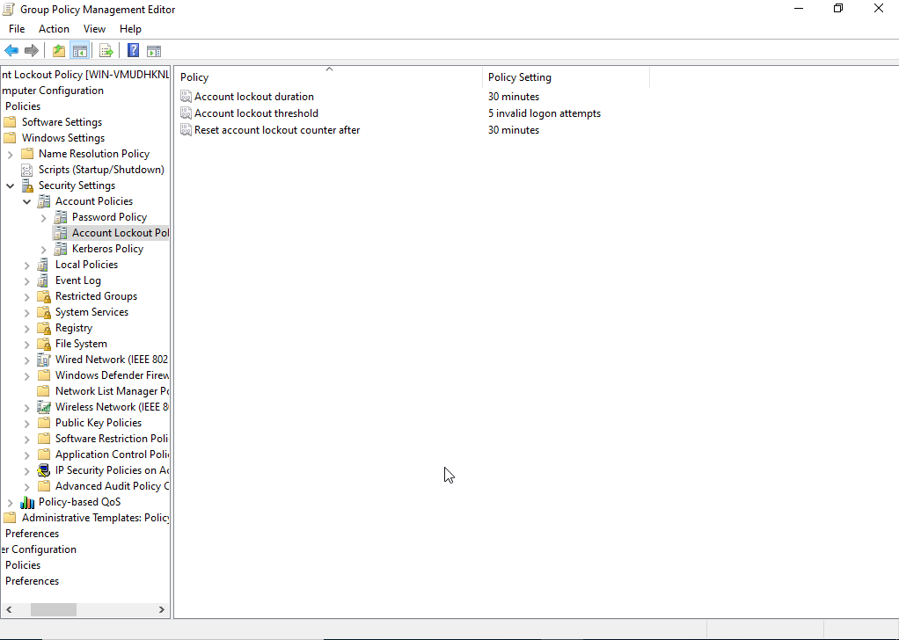

3. Connecting the Client Computer to the Domain

a) Checking Network Settings with ipconfig
Used ipconfig to check the host network details before configuring the server's network settings.
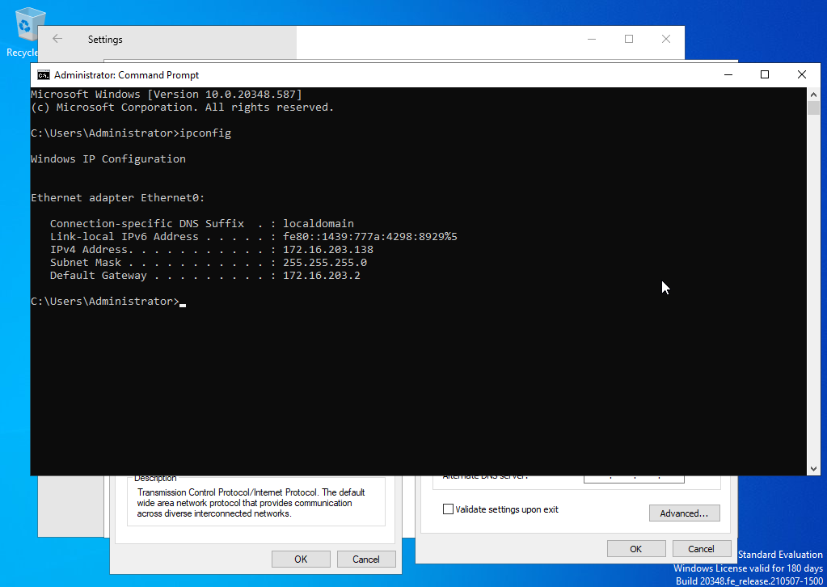

b) Configuring the Server's Static IP Address
Entered the IP address, subnet mask, and default gateway based on the network information. The notes show the server using its loopback address as preferred DNS.
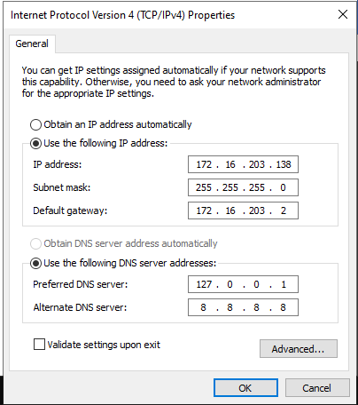

c) Configuring DNS on the Client VM
Configured the Windows 10 client to use the server's static IP address for DNS so it could locate the domain.
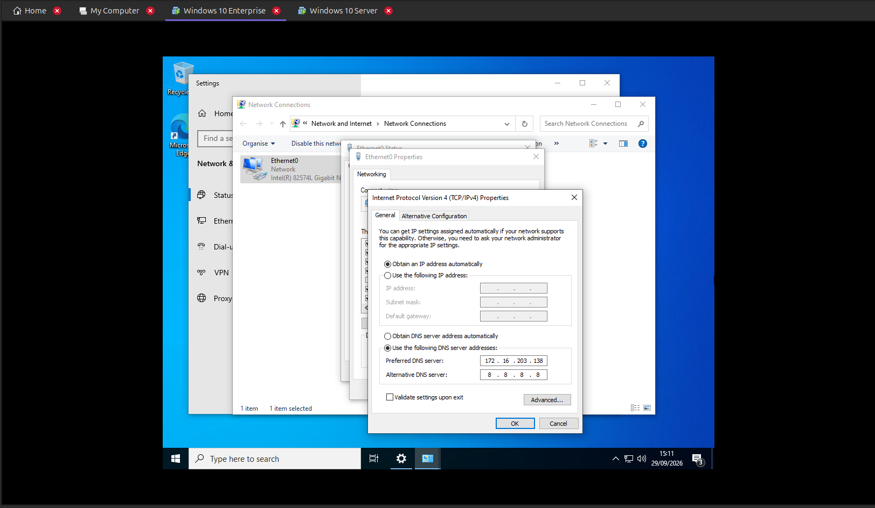

d) Joining the Client to the Domain
Joined the Windows 10 client to the AaronTech.local domain and renamed the computer COMP01.
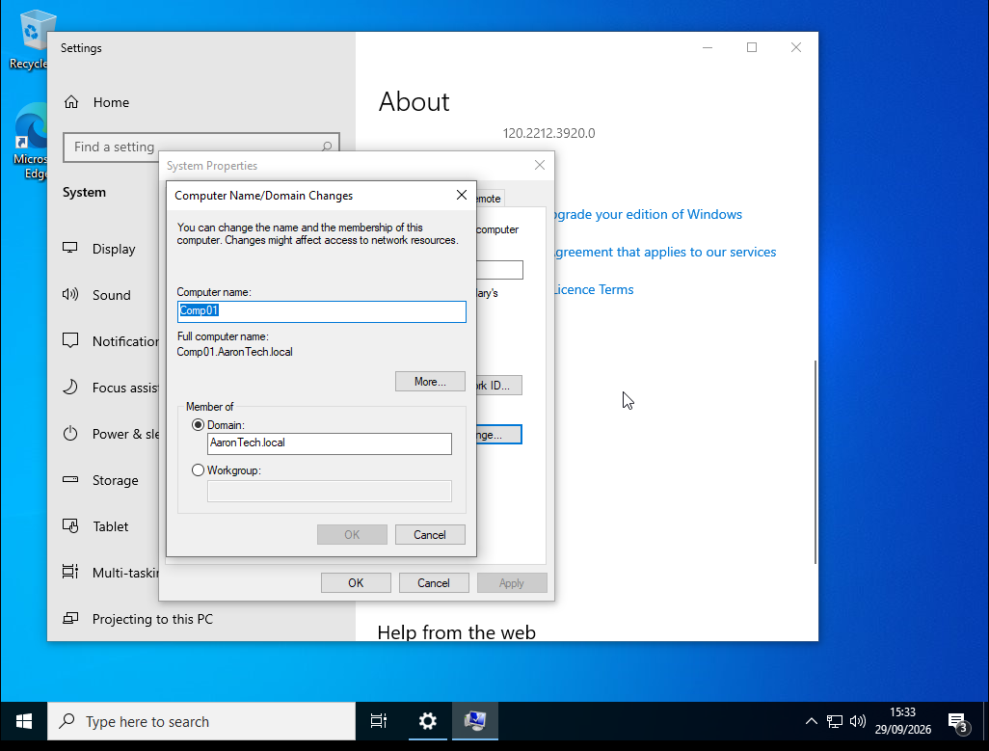

e) Testing a Domain User Login
Tested signing in to the client computer with a separate domain user account.
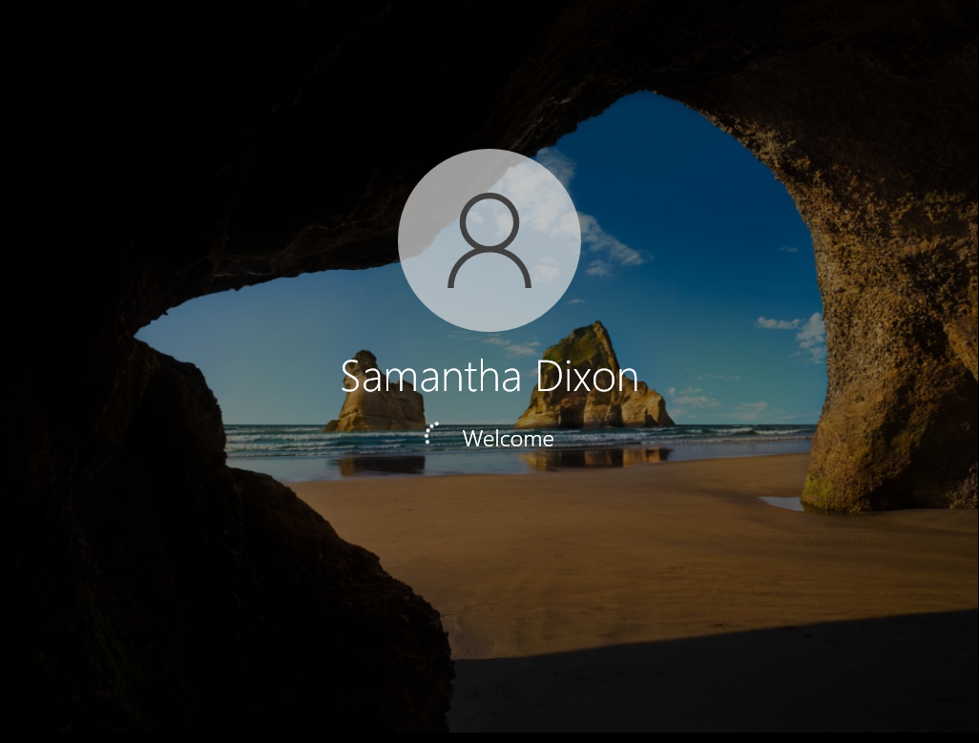

f) Organising the Client in an OU
Moved COMP01 into the appropriate organisational unit (OU) in Active Directory.
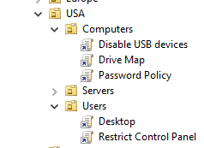

g) Testing Group Policy on the Client
Ran gpupdate /force on the client to apply the latest Group Policy settings, then confirmed that Control Panel access was blocked.
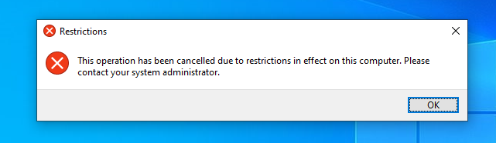

4. Setting Up File Sharing

a) Creating the Shared Folder
Created a shared folder named SHARED and configured sharing access for Domain Users.
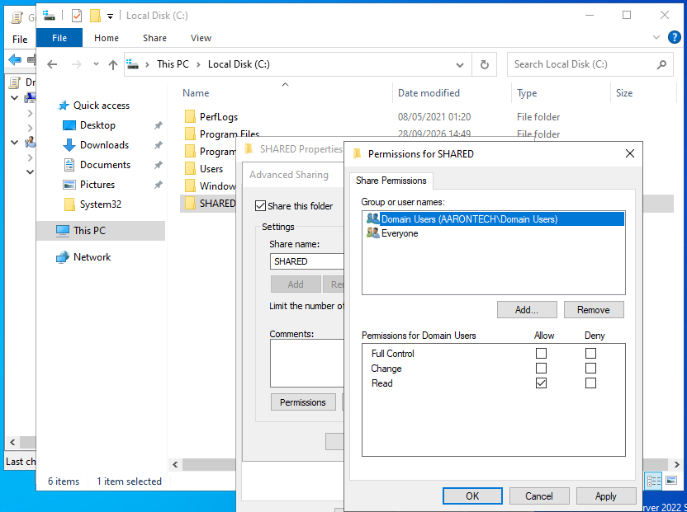

b) Setting Department Folder Permissions
Configured department folders so access could be controlled using the relevant security groups.
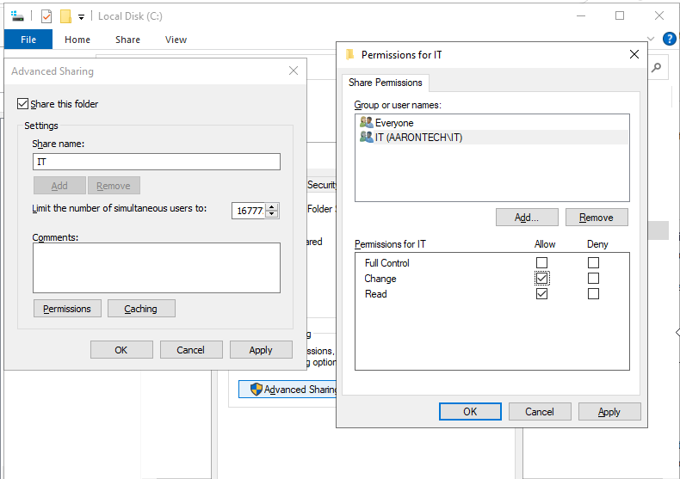

c) Configuring the Mapped Drive Policy
Updated the mapped-drive policy with the server name and shared-folder path, then linked it to users in the USA OU.
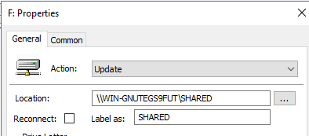

d) Verifying the Shared Drive
Checked that the shared folder was available to the client user.
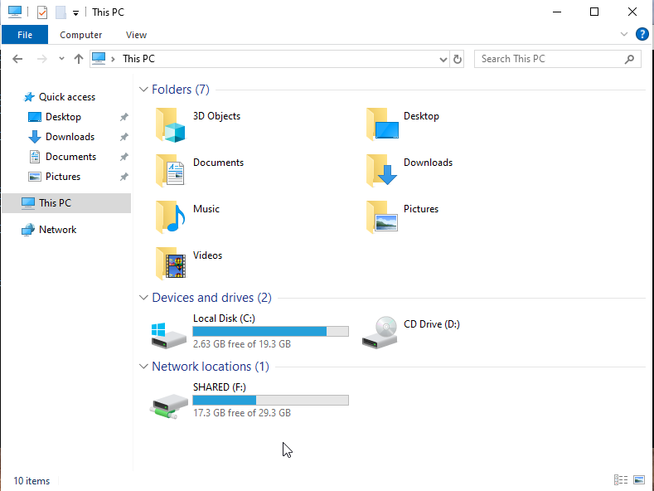

5. Storage Quotas and File Screening

a) Creating a Storage Quota
Configured a quota so the IT department would receive an email notification when the shared drive reached 80% capacity.
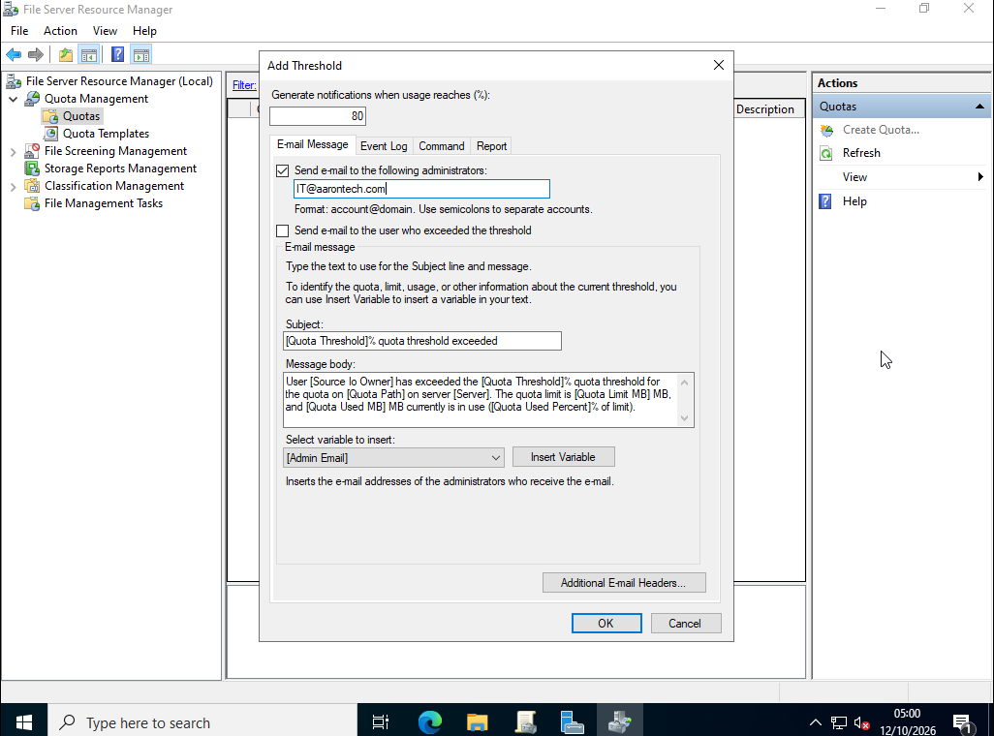

b) Configuring File Screening
Configured file screening to block selected audio/video, compressed, and image file types from being stored in the shared folder.
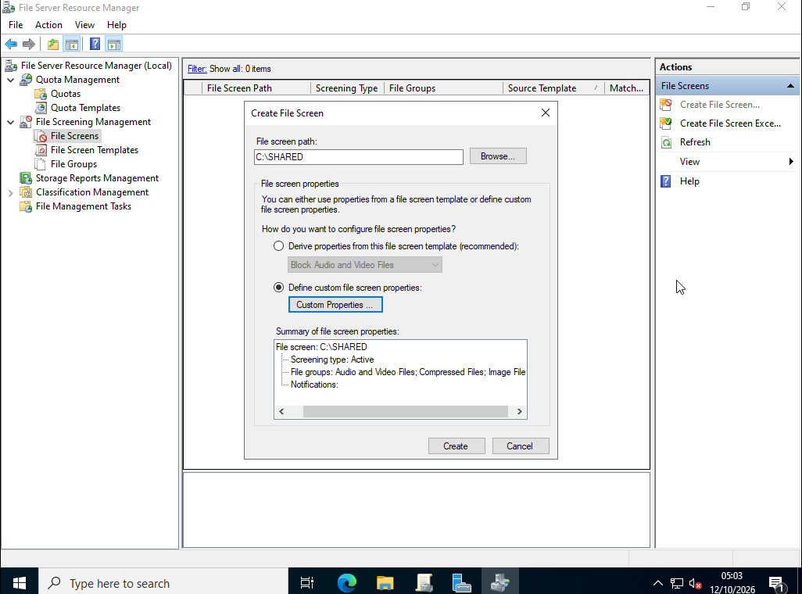

6. Joiner, Mover and Leaver (JML) Process
The following procedure summarises the steps used in this lab to manage access when a user joins, changes department, or leaves the organisation.

Joiner — new employee
1. Create the user's Active Directory account and place it in the appropriate organisational unit.
2. Add the user to the security group for their department.
3. Test that the user can access the resources required for their role and cannot modify other departments' folders.

Mover — employee changes department
1. Review the user's existing group memberships and permissions.
2. Remove group memberships linked to the previous role and add the group membership needed for the new role.
3. Test access to confirm that old permissions have been removed and the user can access the resources required for the new role.

Leaver — employee leaves the organisation
1. Disable the user's Active Directory account.
2. Test that the user can no longer sign in.
3. Complete any later account deletion and data-handling steps according to the organisation's policy. This lab demonstrates disabling the account; it does not document a completed deletion.

a) i) Adding a Joiner to a Security Group
Added Samantha Dixon to the IT security group. The same process was used for Bobby Charles and James McAvoy.
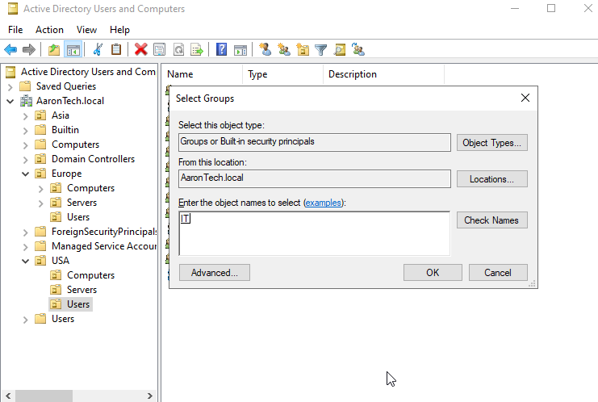

ii) Configuring Department Folder Permissions
Configured permissions so each department group could modify its own folder, while other departments had more limited access.
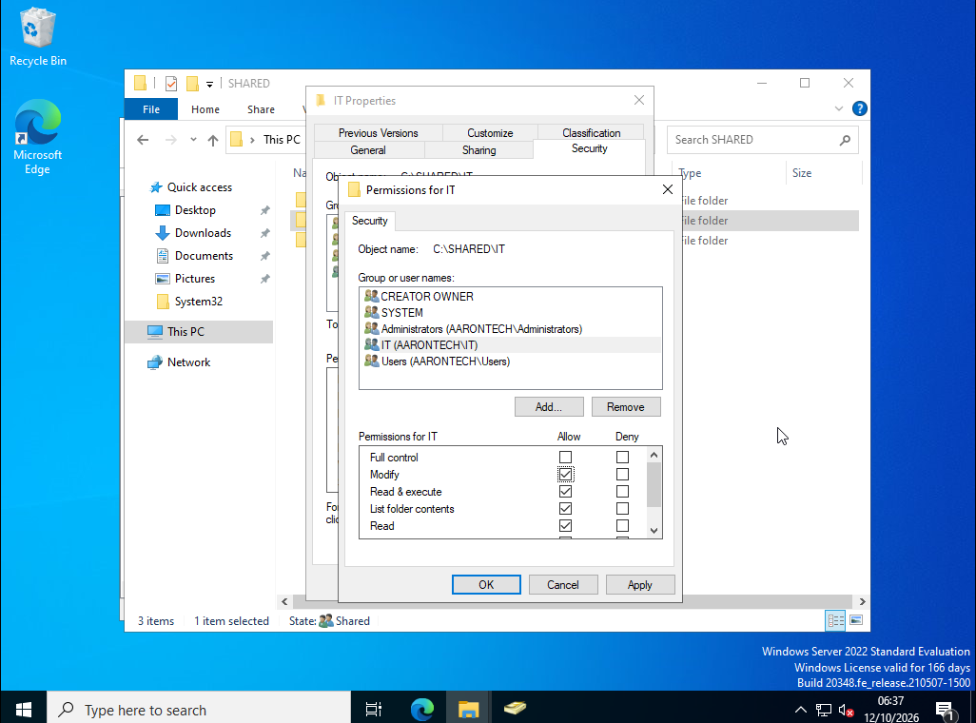

iii) Testing Access from the Client VM
Tested the account from the separate client VM after discovering that local policies on the server VM restricted non-administrator logins.
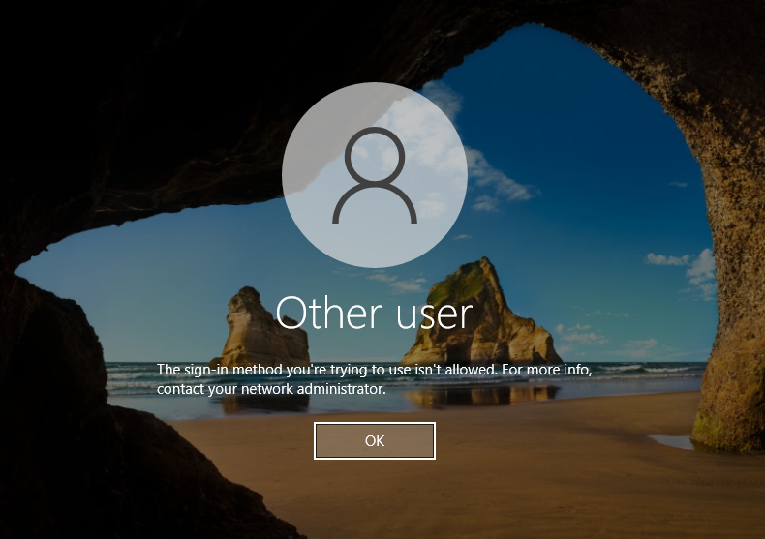

iv) Testing Department Folder Access
Tested the department folders to confirm that users could modify their own department's folder but were blocked from changing another department's folder.
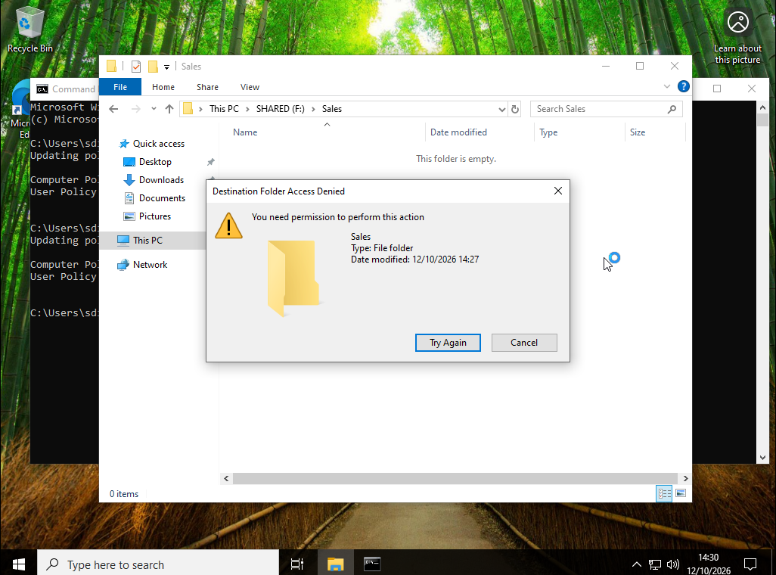

v) Troubleshooting Inherited Permissions
Investigated a permissions issue involving the SHARED folder and its subfolders. Adjusted the share and folder permissions to resolve the conflicting access rights.
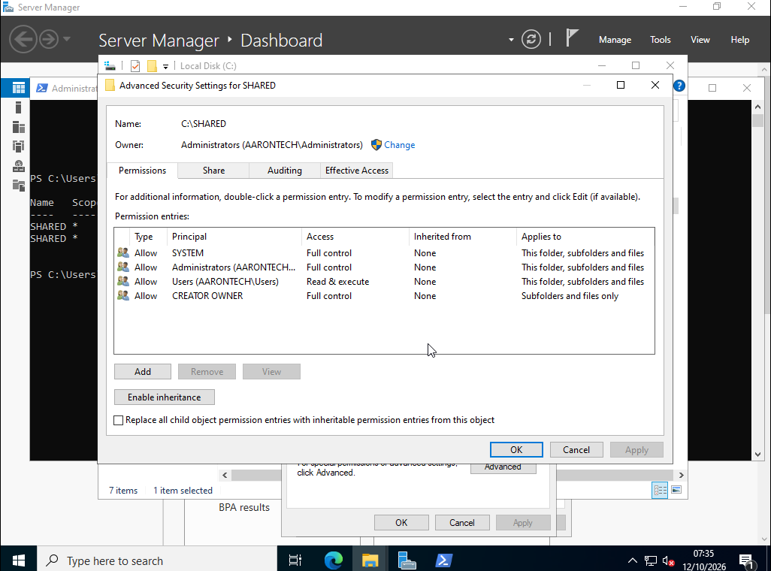

Troubleshooting Case Study: Department Folder Permissions

Problem
An IT user could not create folders inside the IT folder, even though the user was a member of the IT security group.

Investigation
I checked group membership and NTFS permissions, reviewed the permissions inherited from the parent folder, and used PowerShell to inspect the configured access rights. The investigation showed that the shared-folder and subfolder permissions were affecting the result.

Resolution
I adjusted the relevant sharing and folder permissions, including inherited permissions on the department folders, to allow the intended access while restricting modification of other departments' folders.

Validation and learning
I tested the access again after the changes. This highlighted that both share permissions and NTFS permissions need to be checked when troubleshooting access to a network share.

b) i) Mover: Removing Old IT Access
For the mover scenario, Samantha Dixon moved from IT to HR. Her access to the IT folder was removed.
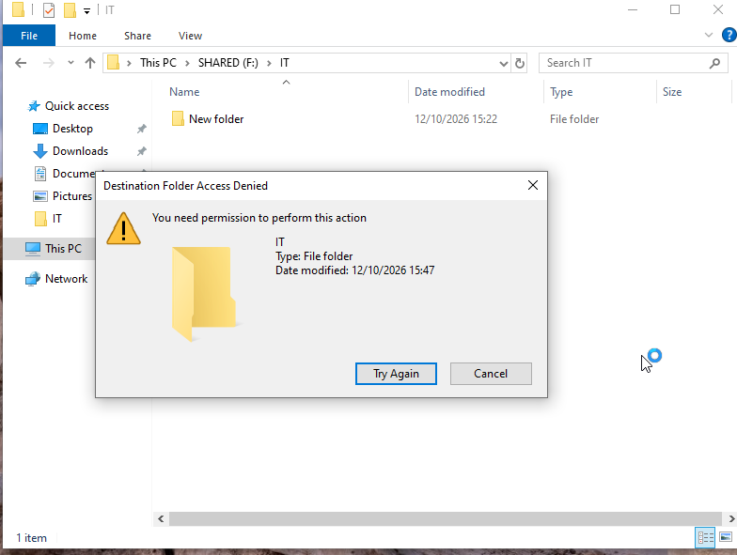

b) ii) Mover: Granting HR Access
Confirmed that Samantha could now create and modify content in the HR folder, showing that her access matched her new role.
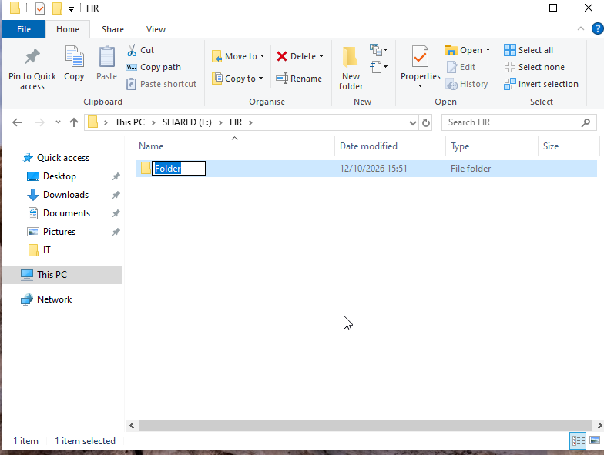

c) i) Leaver: Disabling the Account
Disabled Samantha Dixon's account when she left the organisation.
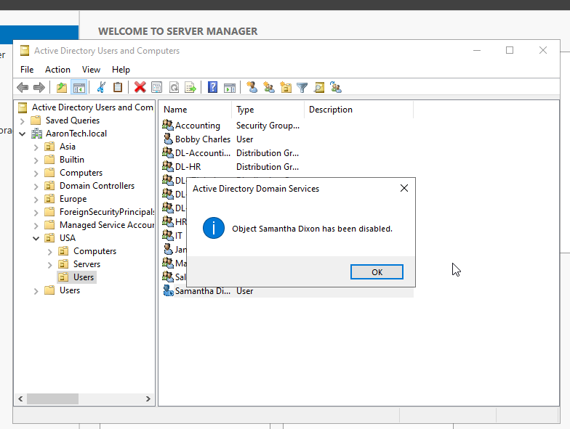

ii) Leaver: Verifying the Account Is Disabled
Confirmed that Samantha could no longer sign in. The notes state that the account would be fully removed from the domain controller according to company policy.
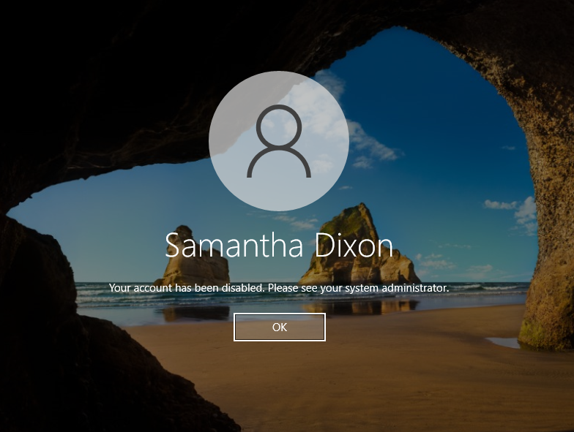

7. Test Results
The table below summarises the tests described in the lab notes and screenshots. Results are limited to what is documented in this report.
Test | Expected result | Result documented
Client joins the domain | Client joins the configured Active Directory domain. | Shown in the domain-joining section.
Group Policy restriction | A domain user is prevented from opening Control Panel on the client. | Observed after running gpupdate /force.
Department folder access | Users can modify their own department folder but cannot modify other departments' folders. | Access restrictions and troubleshooting are documented; recheck final permissions before publishing.
Mover: IT to HR | Old IT access is removed and HR access is granted. | The report documents access being denied to IT and allowed for HR.
Leaver account | The disabled user cannot sign in. | Account disabled and sign-in restriction documented.
Storage quota and file screening | Quota alert is configured and selected file types are blocked. | Configuration is documented; a separate trigger test is not shown in the notes.

8. Example Department Access Matrix
The intended folder access model recorded in the original notes is shown below.
Role | HR folder | Sales folder | IT folder
HR assistant | Read/write | Read | Denied
Sales associate | Denied | Read/write | Denied
IT Support | Denied | Denied | Read/write

Summary
The lab demonstrates the main steps involved in managing an Active Directory environment: creating accounts and groups, applying policies, connecting a client, controlling shared-folder access, managing storage, and changing permissions when a user changes role or leaves. Testing from the client VM helped verify that the policies and permissions behaved as expected and identify configuration issues that needed troubleshooting.

