Dear Student,

If you are reading this document, you are close to graduating with either the Web Application Developer Degree or Certificate. First congratulations! Second, thank you for attending Edmonds Community College. And last, below are the requirements for your exit portfolio.

This portfolio should highlight the work that you’ve completed within your degree or certificate. You will be building a Professional Web site built upon the work that you’ve completed within your courses. This site may be a “re-build” of the personal site that you created in CIS 241, if it was a part of that course.

**Site Requirements:**

Create a professional web site introducing yourself and your work in the degree. This site should include:

1. A home page introducing yourself. This page must be named either **index.html** or **index.php**
2. A resume page. Do not include your address or phone number within this resume; do include your email address.
3. An interest’s page. What is it you do when you’re not being a student?
4. A course studies page. You should include in this page links to the courses that you completed during your studies. You should include links to:   
   1. (if you are completing the degree) 10 of the courses you have completed.
   2. (if you are completing the certificate) 5 of the courses you have completed.
5. Each course that you link should have:
   1. a description of the course.
   2. a copy of the syllabus for the course (another link from that course page).
   3. a summary from you about what you learned in the course.
   4. links to examples of your course work.
6. You should include documentation on this web site in a folder called documentation. This documentation should include:
   1. a folder structure diagram. This folder structure diagram should include all files required to build your exit portfolio site, including this documentation folder. An example of the this diagram is:

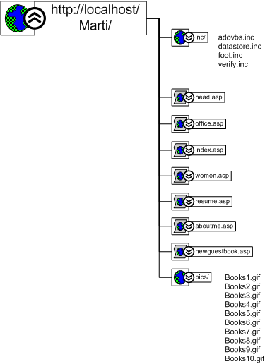

* 1. a site navigation diagram. An example of this diagram is:  
       
     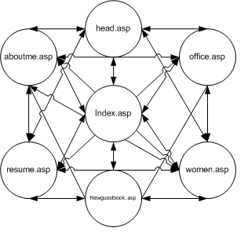
  2. a site “standards” document. An example of this document is:  
       
     Font: Times New Roman

Color scheme:

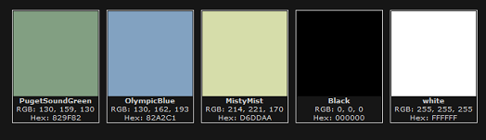

|  |  |  |  |
| --- | --- | --- | --- |
| Color Name | Hex | RGB | General Usage |
| Puget Sound Green | #829F82 | 130, 159, 130 | Background |
| Olympic Blue | #82A2C1 | 130, 162, 193 | Header |
| Misty Mist | #D6DDAA | 214, 221, 170 | Menu background |
| Black | #000000 | 0, 0, 0 | Text |
| White | #FFFFFF | 255,255,255 | Highlight |

* 1. a site wireframe. An example of a wireframe:  
       
     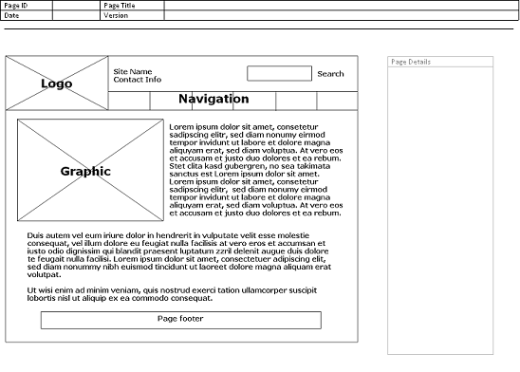

What to turn in and how to turn it in:

Contact Louis Ho @ [louis.ho@email.edcc.edu](mailto:louis.ho@email.edcc.edu) requesting an account / access to the Web Development Production Server: cyberia.sandbox.edcc.edu Once access is given, you will:

* FTP your completed site to the Web Development Production Server
* Notify Jan Griffin at [jgriffin@edcc.edu](mailto:jgriffin@edcc.edu) and Louis Ho at [louis.ho@email.edcc.edu](mailto:louis.ho@email.edcc.edu) that the electronic portfolio (web site) has been FTP’d

Grading rubric:

|  |  |  |
| --- | --- | --- |
| Criteria: | Available Points: | Points Given |
| All pages requested are present:  home page  resume page  course studies page with links to:  10 class pages if in Web Degree.  5 class pages if Web Cert.  example of work pages | 20 |  |
| Course pages include:  Class description  Course Syllabus  Learning description  Links to course work | 20 |  |
| Documentation includes:  Folder structure map  Site Navigation map  Standards information  Wireframe | 20 |  |
| Total Points Available | 60 |  |
| Satisfactory Completion | 48 |  |
| Grade Given S/U |  |  |