Credit Risk Model - Braviant
EDA
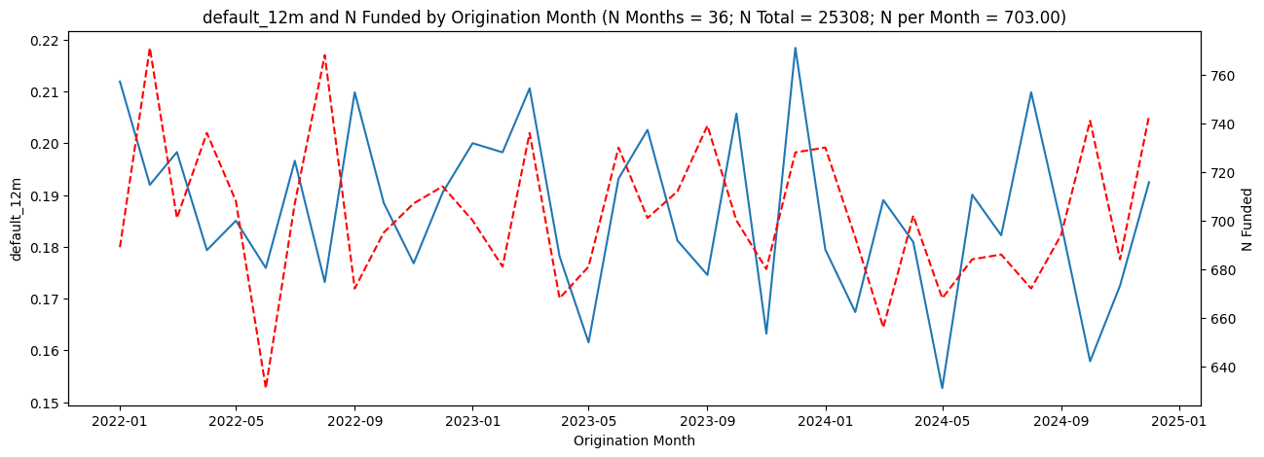
The dataset includes 25,308 funded unsecured installment loans originated between January 2022 and December 2024, with a 12-month default rate of ~18.7%. Data quality is strong, with minimal missingness (~0.7%) and stable origination volume and default rates over time. The portfolio resembles a near-prime population, with an average bureau score of ~630, median stated income of ~$4,965, and average utilization near 37%. Univariate analysis shows APR, inquiries, delinquencies, public records, and utilization are positively associated with default, while bureau score, income, open trades, and term are protective. Channel and state variables show limited standalone predictive value, reinforcing that traditional bureau and affordability metrics are the primary drivers of risk.
Data Split
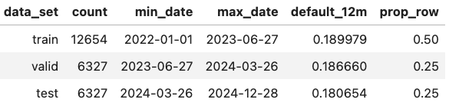
An out-of-time split was used to reflect real deployment. Loans were sorted chronologically, with 50% assigned to training, 25% to validation, and 25% to test. Default rates remain stable across splits—19.0% (train), 18.7% (valid), and 18.1% (test)—indicating minimal time-based drift and supporting reliable performance evaluation.

XGBoost Model
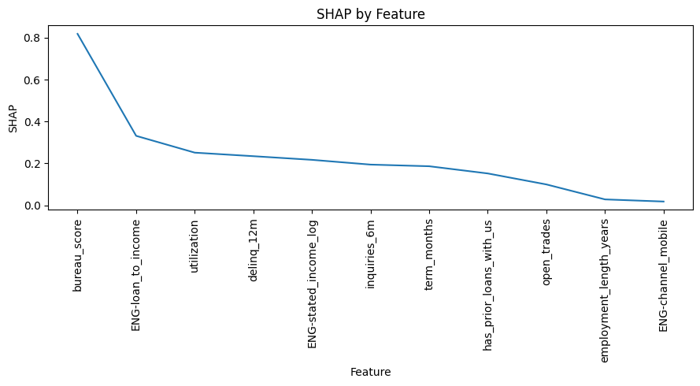
An XGBoost model was developed to capture nonlinear relationships and interactions using only underwriting-available variables. Post-origination fields (e.g., charged_off_amount, paid_interest_amount, apr), state, and engineered age were excluded for compliance and defendability reasons. Preprocessing was fit on training data only and included conservative imputation and engineered features such as log income and loan-to-income. Monotone constraints aligned model behavior with credit intuition, and class imbalance was handled using scale_pos_weight (~4.26). The final model achieved ROC AUC ≈ 0.80 and PR AUC ≈ 0.49–0.50 on validation and test. SHAP analysis confirms bureau score, loan-to-income, utilization, delinquencies, income, and inquiries as the primary risk drivers. The model was simplified from 15 to 11 features with no material loss in PR AUC.

Logistic Regression Model
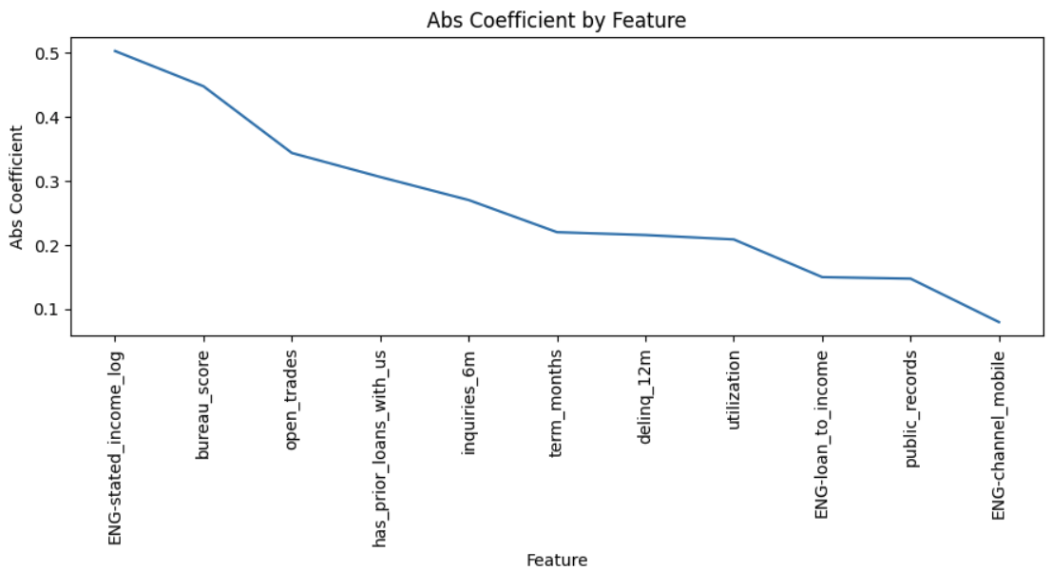
A logistic regression baseline was built using the same features and preprocessing pipeline, with continuous variables standardized. VIF values (≈1.0–1.8) indicate minimal multicollinearity. The model achieved ROC AUC ≈ 0.76 and PR AUC ≈ 0.40 on validation and test. Coefficients align with credit intuition, and performance remained stable after reducing to ~11 core features.

Model Comparison and Conclusion
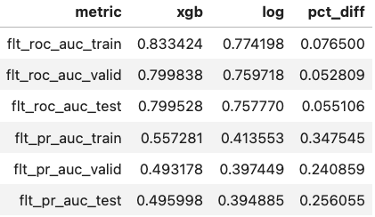
XGBoost outperforms logistic regression across all metrics, delivering a ~5–6% relative lift in ROC AUC and a ~24–26% lift in PR AUC. The improvement is especially meaningful given the ~19% default rate, as it reflects materially better identification of higher-risk borrowers. These gains are consistent from validation to test, suggesting robust generalization. The recommended approach is a balanced, risk-tiered approval strategy: auto-approve low-risk borrowers, apply risk-based pricing or exposure limits to mid-risk applicants, and decline the highest-risk segment. This supports either lower losses at a fixed approval rate or higher approvals at the same risk target. Ongoing governance should include monitoring for performance stability, data drift, score distribution shifts, and fair lending considerations.

