Predicting March Madness with Machine Learning
This year I competed in Kaggle's March Machine Learning Mania 2026, where the goal is to predict the probability of every possible NCAA tournament matchup — men's and women's. I built a full ML pipeline from raw data to 132,133 calibrated probability predictions. You can explore the simulated brackets and full methodology on my site: aaron-england.com/march-madness. The codebase is on GitHub (github.com/aaronengland/march_machine_learning_mania_2026).

The Task
Predict 132,133 matchup probabilities. Scored by Brier score — how close your probabilities are to reality. A coin flip scores 0.250. Just picking the better seed gets ~0.220. My final models scored 0.1747 (men's) and 0.1299 (women's).

Every Decision Was Research-Backed
This wasn't guesswork. Every major design choice came from studying past gold medal Kaggle solutions and academic research:
Decision | Why
Test on one season at a time | Standard in every top solution — prevents peeking at future data
Show each matchup from both sides | 2023 gold medal winner's recommendation — prevents ordering bias
Train neural net on Brier loss | Academic research showed this outperforms standard classification loss
Use specific expert ranking systems | 2023 gold medal winner identified the most predictive systems
Calibrate probabilities after training | Top 2025 solution confirmed this consistently improves scores
Weight recent seasons more in blending | Modern basketball is most relevant to 2026

What the Models See
The models don't see raw team stats — they see the difference between two teams. Instead of "Duke shoots 48% and Oregon shoots 44%," the model sees "+4% shooting difference." 74 features for men's, 63 for women's, spanning seeds, expert rankings, Elo ratings, shooting efficiency, momentum, strength of schedule, and recent form.
Seeds are the most predictive feature — a 1-seed has only lost to a 16-seed twice in men's history — but they're far from the whole story:
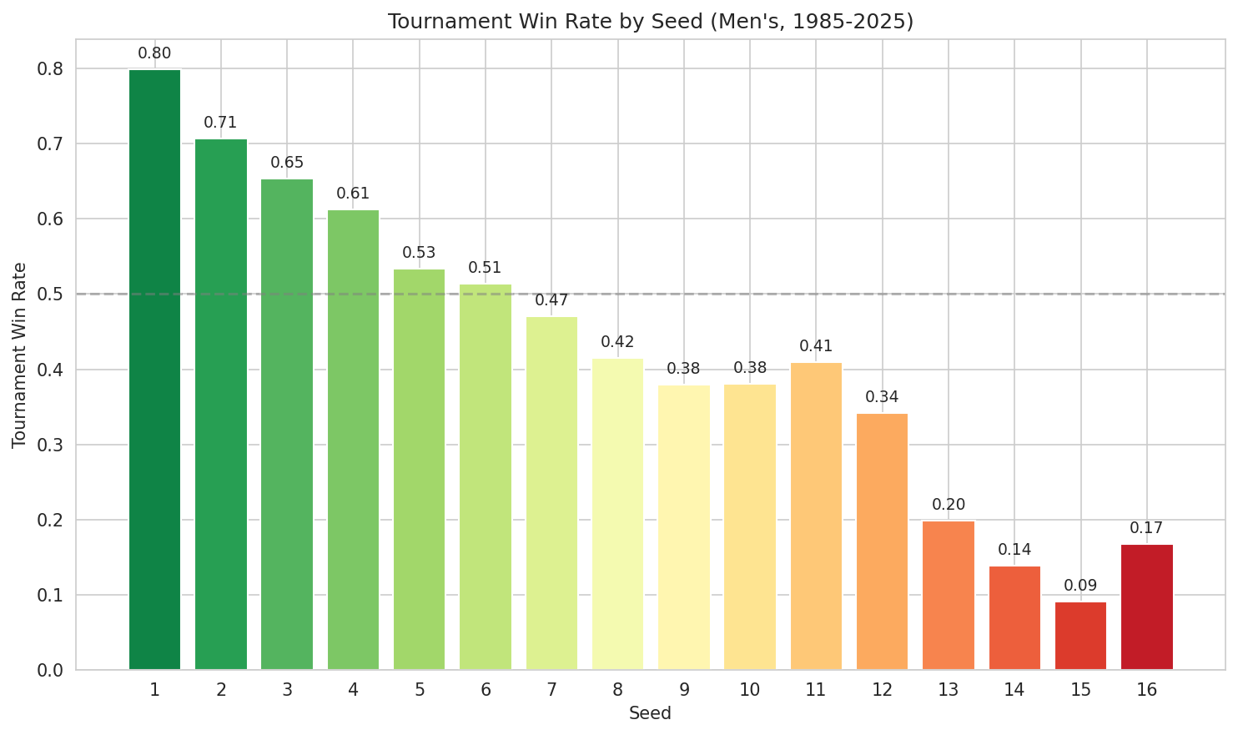
Tournament win rate by seed (Men's, 1985-2025). 8-vs-9 matchups are essentially coin flips.

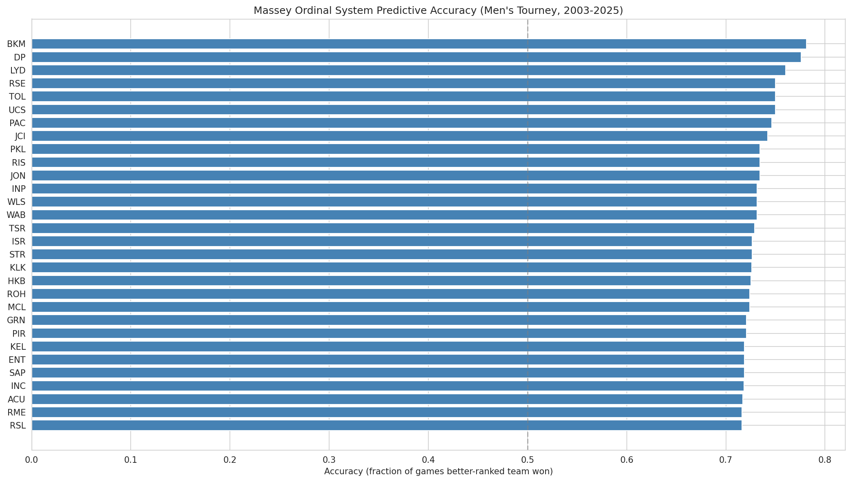
The best expert ranking systems correctly pick the winner ~78% of the time.

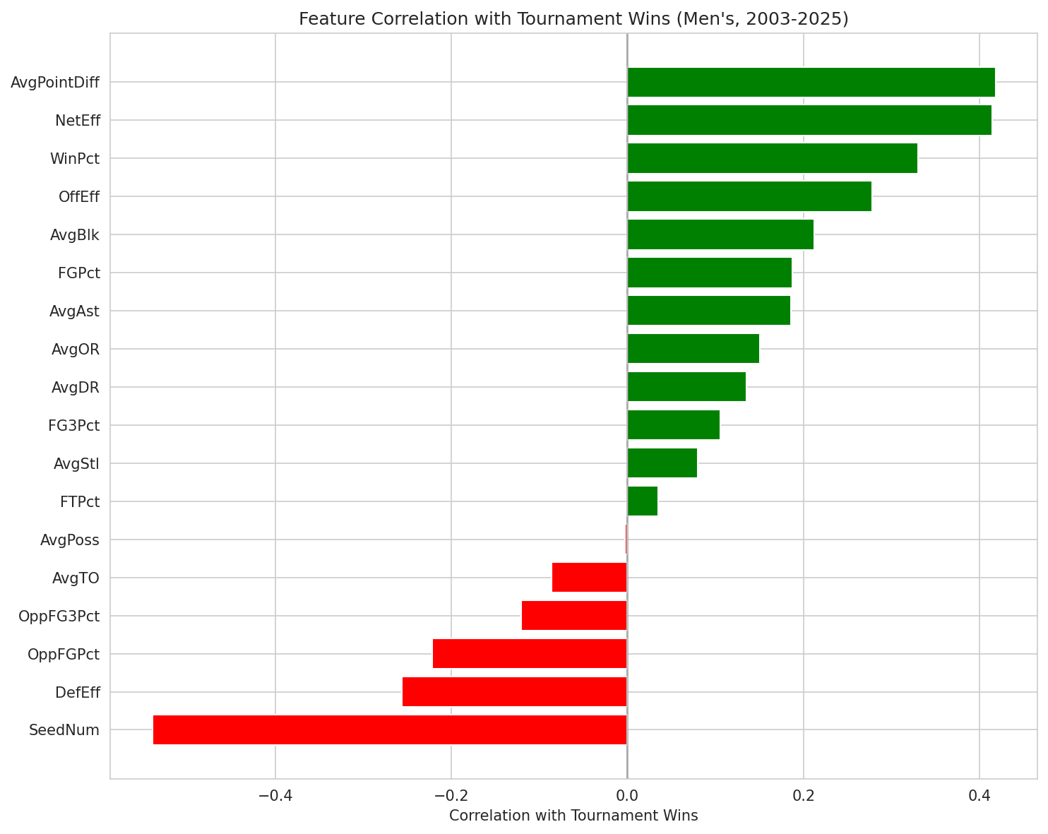
Which statistics predict deep tournament runs. Seed is strongest, but point differential, efficiency, and expert rankings all add signal.

How the Models Were Built
Three models per gender (PyTorch neural network, XGBoost/CatBoost, Logistic Regression), each built in three phases:
- Find the best settings — Optuna tested 30-50 configurations per model on recent seasons
- Test on every historical season — train on all other years, predict the held-out year, repeat for all 40 men's / 27 women's seasons. No data leakage.
- Train on everything — retrain on all history to make the actual 2026 predictions
The three models are then blended into a single prediction, with weights optimized to favor accuracy on recent seasons (2025 games count 40x more than 1985 games).

Results
 | Men's | Women's
Final ensemble | Brier: 0.1747 | Brier: 0.1299
Kaggle validation (2022-2025) | 0.1800 | 0.1244
Blend | 55% PyTorch + 45% XGBoost | 67% PyTorch + 33% CatBoost

The single most impactful decision was training the PyTorch model directly on Brier loss instead of standard binary cross-entropy. It outperformed every gradient boosting model for both genders.
The women's tournament is ~26% more predictable than the men's — fewer upsets, more dominant top seeds — which is reflected in the lower scores.

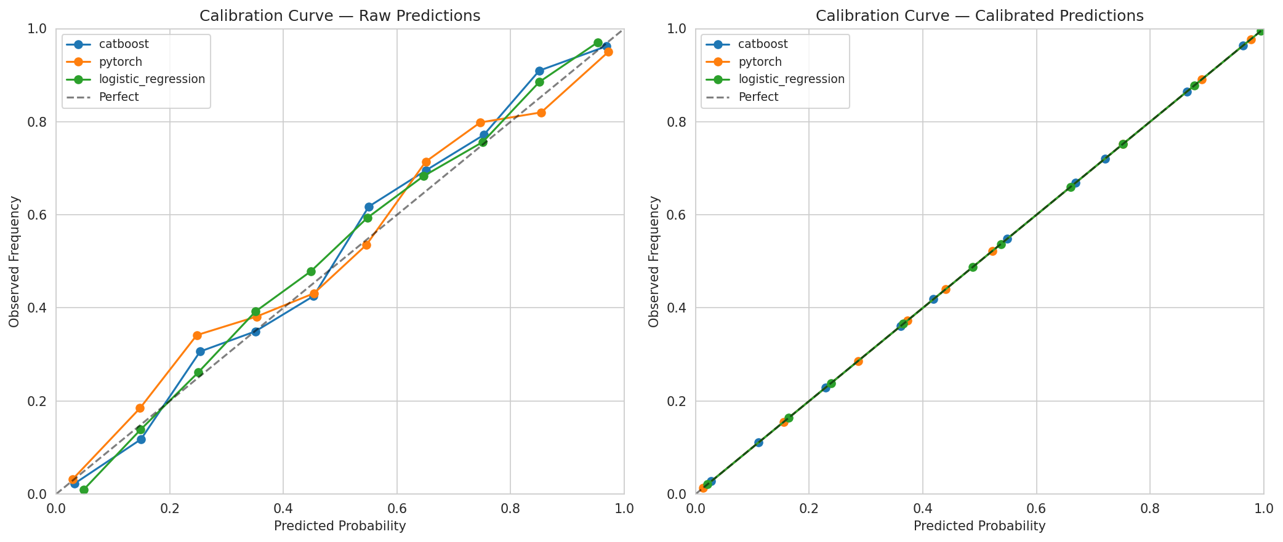
Calibration curves — if a model says "70% chance," does that team actually win ~70% of the time? The closer to the diagonal, the better.

Links
Simulated brackets and full methodology (with all EDA charts, feature tables, and model evaluation plots): aaron-england.com/march-madness
Full codebase: github.com/aaronengland/march_machine_learning_mania_2026
More about me and my other projects: aaron-england.com
Built with Python, PyTorch, XGBoost, CatBoost, Optuna, scikit-learn, pandas, and AWS SageMaker.

