To Flip or Not to Flip: Pancake Sorting with Genetic Algorithms and Wisdom of Crowds

Sai CHINTHALA
Computer Science and Engineering
Speed School of Engineering
University of Louisville, USA
smchin01@louisville.edu
Aaron FOX
Computer Science and Engineering
Speed School of Engineering
University of Louisville, USA
amfox005@louisville.edu
Abby SPALDING
Computer Science and Engineering
Speed School of Engineering
University of Louisville, USA
acspal03@louisville.edu

Abstract—A deeper investigation of the Pancake Sorting problem which involves sorting a stack of pancakes by flipping or reversing at a specific index in the pancake stack. The goal is to achieve the sorted stack in as few flips as possible. For this study, the idea of pancake flipping is applied to a string of unsorted characters in which the string can only be sorted by reversing a prefix from a certain index. A Genetic Algorithm is applied to the problem which presents greater possibility for solutions, as well as a variety of solutions. Wisdom of Crowds is also analyzed as it applies to number of sorts required for the minimum number of reversals. Python is the target language for implementing the algorithm and PyQt is used for Graphical display.
Keywords—pancake sorting, genetics, reversal distance, Genetic Algorithm, Wisdom of Crowds

Introduction
  - History
Pancake sorting finds its origins in genetics, specifically the genome (genomics) where genes and DNA evolve. Although, technically I suppose one would say it found its scientific purpose in Genome Rearrangement. In the 1920s, Alfred H. Sturtevant discovered while studying species of Drosophila (fruit flies), found that some gene segments in the species had inverted or reversed in the descendent generations. These reversals can be harmful to a species mutation but can also allow for beneficial traits necessary for evolution to develop [1]. Roughly a decade after his discovery, Sturtevant partnered with Theodosius Dobzhansky from Caltech to further study Drosophila, suggesting more reversals yielded further evolutionary ‘distance’. Evolutionary distance refers to the minimum number of reversals necessary to change a chromosome A to chromosome B. Measuring the minimum reversal distance, as well as determining exactly which sequence of reversals produced the mutation, was a main focus of research [2][3].

From Genetics to Flipping Pancakes
A little distant from the world of Genetics, flipping pancakes finds its way into the discussion of reversals and sorting algorithms. This time though, the focus steers more towards finding an upper bound where the minimum number of reversals will be no more than X.
First introduced by Jacob E. Goodman in the American Mathematical Monthly, the Pancake Problem involves sorting n pancakes from an unsorted stack by merely flipping a number of pancakes and varying the number each time until the stack is sorted. Since its introduction, a number of sub-genre pancake sorting algorithms have also come to fruition. Two main sub-algorithms are (1) the Burnt Pancake Problem in which each pancake has a good side and a burnt side, and the final stack must be sorted with burnt side down and (2) the Two-Spatula Problem which allows an inner set of pancakes to be flipped while holding a top stack with another spatula [4].
The original pancake sorting algorithm as well as the one studied in this paper, focuses solely on prefix reversals which can be seen in Fig. 1. In genetics, there is no limitation to where the reversal may happen in a certain set of genes.

Figure 1. Provided an unsorted list.
5 | 3 | 1 | 2 | 4
Reversing the entire list.
4 | 2 | 1 | 3 | 5
Reversing the prefix ending at 3
3 | 1 | 2 | 4 | 5
Reversing the prefix ending at 2
2 | 1 | 3 | 4 | 5
Reversing the prefix ending at 1
1 | 2 | 3 | 4 | 5
End with a sorted list.

The first recognized upper bound for this problem involved reversing at whichever index the highest weighted value occupied until it was in its correct place and worked backwards [2]. This naive algorithm provided an upper bound of 2n reversals (one to get it to the top position, and one to place it in its appropriate position) which was not a very tight upper bound. This upper bound was improved in the 70s when Christos H. Papadimitriou and William H. Gates devised an algorithm to sort a stack of pancakes in no more than (5n + 3)/3 moves [5]. The upper bound was improved yet again nearly 30 years later when a group of researchers at the University of Texas at Dallas set out to prove an upper bound of (18/11)n. The lower bound was also improved to (15/4)n [6].

Proposed Approach
  - Building the Chromosomes
Each chromosome is used to represent the indices of the string to flip, with an index of 1 representing the flip of ‘ab’ in ‘abcd’, and an index of 2 representing an index of ‘abc’ in ‘abcd.’ Each chromosome is determined to be a fixed width of the size of the ceiling of (18/11) times the length of the input string based on the .string input files. As 18n/11 evaluated to a number larger than the total number of available indices, the first n indices are set to be all of the possible indices in random order. The remaining 18n/11 indices of the chromosome are then set to completely random possible indices, ranging from 0 to the length of the input string minus one. After each chromosome has been filled to length of 18n/11, each chromosome is added to the initial population until the population reaches a size of the given population_size.
  - Fitness and Cost Functions
To find the cost of each chromosome, the fitness of each chromosome is evaluated in the evaluate_cost method of the genetic_pancake_algorithm class. The fitness function is called on each chromosome of the population so that the roulette wheel selection for the crossover operator can take place. In the function, all of the chromosome’s “flip” indices are applied to the original input string from the bespoke .string files that are used as input to the read_string method. Two weighted inputs are used to determine the cost, and, in turn, fitness of each chromosome. The first determinant regarding the cost of a chromosome concerns the number of substrings, or subarrays, found within a string and the relative length of those ordered substrings
The cost found for this determinant is found in find_sub_arrays_length_and_occ, and this function works by storing each subarray length and the number of occurrences inside a Python dictionary. Initially, each character found inside the string that is used in this function is assigned a relative value based on the character’s order in the original string (i.e. given a string array of {'a', 'f', 'j'}, the resulting dictionary would yield {'a': 0, 'f': 1, 'j': 2}.) The length of the subarrays are then determined by iterating through a forward-seeking while loop, which checks for subarrays like [‘a’, ‘f’] and [‘a’, ‘a’], given the dictionary above. Since the NP-complete version of the pancake sorting problem concerns the use of strings and therefore concerns itself with repeated characters, the forward-seeking while loop accounted for repeated letters. The next while loop, a backward-seeking loop, looked for combinations such as [‘j’, ‘f’, ‘a’] and [‘f’, ‘a’, ‘a’], which are treated as backwards subarrays and thus are determined to help lower the cost of a chromosome. The dictionary is then returned from find_sub_arrays_length_and_occ and the evaluate_cost function then evaluates the fitness of the returned dictionary by summing all the subarray lengths by their occurences. This fitness is turned into the cost by dividing the fitness by one.
The second determinant for the fitness of each chromosome is the actual distance each character of the temporarily ordered string (as determined by applying all the flips to the original unordered input string given by the chromosome of indices.) This “distance cost” is found by comparing the actual locations of the temporarily ordered string relative to the indices that each character actually should be in when compared to the sorted string of characters. This distance approach is similar to the distance methods found in many approaches toward solving the notorious Traveling Salesman Problem, for it considers costs as determined by the relative distance each segment of the chromosome is from its optimal position.
The distance cost is found by simply adding the absolute value of the temporarily ordered string’s character index from where its character should be found in the sorted string. The final distance cost was found by dividing the summed absolute values of the distances by the maximum possible distance cost (i.e. the cost of a string that is completely in reverse sorted order.) This ensures that the cost is always a value between 0.0 and 1.0.
Differing weights for the subsequence and distance costs were assigned to be between 0.0 and 1.0. This allowed for experimenting with rather better results occurred with more emphasis on the string’s order or the number and length of occurrences found within the strings. The weights were then multiplied by their respective costs. After applying these weights, the distance and subsequence costs were multiplied together and returned for the roulette wheel selection to be applied to.
  - Roulette Wheel Selection
A roulette wheel selection approach was taken to find the parents of each crossover and mutation operator. The method of the genetic_pancake_algorithm class, get_roulette_wheel, works be first appending the costs of each chromosome in the given population to an array of costs. The costs are then divided by the summed total costs of every chromosome. Finally, each value in the roulette wheel array is set to be divided by the inverted sum of the costs so that each value inside the costs array sums to 1.0, as is expected behavior of the roulette wheel selection algorithm. Once the roulette wheel’s weights are calculated, Python's builtin in random.choices library then applies those weights to the chromosomes in the current population to select two of the more fit chromosomes in the generation. This helps ensure that the most perfect expert isn’t chosen every time and helps to ensure diversity in the populations by more randomly selecting the parent chromosomes to be selected for later generations.
  - Crossover
The crossover operator in genetic algorithms is used to combine the genetic information of two parents to create a better offspring. The single point crossover function is used in this project. The crossover operator selects an index in the list of indices (ones that have not been used already) and ‘flips’ the list at that index. The cost of the offspring is calculated using the fitness function.
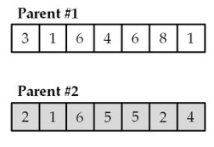

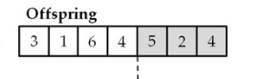

  - Mutation
A simple mutation function was used to implement this project. The mutation probability is set to .01 for optimal results. In this function, an index that has not been visited yet is mutated to a random index that is in the list of indices.
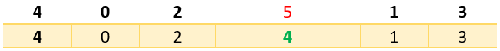

  - Wisdom of Crowds
The wisdom of crowds states that the opinion of group preferred over the opinion of a single expert. The wisdom of crowds chosen for this project was to select the smallest number of flips it takes to get a sorted pancake order, following the NP-complete problem of finding the minimum number of prefix reversals for a string to be sorted. The number of flips from each chromosome list is stored inside a list and the minimum number of flips is chosen at the end. The pancake flipping problem is NP-complete only if the number of flips it takes to sort the pancakes is found. The Wisdom of Crowds approach uses the data from the genetic algorithms to find the minimum number of flips it takes.
Similar to the simple Wisdom of Crowds approach found on the famous game show, “Who Wants to be a Millionaire?,” the mode and mean of the answers yielded by running the genetic algorithm multiple times is found. After running the genetic algorithm number_of_woc_iterations times, the minimum of all the number of flips required to find the strings for each GA is then found. This minimum is then used to determine the rough upper minimum bound required for n number of prefix reversals to occur for the strings to be sorted.

Experimental Results
4.1 Data
Bespoke .string files were created for this problem, with each .string file containing n amount of letters on each line and ending with an empty newline for processing. The read_string function was built to read in these strings and append them to a character array to represent the strings for the prefix reversals to be performed on.
4.2 Results
Below is a graph representing the results of running the Wisdom of Crowds approach over 25 iterations of a string of length 12. Each iteration and their respective costs are illustrated below over 250 generations each. The resulting minimum n number of flips found by this approach was 14 flips, which improves upon the maximum possible number of 17 flips by 30%.
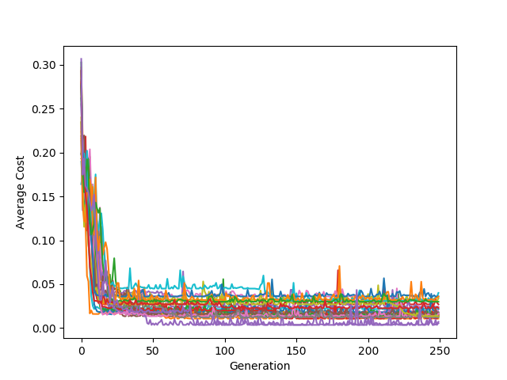

NOTE: More results and conclusions will be placed in the final research paper.

Conclusions
Conclusion to come after more experimentation/research. Will be included in Final Paper.

References
[1] P. Compeau, “Sorting by Signed Reversals,” unpublished.
[2] Hayes, Brian. “Sorting Out the Genome.” American Scientist, vol. 95, no. 5, 2007, pp. 386–387.
[3] Bafna, Vineet, and Pavel A Pevzner. “Sorting by Reversals: Genome Rearrangements in Plant Organelles and Evolutionary History of X Chromosome.” Molecular Biology and Evolution, 1995.
[4] Heyer, Laurie J., et al. “Bacterial Computing: Using E. Coli to Solve the Burnt Pancake Problem.” Math Horizons, vol. 17, no. 3, 2010, pp. 5–10.
[5] Gates, William H., and Christos H. Papadimitriou. “Bounds for Sorting by Prefix Reversal.” Discrete Mathematics, vol. 27, no. 1, 1979, pp. 47–57.
[6] B. Chitturi, et al. “An (18/11)n upper bound for sorting by prefix reversals.” Theoretical Computer Science, 2009, pp. 3372–3390.

