COS30045 Data Visualisation
Demonstration 1 — Week 4 Submission
2026 TV Energy Rating Dataset — KNIME Workflow

Student Name: Aaron Cyril Francis
Student ID: 104447999
Date: 23/03/2026

1. Project Links

GitHub Repository
GitHub: https://github.com/aaronfrancis77/COS30045-EX01n02

Mercury Web Server
In progress

2. KNIME Workflow Overview

Workflow Screenshot
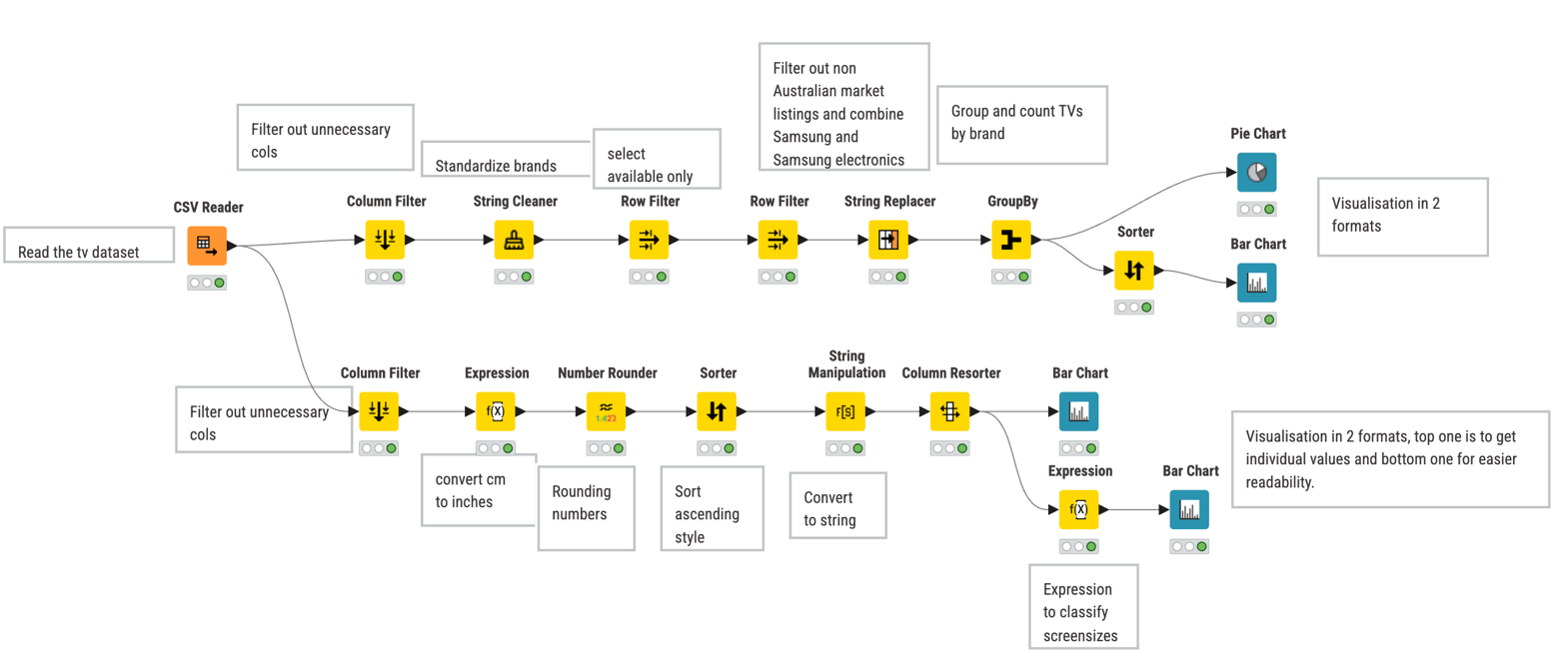

4. Visualisations
Two chart types were used to visualise different aspects of the dataset.

4.1 Bar Chart — Screen Size Classified into Small, Medium & Large against Energy usage
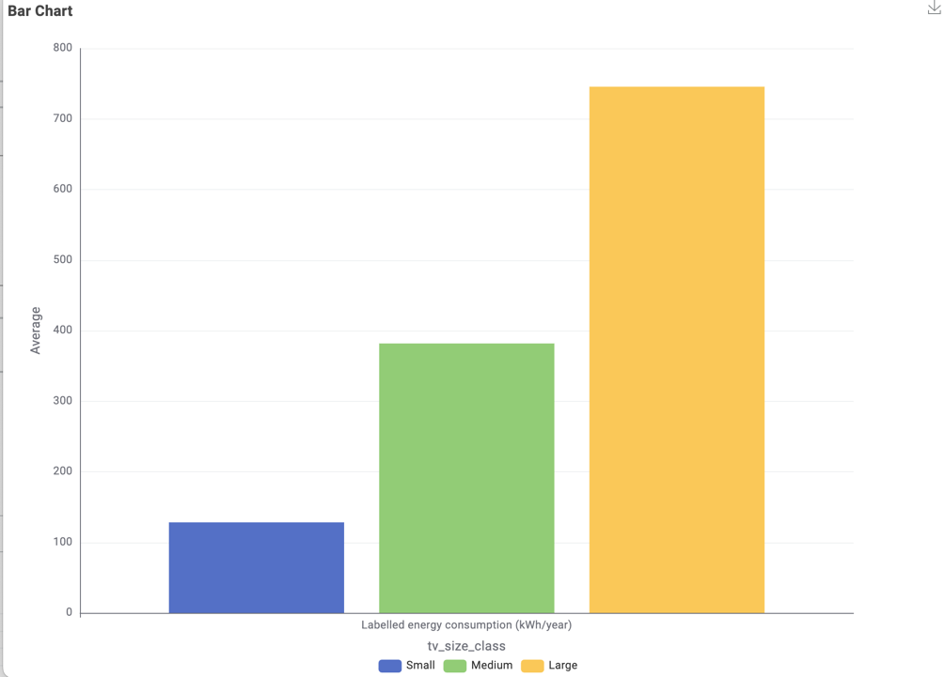

4.2 Bar Chart — Screen Size Distribution against energy distribution
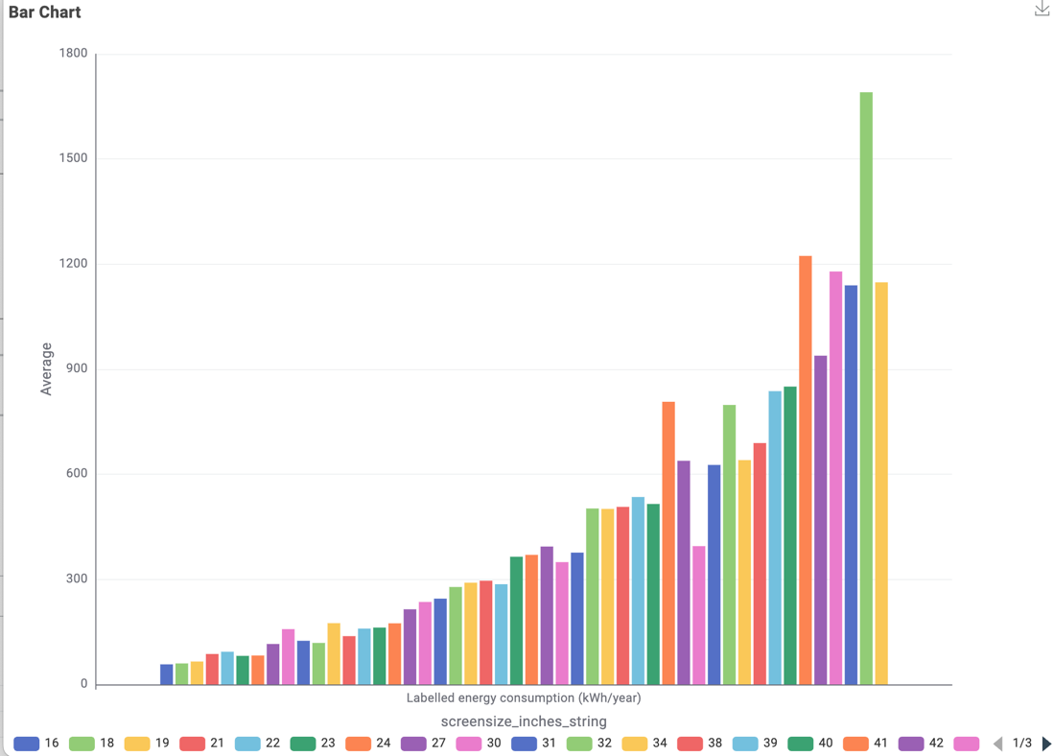

4.3 Pie Chart — Brand Market Share

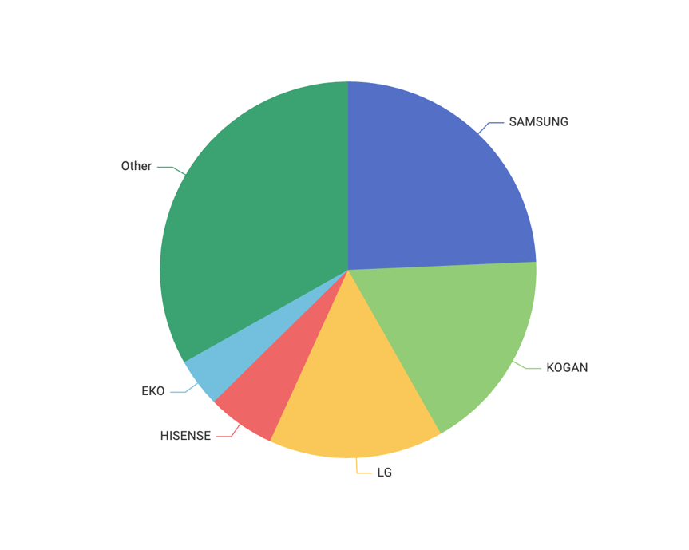

5. Generative AI Declaration
I declare that I did not use any Generative AI tools in the completion of this assessment.
All data processing, workflow design, and analysis was completed independently using KNIMEPlatform.

