Benchmarking Somatic Mutation Representations for Cancer Typing and HRD Prediction
Working draft: full manuscript except Introduction/Discussion (v13) · 2026-09-23
Aaron Ge1,2, Xingyan Liu4,‡ Vijay Vankadaru5,‡ Jonas De Almeida3,§ Jeya Balaji Balasubramanian3,§ Bradley A. Maron1,2*
1 University of Maryland Institute for Health Computing, University of Maryland School of Medicine, Baltimore, MD, USA
2 University of Maryland School of Medicine, Baltimore, MD, USA
3 Division of Cancer Epidemiology and Genetics, National Cancer Institute, National Institutes of Health, Bethesda, MD, USA
4 Harvard T.H. Chan School of Public Health, Harvard University, Boston, MA, USA
5 School of Information, University of California, Berkeley, Berkeley, CA, USA
‡Xingyan Liu and Vijay Vankadaru contributed equally to this work.
§Jonas De Almeida and Jeya Balaji Balasubramanian are co-senior authors.
*Correspondence: Aaron Ge, age1@som.umaryland.edu
Abstract
Motivation. Somatic mutation catalogues can be summarized as mutation burden, mutational spectra, or biologically annotated event features, but the effect of that choice is rarely measured with evaluation held fixed.
Results. We benchmarked four representations: burden, spectra (SBS96+ID83), annotated MAF features (Bio MAF v4), and Sig+MAF, across seven TCGA endpoints under nested cross-validation. Sig+MAF was strongest: 0.767 Spearman for HRD score, 0.901 AUROC for HRD33, and 0.738 balanced accuracy for cancer type. A MuAt-compatible attention model did not beat the tabular HRD baseline. Frozen models transferred: HRD ranking held in 147 POG570 cancers (Spearman 0.667); a frozen spectra model reached 0.479 accuracy in 913 PCAWG tumors. In a 259-clone experimental mutagen panel, the TCGA ranking reversed: spectra alone was best in both model classes (0.331 and 0.250 balanced accuracy), an observed discrepancy, not an explained one. For survival, genomics added nothing once cancer type was known (ΔC +0.0013, p = 0.512); with standard clinical covariates in the model, adding cancer type raised the C-index from 0.669 to 0.779, while adding Bio MAF on top did not improve it (ΔC -0.0036, p = 0.02).
Availability and implementation. Code and benchmark tables: https://github.com/aaronge-2020/uga-maf-representation-paper (software version to be archived at Zenodo).
Contact. age1@som.umaryland.edu
Supplementary information. Supplementary material available at Genome Medicine online.
Keywords. somatic mutations; mutational signatures; TCGA; homologous recombination deficiency; cancer classification; machine learning; nested cross-validation
Introduction
[Introduction: to be drafted by Cindy.]
Results
Study overview
We benchmarked four ways of summarizing a tumor’s somatic mutation catalogue: mutation burden, mutational spectra, biologically annotated MAF features (Bio MAF), and spectra plus Bio MAF (Sig+MAF), across seven primary endpoints in The Cancer Genome Atlas, with progression-free interval as a secondary survival endpoint. Endpoints were HRD score (regression, n = 772 breast cancers), HRD-high/low classification at thresholds 24, 33, and 42 (n = 772), cancer-type classification across 20 cancer types (n = 8,800), mutagen damage-class classification in an experimental clone panel (n = 259), overall survival (n = 9,986), and progression-free interval (n = 9,857). Each representation was evaluated with elastic net and XGBoost under nested cross-validation; survival was modeled separately with CoxNet. The overall design is shown in Figure 1. For HRD, we also evaluated a locally implemented MuAt-compatible attention model [1] on the same held-out folds.
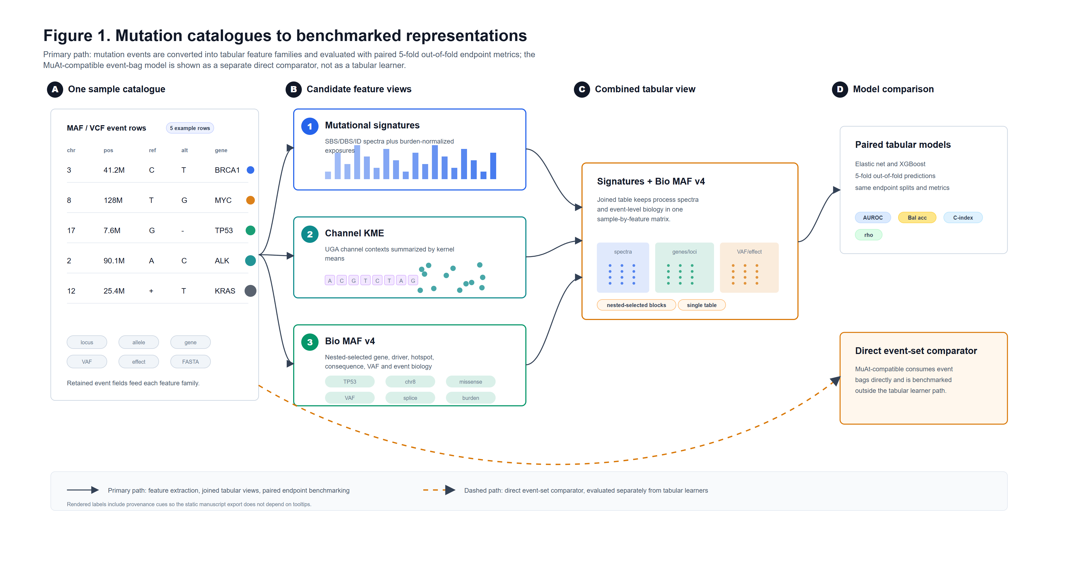
Figure 1. Study design. Mutation catalogues are converted into tabular representations (burden, mutational spectra, Bio MAF v4, and spectra plus Bio MAF) and evaluated with paired five-fold out-of-fold metrics using elastic net and XGBoost; the MuAt-compatible event-bag model is compared separately on HRD endpoints.
Mutational spectra improve on burden, but the gain depends on endpoint and model
We first compared mutational spectra (SBS96 + ID83 channel counts [2]) against a minimal mutation-burden baseline. With XGBoost, spectra outperformed burden on all six non-survival endpoints: Kucab damage class rose from 0.145 to 0.250 balanced accuracy, HRD score from 0.600 to 0.693 Spearman correlation, HRD24 high/low from 0.775 to 0.829 AUROC, HRD33 high/low from 0.799 to 0.850 AUROC, HRD42 high/low from 0.838 to 0.902 AUROC, and cancer type (top 20) from 0.255 to 0.538 balanced accuracy. All six XGBoost gains were statistically significant after FDR correction (paired tests, q < 0.05). Elastic net showed the same qualitative gain for Kucab damage class (0.178 to 0.331) and cancer type (0.247 to 0.526), but not for every endpoint: with elastic net, burden exceeded spectra for HRD33 high/low (0.788 vs. 0.774 AUROC) and for HRD score (0.497 vs. 0.431 Spearman). Spectra are therefore a strong baseline, but their advantage is not uniform across model classes (Figure 2).
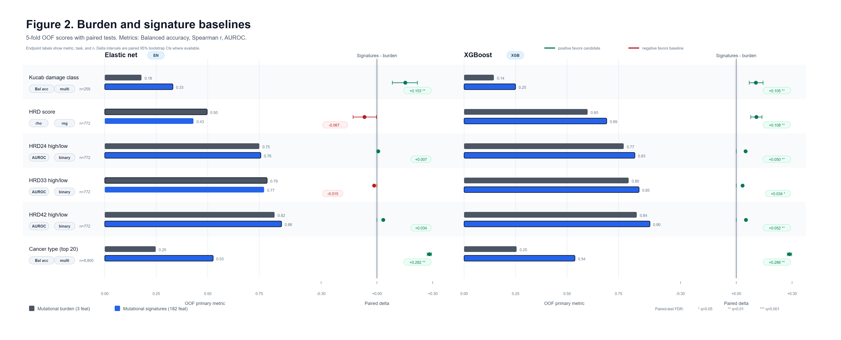
Figure 2. Burden and signature baselines. Five-fold out-of-fold primary metrics for elastic net and XGBoost, with paired deltas (signatures minus burden) and FDR-corrected significance markers.
Biological annotations add signal that spectra miss
Bio MAF aggregates per-tumor summaries of variant consequences, predicted functional effects, driver-gene alterations, cancer hotspots, and allele fractions into a fixed-length profile (see Methods). Used alone, Bio MAF was strongest where gene-level biology matters most: for cancer-type classification with XGBoost, it improved on spectra from 0.538 to 0.662 balanced accuracy (q < 0.05). It was not uniformly better than spectra, however. For Kucab damage class, an experimental panel in which the label is the mutagen applied, Bio MAF alone underperformed spectra with XGBoost (0.174 vs. 0.250 balanced accuracy, q < 0.05), consistent with mutagen exposure being captured better by sequence-context spectra than by gene-level aggregates. For HRD score and HRD33 high/low, Bio MAF alone was numerically close to spectra with XGBoost (0.741 vs. 0.693 Spearman; 0.856 vs. 0.850 AUROC) without reaching significance after FDR correction (Figure 4).
Combined spectra and biological annotations give the strongest tabular performance
Concatenating spectra with Bio MAF (Sig+MAF) produced the best tabular result for five of the six clinical endpoints. With XGBoost, Sig+MAF reached 0.767 Spearman correlation for HRD score, 0.901 AUROC for HRD33 high/low, and 0.738 balanced accuracy for cancer type across 20 cancer types, each the highest value among the evaluated tabular representations. Adding Bio MAF to spectra raised cancer-type balanced accuracy from 0.538 to 0.738, a gain of 0.20 that was significant after FDR correction (q < 0.05). Sig+MAF also led on HRD24 high/low (0.848 AUROC) and on overall survival (0.650 C-index). The clinical exception was HRD42 high/low, where spectra alone were marginally ahead (0.902 vs. 0.897 AUROC); on the non-clinical Kucab panel, spectra alone remained best (0.250 vs. 0.198 balanced accuracy with XGBoost; 0.331 with elastic net). Against spectra alone, Sig+MAF was significantly better with XGBoost for HRD score and cancer type (both q < 0.05); the HRD33 gain (+0.051 AUROC) did not reach significance after correction (q = 0.109). Taken together, spectra and biological annotations carry complementary information, and their combination is the most robust default among the tabular representations tested (Figure 4).
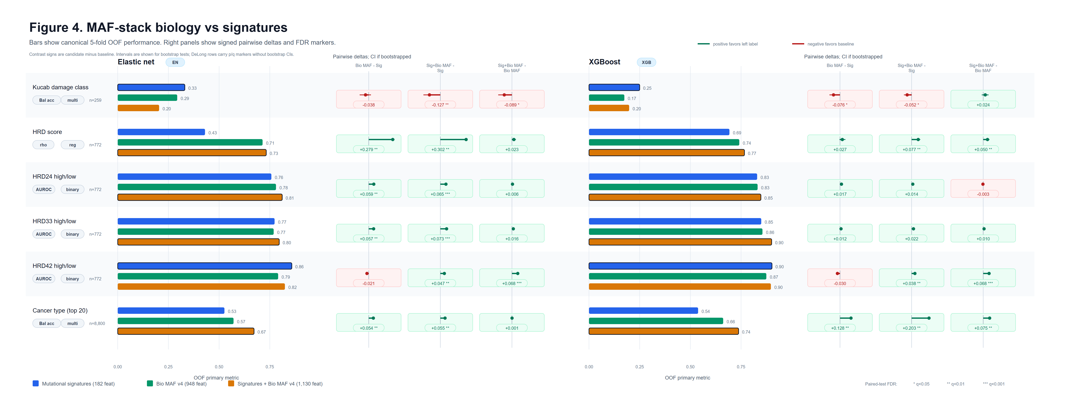
Figure 4. MAF-stack biology versus signatures. Canonical five-fold out-of-fold performance with signed pairwise deltas and FDR markers for Bio MAF minus signatures, Sig+Bio MAF minus signatures, and Sig+Bio MAF minus Bio MAF.
The Kucab cell-line panel reverses the TCGA ranking
The Kucab endpoint differs from the clinical endpoints: its labels are the mutagen applied to experimental cell-line clones (n = 259), not a tumor property. Here the TCGA ranking broke down. With elastic net, spectra alone reached 0.331 balanced accuracy, ahead of Bio MAF (0.293), Sig+MAF (0.204), and burden (0.178); with XGBoost, spectra alone reached 0.250, ahead of Sig+MAF (0.198), Bio MAF (0.174), and burden (0.145). In both model classes spectra alone was best, and the TCGA-leading Sig+MAF fell far short of its TCGA performance, ranking second-weakest with elastic net and second-best with XGBoost. We report this as an observed discrepancy, not an explained one. Plausible contributors include the shift from primary tumors to cell lines, the small sample size, and the fact that mutagen exposure is a sequence-context signal that spectra capture directly; these are interpretations, not demonstrated explanations. The result argues against broad claims that the TCGA representation ranking generalizes beyond TCGA-like tumor data. Balanced accuracy remains the primary metric for this endpoint.
A MuAt-compatible attention model does not beat the tuned tabular baseline on HRD
To test whether a neural event-level model changes the picture, we implemented a MuAt-compatible [1] attention model that reads per-mutation event bags (sequence motif, 1-Mb position bin, and genic/exonic/strand annotation tokens) with query/key/value attention and attention-weighted pooling. We did not have access to the official MuAt weights or its pretraining corpus, so this is a local reimplementation trained from scratch, not a reproduction of the published model. It was evaluated on the identical samples and matched held-out folds as the tabular benchmark, for HRD score and HRD33 high/low only. The comparator reached 0.519 Spearman correlation for HRD score and 0.729 AUROC for HRD33 high/low, compared with 0.767 and 0.901 for Sig+MAF with XGBoost on the same folds. Under this directly comparable evaluation, the attention-based event model did not exceed a tuned tabular baseline (Figure 3).
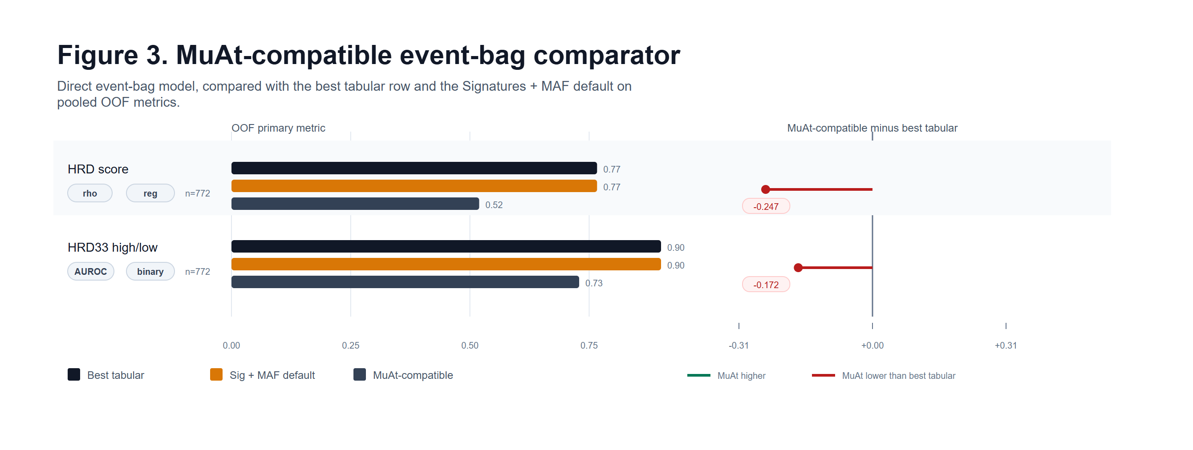
Figure 3. MuAt-compatible event-bag comparator. The attention-based event model is compared with the best tabular row and the Sig+MAF default on pooled out-of-fold HRD metrics (n = 772).
Fidelity fixes did not change the HRD result. We reran the comparator in four arms of increasing fidelity to the published MuAt design: (A) the original implementation (training-budget bookkeeping bug, hashed token dictionaries); (B) adding an epoch-budget fix; (C) additionally using exact token dictionaries; (D) additionally using the exact MuAt motif grammar and transcriptional strand. HRD score Spearman correlation across arms was 0.477, 0.503, 0.504, and 0.482; HRD33 AUROC was 0.758, 0.727, 0.703, and 0.734, a total spread of 0.028 and 0.055, within per-fold standard deviation and directionally inconsistent, so progressive fidelity fixes did not improve HRD prediction. The model consistently selected early stopping epochs (median 6.5, maximum 34 of 150), consistent with rapid overfitting on roughly 600 training samples per fold. On cancer-type classification, by contrast, the fidelity fixes raised accuracy from 0.539 to 0.570 and top-5 accuracy from 0.861 to 0.871, narrowing the gap to the published MuAt result [1] on a comparable 20-type TCGA whole-exome task (0.641 accuracy) from 0.102 to 0.071, where the larger cohort (n = 8,800) supported the richer model. At this sample size, HRD appears data-limited rather than representation-limited.
HRD performance does not depend on homologous recombination repair gene features
Because HRD is mechanistically tied to homologous recombination repair (HRR) genes, we tested whether the models were simply reading HRR gene mutations. The HRD labels are genomic-scar scores whose components (loss of heterozygosity, telomeric allelic imbalance, large-scale state transitions) are copy-number patterns [11,12], while every benchmark predictor is a summary of SNV and indel calls; no copy-number features enter the models. (VAF summaries are computed from read counts and are influenced by copy number, but they are not copy-number inputs.) As a further check, we removed the 32 direct per-gene columns for 16 HRR genes (ABL1, ATM, ATR, BARD1, BRCA1, BRCA2, MDC1, NSD2, PALB2, PARP1, POLD1, POLE, PPP4R2, RAD50, RAD51C, RAD52; the functional-event and role-matched columns for each gene) and remeasured HRD performance. This removes direct per-gene HRR features, not all HRR-related information: the retained pooled families, including the 16 driver-evidence tier aggregates, the 12 OncoKB role aggregates, VAF summaries, and hotspot summaries, can still carry indirect HRR-related signal. HRD performance was essentially unchanged: HRD score Spearman went from 0.7604 to 0.7628 (change +0.002, 95% CI -0.007 to 0.012, p = 0.622), HRD33 AUROC from 0.8995 to 0.8981 (change -0.001, 95% CI -0.007 to 0.004, p = 0.637), and HRD42 AUROC from 0.8966 to 0.8976. By contrast, removing allele-fraction features reduced HRD33 AUROC from 0.8995 to 0.8742 (p < 0.001), consistent with the models using genome-wide mutation patterns rather than direct HRR gene hits.
External validation
We tested the frozen TCGA-trained models in two independent cohorts without any retraining. In 147 POG570 [3] breast cancers with whole-genome sequencing, the Sig+MAF HRD model preserved rank order (Spearman correlation 0.667, 95% CI 0.558 to 0.754), but absolute calibration shifted: the mean predicted HRD score was 41.69 against an observed mean of 22.30, with MAE 15.91 and negative R² (-0.225). HRD ranking therefore transferred across cohorts and sequencing platforms, while the score scale did not. In 913 PCAWG [4] tumors spanning nine cancer types mapped to TCGA labels, the frozen spectra-based cancer-type model reached 0.479 accuracy and 0.365 balanced accuracy, with top-3 accuracy of 0.622; performance was heterogeneous across types (stronger for LIHC, ESCA, and SKCM; weaker for BRCA, PRAD, HNSC, KIRC, and STAD), consistent with the shift from TCGA whole-exome to PCAWG whole-genome data and differences in cohort composition.
Survival: genomic signal adds nothing once cancer type is known
Overall survival was modeled with CoxNet [5], separately from the classification and regression endpoints. Among the four mutation representations alone, Sig+MAF led with a Harrell C-index [6] of 0.650, ahead of Bio MAF alone (0.634), spectra (0.607), and burden (0.584) (Figure 5). The same ordering held for progression-free interval as a secondary endpoint (n = 9,857): Sig+MAF 0.630, Bio MAF 0.622, spectra 0.570, burden 0.555.
A three-arm CoxNet analysis asked the clinically relevant question: does the genomic representation add prognostic information beyond cancer type itself? Cancer type alone reached 0.742; Bio MAF v4 alone reached 0.638; cancer type plus Bio MAF v4 reached 0.743. The combined model gained +0.0013 over cancer type alone (95% CI -0.0028 to +0.0054, p = 0.512), a precise null. Genomic features therefore add no measurable prognostic value once cancer type is known, and the representation-only ranking above largely reflects recovering cancer type imperfectly (Figure 6).
A second CoxNet analysis added standard clinical covariates: age, sex, and AJCC stage. It ran on the identical cohort (n = 9,986) and the identical outer folds as the analyses above, so every C-index is directly comparable. Clinical covariates alone reached a C-index of 0.669; adding cancer type raised it to 0.779 (difference +0.1106, 95% CI 0.1016 to 0.1194, p < 0.001), confirming that cancer type carries the dominant prognostic signal among these covariates. Adding Bio MAF v4 on top of clinical covariates plus cancer type changed the C-index by -0.0036 (95% CI -0.0066 to -0.0006, p = 0.02): no improvement, with the point estimate slightly negative. Genomic features therefore add no measurable prognostic value beyond clinical covariates plus cancer type, consistent with the precise null above (Supplementary Tables S3 and S4).
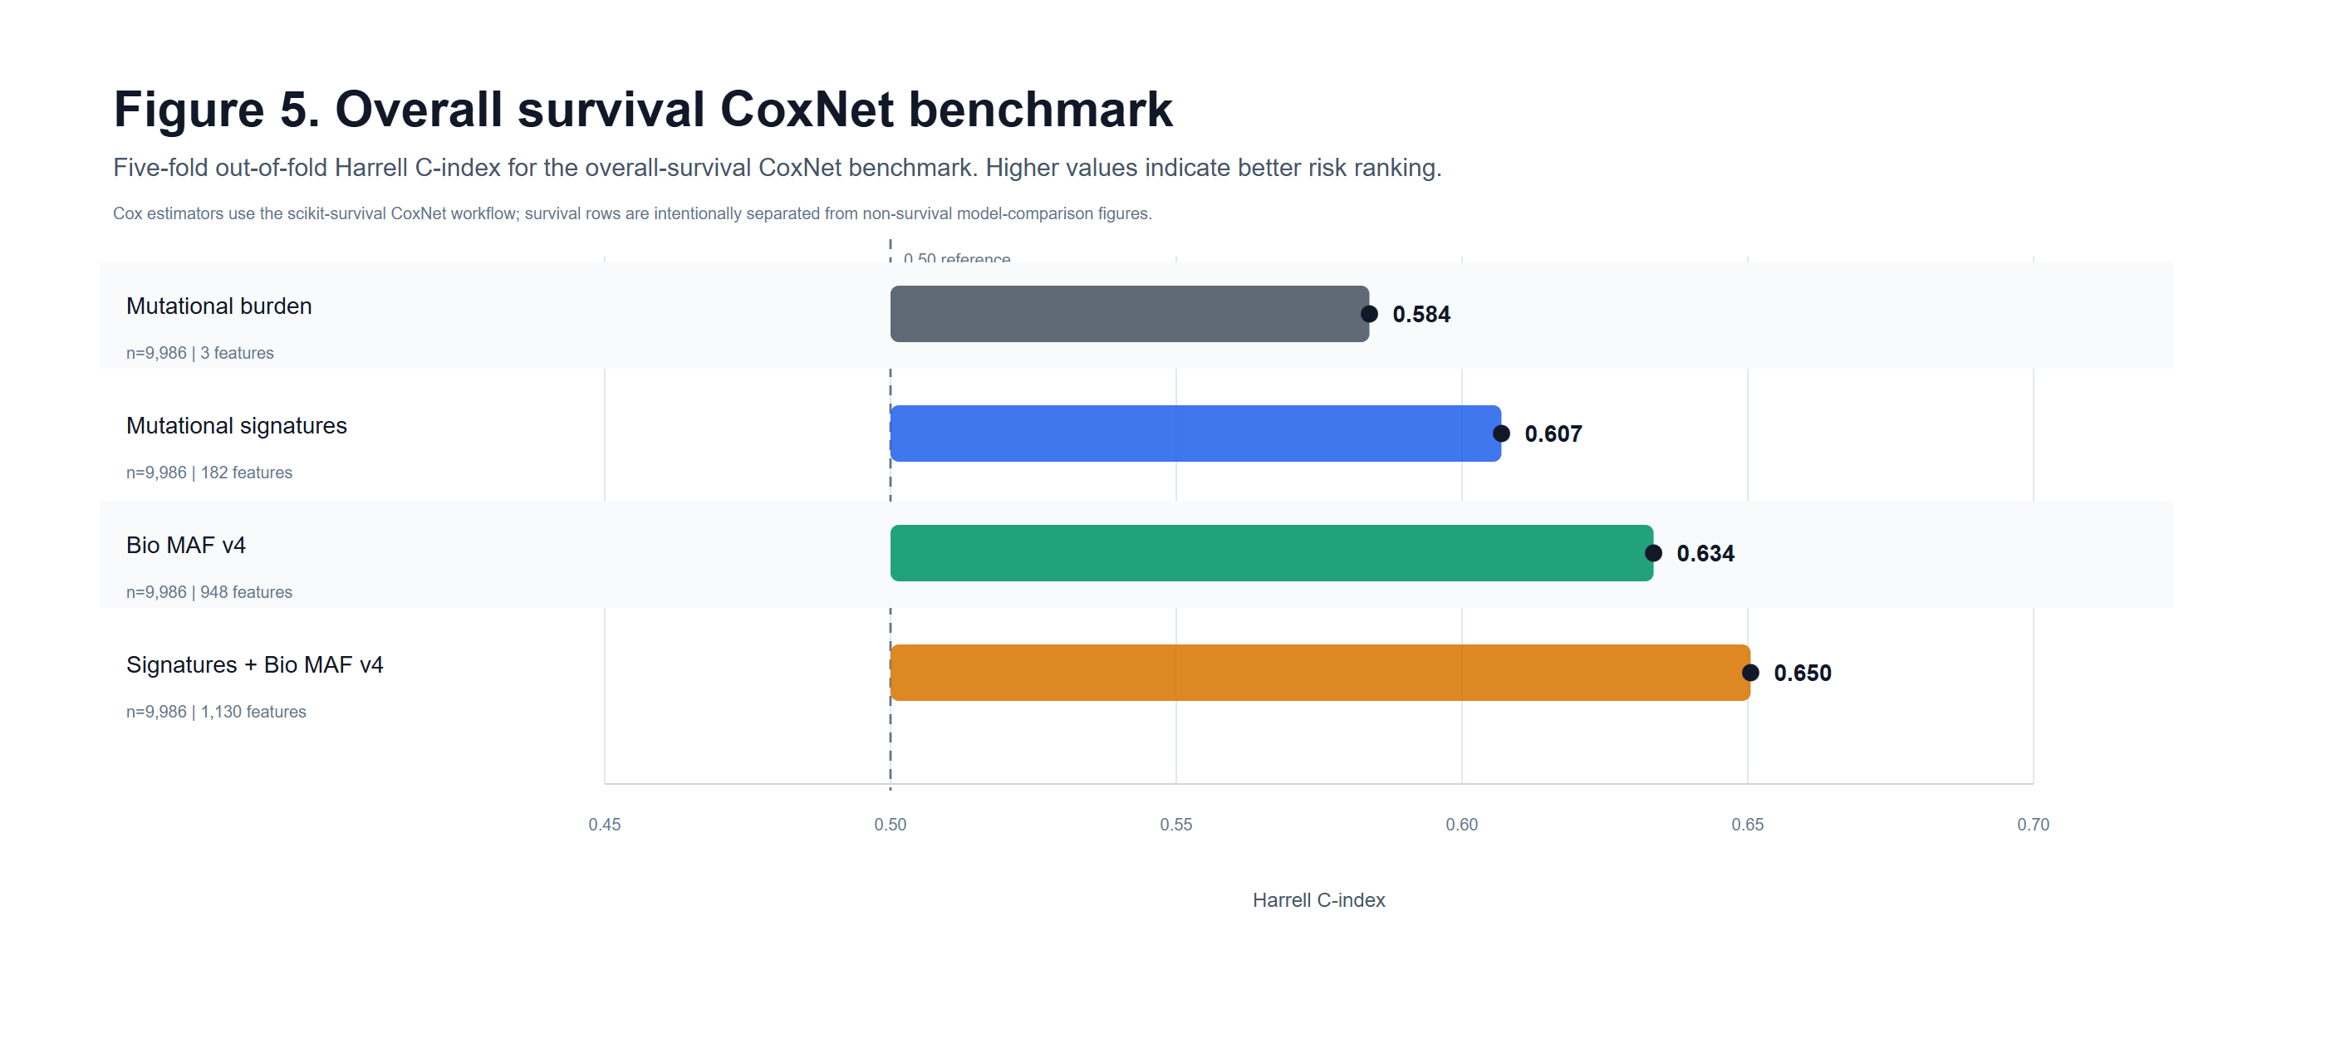
Figure 5. Overall survival CoxNet benchmark. Five-fold out-of-fold Harrell C-index by representation (n = 9,986).
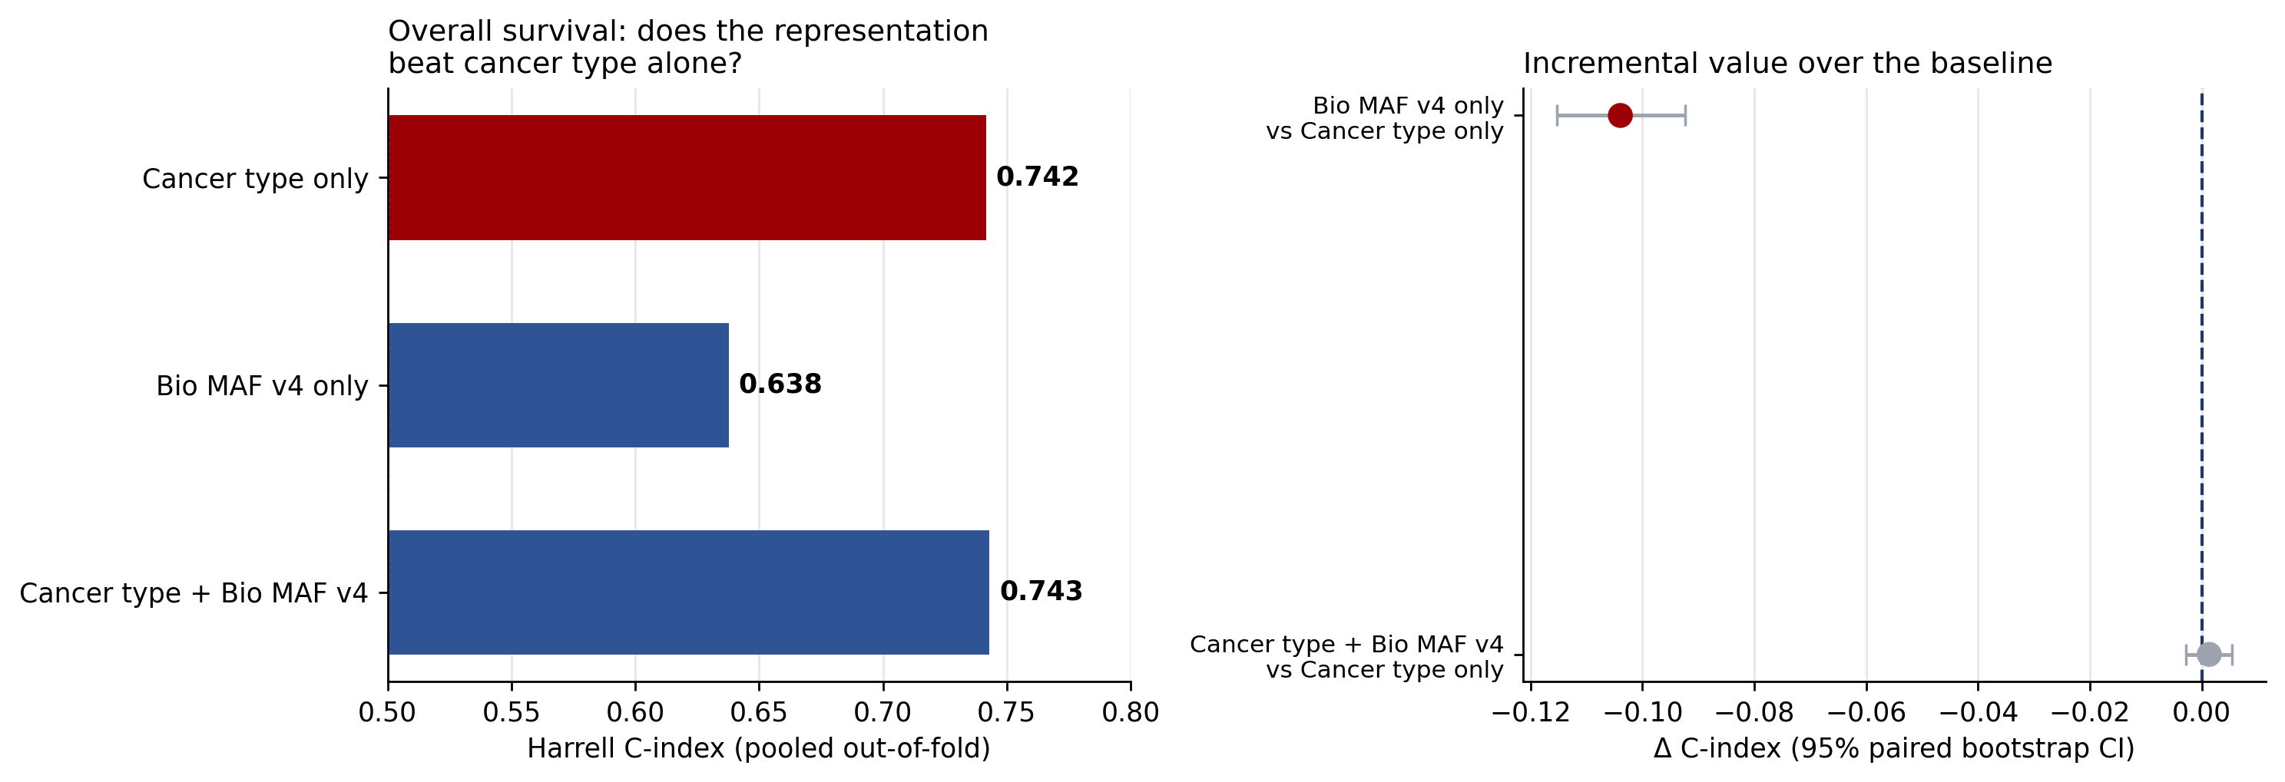
Figure 6. Survival adds nothing beyond cancer type. Three-arm CoxNet comparison of cancer type alone, Bio MAF v4 alone, and both combined (Harrell C-index, n = 9,986; left), with paired bootstrap 95% confidence intervals for the incremental differences (right). The combined model is statistically indistinguishable from cancer type alone.
Table 1. Main-panel performance. Each cell shows elastic net / XGBoost on the endpoint’s primary metric (Spearman r for HRD score; AUROC for binary HRD endpoints; balanced accuracy for multiclass endpoints), except overall survival and progression-free interval, which show CoxNet Harrell C-index. N is the analysis sample size. Bold marks the best tabular value per endpoint.
Endpoint | Metric | N | Burden | Spectra | Bio MAF | Sig+MAF | MuAt-compatible
Kucab damage class | Balanced accuracy | 259 | 0.178 / 0.145 | 0.331 / 0.250 | 0.293 / 0.174 | 0.204 / 0.198 | n/a
HRD score | Spearman r | 772 | 0.497 / 0.600 | 0.431 / 0.693 | 0.714 / 0.741 | 0.733 / 0.767 | 0.519
HRD24 high/low | AUROC | 772 | 0.750 / 0.775 | 0.758 / 0.829 | 0.781 / 0.832 | 0.811 / 0.848 | n/a
HRD33 high/low | AUROC | 772 | 0.788 / 0.799 | 0.774 / 0.850 | 0.769 / 0.856 | 0.797 / 0.901 | 0.729
HRD42 high/low | AUROC | 772 | 0.825 / 0.838 | 0.859 / 0.902 | 0.791 / 0.875 | 0.824 / 0.897 | n/a
Cancer type (top 20) | Balanced accuracy | 8,800 | 0.247 / 0.255 | 0.526 / 0.538 | 0.571 / 0.662 | 0.672 / 0.738 | n/a
Overall survival | Harrell C-index | 9,986 | 0.584 | 0.607 | 0.634 | 0.650 | n/a
Progression-free interval (secondary) | Harrell C-index | 9,857 | 0.555 | 0.570 | 0.622 | 0.630 | n/a

Methods
Cohorts and data sources
Mutation data came from the TCGA MC3 somatic mutation call set [7] (whole-exome sequencing), file mc3.v0.2.8.PUBLIC.maf.gz, aligned to the GRCh37 reference assembly (GCF_000001405.13). Variants were annotated with Ensembl VEP (McLaren et al., 2016) [13] via vcf2maf as part of the TCGA MC3 call set (Ellrott et al., Cell Systems 2018). The exact VEP release is not recoverable from the distributed data: the MC3 paper states VEP annotation via vcf2maf without a version, and the distributed MAF carries no version header lines. HRD endpoints used 772 TCGA breast cancers (TCGA-BRCA) [8] with published HRD labels and MC3 mutation features. Cancer-type classification used a fixed cohort of 8,800 TCGA tumors across the 20 most common cancer types. Overall survival used 9,986 TCGA tumors with clinical follow-up from the TCGA clinical data resource [9]. The experimental control panel used 259 mutagen-treated cell-line clones from the Kucab et al. [10] Mendeley Data mutagenesis dataset (DOI 10.17632/m7r4msjb4c; Version 2, DOI 10.17632/m7r4msjb4c.2, published 21 February 2019, is contemporaneous with the paper, and a Version 3 exists; the repository records the exact raw filenames, denovo_subclone_subs_final.txt, denovo_subclone_doublesub_final.txt, and denovo_subclone_indels.final.txt, but not which dataset version was downloaded), labeled by the DNA-damaging agent applied. For analysis, the 79 mutagens were grouped into eight project-defined damage classes [10]: alkylating and aldehyde adduct stress; aromatic and heterocyclic amines; environmental organ-specific DNA adducts; nitroaromatic and nitro-PAH adducts; oxidative and radiation-like stress; PAH bulky adducts; platinum and crosslinking therapy; and replication stress and DNA repair inhibition. External validation used two independent whole-genome-sequenced cohorts: POG570 [3] (570 tumors; 147 primary breast cancers used for the primary HRD transfer analysis) and PCAWG [4] (913 tumors across nine cancer types mapped to TCGA labels).
Data-generating centers were identified from the terminal two characters of each sample’s full-length TCGA aliquot barcode, which the GDC TCGA Barcode documentation [28] defines as the sequencing or characterization center; we refer to it as the data-generating center. Variant allele fraction (VAF), the share of sequencing reads carrying a mutation, also tracks tumor purity: mean VAF correlates 0.56 with a tumor-purity estimate (n = 9,660), so VAF-based summaries partly reflect how much tumor DNA was in the sample rather than tumor biology alone.
Endpoints
We evaluated seven primary endpoints and one secondary endpoint (progression-free interval). HRD score is the continuous genomic-scar HRD score [11], with per-sample scores and components from Knijnenburg et al. [12]; its components (loss of heterozygosity, telomeric allelic imbalance, large-scale state transitions) and two additional HRD-related scores were evaluated as supplementary endpoints. Binary HRD-high/low labels were defined at score thresholds of 24, 33, and 42; the ≥42 cutoff is the published HRD-positivity threshold [11], and 24 and 33 were prespecified exploratory cutoffs. Cancer type was 20-class classification. Kucab damage class was grouped multiclass classification of the applied mutagen, with clones from the same experiment kept together. Overall survival was a right-censored time-to-event endpoint. Metastatic status was not modeled and is a potential confounder of the survival analyses.
Representations
Each tumor’s mutation catalogue was summarized four ways. (1) Mutation burden: total event counts and compact burden summaries (1 to 3 features). (2) Mutational spectra: per-tumor SBS96 single-base substitution channel summaries plus ID83 indel channel summaries (COSMIC v3.5 [2]), 182 features for the TCGA endpoints; the Kucab panel used SBS96 plus DBS78 plus ID83 channel frequencies plus four burden covariates (log total burden and SBS, DBS, and indel fractions), 261 features. (3) Bio MAF v4: 910 interpretable per-tumor summaries of MAF annotations, built from fixed external references without using endpoint labels; exactly what those 910 numbers are is spelled out in the next paragraph. (Role assignments for 38 panel genes lacked documented OncoKB support and were excluded from the feature set; see below.) All benchmark scores reported in Table 1 and the survival analyses were computed on the original 948-feature matrix; the 910-feature matrix is the corrected public release with the 38 undocumented role-matched columns removed, and every retained column is bit-identical between the two. The 38 removed columns carried negligible selected signal, as documented in Supplementary Results. (4) Sig+MAF: spectra concatenated with the nested-selected Bio MAF blocks (1,130-3,241 features across endpoints and folds). The six candidate Bio MAF feature sets were fixed combinations: the 121-feature compact biology set alone; compact plus hotspot summaries (125); compact plus driver-evidence tiers (137); compact plus exact per-gene driver features (923); the full strict core (943); and the full set plus five optional burden controls (948). These combinations were fixed in the analysis pipeline before the reported endpoint evaluations (block definitions committed 2026-06-12; endpoint result tables committed 2026-06-24 and 2026-08-20), and the inner validation loop selects among them without access to outer-fold labels. That nesting is the guard against endpoint-specific overfitting; it does not remove all researcher degrees of freedom in how the blocks were defined, and we do not claim a formal timestamped prespecification protocol predating all exploratory work. All count-like features used log1p transforms, the standard choice for right-skewed count data: it compresses the long tail of hypermutated tumors so they do not dominate fitting, while mapping zero counts to zero. Fraction features divide by the tumor’s total annotated mutation events (doublet-base and indel fractions divide by total single-base plus doublet-base plus indel burden); tumors with no events get zero. The design overview (Figure 1) additionally depicts a channel kernel-mean-embedding view among the candidate feature views; the benchmark panel evaluated the four representations described above.
What the 910 Bio MAF features actually are. Each tumor’s mutation list is counted and summarized in eight families, from the most generic to the most gene-specific. (1) VEP annotations, 100 features. Every mutation carries standard labels from the Ensembl Variant Effect Predictor [13]: how disruptive it looks (high, e.g. stop-gained or frameshift; moderate, e.g. missense; low, e.g. synonymous; modifier, mostly non-coding or regulatory), what kind of change it is (26 categories: missense, stop-gained, frameshift, splice-site, synonymous, intron, 5′/3′ UTR, and others), whether it falls on the gene’s main (“canonical”) transcript, what kind of RNA the gene makes (protein-coding, lncRNA, and others), and what two protein-damage predictors (SIFT [14], PolyPhen [15]) call it. For each of the 50 labels we record the count and the fraction of the tumor’s mutations. (2) Allele-fraction summaries, 5 features. Variant allele fraction (VAF) is the share of sequencing reads carrying a mutation: high means the mutation is present in most tumor cells (early, “clonal”); low means a small subclone. We record the mean, spread, median, 90th percentile, and maximum VAF across the tumor’s mutations. (3) OncoKB cancer-role summaries, 12 features. OncoKB [16] labels each gene’s cancer role: oncogene (“gas pedal”), tumor suppressor (“brake”), or both. For each of the 3 roles: the number of disruptive mutations, the number of highly disruptive mutations, the number of distinct genes hit, and the highest VAF. (4) Non-driver summaries, 4 features. The same four summaries for disruptive mutations in genes claimed by no driver list, a control for signal outside the known cancer genes. (5) Burden controls, 5 features. Overall mutation load on a log scale for single-base, doublet-base, and indel mutations, plus the fraction of mutations that are doublet-base or indels. (6) Driver-evidence tiers, 16 features. We checked 1,396 candidate genes against four driver catalogs: OncoKB [16], COSMIC Cancer Gene Census v99 [18], IntOGen (release downloaded 18 June 2024) [19], and Vogelstein et al. 2013 [20], and grouped genes by how many catalogs list them (1 to 4). For each tier: counts of disruptive and highly disruptive mutations, the number of distinct genes hit, and the highest VAF. (7) Cancer hotspots, 4 features. Mutations landing on amino-acid positions where cancers mutate again and again, from the cancerhotspots.org catalog [17] (cBioPortal/cancerhotspots repository, commit 8c79cc62e85df53930a775191ca828cf27449152; hotspots_v3.xlsx): the count of exact-variant matches, the count of residue matches, the number of distinct genes, and the highest VAF. (8) Per-gene driver features, 764 features. For each of the 401 panel genes defined above (listed by at least 3 of the 4 catalogs, or a hotspot gene; see Driver-gene panel definition and threshold sensitivity), the log-count of protein-altering or high/moderate-impact mutations in that gene (functional events); for the 363 genes with an OncoKB-supported cancer role, additionally the log-count of mutations whose type fits that role (role-matched events; for example, a truncating mutation in a tumor-suppressor gene, or a hotspot missense in an oncogene). Thirty-eight panel genes whose OncoKB role evidence was recorded as insufficient have no documented role assignment and contribute only the functional-event column. The OncoKB snapshot behind the published matrix was downloaded on or before 12 June 2026; the exact download date was not recorded. The 16 role-aggregate columns (12 oncokb_role and 4 residual non-OncoKB role columns) encode that snapshot’s role flags and are distributed as-is in the released 910-feature matrix: rebuilding them from a 23 September 2026 download changes 15 of the 16, so they cannot be regenerated from the current resource. All 401 panel genes are present in the 23 September 2026 download with agreeing OncoKB type assignments. In total: 100 + 5 + 12 + 4 + 5 + 16 + 4 + 764 = 910 features per tumor.
Driver-gene panel definition and threshold sensitivity
The 401-gene panel was defined from a 1,396-gene universe: the union of genes listed by OncoKB [16], the COSMIC Cancer Gene Census v99 [18], IntOGen (release downloaded 18 June 2024) [19], Vogelstein et al. 2013 [20], or the cancerhotspots.org catalog [17]. A gene entered the panel if it appeared in at least 3 of the 4 catalogs or was a hotspot gene. Eighty-four of the 1,396 genes are mentioned by OncoKB without being annotated as drivers and appear in no other source; they belong to no tier and enter no analysis. Panel sizes under alternate thresholds were 1,312 (at least 1 catalog or hotspot), 623 (at least 2), 401 (at least 3), and 262 (all 4). These are catalog-overlap tiers, not independent lines of evidence: the catalogs overlap substantially (for example, Jaccard similarity 0.47 between COSMIC CGC and IntOGen), and OncoKB acts as a gatekeeper, since all 330 genes entering by catalog count are OncoKB-annotated; 71 of the 401 enter through the hotspot clause alone, including MYC, ESR1, POLE, MSH2, PMS2, CHEK2, and KEAP1. We did not retrain models at alternate thresholds. Descriptively, none of the 234 selected per-gene features fall below the at-least-2 tier, and 92.4% of the selected per-gene attribution (mean |SHAP|) for cancer type sits in genes listed by all four catalogs; however, selection could change after retraining on another candidate panel. A limitation of the at-least-3 rule is that CALR, a well-known myeloproliferative neoplasm driver listed by OncoKB and COSMIC CGC but not a hotspot gene, is excluded from the panel.
Models
Tabular representations were modeled with elastic net [21] and XGBoost [22]. Features were standardized (zero mean, unit variance, scaler fit on the training split) for elastic net but not for XGBoost. Elastic-net regression used coordinate descent (max_iter 10000) over alpha values {1e-4, 1e-3, 1e-2, 1e-1, 1, 10} and l1_ratio values {0, 0.25, 0.5, 0.75, 1}. Classification with fewer than 500 features used logistic regression with the saga solver (elastic-net penalty, max_iter 5000) over C values {0.001, 0.01, 0.1, 1, 10} and the same l1_ratio grid; classification with 500 or more features used stochastic gradient descent with log loss (max_iter 200, tol 1e-3, 5-iteration no-change patience, averaged weights, no internal early stopping). All linear classifiers used balanced class weights. Low-dimensional linear models and elastic-net regression searched the full grid; high-dimensional linear models, XGBoost, and CoxNet tuned 10 seeded random candidates on the inner validation split.
XGBoost used the gpu_hist tree method (falling back to hist when no GPU was available), up to 160 estimators with 20-round early stopping on the inner validation split; the early-stopped round count was used for the final refit on the outer-training fold. The search sampled max_depth {2, 3, 4, 5}, learning_rate {0.01, 0.03, 0.05, 0.08, 0.1}, subsample and colsample_bytree {0.70, 0.85, 1.0}, min_child_weight {1, 3, 5, 10}, reg_lambda {0.5, 1.0, 2.0, 5.0, 10.0}, and reg_alpha {0.0, 0.01, 0.05, 0.1, 0.5}. Binary classification set scale_pos_weight to the training negative-to-positive ratio; evaluation metrics were rmse (regression), auc (binary), and mlogloss (multiclass).
Survival was modeled with CoxNet [5] via scikit-survival [23] (CoxnetSurvivalAnalysis). Each candidate fit used a single penalty alpha from {1e-2, 1e-1, 1, 10} with l1_ratio from {0.25, 0.5, 0.75, 1.0} (16 combinations; 10 sampled per inner split), max_iter 100000, tol 1e-7, on standardized features; features with near-zero variance (standard deviation below 1e-8) were dropped before fitting. When a cold single-alpha fit failed numerically, the solver warm-started down a 12-step geometric path from 1,000 times the target alpha to the target alpha and returned the target-alpha solution. Predictions are risk scores; the reported metric is Harrell C-index computed with concordance_index_censored.
The MuAt-compatible [1] comparator is a query/key/value attention network over per-mutation event bags: each mutation is encoded as a sequence motif token, a 1-Mb genomic position-bin token, and genic/exonic/strand annotation tokens from a fixed 16-value grammar, with attention-weighted set pooling to a tumor-level prediction (up to 5,000 events per tumor). Architecture was selected by a limited inner-split search over embedding sizes {128, 256, 512}, layer counts {1, 2, 4}, and attention heads {1, 2}, with the winner retrained for 150 epochs with epoch selection on the inner split. Token dictionaries were exact (one slot per observed token), not hashed. The source paper does not specify how per-mutation features are pooled into a tumor representation; attention-weighted set pooling is our design choice. Three further deviations from the published design are documented for reproducibility: (1) architecture search was ranked on a short training budget, which biases selection toward small, fast-converging models (embedding 128 and 1 to 4 layers were selected on every fold; the published MuAt used embedding 512 with 2 layers); (2) we report single models under nested five-fold cross-validation, whereas the published MuAt result ensembles logits across the ten fold models; (3) no structural-variant or mobile-element-insertion modalities were used, which whole-exome data cannot supply.
MuAt training used stochastic gradient descent (learning rate 6e-4, momentum 0.9, no weight decay) with cosine annealing, batch size 1, dropout 0.1, automatic mixed precision, and at most 5,000 mutation events per tumor; the architecture search ranked candidates on a 3-epoch budget, and the winner trained for 150 epochs with epoch selection on the inner split. Random seeds were fixed per fold (base seed 20260524 plus fold offsets, applied to torch and CUDA generators and to data-loader shuffling).
Clinical-covariate survival analysis
For the clinical-covariate survival analysis, the CoxNet design matrix added 11 clinical columns from the TCGA clinical data resource [9]: z-scored age at initial pathologic diagnosis with a missing indicator, sex with a missing indicator, and AJCC pathologic stage collapsed to 0/I/II/III/IV with explicit missing-level indicators. Missing values were median/mode-imputed with missing indicators, so no sample was dropped and the cohort stayed at n = 9,986. Three arms were evaluated with the same nested CoxNet procedure on the identical outer folds as the representation-only survival runs (paired seed): clinical covariates; clinical covariates plus one-hot cancer type; and clinical covariates plus cancer type plus Bio MAF v4 (the published 948-feature matrix; the 38 excluded role-matched columns carry negligible selected signal, as documented in Supplementary Results). Arm differences were tested with paired bootstrap 95% confidence intervals on the pooled out-of-fold predictions. The CoxNet procedure was identical to the representation-only survival runs: single-alpha CoxnetSurvivalAnalysis fits with alpha from {1e-2, 1e-1, 1, 10} and l1_ratio from {0.25, 0.5, 0.75, 1.0} (10 sampled candidates per inner split), max_iter 100000, tol 1e-7, on standardized features.
Nested cross-validation and leakage controls
Non-survival tabular models used five outer folds with one inner validation split inside each outer-training fold; the inner split held out 25% of the outer-training samples (stratified shuffle split; grouped shuffle split for Kucab; survival splits stratified on the event indicator). The inner split selected hyperparameters and, for Bio MAF, the fixed feature block, so no held-out outer-fold label ever influenced feature or model choice. Reported metrics are pooled over the concatenated out-of-fold predictions. Kucab used grouped splits so clones from the same experiment never appeared on both sides of a split. Automated checks verified that outer-test, inner-train, and inner-validation index sets were disjoint. All random seeds were derived deterministically with a SHA-256-based scheme (base 1729) from the tuple (benchmark, endpoint, learner, representation), so fold assignments reproduce exactly on rerun; because seeds differ per representation, cross-representation comparisons are pooled-cohort comparisons rather than strictly paired at the fold level. The MuAt-compatible comparator was evaluated on the canonical outer folds of the tabular benchmark (the same held-out samples), with architecture and epoch selection restricted to inner splits.
Training, validation, and independent test design
Non-survival endpoints used nested five-fold cross-validation: hyperparameters and Bio MAF feature blocks were selected on one inner validation split per outer fold, and all reported metrics are pooled over concatenated out-of-fold predictions, so the main TCGA endpoints have no single held-out test set disjoint from model selection. Independent testing came from frozen models: hyperparameters were selected by TCGA-only cross-validation, refit on all eligible TCGA samples, and evaluated in a single pass over two external whole-genome cohorts with no retraining or cutoff tuning: 147 POG570 breast cancers for HRD and 913 PCAWG tumors for cancer type. Kucab used grouped splits keeping clones from the same experiment together.
Metrics and statistical comparisons
Primary metrics were pooled Spearman correlation for HRD score regression, AUROC for binary endpoints, balanced accuracy for multiclass endpoints, and Harrell C-index [6] for survival. Representation comparisons used paired tests on the pooled out-of-fold predictions: the paired DeLong [24] test for AUROC and paired bootstrap tests (500 resamples, stratified by class for classification endpoints) otherwise. Bootstrap confidence intervals are the 2.5th and 97.5th percentiles of the resampled differences, and two-sided p values come from the bootstrap distribution; all comparisons used Benjamini-Hochberg [25] FDR correction across the tested comparisons; q < 0.05 was the significance threshold. Because outer folds differ across representations, these are pooled-cohort comparisons, not strictly fold-paired.
Ablation and external validation
The HRR-gene ablation removed every feature derived from homologous recombination repair genes and remeasured HRD score and HRD binary endpoints; a parallel ablation removed allele-fraction features. For external validation, frozen models were produced by selecting hyperparameters with TCGA-only cross-validation and refitting on all eligible TCGA samples; they are deployment artifacts produced by refitting, not exports of the nested-cross-validation fold models. Each frozen model made a single pass over the external cohort with no retraining, no cutoff tuning, and no post hoc adjustment on external data.
Software environment
All reported tabular and survival results were produced with Python 3.10 and numpy 1.26.4, pandas 2.3.1, scipy 1.15.3, scikit-learn 1.7.2, XGBoost 1.6.2, matplotlib 3.9.2, PyYAML 6.0.2, openpyxl 3.1.5, statsmodels 0.14.4, Optuna 4.1.0, scikit-survival 0.27.0, requests 2.32.3, and tabulate 0.9.0, pinned in environment/environment.yml and requirements.txt. The MuAt-compatible comparator additionally used PyTorch 2.5.1 with the CUDA 12.1 build. Reported runs executed on Linux; the historical feature-selection runs executed on Windows, and an exact rerun on Linux produced different sparsity (documented in Supplementary Results), so the operating system is part of the provenance. Supplementary Table S5 lists the full environment and Supplementary Table S6 the model hyperparameters and search spaces.
Reproducibility
All experiments ran from a versioned pipeline (branch codex/coxnet-muat-manuscript-updates) with a strict validation profile that checks result tables, dataset checksums, endpoint definitions, Bio MAF v4 resources, and leakage guards before any figure or table is generated. Manuscript tables, figures, and plot-level data are regenerated deterministically from the stored result tables. The public reproduction bundle requires four inputs discovered by clean-state runs: TCGA-CDR-SupplementalTableS1.xlsx (uploaded), the COSMIC v3.5 SBS and ID GRCh37 signature files, and the Kucab Mendeley raw mutation tables directory (DOI 10.17632/m7r4msjb4c); scripts/audit_bundle_inputs.py verifies all required inputs. Some repository paths under results/tables/main_manuscript_complete_panel_nested_fold_checkpoints reach 249 characters, exceeding the Windows 260-character path limit with a normal checkout prefix (workaround: git config core.longpaths true). Package versions are pinned in environment/environment.yml and requirements.txt; the strict validation profile (config/experiment_settings.strict_no_leakage.yaml) records the hyperparameter search spaces, seeds, and compute settings used for the reported runs.
Discussion
[Discussion: to be drafted by Cindy.]
Supplementary Results
Individual-feature selection
To ask how much of the 910-feature space carries signal, we ran an 80/20 train/held-out split with 5-fold inner cross-validation over six elastic-net sparsity settings, (reg_alpha, reg_lambda): (0.0, 1.0), (0.1, 1.0), (1.0, 2.0), (5.0, 5.0), (10.0, 10.0), (25.0, 20.0). We selected the sparsest setting whose inner-CV score fell within 0.01 of the best; the 0.01 tolerance operationalizes the team’s ‘comparable performance’ criterion as documented in the analysis script, and is an analysis convention rather than a prespecified statistical threshold. We refit on the training portion and evaluated once on the held-out 20%. On the final 910-feature set the selected lists contain 346 features for cancer type (38.0%) and 92 for overall survival (10.1%): the published selection lists minus the removed role-matched columns (see the audit note below); inner-CV and held-out scores are the historical values from the 948-candidate run. Varying the tolerance around the 0.01 convention changed the winning sparsity setting in the published grids: at 0.005, cancer type stayed at setting 3 while overall survival moved from setting 4 to setting 3; at 0.02, cancer type moved from setting 3 to setting 4 and overall survival from setting 4 to setting 6. For cancer-type classification, 346 of 910 features (38.0%) were selected; the selected setting matched the best inner-CV score (0.6490) and scored 0.6968 on the held-out set. For overall survival, 92 of 910 features (10.1%) were selected at an inner-CV score of 0.6296 (best 0.6391), scoring 0.6108 held-out. Dropping 62% of features cost nothing measurable for cancer type, indicating most of the 910-feature space does not carry additional signal for these endpoints (Supplementary Figure S1). Selection was performed on 948 candidates; 38 role-matched columns were subsequently excluded because their role assignments were undocumented (genes with insufficient OncoKB role evidence), affecting none of the 92 overall-survival-selected features and one of 347 cancer-type-selected features (MDC1 role-matched, 0.0009% of total SHAP mass).
The selected features are easy to interpret. For cancer type, the strongest individual features were the fraction of non-coding/regulatory (“modifier”-impact) mutations, the fraction hitting the 3′ UTR (the tail of the transcript past the stop codon), the number of distinct non-driver genes carrying disruptive mutations, signal from outside the known-driver lists, and the indel fraction. Among per-gene features, the leaders were role-matched IDH1 events (IDH1’s near-pathognomonic hotspot mutations in glioma), disruptive mutations in TP53, PTEN, APC, VHL, and BRAF, frameshift and synonymous consequence fractions, and clonality summaries (the spread, median, mean, and maximum VAF, plus the VAF of hotspot mutations). For overall survival, the top features were the count of protein-coding mutations, total mutation burden, the number of distinct non-driver genes with disruptive mutations, the indel fraction, clonality measures (maximum, mean, spread, 90th percentile, and median VAF), EGFR and TP53 events, 3′ UTR and frameshift fractions, and the clonality of mutations in the most-evidence (4-catalog) driver genes.
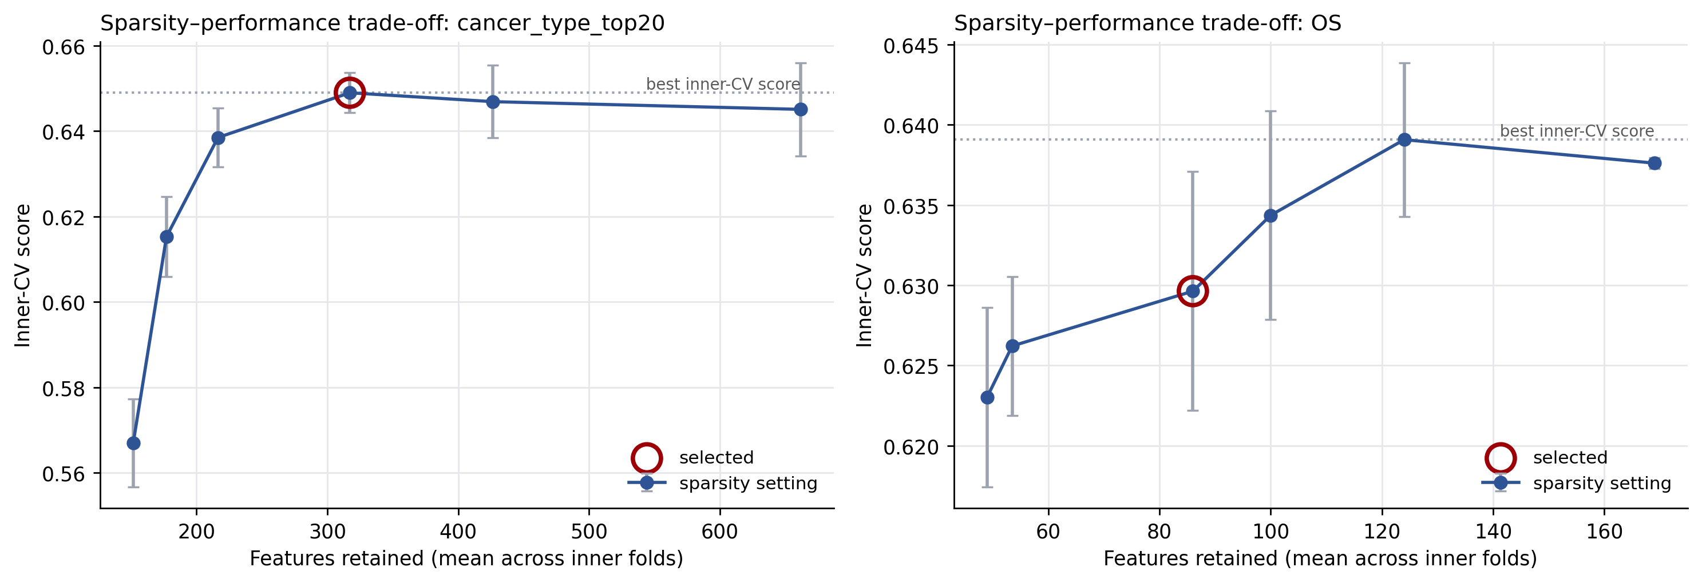
Supplementary Figure S1. Sparsity-performance trade-off. Inner cross-validation score versus mean features retained for cancer-type classification (left) and overall survival (right); the selected (sparsest within 0.01 of best) setting is circled.
SHAP attribution by annotation block
Using exact TreeSHAP values [27] (XGBoost pred_contribs) on the held-out samples, we aggregated mean |SHAP| [26] by annotation family. For cancer type, the largest family was VEP consequence (23.8% of total attribution), followed by per-gene functional events (13.1%), VEP impact (10.9%), allele-fraction summaries (7.8%), and driver-evidence tiers (6.1%); SIFT, PolyPhen, OncoKB roles, transcript biotype, non-driver residual, burden controls, hotspots, and per-gene role-matched events each carried 4 to 6%, with canonical-transcript flags last at 1.0%. For overall survival the attribution was flatter: burden controls (16.4%), VEP consequence (16.2%), non-driver residual (14.0%), transcript biotype (13.8%), and allele-fraction summaries (12.3%) led, with per-gene functional events (5.8%), driver tiers (4.7%), and OncoKB roles (4.1%) behind (Supplementary Figure S2). Gain and SHAP attributions disagreed informatively: IDH1 ranked 5th by total gain but 41st by mean |SHAP| for cancer type, consistent with a feature that is decisive for a small subset (near-pathognomonic for glioma) rather than broadly informative across classes.
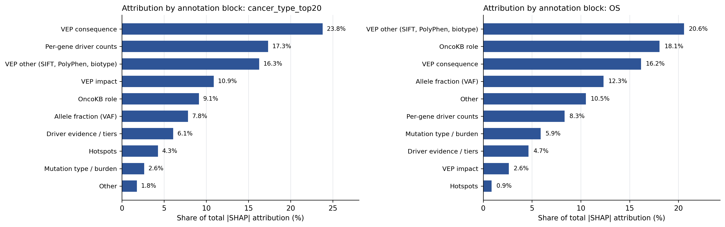
Supplementary Figure S2. Attribution by annotation block. Share of total |SHAP| attribution by annotation family for cancer-type classification (left) and overall survival (right).
HRD shortcut ablation
Supplementary Figure S3 shows the full ablation panel: removing HRR-gene features leaves HRD performance unchanged across all four endpoints, while removing allele-fraction features reduces HRD33 AUROC by 0.025 (95% CI -0.041 to -0.010, p < 0.001).
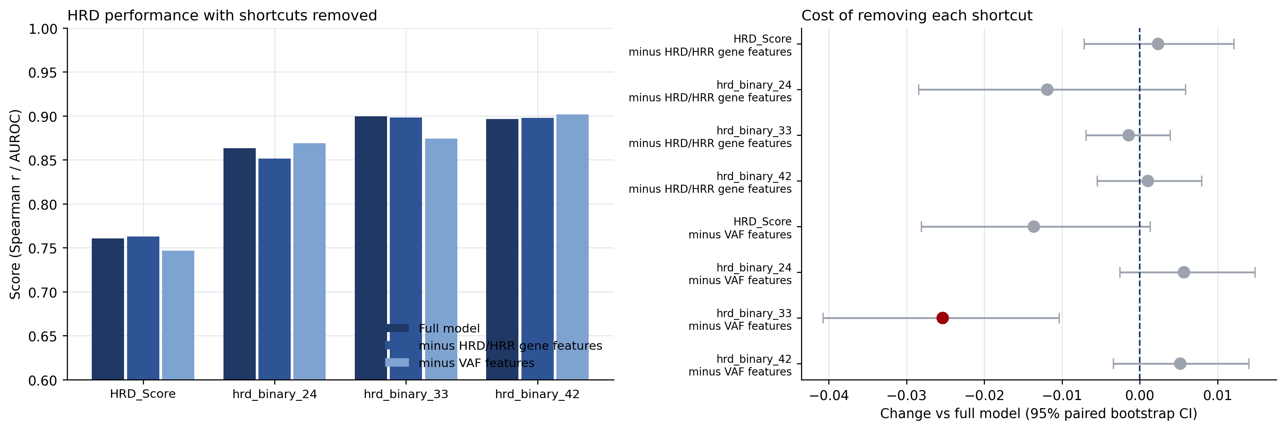
Supplementary Figure S3. HRD shortcut ablation. Performance with HRR-gene or allele-fraction features removed (left) and the change versus the full model with 95% paired bootstrap confidence intervals (right).
External validation details
The POG570 transfer held at prespecified fixed cutoffs (Supplementary Table S1): at cutoff 24, accuracy 0.619 with sensitivity 1.000 and specificity 0.034; at 33, accuracy 0.605, sensitivity 0.905, specificity 0.381; at 42, accuracy 0.626, sensitivity 0.892, specificity 0.536; AUROCs were 0.849, 0.805, and 0.871. The calibration shift seen in the primary breast cohort extended to all 570 POG570 tumors: Pearson 0.551, Spearman 0.520, MAE 20.64, RMSE 23.72, R² -1.201. PCAWG per-type recalls were heterogeneous (Supplementary Table S2): LIHC (0.973) and ESCA (0.856) transferred strongly; SKCM (0.714) and OV (0.507) partially; BRCA (0.077), PRAD (0.006), HNSC (0.000), KIRC (0.000), and STAD (0.156) transferred weakly.
Supplementary Table S1. POG570 breast-cohort HRD metrics at prespecified fixed cutoffs (n = 147).
Cutoff | Accuracy | Balanced accuracy | Sensitivity | Specificity | AUROC
24 | 0.619 | 0.517 | 1.000 | 0.034 | 0.849
33 | 0.605 | 0.643 | 0.905 | 0.381 | 0.805
42 | 0.626 | 0.714 | 0.892 | 0.536 | 0.871

Supplementary Table S2. PCAWG per-cancer-type recall for the frozen spectra cancer-type model (n = 913).
Cancer type | N | Recall (95% CI)
LIHC | 261 | 0.973 (0.950 to 0.992)
ESCA | 97 | 0.856 (0.784 to 0.918)
SKCM | 70 | 0.714 (0.600 to 0.814)
OV | 69 | 0.507 (0.391 to 0.623)
STAD | 32 | 0.156 (0.031 to 0.313)
BRCA | 117 | 0.077 (0.034 to 0.128)
PRAD | 180 | 0.006 (0.000 to 0.017)
HNSC | 13 | 0.000 (0.000 to 0.000)
KIRC | 74 | 0.000 (0.000 to 0.000)

Survival clinical-covariate baselines
Clinical covariates alone (age, sex, AJCC stage) reached a Harrell C-index of 0.669 for overall survival (n = 9,986). Adding cancer type raised the C-index to 0.779, a gain of +0.1106 (95% CI 0.1016 to 0.1194, p < 0.001). Adding Bio MAF v4 on top of clinical covariates plus cancer type changed the C-index to 0.776, a difference of -0.0036 (95% CI -0.0066 to -0.0006, p = 0.02): no improvement. All three arms used the identical cohort and identical outer folds, so the C-index values are directly comparable.
Supplementary Table S3. Survival clinical-covariate CoxNet baselines (overall survival, n = 9,986).
Arm | Features | Harrell C-index
Clinical covariates | 11 | 0.669
Clinical covariates + cancer type | 44 | 0.779
Clinical covariates + cancer type + Bio MAF v4 | 992 | 0.776

Supplementary Table S4. Paired differences between survival clinical-covariate arms.
Comparison | Difference in C-index | 95% CI | p
+ cancer type vs clinical covariates | +0.1106 | 0.1016 to 0.1194 | < 0.001
+ Bio MAF v4 vs clinical covariates + cancer type | -0.0036 | -0.0066 to -0.0006 | 0.02

Supplementary Table S5. Software environment (exact pinned versions).
Component | Version
Python | 3.10
numpy | 1.26.4
pandas | 2.3.1
scipy | 1.15.3
scikit-learn | 1.7.2
XGBoost | 1.6.2
matplotlib | 3.9.2
PyYAML | 6.0.2
openpyxl | 3.1.5
statsmodels | 0.14.4
Optuna | 4.1.0
scikit-survival | 0.27.0
PyTorch (MuAt comparator only) | 2.5.1 (CUDA 12.1 build)
requests | 2.32.3
tabulate | 0.9.0
Operating system (reported runs) | Linux
Operating system (historical feature selection) | Windows

Supplementary Table S6. Model hyperparameters and search spaces.
Model | Fixed settings | Tuned (inner validation split)
Elastic-net regression | Coordinate descent, max_iter 10000, standardized features | Full grid: alpha {1e-4 to 10}, l1_ratio {0 to 1}
Logistic regression (< 500 features) | saga solver, max_iter 5000, balanced class weights, standardized features | Full grid: C {0.001 to 10}, l1_ratio {0 to 1}
SGD log-loss (>= 500 features) | max_iter 200, tol 1e-3, 5-iteration patience, averaged weights, balanced class weights, standardized features | 10 seeded trials: C {0.001 to 10}, l1_ratio {0 to 1}
XGBoost | gpu_hist (hist fallback), 160 estimators max, 20-round early stopping, early-stopped rounds reused for refit, unscaled features | 10 seeded trials: max_depth {2-5}, learning_rate {0.01-0.1}, subsample/colsample_bytree {0.70-1.0}, min_child_weight {1-10}, reg_lambda {0.5-10}, reg_alpha {0-0.5}
CoxNet (survival) | CoxnetSurvivalAnalysis, single-alpha fits, max_iter 100000, tol 1e-7, standardized features, std < 1e-8 dropped, 12-step warm-start path fallback | 10 seeded trials from 16 combos: alpha {1e-2 to 10}, l1_ratio {0.25-1.0}
MuAt-compatible comparator | SGD lr 6e-4 momentum 0.9, cosine annealing, batch size 1, dropout 0.1, AMP, max 5,000 events/tumor, exact token dictionaries, seed 20260524 + fold offsets | 3-epoch budget over embed {128, 256, 512}, layers {1, 2, 4}, heads {1, 2}; winner retrained 150 epochs with inner-split epoch selection

Batch effects and confounding
Some per-tumor summaries differ across data-generating centers. The share of non-coding/regulatory (modifier-impact) mutations and the share hitting the 3′ UTR vary most by center, followed by the indel fraction, and six per-tumor summaries together predict the four largest centers at 69.7% cross-validated accuracy versus a 58.3% majority baseline. But centers handled very different mixes of cancer types: most of the 20 cancer types were sequenced almost entirely by a single center (for example, BRCA and UCEC by Washington University; ten types including LGG, LUAD, and PRAD by the Broad Institute), so center differences necessarily mix processing differences with real biological differences between cancers. Within the three cancer types with enough samples from two centers (OV, KIRC, KIRP; 1,051 of 8,858 top-20 samples with center barcodes; the benchmark cohort itself is 8,800 patients), center differences in modifier and 3′ UTR fractions were roughly half the size seen across all samples, consistent with much of the across-center signal reflecting cancer-type mixture rather than annotation artifacts. KIRP retained a larger residual center difference (modifier eta-squared 0.29), but the two centers drew KIRP samples from different tissue-source sites, so a center effect cannot be separated from site or patient-subpopulation differences; we disclose this rather than explaining it away. These analyses characterize the summaries, not the trained models. The trained models do use VAF summaries: all 14 VAF-derived columns were selected in both endpoints (best gain rank 8th for cancer type, 5th for overall survival), carrying 16.2% of selected SHAP mass for cancer type and 19.1% for overall survival. Because VAF correlates 0.56 with tumor purity, that weight partly reflects how much tumor DNA was in the sample rather than tumor biology alone. A selection rerun with VAF columns excluded was not performed, so the performance cost of removing them is unmeasured.
Per-tumor summary | Across centers (n = 8,858 top-20 samples) | Median within cancer type | Max within cancer type
Modifier fraction | 0.293 | 0.134 | 0.292 (KIRP)
3′ UTR fraction | 0.308 | 0.158 | 0.180 (KIRP)
Indel fraction | 0.033 | 0.024 | 0.045 (KIRP)
Log SBS burden | 0.003 | 0.002 | 0.033 (KIRC)
Mean VAF | 0.035 | 0.011 | 0.063 (KIRP)
Max VAF | 0.021 | 0.002 | 0.007 (KIRP)

Eligible within-type comparisons: OV (n = 399; centers 08: 206, 09: 193), KIRC (n = 370; 08: 207, 10: 163), KIRP (n = 282; 08: 114, 10: 168). Center codes: 08 Broad, 09 Washington University, 10 Baylor.
References
1. Sanjaya P, Maljanen K, Katainen R, et al. Mutation-Attention (MuAt): deep representation learning of somatic mutations for tumour typing and subtyping. Genome Med 2023;15:47.
2. Alexandrov LB, Kim J, Haradhvala NJ, et al. The repertoire of mutational signatures in human cancer. Nature 2020;578:94-101.
3. Pleasance E, Titmuss E, Williamson L, et al. Pan-cancer analysis of advanced patient tumors reveals interactions between therapy and genomic landscapes. Nat Cancer 2020;1:452-468.
4. ICGC/TCGA Pan-Cancer Analysis of Whole Genomes Consortium. Pan-cancer analysis of whole genomes. Nature 2020;578:82-93.
5. Simon N, Friedman J, Hastie T, et al. Regularization paths for Cox’s proportional hazards model via coordinate descent. J Stat Softw 2011;39:1-13.
6. Harrell FE Jr, Lee KL, Mark DB. Multivariable prognostic models: issues in developing models, evaluating assumptions and adequacy, and measuring and reducing errors. Stat Med 1996;15:361-387.
7. Ellrott K, Bailey MH, Saksena G, et al. Scalable open science approach for mutation calling of tumor exomes using multiple genomic pipelines. Cell Syst 2018;6:271-281.e7.
8. Cancer Genome Atlas Network. Comprehensive molecular portraits of human breast tumours. Nature 2012;490:61-70.
9. Liu J, Lichtenberg T, Hoadley KA, et al. An integrated TCGA pan-cancer clinical data resource to drive high-quality survival outcome analytics. Cell 2018;173:400-416.e11.
10. Kucab JE, Zou X, Morganella S, et al. A compendium of mutational signatures of environmental agents. Cell 2019;177:821-836.e16. Raw mutation tables: Mendeley Data, DOI 10.17632/m7r4msjb4c (Version 2: 10.17632/m7r4msjb4c.2).
11. Telli ML, Timms KM, Reid J, et al. Homologous recombination deficiency (HRD) score predicts response to platinum-containing neoadjuvant chemotherapy in patients with triple-negative breast cancer. Clin Cancer Res 2016;22:3764-3773.
12. Knijnenburg TA, Wang L, Zimmermann MT, et al. Genomic and molecular landscape of DNA damage repair deficiency across The Cancer Genome Atlas. Cell Rep 2018;23:239-254.e6.
13. McLaren W, Gil L, Hunt SE, et al. The Ensembl Variant Effect Predictor. Genome Biol 2016;17:122.
14. Ng PC, Henikoff S. SIFT: predicting amino acid changes that affect protein function. Nucleic Acids Res 2003;31:3812-3814.
15. Adzhubei IA, Schmidt S, Peshkin L, et al. A method and server for predicting damaging missense mutations. Nat Methods 2010;7:248-249.
16. Chakravarty D, Gao J, Phillips SM, et al. OncoKB: a precision oncology knowledge base. JCO Precis Oncol 2017;2017:PO.17.00011.
17. Chang MT, Asthana S, Gao SP, et al. Identifying recurrent mutations in cancer reveals widespread lineage diversity and mutational specificity. Nat Biotechnol 2016;34:155-163.
18. Sondka Z, Bamford S, Cole CG, et al. The COSMIC Cancer Gene Census: describing genetic dysfunction across all human cancers. Nat Rev Cancer 2018;18:696-705.
19. Martínez-Jiménez F, Muiños F, Sentís I, et al. A compendium of mutational cancer driver genes. Nat Rev Cancer 2020;20:555-572.
20. Vogelstein B, Papadopoulos N, Velculescu VE, et al. Cancer genome landscapes. Science 2013;339:1546-1558.
21. Zou H, Hastie T. Regularization and variable selection via the elastic net. J R Stat Soc Series B Stat Methodol 2005;67:301-320.
22. Chen T, Guestrin C. XGBoost: a scalable tree boosting system. In: Proceedings of the 22nd ACM SIGKDD International Conference on Knowledge Discovery and Data Mining. New York: ACM; 2016. p. 785-794.
23. Pölsterl S. scikit-survival: a library for time-to-event analysis built on top of scikit-learn. J Mach Learn Res 2020;21:1-6.
24. DeLong ER, DeLong DM, Clarke-Pearson DL. Comparing the areas under two or more correlated receiver operating characteristic curves: a nonparametric approach. Biometrics 1988;44:837-845.
25. Benjamini Y, Hochberg Y. Controlling the false discovery rate: a practical and powerful approach to multiple testing. J R Stat Soc Series B Methodol 1995;57:289-300.
26. Lundberg SM, Lee S-I. A unified approach to interpreting model predictions. Adv Neural Inf Process Syst 2017;30:4765-4774.
27. Lundberg SM, Erion G, Chen H, et al. From local explanations to global understanding with explainable AI for trees. Nat Mach Intell 2020;2:56-67.
28. National Cancer Institute. TCGA Barcode. GDC Documentation. http://docs.gdc.cancer.gov/Encyclopedia/pages/TCGA_Barcode/
Acknowledgements
The authors thank the patients who contributed samples and the TCGA, ICGC/PCAWG, and POG570 consortia for making genomic and clinical data available.
Acknowledgement: The research reported in this manuscript was supported by AIM-AHEAD Coordinating Center at the University of North Texas Health Science Center at Fort Worth. This research was, in part, funded by the National Institutes of Health (NIH) Agreement No. 1OT2OD032581. The views and conclusions contained in this document are those of the authors and should not be interpreted as representing the official policies, either expressed or implied, of the NIH.
AI assistance disclosure: portions of the Results and Methods text were drafted with the assistance of an AI language model and were reviewed and edited by the authors.
Funding
A.G. is supported by an AIM-AHEAD Research Fellowship.
Author contributions
A.G.: conceptualization, methodology, software, formal analysis, writing: original draft. X.L.: writing: original draft (Introduction, Discussion). V.V.: formal analysis, methodology, writing: review and editing. J.B.B.: supervision, data curation, writing: review and editing. J.D.A.: data curation, writing: review and editing. B.A.M.: supervision, funding acquisition, writing: review and editing.
Competing interests
The authors declare no competing interests.
Data availability
TCGA somatic mutation calls are from the MC3 project [7] (mc3.v0.2.8.PUBLIC.maf.gz, GRCh37). Per-sample TCGA HRD scores and components are from Knijnenburg et al. [12]. TCGA clinical and survival outcomes are from the TCGA Clinical Data Resource [9]. The experimental mutagen panel is from Kucab et al. [10] (Mendeley Data DOI 10.17632/m7r4msjb4c). External validation used POG570 whole genomes [3] and PCAWG whole genomes [4]. COSMIC mutational signatures v3.5 underlie the spectrum channels. All benchmark result tables and figure data are available in the project repository (see Code availability).
Code availability
All analyses were run from the project repository at https://github.com/aaronge-2020/uga-maf-representation-paper, which contains the endpoint registry, representation builders, model training and evaluation code, and figure-generation scripts (analyses in this manuscript correspond to the codex/coxnet-muat-manuscript-updates branch).

