Representation choices for somatic mutation catalogues strongly influence prediction performance across mechanistic and clinical endpoints
Aaron Ge1,2, Jeya Balaji Balasubramanian3, Jonas De Almeida3, Bradley A. Maron1,2*
1 University of Maryland-Institute of Health Computing, University of Maryland School of Medicine, Baltimore, MD, USA
2 University of Maryland School of Medicine, Baltimore, MD, USA
3 Division of Cancer Epidemiology and Genetics, National Cancer Institute, National Institutes of Health, Bethesda, MD, USA
Correspondence: Aaron Ge
6116 Executive Blvd, Bethesda, MD 20282, USA
age1@som.umaryland.edu

Abstract
Background. Cancer sequencing produces variable-length catalogues of somatic mutation events. These catalogues can be summarized as mutation burdens, mutational spectra, event-level annotation features, or learned neural event bags, but it remains unclear how much prediction performance depends on representation choice rather than model family alone.
Methods. We regenerated a strict no-leakage benchmark spanning five main endpoints: Kucab DNA damage class (n = 259), TCGA-BRCA HRD score (n = 772), HRD-high status at threshold 33 (n = 772), TCGA cancer type among the ten most common classes (n = 5,462), and TCGA CDR overall survival (n = 9,986). Representations included mutational burden, SBS/DBS/ID mutational spectra, event-level MAF-stack features, and combined Signatures + MAF stack features. Tabular learners used five outer folds, an inner train/validation split for hyperparameter selection, final refitting on the full outer-training fold, and pooled out-of-fold metrics. Survival was modeled with Cox proportional hazards and Harrell's C-index. We also added a MuAt-compatible event-bag comparator on the same manuscript endpoints and outer folds where possible.
Results. Mutational signatures improved over burden for XGBoost on Kucab damage class, HRD score, HRD33 high/low status, and cancer-type prediction. The strongest tabular performance generally came from Signatures + MAF stack with XGBoost: HRD score reached 0.749 Spearman r, HRD33 high/low reached 0.886 AUROC, and cancer type reached 0.969 macro-AUROC. Overall survival was best predicted by mutational signatures under Cox PH (C-index 0.607), while richer event-level MAF features did not improve this survival endpoint. The MuAt-compatible comparator reached 0.928 macro-AUROC for cancer type on the directly comparable TCGA-WES top-10 task, below the tuned Signatures + MAF stack XGBoost baseline.
Conclusions. Representation choice is a first-order determinant of prediction performance for somatic-mutation benchmarks. Mutational signatures remain a strong and efficient baseline, event-level MAF features add endpoint-specific biology, and combining spectra with event-level annotations is the most consistent practical tabular default. A local MuAt-compatible reimplementation does not automatically exceed a tuned tabular baseline under a directly comparable TCGA-WES evaluation.
Trial registration. Not applicable.
Keywords: Somatic mutations; Mutational signatures; Mutation annotation format; Representation learning; Homologous recombination deficiency; Tumour type; Survival analysis; Cox proportional hazards; MuAt; XGBoost

Background
Somatic mutation catalogues integrate the activity of endogenous and exogenous mutational processes, DNA repair defects, and clonal selection. Large pan-cancer resources have catalogued SBS, DBS, and indel signatures across whole genomes and exomes, while controlled mutagen-exposure experiments have shown that many environmental agents leave reproducible sequence-context spectra [1,2]. These observations make mutation catalogues a natural substrate for mechanistic attribution and clinical prediction.
A practical prediction pipeline must decide how to transform a variable-length set of mutation events into model inputs. Common tabular choices include mutation burden, mutational spectra, and aggregated MAF-derived gene, locus, consequence, pathway, and variant-allele-fraction features. More recent neural approaches, including Mutation-Attention (MuAt), instead operate on mutation-level events and learn attention-based tumour representations [10].
The manuscript question is therefore not whether mutation catalogues contain predictive information, but how strongly the chosen representation shapes performance when evaluation is held fixed. We address critiques of exome sparsity, insufficient tuning, survival modeling, and deep-learning comparability by regenerating the benchmark under a strict no-leakage, nested out-of-fold protocol with Cox survival endpoints and a directly comparable MuAt-compatible event-bag model.
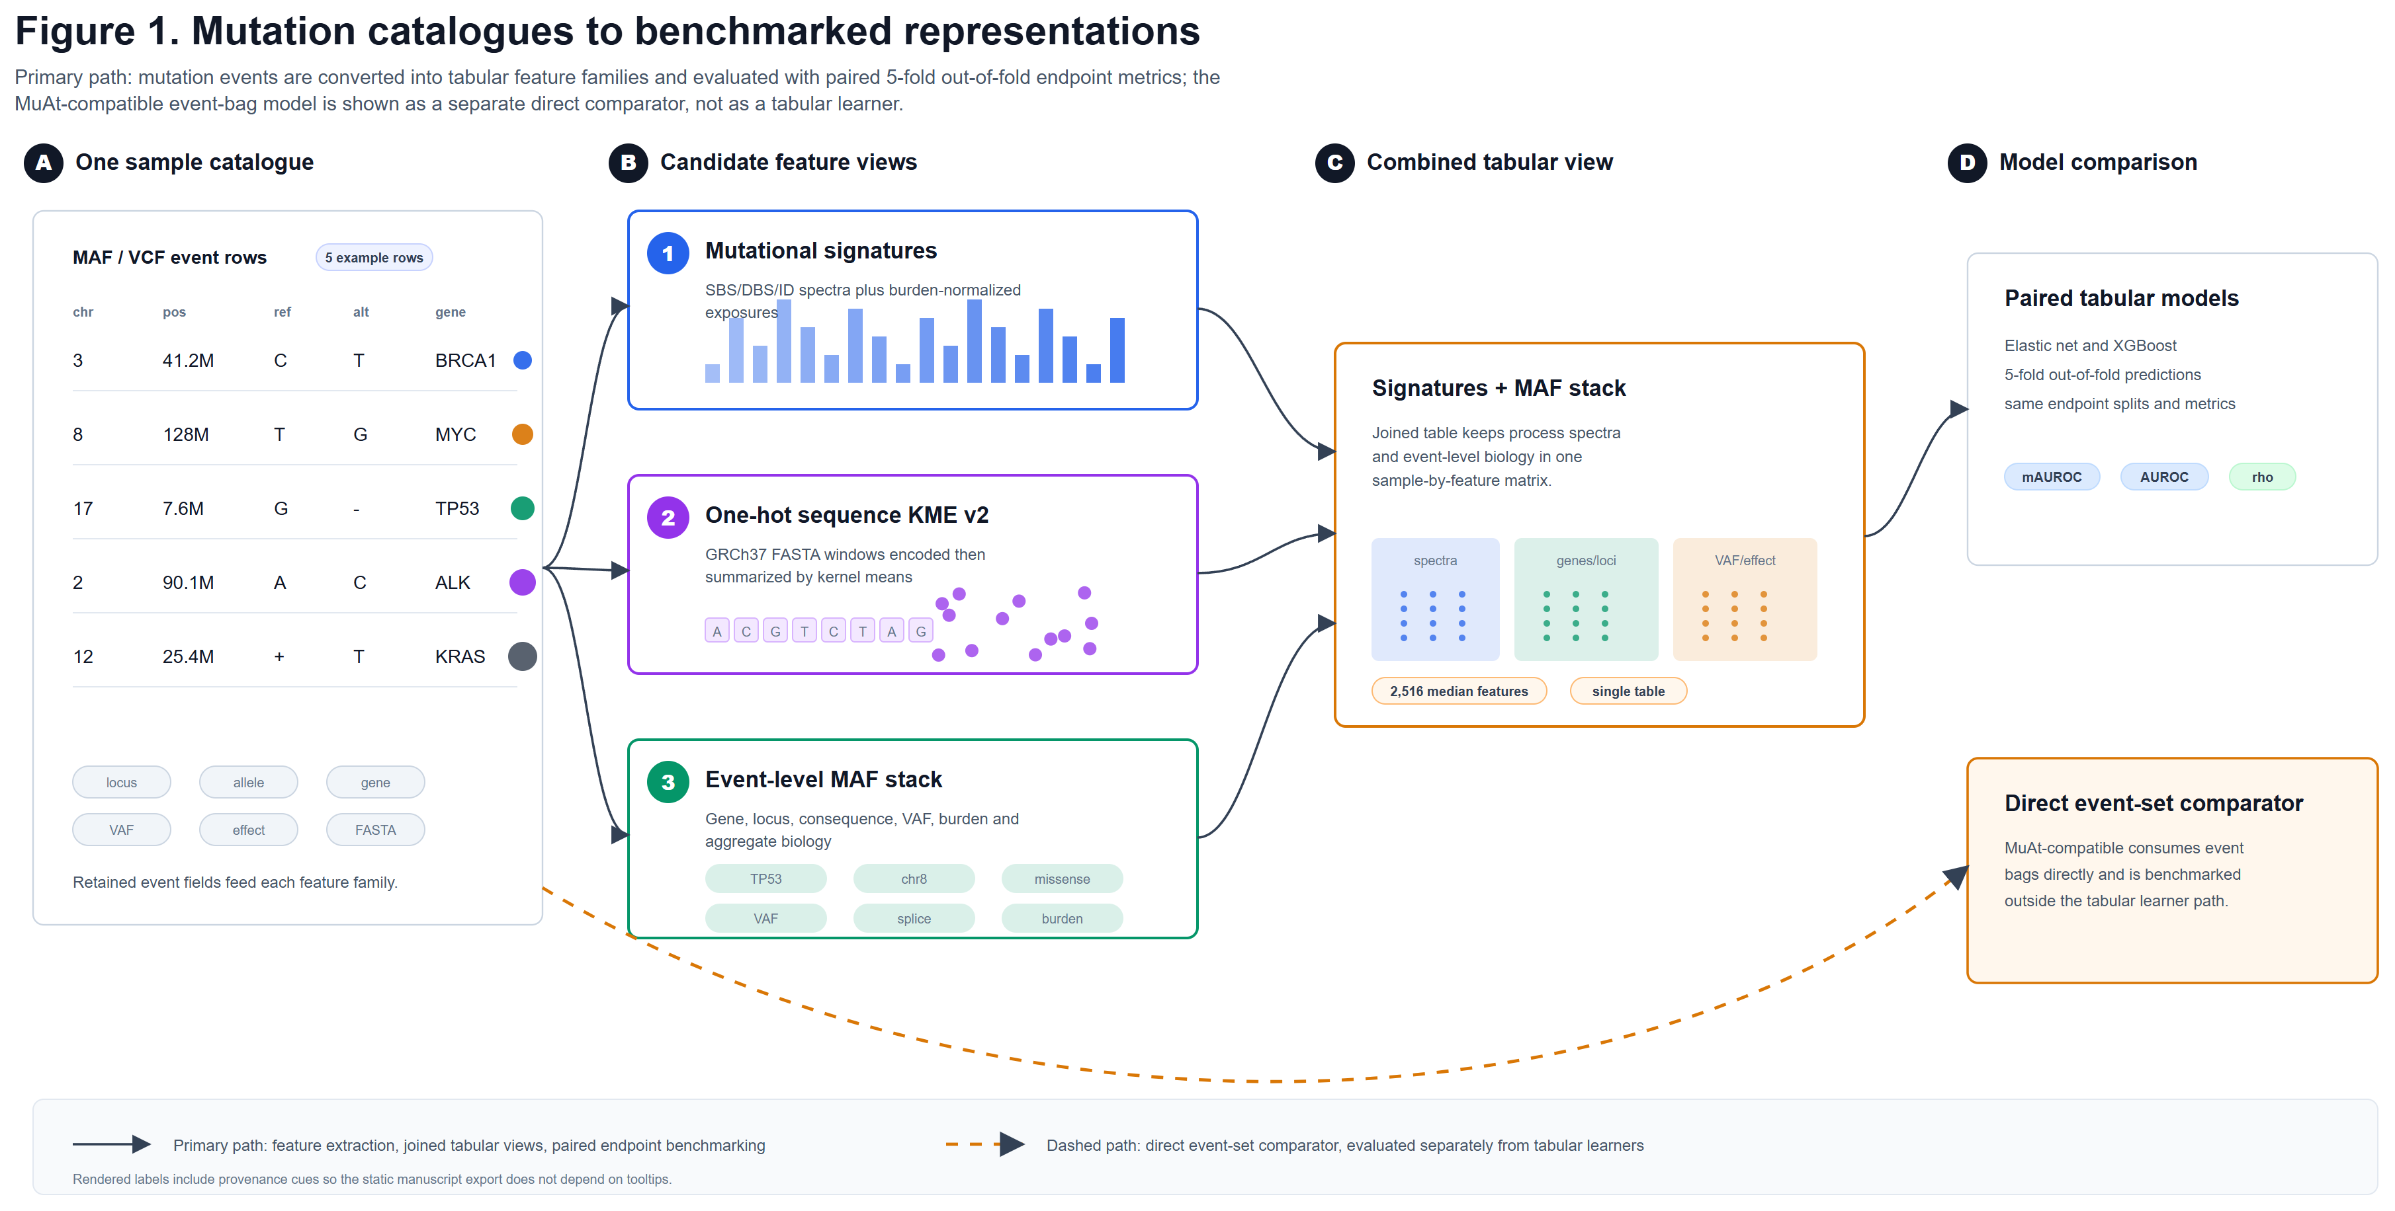
Figure 1. Conceptual overview of mutation-catalogue representations.
Each tumour is represented as a catalogue of somatic mutation events that can be transformed into compact burden summaries, mutational spectra, event-level MAF-stack aggregates, combined tabular representations, or MuAt-compatible mutation bags. The benchmark evaluates these choices under a strict pooled out-of-fold design.

Methods

Study design and endpoint registry
All analyses were regenerated inside the project repository using an endpoint registry and strict completion gate. The main panel contains five endpoints chosen to span mechanism, DNA repair deficiency, tumour identity, and clinical outcome. Binary overall-survival classification was removed from the main benchmark and replaced by Cox proportional hazards modeling of TCGA CDR overall survival.
The five primary endpoints were Kucab DNA damage class; continuous HRD score; HRD-high versus HRD-low at threshold 33; TCGA cancer type among the ten most common classes; and TCGA CDR overall survival. Survival endpoints required positive follow-up time, at least 200 eligible samples, and at least 25 events.
Table 1. Datasets, endpoints, and evaluation design.
Endpoint | Cohort/source | N | Task | Primary metric
Kucab damage class | Kucab mutagen-treated clone mutation catalogues | 259 | Grouped multiclass  Multiclass classification | macro-AUROC
HRD score | TCGA-BRCA HRD labels with MC3 mutation features | 772 | Regression | Spearman r
HRD33 high/low | TCGA-BRCA HRD labels with MC3 mutation features | 772 | Binary classification | AUROC
Cancer type (top 10) | TCGA MC3 clinical endpoint panel | 5,462 | Multiclass classification | macro-AUROC
Overall survival | TCGA MC3 clinical endpoint panel | 9,986 | Survival | Harrell C-index
Note. Label definitions are provided in the endpoint registry; survival is modeled as a time-to-event endpoint with censoring rather than as binary event status.

Representations
Mutational burden features provide the minimal count-based baseline, and mutational signatures summarize SBS, DBS, and indel spectra. Event-level MAF-stack features convert each tumour's variable-length MC3 Mutation Annotation Format table into a fixed-width sample-level vector. Each somatic event contributes deterministic hashed counts for the mutated gene, likely damaging gene events, 1-Mb genomic locus, variant annotation, and curated pathway membership; per-tumour variant-allele-fraction summaries capture mean, dispersion, median, upper-tail, high-VAF, and low-VAF fractions.
The strict no-leakage MAF-stack uses fixed hash buckets rather than cohort-learned vocabularies: 512 gene buckets, 512 damaging-gene buckets, 512 locus buckets, 256 annotation buckets, and 128 pathway buckets, plus seven numeric VAF and burden summaries, yielding 1,927 TCGA MAF-stack features. KMT2C events were excluded from MAF-stack construction to avoid direct leakage into the LUAD KMT2C endpoint. Signatures + MAF stack concatenates mutational spectra with these event-level annotation features.
The MAF-stack is therefore not one feature per mutation. It is one fixed-length vector per tumour. For a given mutation, the feature builder normalizes the gene symbol, chromosome, start position, variant type, variant classification, predicted impact, consequence, tumour alternate-read count, and tumour read depth. The mutation increments one gene-count bucket; increments one damaging-gene bucket if its class is missense, nonsense, frameshift, splice-site, translation-start-site, nonstop, in-frame deletion, or in-frame insertion, or if the predicted impact is high or moderate; increments one 1-Mb locus bucket using chromosome and floor(start position / 1,000,000); increments four annotation buckets for variant type, variant class, impact, and consequence; and increments pathway buckets when the gene belongs to a curated pathway set.
A hash bucket is a fixed column selected by SHA-256(namespace + token) modulo the number of buckets. Thus a token such as TP53 or class=missense_mutation always maps to the same bucket, but two different tokens may collide in the same bucket. The bucket counts are log1p-transformed after all mutations for that tumour are counted. The bucket numbers 512, 256, and 128 are pre-specified representation dimensions chosen in code before cross-validation to keep the feature schema fixed, compact, and independent of the held-out samples; they are not learned from the cohort and are not estimates of the number of genes or annotation classes.
For the neural comparator, a MuAt-compatible preprocessing layer turns each mutation into three token streams: a mutation motif token, a 1-Mb chromosome-position-bin token, and an annotation token derived from available MAF fields. In the bundled MC3 data, gene name, variant type, variant classification, predicted impact, and consequence fields were available and were used; detailed transcript strand and exact exon boundary annotations were not uniformly available, so they were not treated as complete modalities. Tokens are mapped with fixed hash dictionaries rather than cohort-learned vocabularies, preventing held-out test samples from influencing the available token set.

Table 3. Representation summary and dimensionality.
Representation | Input signal | Dimensionality | Evaluated models
Mutational burden | Total mutation burden and compact burden summaries | 1-3 | Elastic net; XGBoost; Cox PH
Mutational signatures | SBS/DBS/ID mutational spectra | 182-261 | Elastic net; XGBoost; Cox PH
Event-level MAF stack | Gene, locus, consequence, VAF, and event-level MAF aggregates | 1,927-2,980 | Elastic net; XGBoost; Cox PH
Signatures + MAF stack | Concatenated mutational spectra and event-level MAF aggregates | 2,109-3,241 | Elastic net; XGBoost; Cox PH
MuAt-compatible | Per-mutation MC3 event bags with motif, position-bin, and genic/exonic/strand tokens | event bag | MuAt-compatible
Note. Feature dimensionality is reported for tabular matrices; MuAt-compatible uses padded mutation bags and learned embeddings rather than a fixed tabular feature count.

Nested out-of-fold evaluation
Each endpoint used five outer folds. For every outer fold, the 80% outer-training partition was split into inner-training and inner-validation partitions. Candidate models were trained only on the inner-training set, selected only on the inner-validation set, refit once on the full 80% outer-training set using the selected hyperparameters, and predicted once on the 20% held-out outer fold. Primary metrics were computed after pooling all out-of-fold predictions over the full cohort.
Classification used stratified splits when feasible; survival used event-stratified splits; regression used shuffled K-fold splits; and Kucab analyses used grouped splitting to prevent treatment-agent leakage across folds. Logistic elastic-net models searched C values of 0.001, 0.01, 0.1, 1, and 10 with l1_ratio values of 0, 0.25, 0.5, 0.75, and 1. Regression elastic net and Cox PH models searched alpha or penalizer values from 1e-4 to 10 with the same l1_ratio grid. XGBoost used seeded candidate search with inner-validation early stopping; final refits used exactly the selected number of boosting rounds.
Primary metrics were Spearman r for continuous endpoints, AUROC for binary endpoints, macro-AUROC for multiclass endpoints, and Harrell C-index for survival endpoints. Multiclass Kucab robustness was further summarized with micro-AUROC, balanced accuracy, macro-F1, and Cohen's kappa. Statistical comparisons used paired tests over pooled out-of-fold predictions with Benjamini-Hochberg FDR correction.

MuAt-compatible comparator
The MuAt-compatible comparator follows the central structure reported for MuAt: separate motif, position, and annotation embeddings; concatenation of modality embeddings; Q/K/V self-attention; residual/normalization layers; a fully connected block; average pooling; and a 24-dimensional tumour feature layer before prediction. We label this model MuAt-compatible rather than MuAt because official MuAt package checkpoints were not used for the manuscript comparison.
The primary manuscript comparison evaluates this neural event-bag model on the same TCGA-WES endpoints as the tabular benchmark. The event tensor allows up to 5,000 mutation events per tumour; samples above this ceiling are deterministically truncated after sorting events by chromosome, position, and motif. In practice, most TCGA-WES tumours were far below this ceiling: the directly comparable cancer-type top-10 task had a median of 96 captured events per tumour, and only 69 of 5,462 tumours reached the 5,000-event cap. Across the TCGA main-endpoint event bags, the median was 94.5 events and 85 of 10,068 tumours reached the cap; Kucab WGS-like clone bags had a median of 386 events and no sample exceeded the cap.
The TCGA 20-type task from the original MuAt paper was retained only as a supplemental fidelity artifact, because it is not directly comparable to the paper's main top-10 cancer-type endpoint and does not share the same fold structure or endpoint definition.

Results

Mutational signatures improve over burden, but not uniformly
In the strict main panel, XGBoost models using mutational signatures outperformed burden on Kucab damage class (0.636 vs 0.505 macro-AUROC), HRD score (0.704 vs 0.596 Spearman r), HRD33 high/low status (0.845 vs 0.811 AUROC), and cancer-type prediction (0.939 vs 0.840 macro-AUROC). Elastic-net models showed the same qualitative gain for Kucab damage class and cancer type but not for every clinical endpoint, underscoring that signatures are strong but not universally dominant.
The survival result should be interpreted separately from the older binary-OS draft: overall survival is now a Cox PH endpoint evaluated by Harrell C-index. Under this survival analysis, mutational signatures achieved the strongest overall-survival C-index among the main tabular representations (0.607).

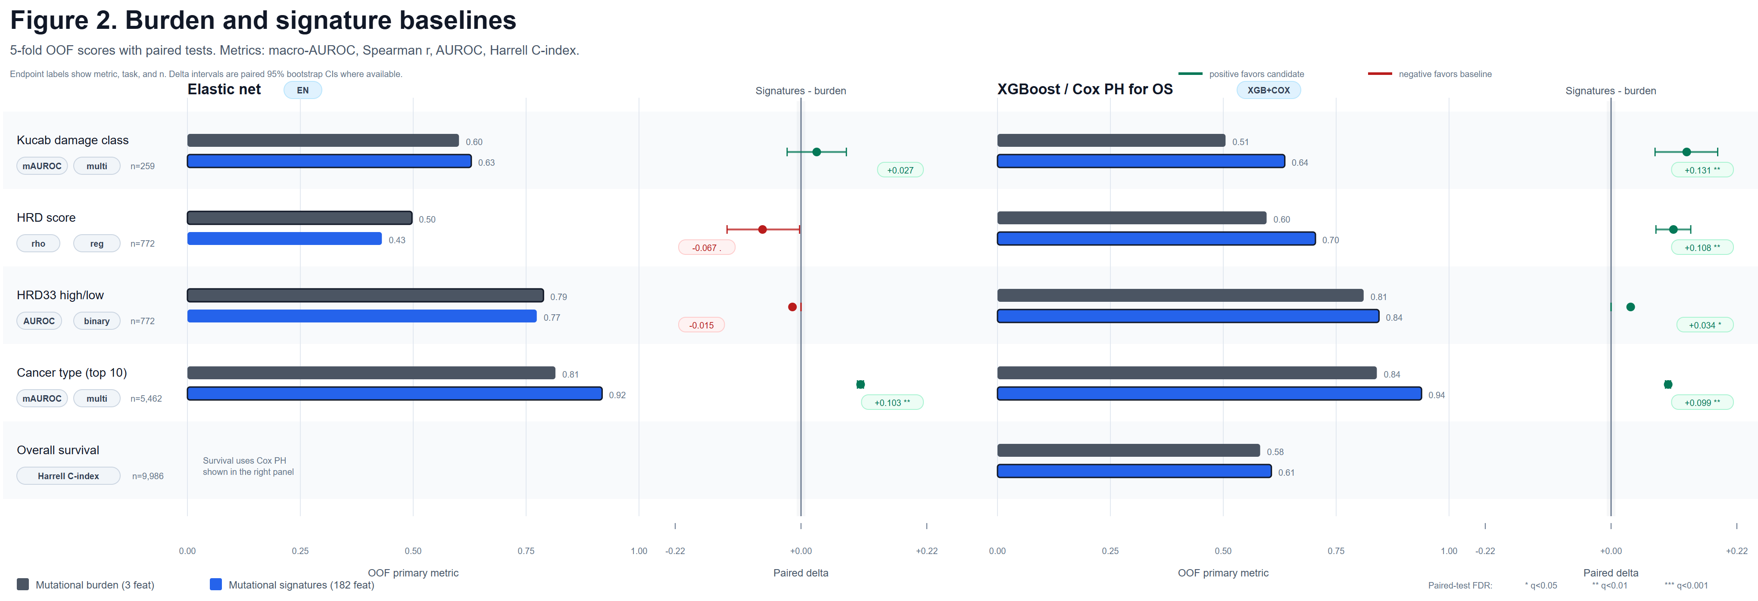
Figure 2. Signature baselines compared with mutational burden.
Nested five-fold out-of-fold performance is shown for burden and mutational signatures across the five main endpoints. Metrics are Spearman r for HRD score, AUROC for HRD33, macro-AUROC for multiclass endpoints, and Harrell C-index for survival.

Event-level MAF features add endpoint-specific biology
Event-level MAF-stack features were most useful for endpoints where gene, locus, consequence, or event-level biology carries direct label information. With XGBoost, MAF stack alone improved cancer-type prediction relative to signatures (0.950 vs 0.939 macro-AUROC), but it underperformed signatures for the mechanistic Kucab damage-class task (0.529 vs 0.636 macro-AUROC). This pattern supports the expected distinction between mutagen-mechanism endpoints, which are strongly sequence-context driven, and clinical or tumour-identity endpoints, which can benefit from broader annotation features.
The combined Signatures + MAF stack representation was the strongest practical tabular default. With XGBoost it reached 0.749 Spearman r for HRD score, 0.886 AUROC for HRD33 high/low, and 0.969 macro-AUROC for cancer type. It did not improve overall survival, where signatures alone remained best under Cox PH.

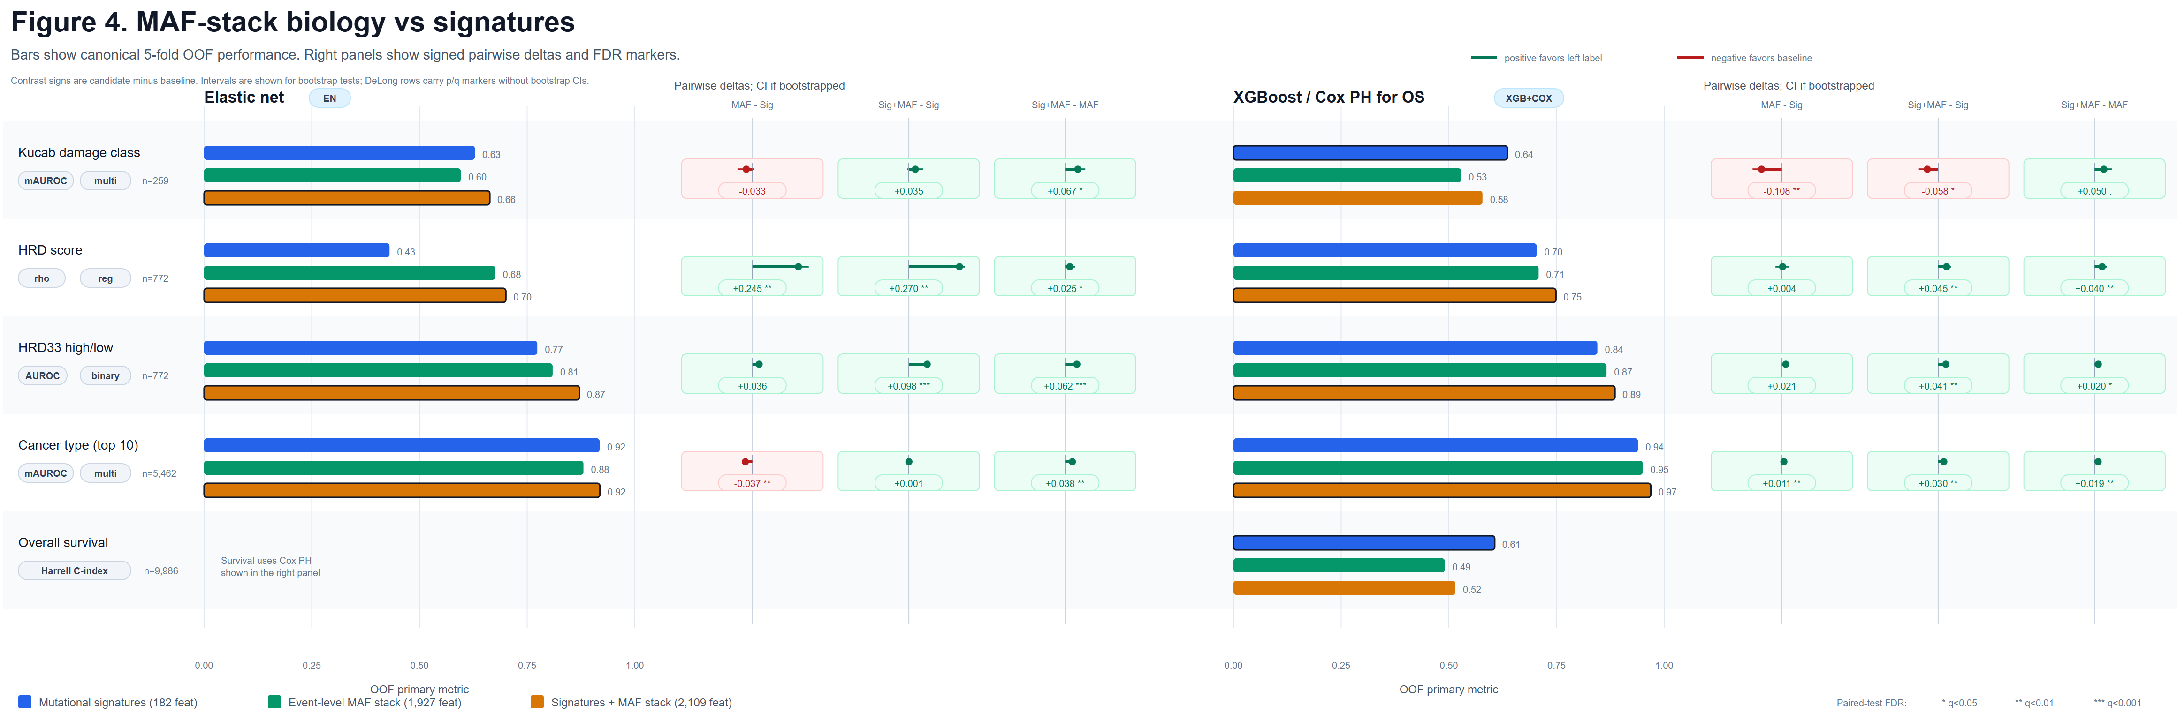
Figure 4. Event-level MAF-stack features and combined signature-plus-event representations.
Mutational signatures, event-level MAF-stack features, and their concatenation are compared for each endpoint and tabular model family. The combined representation is strongest for HRD score, HRD33 status, and cancer type under XGBoost.

MuAt-compatible event-bag modeling is directly comparable but not dominant
The MuAt-compatible comparator was added to avoid treating deep event-level models only as a conceptual future baseline. On cancer type among the same ten TCGA classes, it reached 0.928 macro-AUROC. This exceeds several simpler representations but remains below the tuned Signatures + MAF stack XGBoost model at 0.969. On HRD score, HRD33 high/low, Kucab damage class, and overall survival, the MuAt-compatible model also did not exceed the best tabular result.
These results do not imply that the official pretrained MuAt model is ineffective. They show that, in this manuscript's strict TCGA-WES benchmark and local reimplementation, a mutation-attention architecture does not automatically outperform a leakage-safe, tuned tabular representation.

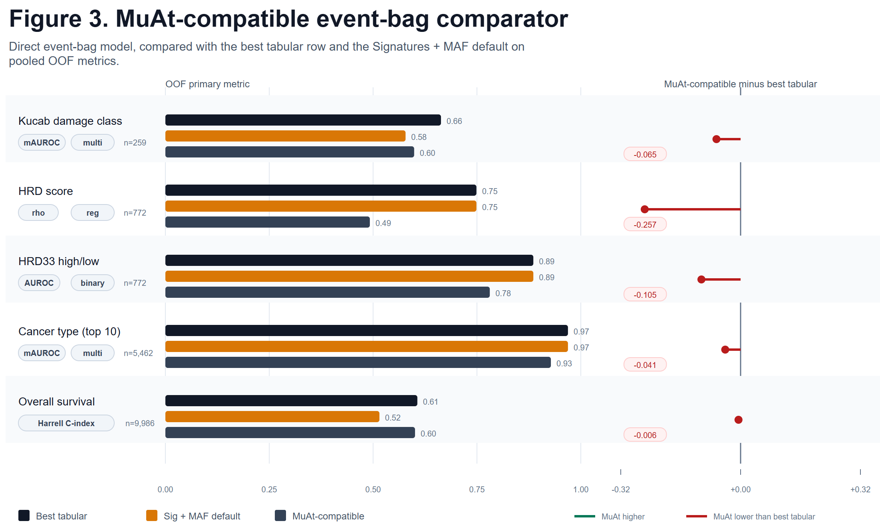
Figure 3. MuAt-compatible event-bag comparator.
The MuAt-compatible reimplementation is evaluated on the manuscript endpoints rather than as a reproduction of the original MuAt TCGA-20 benchmark. For TCGA endpoints, the comparator uses the same held-out folds as the canonical tabular benchmark where configured.

Table 2. Main-panel performance by endpoint and representation.
Endpoint / representation | Elastic net | XGBoost / Cox PH | MuAt-compatible
Kucab damage class (macro-AUROC; n=259)
Mutational burden | 0.601 | 0.505
Mutational signatures | 0.629 | 0.636
Event-level MAF stack | 0.596 | 0.529
Signatures + MAF stack | 0.663 | 0.578
MuAt-compatible event bag |  |  | 0.599
HRD score (Spearman r; n=772)
Mutational burden | 0.497 | 0.596
Mutational signatures | 0.431 | 0.704
Event-level MAF stack | 0.676 | 0.708
Signatures + MAF stack | 0.701 | 0.749
MuAt-compatible event bag |  |  | 0.492
HRD33 high/low (AUROC; n=772)
Mutational burden | 0.788 | 0.811
Mutational signatures | 0.774 | 0.845
Event-level MAF stack | 0.809 | 0.866
Signatures + MAF stack | 0.872 | 0.886
MuAt-compatible event bag |  |  | 0.781
Cancer type (top 10) (macro-AUROC; n=5,462)
Mutational burden | 0.815 | 0.840
Mutational signatures | 0.918 | 0.939
Event-level MAF stack | 0.881 | 0.950
Signatures + MAF stack | 0.919 | 0.969
MuAt-compatible event bag |  |  | 0.928
Overall survival (Harrell C-index; n=9,986)
Mutational burden |  | 0.582
Mutational signatures |  | 0.607
Event-level MAF stack |  | 0.491
Signatures + MAF stack |  | 0.515
MuAt-compatible event bag |  |  | 0.601
Note. Scores are pooled out-of-fold primary metrics. Elastic net and XGBoost columns apply to tabular representations; the Cox PH value is shown in the XGBoost/Cox PH column for survival. MuAt-compatible is shown as a separate event-bag comparator.

Cross-endpoint synthesis
No representation wins across every endpoint. Mutational signatures are a strong and efficient baseline; event-level MAF features capture biology that spectra can miss; and combined signature-plus-MAF features offer the best overall tabular default for HRD and tumour-identity endpoints. Survival remains difficult, and richer annotation stacks did not improve over signatures in the current Cox PH analysis.
The Kucab sparsity control downsampled WGS mutation inventories to budgets of 20, 41, 100, and 200 mutations per clone. These runs provide an exome-like stress test for the mechanistic endpoint and are reported in the supplementary tables. They make explicit that WGS-versus-WES mutation count differences can affect representation stability and should not be ignored when comparing mechanistic and clinical cohorts.

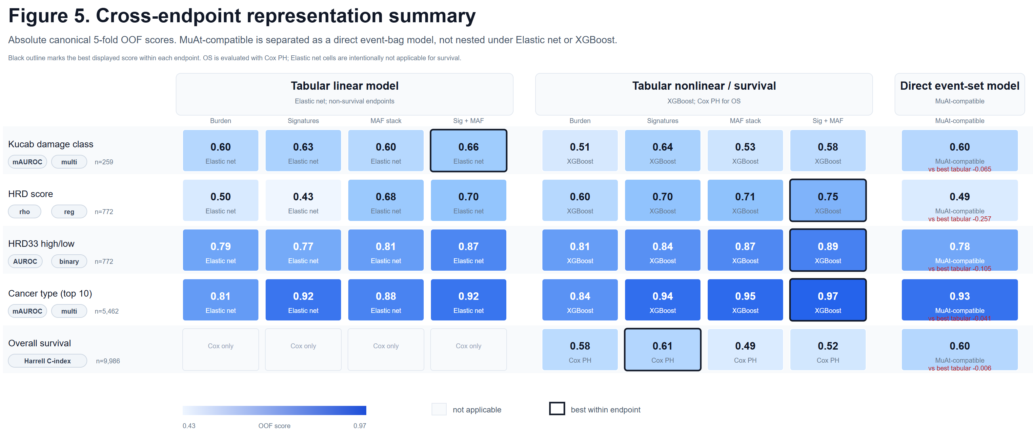
Figure 5. Cross-endpoint representation summary.
The summary heatmap reports the canonical main-panel scores. MuAt-compatible results are displayed as a separate event-bag comparator, and overall survival is reported as a Cox PH C-index rather than a binary event AUROC.

Discussion
This regenerated benchmark changes the interpretation of the original draft in three important ways. First, survival is now evaluated as time-to-event data with censoring rather than as binary event status. Second, high-dimensional tabular baselines are tuned within a nested out-of-fold framework, reducing the risk that poor performance reflects inadequate regularization. Third, the neural event-bag comparator is measured directly rather than invoked as an untested future alternative.
The results support a pragmatic view of mutation-catalogue modeling. For mechanistic mutagen attribution, mutational spectra remain highly competitive because the label is closely tied to sequence-context processes. For HRD and cancer-type endpoints, event-level annotations add useful biological structure, and the combined Signatures + MAF stack representation performs best with XGBoost. For survival, predictive signal from mutation catalogues alone remains modest and appears sensitive to representation and censoring-aware modeling assumptions.
The MuAt-compatible model's weaker performance relative to tuned tabular models is scientifically plausible. Although the model permits 5,000 events per tumour, TCGA WES mutation bags are sparse in the present data, with median event counts near 100 for the primary TCGA comparison. The model was also trained locally rather than initialized from official MuAt checkpoints, and the manuscript endpoints include HRD and survival tasks that were not the original MuAt paper's primary tumour-typing benchmark. The result should therefore be read as a fair local comparator, not as a failure to reproduce the full MuAt PCAWG/TCGA/GEL study.

Limitations
The benchmark uses bundled MC3, CDR, HRD, and Kucab assets rather than downloading new GDC cohorts during the default run. GDC expansion utilities are available but disabled by default to keep the manuscript run offline and reproducible from the bundled assets.
The MuAt-compatible comparator implements the central mutation-attention architecture and token modalities but does not include official pretrained checkpoints, external WGS validation cohorts, structural-variant and mobile-element modalities unavailable in the bundled TCGA WES assets, or the full 150-epoch MuAt paper training regimen. Although the comparator uses a 5,000-event cap, this capacity is rarely used in TCGA-WES; most tumours contribute far fewer events than the cap, so the comparison should be interpreted as a sparse exome-facing benchmark rather than a high-mutation whole-genome MuAt reproduction.
Some comparisons involving MuAt and simpler tabular representations share the same endpoint and out-of-fold pooling but are not all paired on identical fold manifests for every representation family. The strongest TCGA cancer-type comparison was aligned to the canonical tabular fold assignment, and this is the comparison emphasized for direct model interpretation.

Conclusions
Representation choice strongly influences somatic-mutation prediction performance. Mutational signatures are a robust baseline, event-level MAF features add complementary endpoint-specific signal, and their combination with XGBoost is the strongest practical default for several clinical and tumour-identity endpoints. Cox survival modeling and no-leakage feature generation materially strengthen the clinical interpretation of the benchmark. A MuAt-compatible event-bag comparator provides a direct neural-model comparison but does not supersede the tuned tabular baseline under the current TCGA-WES evaluation.

Abbreviations

Table 4. Key terminology and abbreviations.
Term | Definition | Used in
EN / XGB | Elastic-net score / XGBoost score in compact performance tables. | Table 2
AUROC | Area under the receiver operating characteristic curve for binary endpoints. | Tables 2 and S2
macro-AUROC | Class-balanced AUROC averaged across multiclass labels. | Tables 2 and S2
Spearman r | Spearman rank correlation for continuous endpoints. | Tables 2 and S2
HRD | Homologous recombination deficiency. | Endpoint labels
MAF | Mutation annotation format; here also shorthand for event-level mutation annotations. | Representations
SBS/DBS/ID | Single-base substitution, double-base substitution, and insertion/deletion mutation spectra. | Representations
KME | Kernel mean embedding used to summarize event-level mutation contexts. | Representations
UGA | Universal genomic atlas/channel geometry representation used in supplementary analyses. | Supplement
Mutational burden | Compact mutation-count baseline features. | Tables 2 and 3
Mutational signatures | Canonical mutation-spectrum representation. | Tables 2 and 3
One-hot sequence KME | FASTA-window sequence-context KME representation. | Tables 2 and 3
Event-level MAF stack | Gene, locus, consequence, VAF, and event-annotation feature stack. | Tables 2 and 3
Signatures + MAF stack | Combined spectra plus event-level MAF features. | Tables 2 and 3
XGBoost | Gradient-boosted tree model used as the nonlinear learner. | Model columns
Note. Abbreviations and shorthand used in the manuscript figures and tables.

Declarations

Ethics approval and consent to participate
Not applicable. The analyses use public, de-identified research datasets.

Consent for publication
Not applicable.

Availability of data and materials
All analyses were implemented in the GitHub-connected project repository. The default reproducibility run uses bundled MC3, TCGA CDR, TCGA-BRCA HRD, and Kucab assets, with optional GDC utilities disabled by default. Generated tables, figures, split manifests, and audit files are stored under the project results directory.

Competing interests
The authors declare that they have no competing interests.

Funding
The research reported here was supported by the AIM-AHEAD Coordinating Center at the University of North Texas Health Science Center at Fort Worth and, in part, by the National Institutes of Health Agreement No. 1OT2OD032581. The views and conclusions are those of the authors and should not be interpreted as representing the official policies, either expressed or implied, of the NIH.

Authors' contributions
AG designed and implemented the benchmark, performed analyses, generated figures and tables, and drafted the manuscript. JBB and JDA contributed cancer-genomics and benchmarking expertise. BAM supervised the project and revised the manuscript. All authors reviewed and approved the manuscript.

Acknowledgements
The authors thank the teams responsible for TCGA, MC3, TCGA CDR, HRD, and Kucab resources for making reusable cancer-genomics datasets available to the community.

References
1. Alexandrov LB, Kim J, Haradhvala NJ, et al. The repertoire of mutational signatures in human cancer. Nature. 2020;578:94-101. doi:10.1038/s41586-020-1943-3.
2. Kucab JE, Zou X, Morganella S, et al. A compendium of mutational signatures of environmental agents. Cell. 2019;177:821-836.e16. doi:10.1016/j.cell.2019.03.001.
3. Ellrott K, Bailey MH, Saksena G, et al. Scalable open science approach for mutation calling of tumor exomes using multiple genomic pipelines. Cell Systems. 2018;6:271-281.e7. doi:10.1016/j.cels.2018.03.002.
4. Liu J, Lichtenberg T, Hoadley KA, et al. An integrated TCGA pan-cancer clinical data resource to drive high-quality survival outcome analytics. Cell. 2018;173:400-416.e11. doi:10.1016/j.cell.2018.02.052.
5. Knijnenburg TA, Wang L, Zimmermann MT, et al. Genomic and molecular landscape of DNA damage repair deficiency across The Cancer Genome Atlas. Cell Reports. 2018;23:239-254.e6. doi:10.1016/j.celrep.2018.03.076.
6. Davies H, Glodzik D, Morganella S, et al. HRDetect is a predictor of BRCA1 and BRCA2 deficiency based on mutational signatures. Nature Medicine. 2017;23:517-525. doi:10.1038/nm.4292.
7. Chen T, Guestrin C. XGBoost: a scalable tree boosting system. Proceedings of the 22nd ACM SIGKDD International Conference on Knowledge Discovery and Data Mining. 2016:785-794. doi:10.1145/2939672.2939785.
8. Cox DR. Regression models and life-tables. Journal of the Royal Statistical Society: Series B. 1972;34:187-220.
9. Harrell FE Jr, Lee KL, Mark DB. Multivariable prognostic models: issues in developing models, evaluating assumptions and adequacy, and measuring and reducing errors. Statistics in Medicine. 1996;15:361-387. doi:10.1002/(SICI)1097-0258(19960229)15:4<361::AID-SIM168>3.0.CO;2-4.
10. Sanjaya P, Maljanen K, Katainen R, et al. Mutation-Attention (MuAt): deep representation learning of somatic mutations for tumour typing and subtyping. Genome Medicine. 2023;15:47. doi:10.1186/s13073-023-01204-4.

Supplementary Material
Supplementary Table S1. Supplementary endpoint inventory.
Endpoint | N | Task | Source | Metric(s) | Representation families
BRCA-pathway mutated | 10,224 | Binary classification | Regenerated benchmark output | AUROC | COSMIC NNLS exposures; Event-level MAF stack; Mutational burden; Mutational signatures; Signatures + MAF stack; UGA geometry
DFI survival | 5,147 | Survival | TCGA MC3 clinical endpoint panel | Harrell C-index | Event-level MAF stack; Mutational burden; Mutational signatures; Signatures + MAF stack
DSS survival | 9,530 | Survival | TCGA MC3 clinical endpoint panel | Harrell C-index | Event-level MAF stack; Mutational burden; Mutational signatures; Signatures + MAF stack
Ever smoker | 2,798 | Binary classification | TCGA MC3 clinical endpoint panel | AUROC; Balanced accuracy | COSMIC NNLS exposures; Channel KME; Event-level MAF stack; Mutational burden; Mutational signatures; Signatures + MAF stack; UGA geometry
HRD LOH | 772 | Regression | TCGA-BRCA HRD labels with MC3 mutation features | Spearman r | COSMIC NNLS exposures; Channel KME; Event-level MAF stack; Mutational burden; Mutational signatures; Signatures + MAF stack; UGA geometry
HRD LST | 772 | Regression | TCGA-BRCA HRD labels with MC3 mutation features | Spearman r | COSMIC NNLS exposures; Channel KME; Event-level MAF stack; Mutational burden; Mutational signatures; Signatures + MAF stack; UGA geometry
HRD TAI | 772 | Regression | TCGA-BRCA HRD labels with MC3 mutation features | Spearman r | COSMIC NNLS exposures; Channel KME; Event-level MAF stack; Mutational burden; Mutational signatures; Signatures + MAF stack; UGA geometry
HRD24 high/low | 772 | Binary classification; Classification | TCGA-BRCA HRD labels with MC3 mutation features | AUROC | COSMIC NNLS exposures; Channel KME; Event-level MAF stack; Mutational burden; Mutational signatures; Signatures + MAF stack; UGA geometry
HRD42 high/low | 772 | Binary classification; Classification | TCGA-BRCA HRD labels with MC3 mutation features | AUROC | COSMIC NNLS exposures; Channel KME; Event-level MAF stack; Mutational burden; Mutational signatures; Signatures + MAF stack; UGA geometry
High stage | 6,404 | Binary classification | TCGA MC3 clinical endpoint panel | AUROC; Balanced accuracy | COSMIC NNLS exposures; Channel KME; Event-level MAF stack; Mutational burden; Mutational signatures; Signatures + MAF stack; UGA geometry
High tumor purity | 9,591 | Binary classification | TCGA MC3 clinical endpoint panel | AUROC; Balanced accuracy | COSMIC NNLS exposures; Channel KME; Event-level MAF stack; Mutational burden; Mutational signatures; Signatures + MAF stack; UGA geometry
LUAD KMT2C mutated | 515 | Binary classification | TCGA MC3 LUAD driver endpoint | AUROC | Channel KME; Event-level MAF stack; Mutational burden; Mutational signatures; Signatures + MAF stack; UGA geometry
Low-burden Kucab | 259 | Multiclass classification | Kucab mutagen-treated clone mutation catalogues | Balanced accuracy | Mechanistic controls; Mutational signatures
MMR-pathway mutated | 10,224 | Binary classification | Regenerated benchmark output | AUROC | COSMIC NNLS exposures; Event-level MAF stack; Mutational burden; Mutational signatures; Signatures + MAF stack; UGA geometry
Original Kucab | 259 | Multiclass classification | Kucab mutagen-treated clone mutation catalogues | Balanced accuracy | Mechanistic controls; Mutational signatures
PARPi7 | 772 | Regression | TCGA-BRCA HRD labels with MC3 mutation features | Spearman r | COSMIC NNLS exposures; Channel KME; Event-level MAF stack; Mutational burden; Mutational signatures; Signatures + MAF stack; UGA geometry
PARPi7 binary | 772 | Binary classification; Classification | TCGA-BRCA HRD labels with MC3 mutation features | AUROC | COSMIC NNLS exposures; Channel KME; Event-level MAF stack; Mutational burden; Mutational signatures; Signatures + MAF stack; UGA geometry
PFI survival | 9,857 | Survival | TCGA MC3 clinical endpoint panel | Harrell C-index | Event-level MAF stack; Mutational burden; Mutational signatures; Signatures + MAF stack
POLE/POLD1 mutated | 10,224 | Binary classification | Regenerated benchmark output | AUROC | COSMIC NNLS exposures; Event-level MAF stack; Mutational burden; Mutational signatures; Signatures + MAF stack; UGA geometry
TCGA 20 Type | 60 | Multiclass classification | Regenerated benchmark output | Accuracy | MuAt-compatible
eCARD | 772 | Regression | TCGA-BRCA HRD labels with MC3 mutation features | Spearman r | COSMIC NNLS exposures; Channel KME; Event-level MAF stack; Mutational burden; Mutational signatures; Signatures + MAF stack; UGA geometry
Note. Endpoint-level inventory for supplementary analyses outside the five-endpoint main panel.

Supplementary Table S2. Headline supplementary results.
Endpoint | N | Metric(s) | Best baseline/event-level | Best geometry/sensitivity | Best overall | Interpretation
BRCA-pathway mutated | 10,224 | AUROC | Signatures + MAF stack / XGBoost (AUROC 0.995) | COSMIC NNLS exposures / Source model (AUROC 0.820) | Signatures + MAF stack / XGBoost (AUROC 0.995) | Best baseline/event-level result exceeds sensitivity result by 0.175.
DFI survival | 5,147 | Harrell C-index | Mutational signatures / Cox PH (Harrell C-index 0.592) |  | Mutational signatures / Cox PH (Harrell C-index 0.592) | Best result comes from baseline or event-level feature families.
DSS survival | 9,530 | Harrell C-index | Mutational signatures / Cox PH (Harrell C-index 0.591) |  | Mutational signatures / Cox PH (Harrell C-index 0.591) | Best result comes from baseline or event-level feature families.
Ever smoker | 2,798 | AUROC; Balanced accuracy | Signatures + MAF stack / XGBoost (AUROC 0.781) | COSMIC NNLS exposures / Source model (AUROC 0.782) | COSMIC NNLS exposures / Source model (AUROC 0.782) | Best sensitivity result exceeds baseline by 0.001.
HRD LOH | 772 | Spearman r | Signatures + MAF stack / XGBoost (Spearman r 0.674) | UGA geometry / Source model (Spearman r 0.601) | Signatures + MAF stack / XGBoost (Spearman r 0.674) | Best baseline/event-level result exceeds sensitivity result by 0.073.
HRD LST | 772 | Spearman r | Mutational signatures / Source model (Spearman r 0.737) | UGA geometry / Source model (Spearman r 0.749) | UGA geometry / Source model (Spearman r 0.749) | Best sensitivity result exceeds baseline by 0.013.
HRD TAI | 772 | Spearman r | Signatures + MAF stack / XGBoost (Spearman r 0.762) | UGA geometry / Source model (Spearman r 0.721) | Signatures + MAF stack / XGBoost (Spearman r 0.762) | Best baseline/event-level result exceeds sensitivity result by 0.041.
HRD24 high/low | 772 | AUROC | Mutational signatures / Source model (AUROC 0.883) | UGA geometry / Source model (AUROC 0.898) | UGA geometry / Source model (AUROC 0.898) | Best sensitivity result exceeds baseline by 0.015.
HRD42 high/low | 772 | AUROC | Mutational signatures / Source model (AUROC 0.963) | UGA geometry / Source model (AUROC 0.933) | Mutational signatures / Source model (AUROC 0.963) | Best baseline/event-level result exceeds sensitivity result by 0.030.
High stage | 6,404 | AUROC; Balanced accuracy | Signatures + MAF stack / XGBoost (AUROC 0.639) | COSMIC NNLS exposures / Source model (AUROC 0.632) | Signatures + MAF stack / XGBoost (AUROC 0.639) | Best baseline/event-level result exceeds sensitivity result by 0.008.
High tumor purity | 9,591 | AUROC; Balanced accuracy | Signatures + MAF stack / XGBoost (AUROC 0.923) | UGA geometry / Source model (AUROC 0.638) | Signatures + MAF stack / XGBoost (AUROC 0.923) | Best baseline/event-level result exceeds sensitivity result by 0.286.
LUAD KMT2C mutated | 515 | AUROC | Signatures + MAF stack / XGBoost (AUROC 0.747) | UGA geometry / Elastic net (AUROC 0.746) | Signatures + MAF stack / XGBoost (AUROC 0.747) | Best baseline/event-level result exceeds sensitivity result by 0.001.
Low-burden Kucab | 259 | Balanced accuracy | Mutational signatures / Source model (Balanced accuracy 0.225) | Mechanistic controls / Source model (Balanced accuracy 0.274) | Mechanistic controls / Source model (Balanced accuracy 0.274) | Best sensitivity result exceeds baseline by 0.049.
MMR-pathway mutated | 10,224 | AUROC | Signatures + MAF stack / XGBoost (AUROC 0.999) | COSMIC NNLS exposures / Source model (AUROC 0.862) | Signatures + MAF stack / XGBoost (AUROC 0.999) | Best baseline/event-level result exceeds sensitivity result by 0.136.
Original Kucab | 259 | Balanced accuracy | Mutational signatures / Source model (Balanced accuracy 0.274) | Mechanistic controls / Source model (Balanced accuracy 0.357) | Mechanistic controls / Source model (Balanced accuracy 0.357) | Best sensitivity result exceeds baseline by 0.083.
PARPi7 | 772 | Spearman r | Signatures + MAF stack / XGBoost (Spearman r 0.334) | UGA geometry / Source model (Spearman r 0.286) | Signatures + MAF stack / XGBoost (Spearman r 0.334) | Best baseline/event-level result exceeds sensitivity result by 0.048.
PARPi7 binary | 772 | AUROC | Mutational burden / Source model (AUROC 0.754) | UGA geometry / Source model (AUROC 0.755) | UGA geometry / Source model (AUROC 0.755) | Best sensitivity result exceeds baseline by 0.002.
PFI survival | 9,857 | Harrell C-index | Mutational signatures / Cox PH (Harrell C-index 0.568) |  | Mutational signatures / Cox PH (Harrell C-index 0.568) | Best result comes from baseline or event-level feature families.
POLE/POLD1 mutated | 10,224 | AUROC | Event-level MAF stack / XGBoost (AUROC 0.997) | COSMIC NNLS exposures / Source model (AUROC 0.854) | Event-level MAF stack / XGBoost (AUROC 0.997) | Best baseline/event-level result exceeds sensitivity result by 0.143.
TCGA 20 Type | 60 | Accuracy |  |  | MuAt-compatible / MuAt-compatible (Accuracy 0.050) | No compact comparison available; see technical table.
eCARD | 772 | Spearman r | Signatures + MAF stack / XGBoost (Spearman r 0.542) | UGA geometry / Source model (Spearman r 0.415) | Signatures + MAF stack / XGBoost (Spearman r 0.542) | Best baseline/event-level result exceeds sensitivity result by 0.127.
Note. Best baseline/event-level, geometry/sensitivity, and overall result for each supplementary endpoint.

Supplementary Table S3. Non-applicability summary.
Representation/analysis family | Reason | Missing combinations | Example endpoints
COSMIC NNLS exposures | no measured supplementary result for this analysis family/endpoint | 8 | DFI survival; DSS survival; Low-burden Kucab; Original Kucab; PFI survival
Channel KME | no measured supplementary result for this analysis family/endpoint | 10 | DFI survival; DSS survival; Low-burden Kucab; Original Kucab; PFI survival
Mechanistic controls | no measured supplementary result for this analysis family/endpoint | 20 | DFI survival; DSS survival; HRD LOH; HRD LST; HRD TAI
UGA geometry | no measured supplementary result for this analysis family/endpoint | 6 | DFI survival; DSS survival; Low-burden Kucab; Original Kucab; PFI survival
Note. Grouped explanation of unsupported, intentionally omitted, or not-applicable supplementary combinations.

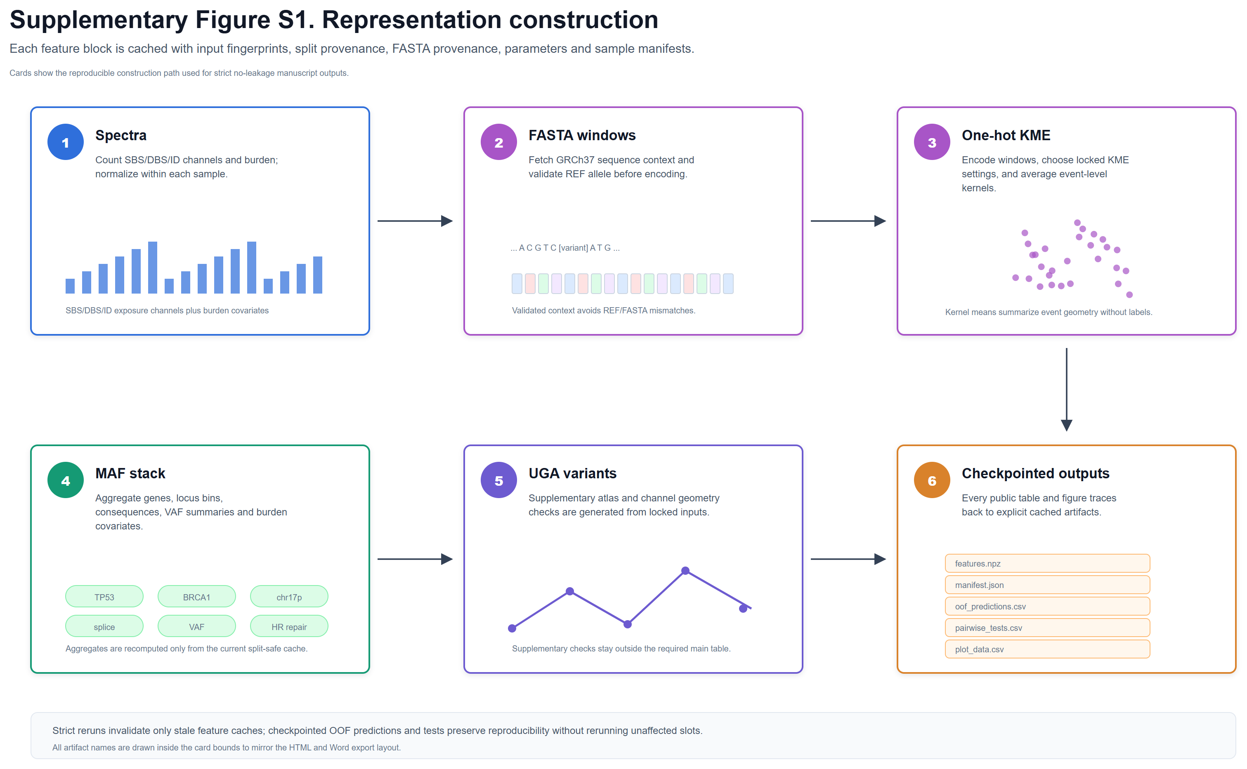
Supplementary Figure S1. Representation construction and reproducibility workflow.
Raw mutation catalogues are converted into spectra, geometry variants, MAF-stack aggregates, combined tabular matrices, and MuAt-compatible event bags with cached, restartable feature-generation steps.

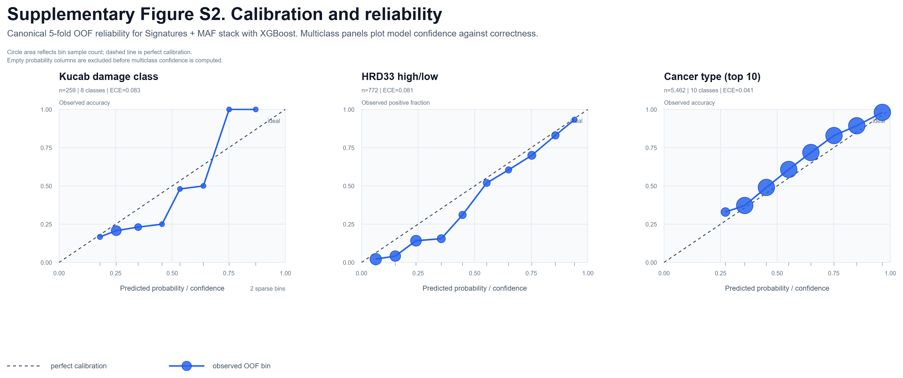
Supplementary Figure S2. Calibration of selected classification models.
Reliability curves are shown for selected out-of-fold classification models to assess whether predicted probabilities are broadly aligned with observed frequencies.

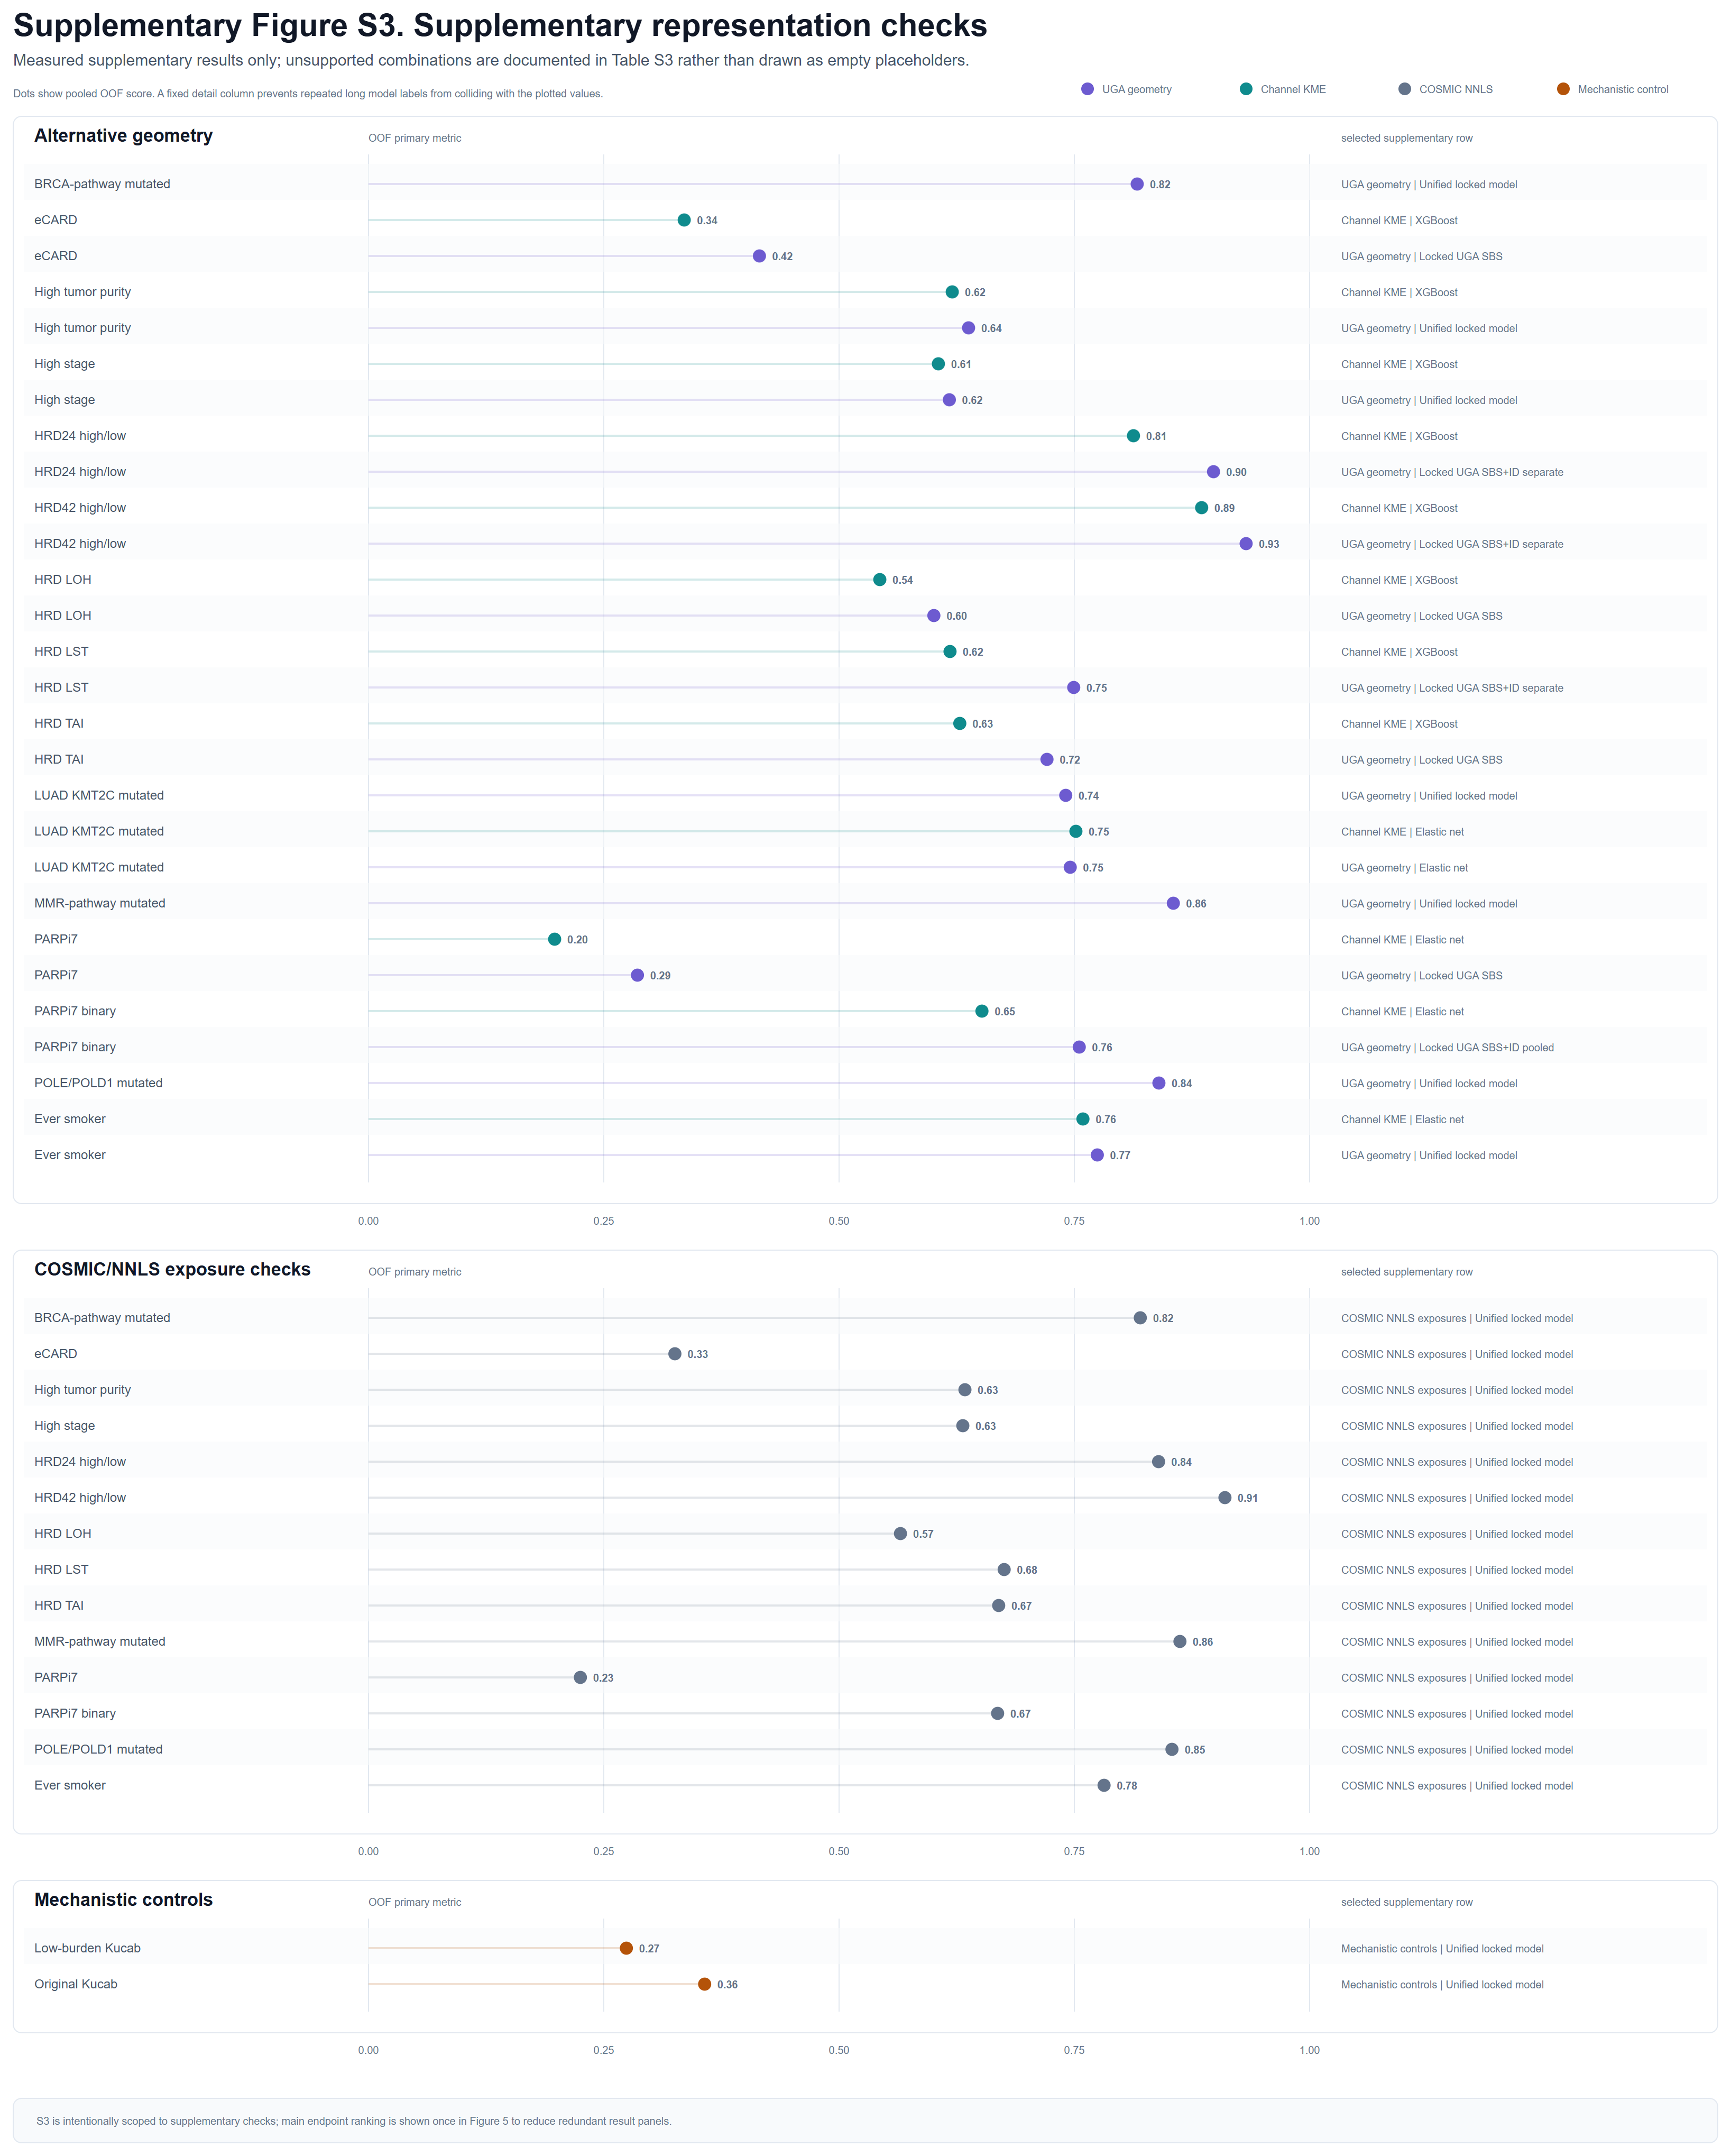
Supplementary Figure S3. Supplementary measured representation panels.
Measured supplementary geometry, exposure, and mechanistic-control results are shown; unsupported combinations are omitted and documented in Supplementary Table S3.

