Representation choices for somatic mutation catalogues strongly influence prediction performance across mechanistic and clinical endpoints
Aaron Ge1,2, Jeya Balaji Balasubramanian3, Jonas De Almeida3, Bradley A. Maron1,2*
1 University of Maryland-Institute of Health Computing, University of Maryland School of Medicine, Baltimore, MD, USA
2 University of Maryland School of Medicine, Baltimore, MD, USA
3 Division of Cancer Epidemiology and Genetics, National Cancer Institute, National Institutes of Health, Bethesda, MD, USA
Correspondence: Aaron Ge
6116 Executive Blvd, Bethesda, MD 20282, USA
age1@som.umaryland.edu

Abstract
Background. Cancer sequencing produces variable-length catalogues of somatic mutation events. These catalogues can be summarized as mutation burdens, mutational spectra, event-level annotation features, or learned neural event bags, but it remains unclear how much prediction performance depends on representation choice rather than model family alone.
Methods. We regenerated a strict no-leakage benchmark spanning five main endpoints: Kucab DNA damage class (n = 259), TCGA-BRCA HRD score (n = 772), HRD-high status at threshold 33 (n = 772), TCGA cancer type among the fixed twenty-class registry (n = 8,800), and TCGA CDR overall survival (n = 9,986). Representations included mutational burden, SBS/DBS/ID mutational spectra, Bio MAF v4 features, and combined Signatures + Bio MAF v4 features. Tabular learners used five outer folds, an inner train/validation split for hyperparameter selection, final refitting on the full outer-training fold, and pooled out-of-fold metrics. Survival was modeled with scikit-survival CoxNet and Harrell's C-index. We also added a MuAt-compatible event-bag comparator for the TCGA-BRCA HRD endpoints, using the same endpoint-specific outer folds where configured.
Results. Mutational signatures improved over burden for XGBoost on Kucab damage class, HRD score, HRD33 high/low status, and cancer-type prediction. The strongest tabular performance generally came from Signatures + MAF stack with XGBoost: HRD score reached 0.781 Spearman r, HRD33 high/low reached 0.867 AUROC, and the fixed top-20 cancer-type endpoint was evaluated by balanced accuracy. Overall survival was best predicted by the combined signatures + Bio MAF v4 representation under CoxNet (C-index 0.647), with Bio MAF v4 alone reaching 0.632 and signatures alone reaching 0.607. The active MuAt-compatible comparator was evaluated on HRD score and HRD33 high/low status and compared with the tuned Signatures + MAF stack XGBoost baselines on the same endpoint-specific folds.
Conclusions. Representation choice is a first-order determinant of prediction performance for somatic-mutation benchmarks. Mutational signatures remain a strong and efficient baseline, event-level MAF features add endpoint-specific biology, and combining spectra with event-level annotations is the most consistent practical tabular default. A local MuAt-compatible reimplementation does not automatically exceed a tuned tabular baseline under a directly comparable TCGA-WES evaluation.
Trial registration. Not applicable.
Keywords: Somatic mutations; Mutational signatures; Mutation annotation format; Representation learning; Homologous recombination deficiency; Tumour type; Survival analysis; scikit-survival CoxNet; MuAt-compatible; XGBoost

Background
Somatic mutation catalogues integrate the activity of endogenous and exogenous mutational processes, DNA repair defects, and clonal selection. Large pan-cancer resources have catalogued SBS, DBS, and indel signatures across whole genomes and exomes, while controlled mutagen-exposure experiments have shown that many environmental agents leave reproducible sequence-context spectra [1,2]. These observations make mutation catalogues a natural substrate for mechanistic attribution and clinical prediction.
A practical prediction pipeline must decide how to transform a variable-length set of mutation events into model inputs. Common tabular choices include mutation burden, mutational spectra, and aggregated MAF-derived gene, locus, consequence, pathway, and variant-allele-fraction features. More recent neural approaches, including Mutation-Attention (MuAt), instead operate on mutation-level events and learn attention-based tumour representations [10].
The manuscript question is therefore not whether mutation catalogues contain predictive information, but how strongly the chosen representation shapes performance when evaluation is held fixed. We address critiques of exome sparsity, insufficient tuning, survival modeling, and deep-learning comparability by regenerating the benchmark under a strict no-leakage, nested out-of-fold protocol with Cox survival endpoints and a directly comparable MuAt-compatible event-bag model.
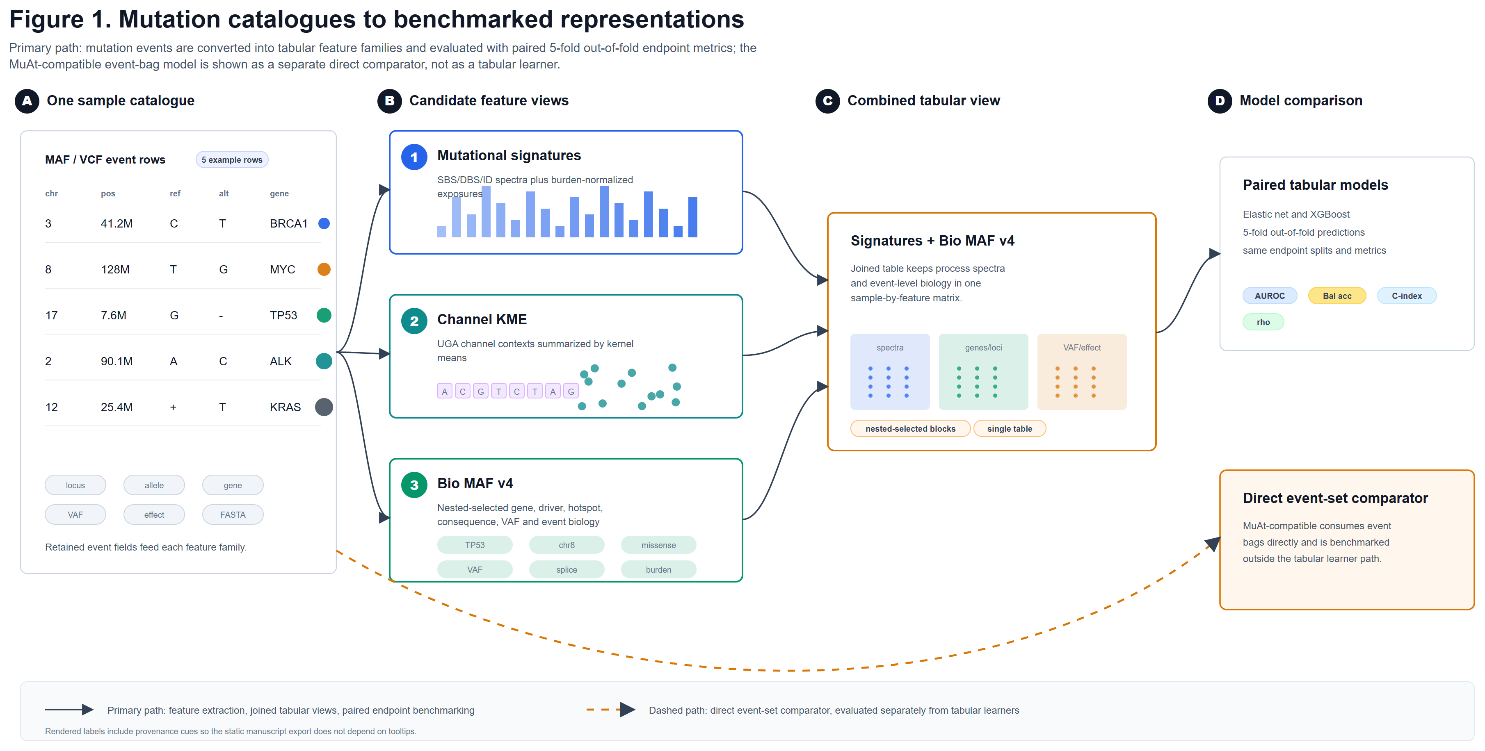
Figure 1. Conceptual overview of mutation-catalogue representations.
Each tumour is represented as a catalogue of somatic mutation events that can be transformed into compact burden summaries, mutational spectra, event-level MAF-stack aggregates, combined tabular representations, or MuAt-compatible mutation bags. The benchmark evaluates these choices under a strict pooled out-of-fold design.

Methods

Study design and endpoint registry
All analyses were regenerated inside the project repository using an endpoint registry and strict completion gate. The main panel contains five endpoints chosen to span mechanism, DNA repair deficiency, tumour identity, and clinical outcome. Binary overall-survival classification was removed from the main benchmark and replaced by scikit-survival CoxNet proportional-hazards modeling of TCGA CDR overall survival.
The five primary endpoint families were Kucab DNA damage class; continuous HRD score; HRD-high versus HRD-low binary thresholds; TCGA cancer type among the fixed twenty-class registry; and TCGA CDR overall survival. Survival endpoints required positive follow-up time, at least 200 eligible samples, and at least 25 events.
Table 1. Datasets, endpoints, and evaluation design.
Endpoint | Cohort/source | N | Task | Primary metric
Kucab damage class | Kucab mutagen-treated clone mutation catalogues | 259 | Grouped multiclass | Balanced accuracy
HRD score | TCGA-BRCA HRD labels with MC3 mutation features | 772 | Regression | Spearman r
HRD24 high/low | TCGA-BRCA HRD labels with MC3 mutation features | 772 | Binary classification | AUROC
HRD33 high/low | TCGA-BRCA HRD labels with MC3 mutation features | 772 | Binary classification | AUROC
HRD42 high/low | TCGA-BRCA HRD labels with MC3 mutation features | 772 | Binary classification | AUROC
Cancer type (top 20) | TCGA MC3 clinical endpoint panel | 8,800 | Multiclass classification | Balanced accuracy
Overall survival | TCGA MC3 clinical endpoint panel | 9,986 | Survival | Harrell C-index
Note. Label definitions are provided in the endpoint registry; survival is modeled as a time-to-event endpoint with censoring rather than as binary event status.

Representations
Mutational burden features provide the minimal count-based baseline, and mutational signatures summarize SBS, DBS, and indel spectra. Bio MAF v4 converts each tumour's variable-length MC3 Mutation Annotation Format table into fixed, named biological feature blocks grounded in MAF/VEP annotations and vendored external cancer-gene, driver-evidence, and hotspot resources.
The strict Bio MAF v4 stack uses predeclared candidate blocks: compact biological annotations, external evidence-confidence controls, hotspot summaries, exact consensus driver-gene features, a full strict core, and optional mutation-load controls. Signatures are not counted as Bio MAF features; signatures + Bio MAF models concatenate the signature matrix with the Bio MAF block chosen inside the inner loop for that outer fold.
Bio MAF v4 is therefore not one feature per mutation. It is one fixed-length vector per tumour. The feature builder normalizes gene symbols and standard MAF/VEP fields, then computes named counts, fractions, unique-gene summaries, hotspot summaries, driver-evidence summaries, and allele-fraction summaries. Count features are log1p-transformed after all mutations for that tumour are counted.
Feature-block selection is nested: candidate Bio MAF v4 blocks are defined before cross-validation, selected only using each outer fold's inner-validation data, and then evaluated once on that outer fold. Held-out fold labels and held-out performance do not define the Bio MAF v4 feature schema.
For the neural comparator, a MuAt-compatible preprocessing layer turns each mutation into three token streams: a mutation motif token, a 1-Mb chromosome-position-bin token, and an annotation token derived from available MAF fields. The active comparator uses fixed-size deterministic token dictionaries, preventing held-out test samples from changing the available token set.

Table 3. Representation summary and dimensionality.
Representation | Input signal | Dimensionality | Evaluated models
Mutational burden | Total mutation burden and compact burden summaries | 1-3 | Elastic net; XGBoost; CoxNet
Mutational signatures | SBS/DBS/ID mutational spectra | 182-261 | Elastic net; XGBoost; CoxNet
Bio MAF v4 | Predeclared Bio MAF v4 blocks selected inside each outer fold's inner validation split | 948-2,980 | Elastic net; XGBoost; CoxNet
Signatures + Bio MAF v4 | Mutational spectra plus predeclared Bio MAF v4 blocks selected by nested validation | 1,130-3,241 | Elastic net; XGBoost; CoxNet
MuAt-compatible | Per-mutation MC3 event bags with motif, position-bin, and genic/exonic/strand tokens | Event bag | MuAt-compatible
Note. Feature-dimensionality ranges are observed across endpoint/model rows because spectrum channels vary by endpoint data source and Bio MAF v4 blocks are selected within each outer fold's inner-validation split; MuAt-compatible uses padded mutation bags and learned embeddings rather than fixed tabular columns.

Nested out-of-fold evaluation
Each endpoint used five outer folds. For every outer fold, the 80% outer-training partition was split into inner-training and inner-validation partitions. Candidate models were trained only on the inner-training set, selected only on the inner-validation set, refit once on the full 80% outer-training set using the selected hyperparameters, and predicted once on the 20% held-out outer fold. Primary metrics were computed after pooling all out-of-fold predictions over the full cohort.
The current implementation uses one inner validation split per outer fold because the feature-generation and neural comparator experiments are expensive. This split is retained as a leakage-prevention and correctness check for the current manuscript rerun; broader repeated inner resampling is a future precision improvement rather than part of the present statistical claim.
Classification used stratified splits when feasible; survival used event-stratified splits; regression used shuffled K-fold splits; and Kucab analyses used grouped splitting to prevent treatment-agent leakage across folds. Logistic elastic-net models searched C values of 0.001, 0.01, 0.1, 1, and 10 with l1_ratio values of 0, 0.25, 0.5, 0.75, and 1. Regression elastic net searched alpha values from 1e-4 to 10 with the same l1_ratio grid. Survival used scikit-survival CoxnetSurvivalAnalysis with elastic-net penalties, l1_ratio values of 0.25, 0.5, 0.75, and 1.0, and alpha >= 1e-2 by default. XGBoost used seeded candidate search with inner-validation early stopping; final refits used exactly the selected number of boosting rounds.
Primary metrics were Spearman r for continuous endpoints, AUROC for binary endpoints, balanced accuracy for multiclass endpoints, and Harrell C-index for survival endpoints. Multiclass robustness was further summarized with macro-AUROC, micro-AUROC, macro-F1, and Cohen's kappa. Statistical comparisons used paired tests over pooled out-of-fold predictions with Benjamini-Hochberg FDR correction.

MuAt-compatible comparator
The MuAt-compatible comparator follows the central structure reported for MuAt: separate motif, position, and annotation embeddings; concatenation of modality embeddings; stacked Q/K/V self-attention; residual/normalization layers; attention-weighted set pooling; and a 24-dimensional tumour feature layer before prediction. The limited architecture search evaluates embedding sizes 128, 256, and 512; self-attention layer counts 1, 2, and 4; and attention-head counts 1 and 2 on the inner split before outer-fold refitting. We label this model MuAt-compatible rather than MuAt because official MuAt package checkpoints were not used for the manuscript comparison.
The MuAt paper clearly specifies sequence-context style mutation encodings, but the exact auxiliary biological annotation vocabulary is not fully reproducible from the bundled manuscript sources. The local event bag therefore uses deterministic MAF/VEP-derived motif, 1-Mb position-bin, and genic/exonic/strand annotation tokens. Broader external-resource annotations are confined to Bio MAF v4 tabular features and are treated as part of the representation difference tested by the benchmark.
The active manuscript comparison evaluates this neural event-bag model only on raw HRD score and HRD33 high/low status. The event tensor allows up to 5,000 mutation events per tumour; samples above this ceiling are deterministically truncated after sorting events by chromosome, position, and motif. In practice, most TCGA-WES tumours were far below this ceiling.
The HRD endpoints are active because measured MuAt-compatible OOF rows are present for them. Cancer-type, Kucab, survival, HRD24, and HRD42 MuAt rows are not active manuscript comparator claims.

Results

Mutational signatures improve over burden, but not uniformly
In the strict main panel, XGBoost models using mutational signatures outperformed burden on Kucab damage class (0.277 vs 0.114 balanced accuracy), HRD score (0.704 vs 0.596 Spearman r), HRD33 high/low status (0.845 vs 0.811 AUROC), and cancer-type prediction by balanced accuracy. Elastic-net models showed the same qualitative gain for Kucab damage class and cancer type but not for every clinical endpoint, underscoring that signatures are strong but not universally dominant.
The survival result should be interpreted separately from the older binary-OS draft: overall survival is now a time-to-event CoxNet endpoint evaluated by Harrell C-index. Under this survival analysis, the combined signatures + Bio MAF v4 representation achieved the strongest overall-survival C-index among the main tabular representations (0.647).

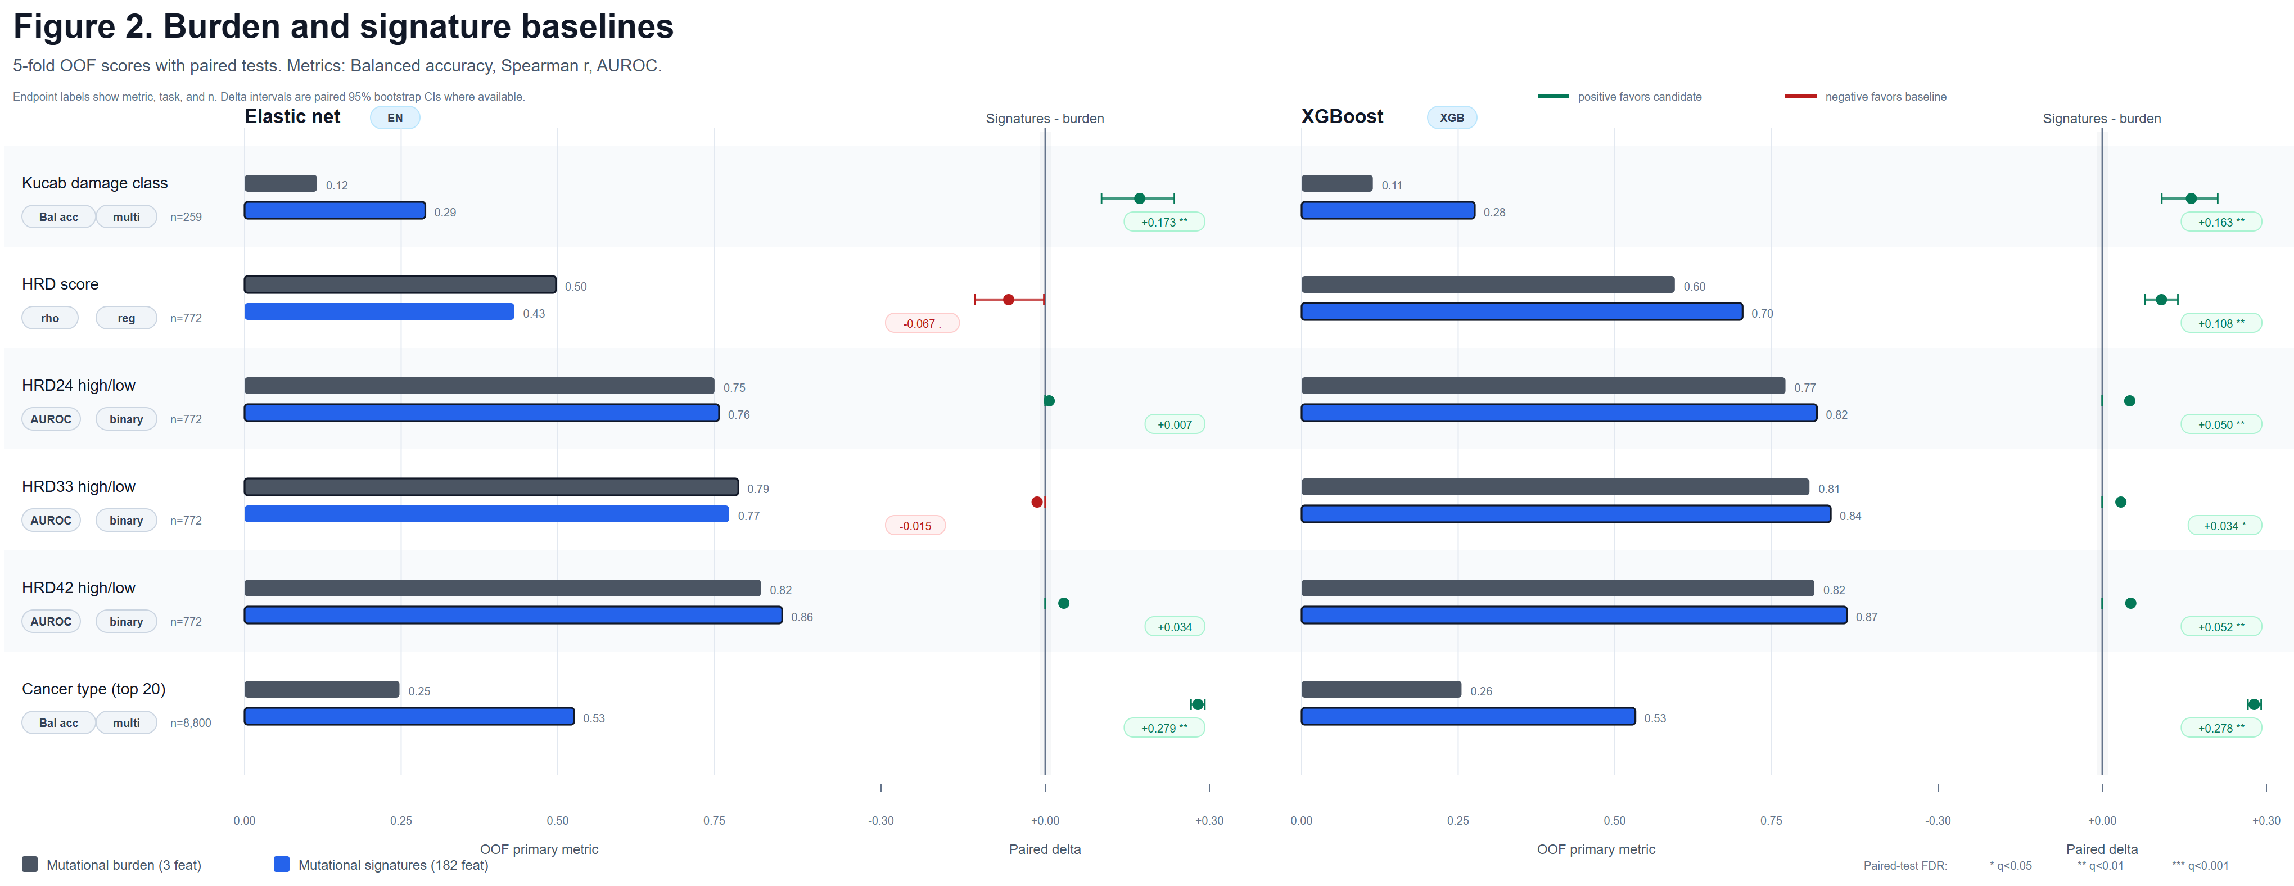
Figure 2. Signature baselines compared with mutational burden.
Nested five-fold out-of-fold performance is shown for burden and mutational signatures across the non-survival model-comparison endpoints. Survival CoxNet C-index results are reported separately in Figure 5 and the tables.

Event-level MAF features add endpoint-specific biology
Event-level MAF-stack features were most useful for endpoints where gene, locus, consequence, or event-level biology carries direct label information. With XGBoost, MAF stack alone improved cancer-type prediction relative to signatures by balanced accuracy, but it underperformed signatures for the mechanistic Kucab damage-class task (0.188 vs 0.277 balanced accuracy). This pattern supports the expected distinction between mutagen-mechanism endpoints, which are strongly sequence-context driven, and clinical or tumour-identity endpoints, which can benefit from broader annotation features.
The combined Signatures + MAF stack representation was the strongest practical tabular default. With XGBoost it reached 0.781 Spearman r for HRD score, 0.867 AUROC for HRD33 high/low, and the strongest balanced accuracy for cancer type. It was also strongest for overall survival under CoxNet in the current rerun.

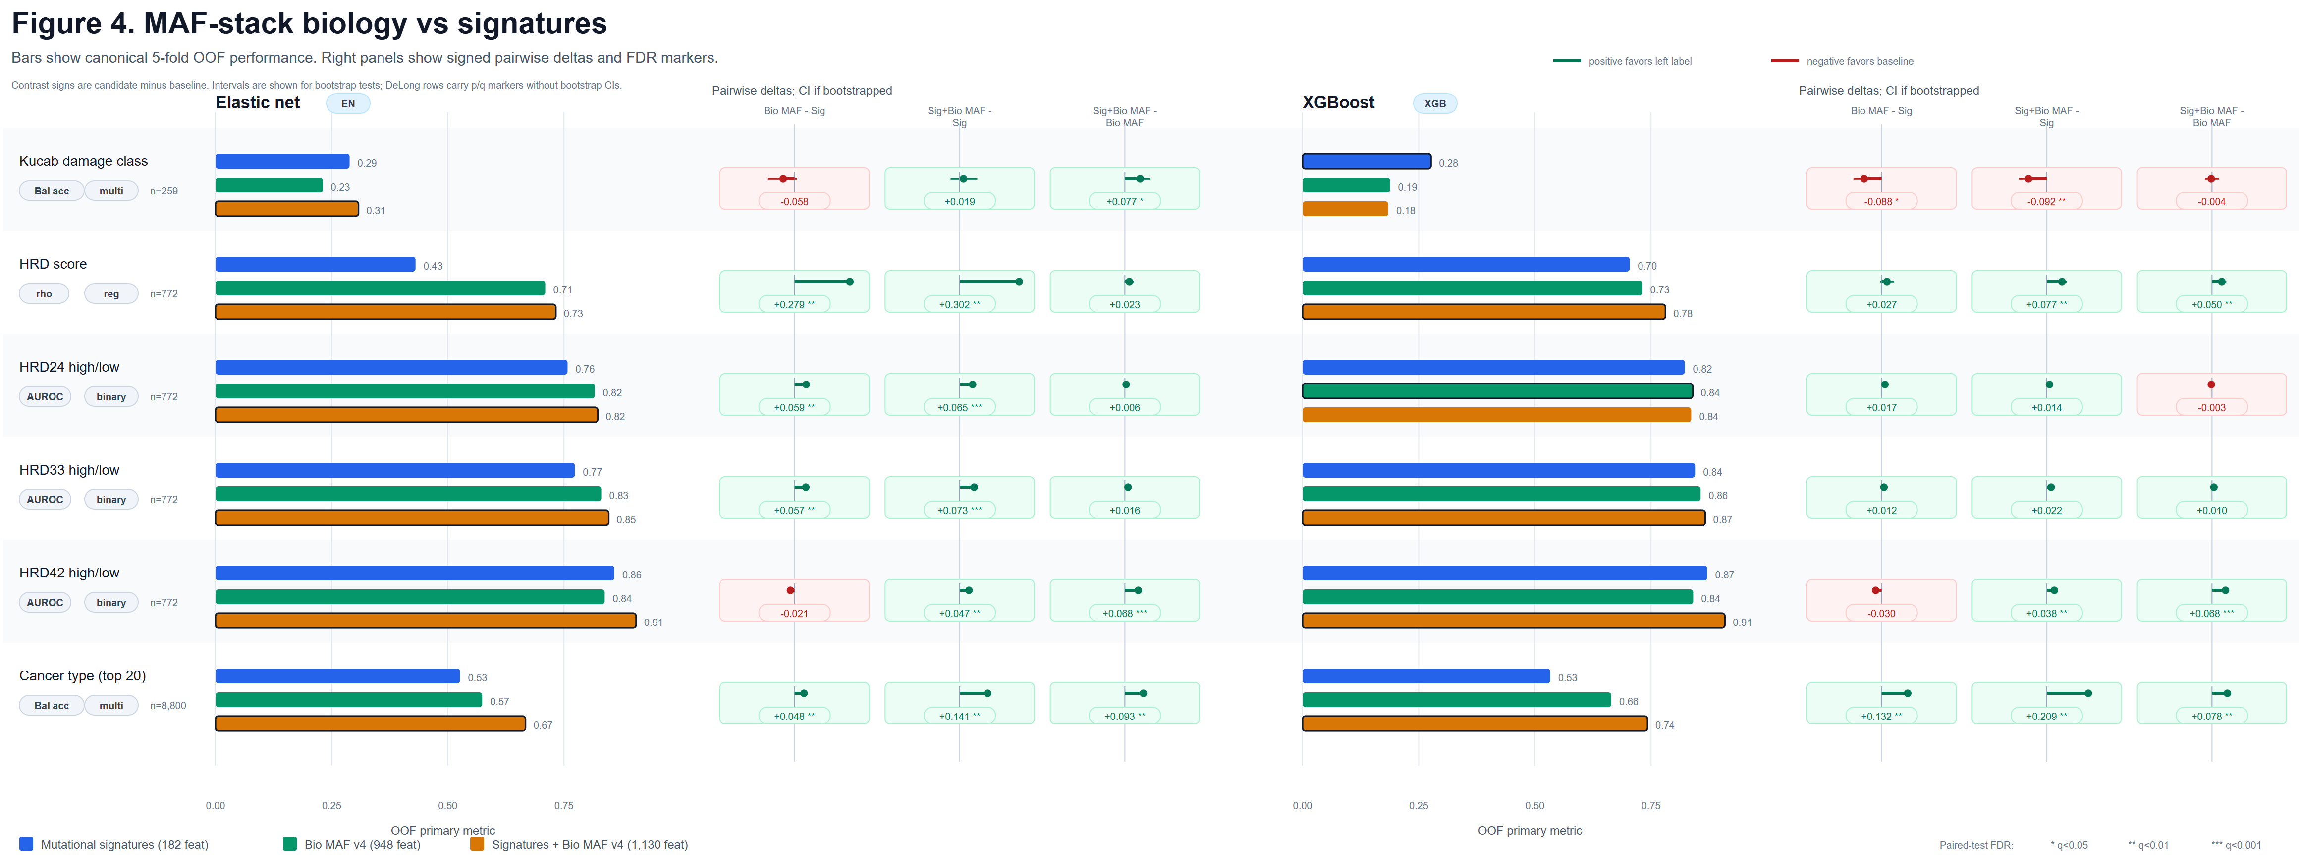
Figure 4. Event-level MAF-stack features and combined signature-plus-event representations.
Mutational signatures, event-level MAF-stack features, and their concatenation are compared for each endpoint and tabular model family. The combined representation is strongest for HRD score, HRD33 status, and cancer type under XGBoost.

MuAt-compatible event-bag modeling is directly comparable but not dominant
The MuAt-compatible comparator was added to avoid treating deep event-level models only as a conceptual future baseline. In the active manuscript comparison, it is evaluated on raw HRD score and HRD33 high/low status against the tuned Signatures + MAF stack XGBoost baselines on the matching folds.
These results do not imply that the official pretrained MuAt model is ineffective. They show that, in this manuscript's strict TCGA-WES benchmark and local reimplementation, a mutation-attention architecture does not automatically outperform a leakage-safe, tuned tabular representation.

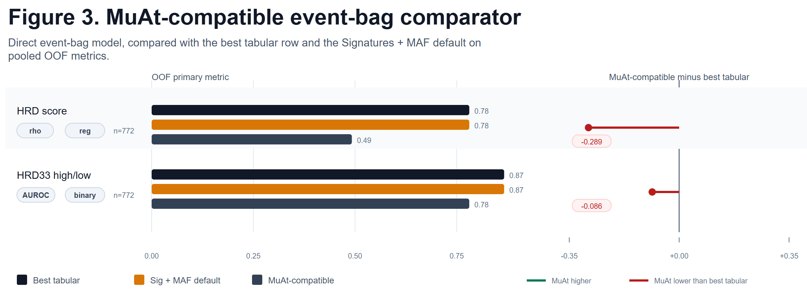
Figure 3. MuAt-compatible event-bag comparator.
The MuAt-compatible reimplementation is evaluated on raw HRD score and HRD33 high/low rather than as a reproduction of the original MuAt TCGA-20 benchmark. The comparator uses the same held-out folds as the corresponding canonical tabular benchmark.

Table 2. Main-panel performance by endpoint and representation.
Endpoint / representation | Elastic net | XGBoost / CoxNet | MuAt-compatible
Kucab damage class (Balanced accuracy; n=259)
Mutational burden | 0.116 | 0.114
Mutational signatures | 0.289 | 0.277
Bio MAF v4 | 0.231 | 0.188
Signatures + Bio MAF v4 | 0.308 | 0.184
MuAt-compatible event bag
HRD score (Spearman r; n=772)
Mutational burden | 0.497 | 0.596
Mutational signatures | 0.431 | 0.704
Bio MAF v4 | 0.710 | 0.731
Signatures + Bio MAF v4 | 0.733 | 0.781
MuAt-compatible event bag |  |  | 0.492
HRD24 high/low (AUROC; n=772)
Mutational burden | 0.750 | 0.773
Mutational signatures | 0.758 | 0.823
Bio MAF v4 | 0.816 | 0.840
Signatures + Bio MAF v4 | 0.823 | 0.837
MuAt-compatible event bag
HRD33 high/low (AUROC; n=772)
Mutational burden | 0.788 | 0.811
Mutational signatures | 0.774 | 0.845
Bio MAF v4 | 0.830 | 0.857
Signatures + Bio MAF v4 | 0.846 | 0.867
MuAt-compatible event bag |  |  | 0.781
HRD42 high/low (AUROC; n=772)
Mutational burden | 0.825 | 0.819
Mutational signatures | 0.859 | 0.871
Bio MAF v4 | 0.838 | 0.841
Signatures + Bio MAF v4 | 0.905 | 0.909
MuAt-compatible event bag
Cancer type (top 20) (Balanced accuracy; n=8,800)
Mutational burden | 0.247 | 0.255
Mutational signatures | 0.526 | 0.533
Bio MAF v4 | 0.574 | 0.665
Signatures + Bio MAF v4 | 0.667 | 0.742
MuAt-compatible event bag
Overall survival (Harrell C-index; n=9,986)
Mutational burden |  | 0.584
Mutational signatures |  | 0.607
Bio MAF v4 |  | 0.632
Signatures + Bio MAF v4 |  | 0.647
MuAt-compatible event bag
Note. Scores are pooled out-of-fold primary metrics. Elastic net and XGBoost columns apply to tabular representations; the CoxNet value is shown in the XGBoost/CoxNet column for survival. MuAt-compatible is shown as a separate event-bag comparator.

Cross-endpoint synthesis
No representation wins across every endpoint. Mutational signatures are a strong and efficient baseline; event-level MAF features capture biology that spectra can miss; and combined signature-plus-MAF features offer the best overall tabular default for HRD, tumour-identity, and the current CoxNet overall-survival endpoint. Survival remains difficult, with modest C-index values even under the validated scikit-survival implementation.
The Kucab sparsity control downsampled WGS mutation inventories to budgets of 20, 41, 100, and 200 mutations per clone. These runs provide an exome-like stress test for the mechanistic endpoint and are reported in the supplementary tables. They make explicit that WGS-versus-WES mutation count differences can affect representation stability and should not be ignored when comparing mechanistic and clinical cohorts.

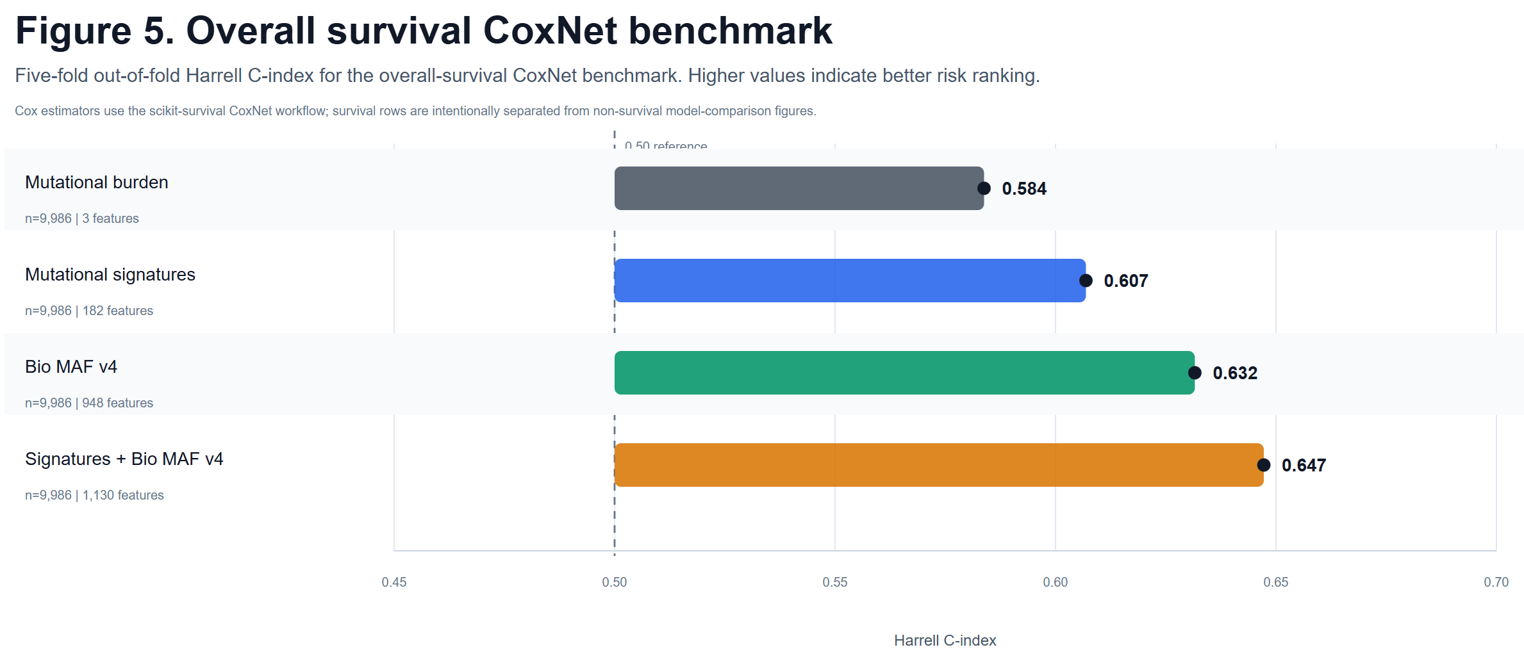
Figure 5. Overall survival CoxNet benchmark.
Overall-survival C-index is shown for the scikit-survival CoxNet benchmark across burden, signatures, Bio MAF v4, and combined signature-plus-Bio MAF v4 representations.

Discussion
This regenerated benchmark changes the interpretation of the original draft in three important ways. First, survival is now evaluated as time-to-event data with censoring rather than as binary event status. Second, high-dimensional tabular baselines are tuned within a nested out-of-fold framework, reducing the risk that poor performance reflects inadequate regularization. Third, the neural event-bag comparator is measured directly rather than invoked as an untested future alternative.
The results support a pragmatic view of mutation-catalogue modeling. For mechanistic mutagen attribution, mutational spectra remain highly competitive because the label is closely tied to sequence-context processes. For HRD and cancer-type endpoints, event-level annotations add useful biological structure, and the combined Signatures + MAF stack representation performs best with XGBoost. For survival, predictive signal from mutation catalogues alone remains modest and appears sensitive to representation and censoring-aware modeling assumptions.
The MuAt-compatible model's weaker performance relative to tuned tabular models is scientifically plausible. Although the model permits 5,000 events per tumour, TCGA WES mutation bags are sparse in the present data, with median event counts near 100 for the HRD comparison. The model was also trained locally rather than initialized from official MuAt checkpoints, and the active manuscript endpoints are HRD tasks rather than the original MuAt paper's primary tumour-typing benchmark. The result should therefore be read as a fair local comparator, not as a failure to reproduce the full MuAt PCAWG/TCGA/GEL study.

Limitations
The benchmark uses bundled MC3, CDR, HRD, and Kucab assets rather than downloading new GDC cohorts during the default run, so manuscript reproduction stays offline and reproducible from the bundled assets.
The MuAt-compatible comparator implements the central mutation-attention architecture, attention-weighted set pooling, token modalities, and limited inner-split architecture search, but it does not include official pretrained checkpoints, external WGS validation cohorts, structural-variant and mobile-element modalities unavailable in the bundled TCGA WES assets, or the complete original-study training program. Although the comparator uses a 5,000-event cap, this capacity is rarely used in TCGA-WES; most tumours contribute far fewer events than the cap, so the comparison should be interpreted as a sparse exome-facing benchmark rather than a high-mutation whole-genome MuAt reproduction.
Some comparisons involving MuAt and simpler tabular representations share the same endpoint and out-of-fold pooling but are not all paired on identical fold manifests for every representation family. The active HRD MuAt comparisons use the canonical tabular fold assignments and are the only MuAt comparisons emphasized for direct model interpretation.

Conclusions
Representation choice strongly influences somatic-mutation prediction performance. Mutational signatures are a robust baseline, event-level MAF features add complementary endpoint-specific signal, and their combination with XGBoost is the strongest practical default for several clinical and tumour-identity endpoints. CoxNet survival modeling and no-leakage feature generation materially strengthen the clinical interpretation of the benchmark. A MuAt-compatible event-bag comparator provides a direct neural-model comparison but does not supersede the tuned tabular baseline under the current TCGA-WES evaluation.

Abbreviations

Table 4. Key terminology and abbreviations.
Term | Definition | Used in
EN / XGB | Elastic-net score / XGBoost score in compact performance tables. | Table 2
AUROC | Area under the receiver operating characteristic curve for binary endpoints. | Tables 2 and S2
macro-AUROC | Class-balanced AUROC averaged across multiclass labels. | Tables 2 and S2
Balanced accuracy | Mean per-class recall; the primary metric for the fixed top-20 TCGA cancer-type endpoint. | Tables 2 and S4
Spearman r | Spearman rank correlation for continuous endpoints. | Tables 2 and S2
HRD | Homologous recombination deficiency. | Endpoint labels
MAF | Mutation annotation format; here also shorthand for event-level mutation annotations. | Representations
SBS/DBS/ID | Single-base substitution, double-base substitution, and insertion/deletion mutation spectra. | Representations
KME | Kernel mean embedding used to summarize event-level mutation contexts. | Representations
UGA | Universal genomic atlas/channel geometry representation used in supplementary analyses. | Supplement
Mutational burden | Compact mutation-count baseline features. | Tables 2 and 3
Mutational signatures | Canonical mutation-spectrum representation. | Tables 2 and 3
Bio MAF v4 | Predeclared named cancer-gene, evidence-confidence, hotspot, consequence, allele-fraction, and event-annotation feature blocks selected inside nested CV. | Tables 2 and 3
Signatures + bio MAF | Combined spectra plus frozen named event-level MAF features. | Tables 2 and 3
XGBoost | Gradient-boosted tree model used as the nonlinear learner. | Model columns
Note. Abbreviations and shorthand used in the manuscript figures and tables.

Declarations

Ethics approval and consent to participate
Not applicable. The analyses use public, de-identified research datasets.

Consent for publication
Not applicable.

Availability of data and materials
All analyses were implemented in the GitHub-connected project repository. The default reproducibility run uses bundled MC3, TCGA CDR, TCGA-BRCA HRD, and Kucab assets; no active manuscript command downloads GDC data. Generated tables, figures, split manifests, and audit files are stored under the project results directory.

Competing interests
The authors declare that they have no competing interests.

Funding
The research reported here was supported by the AIM-AHEAD Coordinating Center at the University of North Texas Health Science Center at Fort Worth and, in part, by the National Institutes of Health Agreement No. 1OT2OD032581. The views and conclusions are those of the authors and should not be interpreted as representing the official policies, either expressed or implied, of the NIH.

Authors' contributions
AG designed and implemented the benchmark, performed analyses, generated figures and tables, and drafted the manuscript. JBB and JDA contributed cancer-genomics and benchmarking expertise. BAM supervised the project and revised the manuscript. All authors reviewed and approved the manuscript.

Acknowledgements
The authors thank the teams responsible for TCGA, MC3, TCGA CDR, HRD, and Kucab resources for making reusable cancer-genomics datasets available to the community.

References
1. Alexandrov LB, Kim J, Haradhvala NJ, et al. The repertoire of mutational signatures in human cancer. Nature. 2020;578:94-101. doi:10.1038/s41586-020-1943-3.
2. Kucab JE, Zou X, Morganella S, et al. A compendium of mutational signatures of environmental agents. Cell. 2019;177:821-836.e16. doi:10.1016/j.cell.2019.03.001.
3. Ellrott K, Bailey MH, Saksena G, et al. Scalable open science approach for mutation calling of tumor exomes using multiple genomic pipelines. Cell Systems. 2018;6:271-281.e7. doi:10.1016/j.cels.2018.03.002.
4. Liu J, Lichtenberg T, Hoadley KA, et al. An integrated TCGA pan-cancer clinical data resource to drive high-quality survival outcome analytics. Cell. 2018;173:400-416.e11. doi:10.1016/j.cell.2018.02.052.
5. Knijnenburg TA, Wang L, Zimmermann MT, et al. Genomic and molecular landscape of DNA damage repair deficiency across The Cancer Genome Atlas. Cell Reports. 2018;23:239-254.e6. doi:10.1016/j.celrep.2018.03.076.
6. Davies H, Glodzik D, Morganella S, et al. HRDetect is a predictor of BRCA1 and BRCA2 deficiency based on mutational signatures. Nature Medicine. 2017;23:517-525. doi:10.1038/nm.4292.
7. Chen T, Guestrin C. XGBoost: a scalable tree boosting system. Proceedings of the 22nd ACM SIGKDD International Conference on Knowledge Discovery and Data Mining. 2016:785-794. doi:10.1145/2939672.2939785.
8. Cox DR. Regression models and life-tables. Journal of the Royal Statistical Society: Series B. 1972;34:187-220.
9. Harrell FE Jr, Lee KL, Mark DB. Multivariable prognostic models: issues in developing models, evaluating assumptions and adequacy, and measuring and reducing errors. Statistics in Medicine. 1996;15:361-387. doi:10.1002/(SICI)1097-0258(19960229)15:4<361::AID-SIM168>3.0.CO;2-4.
10. Sanjaya P, Maljanen K, Katainen R, et al. Mutation-Attention (MuAt): deep representation learning of somatic mutations for tumour typing and subtyping. Genome Medicine. 2023;15:47. doi:10.1186/s13073-023-01204-4.

Supplementary Material
Supplementary Table S1. Supplementary endpoint inventory.
Endpoint | N | Task | Source | Metric(s) | Representation families
HRD LOH | 772 | Regression | TCGA-BRCA HRD labels with MC3 mutation features | Spearman r | Bio MAF v4; Mutational burden; Mutational signatures; Signatures + Bio MAF v4
HRD LST | 772 | Regression | TCGA-BRCA HRD labels with MC3 mutation features | Spearman r | Bio MAF v4; Mutational burden; Mutational signatures; Signatures + Bio MAF v4
HRD TAI | 772 | Regression | TCGA-BRCA HRD labels with MC3 mutation features | Spearman r | Bio MAF v4; Mutational burden; Mutational signatures; Signatures + Bio MAF v4
PARPi7 | 772 | Regression | TCGA-BRCA HRD labels with MC3 mutation features | Spearman r | Bio MAF v4; Mutational burden; Mutational signatures; Signatures + Bio MAF v4
PFI survival | 9,857 | Survival | TCGA MC3 clinical endpoint panel | Harrell C-index | Bio MAF v4; Mutational burden; Mutational signatures; Signatures + Bio MAF v4
eCARD | 772 | Regression | TCGA-BRCA HRD labels with MC3 mutation features | Spearman r | Bio MAF v4; Mutational burden; Mutational signatures; Signatures + Bio MAF v4
Note. Endpoint-level inventory for supplementary analyses outside the five-endpoint main panel.

Supplementary Table S2. Headline supplementary results.
Endpoint | N | Metric(s) | Best baseline/event-level | Best geometry/sensitivity | Best overall | Interpretation
HRD LOH | 772 | Spearman r | Signatures + Bio MAF v4 / XGBoost (Spearman r 0.658) |  | Signatures + Bio MAF v4 / XGBoost (Spearman r 0.658) | Best result comes from baseline or event-level feature families.
HRD LST | 772 | Spearman r | Signatures + Bio MAF v4 / XGBoost (Spearman r 0.716) |  | Signatures + Bio MAF v4 / XGBoost (Spearman r 0.716) | Best result comes from baseline or event-level feature families.
HRD TAI | 772 | Spearman r | Bio MAF v4 / XGBoost (Spearman r 0.753) |  | Bio MAF v4 / XGBoost (Spearman r 0.753) | Best result comes from baseline or event-level feature families.
PARPi7 | 772 | Spearman r | Signatures + Bio MAF v4 / XGBoost (Spearman r 0.356) |  | Signatures + Bio MAF v4 / XGBoost (Spearman r 0.356) | Best result comes from baseline or event-level feature families.
PFI survival | 9,857 | Harrell C-index | Signatures + Bio MAF v4 / CoxNet (Harrell C-index 0.614) |  | Signatures + Bio MAF v4 / CoxNet (Harrell C-index 0.614) | Best result comes from baseline or event-level feature families.
eCARD | 772 | Spearman r | Bio MAF v4 / XGBoost (Spearman r 0.539) |  | Bio MAF v4 / XGBoost (Spearman r 0.539) | Best result comes from baseline or event-level feature families.
Note. Best baseline/event-level, geometry/sensitivity, and overall result for each supplementary endpoint.

Supplementary Table S3. Non-applicability summary.
Representation/analysis family | Reason | Missing combinations | Example endpoints
COSMIC NNLS exposures | no measured supplementary result for this analysis family/endpoint | 6 | HRD LOH; HRD LST; HRD TAI; PARPi7; PFI survival
Channel KME | no measured supplementary result for this analysis family/endpoint | 6 | HRD LOH; HRD LST; HRD TAI; PARPi7; PFI survival
Mechanistic controls | no measured supplementary result for this analysis family/endpoint | 6 | HRD LOH; HRD LST; HRD TAI; PARPi7; PFI survival
One-hot sequence KME v2 | no measured supplementary result for this analysis family/endpoint | 6 | HRD LOH; HRD LST; HRD TAI; PARPi7; PFI survival
UGA geometry | no measured supplementary result for this analysis family/endpoint | 6 | HRD LOH; HRD LST; HRD TAI; PARPi7; PFI survival
Note. Grouped explanation of unsupported, intentionally omitted, or not-applicable supplementary combinations.

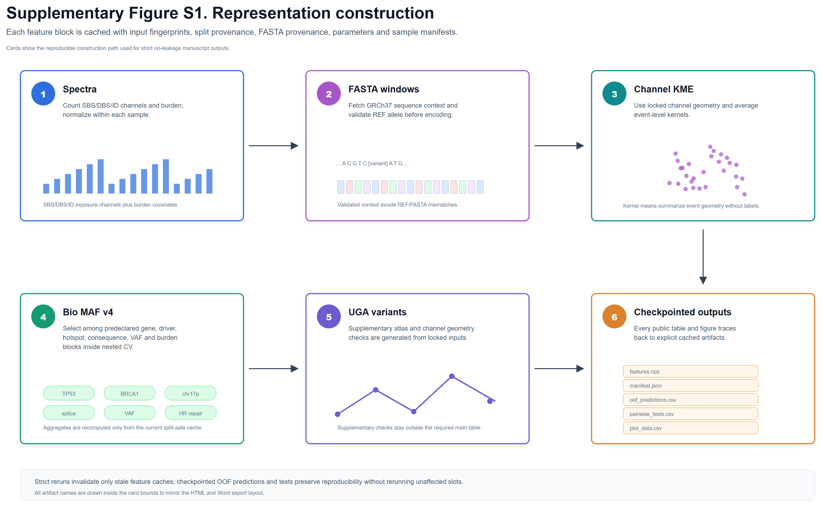
Supplementary Figure S1. Representation construction and reproducibility workflow.
Raw mutation catalogues are converted into spectra, geometry variants, MAF-stack aggregates, combined tabular matrices, and MuAt-compatible event bags with cached, restartable feature-generation steps.

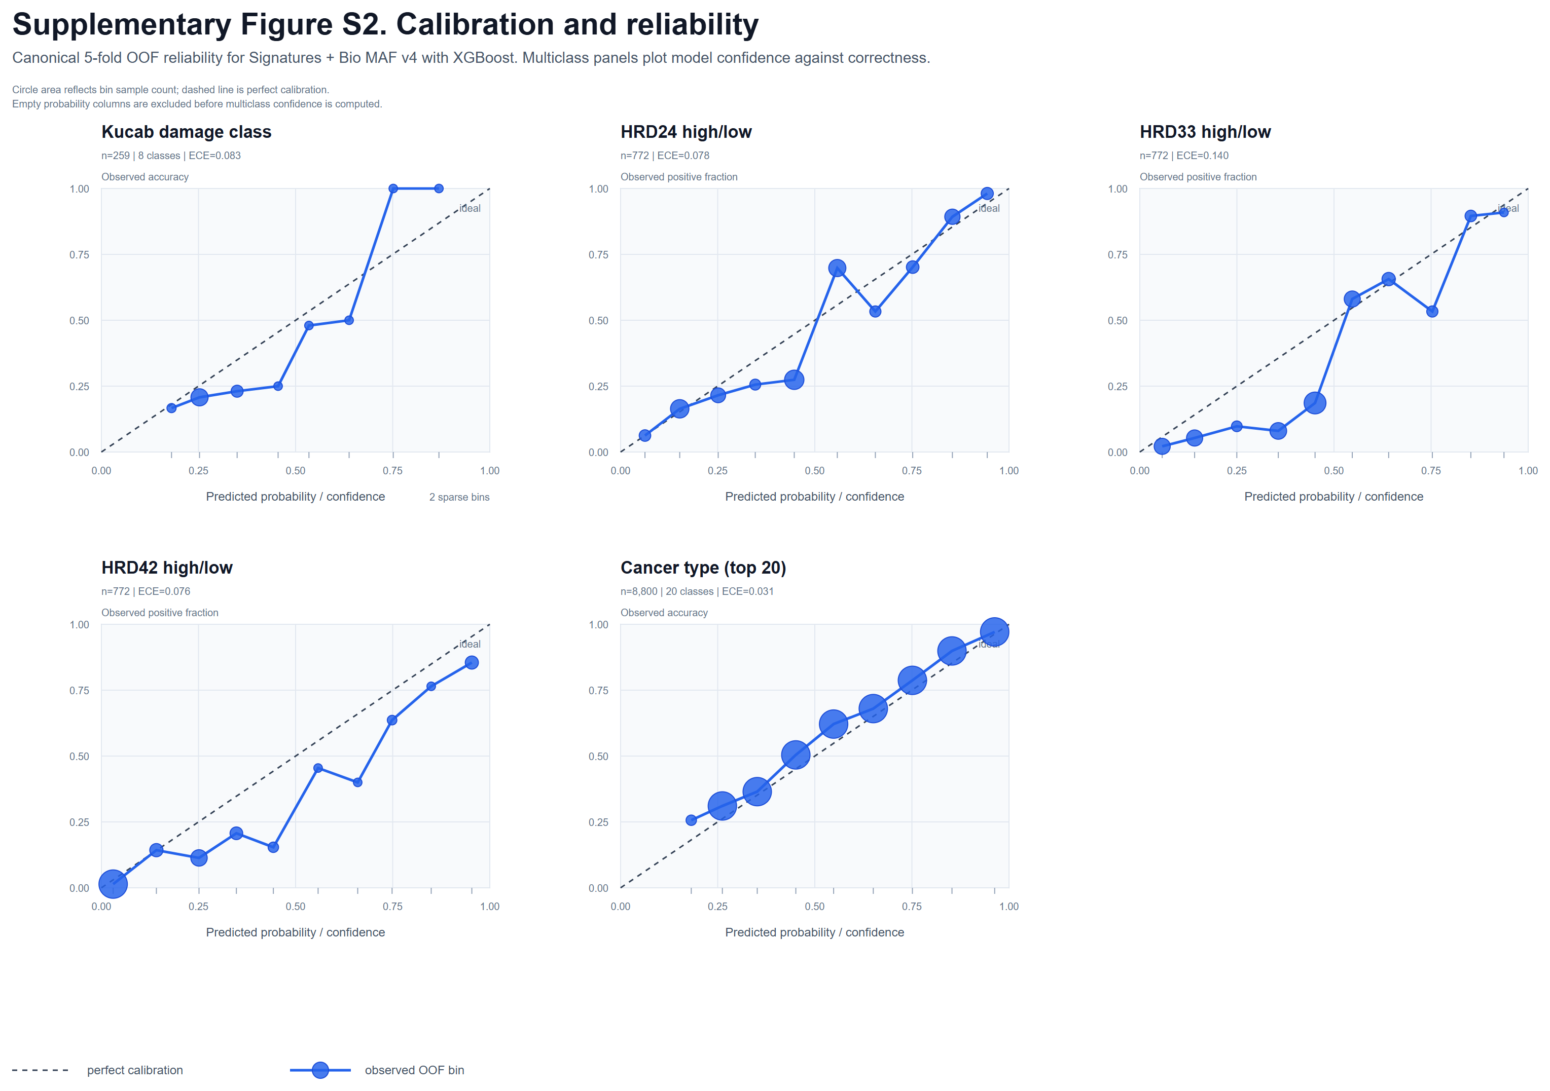
Supplementary Figure S2. Calibration of selected classification models.
Reliability curves are shown for selected out-of-fold classification models to assess whether predicted probabilities are broadly aligned with observed frequencies.

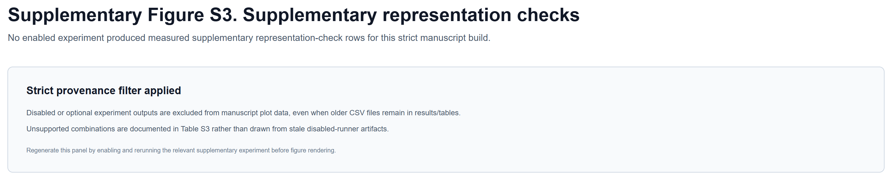
Supplementary Figure S3. Supplementary measured representation panels.
Measured supplementary geometry, exposure, and supplementary check results are shown; unsupported combinations are omitted and documented in Supplementary Table S3.

