**Practical 2**

**Aim:- Write code to control the LED**

**Theory**

1. **LED (Light Emitting Diode)**

An LED is a semiconductor device that emits light when current flows through it. LEDs are commonly used in electronics to indicate status or provide visual feedback.

1. **Arduino**

The Arduino is an open-source microcontroller platform used to control various electronic components. It can be programmed to read inputs, control outputs, and interact with other hardware.

**Materials Required**

* Arduino Uno board
* LED
* 220-ohm resistors (for LED and SSD)
* Breadboard
* Jumper wires

**Procedure**

**Connecting the LED**

1. **Connect the LED:**
   * Place the LED on the breadboard.
   * Connect the anode (long leg) of the LED to digital pin 9 on the Arduino through a 220-ohm resistor.
   * Connect the cathode (short leg) of the LED to the ground (GND) on the Arduino.

**Code**

**Arduino Sketch for LED**

const int greenLedPin = 11;

void setup() {

// Set up the pin using its new name.

pinMode(greenLedPin, OUTPUT);

}

void loop() {

// For Green Light LED

digitalWrite(greenLedPin, HIGH); // Turn the LED ON

delay(1000); // Wait for 5 seconds

digitalWrite(greenLedPin, LOW); // Turn the LED OFF

delay(1000); // Wait for 1 second

}

**Image**

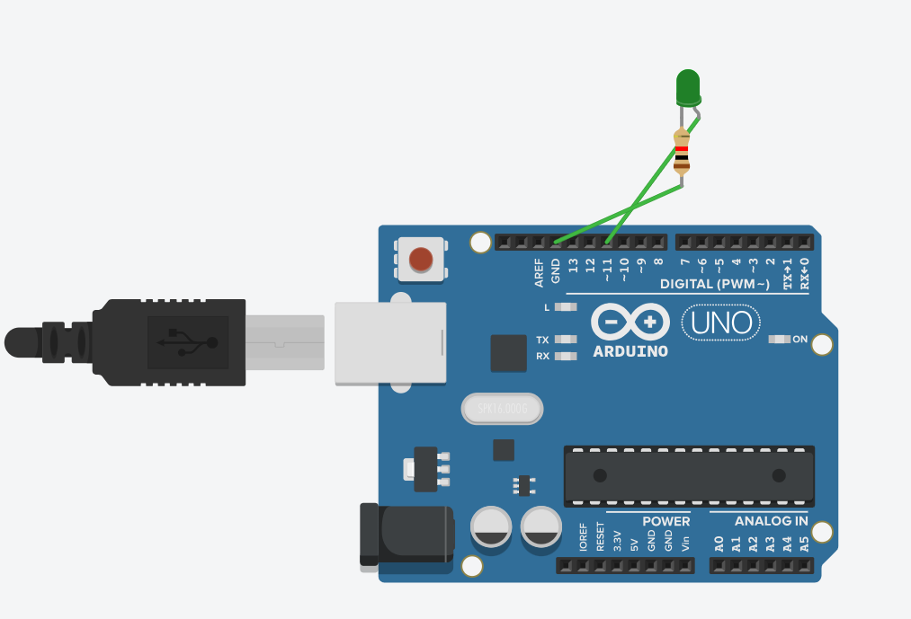

*Fig;- Arduino board with the LED*

**Working**

* **LED Control:**

The LED connected to pin 9 blinks on and off every second. This demonstrates basic digital output control using the Arduino.

**Conclusion**

The lab successfully demonstrated how to control an LED and a 7-segment display using an Arduino. Students learned to wire up basic electronic components and write code to control them, understanding the concepts of digital output and display management. This exercise provided foundational skills in interfacing components with an Arduino.