**Aim:- Write code to read temperature values from the sensor.**

**Theory**

## The LM35 is a temperature sensor that gives an output voltage which increases as the temperature increases. Its reading is directly in degree Celsius, so you don't need any extra calculations to find the temperature. It is accurate and does not usually need extra calibration.C:\Users\user\Desktop\lm35_device.jpg

**DHT11/DHT22 Sensor**

The DHT11 and DHT22 are digital sensors used to measure temperature and humidity. The DHT22 is a more accurate and wider-ranging version of the DHT11. Both sensors provide a digital output, which can be read by a microcontroller like the Arduino.

**Arduino**

The Arduino is a microcontroller platform used for interfacing with various electronic components. It processes sensor data and can control outputs based on sensor inputs.

**Materials Required**

* Arduino Uno board
* DHT11 or DHT22 sensor
* 10k-ohm resistor (for DHT22)
* Breadboard
* Jumper wires
* USB cable for Arduino
* Arduino IDE

**Procedure**

**1. Connect the Sensor:**

1. **DHT11 Sensor Connections:**
   * Connect the VCC pin of the DHT11 sensor to the 5V pin on the Arduino.
   * Connect the GND pin of the DHT11 sensor to the GND pin on the Arduino.
   * Connect the DATA pin of the DHT11 sensor to digital pin 2 on the Arduino.
2. **DHT22 Sensor Connections:**
   * Connect the VCC pin of the DHT22 sensor to the 5V pin on the Arduino.
   * Connect the GND pin of the DHT22 sensor to the GND pin on the Arduino.
   * Connect the DATA pin of the DHT22 sensor to digital pin 2 on the Arduino.
   * Place a 10k-ohm resistor between the VCC and DATA pins of the DHT22 sensor (for pull-up functionality).

**2. Install the DHT Sensor Library:**

* Open the Arduino IDE.
* Navigate to **Sketch > Include Library > Manage Libraries**.
* Search for "DHT sensor library" and install it by Adafruit.

**3. Write and Upload the Code:**

**Arduino Sketch**

#include <dht.h>

dht DHT;

int sensor\_pin = 4;  // corrected to match the wiring (pin 2)

void setup() {

**Serial**.begin(9600);

}

void loop() {

  int chk = DHT.read22(sensor\_pin); // corrected to read DHT22

**Serial**.print("Temperature = ");

**Serial**.print(DHT.temperature);

**Serial**.println(" °C");

**Serial**.print("Humidity = ");

**Serial**.print(DHT.humidity);

**Serial**.println(" %");

**Serial**.println();

  delay(4000);

}

**4. Open the Serial Monitor:**

* After uploading the code, open the Serial Monitor from **Tools > Serial Monitor** in the Arduino IDE.
* Set the baud rate to 9600 to match the Serial.begin(9600) setting in the code.

**Image**

**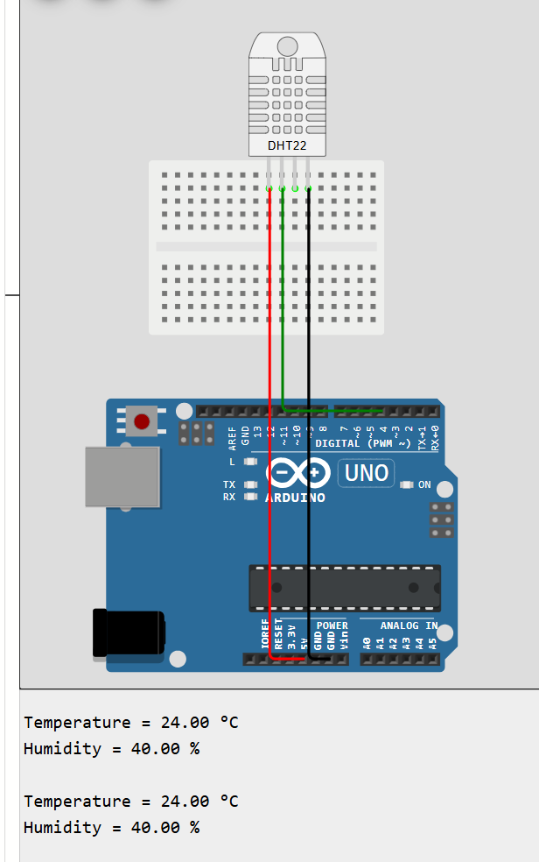**

**Working**

**Sensor Operation:**

The DHT sensor measures temperature and humidity and sends this data to the Arduino as a digital signal. The Arduino processes this signal and uses the DHT library to interpret the data.

**Arduino Code Operation:**

The code initializes the sensor and reads temperature and humidity values every 2 seconds. It then prints these values to the Serial Monitor. If the sensor fails to read data, an error message is displayed.

**Conclusion**

The lab showed how to connect a DHT11 or DHT22 sensor to an Arduino and read temperature values. Students learned to hook up the sensor, install the required library, and write simple code to display readings on the Serial Monitor. This helped everyone understand how to use sensors and collect data with Arduino.