# Innovations

* As one of the extras I have made style style sheets for the add and list pages.

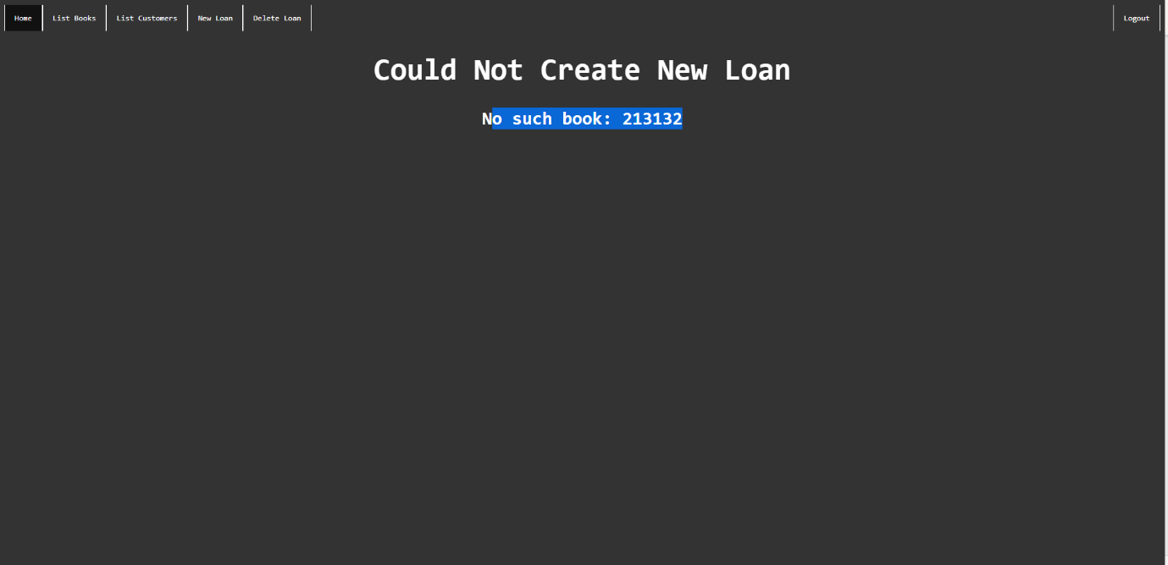

* I have also done a test plan to ensure that there are no bugs when using the entire application

