**Purpose**

To automate the group changes when a “Perforce Request for Integration Token” is approved or rescinded.

**Document History**

06/09/2015 – Benjamin Mayeux – Initial specification

07/06/2015 – Benjamin Mayeux – Updated to remove Outlook dependency

07/01/2016 – Aaron Iniguez – Updated to the new SharePoint token request website

**Introduction**

**Summary**

An employee goes to the SharePoint website located at

<https://spirent1.sharepoint.com/sites/cip/stcrelplan/Lists/Perforce%20Mainline%20Token/AllItems.aspx>

He can then add a new token.

Given this change to the Perforce SharePoint list, the software must automatically update group settings for a specified branch on P4Admin to grant sufficient permissions according to the token. If the token request is a request to be added to the group of a branch, an email will be automatically sent to the manager asking for permission to be added to the group.

All of the python files will be run on the Jenkins server located at

<http://jenkins-devops.cal.ci.spirentcom.com:8080/job/token_automation>

The python files get the data from the SharePoint site though an API located at

<http://srs.spirent.com/STCRelPlan/>

Which returns a json file of all the token requests

**Issues**

Input validation – Since the Users column is not standardized in the request list, it is not completely automated. The best we can do is send an error message if a username does not exist.

**Feature Specification**

* **Supportability**
  + Logging keeps track every time the file setP4Permissions.py with time/date/and argument variables
  + On failure, software sends an error email specifying what went wrong
* **Polling**
  + The software is triggered on a change to the SharePoint list
  + Once triggered, the change is processed and perforce is updated accordingly
* **Token Processing**
  + Relevant information is extracted from SharePoint
  + The process pipes this information to P4Admin to change permissions
* **Notification**
  + After completion, the software notifies the token’s user and any other specified user
  + If it is a request for a restricted branch, a query must be sent to the current administrator (TBA) before approval is set

**Typical use cases**

Update branches:

When a branch name is changed, all that must be done is adding a line to the branches.txt file ***Do not delete any entries unless the branches are deleted on Sharepoint and the database has been cleaned of any references.***

Restrict branch: simply find the branch in branches.txt and change the ‘n’ at the end of the line to an ‘r’.

Un-restrict a branch: simply find the branch in branches.txt and change the ‘r’ at the end of the line to an ‘n’.

Add a branch: add a line in the following format

“[list_name] [perforce_branch_name] [‘r’|’n’]”

r for restricted and n for not restricted

Change a branch: ***Important: do not just change the list_name of a branch. You must create a new entry with the new list name and point it to the perforce branch.***

To change a branch, simply update the perforce_branch_name in the entry.

Example for changing a list_name:

If branches.txt reads:

List_1 perforce_branch_1 r

And you want to change the name of perforce_branch_1 on sharepoint, you must add an entry that reads:

New_List_1 perforce_branch_1 r

You must keep the previous name in there for legacy compatability.

In the end, branches.txt must read

List_1 perforce_branch_1 r

New_List_1 perforce_branch_1 r

Add notification email address:

Open the emails table in the tokenrequests database at smarttestdb.cal.ci.spirentcom.com and add an entry with the requested email along with whether or not the email belongs to a manager.

Example:

<postgresql>

INSERT INTO emails VALUES

(‘email1@spirent.com’, False)

</postgresql>

Script calls:

**update**

Use: “python setP4Permissions update”

Effect:

The software will poll the latest entries in the list since [lastUpdate] and set [lastUpdate] to the current time. it will then take these entries and set their permissions on perforce if there is not a restricted branch requested. If there is, the software will send a parameterized link to a Jenkins job to approve the restricted request to the acting manager. Finally, the software will update the token database.

**addRestricted**

Use: “python setP4Permissions addRestricted [user] [created] [branch]”

Effect:

The software will pull the most recent token matching [created] from the tokenrequests database. If the parameters of user or branch do not match, the request is ignored as it is, most likely, somebody trying to give themselves access. If they do match, the user is given access to [branch] and notification emails are sent out.

**buildDB**

Use: “python setP4Permissions buildDB”

Pulls top 250 entries in the SharePoint list and builds a database from them and submits to tokenrequests database

**refreshToken**

use: “python setP4Permissions refreshToken [created]”

manually re-processes the token specified by [created]

**dumpStats**

use: “python setP4Permissions dumpStats”

provides a simple data dump of the tokenrequests database to stdout

**Component Interactions**

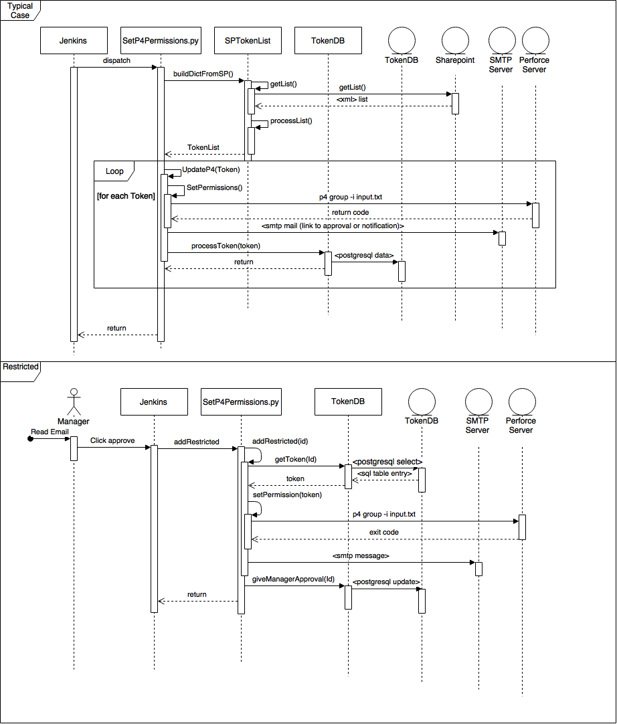

**Resources and Generated Files**

TokenDB.py:

Python interface to the tokenrequests database

SPTokenList.py

Python interface to the Sharepoint Perforce Request for Integration list

lastUpdate:

Generated timestamp file. Only list entries newer than this timestamp will be processed

branches.txt:

Translation document for converting Sharepoint branch name to p4 branch name. Do not delete any entries unless the branches are deleted on Sharepoint and the database has been cleaned of any references.

entry format:

“[list_name] [perforce_branch_name] [‘r’|’n’]”

r for restricted and n for not restricted

input.txt

Generated file that pipes into p4 command to update a p4 group

tokenrequests:

postgresql database for keeping track of token requests.

smtdb-test.cal.ci.spirentcom.com:5432

Perforce Request for Integration Token List:

[*https://spirent1.sharepoint.com/sites/cip/stcrelplan/Lists/Perforce%20Mainline%20Token/AllItems.aspx*](https://spirent1.sharepoint.com/sites/cip/stcrelplan/Lists/Perforce%20Mainline%20Token/AllItems.aspx)

perforce server:

main perforce server

perforce.spirentcom.com