Course: CCE106L Applications Development and Emerging Technologies
Project: Store POS
Selected Resource: Stores
Test Date: August 29, 2026 (Asia/Manila)

Selected Resource
Stores was selected because the existing superadmin API already provided list, detail, create, and update operations. A protected DELETE route completed the CRUD set.

REST Endpoints
Method | Endpoint | Purpose | Status
GET | /v1/superadmin/stores | Retrieve all stores | 200
GET | /v1/superadmin/stores/{storeId} | Retrieve one store | 200 / 404
POST | /v1/superadmin/stores | Create a store and owner | 201
PATCH | /v1/superadmin/stores/{storeId}/status | Activate or deactivate a store | 200
DELETE | /v1/superadmin/stores/{storeId} | Delete an inactive, empty store | 200 / 404 / 409
All routes are protected by session authentication and the superadmin role guard.

How the API Meets the Requirements
Database connection. The NestJS API uses the pg pool and configured DATABASE_URL to read and write PostgreSQL records.
JSON data. POST and PATCH accept JSON bodies; the tested CRUD and error responses are JSON.
Correct HTTP methods. GET retrieves, POST creates, PATCH updates, and DELETE removes an inactive empty store.
Missing-record handling. Requesting the deleted UUID returns HTTP 404 with the JSON message “Store not found”.
Authorization and safety. All routes require a superadmin; DELETE returns 409 for active or nonempty stores.

Test 1: GET all stores
HTTP 200 The list response included the newly created temporary store.
Figure 1. Retrieve all stores - live API-console request and JSON response.
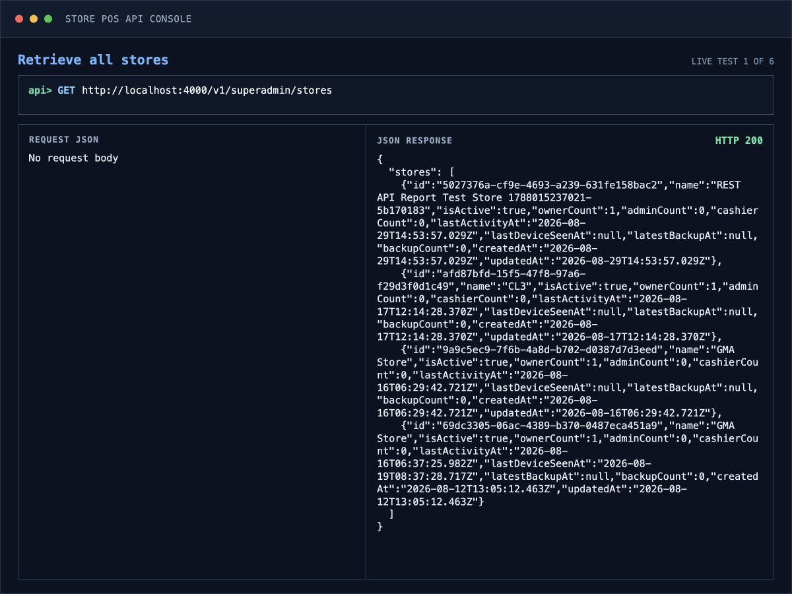

Test 2: GET store by ID
HTTP 200 The API returned the selected store and its owner record.
Figure 2. Retrieve one store by ID - live API-console request and JSON response.
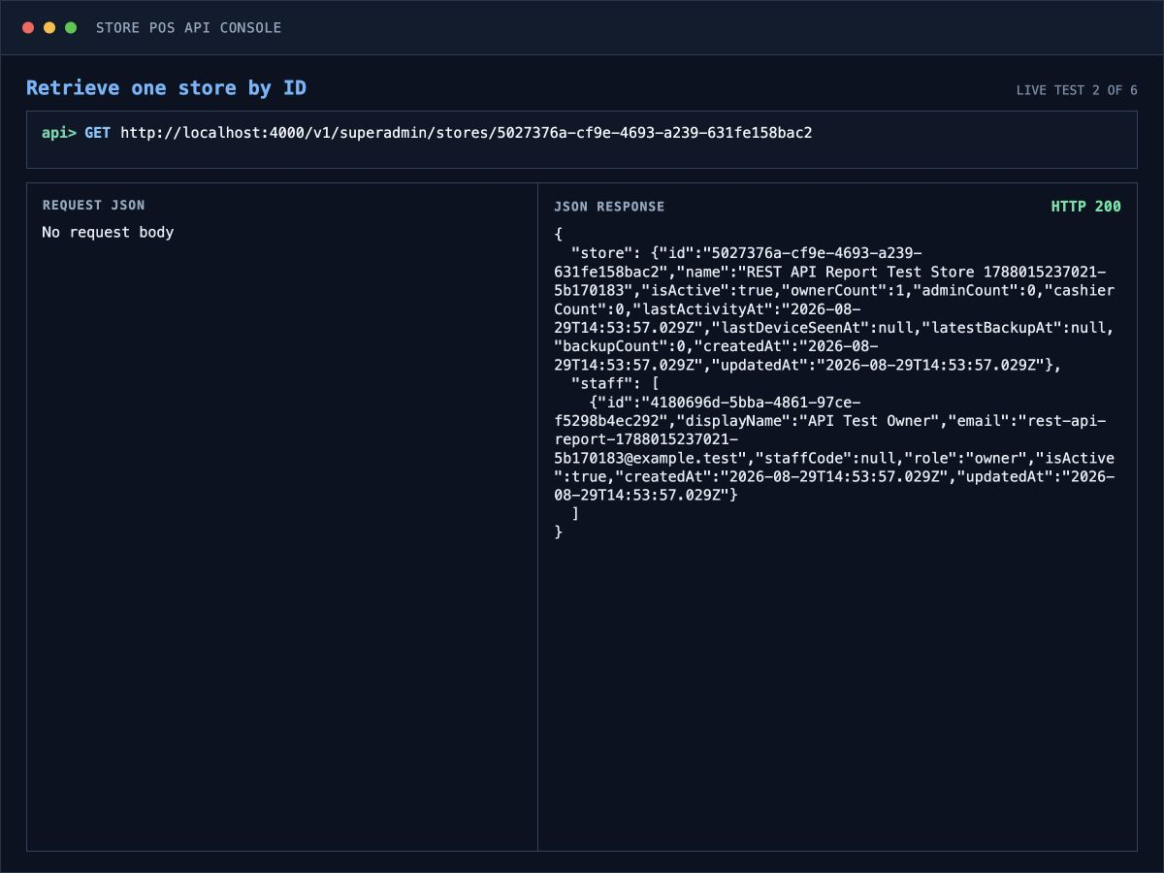

Test 3: POST create store
HTTP 201 A unique temporary store and owner were created. The disposable password is redacted in the evidence view.
Figure 3. Create a new store - live API-console request and JSON response.
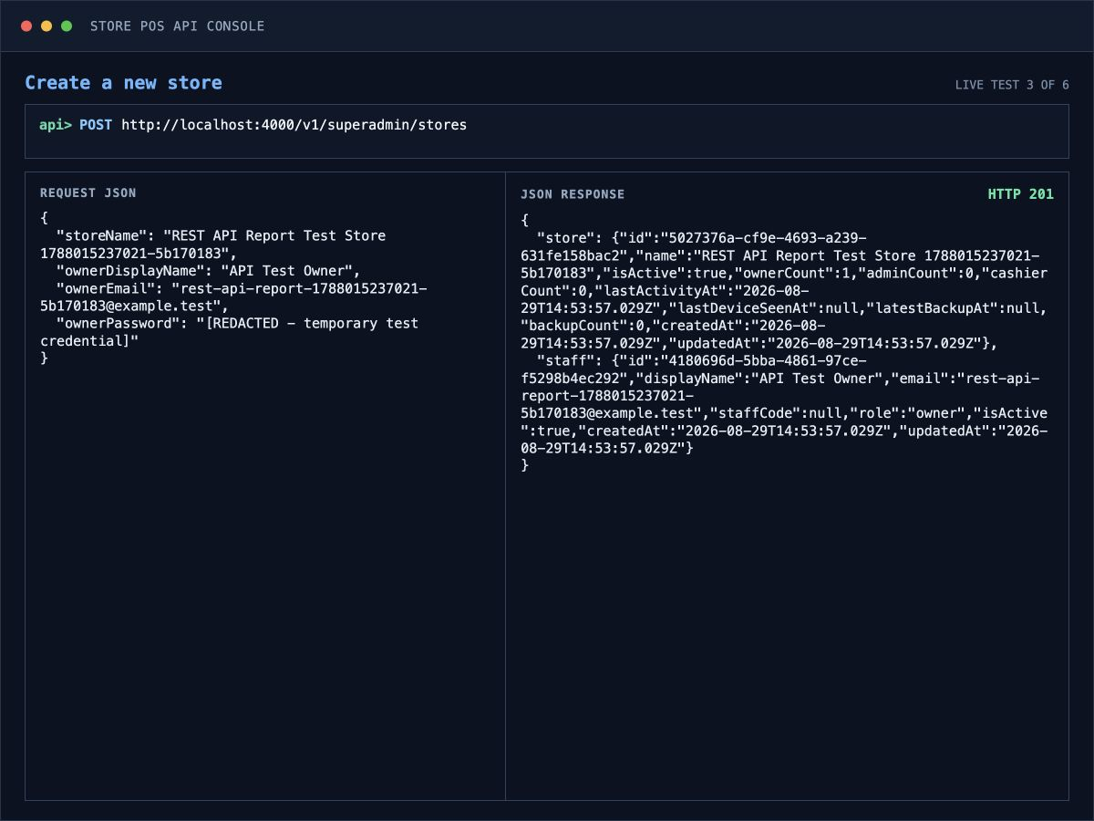

Test 4: PATCH update store status
HTTP 200 The JSON request set isActive to false and the response confirmed the updated state.
Figure 4. Update the store status - live API-console request and JSON response.
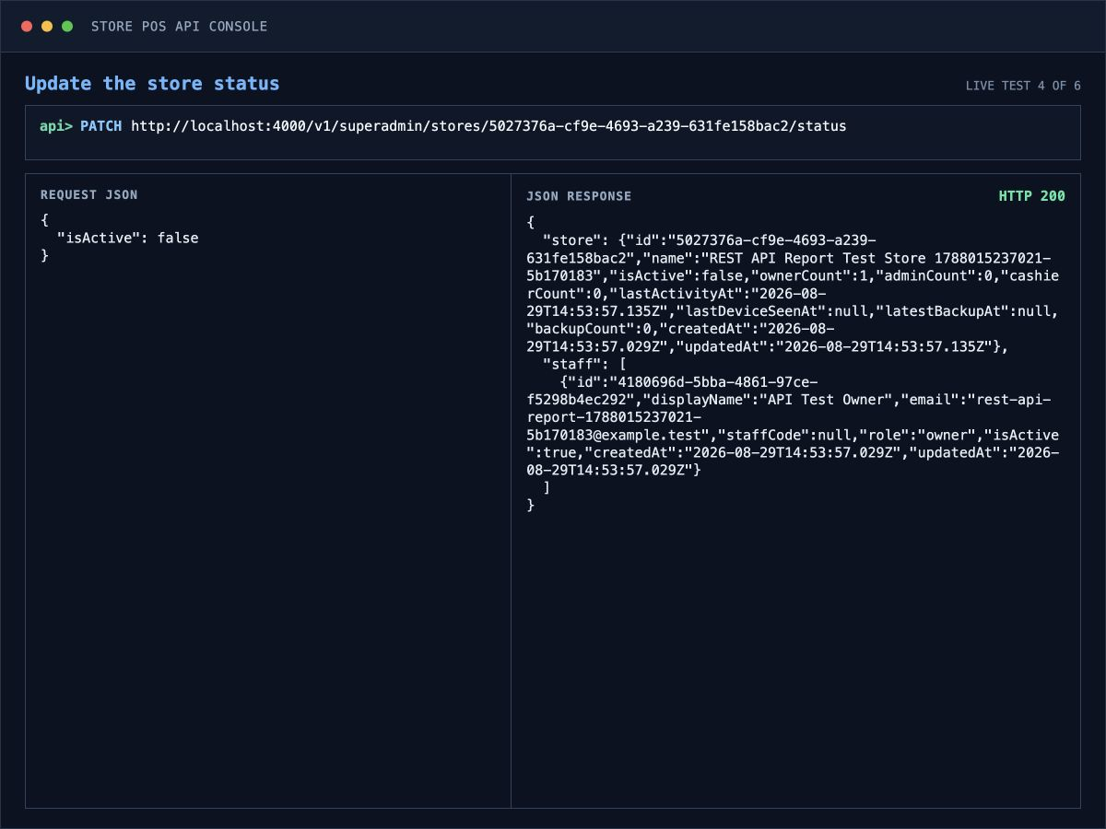

Test 5: DELETE delete store
HTTP 200 The inactive, empty test store was removed and the response confirmed its UUID.
Figure 5. Delete the inactive empty store - live API-console request and JSON response.
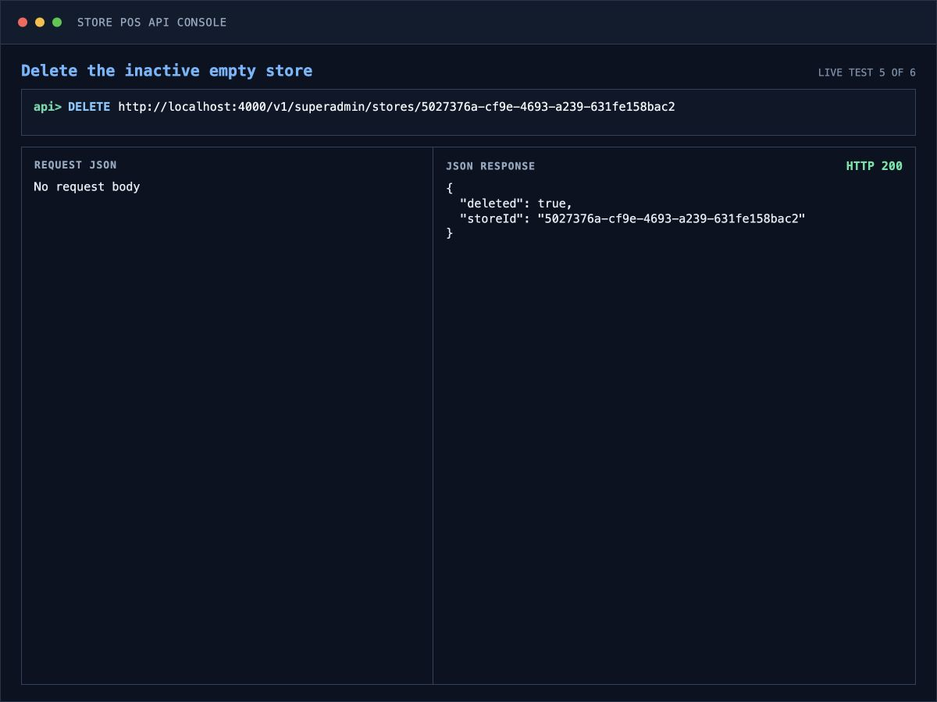

Test 6: GET deleted store by ID
HTTP 404 The same UUID correctly returned HTTP 404 with a JSON error response.
Figure 6. Request the deleted store - live API-console request and JSON response.
