
IQueue
Smart boarding intelligence for inter-provincial transport

A. Business Identity
Inter-provincial bus terminals are high-volume public spaces where small operational failures quickly become visible passenger problems. Demand is often planned reactively, producing crowded gates, rushed dispatch decisions and uneven use of available buses. At the passenger level, manual or fragmented seat assignment can enable seat hoarding, split families and create avoidable boarding disputes. Paper tickets and online-only validation slow gate work when connectivity is weak, while language barriers make schedule changes and boarding instructions harder to understand.
IQueue is an independent business-to-business software-as-a-service venture designed for bus operators and terminal authorities. The platform connects four operating functions that are commonly handled in separate tools: seven-day demand forecasting, explainable seat allocation, cryptographically signed QR boarding passes that can be checked offline, and multilingual passenger assistance in Filipino, Bahasa Indonesia, Vietnamese and English. The result is one operating flow from demand visibility and capacity preparation to seat assignment, timed gate arrival and boarding verification.
For operators, the product is intended to turn advance demand signals into practical decisions: when to add capacity, which departures need attention and how boarding windows can distribute passenger arrivals. The seat engine applies explicit rules for accessibility, family grouping and stated preferences, while keeping staff in control of exceptions. At the gate, the signed boarding token supports verification without depending on a continuous network connection. Passenger assistance extends the same operational information through a conversational interface.
Paying customers are expected to be inter-provincial bus operators and terminal authorities that need a configurable layer above their existing ticketing, dispatch and gate processes. A fleet-based subscription and one-time implementation fee align pricing with operating scale, while pilot onboarding can begin with a single terminal, selected routes and a defined evidence plan before expansion.
CURRENT STAGE IQueue is a functional pre-pilot prototype. Current demonstrations, benchmarks and operating scenarios use synthetic or simulated data; they are not measured terminal outcomes. The next evidence step is a paid operator pilot using consented operational data and independently reviewable success criteria.

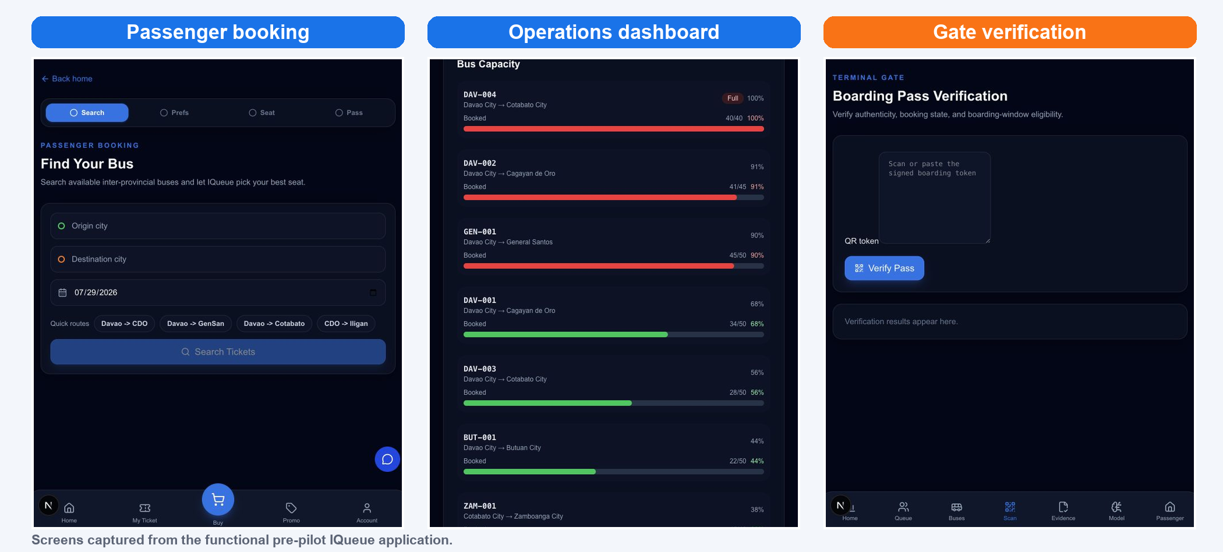
Figure 1. IQueue Smart Boarding Platform. Functional pre-pilot interface; displayed operating data are prototype examples.

B. Business Highlights

Unique Value Proposition
IQueue’s principal advantage is not a single prediction or automated rule; it is the unified, human-governed workflow connecting preparation, booking and boarding. Forecasts are translated into route-level recommendations that staff may accept, modify or reject. Seat allocation follows visible constraints and preference rules instead of relying on an unexplained outcome. Boarding passes carry signed route, passenger, seat and time-window information so authorized personnel can verify integrity even during intermittent connectivity.
This approach reduces integration burden for early customers and preserves operational accountability. It also gives a pilot partner one coherent evidence trail for forecasts, staff decisions, seat outcomes and gate checks. Offline verification and multilingual assistance address practical conditions that generic reservation products may not treat as core design requirements.

Market Opportunity and Competitive Edge
The Philippine Statistics Authority’s 2024 Annual Survey of Philippine Business and Industry reported 257 formal establishments and 30,483 workers in the bus-transport segment. These figures establish a broad operating context—not an immediately addressable sales pipeline. IQueue’s serviceable entry market will be narrower: operators and terminal authorities with sufficient route volume, management readiness, compatible processes and willingness to run a structured paid pilot.
Initial adoption will focus on the Philippines, where product fit can be tested against local employment rules, privacy obligations, connectivity constraints and terminal workflows. Commercial entry is expected through a limited-route pilot, followed by fleet or terminal expansion when agreed service, reliability and passenger-experience thresholds are met. Published bus-platform offerings provide useful pricing references, but IQueue’s proposed tiers remain planning assumptions pending customer interviews and procurement validation.
ASEAN expansion is a second-stage option rather than a launch claim. Expansion decisions should be evidence-led, beginning with markets where inter-provincial bus networks, language coverage and offline gate requirements resemble validated Philippine use cases. The competitive edge will depend on demonstrable integration speed, staff acceptance, security, forecast usefulness and reliable boarding under real operating conditions—not on prototype simulations alone.

Management and Key Team Members
Aaron Jalapon, Project and Technical Lead, directs product strategy, architecture, model integration, security and pilot delivery. Robert Jhon D. Aracena, Software Development Lead, leads application engineering, testing, deployment and production reliability. Hazel Mae B. Fuerzas, Marketing Lead, owns customer discovery, positioning, operator outreach, onboarding communications and market feedback. Ana Mae M. Viduya, Finance Lead, manages budgeting, pricing analysis, unit economics, compliance planning and investor reporting. Together, the team covers product, engineering, commercialization and financial control while keeping pilot decisions accountable to operator evidence.

Financial Snapshot
YEAR 1 | YEAR 2 | YEAR 3
₱1.5M | ₱4.5M | ₱12.0M
IQueue’s preliminary funding requirement is approximately ₱4.0 million for an 18-month runway. The working pricing architecture has three fleet-based tiers: Starter at about ₱15,000 per month plus ₱100,000 setup; Growth at about ₱25,000 per month plus ₱150,000 setup; and Large Operator at about ₱35,000 per month plus ₱200,000 setup. The projection uses a blended planning value of ₱25,000 monthly recurring revenue and ₱150,000 setup revenue per operator.
Assuming 5, 15 and 40 paying operators at the end of Years 1, 2 and 3, with newly acquired customers contributing an average of six months of subscription revenue in their acquisition year, projected gross revenue is approximately ₱1.5 million, ₱4.5 million and ₱12.0 million respectively. The model targets operating break-even in late Year 2 and a positive annual operating position in Year 3. These figures are planning assumptions, not historical results, contracted revenue, valuations or guaranteed returns.
The runway assumes monthly base salaries of ₱45,000 for each developer, ₱30,000 for marketing and ₱35,000 for finance, together with 13th-month pay and employer contributions. Capital is intended to support four full-time team members, statutory employment costs, product hardening, cloud services, pilot equipment, operator onboarding, security and privacy work, marketing, travel, administration and working capital. At this funding level, non-payroll spending must be tightly phased and any scale-up should follow paid-pilot evidence and verified sales timing.

Socio-Economic Impact
If validated in live terminals, IQueue can support safer and more orderly boarding through assigned windows, clearer seat rules and faster authenticity checks. Accessibility constraints and family grouping can be made explicit, while multilingual assistance and offline verification broaden access for passengers with different languages or unreliable connectivity. For operators and terminal authorities, better demand visibility can support congestion management, service planning and new operational roles in onboarding, data stewardship and customer support.
The intended contribution aligns with SDGs 8, 9, 10, 11 and 16 through productive digital work, resilient transport infrastructure, reduced access barriers, more orderly cities and accountable operating decisions. These are intended pathways, not measured impact claims. The immediate milestone is a paid operator pilot that enables real operational-data collection, external validation and production hardening before broader deployment.
Sources and planning assumptions
Market context: PSA 2024 ASPBI. Statutory-cost benchmarks: SSS, PhilHealth, Pag-IBIG and DOLE. Pricing comparisons: Busae, RIDEO and Trublo. Infrastructure and foreign-exchange references: Azure, Vercel, Hugging Face and BSP. Revenue arithmetic: Y1 = 5 new operators × (₱150,000 setup + 6 × ₱25,000 monthly); Y2 = 5 retained × 12 × ₱25,000 + 10 new × (₱150,000 + 6 × ₱25,000); Y3 = 15 retained × 12 × ₱25,000 + 25 new × (₱150,000 + 6 × ₱25,000). All prices, contribution rates, exchange rates, customer timing and operating costs must be refreshed during diligence.

