[TO COMPLETE - Owner: Aaron | Required evidence: Official BIDA 2026 and PCCI logo files approved for use | Due: August 28, 2026]

BIDA 2026 BUSINESS PLAN
Technology Category
A business-to-business smart boarding service for bus operators and terminal authorities
Presented by
Aaron Jalapon
John Benedict J. Bongcac
Hazel Mae B. Fuerzas
Ana Mae M. Viduya
University of Mindanao

Faculty adviser: Clyde Abner Valdez, MBA, REB
Submission date: August 31, 2026
DRAFT STATUS
Highlighted yellow tags mark evidence or approvals that the team must complete before submission.

Table of Contents

I. Executive Summary 4
II. Market Analysis and Strategy 7
III. Operations and Production Plan 15
IV. Organizational Plan 22
V. Financial Plan 28
References 36
Annexes 38
Update all fields in Microsoft Word before final submission so the contents page reflects final edits.

List of Figures and Tables
Figures
- TripSync passenger-to-boarding operating flow
- TripSync functional pre-pilot interface
- Three-year planning revenue trajectory
- Planned use of the PHP 4.0 million funding requirement
- Organization structure and three-year implementation roadmap
Tables
- Target-customer qualification criteria and customer needs
- Competitive landscape and defensible differences
- Ninety-day paid-pilot schedule, responsibilities, and measures
- Founder ownership, qualifications, and staged hiring
- Pricing tiers, revenue build, operating budget, cash flow, and ratios
- BIDA judging-criteria coverage matrix
Reader guide
The main body uses plain business language. Technical details and prototype evidence are placed in the annexes so the plan remains accessible to non-technical judges.

I. Executive Summary

A. Business Identity

Transportation plays a vital role in developing countries such as the Philippines. Convenience, reliability, and safety remain primary concerns for everyday commuters. Bus terminals still experience crowding, boarding disputes, and delays when passenger demand and gate processes are handled through manual or disconnected tools. Holiday travel reports show how quickly terminals can fill when passenger volume rises (GMA Integrated News, 2025a, 2025b).
TripSync is an independent business-to-business software service for bus operators and terminal authorities. It connects four operating functions that are often handled separately: seven-day demand planning, explainable seat allocation, tamper-resistant QR boarding passes that can be checked offline, and passenger assistance in Filipino, Bahasa Indonesia, Vietnamese, and English.
The result is one operating flow from early demand visibility and capacity preparation to seat assignment, timed gate arrival, and boarding verification. Staff remain in control. They may accept, change, or reject recommendations, resolve exceptions, and review the recorded basis for operational decisions.
At launch, TripSync will work as a configurable layer above an operator's existing ticketing, dispatch, and gate processes. A later full replacement for ticketing and payments will be considered only after live pilots show that customers need it and the team can support the additional regulatory and operational responsibility.
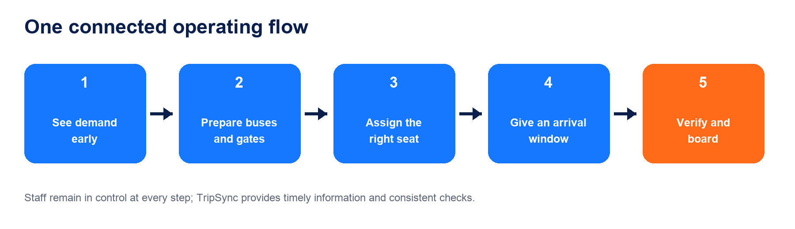
Figure 1. TripSync connects preparation, passenger service, and boarding in one staff-governed flow.

B. Business Highlights

a. Unique Value Proposition
TripSync's principal advantage is not a single prediction or automated rule. It is the unified, human-governed workflow connecting preparation, booking, and boarding. Demand signals become route-level recommendations. Seat allocation follows visible accessibility, family-grouping, and passenger-preference rules. Boarding passes carry the trip, passenger, seat, and arrival-window information needed for authorized gate staff to verify integrity during intermittent connectivity.

b. Market Opportunity and Competitive Edge
The Philippine Statistics Authority reported 257 formal establishments in the bus-transport segment in the 2024 Annual Survey of Philippine Business and Industry. This is broad industry context, not an immediate sales pipeline. TripSync's first serviceable market is narrower: operators and terminal authorities with enough route volume, management readiness, usable records, and willingness to run a structured paid pilot (PSA, 2026).
The first commercial offer is a 90-day pilot at one Mindanao terminal across three routes. The pilot is priced at PHP 225,000: PHP 150,000 for implementation and three monthly payments of PHP 25,000. It will test whether TripSync can be installed quickly, accepted by staff, and associated with more orderly boarding under agreed measures.

c. Management and Key Team Members
Aaron Jalapon, fourth-year BS Computer Science student, leads product strategy, architecture, security, and pilot delivery. John Benedict J. Bongcac, fourth-year BS Computer Science student, leads application engineering, testing, deployment, and reliability. Hazel Mae B. Fuerzas, fourth-year BSBA Marketing Management student, leads customer discovery, positioning, operator outreach, and onboarding communication. Ana Mae M. Viduya, fourth-year BSBA Financial Management student, leads budgeting, pricing, financial schedules, and compliance planning.
Clyde Abner Valdez, MBA, REB, a full-time faculty member of the University of Mindanao College of Business Administration Education, serves as faculty adviser for business-model and commercialization review.

d. Financial Snapshot
Table 1. Three-year gross-revenue planning snapshot
Year 1 | Year 2 | Year 3
PHP 1.5M | PHP 4.5M | PHP 12.0M

TripSync's preliminary funding requirement is approximately PHP 4.0 million for an 18-month runway. The working pricing architecture has three fleet-based tiers: Starter at about PHP 15,000 per month plus PHP 100,000 setup; Growth at about PHP 25,000 per month plus PHP 150,000 setup; and Large Operator at about PHP 35,000 per month plus PHP 200,000 setup.
Assuming 5, 15, and 40 paying operators at the end of Years 1, 2, and 3, and six months of subscription revenue for newly acquired customers in their acquisition year, projected gross revenue is PHP 1.5 million, PHP 4.5 million, and PHP 12.0 million. The model targets operating break-even in late Year 2 and a positive annual operating position in Year 3. These are planning assumptions, not historical results, contracted revenue, valuations, or guaranteed returns.
The funding plan combines a targeted PHP 1.0 million in grants or awards with PHP 3.0 million in angel or strategic equity. Base monthly salaries are PHP 45,000 for each technical founder, PHP 30,000 for marketing, and PHP 35,000 for finance, together with statutory employment costs and thirteenth-month pay. Non-payroll spending must be tightly phased.

e. Socio-Economic Impact and SDG Alignment
If validated in live terminals, TripSync can support safer and more orderly boarding through assigned arrival windows, clearer seat rules, and faster authenticity checks. Accessibility needs and family grouping can be made explicit. Multilingual assistance and offline checking can broaden access for passengers with different languages or unreliable connectivity.
TripSync aligns with SDGs 8, 9, 10, 11, and 16 through productive digital work, resilient transport services, reduced access barriers, more orderly cities, and accountable decisions. These are intended pathways, not measured impact claims. The immediate milestone is a paid operator pilot that enables real data collection and external validation.
Evidence boundary
TripSync is a functional pre-pilot prototype. Current operating and forecasting evidence uses synthetic data or controlled simulations and must not be presented as measured terminal impact.

II. Market Analysis and Strategy

A. Industry and Market Overview
The Philippine transport market is large, essential, and operationally varied. The 2024 ASPBI counted 3,309 formal transportation and storage establishments, including 257 establishments classified under transport via buses. The survey also reported 30,483 workers in the bus-transport segment. These figures show the size of the formal operating context but do not mean every establishment is ready or suitable for TripSync.
The stronger opportunity is created by the gap between digital ticket selling and day-of-departure coordination. Many platforms help passengers search, reserve, or pay for trips. TripSync focuses on what happens around those transactions: anticipating busy departures, applying understandable seat rules, pacing passenger arrival, and checking boarding passes even when connectivity is unstable.
The Philippine Development Plan 2023-2028 calls for digitalization in transport and logistics, improved coordination among stakeholders, and modernization of land transport terminals. TripSync fits this direction as a practical operating layer, but government alignment does not imply endorsement, procurement, or regulatory approval.
Market sizing discipline
The 257 establishments are a broad national context. TripSync will calculate its serviceable and obtainable market only after applying route-volume, readiness, data, and procurement filters.

- Broad context: 257 formal bus-transport establishments reported by PSA.
- Entry market: operators with sufficient routes, records, staff readiness, and decision authority.
- Launch geography: Mindanao, beginning with a one-terminal, three-route pilot.

Customer Problem
Passenger surges are not evenly distributed. They build around holidays, weekends, school calendars, weather disruption, and high-demand routes. Reports from Philippine terminals show hundreds of thousands of passenger movements during peak periods and passengers arriving hours ahead of departure. These examples support the need for better preparation, but TripSync will still measure each pilot terminal's own baseline.
Operators often have useful information in separate places: ticket sales, dispatch logs, passenger manifests, seat records, gate checks, and staff experience. When these sources are not connected, decisions can become reactive. Extra capacity may be prepared too late; accessibility and family requests may be handled inconsistently; and gate staff may depend on a live connection to check a ticket.
TripSync does not promise to remove every queue. Weather, road incidents, vessel availability, late buses, and passenger behavior remain outside the system's control. Its purpose is to give staff earlier visibility, a shared operating picture, and consistent checks so preventable confusion is reduced.
- Operator need: early warning and clear route-level actions.
- Frontline need: simple tools that work during busy periods and weak connectivity.
- Passenger need: understandable instructions, fair seat handling, and trustworthy boarding.

B. Target Market
TripSync's paying customer is the organization responsible for bus or terminal operations, not the individual passenger. The first target is a Mindanao bus operator managing intercity routes from a busy terminal. A terminal authority may become a second customer type after the product proves it can support more than one operator without mixing records or responsibilities.
The team will qualify prospects before proposing a pilot. A good first customer has at least three active routes, a named executive sponsor, a frontline operations lead, accessible historical records, an agreed terminal test area, and willingness to share baseline and outcome data under a written agreement.
Prospects will be declined or deferred when they cannot identify a decision-maker, cannot provide legal access to required data, expect unsupported 24-hour service, or require immediate replacement of ticketing and payments. This protects both the operator and the four-person startup team.
Table 2. First-pilot customer qualification
Qualification area | Minimum condition | Why it matters
Route activity | At least three active intercity routes | Creates a meaningful but manageable pilot
Data readiness | 12 months of route-day records | Supports seasonality review and baseline planning
Sponsor | Named executive decision-maker | Enables approvals and issue resolution
Operations owner | Named terminal or dispatch lead | Ensures daily use and feedback
Pilot commitment | One terminal and three routes | Controls delivery risk

Buyer, User, and Passenger Perspectives
The economic buyer is likely to be an owner, general manager, operations director, or terminal administrator. This person cares about service reliability, staff accountability, implementation effort, risk, and whether the pilot produces evidence that justifies expansion.
The daily users are dispatchers, gate personnel, customer-service staff, and terminal supervisors. Their acceptance is essential. A system that adds duplicate work or hides the reason for a recommendation will not be sustained, even if the underlying technology performs well.
Passengers do not purchase the software, but they experience its consequences. Their priorities include clear departure information, practical arrival instructions, fair seat handling, assistance in a familiar language, and a fast boarding check. Passenger research therefore validates service design, while operator interviews validate willingness to pay and procurement.
Table 3. Stakeholder evidence plan
Stakeholder | Decision or need | Evidence to collect
Buyer | Budget, risk, approval | Purchase process and willingness to pay
Operations staff | Usability and exception handling | Workflow observation and feedback
Passenger | Clarity, fairness, trust | Interview and short satisfaction survey

C. Competitive Landscape
TripSync competes with several categories rather than one identical product. Manual spreadsheets and messaging groups are familiar and inexpensive but provide limited traceability. Online booking platforms make ticket purchase easier. Operator platforms may combine ticketing, fleet monitoring, and reporting. Custom systems can fit one company's processes but may require long development and maintenance cycles.
Public product pages from Easybus PH, DLTB, IWantSeats, and EtiGo show that online booking, digital tickets, seat reservation, fleet information, and operator dashboards already exist in the Philippine market. TripSync therefore will not claim that digital bus booking is new. Its claim is narrower: a unified, staff-governed flow connecting seven-day preparation, visible seat rules, timed arrival, offline boarding checks, and multilingual assistance.
This difference must be proven through implementation speed, staff acceptance, reliable gate use, and decision evidence. Features alone are not a defensible barrier. Over time, operator-specific workflow knowledge, clean historical outcomes, trusted integrations, and repeatable onboarding can become stronger barriers to entry.
Table 4. Competitive categories and disciplined positioning
Alternative | Established strength | TripSync response
Manual tools | Low cost and familiar | Fragmented records and limited evidence trail
Booking platforms | Search, ticketing, payments, seat choice | May not center demand-to-gate operations
Operator suites | Ticketing, fleet, reporting | Fit and integration vary by operator
Custom software | Tailored process | Higher build and maintenance burden
TripSync | Preparation-to-boarding flow with staff control | Pre-pilot; live proof still required

Competitive Positioning
For operators, TripSync turns scattered operating information into a short list of practical actions: which departure needs attention, when extra capacity should be considered, how seat rules are applied, and when passengers should approach the gate. Staff see the recommendation and remain responsible for the final decision.
For terminal authorities, the longer-term value is a clearer view of planned passenger movement and a more consistent gate process. For passengers, the visible benefit is a calmer journey with clearer instructions and fewer avoidable disputes.
The launch message is: 'Prepare earlier. Seat fairly. Board with confidence.' The supporting promise is one connected operating flow, not autonomous dispatch. TripSync will avoid broad claims such as eliminating congestion or guaranteeing safety because these depend on many factors beyond software.
- Relevant: designed around actual bus-terminal decisions.
- Understandable: recommendations and seat rules can be explained.
- Resilient: boarding checks continue during intermittent connectivity.
- Accountable: important staff actions and outcomes can be reviewed.

D. Sales and Marketing Strategy
TripSync will use founder-led direct sales for its first five customers. Hazel will coordinate prospect research, outreach, interviews, and follow-up. Aaron will lead site assessment and product fit. John will assess integration and equipment needs. Ana will prepare the commercial offer, payment schedule, and financial review.
The first commercial offer is a 90-day Growth-tier pilot priced at PHP 225,000. The operator pays PHP 75,000 at signing, PHP 75,000 at go-live, and PHP 25,000 at the start of each pilot month. This structure shares risk, funds implementation work, and tests willingness to pay without promising a free proof of concept.
Expansion is offered only if the agreed measures, staff feedback, and reliability thresholds support it. After the pilot, the customer may continue at the applicable monthly tier, expand routes or terminals, request additional integration work, or stop without implying that the prototype failed universally.
Table 5. Paid-pilot billing schedule
Pilot charge | Timing | Amount
Implementation - first half | At signing | PHP 75,000
Implementation - second half | At go-live | PHP 75,000
Subscription | Monthly in advance x 3 | PHP 75,000
Total | 90-day pilot | PHP 225,000

Five-Interview Validation Plan
Marketing during the pre-pilot stage will emphasize evidence and education. The team will use a short demonstration, a one-page pilot brief, a site-assessment checklist, and a plain-language explanation of how TripSync fits existing operations. Claims will distinguish current prototype capability from planned production features.
Before submission, the team plans five structured interviews: three passengers, one operator decision-maker, and one dispatcher or gate staff member. Passenger interviews will explore arrival behavior, queue pain, seat expectations, language, and trust in digital boarding. Operator and staff interviews will test workflow fit, data availability, purchasing concerns, and acceptable pilot measures.
Interview findings will be reported only after the method, consent, notes, and sample are documented. With five interviews, results will be treated as directional themes rather than market-wide statistics.
[TO COMPLETE - Owner: Hazel | Required evidence: Five completed interview records, consent notes, respondent profile summary, and directional findings | Due: August 28, 2026]
[TO COMPLETE - Owner: Hazel and Aaron | Required evidence: Named operator prospect list and documented outreach status | Due: August 28, 2026]

III. Operations and Production Plan

A. Operations Model
TripSync is delivered as a subscription service with a one-time implementation project. The operator continues to own and control its operational records. TripSync receives only the information required for the agreed functions and presents authorized staff with a shared view of preparation, seating, passenger guidance, and boarding.
The workflow begins before queues form. Seven-day demand planning highlights departures that may need attention. Staff decide whether to prepare an extra bus, open a lane, adjust a boarding window, or take no action. Booking and passenger preferences then feed visible seat rules. At the gate, the boarding pass is checked against its signed details and allowed time window, including when the internet connection is temporarily unavailable.
The product is not an autonomous dispatcher. It does not issue a bus franchise, set regulated fares, control road conditions, or replace the legal responsibility of the operator and terminal staff.

Figure 2. Passenger-to-boarding flow in plain language

Prototype Capabilities and Readiness Boundary
The working prototype is derived from the student-built IQueue architecture. It includes passenger booking screens, an operator capacity view, explainable seat recommendations, boarding-pass generation and checking, demand-planning models, an evidence view, and a multilingual passenger assistant.
Current demonstrations use synthetic route and passenger records. The project evidence separates controlled simulations, model test results, and operational claims. This is a strength because it makes uncertainty visible; it is also a reminder that field performance has not yet been established.
Before a paid pilot, the system needs production authentication, stronger separation between operator accounts, key management for gate devices, privacy and retention rules, backup and monitoring, support procedures, and integration testing with the partner's actual data format.
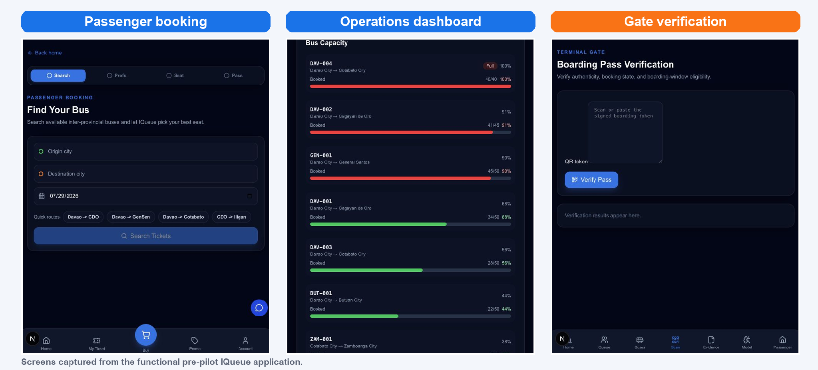
Figure 3. Current functional prototype; displayed operating data are examples
[TO COMPLETE - Owner: John | Required evidence: TripSync-rebranded passenger, operator, and gate screenshots for final submission | Due: August 29, 2026]

B. Location and Facilities
TripSync's core team can work from the University of Mindanao or an approved startup workspace during the pre-incorporation stage. The product is hosted online, while authorized gate devices keep the information needed to check boarding passes during temporary loss of connectivity.
The pilot partner supplies access to the terminal, designated work areas, operational staff, existing scanners or compatible phones where available, and safe access for observation. TripSync supplies configuration, training, setup documentation, agreed test devices, remote monitoring, and escalation support.
Support covers agreed departure windows rather than an unsupported 24/7 promise. Urgent boarding or security issues receive immediate escalation during covered windows. Routine requests are acknowledged by the next business day. Final service levels will be written into the pilot agreement.
Table 6. Pilot responsibility split
Responsibility | TripSync | Pilot partner
Data and access | Provide secure import method | Provide lawful records and named owners
Equipment | Supply agreed test devices | Provide terminal power, space, and existing devices
Training | Prepare and deliver role-based sessions | Release staff and enforce attendance
Support | Cover agreed departure windows | Use escalation path and document incidents

C. Resource Needs
The first pilot covers one terminal, three routes, and a controlled number of buses and staff accounts. Scope is intentionally limited so the four-person team can observe use, respond to issues, and produce credible evidence. Adding routes or terminals during the 90 days requires written agreement and a revised support plan.
The operator provides at least 12 months of route-day passenger totals, schedules, capacity, dispatch outcomes, and relevant holiday or disruption notes. TripSync begins with secure scheduled file exchange and adds a direct connection only where the operator's system is ready. No direct payment integration is required for the first pilot.
A two-week observed baseline records queue time, passenger arrival patterns, gate-check time, missed boarding, staffing, service disruptions, and accessibility exceptions. The baseline method must remain the same during the comparison period.
Table 7. Minimum pilot data package
Data group | Minimum input | Purpose
Route demand | 12 months of daily passenger totals | Seasonality and demand planning
Service plan | Schedules, capacity, assigned buses | Operational recommendations
Boarding | Arrival, scan, queue, missed boarding | Baseline and pilot comparison
Context | Holidays, closures, disruptions | Explain unusual demand

[TO COMPLETE - Owner: Aaron | Required evidence: Operator-approved data dictionary and sample anonymized export | Due: Before pilot contracting]

Privacy, Security, and Reliability
TripSync will follow the Data Privacy Act of 2012 and conduct a privacy impact assessment before processing real passenger information. The pilot agreement will define purpose, lawful basis, data fields, access, retention, deletion, incident handling, and the responsibilities of TripSync and the operator.
Access will be based on staff role. Operator records will be kept separate. Sensitive configuration values will not be stored in public code. Gate devices will be registered and keys will be rotated or revoked when a device is lost, replaced, or reassigned.
Reliability will be supported through backups, health checks, monitoring, incident logs, and a tested recovery procedure. Offline boarding is a resilience feature, not a substitute for all network-dependent functions. Changes made offline must be reconciled when connection returns.
[TO COMPLETE - Owner: Aaron and UM representative | Required evidence: Privacy impact assessment, data-sharing terms, retention schedule, and incident contacts | Due: Before any live passenger data]

D. Implementation Schedule and Cost
The pilot has four controlled phases. Discovery confirms decision rights, data, privacy, terminal layout, and measures. Configuration maps routes, seats, gates, users, and existing ticket fields. Controlled live use starts with selected departures before broader pilot operation. Evaluation compares results with the agreed baseline and records staff and passenger feedback.
The primary outcome target is at least a 20 percent reduction in the terminal's p95 wait time against the two-week baseline. Supporting thresholds are at least 95 percent successful checks of valid passes and zero accessibility-rule violations caused by the seat process. These are pilot targets, not guaranteed commercial outcomes.
Table 8. Ninety-day paid-pilot schedule
Phase | Days | Main work | Exit evidence
1. Discovery | 1-15 | Site, data, privacy, baseline design | Signed scope and measurement plan
2. Configure | 16-30 | Routes, seats, users, training | Readiness checklist passed
3. Controlled use | 31-75 | Selected departures, support, fixes | Stable operating logs
4. Evaluate | 76-90 | Comparison, interviews, decision | Pilot report and rollout decision

Costs, Risks, and Sustainability Commitments
The pilot requires four founders, the operator sponsor, operations and IT contacts, selected gate and dispatch staff, secure hosting, test devices, staff training time, travel, and privacy or legal review. Implementation costs are recovered through the PHP 150,000 setup component, while the subscription supports hosting, monitoring, support, and continuous improvement.
TripSync will measure sustainability rather than promise unverified environmental savings. The pilot can record paper tickets avoided, occupancy, additional or unnecessary dispatches, and observed idling around boarding. Any conversion to emissions estimates requires an agreed method and operator data.
The main risks are unavailable or poor-quality data, staff resistance, delayed procurement, weak connectivity, security incidents, scope expansion, and failure to show measurable benefit. The operating plan uses qualification, staged rollout, clear decision rights, offline checking, backups, and a written exit process to reduce these risks.
Table 9. Pilot operating-risk register
Risk | Likelihood | Impact | Primary response
Insufficient data | Medium | High | Qualification and sample-data review
Staff adoption | Medium | High | Co-design, training, visible override
Connectivity | High | Medium | Offline gate check and reconciliation
Scope growth | Medium | High | Written change control
Security/privacy event | Low | High | Access control, device management, response plan

[TO COMPLETE - Owner: Ana | Required evidence: Supplier quotations for hosting, security review, pilot devices, travel, and legal/privacy advice | Due: August 29, 2026]

IV. Organizational Plan

A. Legal and Ownership Structure
TripSync plans to form a Philippine stock corporation under the Revised Corporation Code. The founders' provisional pre-financing ownership is Aaron Jalapon 35 percent, John Benedict J. Bongcac 30 percent, Hazel Mae B. Fuerzas 20 percent, and Ana Mae M. Viduya 15 percent. Final shares, vesting, voting, and transfer restrictions require written founder and legal review.
BIDA mechanics state that the business ideas and prototypes remain properties of the students and the school they represent. The plan therefore does not claim exclusive founder ownership. Before commercial operation or outside investment, the founders and University of Mindanao must document whether the corporation receives an assignment, license, or other authorized right to use and develop the relevant intellectual property.
The corporation will also need SEC registration, tax registration, local permits, contracts, privacy documentation, employment registrations, and applicable transport-partner approvals. TripSync itself does not operate buses or claim a transport franchise.
Table 10. Provisional pre-financing founder ownership
Founder | Role | Provisional share
Aaron Jalapon | Project and Technical Lead | 35%
John Benedict J. Bongcac | Software Development Lead | 30%
Hazel Mae B. Fuerzas | Marketing Lead | 20%
Ana Mae M. Viduya | Finance Lead | 15%

[TO COMPLETE - Owner: Aaron and UM authorized representative | Required evidence: Written IP ownership, licensing or assignment terms consistent with BIDA mechanics | Due: Before incorporation or investment]

B. Organizational Chart and Key Roles
The founding structure combines technical delivery with marketing and financial control. Aaron coordinates product decisions and pilot accountability. John owns software delivery and reliability. Hazel owns customer discovery, sales communication, and adoption. Ana owns budgeting, pricing, controls, and reporting.
Decisions affecting passenger safety, privacy, legal commitments, large spending, or changes in pilot scope require documented founder review. Day-to-day work remains with the role owner so the team can move quickly without losing accountability.
During the first pilot, the team will use a simple weekly operating review covering product readiness, customer issues, data quality, financial position, risks, and evidence collection.
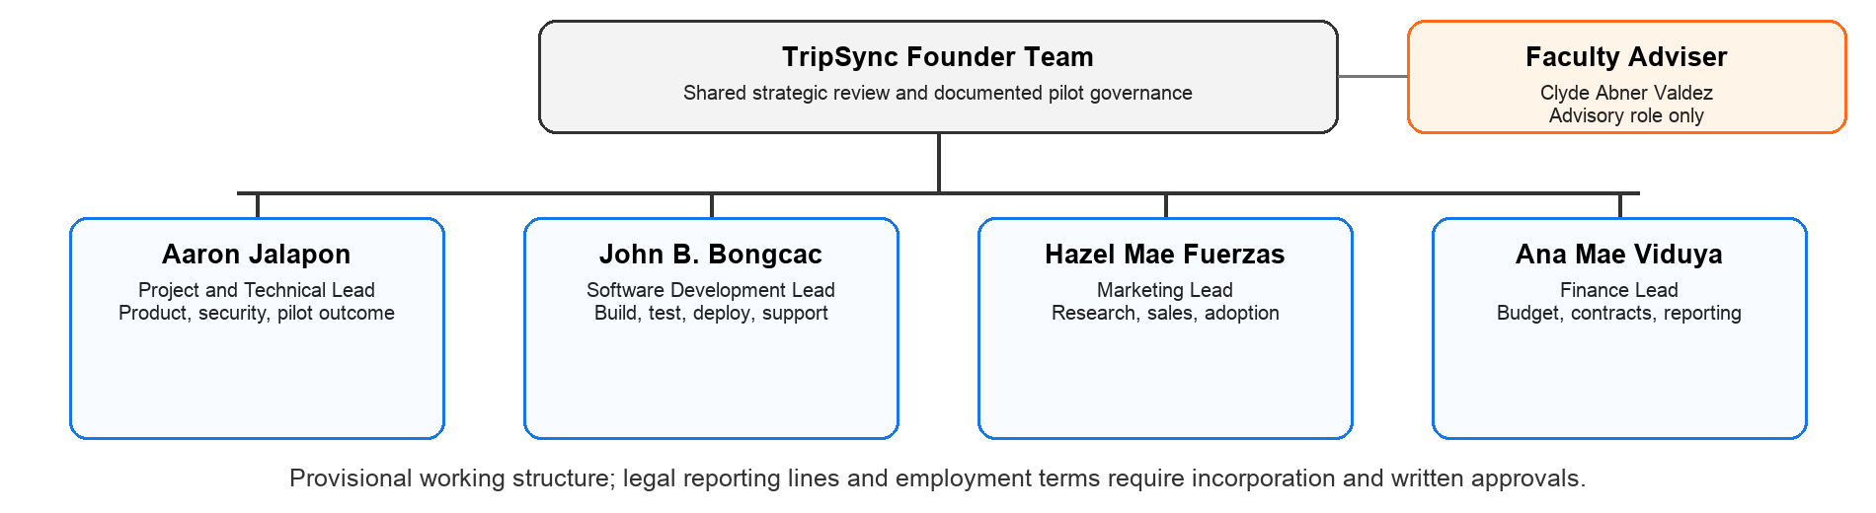
Figure 4. Planned organizational chart; the adviser provides guidance but is not a company officer
Table 11. Founder accountability map
Role owner | Primary accountability | Key evidence
Aaron | Product, security, pilot outcome | Scope, decision log, readiness review
John | Build, test, deploy, support | Release and incident records
Hazel | Discovery, sales, adoption | Interview, pipeline, onboarding records
Ana | Budget, contracts, reporting | Cash forecast, controls, schedules

C. Management Team Qualifications
Aaron Jalapon is a fourth-year Bachelor of Science in Computer Science student. His academic preparation supports software architecture, data systems, model integration, security thinking, and technical project leadership. In TripSync, these capabilities are applied under adviser and partner oversight; the plan does not present him as a licensed transport or cybersecurity professional.
John Benedict J. Bongcac is a fourth-year Bachelor of Science in Computer Science student. His preparation supports application development, testing, deployment, troubleshooting, and production reliability. He leads implementation quality and technical support for the pilot.
Hazel Mae B. Fuerzas is a fourth-year Bachelor of Science in Business Administration student majoring in Marketing Management. Her preparation supports customer research, segmentation, positioning, communication, relationship development, and onboarding materials.
Ana Mae M. Viduya is a fourth-year Bachelor of Science in Business Administration student majoring in Financial Management. Her preparation supports budgeting, pricing analysis, cash planning, financial schedules, controls, and investor or grant reporting.
[TO COMPLETE - Owner: All founders | Required evidence: One-page CV for each founder, including education, relevant projects, competitions, training, and verifiable achievements | Due: August 29, 2026]

Adviser and Governance
Clyde Abner Valdez, MBA, REB, is identified by the University of Mindanao as a full-time faculty member in the College of Business Administration Education. His proposed role is to review the business model, market evidence, commercialization logic, and presentation readiness. The plan does not imply a corporate board seat or equity unless separately agreed.
Administrative work includes meeting records, contracts, procurement, payroll, statutory contributions, tax records, data-processing records, customer support logs, and evidence files. The finance lead maintains a monthly closing checklist and cash forecast; the technical leads maintain release, incident, and access records.
External advisers will be engaged as needed for Philippine corporate law, data privacy, employment, transport operations, and security. Student status and academic credentials do not replace professional advice in these areas.
[TO COMPLETE - Owner: Hazel | Required evidence: Written permission from Professor Valdez to name him and state his agreed advisory contribution | Due: August 28, 2026]

D. Timeline of Key Activities
The roadmap moves from compliance and pilot evidence to repeatable delivery and then controlled scale. Each stage has an evidence gate. The team will not enter a new geography or offer a complete ticketing replacement merely because it appears on a calendar.
Year 1 focuses on incorporation readiness, IP permission, privacy, production hardening, five customer wins, and at least one completed paid pilot. Year 2 standardizes integrations and onboarding, adds two delivery roles, and reaches fifteen customers. Year 3 reaches forty customers only if service quality, cash, and team capacity remain healthy.
Table 12. Three-year implementation roadmap
Activity | Y1 H1 | Y1 H2 | Y2 | Y3
IP, legal, privacy | Complete | Maintain | Review | Review
Production hardening | Build | Validate | Improve | Scale
Paid pilots | Prepare | 1-5 | Repeat | Repeat
Customers | 0-2 | 5 | 15 | 40
Team | 4 founders | 4 founders | +2 roles | +4 roles
Full replacement option | No | Research | Gate decision | Only if proven

E. Administrative and Operating Expenses
The four founders remain the Year 1 core. Hiring is tied to paying customers rather than optimistic dates. After the first five customers and evidence of recurring implementation demand, Year 2 adds an implementation/customer-success role and a support or data-operations role. Year 3 may add sales, implementation engineering, customer support, and operations/security capability.
Every new role must have a defined customer or risk outcome. Implementation staff reduce founder deployment load. Customer success supports adoption and renewal. Data operations improves input quality and evidence. Security and reliability capacity becomes more important as customer and passenger records increase.
The company will document role descriptions, supervised onboarding, confidentiality, acceptable use, privacy training, and service procedures before staff receive production access.
Table 13. Lean staged hiring assumptions
Timing gate | Role | Planning monthly salary | Reason
Year 2 after 5 customers | Implementation/customer success | PHP 35,000 | Reduce founder onboarding load
Year 2 after 5 customers | Support/data operations | PHP 40,000 | Improve service and evidence quality
Year 3 capacity gate | Sales account executive | PHP 35,000 | Support qualified pipeline
Year 3 capacity gate | Implementation engineer | PHP 45,000 | Increase concurrent delivery
Year 3 capacity gate | Customer support | PHP 30,000 | Extend covered support
Year 3 capacity gate | Operations/security | PHP 50,000 | Protect reliability and records

V. Financial Plan

A. Startup/Expansion Capital Requirements
TripSync requires PHP 4.0 million to fund an 18-month runway through product hardening, legal and privacy work, initial customer acquisition, pilot delivery, and evidence collection. The runway is deliberately tight because the four founders receive base salaries and statutory employment costs consume most of the capital.

B. Sources of Funds
The planned source is PHP 1.0 million in grants, awards, or other non-dilutive support and PHP 3.0 million in angel or strategic equity. The draft does not assign a valuation or investor ownership percentage. Those terms require a documented financing process, incorporation, and resolution of student-UM intellectual-property rights.
Funds will be released by budget rather than spent immediately. Hiring beyond the founders is tied to paying customers. Large equipment purchases and full ticketing replacement work are outside the initial runway unless separately funded.
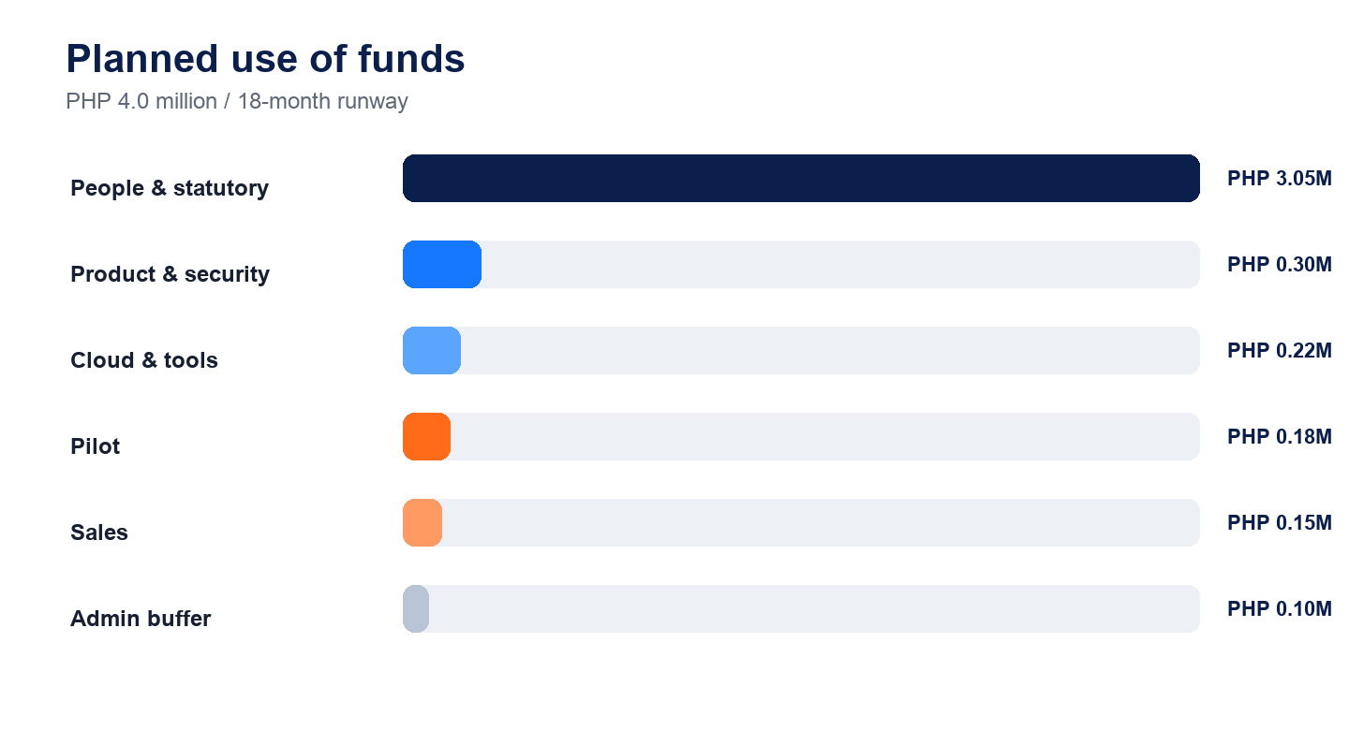
Figure 5. Planned use of the PHP 4.0 million funding requirement

C. Financial Projections (3 Years)
TripSync uses fleet-based monthly subscriptions plus a one-time implementation fee. The fee recognizes that each operator requires route mapping, data preparation, configuration, training, testing, and go-live support. The monthly charge covers continued use, hosting, monitoring, support, and product improvement.
The planning model uses the Growth tier as the blended customer value: PHP 25,000 monthly recurring revenue and PHP 150,000 setup revenue per operator. Actual contracts may use Starter or Large Operator pricing based on routes, fleet, terminals, integrations, support windows, and risk.
New customers contribute an average of six subscription months in their acquisition year. Existing customers contribute twelve months. The draft assumes no churn solely to reconcile the executive-summary totals; the sensitivity section shows why retention must be tested before final investor use.
Table 14. Working fleet-based pricing architecture
Tier | Monthly | Implementation | Planning fit
Starter | PHP 15,000 | PHP 100,000 | Small fleet or limited routes
Growth | PHP 25,000 | PHP 150,000 | First-pilot blended assumption
Large Operator | PHP 35,000 | PHP 200,000 | Larger fleet and support needs

Revenue Projection and Customer Build
Year 1 ends with five paying operators. Five setup fees produce PHP 750,000 and six average subscription months produce another PHP 750,000, for PHP 1.5 million total revenue.
Year 2 adds ten operators. Five existing operators contribute PHP 1.5 million in subscriptions. Ten new operators contribute PHP 1.5 million in setup and PHP 1.5 million in subscriptions, for PHP 4.5 million total.
Year 3 adds twenty-five operators. Fifteen existing operators contribute PHP 4.5 million in subscriptions. New operators contribute PHP 3.75 million in setup and PHP 3.75 million in subscriptions, for PHP 12.0 million total.
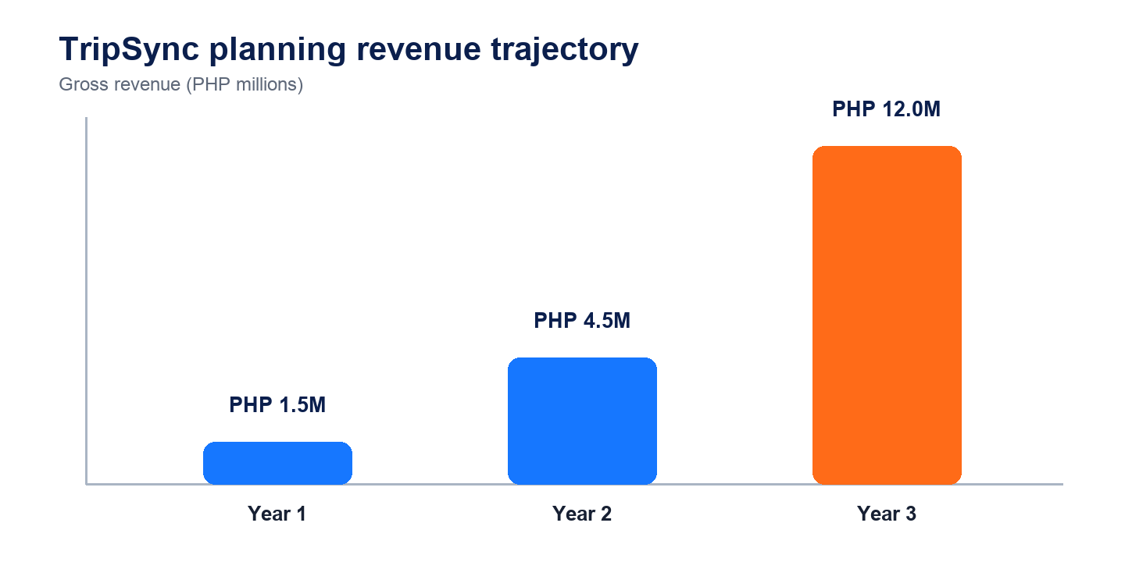
Figure 6. Three-year planning revenue trajectory
Year | End customers | New | Subscription | Setup | Total
Year 1 | 5 | 5 | PHP 0.75M | PHP 0.75M | PHP 1.50M
Year 2 | 15 | 10 | PHP 3.00M | PHP 1.50M | PHP 4.50M
Year 3 | 40 | 25 | PHP 8.25M | PHP 3.75M | PHP 12.00M

Payroll and Operating Expense Plan
Founder base payroll is PHP 155,000 per month: PHP 45,000 each for Aaron and John, PHP 30,000 for Hazel, and PHP 35,000 for Ana. The funding schedule includes thirteenth-month pay and a provisional allowance for employer contributions. Final statutory calculations must use the current SSS, PhilHealth, and Pag-IBIG schedules.
Other costs include secure hosting, product and security work, pilot devices, operator onboarding, travel, legal and privacy advice, communication, accounting, permits, and a small working buffer. The team will collect quotations before final submission and replace provisional amounts where possible.
The operating model keeps a variable portion of delivery cost connected to new implementations and customer count. This reduces the risk of building a large fixed team before revenue is established.
Table 15. Founder base payroll
Founder/role | Monthly base | Annual base
Aaron - technical lead | PHP 45,000 | PHP 540,000
John - development lead | PHP 45,000 | PHP 540,000
Hazel - marketing lead | PHP 30,000 | PHP 360,000
Ana - finance lead | PHP 35,000 | PHP 420,000
Total | PHP 155,000 | PHP 1,860,000

[TO COMPLETE - Owner: Ana | Required evidence: Current statutory contribution computation and vendor quotations replacing provisional operating-cost allowances | Due: August 29, 2026]

Projected Income Statement
The illustrative income statement is built to reconcile the published revenue trajectory and late-Year-2 break-even target. Cost of service includes cloud use, implementation labor or contractors, pilot equipment consumed, and direct support. Operating expenses include founder and employee payroll, marketing, administration, legal, privacy, and product work not assigned to one customer.
The model shows a Year 1 operating loss while TripSync completes production work and wins initial customers, a small positive position in Year 2, and a stronger Year 3 result if forty customers are reached without service quality declining. The figures are planning assumptions and should not be interpreted as guaranteed returns.
Table 16. Illustrative projected income statement
PHP millions | Year 1 | Year 2 | Year 3
Revenue | 1.50 | 4.50 | 12.00
Cost of service | 0.55 | 1.10 | 2.40
Gross profit | 0.95 | 3.40 | 9.60
Operating expenses | 2.50 | 3.08 | 5.32
Operating profit/(loss) | (1.55) | 0.32 | 4.28

Planning disclosure
Expense lines are provisional and must be updated with quotations and current statutory calculations. Revenue totals are fixed to the executive summary.

Projected Cash Flow and Break-Even
The PHP 4.0 million funding round provides the initial cash buffer. Year 1 operating loss and small equipment purchases draw down that buffer. Paid implementation fees and advance monthly subscriptions improve working capital because cash is collected before or during delivery.
Late-Year-2 operating break-even depends on reaching approximately fifteen active operators, continuing setup revenue from new customers, and maintaining staged hiring. If sales arrive later, the team must delay hiring, reduce discretionary spending, secure additional grant support, or extend founder-funded work.
A monthly 13-week cash forecast will be maintained once incorporation begins. No hiring or nonessential purchase will be approved when the forecast shows less than six months of committed operating cash without a documented financing response.
Table 17. Illustrative cash-flow summary
PHP millions | Year 1 | Year 2 | Year 3
Opening cash incl. financing | 4.00 | 2.30 | 2.52
Operating cash movement | (1.55) | 0.32 | 4.28
Equipment/capital purchases | (0.15) | (0.10) | (0.20)
Indicative closing cash | 2.30 | 2.52 | 6.60

D. Financial Ratios and Metrics
Gross margin improves as implementation becomes repeatable and subscription revenue grows. The model's operating margin moves from negative in Year 1 to modestly positive in Year 2 and strongly positive in Year 3. This improvement requires product stability and does not happen automatically with customer count.
The largest sensitivities are customer acquisition timing, retention, implementation effort, cloud and support cost, and hiring pace. A six-month sales delay or loss of several Year 2 customers would push break-even beyond the executive-summary target.
The plan therefore treats Year 2 break-even as a management target with defined corrective actions rather than a promise. Monthly review will compare actual recurring revenue, gross margin, burn, runway, collections, and customer retention against plan.
Table 18. Planning ratios and growth measures
Metric | Year 1 | Year 2 | Year 3 | Interpretation
Gross margin | 63.3% | 75.6% | 80.0% | Improves with recurring revenue
Operating margin | -103.3% | 7.1% | 35.7% | Late-Y2 break-even target
Revenue growth | n/a | 200% | 166.7% | Depends on 5/15/40 customers
End customers | 5 | 15 | 40 | Not contracted

Scenario | Effect | Management response
Sales 6 months late | Break-even shifts beyond Year 2 | Freeze hiring and extend grant runway
10% churn in Year 3 | Lower recurring revenue and proof | Customer-success recovery plan
Implementation cost +25% | Lower gross margin | Standardize integrations and price scope

E. Assumptions and Methodology
Revenue is recognized from implementation work and monthly subscriptions using the fixed pricing and customer counts in the executive summary. The draft uses a blended Growth-tier customer value and six months of subscription revenue for newly acquired customers. It assumes monthly billing in advance and implementation billing in two parts.
Expense projections begin with founder salaries disclosed in the executive summary. Employer contributions, thirteenth-month pay, staged hiring, hosting, delivery, security, legal, and sales costs are added as planning assumptions. Taxes, depreciation, receivables, and financing terms require accountant and legal review before the document is used for investment solicitation.
All figures are nominal Philippine pesos. No inflation, foreign-exchange movement, debt interest, dividend, or valuation is modeled. The full-replacement product option is not funded in the base case. Financial schedules will be updated when vendor quotations, statutory calculations, and customer evidence become available.

F. Financial Schedules
Detailed financial schedules and the reconciled 18-month use-of-funds table are provided in Annex E.
[TO COMPLETE - Owner: Ana and external accountant | Required evidence: Review of taxes, revenue recognition, depreciation, statutory contributions, and financing presentation | Due: Before investment use]

References
Government, Policy, and Market Sources
Department of Economy, Planning, and Development. (2023). Philippine Development Plan 2023-2028. https://pdp.depdev.gov.ph/wp-content/uploads/2023/01/PDP-2023-2028-web.pdf
GMA Integrated News. (2025a, January 3). Terminals brace for influx of passengers as long holiday break ends. https://www.gmanetwork.com/news/topstories/nation/931685/terminals-brace-for-influx-of-passengers-as-long-holiday-break-ends/story/
GMA Integrated News. (2025b, October 31). Influx of passengers at terminals as Undas 2025 long weekend starts. https://www.gmanetwork.com/news/topstories/nation/964395/influx-of-passengers-at-terminals-as-undas-2025-long-weekend-starts/story/
Land Transportation Franchising and Regulatory Board. (2020). Memorandum Circular No. 2020-051. https://ltfrb.gov.ph/wp-content/uploads/2020/09/LTFRB-MC-2020-051.pdf
National Privacy Commission. (2012). Republic Act No. 10173: Data Privacy Act of 2012. https://privacy.gov.ph/data-privacy-act/
National Privacy Commission. (2017). Guidelines on Privacy Impact Assessment. https://privacy.gov.ph/wp-content/uploads/2022/01/NPC_AdvisoryNo.2017-03.pdf
Philippine Chamber of Commerce and Industry. (2026). BIDA 2026 Primer. https://tinyurl.com/BIDA2026Requirements
Philippine Statistics Authority. (2026, June 24). 2024 ASPBI - Transportation and Storage Section: Final Results. https://psa.gov.ph/statistics/transp-stge-comm/aspbi

Legal, Competitor, and Project Sources
Republic of the Philippines. (2019). Republic Act No. 11232: Revised Corporation Code of the Philippines. https://lawphil.net/statutes/repacts/ra2019/ra_11232_2019.html
Social Security System. (2024). Circular No. 2024-006: Schedule of SSS Contributions Effective January 2025. https://www.sss.gov.ph/wp-content/uploads/2024/12/2025-SSS-Contribution-Table-rev.pdf
United Nations. (n.d.). The 17 Sustainable Development Goals. https://sdgs.un.org/goals
DLTB Co. (n.d.). Ticket booking and online reservation engine. https://www.dltb.ph/
Easybus PH. (n.d.). Online bus booking in the Philippines. https://www.easybus.ph/
EtiGo. (n.d.). About EtiGo: Modernizing bus travel in the Philippines. https://etigo.com.ph/about
IWantSeats. (n.d.). Online bus ticket booking. https://iwantseats.com.ph/
UM Siklab. (2026a). IQueue prototype data card [Unpublished project documentation].
UM Siklab. (2026b). IQueue forecasting model card [Unpublished project documentation].
UM Siklab. (2026c). IQueue system evidence [Synthetic benchmark record].
Citation note
Competitor references document publicly presented capabilities only. They do not establish pricing, market share, performance, or customer satisfaction.

ANNEX A

Prototype and Product Evidence

Figure 7. Functional pre-pilot screens; data shown are prototype examples
TripSync is the commercialization name. The current interface was developed under the IQueue student project and is shown transparently as the underlying prototype architecture. The final competition images will use TripSync-facing labels while retaining this origin note.
[TO COMPLETE - Owner: John | Required evidence: Final TripSync-rebranded screenshots and a safe demonstration QR code that contains no real passenger data | Due: August 29, 2026]

ANNEX B

Customer Interview Guide and Results

Passenger questions
- Describe what usually happens from arrival at the terminal until you board.
- When do you decide how early to arrive, and what information would help?
- What causes confusion or disagreement about seats, queues, or boarding?
- Would you trust a phone-based boarding pass, and what would make it trustworthy?
- Which language and assistance channel would be most useful?

Operator buyer and frontline questions
- Which departures or seasons create the most difficult boarding conditions?
- What records are available for demand, dispatch, queues, and boarding outcomes?
- Who approves a pilot, what budget is realistic, and how long does procurement take?
- Which measures would justify continued payment after 90 days?
- What would cause staff to reject or stop using the service?
[TO COMPLETE - Owner: Hazel | Required evidence: Three passenger interviews, one operator decision-maker interview, one dispatcher/gate interview, consent record, coded themes, and limitations | Due: August 28, 2026]

ANNEX C

Founder Curriculum Vitae Summaries

Aaron Jalapon
Fourth-year BS Computer Science | Project and Technical Lead
[TO COMPLETE - Owner: Aaron | Required evidence: Relevant coursework, projects, competitions, training, verifiable achievements, and contact details approved for submission | Due: August 29, 2026]

John Benedict J. Bongcac
Fourth-year BS Computer Science | Software Development Lead
[TO COMPLETE - Owner: John | Required evidence: Relevant coursework, projects, competitions, training, verifiable achievements, and contact details approved for submission | Due: August 29, 2026]

Hazel Mae B. Fuerzas
Fourth-year BSBA Marketing Management | Marketing Lead
[TO COMPLETE - Owner: Hazel | Required evidence: Relevant coursework, projects, competitions, training, verifiable achievements, and contact details approved for submission | Due: August 29, 2026]

Ana Mae M. Viduya
Fourth-year BSBA Financial Management | Finance Lead
[TO COMPLETE - Owner: Ana | Required evidence: Relevant coursework, projects, competitions, training, verifiable achievements, and contact details approved for submission | Due: August 29, 2026]

ANNEX D

Plain-Language Product Architecture and Evidence
Table 19. TripSync architecture in non-technical language
Layer | What judges need to know | Current status
Passenger and staff screens | One web-based experience for booking, operations, and boarding | Functional prototype
Operating services | Applies business rules, records decisions, and checks boarding passes | Functional prototype; hardening needed
Protected records | Keeps routes, buses, passengers, bookings, seats, and outcomes | Prototype records; production controls needed
Demand and assistance | Highlights busy departures and answers common passenger questions | Synthetic/model evidence; field validation needed
Cloud and gate devices | Online coordination with temporary offline boarding checks | Demonstrated; device management needed

Evidence disclosures
- Forecasting data are synthetic and cover six demonstration routes.
- Seat-allocation results are controlled simulations, not passenger outcomes.
- Offline pass checks use provisioned device secrets in the prototype; commercial key management remains to be completed.
- Chatbot evaluation uses curated and public holdout examples; live passenger satisfaction is unmeasured.
- Operational queue improvements are scenario estimates, not field results.

ANNEX E

Detailed Financial Schedules
Table 20. Illustrative 18-month use of funds
Use of funds | PHP M | Share | Draft basis
People and statutory costs | 3.05 | 76.2% | Four founders, 18 months, 13th month, provisional employer costs
Product and security | 0.30 | 7.5% | Hardening, privacy/security specialist review
Cloud and tools | 0.22 | 5.5% | Hosting, monitoring, development services
Pilot equipment/onboarding | 0.18 | 4.5% | Test devices, training materials, setup
Marketing and travel | 0.15 | 3.8% | Direct sales, site assessment, travel
Legal/admin/buffer | 0.10 | 2.5% | Registration, accounting, contingency
Total | 4.00 | 100% | 18-month planning requirement

[TO COMPLETE - Owner: Ana | Required evidence: Replace provisional allocations with current quotations and statutory calculations; confirm total remains PHP 4.0M | Due: August 29, 2026]

ANNEX F

BIDA Judging-Criteria Coverage
Table 21. Business-plan and presentation coverage against BIDA scoring
Criterion | Weight | Where addressed | Final proof needed
Viability / Feasibility | 30% | Market, pilot, operations, financials | Interviews, quotations, partner outreach
Originality / Innovation | 25% | Unified workflow and comparison | Rebranded prototype demonstration
Creativity / Sustainability | 20% | Measured resource and operating indicators | Baseline method and pilot commitments
Social Impact | 10% | Accessibility, language, orderly boarding, SDGs | Pilot measurement and safeguards
Oral Presentation | 15% | Reusable figures and evidence disclosures | 14-14.5 minute recorded demo

Submission gate
No yellow placeholder may remain in the final submitted version unless it explicitly identifies a post-award milestone rather than missing submission evidence.

