Initial Project Document

**Portable Fluorescence Sensor Using Thin Optical Filters**

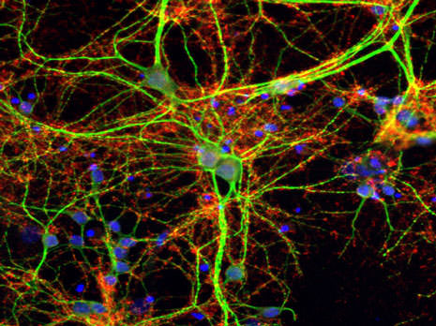

**University of Central Florida**

Department of Electrical Engineering and Computer Science

Department of Photonic Sciences and Optical Engineering

Dr. Richie & Dr. Kar

Sponsors:

Everix

Senior Design 1

**Group 6**

Cristian Pearson - Photonics & Optics Engineering

Christian Spurgeon – Photonics & Optics Engineering

Gean Morales – Electrical Engineering

Aaron Jevitt – Computer Engineering

**Project Narrative:**

In modern day technology there are many different types of optical detection techniques that are used widely around the world. From microscopy to fluorescence detection. Fluorescence detection has been around since 1845 and since then is used throughout biology and medicine to deduce certain characteristics about a certain ailment, illness or even genes that someone has. One of the main benefits of doing fluorescence detection is accuracy and repeatability. Because of modern day technology, scientists can detect ailments on a very small scale very accurately either through imaging or sensing. Most fluorescence detection devices use imaging to show that something has been detected or not, while this method is very expensive, the cheaper alternative is using a sensor for the detection. Currently on the market there are a few fluorescence sensor devices, but they are bulky and unable to be carried around easily. Being able to take a fluorescence detection machine on the go will make data analysis of samples faster and easier without having to get back to the lab.

The goal of this project is to create a fluorescence detecting device to detect the fluorescent light emitted by markers using a photodetector. The type of fluorescent light and concentration of light emitted by the markers is used to determine a certain ailment, gene or illness that a person may have. One of the largest issues about fluorescent detection devices is the portability of the device. To solve this issue, we will be using revolutionary thin filters to make the overall design compact and less expensive than most fluorescence sensing devices.

Some key functions of this project are that there will be an LED which produces light that passes through a band pass filter allowing only the excitation wavelength to pass through. From there the light will shine on the sample, exciting the fluorescent material in it causing the emission of a unique frequency of light that is different from the exciting light. The light will then pass through a bandpass filter that will only allow the emission light from the markers to pass, and a focusing lens will be used to focus the emitted light from the sample onto the sensor. The microcontroller will sample the signal multiple times and generate a reading for the total amount of fluorescent material in the sample. The user will be able to calibrate the device and operate it using a touchscreen interface directly on the device or transmit the data to a cell phone or computer and be controlled via the connected device.

**Project Objectives:**

• Select an ailment/marker to detect(multiple)

• Determine the wavelength of each ailment/marker

• Determine fluorescence emission wavelength of light for each marker

• Determine lenses and filters for the correct wavelength of light confinement and transmission

• Determine optical system spacing for efficient fluorescence detection and compact design

• Choosing LED with a spectrum that includes excitation wavelengths

• Choosing a photodetector with effective sensitivity

• Designing photodetector circuit for converting analog signal to digital signal for microcontroller

• Design Software to read sensor signal and calculate concentration of fluorescent material

• Create Simple to use interface for taking readings and configuring sampling settings

**Requirements & Specifications**

Requirements for Hardware:

|  |  |
| --- | --- |
| 1.0 | System shall contain a light emitter for exciting samples |
| 1.1 | System shall contain a light collector able to accurately sample the concentration of fluorescent material in a sample |
| 1.2 | System shall allow switching either manually or automatically between different optical filters for measuring different frequencies of emitted fluorescence |
| 1.3 | System shall accurately measure analog signal from light sensor |
| 1.4 | System shall be battery operated using commonly available batteries, or rechargeable non-user-replaceable battery |
| 1.5 | System shall include serial port for programming microcontroller |
| 1.6 | System shall contain a local or remote display for viewing sample data, and editing configuration |
| 1.7 | System shall contain a microcontroller for sampling data and calculating output, as well as operating display, and accepting user input to adjust parameters of sample collection calculation |
| 1.8 | Circuitry will be small enough to fit inside custom enclosure, and be on a custom PCB |

Requirements for Software:

|  |  |
| --- | --- |
| 2.0 | Software shall have a simple to operate GUI for taking samples, and calibrating sensor either on the device or wirelessly transmitted to another device |
| 2.1 | Software shall be able to take multiple readings of collected light and calculate fluorescence readings |
| 2.2 | Software shall have the ability to calibrate the fluorescence calculation to increase the accuracy |
| 2.3 | Software shall be able to store calibration profiles for different excitations |
| 2.4 | If an automated filter switching mechanism is required, precisely control filter actuator to position different filters for different frequencies of light in front of the emitter and detector. |

Optical System Requirements:

|  |  |
| --- | --- |
| 3.0 | The system shall be able to confine and focus fluorescent light upon the photodetector. |
| 3.1 | The bandpass optical filter shall allow light in the visible spectrum to be transmitted and filter out the rest of the LED light spectrum. |
| 3.2 | The bandpass optical filter shall only allow light of the fluorescent emission wavelength (517nm) to pass through and filter out all other wavelengths of light. |
| 3.3 | A lens shall have a small focal length, between 10-30 mm, to focus light at a close proximity to the device. |
| 3.4 | A lens shall have a small focal length, between 10-30 mm, to gather the most fluorescent light transmitted and focus said light on a photodetector at a short distance away. |
| 3.5 | The LED shall emit a spectrum of light with the highest intensity peak centered within the desired excitation wavelength range (400-500nm). |
| 3.6 | The optical system will have spacing between optics that allows for a compact design of the optical system. |
| 3.7 | The optical system shall have a limit of detection <5 picomolar (pM) for fluorescence emission detection |

**Possible Project Constraints**

Since our project is still in the early stages, we have not come across many constraints. One major constraint that has come to our attention is the filtering of the light incoming to the photodetector so that only the fluorescent light emitted by the biomarker is picked up by the detector. It is important that LED light intended to excite the markers does not pass through the optical filter and become processed into the fluorescent light believed to be detected by the device. This means that it is important for us to filter out as much light as possible outside of the fluorescent wavelength we intend to measure. Additional constraints may come from implementation of stretch goals such as transmission of data via Wi-Fi or bending the optical filters instead of using lenses.

**Block Diagrams**

Group Breakdown Diagram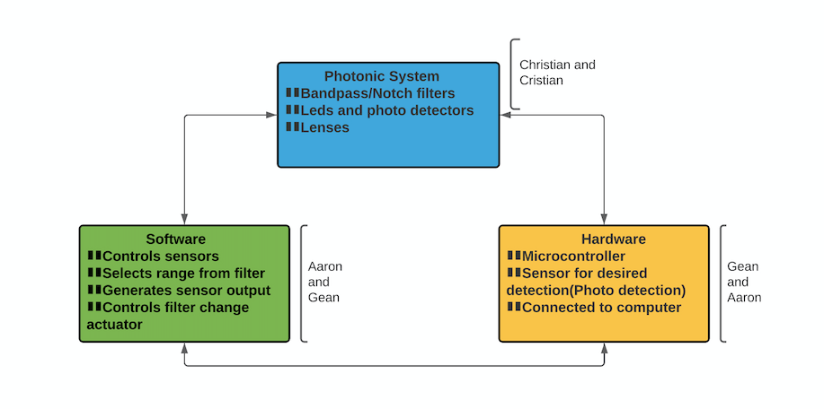

Optical System Diagram:

**Legend:**

Christian Spurgeon

Cristian Pearson

TBA – To be acquired

R - Research

Optical System:

Hardware Diagram:

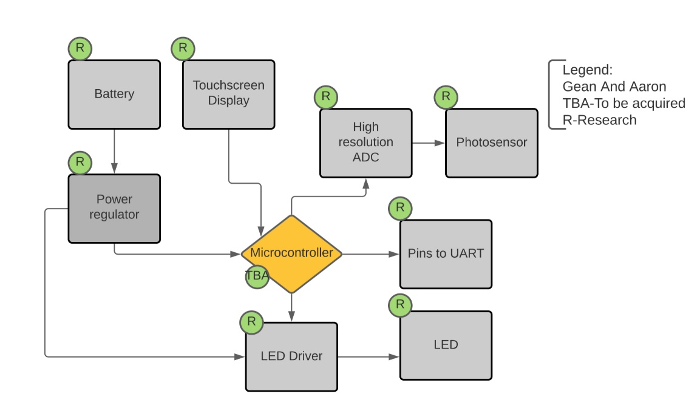

Software Flow Diagram:

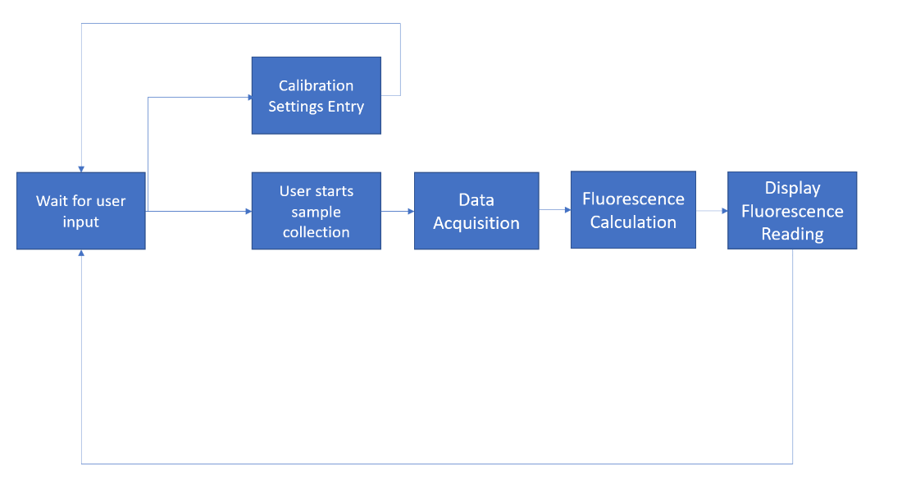

**Budget & Funding**

Our budget will be funded by our sponsor Everix. The most expensive costs come from the optical filters and lenses. Our sponsor Everix intends to provide their thin optical filters for use in our portable fluorescence sensing device. The lenses have a large cost due to their small dimensions and focal length. Discounting any malfunctions or breakage, the total cost can be calculated from the estimated cost for each component below.

|  |  |  |
| --- | --- | --- |
| ITEM | QUANTITY | PRICE ESTIMATE |
| LED | 1 | $1-$20 |
| Cooling for LED | 1 | $10-$50 |
| Photodetector | 1 | $2-$20 |
| Optical filter | 2 | $400-$800 |
| Lens | 4 | $150-$500 |
| Custom optical housing | 1 | $10-$100 |
| Custom enclosure | 1 | $15-$20 |
| Display | 1 | $7-$15 |
| Microcontroller | 1 | $3-$30 |
| Power Source | 1 | $10-$50 |
| PCB panel | 1 | $25-$75 |
| **TOTAL (Estimated Range)** | **N/A** | **~$633-$1,680** |

**Project Milestones**

|  |  |  |
| --- | --- | --- |
| Number | Milestone | Planned Completion Week (SD1 & SD2) |
| 1 | Initial project document-Divide and Conquer | 5 |
| 2 | Decide on ailment/marker for detection | 6 |
| 3 | Use ailment/marker to choose optical filters | 6 |
| 4 | Use Zemax to test lens designs/choose focal length of lens | 7 |
| 5 | Investigate HMI designs | 7 |
| 6 | Test lenses/photodetector/ADC designs | 8 |
| 7 | Create prototype PCB | 9 |
| 8 | Create Software outline | 9 |
| 9 | Test software for interfacing microcontroller with different components | 10 |
| 10 | Design Enclosure and Optical Housing | 10 |
| 11 | Finalize part selection and PCB design after testing individual components | 11 |
| 12 | Design finalized PCB | 12 |
| 13 | Order PCB and parts | 14 and 1-SD2 |
| 14 | Order Optical Components | 14 and 1-SD2 |
| 15 | Complete Microcontroller software | 14 and 1-SD2 |
| 16 | Manufacture enclosure and optical housing | 2-SD2 |
| 17 | Assemble PCB and test circuit works correctly | 3-SD2 |
| 18 | Complete Microcontroller software | 4-SD2 |
| 19 | Begin Integration | 5-SD2 |
| 20 | Complete Integration | 6-SD2 |
| 21 | Complete Testing | 8-SD2 |
| 22 | Deliver Product | 9-SD2 |