AWS Fundamentals and Azure Mapping
A concise guide to AWS, IaaS/PaaS/SaaS, and Azure → AWS service mapping

1) Brief about AWS and how it differs from Microsoft Azure
Amazon Web Services (AWS) is a comprehensive public cloud platform offering on‑demand compute, storage, databases, networking, analytics, AI/ML, and developer tools. AWS pioneered the public cloud (2006) and now operates a vast global infrastructure of Regions and Availability Zones.
Key differences compared to Azure:
- Market maturity & breadth: AWS generally offers the broadest service catalog and deep feature sets across compute (EC2), storage (S3), serverless (Lambda), containers (ECS/EKS), and databases. Azure is deeply integrated with Microsoft 365, Windows Server, and Active Directory, often preferred for Microsoft‑centric estates.
- Global footprint & architecture: Both have wide global presence; AWS popularized the multi‑AZ architecture pattern with consistent primitives (VPC, Subnets, Security Groups). Azure uses VNets, NSGs, and a slightly different regional/zone model.
- Hybrid & enterprise integration: Azure shines with native integration to on‑prem Windows/AD and services like Azure Arc. AWS provides hybrid via Outposts, Local Zones, and robust IAM with federation and Organizations.
- Pricing & purchasing: Both use pay‑as‑you‑go with discounts (Reserved/ Savings Plans on AWS). Service names differ but capabilities broadly align.

2) What are IaaS, PaaS, and SaaS on AWS?
Cloud service models describe the shared‑responsibility split between provider and customer:
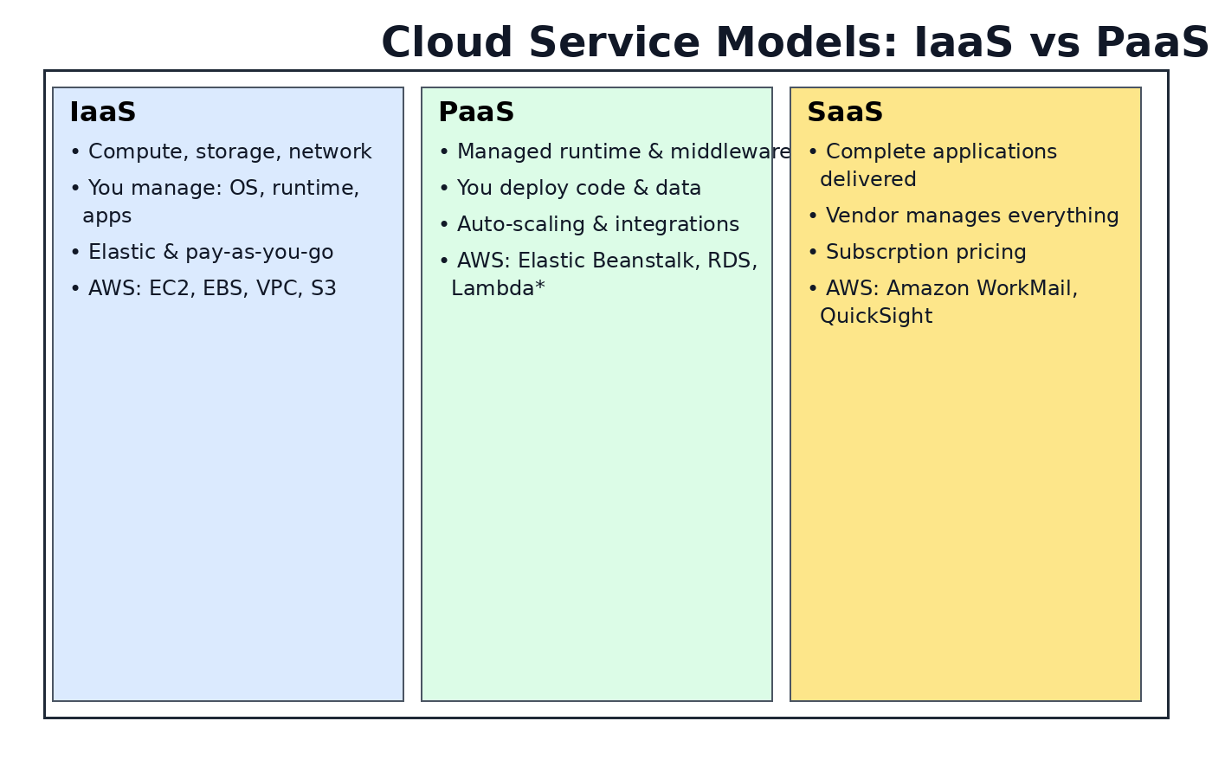
Figure: Roles and examples for IaaS, PaaS, and SaaS (AWS context).

Infrastructure as a Service (IaaS)
You provision fundamental building blocks such as virtual machines, block/object storage, and networks. You manage OS patching, runtime, and applications.
- Core AWS examples: Amazon EC2, Amazon EBS, Amazon S3, Amazon VPC, Elastic Load Balancing.
- Use when you need maximum control or must run custom OS images and agents.

Platform as a Service (PaaS)
AWS provides managed platforms where you deploy code or data while AWS manages the underlying OS, runtime, scaling, and patching.
- Core AWS examples: AWS Elastic Beanstalk, Amazon RDS/Aurora, Amazon OpenSearch Service, AWS Fargate, Amazon EMR, API Gateway.
- Use when speed to market and reduced ops overhead are priorities.

Software as a Service (SaaS)
Complete applications delivered over the internet; subscription‑based with minimal admin. On AWS, these are often AWS‑native applications or third‑party SaaS built on AWS.
- Examples: Amazon QuickSight (BI), Amazon Chime, Amazon WorkSpaces Web, AWS Managed Microsoft AD as a managed directory service.

3) Map Azure services to AWS equivalents
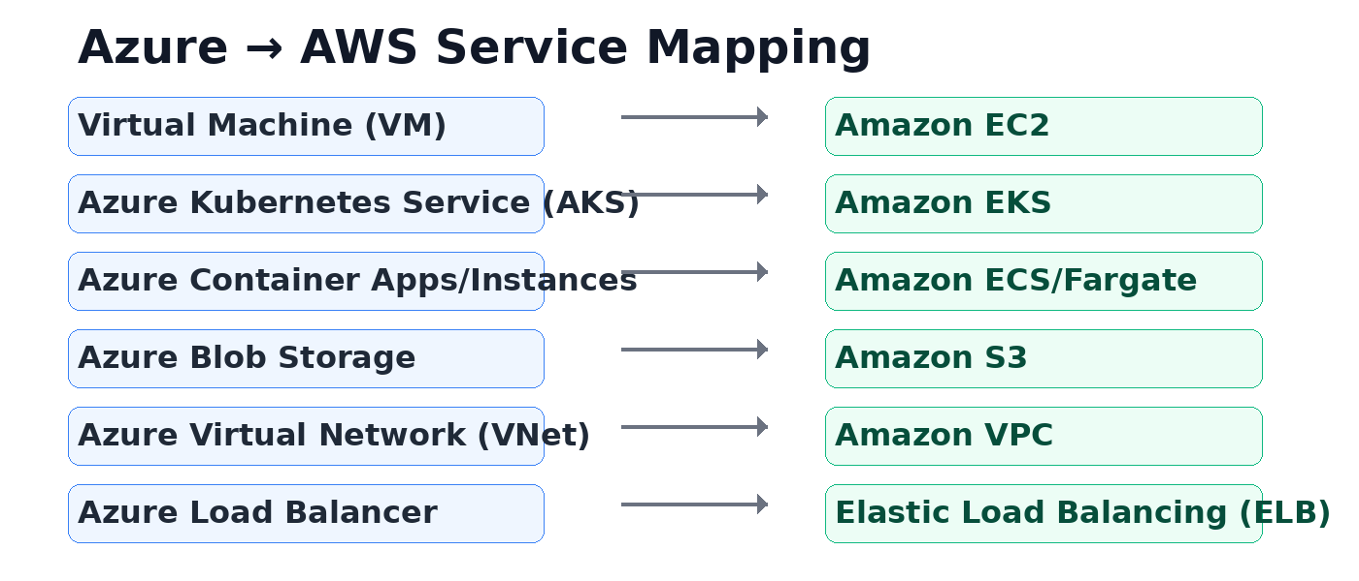
Figure: Common Azure → AWS service pairs for quick orientation.
Detailed mapping and explanations:
Azure Service | Closest AWS Service | What it does / Notes
Virtual Machine (VM) | Amazon EC2 | Provision resizable virtual servers. Choose instance families, sizes, and purchase options (On‑Demand, Savings Plans, Spot).
Azure Container Instances/Apps | Amazon ECS (+ Fargate) | Run containers with orchestration and serverless compute via Fargate; integrates with ECR, CloudWatch.
Azure Kubernetes Service (AKS) | Amazon EKS | Managed control plane for Kubernetes; run worker nodes on EC2 or Fargate.
Azure Blob Storage | Amazon S3 | Object storage for any scale; tiers (Standard/IA/Glacier), lifecycle policies, versioning.
Azure Files | Amazon EFS/FSx | Managed file systems (NFS via EFS; SMB via FSx for Windows).
Azure Virtual Network (VNet) | Amazon VPC | Isolated virtual network with subnets, route tables, security groups, NACLs.
Azure Load Balancer/App GW | Elastic Load Balancing (ALB/NLB) | Distribute traffic at L7 (ALB) or L4 (NLB); integrate with autoscaling.
Azure Monitor/Log Analytics | Amazon CloudWatch | Metrics, logs, dashboards, alarms, traces.
Azure Key Vault | AWS KMS/Secrets Manager | Key management, encryption, secret rotation.
Azure SQL Database | Amazon RDS/Aurora | Managed relational databases (MySQL, PostgreSQL, SQL Server, Aurora).

4) Terms referenced in the brief (detailed)
EC2 (Elastic Compute Cloud)
AWS virtual servers with many instance families (general‑purpose, compute‑optimized, memory‑optimized, GPU, ARM/Graviton). Supports Auto Scaling, placement groups, EBS volumes, and multiple purchasing models (On‑Demand, Reserved, Savings Plans, Spot).
ECS (Elastic Container Service)
AWS container orchestration for Docker with native integrations and simple operational model. Can run on EC2 or serverless using AWS Fargate.
EKS (Elastic Kubernetes Service)
Managed Kubernetes control plane with high availability and versioned upgrades. Worker nodes on EC2 or Fargate; integrates with IAM, ALB, CloudWatch, and ECR.
S3 Bucket (Amazon Simple Storage Service)
Highly durable (11 9s) object storage with buckets, versioning, lifecycle rules, encryption (SSE‑S3/SSE‑KMS), and storage classes (Standard, Intelligent‑Tiering, IA, Glacier).

5) Practical tips & best practices
- Design for availability using multiple Availability Zones; use Auto Scaling with ALB/NLB.
- Use IAM least privilege, roles for workloads, and AWS Organizations + SCPs for guardrails.
- Encrypt data at rest (S3/KMS, EBS) and in transit (TLS). Enable S3 Block Public Access and bucket policies.
- Employ CloudWatch metrics/logs, CloudTrail auditing, and AWS Config for compliance.
- Choose cost‑efficient options: right‑size, use Savings Plans/Reserved Instances, and S3 lifecycle policies.

