Understanding Different Data Formats: Parquet, ORC, and Avro

Introduction
In the world of Big Data and analytics, data formats play a crucial role in optimizing storage, performance, and interoperability. Commonly used formats like Parquet, ORC, and Avro are designed to handle large-scale data efficiently. These formats are widely used in Hadoop and Spark ecosystems for batch and real-time processing.

Parquet
Parquet is a columnar storage format developed by Apache. It is highly efficient for analytical queries because it stores data by columns rather than rows, reducing I/O and improving compression.

Features:
- - Columnar storage for efficient queries
- High compression ratio
- Supports complex nested data structures
- Optimized for Spark and Hadoop

Use Cases:
- - Data warehousing
- Business intelligence
- Machine learning pipelines
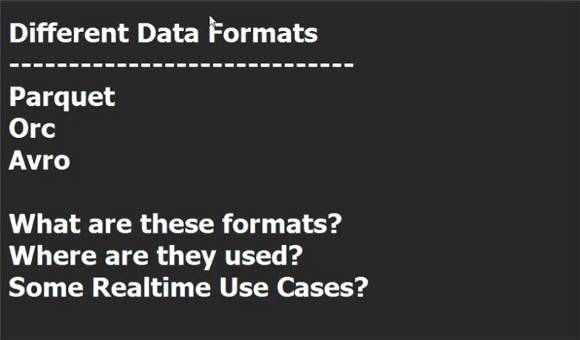

ORC
Optimized Row Columnar (ORC) is another columnar format designed for Hadoop. It provides lightweight compression and fast read performance, making it ideal for Hive and Spark.

Features:
- - Highly efficient compression
- Splittable for parallel processing
- Stores indexes for faster queries

Use Cases:
- - Hive tables
- ETL pipelines
- Big Data analytics

Avro
Avro is a row-based format primarily used for data serialization. It is schema-based and supports dynamic schema evolution, making it ideal for streaming and messaging systems.

Features:
- - Row-based storage
- Schema evolution support
- Compact binary format
- Ideal for Kafka and streaming

Use Cases:
- - Real-time streaming
- Kafka message serialization
- Inter-service communication

Comparison Table
Feature | Parquet | ORC | Avro
Storage Type | Columnar | Columnar | Row-based
Best For | Analytics | Hive/Spark | Streaming
Compression | High | High | Moderate

Conclusion
Choosing the right format depends on your use case. For analytical workloads, Parquet and ORC are preferred due to their columnar nature. For real-time streaming and serialization, Avro is the best choice.

