Cloud Service Models: On-Premises vs IaaS vs PaaS vs SaaS

Introduction
Cloud computing offers different service models that shift who manages what. This document explains four models—On-Premises, Infrastructure as a Service (IaaS), Platform as a Service (PaaS), and Software as a Service (SaaS). You will see what each model means, who is responsible for which parts, and simple examples. Two images are also explained: a responsibility chart and a practical Java/.NET example.

On-Premises
Definition: Everything is owned and managed by your organization, inside your data center or office. You buy the hardware, install and patch software, secure the network, and deploy your applications.
You manage: Networking, Storage, Servers, Virtualization (if any), Operating System, Middleware, Runtime, Data, and Applications.
When to use: When you need maximum control, strict data residency, specialized hardware, or offline environments.
Example: A bank hosts its core banking system in its own data center with dedicated firewalls, SAN storage, and a clustered application server managed by its IT team.

Infrastructure as a Service (IaaS)
Definition: The cloud provider delivers virtualized compute, storage, and networking. You create virtual machines (VMs) and manage the OS and everything above it.
You manage: Operating System, Middleware, Runtime, Data, and Applications.
Provider manages: Physical servers, storage, networking, and the virtualization layer.
Example: Launching an Azure VM or AWS EC2 instance, installing Ubuntu/Windows, setting up Java and Tomcat, and deploying your WAR/JAR.

Platform as a Service (PaaS)
Definition: The provider gives you a ready-made platform (runtime, middleware, OS, and infrastructure). You focus on your code and data; the platform scales, patches, and monitors for you.
You manage: Applications and Data.
Provider manages: Runtime, Middleware, Operating System, Virtualization, Servers, Storage, and Networking.
Example: Deploying a Spring Boot or .NET API to Azure App Service or Google App Engine by pushing the package or connecting a GitHub repo; the platform handles capacity, scaling, and patching.

Software as a Service (SaaS)
Definition: A complete application delivered over the internet. Users just sign in and use it. You do not manage servers, runtimes, or even application updates.
You manage: Mostly configuration and your own data (users, permissions, settings).
Provider manages: Everything else, including infrastructure, platform, and application updates.
Example: Microsoft 365 Word Online, Salesforce CRM, or Gmail. Open a browser and start working—no installation needed.

Side-by-Side Responsibility Comparison
Layer | On-Premises | IaaS | PaaS | SaaS
Applications | You | You | You | Provider
Data | You | You | You | Provider (with your config)
Runtime | You | You | Provider | Provider
Middleware | You | You | Provider | Provider
Operating System | You | You | Provider | Provider
Virtualization | You | Provider | Provider | Provider
Servers | You | Provider | Provider | Provider
Storage | You | Provider | Provider | Provider
Networking | You | Provider | Provider | Provider

Image 1: Who Manages What
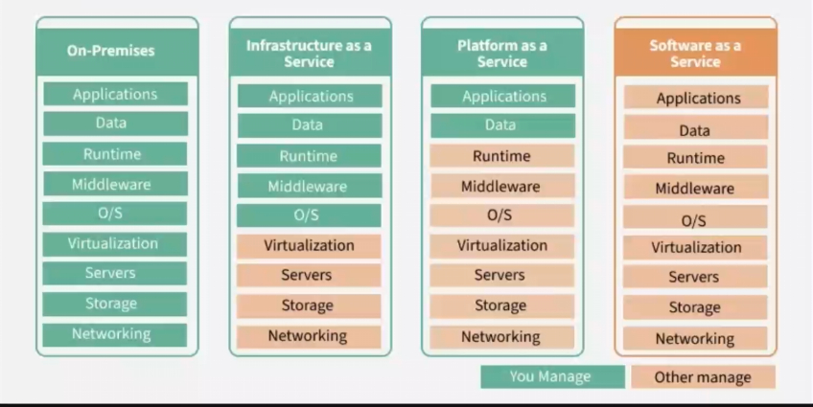
Caption: In green, items managed by you; in orange, items managed by the provider. As we move from On-Premises to IaaS to PaaS to SaaS, more responsibility shifts to the provider.
Explanation: The leftmost column (On-Premises) shows that you own and run every layer. In IaaS, the provider takes over the bottom four layers (Networking, Storage, Servers, Virtualization). In PaaS, the provider also manages Operating System, Middleware, and Runtime, leaving you with Application and Data. In SaaS, even the application itself is managed by the provider—you simply use it.

Image 2: Practical Example (Java/.NET)
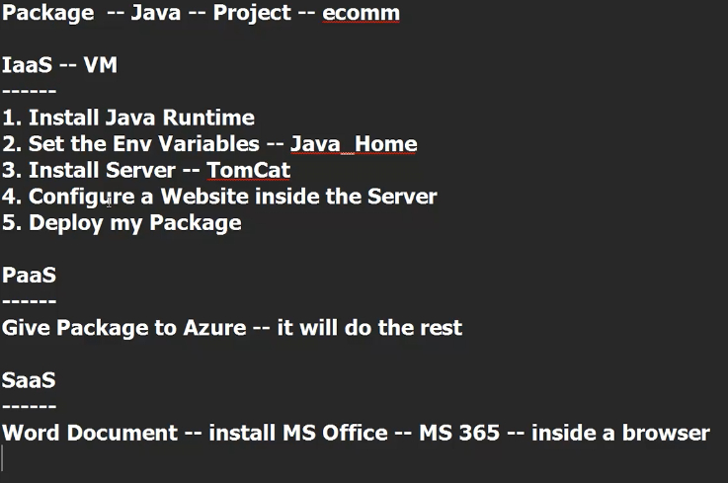
Caption: Step-by-step tasks differ by model. With IaaS, you install and configure runtimes and servers yourself. With PaaS, you hand over a package and the platform handles runtime and hosting. With SaaS, you just use the finished application in a browser.

Detailed Examples
On-Premises – Manufacturing ERP: A factory runs an ERP system on its own racks. IT teams manage VMware clusters, Windows Server patches, SQL Server backups, and network segmentation. Deployments are coordinated during scheduled maintenance windows.
IaaS – E‑commerce on VMs: A startup spins up three Azure VMs (web, app, DB). They install Java, set JAVA_HOME, deploy Tomcat, configure reverse proxies, and manage OS updates with Azure Update Management. Scaling is manual or via VM Scale Sets.
PaaS – API on Azure App Service: Developers push a Spring Boot JAR or a .NET Web API to App Service. The platform provides HTTPS, auto-scale, deployment slots, logs, and rolling updates. They focus on code and data, not servers.
SaaS – Productivity Suite: Teams collaborate in Microsoft 365 Word, Excel, and Teams directly in the browser. Admins set users and policies; feature updates arrive automatically without downtime.

How to Choose the Right Model
- Speed: PaaS and SaaS launch fastest; On-Prem is slowest.
- Control: On-Prem and IaaS give the most control; SaaS the least (by design).
- Cost model: On-Prem is capital heavy (CapEx); cloud models shift to operational spend (OpEx).
- Skills: IaaS requires OS and middleware admins; PaaS reduces that need; SaaS mainly needs app admins.
- Compliance: If data residency or legacy hardware is strict, On-Prem or IaaS may be required.

Conclusion
As you move from On-Premises to IaaS to PaaS to SaaS, more responsibility shifts to the provider, allowing teams to focus more on business value rather than infrastructure. Use On-Prem or IaaS for control and special requirements; choose PaaS for speed and managed operations; and pick SaaS when a ready-to-use solution fits the need.

