Tutorial 4

Q1. Consider two ‘ideal’ Ti/oxide/p-Si capacitors
φ_{Ti} = 4.3eV, E_{g} = 1.1eV, χ_{Si} = 4.05eV, φ_{Si} = 4.8eV
One uses a low-k (SiO₂), the other uses a high-k (HfO₂) dielectric, but are otherwise identical. What will be the relation between the threshold voltages using SiO₂ and HfO₂?

Soln:
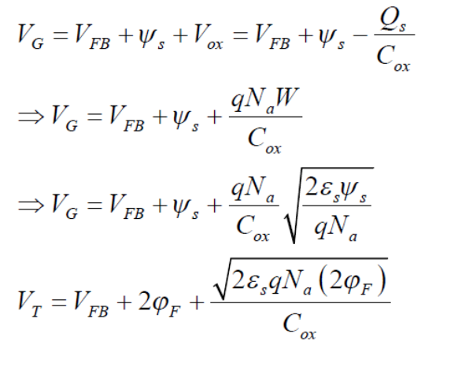
=> 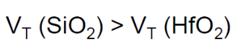

Q2. Consider two ideal MIS capacitors A and B. They differ in only one respect, viz. the semiconductor material in the two cases is different – but only in the relative permittivity (ε_{A} > ε_{B}). In the depletion regime, for the same applied gate voltage, determine the relation between the surface potentials in the two cases.

Soln:
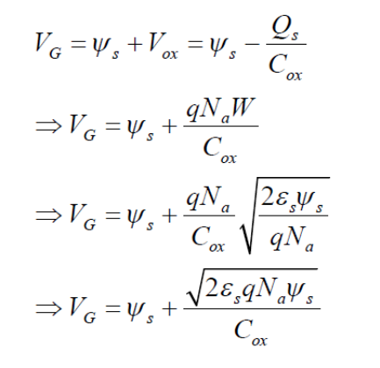
=>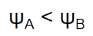

Q3. An ideal MOSCAP has V_{FB} = 0. Now, a sheet of positive charge density Q_{ox} is introduced within the oxide at a distance x_{ox} from the Si/SiO₂ interface. Assume the total oxide thickness is t_{ox}, what is V_{FB} now?

Soln:
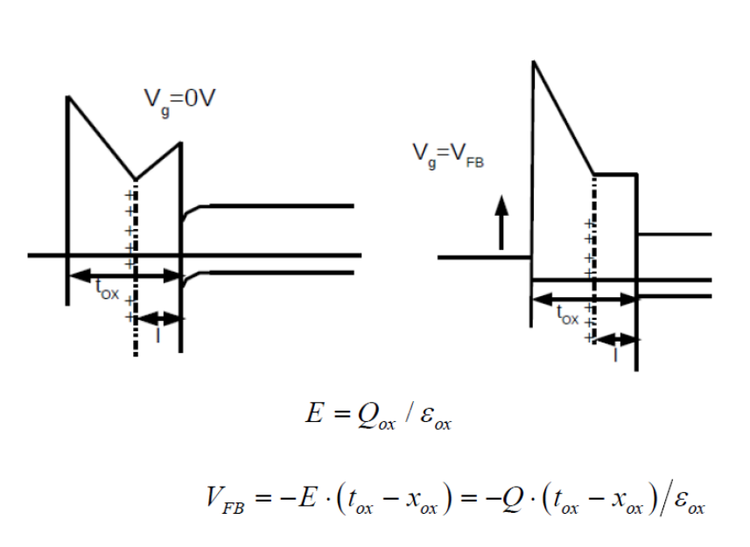

Q4. The C-V characteristic exhibited by a MOS-C (assumed to be ideal) is displayed
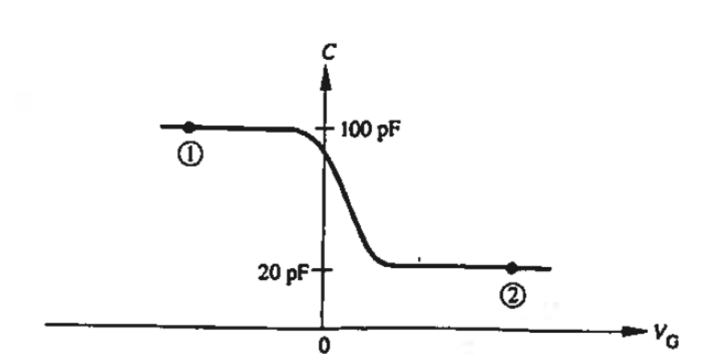
- Is the semiconductor component of the MOS-C doped n-type or p-type? Indicate how you arrived at the result.
- Draw the MOS-C energy band diagram corresponding to point (2) on the C-V characteristic. (Be sure to include the diagrams for all three components of the MOS-C, show the proper band bending in both the oxide and semiconductor, and properly position the Fermi level in the metal and semiconductor.)
- If the area of the MOS-C is 3 x l0⁻³cm². what is the oxide thickness (x_{o})?
- Invoking the delta-depletion approximation, determine W_{T}.

Soln:
- Its p-type semiconductor. For p-type semiconductor, accumulation (C_{max}) occurs for negative V_{G} and inversion (C_{min}) occurs at positive V_{G}.
- At point (2), it is far in inversion being operated at high frequencies.
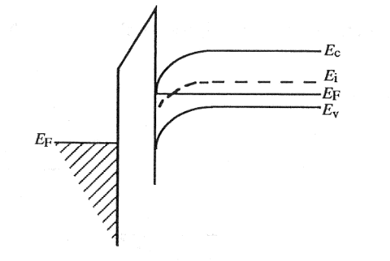

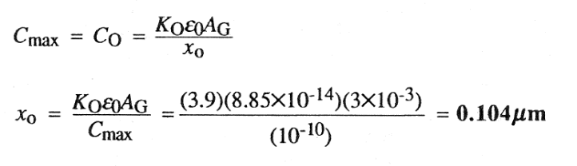

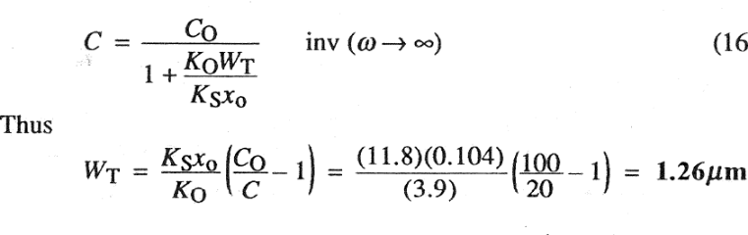

Q5. An MOS-C is maintained at T = 300 K, x_{o} = 0.1 µm, and the silicon doping is
N_{A} = 10¹⁵/cm³. Compute:
- φ_{F} in kT/q units and in volts.
- W when φ_{S} = φ_{F}.
- ξ_{S} when φ_{S} = φ_{F}.
- V_{G} when φ_{S} = φ_{F}.

Soln:

