Training vs. Testing
Laboratory Exercise 5

Antonio, Daniel
Electronics and Communications Engineering Department
De La Salle University - Manila
Manila, Philippines

Eco, Lance Randall Lim
Electronics and Communications Engineering Department
De La Salle University – Manila
Manila, Philippines
lance_eco@dlsu.edu.ph

Tan, Sidney Sheldon Urlanda
Electronics and Communications Engineering Department
De La Salle University - Manila
Manila, Philippines
sidney_tan@dlsu.edu.ph

Zarzoso, Aaron John Pascua
Electronics and Communications Engineering Department
De La Salle University - Manila
Manila, Philippines
aaron_zarzoso@dlsu.edu.ph

Abstract—This document represent the students’ lab report for experiment 5 of the course LBYCP29. It contains the procedures done in the implementation of training vs testing
Keywords—github; training; testing; validation; data, example; instances;

Introduction

Training data is basically defined to be a data wherein the labels are given which means that the data is given and is known. Meanwhile, for testing data or test data, the information is known however it is not given.

In a data set, we can either train or test data which would correspond to a training set of we choose to train data while test set should we choose to test data. A training set is being put into effect in order to accomplish the task of developing a model. Meanwhile, a test set which can otherwise be called a validation of data based from its definition of validation is used to validate or test the model that is being developed. This means that the points of the data in the training set are being rejected from the test set. In each iteration, the data set is divided into a training set and a validation set. In every cycle the data set is further divided or separated into a training set, a validation set and a test set.

Instructions/procedure

Procedure
- The data is loaded from housing.data. An extra ‘1’ feature is added to the dataset so that θ1 will act as an intercept term in the linear function.
- The examples in the dataset are randomly shuffled and the data is then split into a training and testing set. The features that are used as input to the learning algorithm are stored in the variables train.X and test.X. The target value to be predicted is the estimated house price for each example. The prices are stored in “train.y” and “test.y”, respectively, for the training and testing examples. You will use the training set to find the best choice of θ for predicting the house prices and then check its performance on the testing set.
- The code calls the minFunc optimization package. minFunc will attempt to find the best choice of θ by minimizing the objective function implemented in linear_regression.m. It will be your job to implement linear_regression.m to compute the objective function value and the gradient with respect to the parameters.
- After minFunc completes (i.e., after training is finished), the training and testing error is printed out. Optionally, it will plot a quick visualization of the predicted and actual prices for the examples in the test set.

Data and results

Procedure
1. Code:
% load housing data from file
data=load(housing.data);
data=data;
data=[ones(1,size(data,2));data];

% Shuffle.
data=data(:, randperm(size(data,2)));
% last row is median home price.
% train and test sets
train.X=data(1:end-1,1:400);
train.y=data(end,1:400);
test.X=data(1:end-1,401:end);
test.y=data(end,401:end);
m=size(train.X,2);
n=size(train.X,1);
% coefficient vector theta (random).
theta=rand(n,1);

tic;
options=struct('MaxIter',200);
theta=minFunc(@linear_regression,theta,options, train.X,train.y);
fprintf('Optimization took %f seconds.\n', toc);

% predicted prices and actual prices.
actual_prices=train.y;
predicted_prices=theta'*train.X;
% RMS training error.
train_rms=sqrt(mean((predicted_prices - actual_prices).^2));
fprintf('RMS training error: %f\n',train_rms);
% RMS test error
actual_prices=test.y;
predicted_prices=theta'*test.X;
test_rms=sqrt(mean((predicted_prices - actual_prices).^2));
fprintf('RMS testing error: %f\n',test_rms);

% predictions.
plot_prices=true;
if (plot_prices)
[actual_prices,I]=sort(actual_prices);
predicted_prices=predicted_prices(I);
plot(actual_prices,'rx');
hold on;
plot(predicted_prices,'bx');
legend('Actual Price','Predicted Price');
xlabel('House #');
ylabel('House price ($10005)');
end
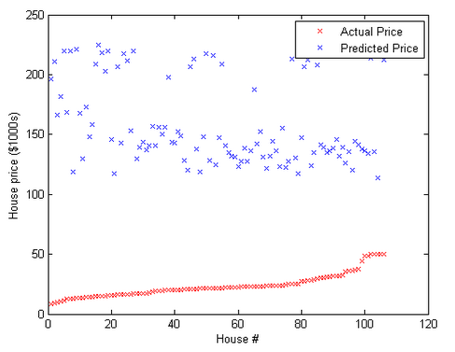
Fig. 1. Initial data plot of house number vs house price.
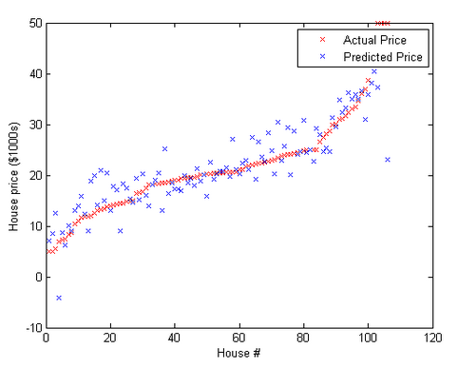
Fig. 2. House number vs house price undergoing .

problem
- Fill in the linear_regression.m file to compute J(θ) for the linear regression problem as defined earlier. Store the computed value in the variable f.
Code:
for i=1:m
f=f+0.5*(y(i)-theta’*X(:,i))^2;
g=g-(y(i)-theta’*X(:,i))*X(:,i);
end

analysis and conclusion
In this experiment, the students was able to make use of the octave software in order to use linear regression to be able to simulate or run the training and testing. Last experiment, the group were able to do the training but the testing part is done in this experiment. The experiment simulate the training data to a different test data which permit the users to recognize the training set relates to the testing set. In addition, this could be the amount on how precise the machine learning algorithm. In conclusion, the group were able to run the simulation of the experiment successfully by finding the lost algorithm in the linear regression which is comparable but in a for loop.

References

- MathWorks. (N.A.). MATLAB - The Language of Technical Computing. [Online]. Available: http://www.mathworks.com/
products/matlab/
- Eaton, J. (N.A.). About GNU Octave. [Online]. Available: https://www.gnu.org/software/octave/about.html
- Andrew Ng. Stanford University, CS 229. Machine LearningCourse Materials. [Online]. Available: http://cs229.stanford.edu/materials
.html

