**7-2 Project Two**

Aaron Ciminelli

SNHU

CS-340-T3341 Client/Server Development 23EW3

Hari Paruchuri, Adjunct Professor (M.S, MBA)

February 19, 2023

1. **Grazioso Salvare logo and a unique identifier containing my name.**



1. **Create the Data Table for the Animal Center, The Retrieve all button will bring in the Data.**

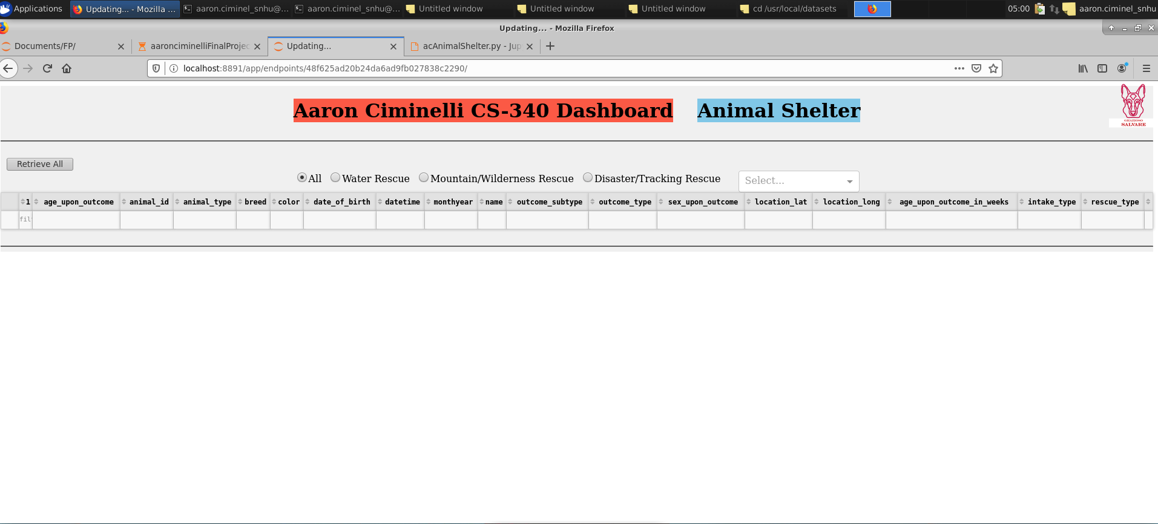

After the button is pressed the data will populate. (the Retrieve all button will also reset all filters)

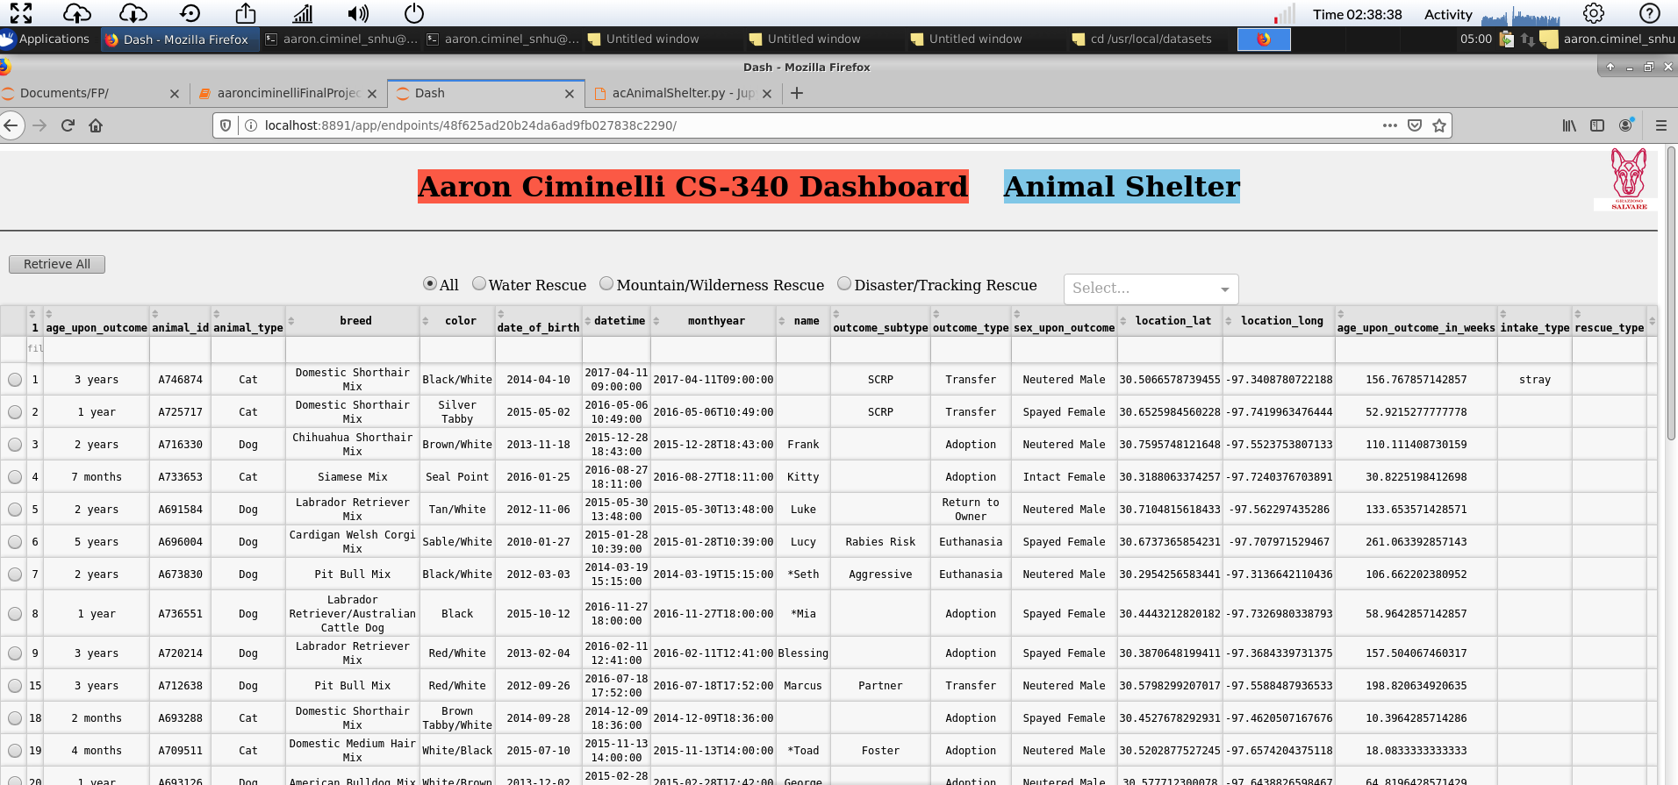

Optional features.

* Selectable Rows
* Cells can be filtered using user imputed values
* Cells can be sorted in ascending or descending order
* Only 20 rows are displayed, the page starts at 1

1. **Database queries that match the required filter functionality**
   1. **Show All**

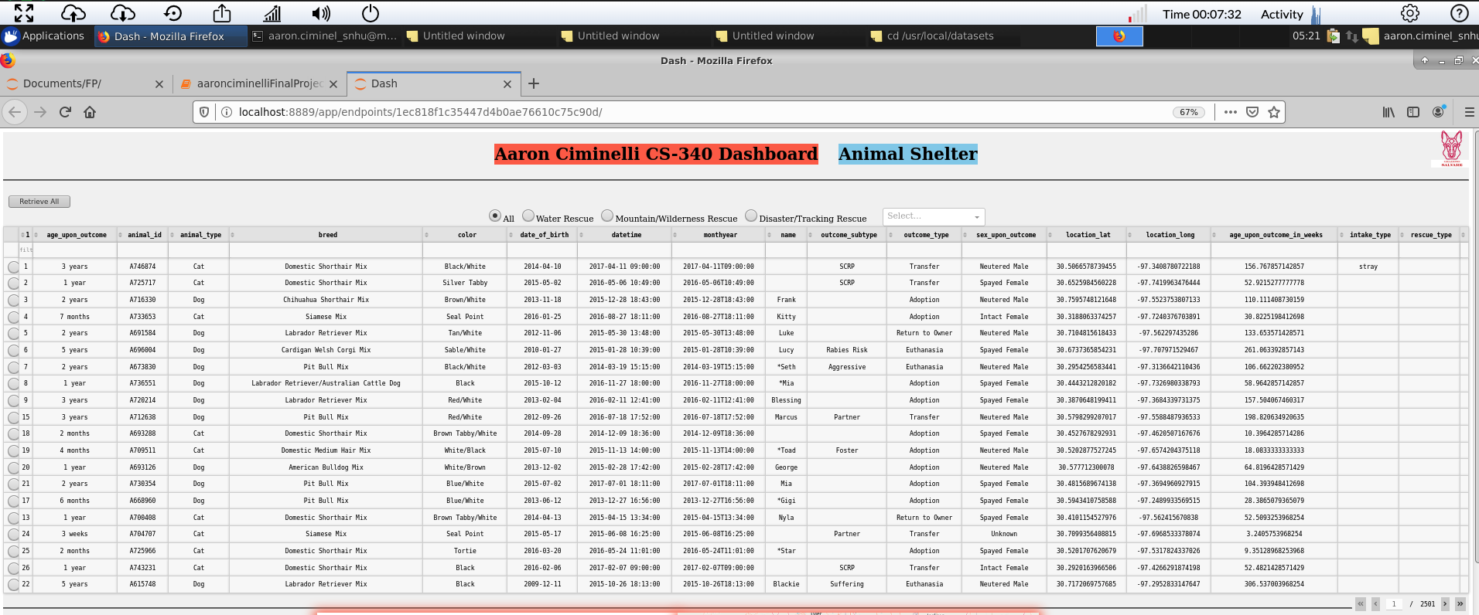

* 1. **Water Rescue**

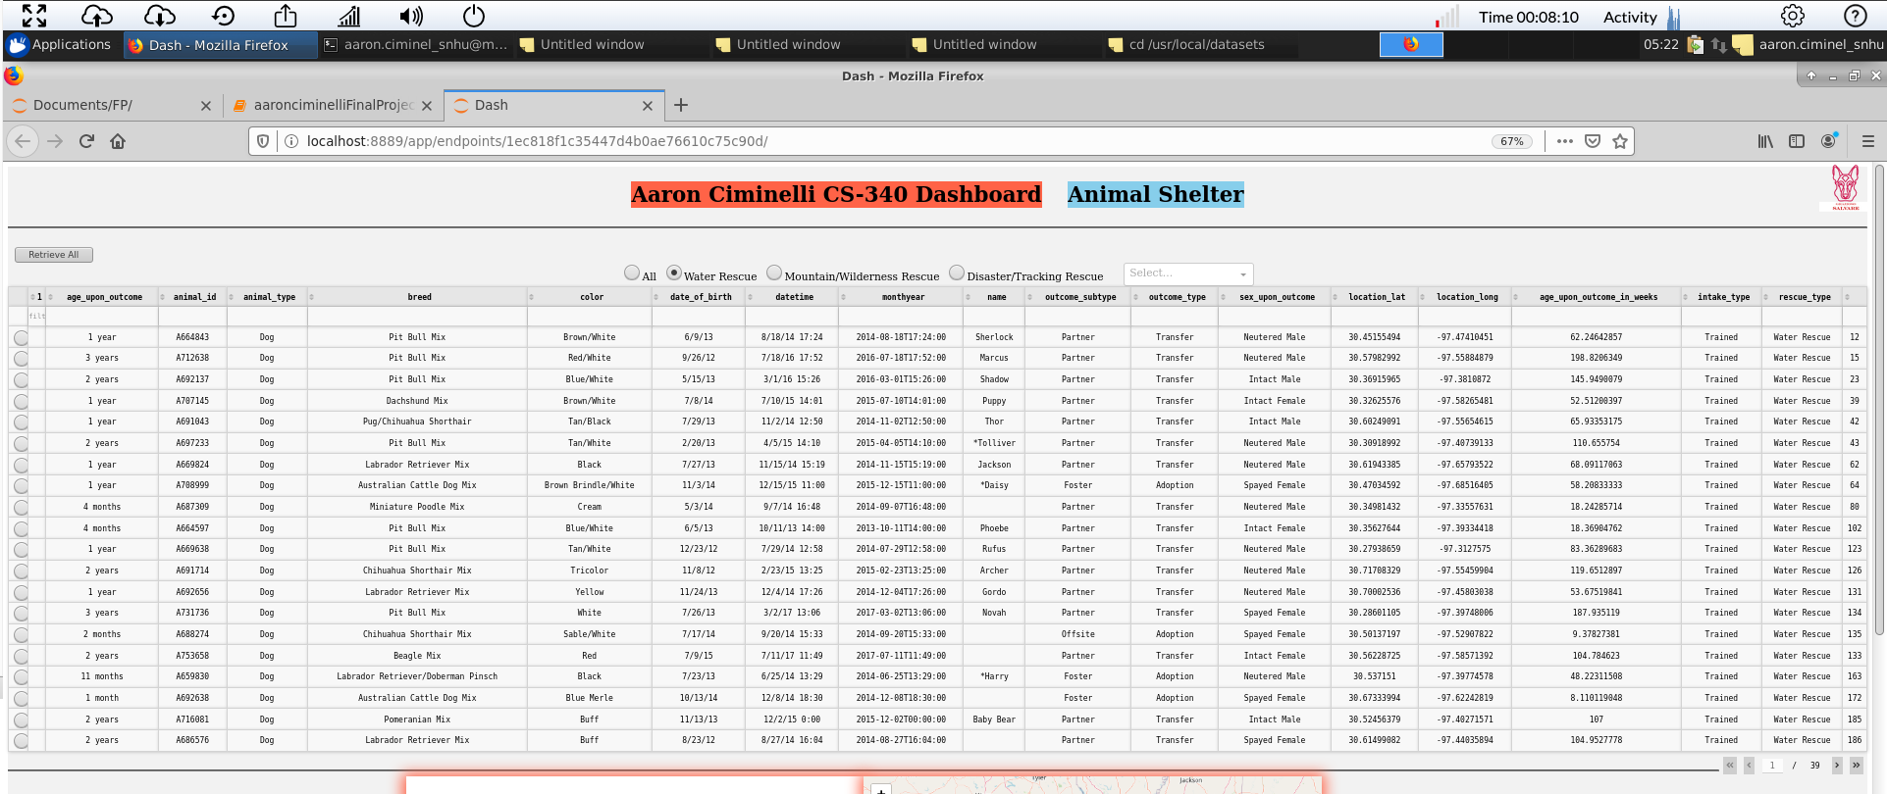

* 1. **Mountain/Wilderness Rescue**

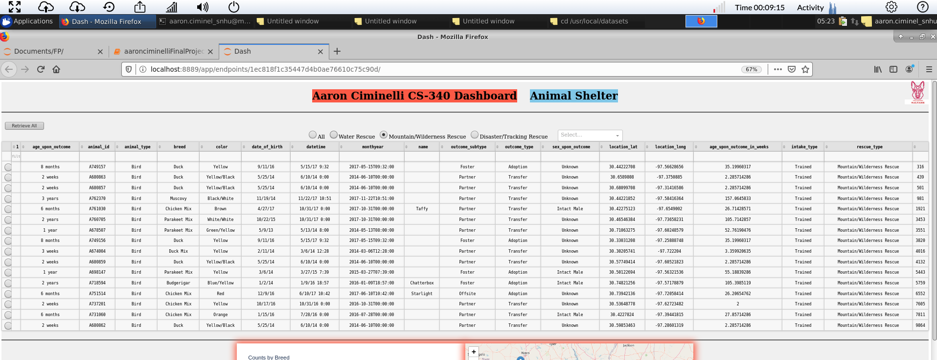

* 1. **Disaster/Tracking Rescue**
  2. 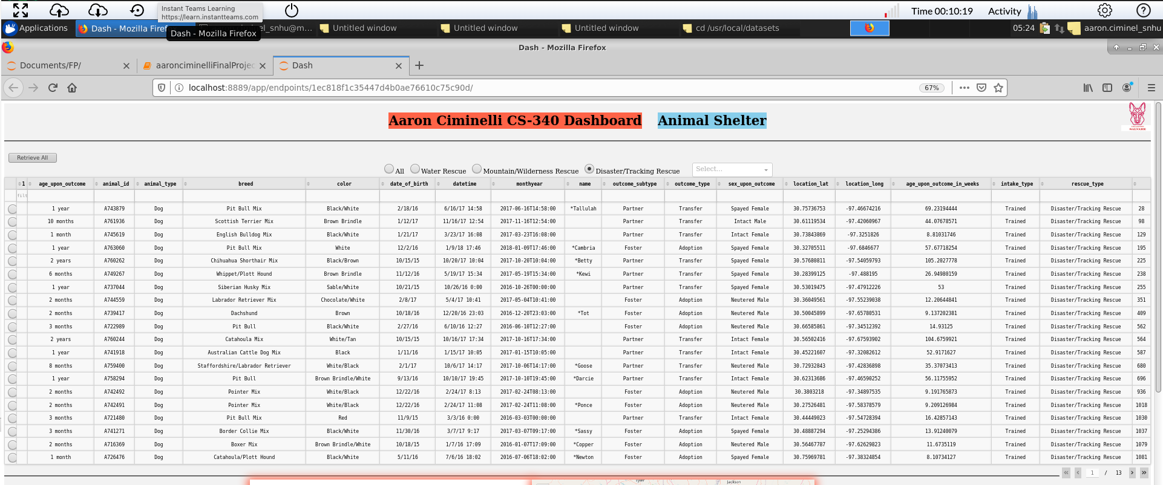**Utilize your previous CRUD Python module (a PY file)**

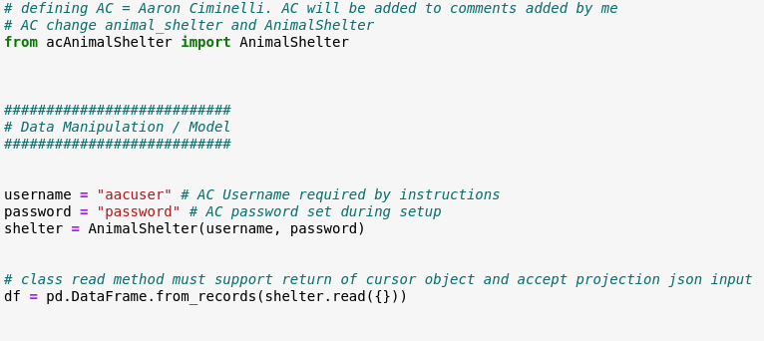

1. **Required interactive map**

**Starts at first animal in row**

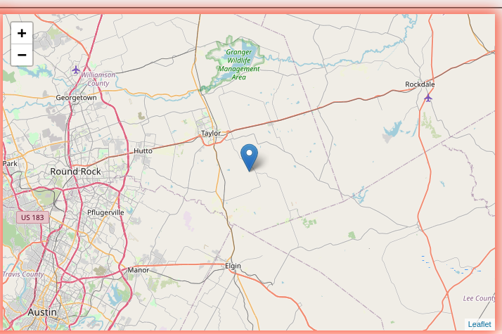

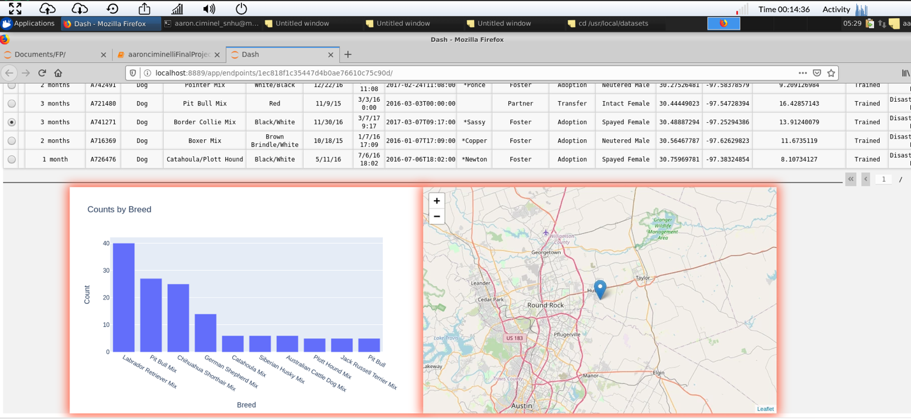

**Location of pin changes when another animal is selected.**

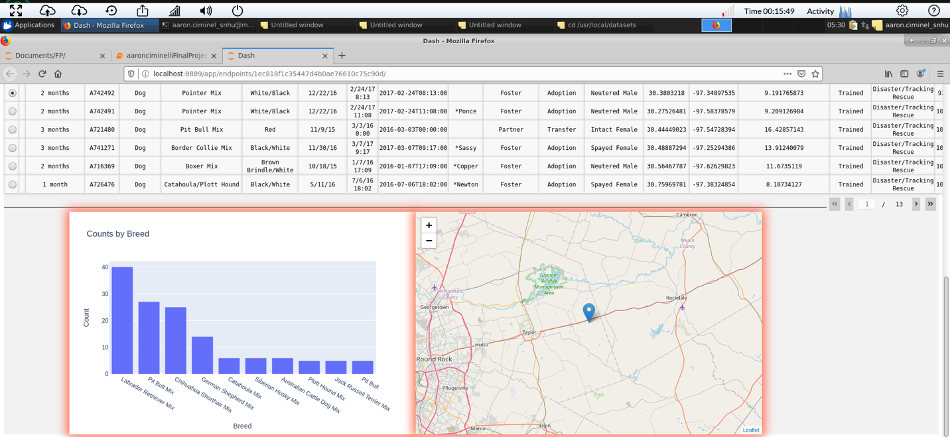

**The pin has a popup display with a description of the breed**

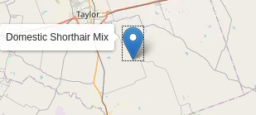

**The Chosen Graph displays the top most common breed in the Animal Shelter**

