1. create an interactive data table

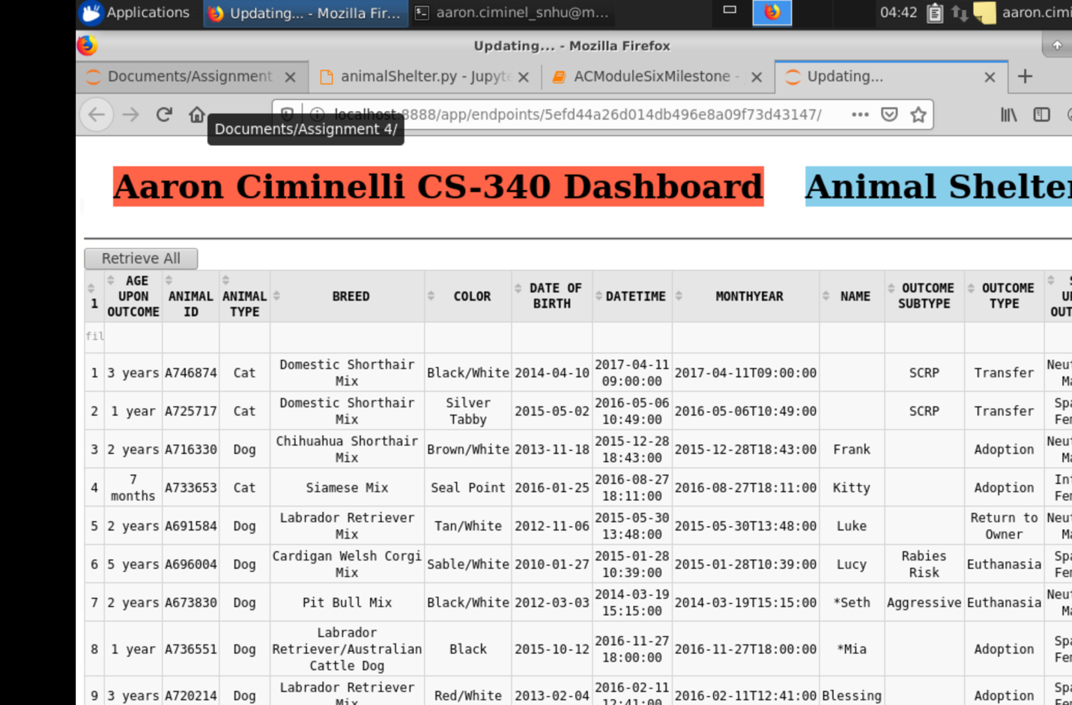

2. **Add a geolocation chart that displays data from the interactive data table**

