# CS 340 README Template

## About the Project/Project Title

The project is a dashboard application that provides information on animal rescues and shelters. The dashboard is built using the Dash framework and the MongoDB database. The data is displayed in a variety of interactive charts and tables, allowing users to easily filter and sort the data to better understand the information being presented. The dashboard includes a bar chart of the top 10 animal breeds by count, a map that displays the location of a selected animal, and a data table that provides information on all of the animals in the shelter.

## Motivation

The motivation behind the creation of this project is to provide a user-friendly and interactive interface for animal shelters and rescue organizations to manage and display their data. The use of MongoDB as the database provides a flexible and scalable solution for storing and retrieving the data, while the Dash framework provides the necessary functionality for creating a dynamic and interactive dashboard. By using these tools, the project aims to improve the visibility and accessibility of information on animal rescues and shelters, helping to bring attention to the efforts of these organizations and the animals they serve.

## Getting Started

1. Install the necessary software and dependencies:
   1. Python 3.x: https://www.python.org/downloads/
   2. Dash: https://dash.plotly.com/installation
   3. Plotly Express: https://plotly.com/python/plotly-express/
   4. Pymongo: https://api.mongodb.com/python/current/installation.html
   5. Jupyter Notebook: https://jupyter.org/install
2. Clone the repository to your local machine using the following command in your terminal:

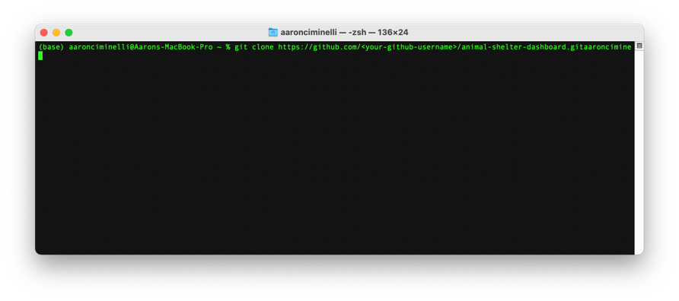

Open the AnimalShelter.ipynb file in Jupyter Notebook and run the cells to launch the dashboard.

## Usage

### Code Example

The table in the code example works by displaying data from an animal shelter database. The data can be filtered by rescue type using a radio button, and by breed using a dropdown menu. The table displays selected columns from the animal shelter data, and allows for filtering, sorting, and selecting rows. The table also updates to show only the data that meets the filter criteria selected by the user.

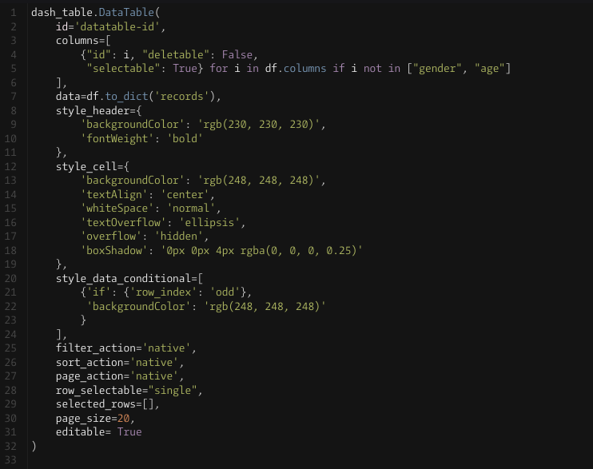

for instance if brown is typed in the “color” cell the data table will show all animals with a brown color.

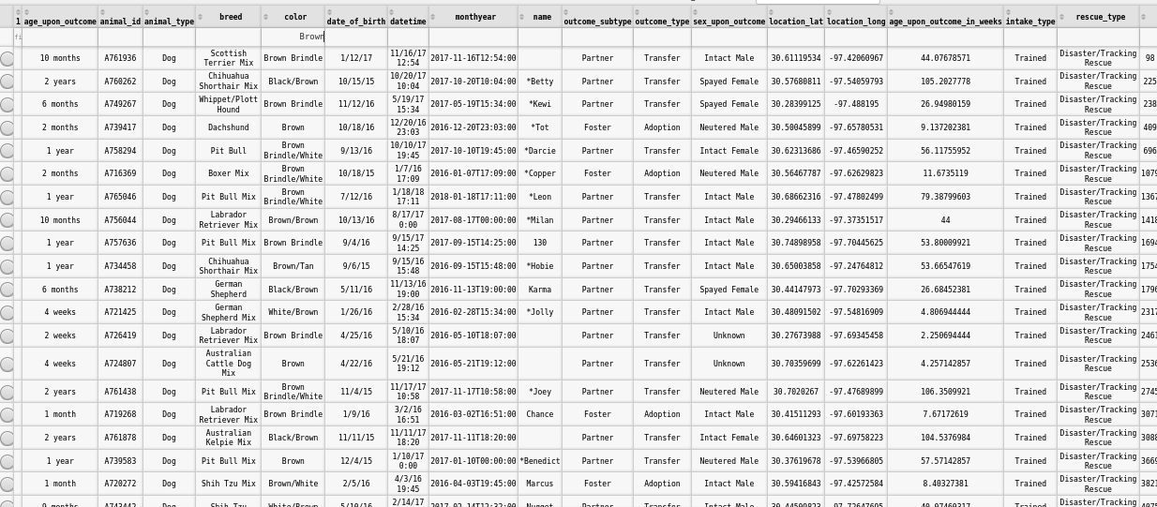

### Tests

This code example shows how to interact with an AnimalShelter class, which provides a simple way to manage a collection of animal information. The example starts by importing the AnimalShelter class and creating a test instance using a username and password.

The example then uses the create method to insert a new animal into the collection, storing the result for later inspection. The read method is then used with a key-value lookup to retrieve the newly created animal from the collection and print its information.

Next, the update method is used to modify the age of the animal, and the read method is used again to verify the update was successful.

Finally, the delete method is used to remove the animal from the collection, and the read method is used one last time to show that the animal is no longer present in the collection.

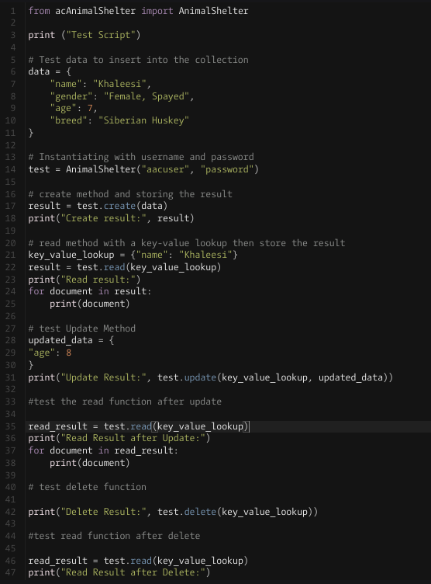

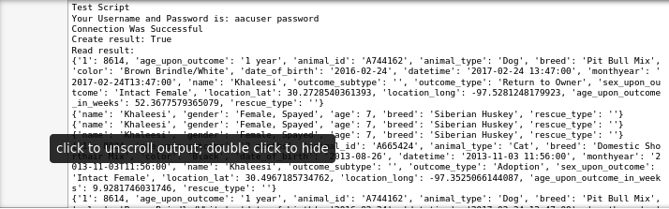

## Contact

Your name: Aaron Ciminelli

Email: [aaron.ciminelli@snhu.edu](mailto:aaron.ciminelli@snhu.edu)