Explaining Process Outcomes with interox
Tutorial: the rule-induction notebook, using the sepsis event log
This tutorial shows you how to use the interox notebook to explain an outcome of a process with a small set of readable rules. It uses one running example: why do some sepsis patients end without a recorded release from the hospital? It shows you the tools, not the answer; screenshots that would reveal it are blurred. What exactly you have to submit is described in your assignment sheet.
The sepsis notebook is for learning the tools. The assignment uses the Road Fines notebook in the same repository, which works the same way: the same four parts and the same cells, only the log and the outcome differ.
Section 1, 2, … refers to this tutorial; notebook Part 1 to 4 and notebook cell 1.2, 3.3, … refer to the numbered headings in the notebook.

1 The example
The Sepsis Cases event log (Mannhardt, 4TU.ResearchData, 2016) records 1,050 patient visits in a Dutch hospital, from registration at the emergency room (ER) to discharge. It has 16 activities: three ER steps (ER Registration, ER Triage, ER Sepsis Triage), three lab tests (Leucocytes, CRP, LacticAcid, each carrying the measured value), IV Liquid and IV Antibiotics, admission to a normal ward (Admission NC) or intensive care (Admission IC), five anonymised kinds of discharge (Release A to Release E), and Return ER when a patient comes back later. Events carry attributes, e.g. the department (org:group), and at ER Registration the age, an anonymised diagnosis and about twenty yes/no triage findings.
About one in four cases has no release activity at all. These cases are the outcome to explain. The notebook calls them positive (part of the outcome) and all others negative; "positive" says nothing about whether the outcome is good for the patient.
Watch out: the one thing to keep in mind
An explanation that uses the answer is not an explanation. Some features are computed from the very thing you want to explain, or only exist because of it. Rules built on them score perfectly and say nothing. Finding and excluding these features is part of the work (Section 4).

2 Setup
- Install uv and git, then git clone https://github.com/aaronkurz/interox-notebooks and run uv sync in the new folder interox-notebooks.
- Download the "Sepsis Cases – Event Log" from 4TU.ResearchData (https://data.4tu.nl/articles/dataset/Sepsis_Cases_-_Event_Log/12707639), unpack it if needed, and save it as logs/SepsisCases2020EventLog.xes inside the repository. For the assignment you also need the Road Fines log (logs/Road_Traffic_Fine_Management_Process.xes); the README says where to get it.
- Start the notebook with uv run marimo edit rule_induction_sepsis_marimo_iox.py and click the yellow Run button at the bottom right to run all cells.
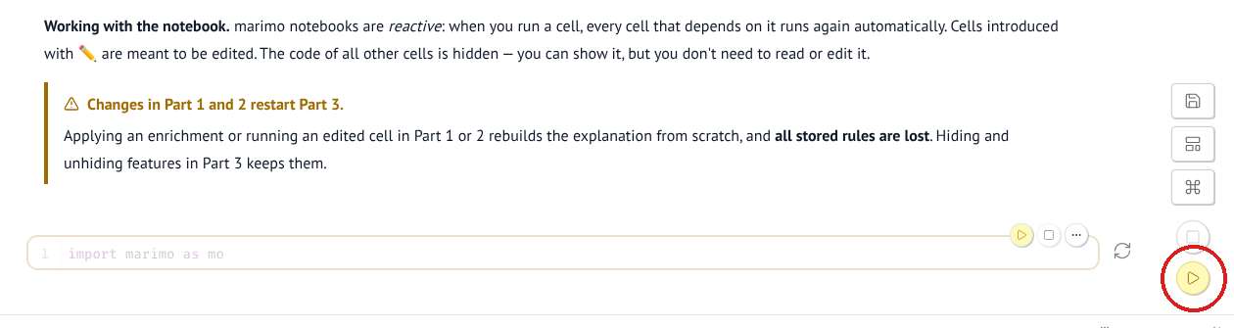
The circled button runs all cells.
The notebook is reactive: when a cell changes, every cell that depends on it runs again. Cells marked ✏️ (a pencil symbol) are meant to be edited; the code of the other cells is hidden (you can also edit it though, by clicking on the hidden cells).
Notebook part | What you do there
Part 1 Prepare the data | Load the log (1.1); add event attributes in code (1.2); turn events into one row per case with the enrichment widget "Log enrichment" (1.3); add case features in code (1.4); encode features for rule induction (1.5)
Part 2 Define what to explain | The outcome (2.1); choose the cases to analyse: restrict to a baseline population or remove cases you have already explained (2.2)
Part 3 Explain interactively | Status (3.1), hidden features (3.2), suggested and stored rules (3.3), rule builder (3.4)
Part 4 Inspect cases | Browse cases (4.1), compare timelines (4.2), read one case (4.3)

3 A first look
Notebook cell 3.1 shows the explanation status: positive cases on the left, your stored rules in the middle, what they claim on the right. With rules stored, a positive case is explained (TP) if a stored rule claims it and remaining (FN) if not; a negative case a rule claims is wrongly claimed (FP). Precision = TP / (TP + FP), recall = TP / (TP + FN).
Notebook cell 3.3 shows rules that a rule-induction algorithm (RIPPER) suggests for all cases no stored rule claims yet. Rule names are random word pairs.
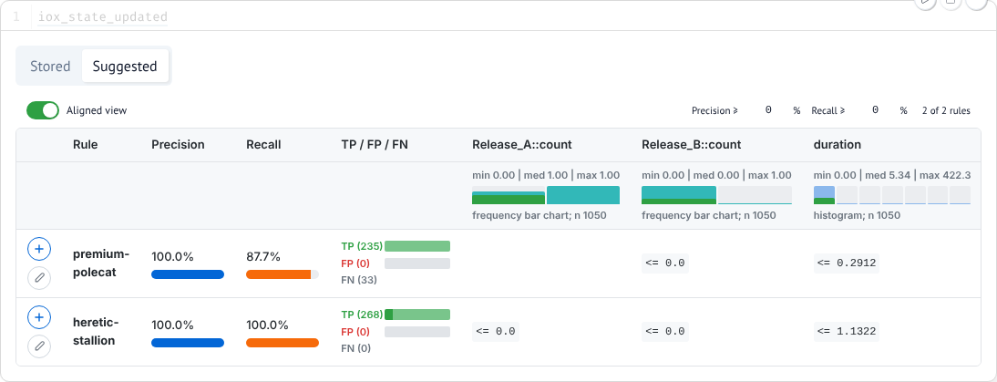
Suggested rules right after running the notebook, with nothing hidden.
Think about it
The second rule claims all positive cases and no negative one. Read its conditions in plain words. Why is it so good, and what would you learn about the patients if you accepted it? Is duration a fair feature?

Before that, it helps to read a few cases yourself. At the very end of the notebook, cell 4.3 shows any case as a timeline and as a table of its events with all attributes. Look at a released case, one with Return ER, and an unresolved one. To find case ids, use notebook cell 4.1: choose "the whole" case log with "cases that are part of the outcome" (unresolved) or "cases that are not part of the outcome" (released) and press Show; the first column of the table is the case id. Sort the released cases by Return_ER::count to find one with a return. Then type the id into the case picker of cell 4.3.

4 Hiding features that give the answer away
Apply these four questions to the features of a rule before you accept it, and whenever a suggestion looks too good:
- Definition: is the feature computed from the activities that define the outcome?
- Removal test: delete the release event of a resolved case in your head. Would the feature change?
- Timing: can the feature only be known, or only take certain values, after the outcome?
- Trace size: does it mainly measure how long or large the recorded trace is?
A "yes" means: hide the feature, or argue why it is still fair. To hide features, use the Hidden features list in notebook cell 3.2: tick them (type to search), close the list and press Apply. The suggestions are induced again without them; stored rules stay.
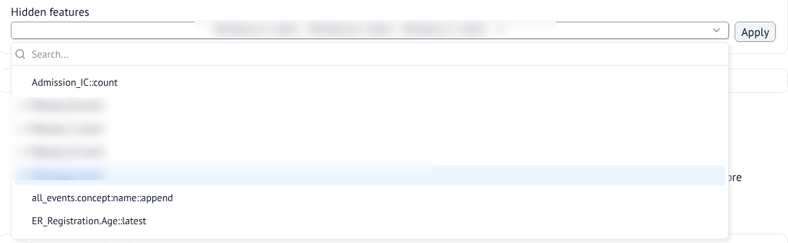
Notebook cell 3.2: choosing features to hide (names blurred).
Try it
Hide features step by step and check the new suggestions after each Apply. Hiding one giveaway often makes the next one visible. Note for each hidden feature why you hid it.

Tip: keep the list across restarts
Show the code of the hidden cell iox = InterOX(outcome, filtered_case_log) in notebook Part 3 and pass your list: InterOX(outcome, filtered_case_log, hidden_feats=['Some::count', r'Prefix_.*']). Entries are names or regular expressions.

5 Adding features
By default the case log has start_time, end_time, no_of_events, duration, one count per activity (e.g. CRP::count) and the variant (the sequence of activities). Patient information sits in event attributes. To use it, open the Case log tab of the enrichment widget (notebook cell 1.3):
- Attribute tracking: pick an event type and an attribute, then an aggregation: latest (last value, e.g. age at registration), max/min/sum (numbers, e.g. highest CRP), count, append (all values as a sequence) or is_unique.
- First/last occurrence: time from the case start to the first (::start) or last (::end) occurrence of an activity. Activity delays: time between two activities.
- Preview sample cases checks the staged features on five cases; Apply enrichments adds them for all cases.
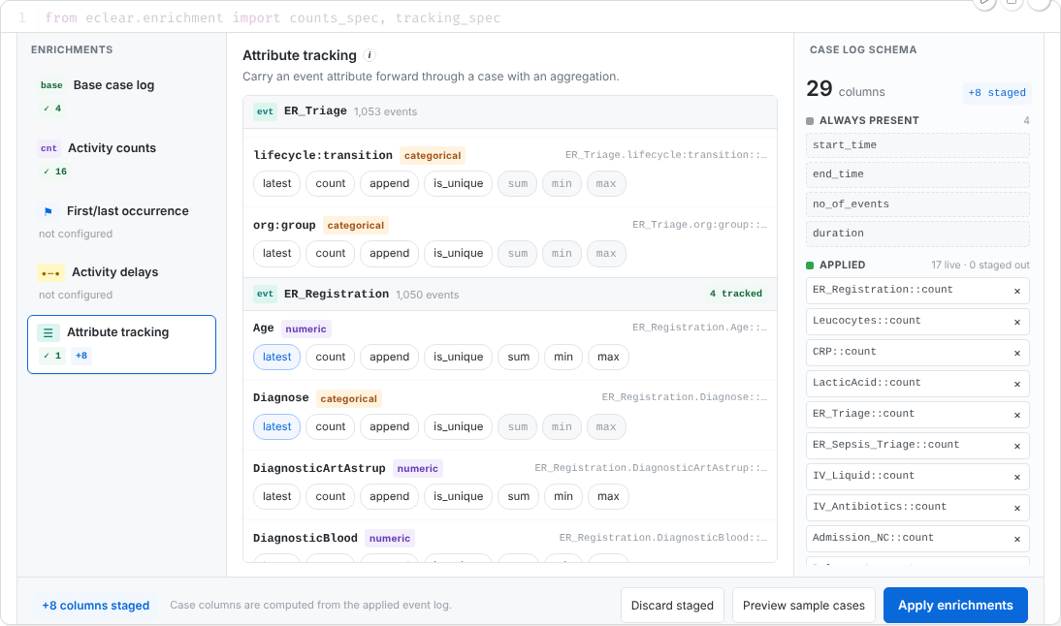
Enrichment widget, Attribute tracking: two attributes of ER_Registration staged (blue).
Watch out: Apply resets notebook Part 3
Applying enrichments rebuilds the explanation: stored rules and hidden features are lost. Add the features you need early, or, before you change the enrichments, note down your stored rules or write them into notebook cell 2.2 so that the cases they explain stay removed (Section 7). New features can be giveaways too (e.g. All first / All last includes the release activities).

Event attributes in code (notebook cell 1.2)
Some event attributes are easier to write in pandas than to click together in the widget, e.g. a formula over several attributes or a running value along a case. Add them as columns to custom_event_log in cell 1.2. They then appear in the enrichment widget like any other attribute: use them on its Event log tab, or track them on the Case log tab (latest, max, …) to get a case feature. For example, the highest CRP value measured so far, which you can then track as CRP.crp_so_far::latest:
custom_event_log = custom_event_log.sort_values(
['case:concept:name', 'time:timestamp'])
_by_case = custom_event_log.groupby('case:concept:name')
custom_event_log['crp_so_far'] = _by_case['CRP'].cummax()

Case features in code (notebook cells 1.4 and 1.5)
You can also compute case features in pandas in notebook cell 1.4 (case_log has one row per case, enriched_event_log the events). That cell re-runs on every Apply. Cell 1.5 converts timestamps to days since 1970-01-01 (convert back with pd.Timestamp(0) + pd.Timedelta(days=x)) and missing text to the category missing_value. To keep widget enrichments after a restart, add them to initial_specs in the hidden code of cell 1.3, e.g. tracking_spec('Age', 'latest', 'ER Registration').

6 Building the explanation
A rule is a set of conditions that must all hold (AND). Your explanation (the stored ruleset) is a set of rules of which at least one must fire (OR), i.e. a formula in disjunctive normal form, which the status widget shows as R0 ∨ R1 ∨ …. Adding a condition makes a rule narrower; adding a rule makes the explanation wider. Each rule should describe one group of positive cases on its own.
To store a suggested rule, click +, write a short note on what the rule means and why you accept it, and press Store rule. The status and the suggestions update for the cases that are still unclaimed. In the Stored tab, the bin icon removes a rule and the speech bubble shows its note. Aligned view off lists all conditions of a rule in one cell, which is easier to read.
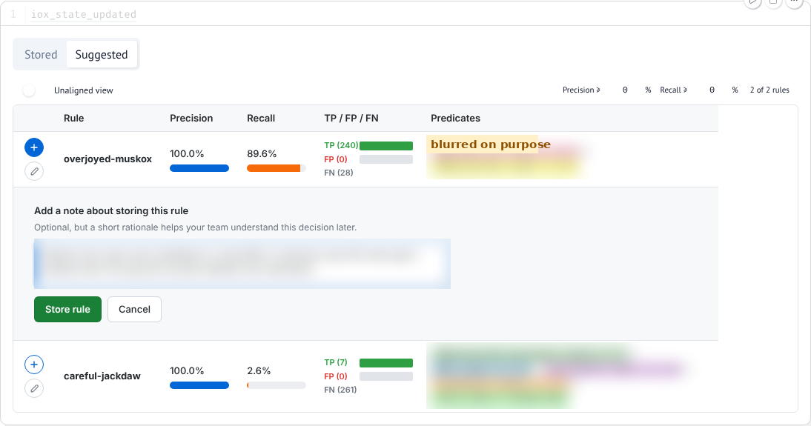
Storing a suggested rule with a note (blurred).
Think about it: before you store
Can you say in one sentence what the rule means? Do its features pass the four questions? How many cases does it claim wrongly? A rule with four conditions for three cases, or with a narrow start_time window, usually describes noise.

The rule builder (notebook cell 3.4)
The rule builder works on the unclaimed cases. Click an attribute on the left (sorted by importance) to add a condition card, then drag the handles or type bounds (numbers) or click values (categories). Evaluate shows precision and recall. Attribute importance shows each condition’s unique removal impact: the cases the rest of the rule would claim but this condition keeps out. The pencil icon of a suggested rule loads it into the builder, which is the easiest way to simplify it.
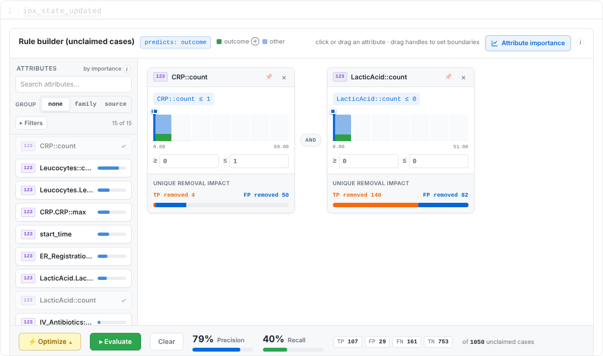
A rule with two conditions, evaluated, with the removal impact of each condition.
Optimize lets the algorithm improve the rule under your constraints. Pin an attribute (pin icon on its card) to keep it in the rule with bounds chosen by the optimizer; on a pinned card, close a lock to keep a bound exactly; add attributes to Never use in the Optimize panel to exclude them. Then press ⚡ Run optimize in that panel, evaluate, adjust and repeat. Without any pin or Never use, Run optimize is greyed out.
Try it
Store rules one at a time, each with a note, and look at the remaining cases in between. Use the rule builder at least once, e.g. to simplify a long suggestion or to test your own idea with Optimize.

7 Checking rules against real cases
Numbers can mislead. Notebook Part 4 shows the cases behind a rule.
- 4.1 Browse: choose a base (all or unclaimed cases), an outcome filter and optionally a rule, then Show to get a table of the cases with all features.
- 4.2 Compare timelines: each case is a row, each event a marker by hours since the case started. Tick Compare against a second group. Drag to zoom, double-click to zoom out, click an activity in the legend to show or hide it.
- 4.3 Read one case: all events and attributes of a single case.
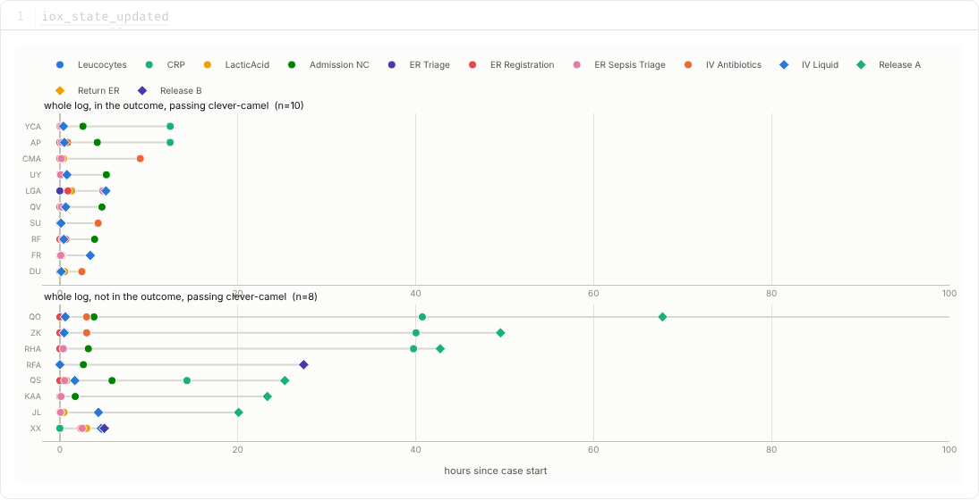
Notebook cell 4.2: cases a rule claims correctly (top) and wrongly (bottom), zoomed to the first 100 hours.
Try it
For a stored rule with wrongly claimed cases, compare Group A (positive, passing the rule) with Group B (negative, passing the rule). Why do the wrongly claimed cases pass? How could the rule leave them out? Then compare the remaining positive cases with the unclaimed negative ones: is there a feature that would capture the difference?

Notebook cell 2.2 decides which cases are analysed at all. Use it to restrict the analysis to a baseline population (in Road Fines, e.g. only the fines that could still be sent for credit collection), or, if you are sure about a rule, to remove the cases it explains, which keeps your progress when you add features or restart. Removed cases count neither as positive nor as negative.

8 Keep a record of your findings
The notebook does not save stored rules; they exist only while it runs. Your assignment sheet says what to submit. Keep notes as you go, wherever it is easiest for you: a Markdown cell in the notebook (add a cell, then ⋯ → Convert to Markdown, or write the text in mo.md(r"""...""")), a Word document with screenshots, a text or Markdown file, or paper. Worth noting:
- your final rules with precision, recall and why you consider each one meaningful;
- the features you hid and why (which of the four questions);
- for one rule: what the comparison of its correctly and wrongly claimed cases showed;
- what remains unexplained, and anything surprising you noticed about the data, the explanations or the tool.
To save the whole state (stored rules with notes, hidden features, applied enrichments, the views in Part 4), use the menu at the top right (☰) → Download → Download as HTML. Do this before you close or restart the notebook.

9 Quick reference
Action | Stored rules | Hidden features | Applied enrichments
Hide / unhide features (3.2) | kept | – | kept
Apply enrichments or re-run Part 1/2 cells | lost (cell 2.2 stays applied) | lost (unless in code) | kept
Reload the browser tab | kept | kept | kept (staged ones lost)
Restart marimo | lost (cell 2.2 stays applied) | lost (unless in code) | lost (unless in code)

Problem | What to do
Cells show nothing after opening | Press the yellow Run button at the bottom right
A widget or table is cut off | Hover over the output and click Expand output to show it in full height (or Fullscreen). For the rule table, you can also scroll sideways or switch off Aligned view
start_time, end_time or duration values look odd | Points in time are days since 1970-01-01; durations are in days (0.5 = 12 hours)
The page stops responding | Reload the browser tab (keeps your state); restart marimo only as a last resort

Hints, if you are stuck
- One activity can only happen after a patient was released.
- The variant lists every activity of a case. What does it contain for a released case?
- A release is usually the last event of a case, often days after admission. Would duration and no_of_events of a released case change if its release event were missing?
- Check which activities never occur in positive cases.
- For the few positive cases that remain after your first rule: which department (org:group) admitted them?
- Check for which cases the registration attributes are filled in.

