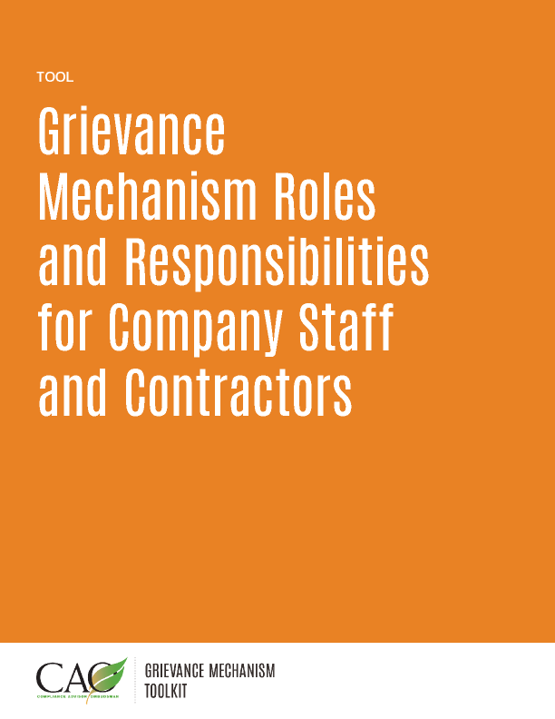

*Last updated: May 2016*

|  |  |
| --- | --- |
| Roles | Responsibilities |
| Grievance Officer | * Informs the public about the grievance mechanism. * Ensures that all individuals with responsibilities under the grievance mechanism are made aware of the existence of the process and receive adequate training. * Receives and reports complaints. * Serves as principal point of contact and liaison with complainants. * Ensures communication with the complainant and follows specified procedures and timelines. * Maintains a log of complaints received. * Resolves complaints that do not need a substantive expert. * Supports the substantive expert, if necessary. * Serves as a liaison between company and third parties, as required. * Monitors resolution of complaints. * Prepares monitoring reports. * Provides feedback on the effectiveness of the grievance mechanism to management. |
| Complaint owner | * Responsible for investigating and resolving complaints.   The complaint owner may be either:   * The Grievance Officer, if the complaint can be resolved with limited additional information expertise or resources; or * A substantive expert, such as a manager from the area of operations implicated by the complaint, if the complaint cannot be easily or quickly resolved by the Grievance Officer. |
| Appeals Committee | * May be composed of company officials that have not been involved with the complaint to date. * May also include or be exclusively composed of other trusted people from outside the company, if an independent view is necessary. * Intervenes when the proposed resolution is not accepted by the complainant and identifies additional actions to address the complaint. * Approves the close-out of complaints when an agreement cannot be reached with the complainant. |
| Contractors | * Understand the basics of the grievance mechanism, having received information about and training in the grievance resolution process from the company. * Assist the complaint owner to manage and resolve complaints in a timely manner when the contractor may be involved. |
| Project/Operation manager | * Approves and is accountable for implementation of the grievance mechanism. * Provides support for implementation of the grievance resolution process and enforcement of specific agreements. |