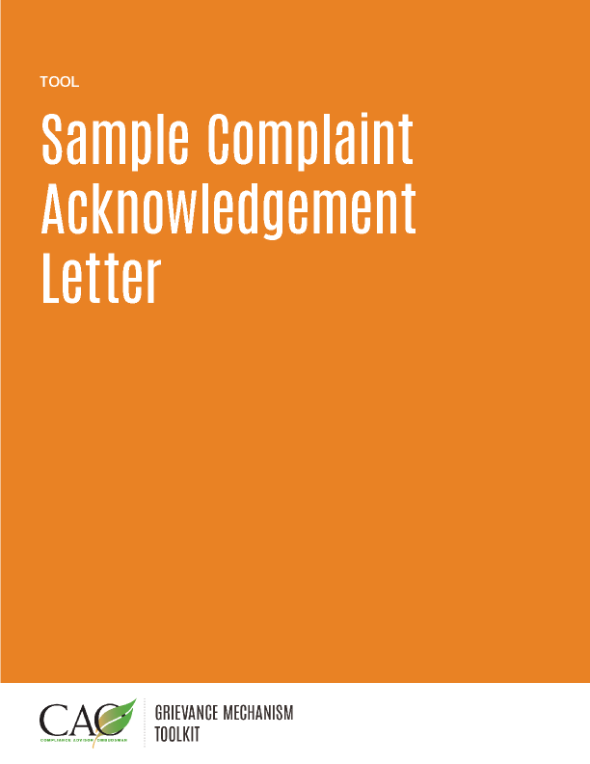

[*Your contact information here*]

[*Date*]

[*Complainant’s name or the name of the organization submitting the complaint if the complainant wishes to remain anonymous*]

[*Complainant’s address or “No physical address*”]

Submitted ______ [*in person or by mail/e-mail/telephone*]

Dear Mr./Mrs./Ms. [*family name of complainant*]:

Re: Complaint regarding [*describe briefly*]

______________ [*name of your company/organization*] acknowledges that we received your complaint dated __________ [*date*]. Our [*company/organization*] takes community concerns seriously, and we thank you for submitting your complaint. We will make every effort to ensure that your complaint is considered quickly and fairly.

Our company has a grievance mechanism process that we follow to consider and resolve complaints. Attached is a description of the process, so you can learn more about it. In accordance with our grievance mechanism procedures, we will determine whether your complaint is eligible for our grievance resolution process and consider next steps, as relevant. We will contact you during this period should we need more information.

You can expect to hear from us within [*xx*][1] business days from the date of this letter.

Please refer to the attached grievance mechanism procedures for more information on what you can expect as we address your complaint, including timeframes, responsibilities, and your rights throughout the process.

Sincerely,

[*Name of senior-level management representative*]

[*Title*]

[*Name of your company/organization*]

Enclosure: [*Any relevant company policies or procedures on submitting grievances*]

1. Generally, the timeframe for the first response to a complainant after receipt and acknowledgement should be between three and five business days. However, there are circumstances where this is not feasible. Examples include complaints involving people living in remote areas without good access to communication channels or a particularly difficult complaint that requires the input of other company or official parties. In such instances, additional time to develop an initial response may be necessary.

   *Last updated: May 2016*