Post Deployment Setup

## Connect VM’s to OMS Workspace

We need to connect the VM’s to the OMS workspace in order to collect stats on the VM’s. This should be done at least 24 hours prior to demo as it will have a chance to collect data.

1. After the deployment has completed, find the resource group you deployed the resources into and click on one of the VM’s
2. From the overview page click on **“Insights (preview)”** under the Monitoring section  
   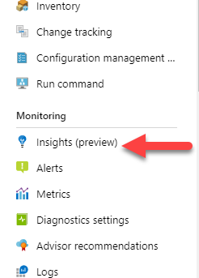
3. Click on the **“Performance”** tab  
   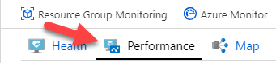
4. On the Azure Monitor Insights Onboarding blade, click on the ***“Choose a Log Analytics Workspace”*** drop down and select the workspace that was created as part of this deployment.
5. Click ***“Enable”***

## Setup Alerts

Setup 2 alerts for use during the demo.

1. Click on the “Resource Group” that was created as part of the deployment
2. Scroll down to ***“Alerts”*** under the ***“Monitoring”*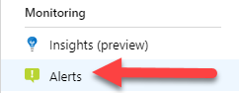**
3. Click on ***“New Alert Rule”***
4. Click ***“Select”*** in the ***“Resource”*** section  
   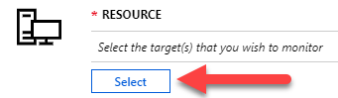
5. Select ***“Load Balancers”*** from the ***“Filter by resource type”*** drop down  
   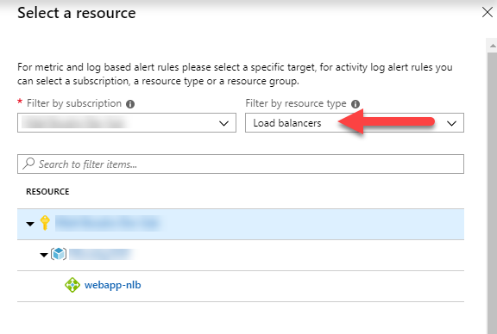
6. Select the ***“webapp-nlb”*** from the list and click ***“Done”*** at the bottom of the ***“Select a resource”*** blade
7. Click the ***“Add Condition”*** button  
   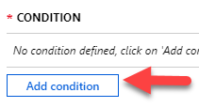
8. From the ***“Configure signal logic”*** select ***”Health Probe Status”***
9. From here you can select the different criteria for your alerts
10. Click ***“Create New” in the Action Groups section***
11. Configure the ***“Action Group”*** as you see appropriate
12. Click ***“Create Alert Rule”*** at the bottom to establish the alert

Stop a Web Server

To trigger the alert you will need to shut down one of the web servers. Shutting down a server from the Azure portal will not work. You will need to RDP into one of the webservers and shut it down via windows. All this will take some time to start to work as the system needs time to build up some data collection.