Step 1 **Install Minetest Locally**

1. Create a folder named DIR
   1. I put it in my c driver under the path C:\users\name
   2. I got several errors from paths having spaces, so don’t choose paths with spaces
      1. If you can’t avoid this refer to the error section at the end for a solution
2. Clone the minetest game from the GitHub master branch
   1. Open the windows command terminal and cd into DIR directory
   2. Type **git clone https://github.com/cacticouncil/minetest.git**
   3. Took a few minutes
3. You may want to delay switching to the spidermonkey branch and pulling the latest code until after building the original minetest game.
   1. We encountered some issues with the debug folder missing files. We had to copy them from the release folder and place them in the debug folder.
      1. Once you link the spidermonkey dll you cannot easily run release as the dll has been configured to run in debug. Thus you won’t be able to get the missing files.
   2. You can skip to step 2, system configuration, then hop to step 4 to execute release x64. Afterwards, come back to Step 1, install minetest locally, number 4.
4. Switch to the GitHub spidermonkey branch
   1. Command **git checkout spidermoneky**
   2. Might be prompted to commit changes / stash them before switching branches
      1. Command **git stash save <folder name containing files to update>**
      2. Command **git pull** to ensure you have the latest code
      3. 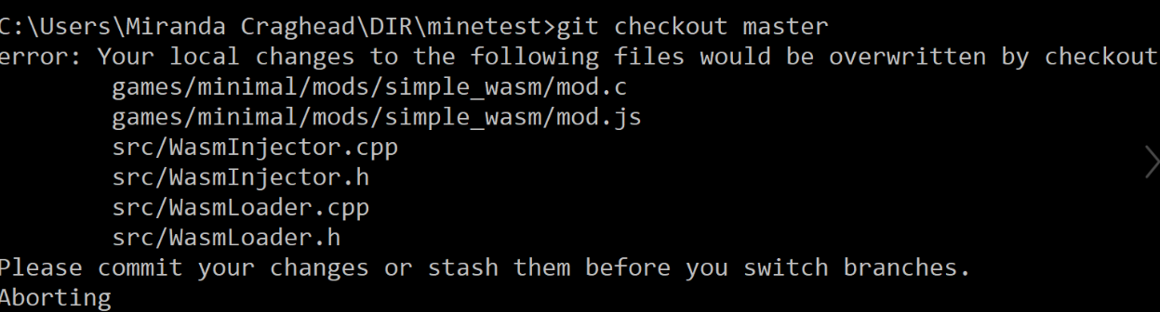Push/pull updates to GitHub as needed

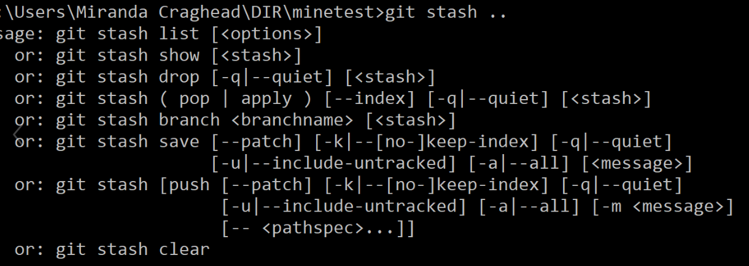



Step 2 **System Setup**

1. Visual Studio 2017
   1. 2019 might have compatibility issues / unresolved errors
   2. URL to older editions of visual studios: <https://my.visualstudio.com/Downloads?q=visual%20studio%202017&wt.mc_id=o~msft~vscom~older-downloads>
   3. I kept the original paths for visual studios, but this is up to you
      1. Although I kept the defaults, I got an error as my visual studios path had spaces in it. Check the error section at the bottom for a solution.
      2. Note I solved the solution in the visual studios command terminal, which can be found by searching command in the windows search box and looking for the name provided below.

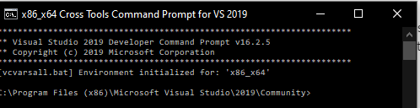

1. CMake
   1. Link to download for x64 [cmake-3.16.0-rc3-win64-x64.msi](https://github.com/Kitware/CMake/releases/download/v3.16.0-rc3/cmake-3.16.0-rc3-win64-x64.msi)
   2. Had compatibility errors with other window versions (X32, X84)
   3. 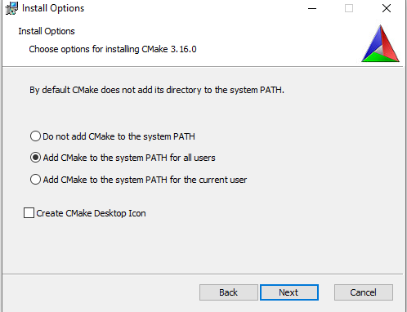Make sure you add CMake to the system path either for all users, or just you
2. Vcpkg
   1. URL: <https://github.com/Microsoft/vcpkg>
   2. Open the windows command line terminal and power shell
      1. I ran the command line terminal from my user/name folder
      2. The DIR/minetest directory exists in my user folder
   3. In the command line terminal type command **git clone https://github.com/Microsoft/vcpkg.git**
      1. PAUSE ANTIVIRUS BEFORE INSTALLING
         1. I had various problems installing vcpkg due to my antivirus that disappeared after pausing during instillation.
   4. In the PowerShell commands
      1. **cd vcpkg**
      2. **.\bootstrap-vcpkg.bat**
      3. **.\vcpkg integrate install**
      4. **.\vcpkg install sdl2 curl**
   5. In the command line terminal type **vcpkg install irrlicht zlib curl[winssl] openal-soft libvorbis libogg sqlite3 freetype luajit --triplet x64-windows**
      1. This step can take some time 10+ minutes
   6. TURN ANTIVIRUS BACK ON

Step 3 **SpiderMonkey Dll Linking**

1. Open CMake GUI
   1. CMake GUI should appear if you search cmake in your Windows search box
2. Configure Cmake
   1. You may need to create a build folder inside minetest folder

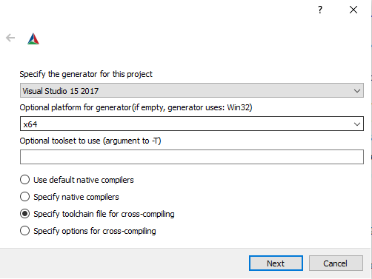

* 1. Click configure
     1. If you aren’t prompted here under files click delete cache then re-click configure

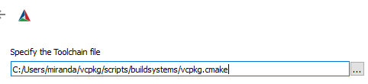

* + 1. Select the vcpkg toolchain file e.g. D:/vcpkg/scripts/buildsystems/vcpkg.cmake
  1. Assuming no errors were generated from configure hit generate
     1. Various warnings are expected
     2. If errors are generated click **file** at the top left corner and select **delete cache**. After this try reconfiguring, and generating. Hopefully the errors will be gone.
        1. 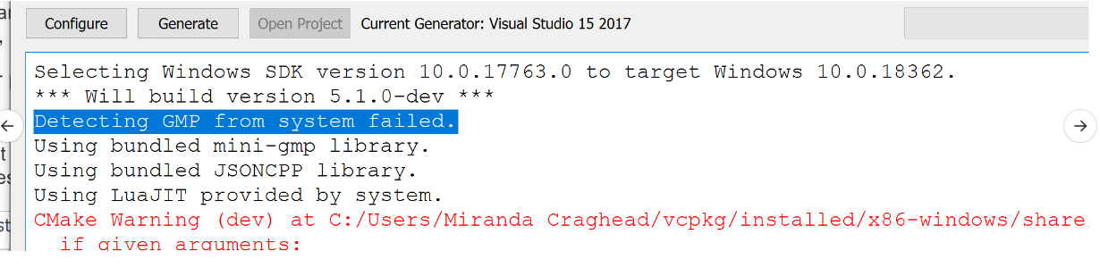The solution above worked for this error
        2. If CMake can’t find SQLITE3, choose "Advanced" box on the right top corner, then specify the location of SQLITE3_INCLUDE_DIR and SQLITE3_LIBRARY manually

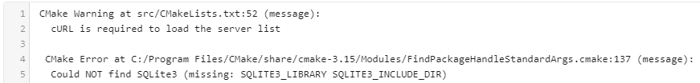

* 1. Hit open project

1. Link the spidermonkey dll
   1. Download Spidermonkey **build_DBG.OBJ** folder **\*\*location** 
      1. I saved it under the path user/name after extract all/unzipping it
      2. The download takes a decent amount of time
      3. Note several team members experienced errors with not getting the entire install for the build_DBG.OBJ, casing errors. File structure provided below to eliminate this error.

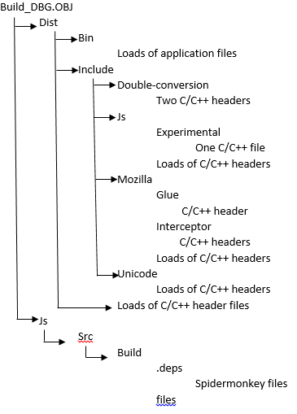

* 1. Visual Studios steps
     1. Replace main.cpp with the updated main.cpp under the Source Files. Link: <https://cacticouncil.slack.com/files/UM999UGL9/FPD1TDGHK/main.cpp?origin_team=T0WGWK859&origin_channel=CFFQURZA9>
     2. Make sure you are on Debug x64 before attempting to link, otherwise you will experience errors.
        1. If you do link in the wrong setting you can try to relink in Debug x64. If the build still generates errors exit Visual Studios and go back to the prior step of Configure CMake.

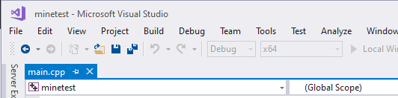



* + 1. At the upper right corner in the solution explore right click minetest and select properties
    2. 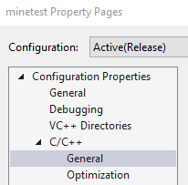On the left option menu **Go to C/C++ 🡪 General 🡪 Additional Include Directories**
       1. Click on **Additional Include Directories** to highlight, then click the down arrow to the right and select edit
       2. Add your path to **build_DBG.OBJ\dist\include** by clicking and then pasting the path.

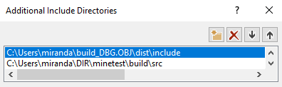

* + - 1. Click ok then apply
         1. Note clicking ok twice will close the window and won’t save your changes. **You need to click apply on the minetest Property Pages.**
    1. Go to **Linker 🡪 Input 🡪 Additional Library Directories**
       1. Click on **Additional Library Directories**, then click the down arrow and select edit.
       2. 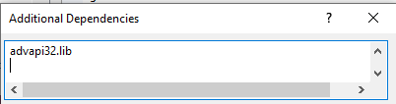Scroll to the bottom of the list and then click enter to add a new space
       3. Paste **mozjs-71a1.lib** Then click ok and apply.
    2. Go to **Linker 🡪 General 🡪 Additional Library Directories**
       1. Click **Additional Library Directories**, then click the down arrow and select edit.
       2. Paste your path to **build_DBG.OBJ\js\src\build** and then click ok and apply.
    3. Go to C/C++ 🡪 Command Line 🡪 Additional Options
       1. Replace **%(AdditionalOptions) /FD** with **–DDEBUG** or just write –DDEBUG if the box is empty
       2. Click apply then ok to exit the minetest Property page

Step 4 **Run the game**

1. Run Local Windows Debugger (Running the Debug version from following the steps above)
   1. If the game builds successfully go to file path **DIR/minetest/bin/Debug** and select **minetest** to open the game
      * 1. 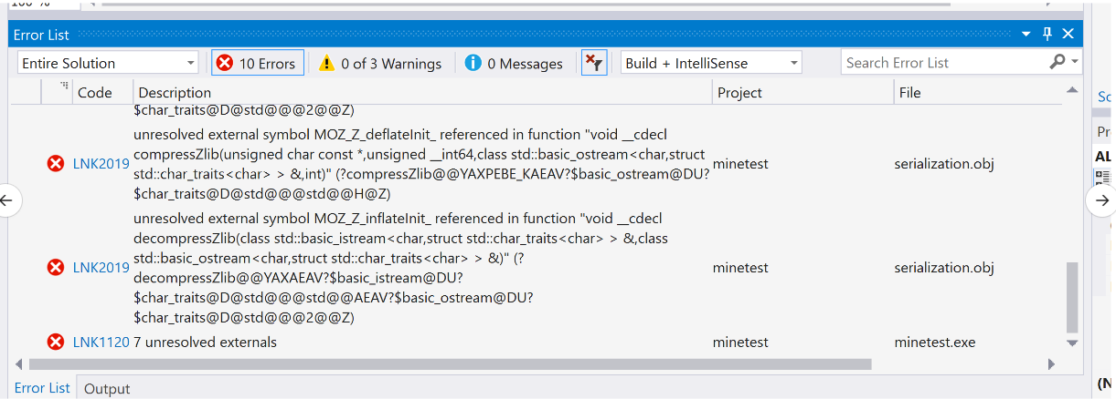If your build results in errors, such as these below the spidermonkey dll didn’t link successfully
           1. **Solution 1**: go back to #3 - link the spidermonkey dll and repeat the steps
           2. **Solution 2:** close Visual Studios and go at Step 3 Spidermonkey dll Linking.

If you get errors in CMake at the top left corner click **file 🡪 delete cache** and then try **configure** again.

Solution 2 is also relevant if you get errors that make no sense such as the ones below.

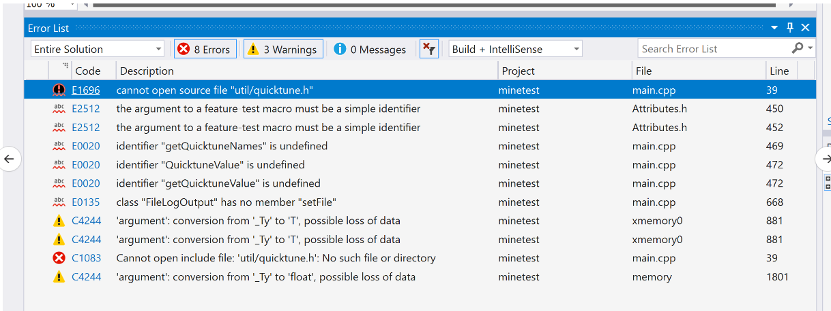

1. Building **release x64** minetest before switching to spidermonkey GitHub branch
   1. Follow the steps in step 3 Spidermonkey dll linking for #2 Configure CMake.
   2. 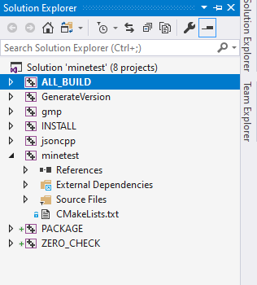Once the visual studios project is open
      1. Right click **ALL_BUILD** and select build
      2. Assuming no errors go to **DIR/minetest/bin/Release** and select minetest to open the game
   3. Go back to step 1 Install Minetest Locally. Continue to #4 and switch the GitHub branch to spidermonkey and pull the latest code. Afterwards, continue through the steps.

**Errors Encountered and Solutions**

Error related to compiling a C file to Web Assembly, WASM. Not related to the minetest setup.



Solution: mistype in the emscripten command. EXPORT_ALL =1 doesn’t work causes different errors.

Correct command: **emcc mod.c -o mod.wasm -s "EXPORTED_FUNCTIONS=["_getName", "_getDescription", "_getTexture", "_getMaterial"]"**

Refer to the link below to resolve errors involving spaces in path names

<https://manjusullad.wordpress.com/2016/01/06/how-can-i-find-create-short-path-for-windows-folders-directories/>

One thing to note, if you get an error while trying to set a short path name it’s probably because the name you are setting is too long. If I recall correctly this command lets you set the path to up to 8 characters.

Documentation providing information on bugs we encountered

<https://bugzilla.mozilla.org/show_bug.cgi?id=1579743>