淡江大學資訊工程學系113學年度
專題實作成果報告

專題名稱:
指導教授: 黃煌文 教授
專題學生: 資工系英語班(四) 410850282 莊學霖
資工系英語班(四) 410850191 黃御宸
資工系英語班(四) 410850266 林家安
資工系英語班(四) 410850183 岑浩昀
資工系英語班(五) 409850335 徐為晨
Project Outline
Chapter 1. Overview of the project
1.1 Project Introduction 3
1.1.1 Background of the Project 3
1.1.2 Target Audience 3
1.1.3 Scope of the Project 3
1.2 Research Motivation 3
1.2.1 Current Trends in Game Development 4
1.2.2 Challenges in Existing Games 4
1.2.3 Personal Inspiration and Purpose 4
1.3 Research Objectives 5
1.3.1 Main Objectives 5
1.3.2 Sub-objectives 5
1.3.3 Expected Impact and Contribution 5
Chapter 2. System Architecture 6
2.1 Game Program Architecture 6
2.1.1 Component Breakdown 6
2.1.2 Data Flow and Interaction 6
2.2 Main Game Program Logic 7
2.2.1 Core Game Loop 7
2.2.2 vent Handling and State Management 8
2.3 HTML and CSS Design 9
2.3.1 Responsive Web Design Principles 9
2.3.2 Key Visual Elements 10
2.3.3 Usability and Accessibility Features 11
2.4 Innovative Game Design 11
2.4.1 Unique Gameplay Features 11
2.4.2 Player Interaction Design 12
2.4.3 Feedback and Reward Systems 13
2.5 Mobile Operation Method 14
2.5.1 Set up the environment on mobile 14
2.5.2 Run on mobile phone 16
2.6 Conclution 17
Chapter 3. References 17
3.1 References 17

Chapter 1. Overview of the project
- 1.1 Project Introduction
1.1.1 Background of the Project
In today's fast-paced world, people often look for short and engaging activities to unwind during their free time or while commuting. Casual games have gained popularity for their simplicity, accessibility, and ability to provide quick entertainment. Inspired by this trend, our project aims to create a fun and interactive 2D memory card matching game that caters to players looking for an easy and enjoyable way to relax. For the software part, we used JavaScript, CSS, and HTML to develop this game, we used Sublime text for CSS and HTML development, for JavaScript we use Microsoft Visual Studio.
1.1.2 Target Audience
The target audience for our game includes individuals of all ages who enjoy casual gaming. This game is particularly suited for people who want a quick yet entertaining experience during short breaks or while commuting. Its simplicity and intuitive design make it accessible to both seasoned gamers and those new to gaming. Additionally, the cross-platform compatibility ensures that it can be enjoyed on various devices, including computers, smartphones, and tablets.
1.1.3 Scope of the Project
In our project, we developed a 2D memory card matching game where players need to flip over two identical cards to remove them from the board. The game is designed with a time limit, requiring players to clear all cards within the allotted time to win. To enhance the gameplay experience, the game includes auxiliary features, such as clickable items on the sides of the screen. For instance, clicking on a four-leaf clover extends the remaining time. At the top of the screen, three functional buttons provide additional assistance, each usable once. The game is hosted on a web platform, ensuring accessibility across devices and offering an adaptive interface that adjusts to different screen or window sizes. This design ensures an optimal experience for players, making it perfect for short gaming sessions.
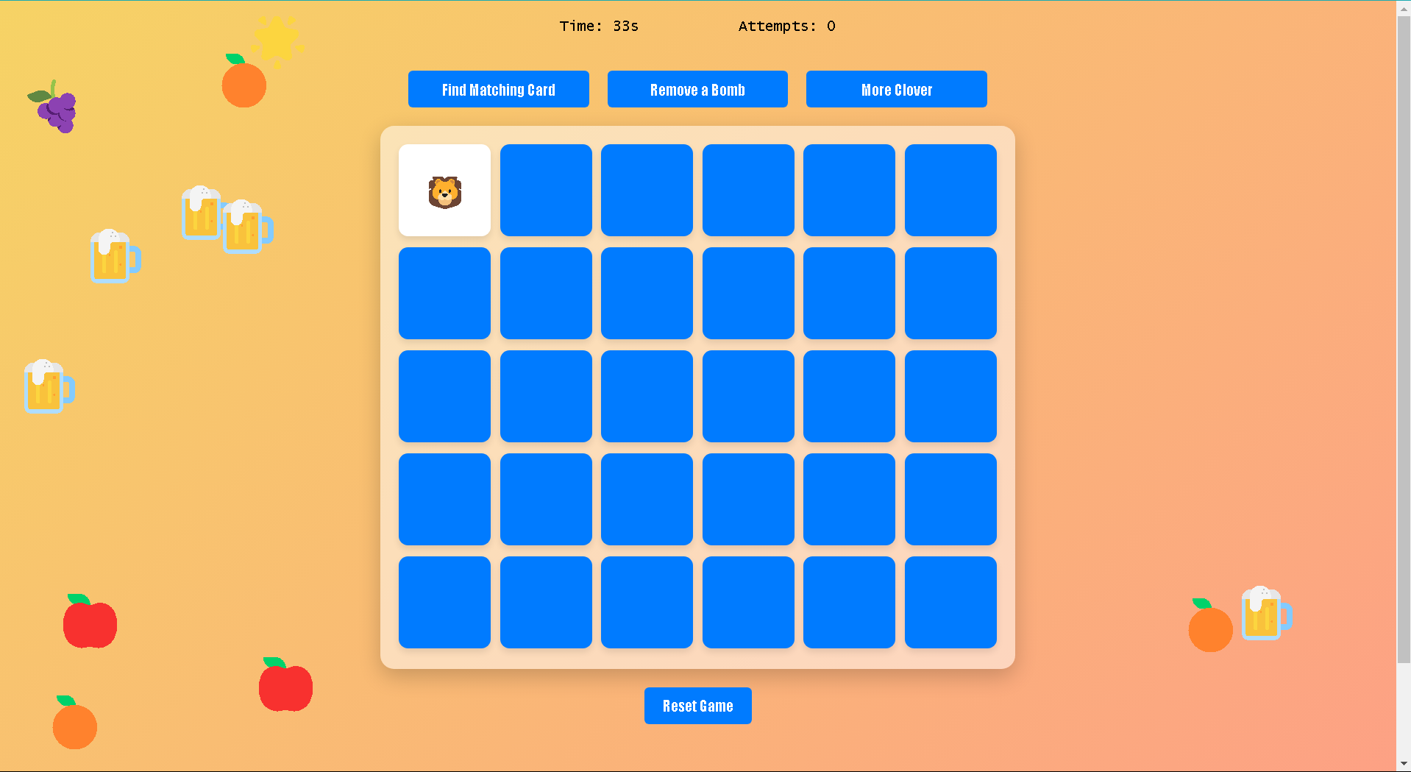
- 1.2 Research Motivation
1.2.1 Current trends in game development
Flashcards are a popular tool for improving memory through active recall and spaced repetition. They are very effective in helping people remember and understand information. Traditionally, flashcards have been used in general education for studying facts, formulas, and key concepts. However, their potential in specific fields like medicine, language learning, and professional training is not yet fully explored. These areas have unique learning challenges that flashcards can help solve.
For example, in medical education, flashcards are used to learn difficult terms, anatomy, and drug interactions. These topics require regular review, making flashcards a great tool for long-term learning. In language learning, flashcards help students build vocabulary, practice grammar, and create sentences. Their interactive and repetitive nature helps learners improve step by step. Professionals also use flashcards to prepare for certifications or exams and to quickly learn technical skills.
Digital tools have made flashcards even more effective by adding features like smart algorithms, gamification, and multimedia. Smart algorithms can adjust review schedules to ensure users don’t forget information. Gamification, such as points or badges, makes studying more fun and motivating. Multimedia elements like pictures, audio, and videos appeal to different learning styles and make studying more engaging.
1.2.2 Challenges in existing games
However, there are still challenges with these digital tools. It is not yet clear how effective these features are in different fields, such as medicine, language learning, or professional training. Some users may find certain features helpful, while others might not benefit as much. For example, while gamification can make learning enjoyable, it might distract some users from focusing on the content itself.
Another challenge is understanding how digital flashcards compare to traditional paper flashcards. While digital tools offer convenience and customization, some learners may prefer the simplicity and tactile experience of paper cards. Additionally, it is important to find the best ways to use these features to ensure long-term learning and retention. Questions remain about how often users should review their flashcards, which types of content work best, and how to keep users engaged over time.
Addressing these challenges is key to improving digital flashcards and ensuring they meet the needs of learners in different contexts.

1.2.3 Personal Inspiration and Purpose
This research focuses on how flashcards are used in different fields and how digital tools can make them more effective. By examining factors like the content of the flashcards, how users engage with them, and the learning outcomes they achieve, this study aims to give useful recommendations for building better flashcard systems. These systems can be tailored to meet the needs of both educational and professional settings, helping learners improve their skills and knowledge more effectively.
Our team decided to create a card-flipping game for this project because all members enjoy playing video games, and this type of game is relatively easy to develop. Unlike other games that require complex designs or a lot of development time, a card-flipping game is simpler and faster to create. It is also easy for players to understand, making it suitable for a wide range of audiences. The game’s simple interface ensures that players can quickly learn how to play, while also being straightforward for developers to build and refine. This makes the card-flipping game a great choice for our research and development efforts.
- 1.3 Research Objectives
1.3.1 Main Objectives
By creating this game, our goal is to understand the process of developing a game from the initial concept to the finished product. The primary objective of this research is to explore how flashcards can be utilized to enhance learning in various fields and how digital tools can make flashcards more effective and engaging. By focusing on both traditional and digital flashcard systems, the research aims to provide comprehensive insights into our design, implementation, and impact on learning outcomes. Additionally, the study seeks to evaluate the effectiveness of gamified flashcard applications, particularly in fostering long-term retention and learner motivation.
1.3.2 Sub-objectives
1. To identify key features of effective flashcards: This involves studying the role of design elements such as content structure, visuals, and interactivity in improving memory retention and recall.
2. To analyze the impact of digital tools on flashcard learning: The study will examine how features like adaptive learning algorithms, gamification, and multimedia integration influence user engagement and learning efficiency.
3.To assess the usability of card-flipping games as learning tools: By integrating flashcards into a gamified card-flipping format, the research will evaluate the effectiveness of this approach in making learning enjoyable and accessible.
1.3.3 Expected Impact and Contribution
1. Provide actionable recommendations for designing effective flashcards: Insights from this study can guide educators, instructional designers, and app developers in creating flashcards that maximize learning outcomes.
2. Support the integration of gamification in education: By demonstrating the value of gamified flashcard applications, the research can encourage the development of innovative learning tools that combine fun and functionality.
3. Improve learning strategies across different fields: The research will offer tailored solutions for using flashcards in specialized areas, helping learners overcome specific challenges and achieve their goals more effectively.
4. Enhance user experience in educational games: The research will contribute to the growing field of serious games by showcasing how a simple card-flipping game can be both engaging and educational, offering a practical model for other developers.

Chapter 2. System Architecture
- 2.1 Game Program Architecture
2.1.1 Component Breakdown
The game system is made up of several core components, each responsible for different functions that work together to create a complete gameplay experience. The game interface includes the game board, time display, attempts display, and a set of functional buttons. The game board is designed with a 6x5 grid layout displaying 30 cards, including 26 emoji cards (two of each emoji) and 4 bomb cards. The time display and attempts display help players keep track of their remaining time and the number of tries they’ve made. Meanwhile, the functional buttons provide three special abilities: “Find Matching Card,” “Remove a Bomb,” and “More Clover,” which add strategy and fun to the game.
The game logic is the heart of the system, handling player actions and system responses. The logic for card matching uses JavaScript to compare the data attributes of flipped cards, determining whether they match and updating the game state accordingly. Special card mechanics, like the bomb and clover cards, are handled with dedicated functions. For instance, flipping a bomb card triggers a time penalty, while collecting a clover emoji increases the remaining time. Additionally, the game integrates animations and visual effects. Card flipping animations are achieved with CSS 3D transformations, while falling emojis are dynamically generated through JavaScript and animated with CSS to enhance the visual appeal of the game.
At the end of the game, a "Game Over" or "You Win" screen is displayed based on the player’s performance. Players can restart the game by clicking the reset button, which reinitializes all game states, including time, card layout, and button availability. The game system is also designed to be mobile-responsive, ensuring that players on different devices can enjoy a seamless gaming experience.

2.1.2 Data Flow and Interaction
The game’s data flow and interaction design are tightly connected to ensure that every player action is reflected in the game state in real-time. Card data is stored in a JavaScript array, randomly shuffled during initialization, and marked with a “data-value” attribute to identify each card’s type. During gameplay, when a player clicks on a card, the “flipCard()” function flips the card and compares its data with the previously flipped card. If the two cards match, their states are updated, and additional time is awarded; if they do not match, the cards are flipped back after a brief delay. Special card mechanics, like bomb cards, are handled through the “handleBomb()” function, which deducts time and hides the card when flipped.
Time management plays a key role in the game, with the “timeRemaining” variable keeping track of the countdown. The timer updates every second using “setInterval”. Players can gain 5 seconds by collecting a falling clover emoji or lose 10 seconds by flipping a bomb card. Interactive buttons also provide unique functionalities, such as the "Find Matching Card" feature, which automatically flips the card that matches the one the player has already flipped. This feature disables itself after one use. Similarly, the "Remove a Bomb" button randomly selects and removes one bomb card from the board, reducing the risk of time penalties.
The overall interaction process aims to provide a smooth and strategic gameplay experience. Player actions, like flipping cards or clicking buttons, trigger immediate system responses, while endgame conditions (such as running out of time or matching all cards) activate specific screens and disable further interactions. The reset function allows players to quickly start a new game, reinitializing all data and dynamic effects. This design not only enhances the game’s playability but also ensures an intuitive and engaging experience for players.

- 2.2 Main Game Program Logic
2.2.1 Core Game Loop
The core game loop ensures the progression and flow of the memory game. It integrates card flipping, time management, emoji interactions, and endgame logic, creating a dynamic and engaging gameplay experience. The loop is triggered when the player interacts with the game, beginning with a card flip, and ends either in victory when all matches are found or in defeat when time runs out. Here's a breakdown of the key responsibilities:
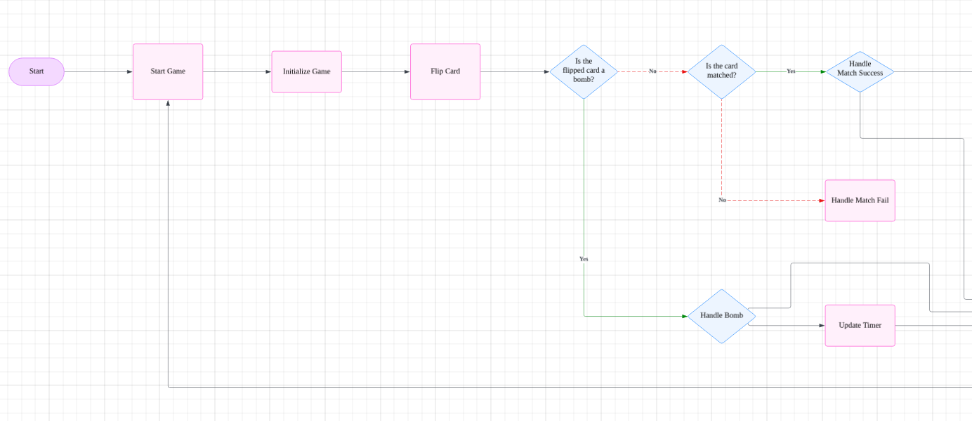
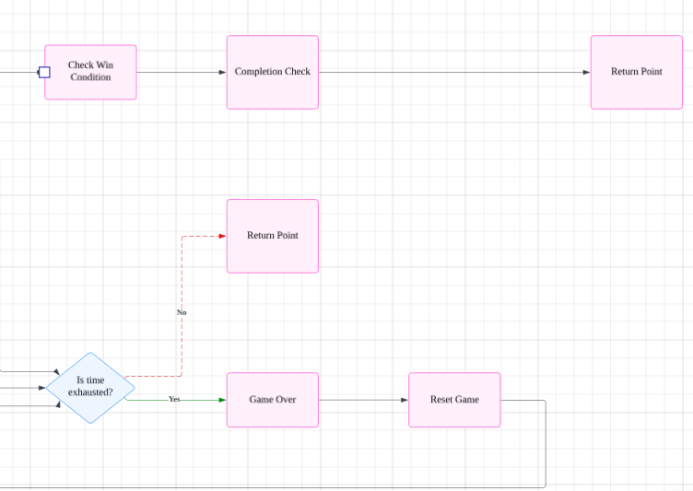

The Core loop for this game can be summarized as:
- Start Game:
  - The game is initialized with essential data and variables.
  - Players can begin by flipping a card.
- Flip Card:
  - The flipped card is evaluated for two conditions:
    - Is the card a bomb?
      - If yes, handle the bomb (e.g., end the game, deduct points, or trigger specific mechanics).
      - If no, proceed to the next step.
    - Is the card matched with a previous flip?
      - If yes, handle match success (e.g., score points, remove the pair).
      - If no, handle match failure (e.g., flip the cards back).
- Timer and Game State Updates:
  - A timer continuously updates to impose a time limit.
  - The game checks for win conditions or whether the timer is exhausted.
- Win or Game Over Check:
  - If all pairs are matched within the time limit, the player wins.
  - If the timer runs out, the game ends with a "Game Over."
  - Both conditions funnel into resetting or returning to the start point.
2.2.2 Event Handling and State Management

The event handling system governs player interactions and updates game states based on events like card flips, timer ticks, and power-up activations. A robust state management structure ensures smooth transitions and prevents conflicting interactions.
Event Listening:
- Assigns click listeners to cards for flipping, clovers for bonuses, and bombs for penalties.
- Handles button clicks for power-ups like match-finding, bomb removal, and increasing clover drop rates.
State Updates:
- Tracks game state variables (firstCard, secondCard, lockBoard, timeRemaining, etc.).
- Ensures state consistency by locking the board during animations or critical updates.
- Disables power-up buttons after use to prevent repetitive actions.
Dynamic Feedback:
- Updates the DOM to reflect changes in time, attempts, and matches.
- Animates emoji drops and provides interactive feedback for bonuses and penalties.
- Visually hides matched or bomb cards and resets flipped cards.
Endgame Transitions:
- Displays victory or game-over messages based on the state of matches or time remaining.
- Deactivates all listeners to halt gameplay and ensures proper reset functionality.

- 2.3 HTML and CSS Design

2.3.1 Responsive Web Design Principles
The game is designed to work seamlessly on both desktop and mobile devices. Using responsive web design principles, the layout adjusts automatically based on the screen size.
Media Queries: CSS media queries ensure the game board and other elements resize properly for smaller screens. For example, the card size and grid layout adjust to fit within the mobile screen.
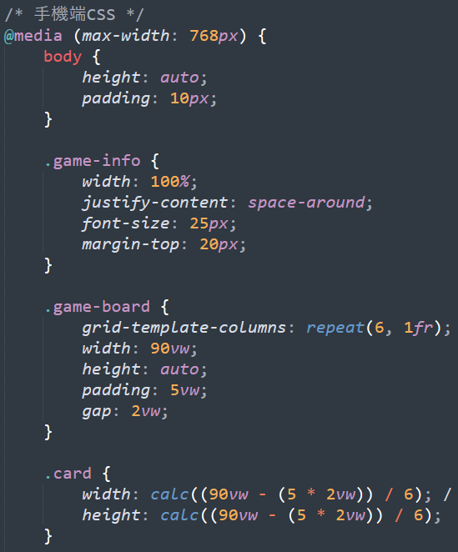
Flexible Layouts: The game board uses percentage-based widths (vw and vh) to ensure the design fits different screen dimensions.
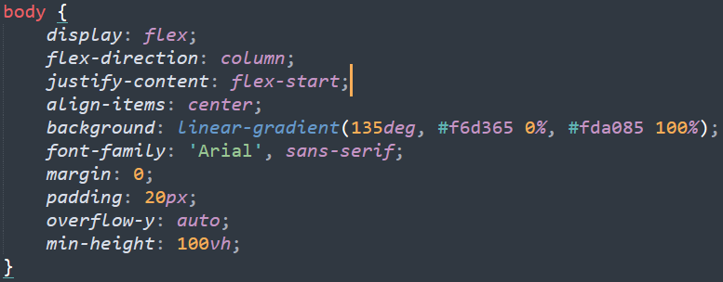
Scalable Content: Font sizes, paddings, and gaps are scaled proportionally to the viewport size, maintaining a consistent look across devices.

2.3.2 Key Visual Elements
The game incorporates engaging visual elements to enhance the user experience:
Gradient Background: A soft gradient background creates an appealing and modern visual style.
Interactive Cards: Cards use flip animations implemented with CSS transform and transition, making the game dynamic and fun to play.
Falling Emojis: Emojis fall from the screen’s sides as animated elements, providing an additional interactive layer.
Game States: Visual indicators, such as overlays for “Game Over” and “You Win,” inform players of the current state of the game.

2.3.3 Usability and Accessibility Features
The game is designed to be user-friendly and accessible for a broad audience:

Keyboard and Mouse Support: The game is optimized for both mouse and touch inputs, ensuring accessibility for desktop and mobile users.

Clear Instructions: A tutorial model explains the rules of the game in a step-by-step manner with visuals, making it easy for new players to understand.

Color Contrast: High-contrast text and buttons ensure readability for all users, including those with visual impairments.

Responsive Feedback: Actions like card flips and falling emoji clicks provide immediate visual and auditory feedback, enhancing interactivity.

- 2.4 Innovative Game Design
2.4.1 Unique Gameplay Features
This card-matching game incorporates several innovative elements, providing players with a fresh experience that goes beyond traditional gameplay, making it both challenging and enjoyable.

Bomb Cards: Risk and Challenge
The bomb cards introduce a core element of risk into the gameplay. Unlike typical card-matching games, flipping a bomb card immediately deducts 10 seconds from the timer and can potentially lead to failure. This design encourages players to carefully plan each move while memorizing card positions, adding a layer of strategy. Additionally, the game includes a "Remove a Bomb" special ability button, allowing players to reduce risk by removing a bomb card from the board. However, this ability can only be used once per game, adding an element of decision-making.

Dynamic Falling Emojis
Falling emojis are another highlight of the game, appearing randomly from both sides of the screen at varying speeds and intervals. Among these, the clover emoji offers a positive reward mechanic: clicking on it adds 5 seconds to the remaining time, increasing the chances of survival. Other emojis, such as stars or fruits, serve more as visual enhancements, making the game feel lively. This dynamic falling feature not only enriches the visual presentation but also challenges players to multitask by focusing on card matching while catching rewards.

Strategic Special Ability Buttons
The game offers three special ability buttons: "Find Matching Card," "Remove a Bomb," and "Increase Clover Drop Rate," giving players additional strategic options. The "Find Matching Card" feature helps players by automatically flipping a card that matches the one they have already revealed, speeding up progress. The "Remove a Bomb" button randomly eliminates one bomb card from the board, significantly reducing the risk of time penalties. Lastly, the "Increase Clover Drop Rate" button increases the chance of clover emojis dropping from 10% to 30%, giving players more opportunities to extend their time. Since each button can only be used once per game, players must carefully decide the best timing to use them, adding strategic depth to the gameplay.

Time Pressure and Reward Mechanism
Time management is another standout feature. Players start with 60 seconds, and successfully matching a pair of cards rewards them with an additional 5 seconds. This time-reward mechanism encourages players to match cards quickly, maintaining a fast-paced rhythm. However, flipping a bomb card deducts 10 seconds, increasing the pressure on players. The inclusion of falling clover emojis provides an extra layer of assistance, allowing players to extend their time through quick reflexes and multitasking.

3D Flip and Visual Effects
The card-flipping animation utilizes CSS 3D effects (transform: rotateY()), making each flip visually appealing. Additionally, matched cards gradually fade and disappear, offering satisfying visual feedback. When a bomb card is flipped, subtle visual cues such as vibration or color changes highlight the mistake. At the end of the game, winning or losing screens feature animations tailored to the outcome, creating a sense of closure and achievement.

Varied Difficulty Design
The game balances the needs of different players through its dynamic difficulty design. Randomized card layouts and bomb placements ensure that each round presents a unique challenge. The combination of falling emojis and the time pressure from card matching creates a dual-layered challenge, engaging both casual players and those seeking a higher level of efficiency and mastery.

Responsive and Cross-Platform Support
To enhance user experience, the game is designed with responsiveness in mind, ensuring it works seamlessly across various devices. Whether on desktop browsers or mobile devices, the game adapts to different screen sizes while keeping the content clear and accessible. The sizes and positions of cards and buttons have been optimized for touch interactions, making it user-friendly for mobile players.
2.4.2 Player Interaction Design
The interaction design of the game is simple and intuitive, making it easy for players to understand and engage with. When players first start the game, a tutorial modal pops up to explain the rules and special features step by step. This guide uses clear text and images to ensure even first-time players can quickly get familiar with the gameplay.
The main interaction in the game is card flipping. Players click on a card to flip it, revealing its content with a smooth 3D animation. If two cards match, they remain visible, and the player progresses closer to winning. If they don’t match, the cards flip back after a short delay, adding an element of memory and concentration. This simple yet engaging mechanic ensures that players stay focused while having fun.
In addition to the main card-matching mechanic, the falling emojis provide an extra layer of interaction. Players can click on clover emojis to gain time while keeping an eye on the game board, creating a multi-tasking challenge. Special ability buttons like “Find Matching Card” or “Remove a Bomb” are also easy to use and are placed conveniently below the game board. These buttons are visually distinct, so players can quickly understand their purpose and make strategic decisions.
Overall, the interaction design ensures players can enjoy the game without being overwhelmed by complex controls. The balance between simplicity and interactivity makes it engaging for a wide range of players.
2.4.3 Feedback and Reward Systems
The game’s feedback and reward systems are designed to keep players motivated and immersed throughout the experience. One of the key features is the immediate visual feedback provided for every action. For instance, when players successfully match two cards, the matched cards disappear with a smooth fading animation, and the remaining time increases by 5 seconds. This small reward reinforces the player’s progress and encourages them to keep playing.
On the other hand, flipping a bomb card results in a negative feedback mechanism. The remaining time decreases by 10 seconds, and the bomb card briefly displays a warning effect before disappearing. This serves as a reminder for players to be more cautious without discouraging them too much.
The reward system is further enhanced by the dynamic clover emojis. These emojis fall randomly on the screen, and clicking them adds extra time. This introduces an element of surprise and excitement, as players can actively seek out rewards during gameplay. Additionally, the special ability buttons also serve as a form of reward. Players can use them strategically to gain advantages, such as finding a matching card or increasing clover drop rates, which adds variety and fun to the game.
At the end of the game, the system provides clear feedback depending on the result. If the player wins, a celebratory animation is displayed, accompanied by the message “You Win,” giving a sense of achievement. If they lose, the “Game Over” screen provides a moment of reflection before allowing them to restart the game with the reset button. This quick reset function ensures players can immediately jump back into a new round and try to improve their performance.
In summary, the feedback and reward systems create a positive loop of action, response, and motivation. Players are constantly rewarded for their efforts while being gently reminded to improve through challenges, making the game enjoyable and engaging.
- 2.5 Mobile Operation Method
2.5.1 Set up the environment on mobile
Since we are developing a web-based game, we need to ensure it works seamlessly on mobile devices. We are using Android smartphones and have installed the Dcoder app on them. By transferring our HTML, CSS, and JavaScript code to the app, the game runs smoothly. It is important to note that the screen size of a mobile device is different from a computer. Therefore, we made specific layout adjustments in the CSS code to accommodate mobile screens. When the screen or window size becomes smaller than a certain threshold, the three auxiliary buttons that were originally arranged horizontally are changed to a vertical arrangement. Below are the modifications we made.
When the screen size is reduced, especially to a width of less than 768px, several adjustments are made to ensure the page layout remains responsive and user-friendly. These changes focus on optimizing the design for smaller screens, such as mobile devices.

First, the overall layout becomes more compact. The body adjusts its height to fit the content, and the padding is reduced to make better use of the available space. The game information section expands to fill the entire width of the screen, with the content spaced out evenly for better visibility. The font size in this section is also increased to improve readability.
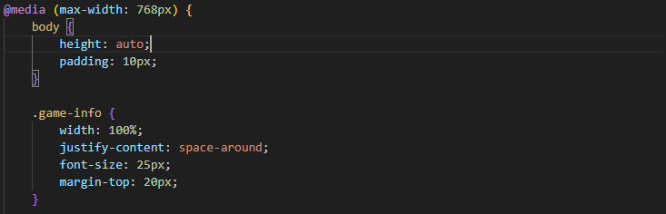
The game board adapts by resizing its width to 90% of the screen and automatically adjusting its height to fit the content. The spacing between cards and the padding around the board are calculated proportionally to the screen width. Individual cards also resize dynamically to maintain their square shape, ensuring a consistent and clean layout.
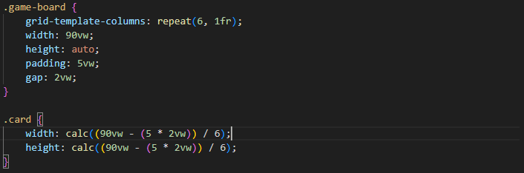
Button layouts are simplified for smaller screens. Buttons in the effect card section are arranged vertically, with each button occupying 90% of the container's width and having adequate vertical spacing. The reset button similarly adjusts its width to 70% of the screen for a balanced appearance.
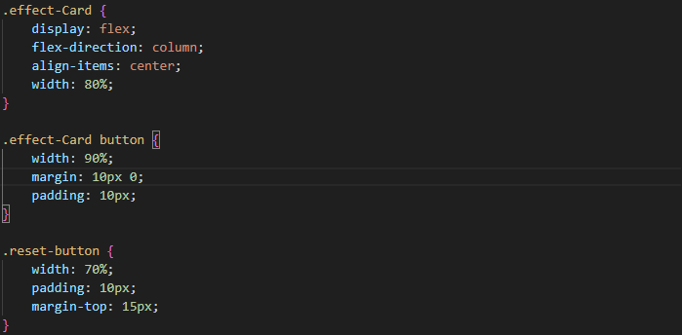
Game notifications, such as "Game Over" and "Game Win" messages, are resized to occupy 90% of the screen width. Falling emoji animations are also adjusted, with their size reduced and their drop area restricted to the sides of the game board, preventing them from overlapping unnecessarily with other elements.
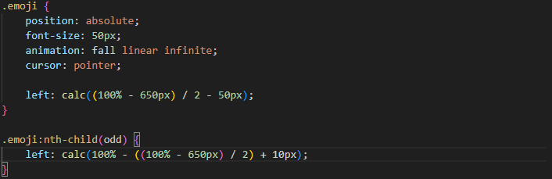
Modal content, such as tutorials or pop-up messages, is redesigned to fit smaller screens. The modal width is reduced to 90% of the screen, and its height is capped at 80%. Padding is minimized, and images within the modal are scaled to fit comfortably while maintaining a maximum height to avoid overflowing. Text size is also slightly reduced for better proportionality.
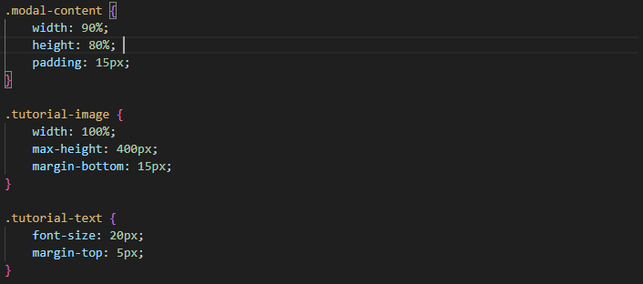
Finally, navigation buttons and indicators are optimized for mobile use. Buttons are widened to occupy 90% of the screen, and their font size is reduced slightly to save space. Indicators, such as dots for navigation, are spaced closer together, with proper spacing maintained between them and other elements.
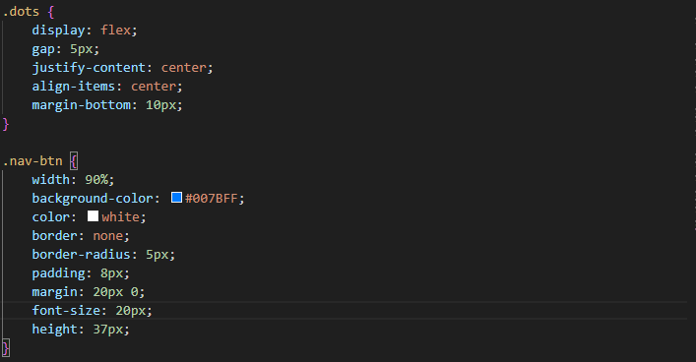
These adjustments ensure the interface remains visually appealing, functional, and easy to use across different screen sizes, providing a seamless experience for users on smaller devices.
2.5.2 Run on mobile phone
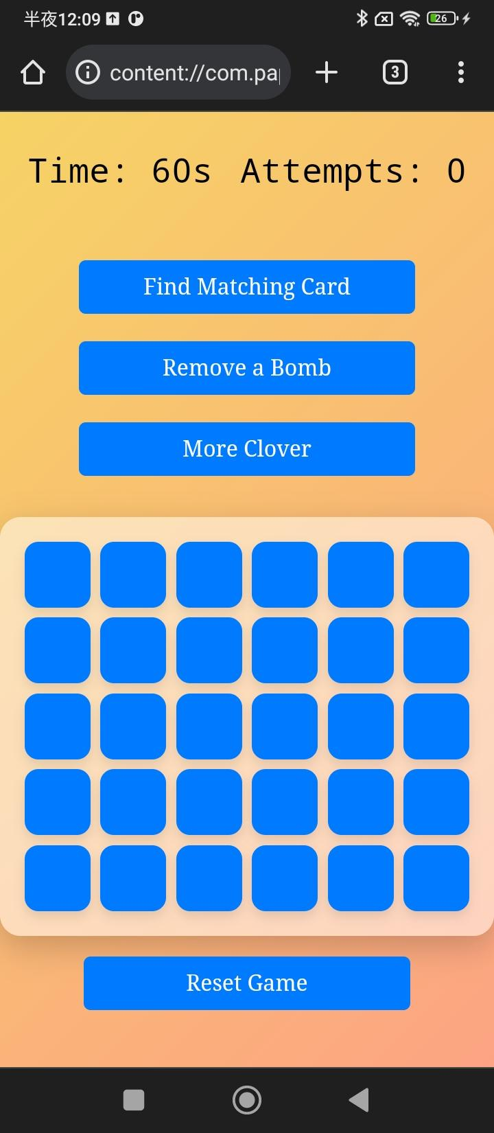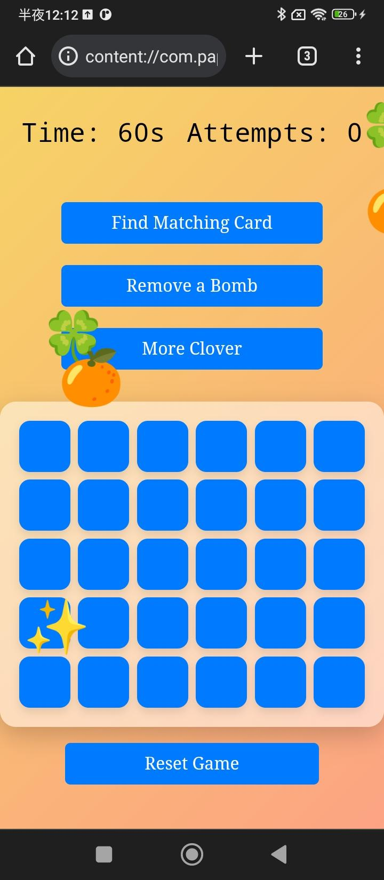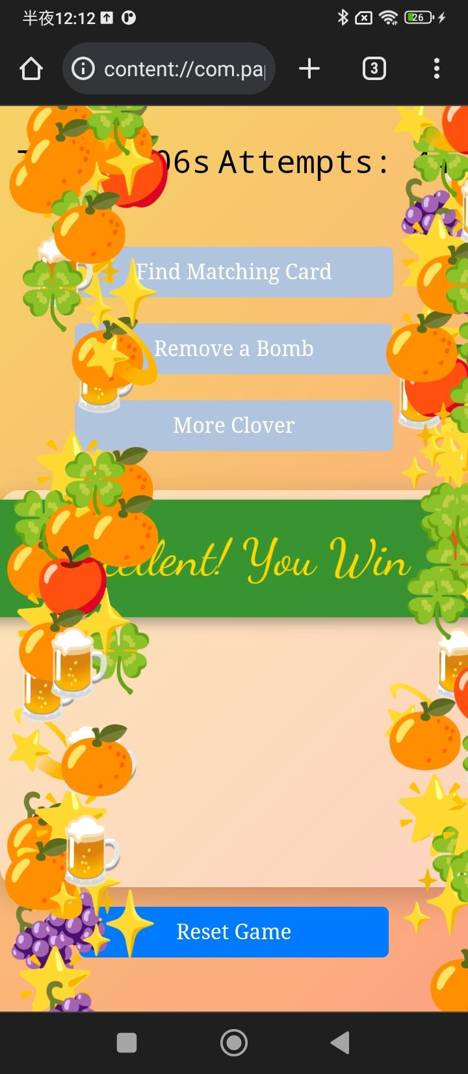
- 2.6 Conclution
Initially, we thought this card-flipping game would be very simple. However, after actually playing it, we realized that wasn’t the case. In the early stages, we tried avoiding clicking on clovers, but if bombs deducted time, it became impossible to finish the game within the time limit. Later on, we started focusing on clicking the falling clovers at the beginning of the game and found that the time was always sufficient, even if we flipped a bomb.
We believe that to increase the difficulty in the future, we could adjust the falling speed and frequency of the clovers or increase the amount of time deducted when flipping a bomb. This would make the game more challenging. Additionally, Limiting the number of card-flipping attempts in the game and adding a scoreboard to track each playthrough would more effectively record players’ progress, enhance competition, and increase their willingness to play.
Chapter 3. References
- 3.1 References
HTML5 Game Dev Tutorials
https://gamedevacademy.org/

Build a Memory Card Game Using HTML CSS and JavaScript
https://www.geeksforgeeks.org/build-a-memory-card-game-using-html-css-and-javascript/

MDN Web Docs
https://developer.mozilla.org/en-US/docs/Web/API/Document/createElement

