Message of length 5 digits is to be sent. digit can be a 0, 1, or 2

There are 243 possibilities, I guess and that is the case will we just add since each is equally likely to occur ?

If every message is equally likely, what is the probability that the message consists of 2 zeros, 2 ones, and 1 two? Round your answer to have four decimal places.

What is the probability that the message has at least one zero

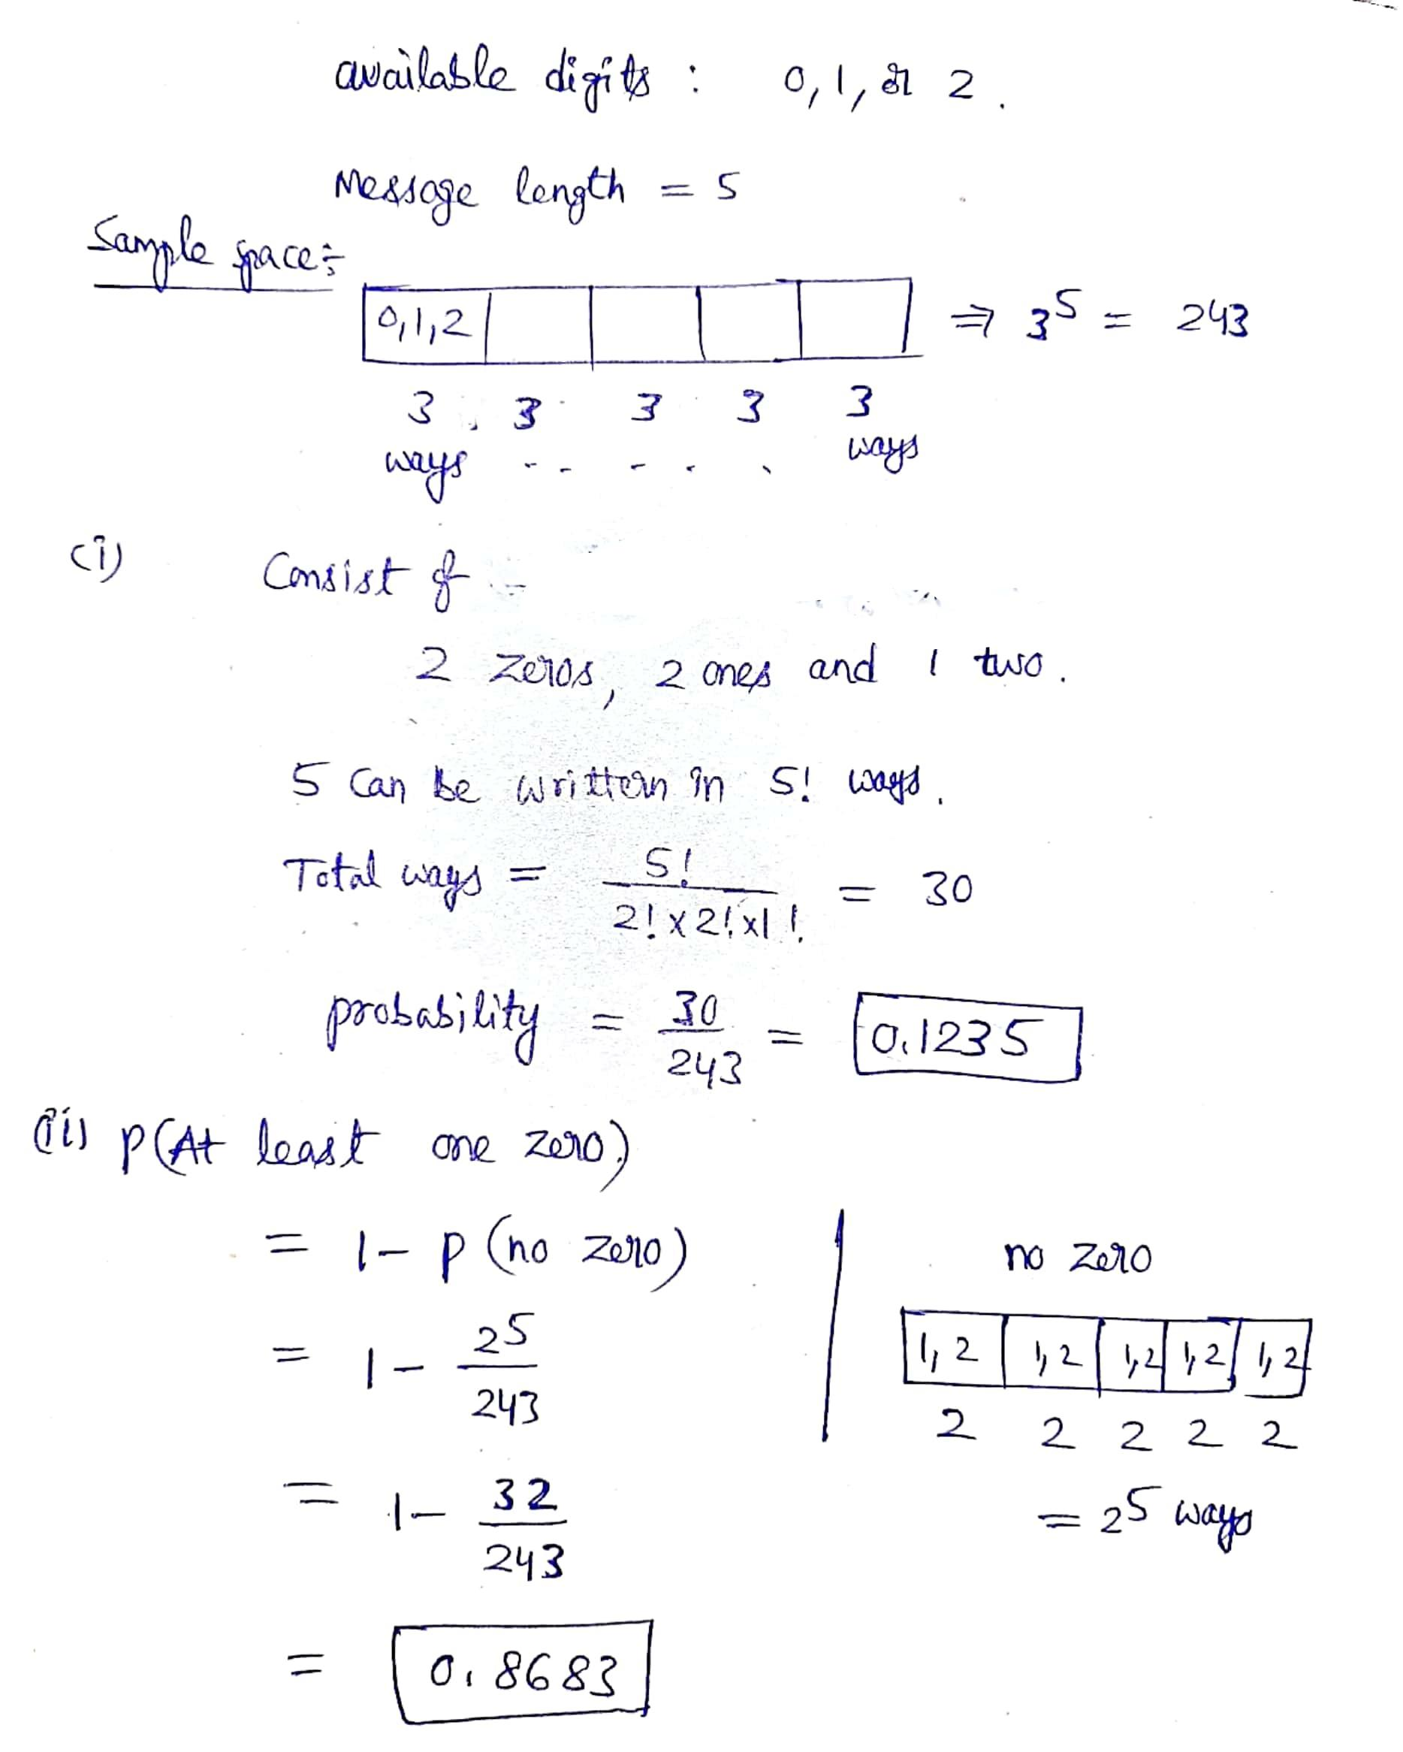

1.

Question 1

**Prompt 1:** For each of the following scenarios, find the requested probability. Assume the sets AA, BB, and CC are events from the same sample space SS. (Hint: Venn diagrams may help with the visualization, although they are not required to answer the questions.) If P(A) = .4P(A)=.4, P(B^c) = .7P(Bc)=.7, and P(A ∩ B^c) = .2P(A∩Bc)=.2, find P(A ∩ B)P(A∩B)

1 point

2.

Question 2

**Prompt 1:** For each of the following scenarios, find the requested probability. Assume the sets AA, BB, and CC are events from the same sample space SS. (Hint: Venn diagrams may help with the visualization, although they are not required to answer the questions.)

If P(A) = 0.9P(A)=0.9 and P(B) = 0.9P(B)=0.9, what is the lower bound for P(A \cup B)P(A∪B).

1 point

3.

Question 3

**Prompt 2:** Three popular options on a certain type of car are AA leather seats, BB a sunroof, and CC heated seats. In the past, P(A) = 0.55P(A)=0.55 (i.e. 55% of the customers have requested option A), P(B) = 0.45P(B)=0.45, P(C) = 0.4P(C)=0.4. Furthermore, P(A ∩ B) = 0.25P(A∩B)=0.25, P(A ∩ C) = 0.2P(A∩C)=0.2, P(B ∩ C) = 0.15P(B∩C)=0.15 and P(A ∩ B ∩ C) = 0.1P(A∩B∩C)=0.1. Find the probability that a customer will ask for at least one of the three options.

1 point

4.

Question 4

**Prompt 2:** Three popular options on a certain type of car are AA leather seats, BB a sunroof, and CC heated seats. In the past, P(A) = 0.55P(A)=0.55 (i.e. 55% of the customers have requested option A), P(B) = 0.45P(B)=0.45, P(C) = 0.4P(C)=0.4. Furthermore, P(A ∩ B) = 0.25P(A∩B)=0.25, P(A ∩ C) = 0.2P(A∩C)=0.2, P(B ∩ C) = 0.15P(B∩C)=0.15 and P(A ∩ B ∩ C) = 0.1P(A∩B∩C)=0.1.

Find the probability that a customer will not ask for any of these three options.

1 point

5.

Question 5

**Prompt 2:** Three popular options on a certain type of car are AA leather seats, BB a sunroof, and CC heated seats. In the past, P(A) = 0.55P(A)=0.55 (i.e. 55% of the customers have requested option A), P(B) = 0.45P(B)=0.45, P(C) = 0.4P(C)=0.4. Furthermore, P(A ∩ B) = 0.25P(A∩B)=0.25, P(A ∩ C) = 0.2P(A∩C)=0.2, P(B ∩ C) = 0.15P(B∩C)=0.15 and P(A ∩ B ∩ C) = 0.1P(A∩B∩C)=0.1.

Find the probability that a customer will ask for heated leather seats but not a sunroof.

1 point

6.

Question 6

**Prompt 2:** Three popular options on a certain type of car are AA leather seats, BB a sunroof, and CC heated seats. In the past, P(A) = 0.55P(A)=0.55 (i.e. 55% of the customers have requested option A), P(B) = 0.45P(B)=0.45, P(C) = 0.4P(C)=0.4. Furthermore, P(A ∩ B) = 0.25P(A∩B)=0.25, P(A ∩ C) = 0.2P(A∩C)=0.2, P(B ∩ C) = 0.15P(B∩C)=0.15 and P(A ∩ B ∩ C) = 0.1P(A∩B∩C)=0.1.

Find the probability that a customer will ask for at most two of the options.

1 point

7.

Question 7

**Prompt 2:** Three popular options on a certain type of car are AA leather seats, BB a sunroof, and CC heated seats. In the past, P(A) = 0.55P(A)=0.55 (i.e. 55% of the customers have requested option A), P(B) = 0.45P(B)=0.45, P(C) = 0.4P(C)=0.4. Furthermore, P(A ∩ B) = 0.25P(A∩B)=0.25, P(A ∩ C) = 0.2P(A∩C)=0.2, P(B ∩ C) = 0.15P(B∩C)=0.15 and P(A ∩ B ∩ C) = 0.1P(A∩B∩C)=0.1.

Find the probability that a customer will ask for exactly two of the options.

1 point

8.

Question 8

**Prompt 3:** A message of length 5 digits is to be sent. Each digit can be a 0, 1, or 2.

What is the cardinality of the sample space?

1 point

9.

Question 9

**Prompt 3:** A message of length 5 digits is to be sent. Each digit can be a 0, 1, or 2.

If every message is equally likely, what is the probability that the message consists of 2 zeros, 2 ones, and 1 two? Round your answer to have four decimal places.

1 point

10.

Question 10

**Prompt 3:** A message of length 5 digits is to be sent. Each digit can be a 0, 1, or 2.

What is the probability that the message contains at least one zero? Round your answer to have three decimal places.

Q1)We are given here that:  
P(A) = 0.4,  
P(Bc) = 0.7 and  
P(A \cap Bc) = 0.2

The required probability here is computed as:  
P(A \cap Bc) = 0.2

P(A) - P(A \cap B) = 0.2

P(A \cap B) = P(A) - 0.2 = 0.4 - 0.2 = 0.2  
**Therefore 0.2 is the required probability here.**

Q2) P(A) = 0.9, P(B) = 0.9  
P(A \cup B) is computed as:

P(A \cup B) = P(A) + P(B) - P(A \cap B)

P(A \cup B) = 1.8 - P(A \cap B)

As the max value of P(A \cap B) could be 0.9 as both of them can be exact same events, therefore the lower bound here is computed as:

P(A \cup B) = 1.8 - P(A \cap B) = 1.8 - 0.9 = 0.9  
**Therefore 0.9 is the required lower bound value here.**

Q3) We have here:  
P(A) = 0.55,  
P(B) = 0.45,  
P(C) = 0.4,  
P(A \cap B) = 0.25  
P(A \cap C) = 0.2  
P( B \cap C) = 0.15  
P(A \cap B \cap C) = 0.1

P(A and B only ) = 0.25 - 0.1 = 0.15  
P(A and C only ) = 0.2 - 0.1 = 0.1  
P(B and C only ) = 0.15 - 0.1 = 0.05

P(A only ) = 0.55 - 0.15 - 0.1 - 0.1 = 0.2  
P(B only ) = 0.45 - 0.15 - 0.05 - 0.1 = 0.15  
P(C only ) = 0.4 - 0.1 - 0.05 - 0.1 = 0.15

P(At least one ) = 0.2 + 0.15 + 0.15 + 0.15 + 0.1 + 0.05 + 0.1 = 0.9

Therefore, 0.9 is the required probability here.

Q4) P( not asking any of the three options )

= 1 - P( at least one ) = 1 - 0.9 = 0.1  
**Therefore 0.1 is the required probability here.**

Q5) P( A and C but not B)

= P(A and C only ) = 0.1 as computed above already. **Therefore 0.1 is the probability here.**

Q6) P( at most 2 options )

= 1 - P( All 3 ) = 1 - 0.1 = 0.9  
**0.9 is the required probability here.**

Q7) P( exactly 2 options )

= P(A and B only ) + P(A and C only ) + P(B and C only )

= 0.15 + 0.1 + 0.05 = 0.3  
**therefore 0.3 is the required probability here.**

Q8) The cardinality of the sample space here is computed as:  
= Number of ways to make the 5 digit number

= 35 = 243 is the required value here.

Q9) The probability here is computed as:  
= Number of permutations of 2 zeros, 2 ones, and 1 two / Total cardinality

= (5! / 22) / 243

= 30 / 243 = 0.1235 is the required probability here.

Q10) The probability that he message contains at least one zero is computed here as:

= 1 - Probability that the message contains no 0

= 1 - (25 / 35 ) = 0.8683 is the required probability here.