# Standard Choice Baseline

This package will create every standard choice available in the platform with descriptions to help understand the use of each system switch and tags to organize them by features. This package will also deploy a series of ad hoc reports that can be used to view all of the standard choices associated with each feature.

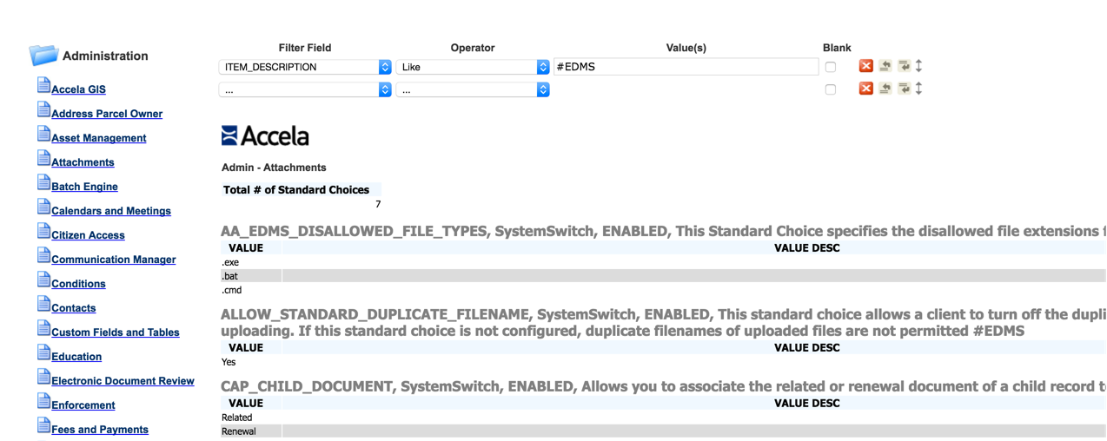

***\*This package will not impact Shared Drop Down lists or EMSE scripts.***

***\*\*This package is only supported on v8.0 and above.***

There are three steps involved to import this package into an existing Civic Platform environment. ALWAYS test this in a lower environment before running in production.

1. Download the Standard Choice Baseline Package
2. Backup the current configuration
3. Import the Standard Choices, Ad hoc Reports and Batch Job
4. Batch update the descriptions for existing standard choices

## Step 1 – Download and Extract the Package

1. Download the package here: <https://github.com/Accela-Inc/DataManagerExports/tree/master/StandardBase>
2. Extract the zip file to a new folder

## Step 2 – Backup the current configuration

1. Create a data manager export to backup all existing standard choices before running the import
2. Select all standard choices
3. Save the changes, Run the export and save the backup in a safe place

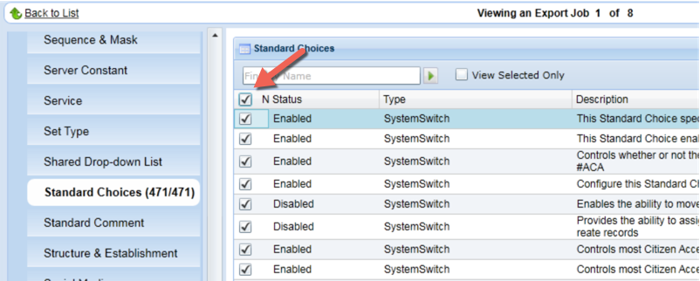

## Step 3 – Import the Standard Choices, Ad Hoc Reports and Batch job

1. Create a new Data Manager Import job and select the ImportStandardChoiceBaseline_exportData_v8.0.zip file for import.
2. **IMPORTANT!!! Set the conflict action = Reject to ensure the import does not replace your existing configuration.  
   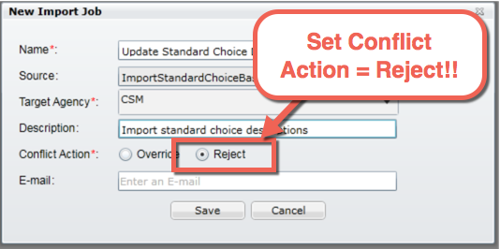**
3. Save and Open the Import to review the data manager package before importing. Under AA Configuration, review Standard Choices, Batch Engine and Event Manager > Scripts.
   1. **Standard Choices:** Validate that the conflict action = “R”, for Reject, to ensure only new standard choices are imported.  
      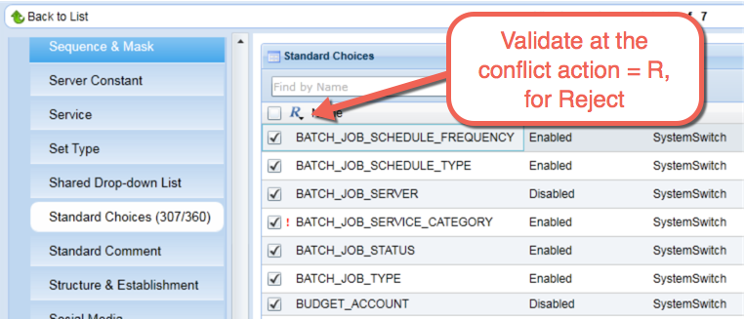
   2. **Batch Engine:** This batch job will be used to update the descriptions for existing standard choices.  
      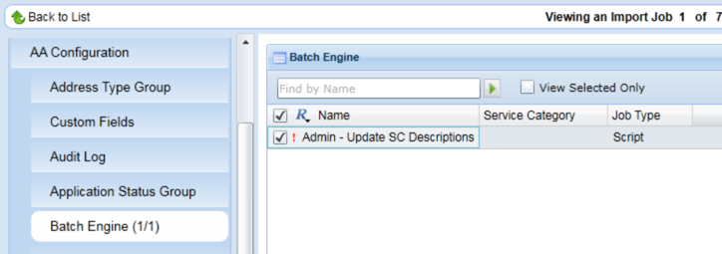
   3. **Event Manager > Scripts:** This script is used by the batch job to update the standard choice descriptions.  
      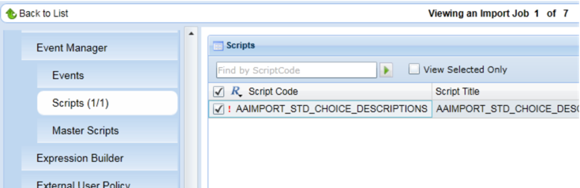
4. Run the Import and review the Import Log for Errors
5. Use the ad hoc reports to view the new imported standard choices.

## Step 4 – Update the descriptions for existing standard choices

This is a batch script that contains a list of all standard choices and descriptions in the platform. It will go through and update all standard choice descriptions with the new baseline product descriptions. It will skip standard choices that have already been tagged and list exceptions for standard choices that do not exist.

1. Manually update any standard choice descriptions that you do not want to be updated by the batch script. Add a hash tag “#” to the description and the script will skip the standard choice.   
   ***You can name the tag whatever you want, as long as it has the # sign in it.***  
   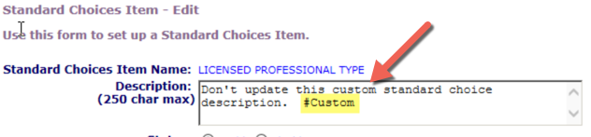
2. Execute the “Admin – Update SC Descriptions” batch job  
   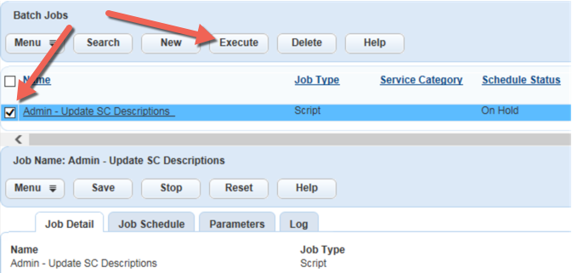
3. Review the script log
   1. Review the stats at the top of the log  
      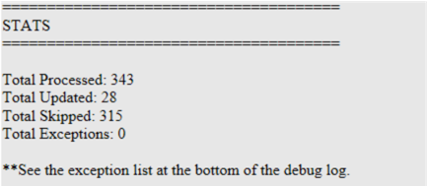
   2. You can review the detailed debug log  
      
   3. A comma delimited list of exceptions is provided at the bottom of the log. Review any exceptions and determine why the standard choices are missing. If the standard choice import was successful, there should be no exceptions.  
      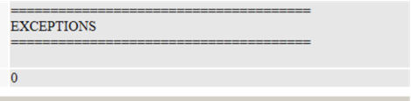

## Tip – Use Ad hoc reports and hash tags to Organize your own custom standard choices

1. Add hash tags to your custom standard choices
2. Copy one of the Administration ad hoc reports and update the filter to match your custom tags