URI: mongodb://localhost:27017/DressStore

MongoDB Set up:

Express server:

Testing:

GET:

POST:

PUT:

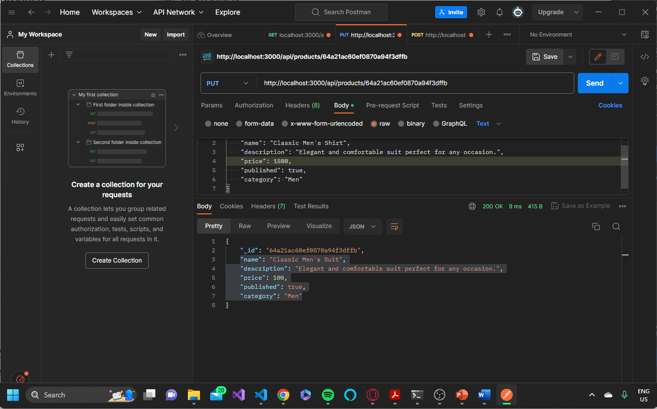

DELETE:

GET:

