batMods

AM

28 June, 2020

This is an overview of an R package I am currently developing as part of a research paper looking into virus dynamics in bat populations of Australia.

The link to the github repo is: <https://github.com/aaronm70/batMods>, which contains all code and associated data.

# Overview

batMods fits a number of discrete time stochastic models of varying structures with and without seasonal forces, to observed bat virus data (currently from boonah australia (Field et al. 2015)), using particle MCMC based methods. The goal is to identify which dynamical model best represents the observed viral samples from wild populations and gain further insight into between-host viral dynamics in bats. Model comparison is conducted using an approximate leave one out cross validation algorithm, incorporating Pareto smoothed importance sampling (Vehtari et al. 2019). This algorithm uses pointwise likelihood values to compute the log pointwise predictive density and its Monte Carlo standard error, the effective number of parameters, Pareto k diagnostic values (which can help assess if a model is well specified) and an information criterion “looic” (lower values suggest a better model fit). (Vehtari, Gelman, and Gabry 2017a, 2017b; Vehtari et al. 2015).

* Currently batMods fits three primary models structures with and without maternal immmunity and seasonal forces (figure 1) to multiple data-types, including serology and PCR data.
* The analysis can be run from the runscript.R file.
* The metropilis hastings and particle filter algorithms run in R, whilst the model itself runs in C code, which is implemented via the Odin package.
* The model and fitting methods are described in modelMethods.pdf <https://github.com/aaronm70/batMods/blob/master/modelMethods.pdf>
* This is a work in progress as part of a paper on bat virus dynamics, as such should not be seen as a final analysis

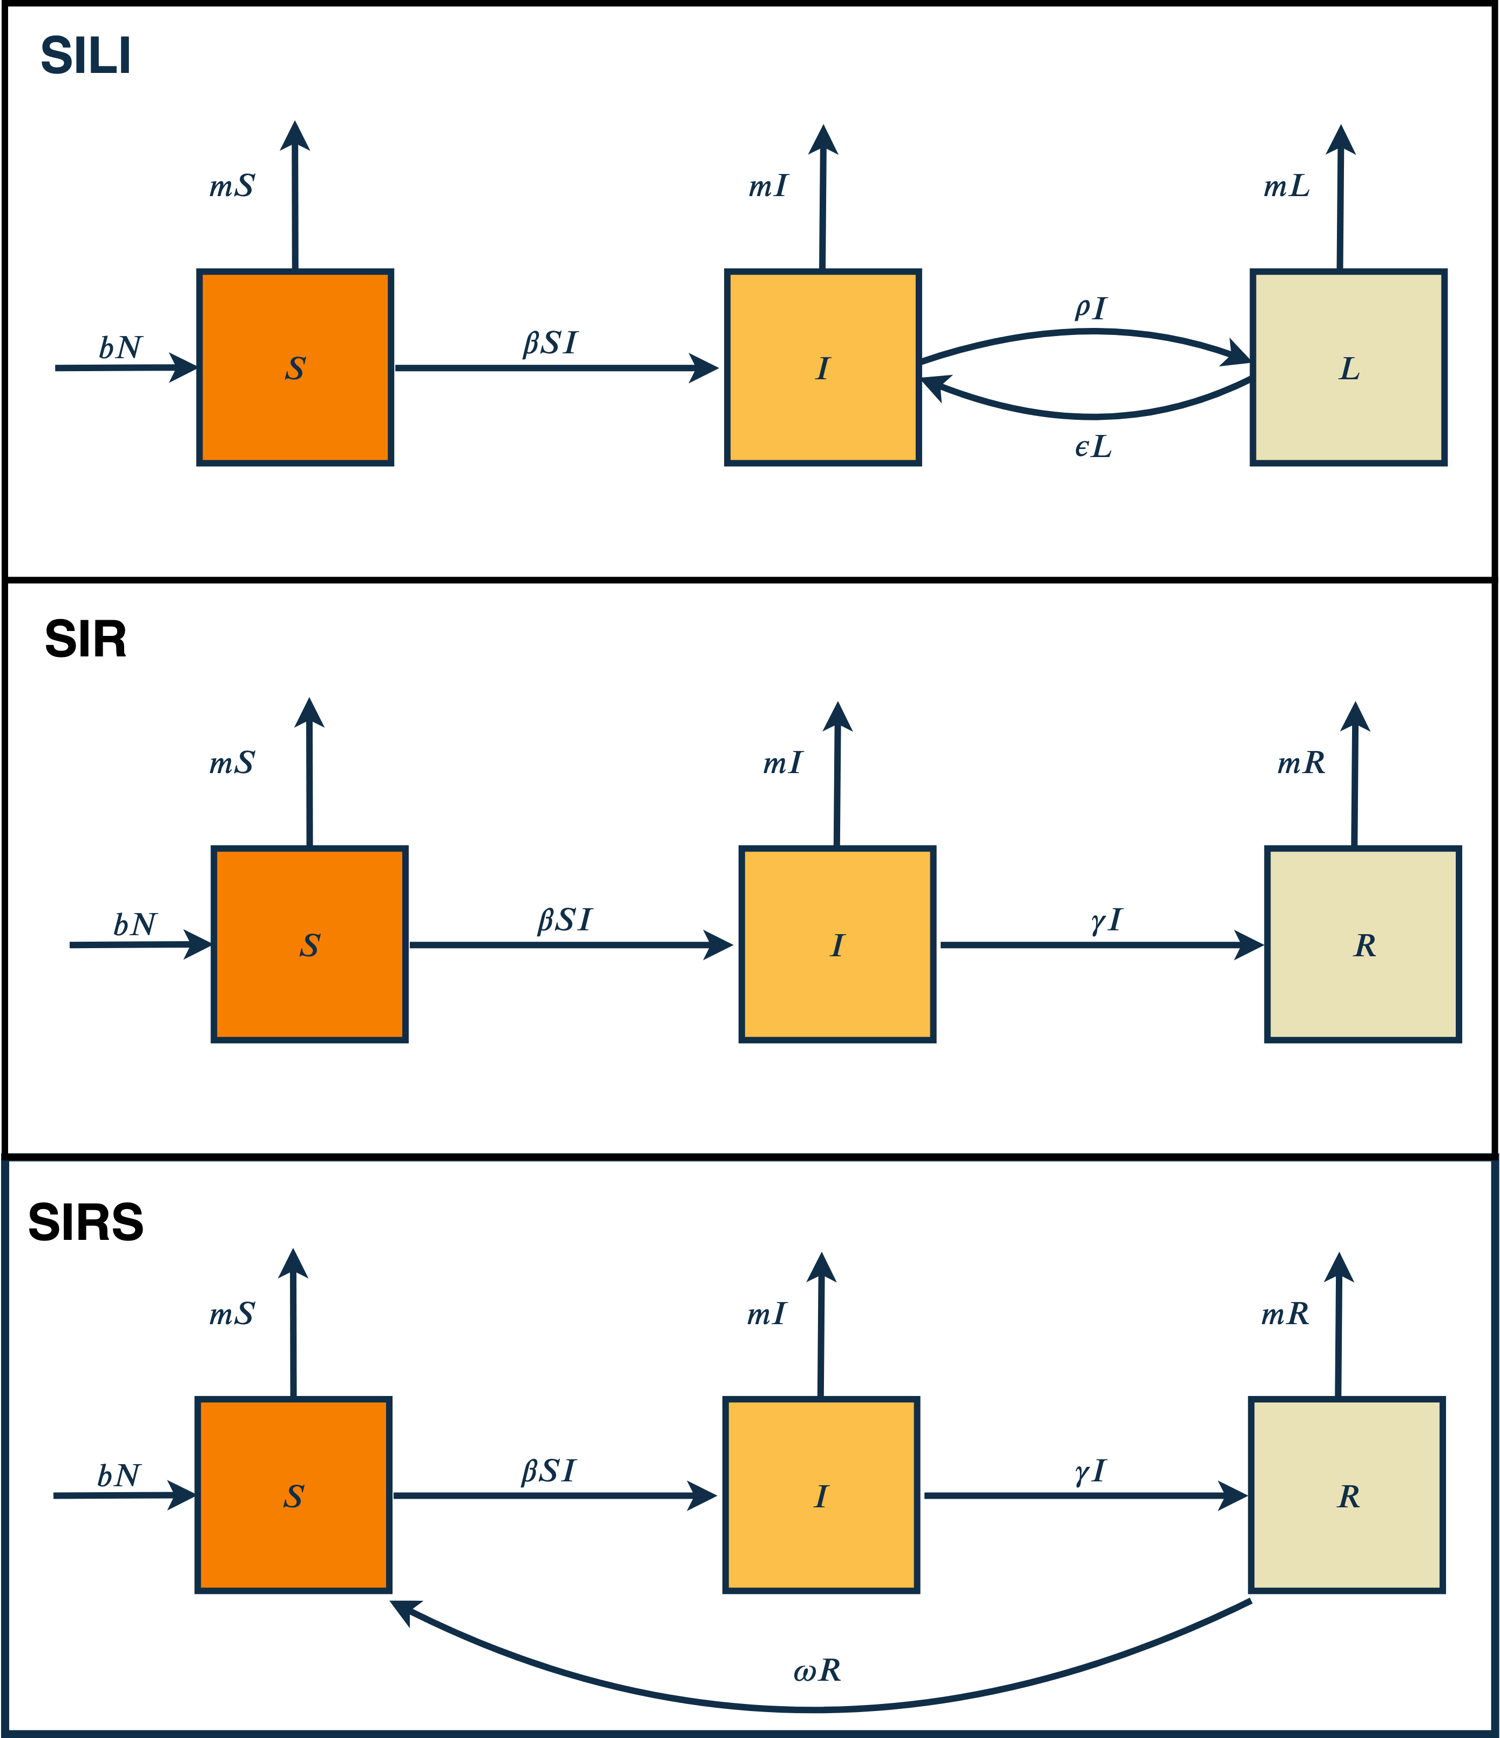

Figure 1: Model structures for SILI, SIR and SIRS type models, each model is built on top of an age structured bat population model with stochastic transitions between empirical states, see model methods (<https://github.com/aaronm70/batMods/blob/master/modelMethods.pdf>) for full details

# References

Field, Hume, David Jordan, Daniel Edson, Stephen Morris, Debra Melville, Kerryn Parry-Jones, Alice Broos, et al. 2015. “Spatiotemporal Aspects of Hendra Virus Infection in Pteropid Bats (Flying-Foxes) in Eastern Australia.” *PloS One* 10 (12): e0144055.

Vehtari, Aki, Jonah Gabry, Mans Magnusson, Yuling Yao, and Andrew Gelman. 2019. “Loo: Efficient Leave-One-Out Cross-Validation and Waic for Bayesian Models.” <https://mc-stan.org/loo>.

Vehtari, Aki, Andrew Gelman, and Jonah Gabry. 2017a. “Practical Bayesian Model Evaluation Using Leave-One-Out Cross-Validation and Waic.” *Statistics and Computing* 27 (5): 1413–32.

———. 2017b. “Practical Bayesian Model Evaluation Using Leave-One-Out Cross-Validation and Waic.” *Statistics and Computing* 27 (5): 1413–32. <https://doi.org/10.1007/s11222-016-9696-4>.

Vehtari, Aki, Daniel Simpson, Andrew Gelman, Yuling Yao, and Jonah Gabry. 2015. “Pareto Smoothed Importance Sampling.” *arXiv Preprint arXiv:1507.02646*.