Image1: Below is the basket (Fetch Selected Classify) before sending the documents to thought express.

Image 2: This is the image of the basket after sending the document, kindly note that the number is still constant.

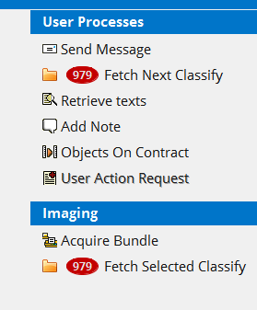

Image 3: This is image is after is after I open the basket and there are no sent items by me.

