**INFORMATION AND COMMUNICATIONS UNIVERSITY**

**SCHOOL OF HUMANITI**

**BUSINESS**

**Assignment No. TWO**

**Student details**

**Name:**

**SIN:**

**Lecturer’s Name: COLLINS MONDOKA**

**Year: 2023**

1. Describes the shape of a typical demand curve.

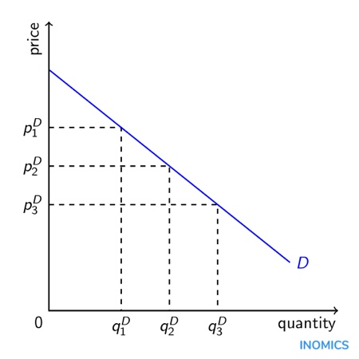

A typical demand curve has a negative slope, which means that as the price of a good or service increases, the quantity demanded of that good or service decreases. This negative relationship between price and quantity demanded is known as the law of demand. The demand curve typically slopes downward from left to right on a graph, showing the quantity demanded on the x-axis and the price on the y-axis. The exact shape of the demand curve can vary depending on factors such as the type of good or service being considered, the preferences and income levels of consumers, and the availability of substitutes or complements. However, in general, the demand curve is downward sloping, indicating that consumers are willing to purchase more of a good or service at lower prices and less at higher prices.

1. What is the difference between a shift in demand and an expansion of demand?

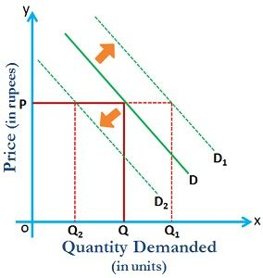 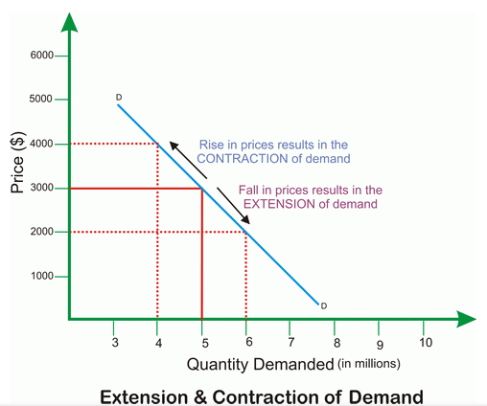  
Shift

A shift in demand and an expansion of demand are two different concepts in economics that refer to changes in the quantity demanded of a good or service, but they have different causes and implications.

A shift in demand refers to a change in the quantity demanded of a good or service at every price level, caused by a change in one or more of the factors that influence demand, such as a change in consumer preferences, income levels, population, or the availability of substitutes or complements. For example, if consumers become more health-conscious, they may shift their demand from sugary drinks to healthier beverages, causing a shift in the demand curve for sugary drinks to the left.

On the other hand, an expansion of demand refers to an increase in the quantity demanded of a good or service at the same price level, caused by a change in the price of the good or service itself. For example, if the price of a good decreases, consumers may be willing and able to purchase more of it, causing an expansion of demand along the existing demand curve.

1. What would happen if the cabinet minister urged people in Zambia to cut down on the high cost of living?

If a cabinet minister urged people in Zambia to cut down on the high cost of living, it would raise awareness of the issue and encourage individuals to take actions to reduce their expenses. However, it is unclear if this alone would have a significant impact on the cost of living, as the cost of living is influenced by a variety of factors such as inflation, economic policies, and global market conditions.

1. By buying only ‘cheap’ products, is that economically sound?

. Buying only 'cheap' products may not always be economically sound, as the quality of a product is often reflected in its price. While a lower price may be attractive in the short term, cheaper products may have a shorter lifespan or be less efficient, leading to additional expenses in the long run. Additionally, buying only cheap products may not support sustainable and ethical production practices, which can have broader economic and social impacts.

1. How does consumer surplus arise?

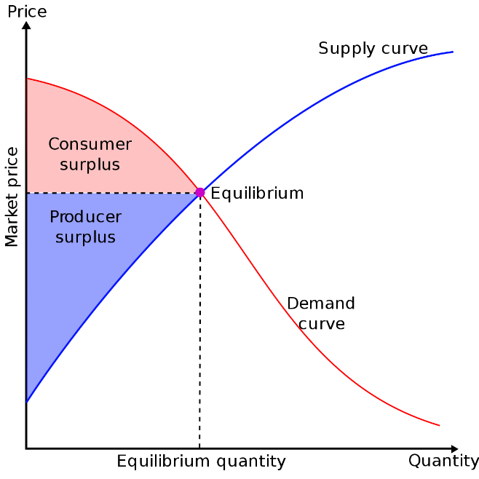

Consumer surplus arises when consumers are willing to pay more for a good or service than the market price they actually pay. It is the difference between what a consumer is willing to pay for a good or service and the actual price paid. Consumer surplus occurs when the market price is below the consumer's willingness to pay, and consumers benefit from the difference in value. Consumer surplus can be generated by factors such as a decrease in the price of a good, an increase in the consumer's income, or an improvement in the quality of the good or service. Consumer surplus is a measure of the net benefit or value that consumers receive from a transaction and is considered a key concept in the field of welfare economics.

1. List some factors can cause a change in supply?

Technology, Cost of production, price of related goods, Natural disasters & state policies.

1. What are substitutes and complementary goods?

Substitutes are goods that can be used in place of each other to satisfy a similar need or want. For example, tea and coffee are substitutes as they can both be consumed as hot beverages. Complementary goods are goods that are used together to satisfy a particular need or want. For example, cars and gasoline are complementary goods, as a car requires gasoline to function.

1. What is a shape of a typical supply curve?

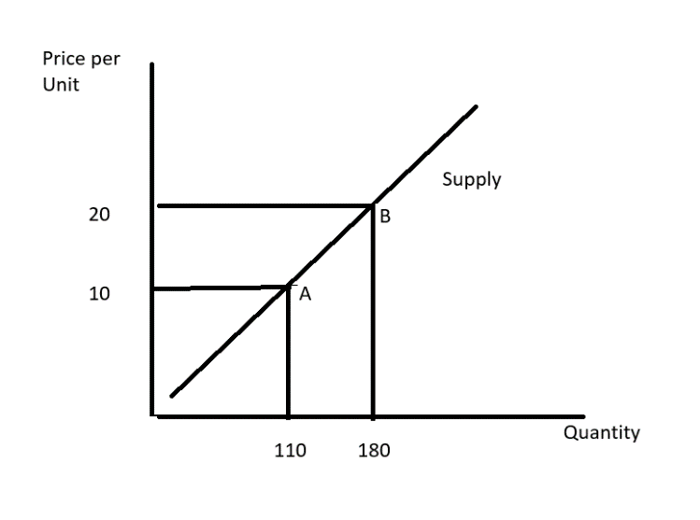

A typical supply curve is upward sloping, indicating that as the price of a good or service increases, the quantity supplied by producers also increases. This relationship is based on the principle of profit maximization, where suppliers are incentivized to produce and sell more at higher prices. However, the slope of the supply curve can vary depending on factors such as production costs, technology, and resource availability. In some cases, the supply curve may be perfectly elastic or perfectly inelastic, indicating a highly responsive or unresponsive supply to changes in price, respectively.

1. When the price of a good is set above the equilibrium price, what is the result?

When the price of a good is set above the equilibrium price, there will be a surplus of the good, as the quantity supplied will exceed the quantity demanded. Producers will have a harder time selling their goods, and may be forced to lower the price to attract buyers.

10. Illustrating graphically in specifying the assumption upon which your reasoning is based, describe briefly:

1. The effect on the price and output of fresh maize of adverse weather condition.

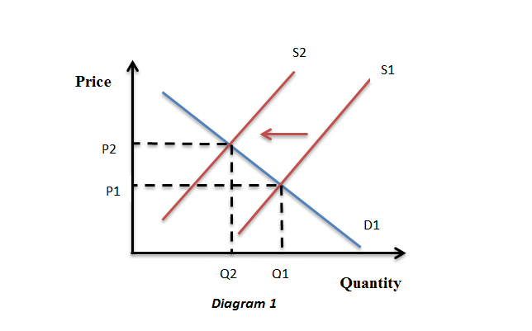

Adverse weather conditions can reduce the supply of fresh maize, causing a leftward shift in the supply curve. This will cause the equilibrium price to increase and the equilibrium quantity to decrease, resulting in higher prices and a reduced output of fresh maize. Producers may also experience higher production costs, which could lead to further price increases for consumers.

1. The effects on price and output of oranges of an increase in consumer’s income.

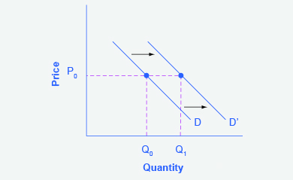

An increase in consumers' income can lead to an increase in demand for oranges, causing a rightward shift in the demand curve. This will cause the equilibrium price and quantity to both increase, resulting in higher prices and a larger output of oranges. Producers will be incentivized to supply more oranges to meet the higher demand, leading to increased revenue and potentially expanding production.

Question 2.1

1. Explain the difference between ‘ change in supply’ and a ‘change in the quantity supplied’

"Change in supply" refers to a shift in the entire supply curve caused by factors that affect the willingness or ability of suppliers to produce and sell a good or service, such as changes in production costs, technology, or government regulations. A change in supply will cause a new equilibrium price and quantity to emerge.

In contrast, "change in quantity supplied" refers to a movement along the supply curve in response to a change in price. It represents a change in the amount of a good or service that producers are willing and able to sell at a given price, but does not shift the entire supply curve. A change in quantity supplied does not affect the equilibrium price or quantity, only the movement along the supply curve.

1. **Zim Police warns dubious traders**.

HARARE–“The Zimbabwean police warned last Monday unscrupulous traders selling commodities at above the government stipulated prices that they risked being arrested if caught doing the unlawful act.

Police spokesperson Inspector, Cecilia Churu, said that police would not hesitate to arrest any retailer caught flouting the gazette price.

The warning comes in the wake of unjustified price increases of Mealie Meal in the past two weeks by millers without the approval of the government**.”**

**Zambia Daily Mail, 24th July, 2003.**

You are required to:

Explain, with the aid of a diagram, the effect of this form of government intervention on the price mechanism.

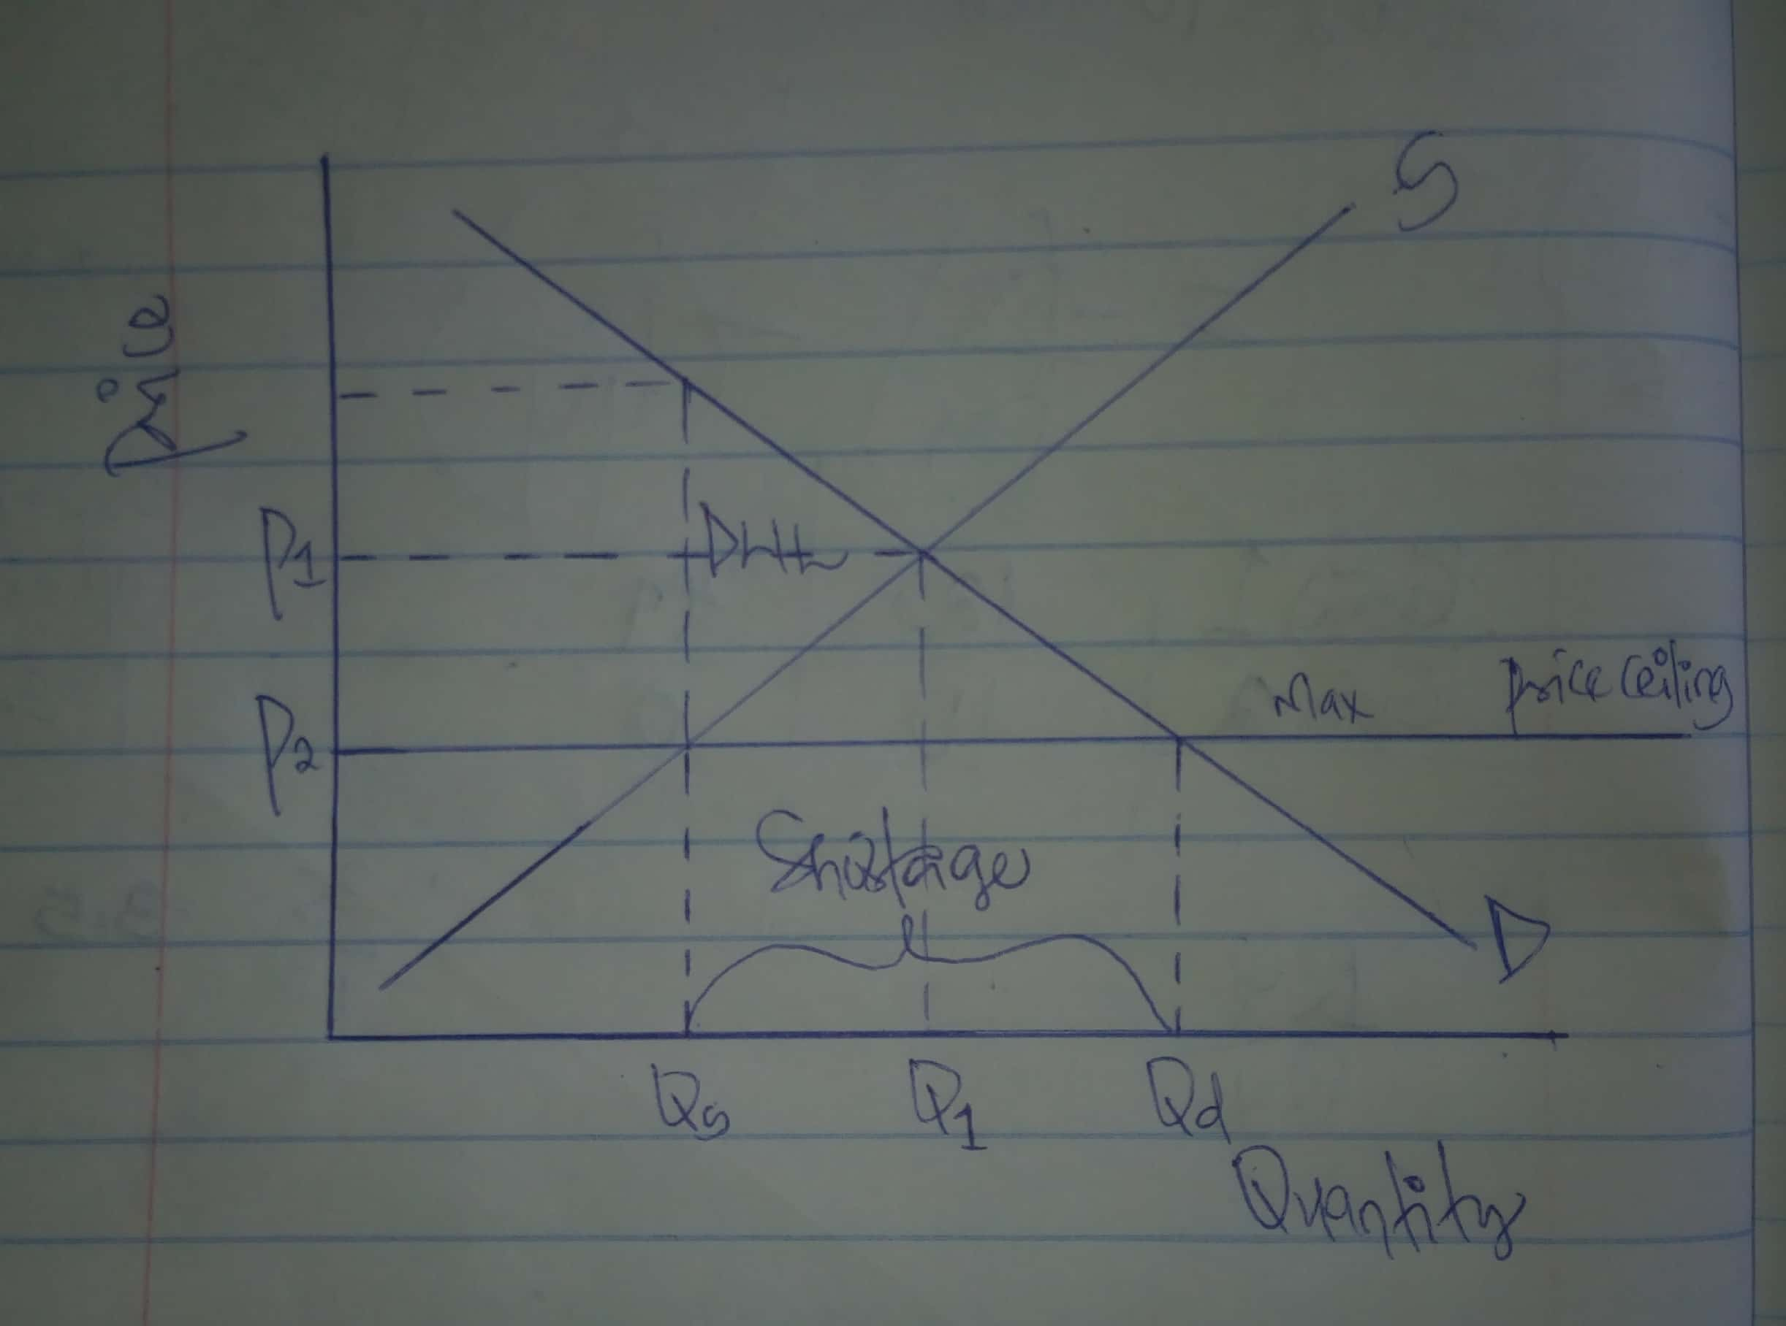

The government intervention described in the article is an example of a price ceiling, which is a legal maximum price that can be charged for a good or service. In this case, the government has set a maximum price for Mealie Meal, a staple food in Zimbabwe.

The effect of this intervention can be illustrated in a diagram of the market for Mealie Meal. Assuming the initial equilibrium price is above the government's stipulated price, the price ceiling is binding and creates a shortage of Mealie Meal, as the quantity demanded exceeds the quantity supplied at the lower price. This is shown by the distance between the demand curve and the supply curve at the government-mandated price.

Consumers benefit from the lower price of Mealie Meal, but producers may reduce output due to lower profit margins. In the long run, this could result in a decrease in the supply of Mealie Meal, exacerbating the shortage and potentially leading to a black market.

Overall, while price ceilings can provide short-term benefits to consumers, they can also distort market incentives and lead to unintended consequences such as shortages and black markets.