IT WS02 – Web Systems and Technologies 2

Discord Clone

Submitted by:

Rea Jean Castillo

Nicko Valmonte

John Kenneth Caparas

Submitted to:

Mr. Edgen Dy M. Gavino

Instructor

1. Application Functionality

(Explain the overall functionality and importance of the web application)

The web application is a single-page Discord clone designed using only HTML, CSS, and JavaScript. It focuses primarily on replicating the layout and visual design of ***Discord***, providing a familiar interface for users. The application uses JavaScript to simulate navigation between sections, creating a lightweight and seamless single-page experience without the backend server. It also includes a basic login simulation, allowing users to experience the interface as though they are authenticating, though this is not connected to any real authentication system.

The application features a clean and intuitive interface that mirrors Discord, including key elements such as a sidebar for channels, a chat display area, and a text input box for sending messages. Users can simulate logging in, and once logged in, they can send messages that are displayed in real-time on the same page. The navigation between sections, such as different channels or server-like layouts, is handled dynamically using JavaScript.

One of the key features is a simple messaging system where users can type and send messages that are displayed locally within the interface. However, without backend support or a database, messages are not saved or shared between users. The layout incorporates core Discord elements, such as a sidebar for channels, a message view area, and a text input box, showcasing a visually appealing and functional design.

This project is significant as it serves as a demonstration of your front-end development skills and understanding of fundamental web technologies. It highlights your ability to create responsive, engaging interfaces and mimic the design of a complex application using basic tools. Additionally, it acts as a prototype that could be expanded with backend features in the future, laying the groundwork for a fully functional chat application.

It highlights your creativity and problem-solving skills in mimicking a complex application using only basic web technologies, serves as a learning project for HTML, CSS, and JavaScript, helping you understand fundamental web development concepts and showcases your understanding of user interface (UI) and user experience (UX) design principles, replicating a popular platform's look and feel.

1. Application Views

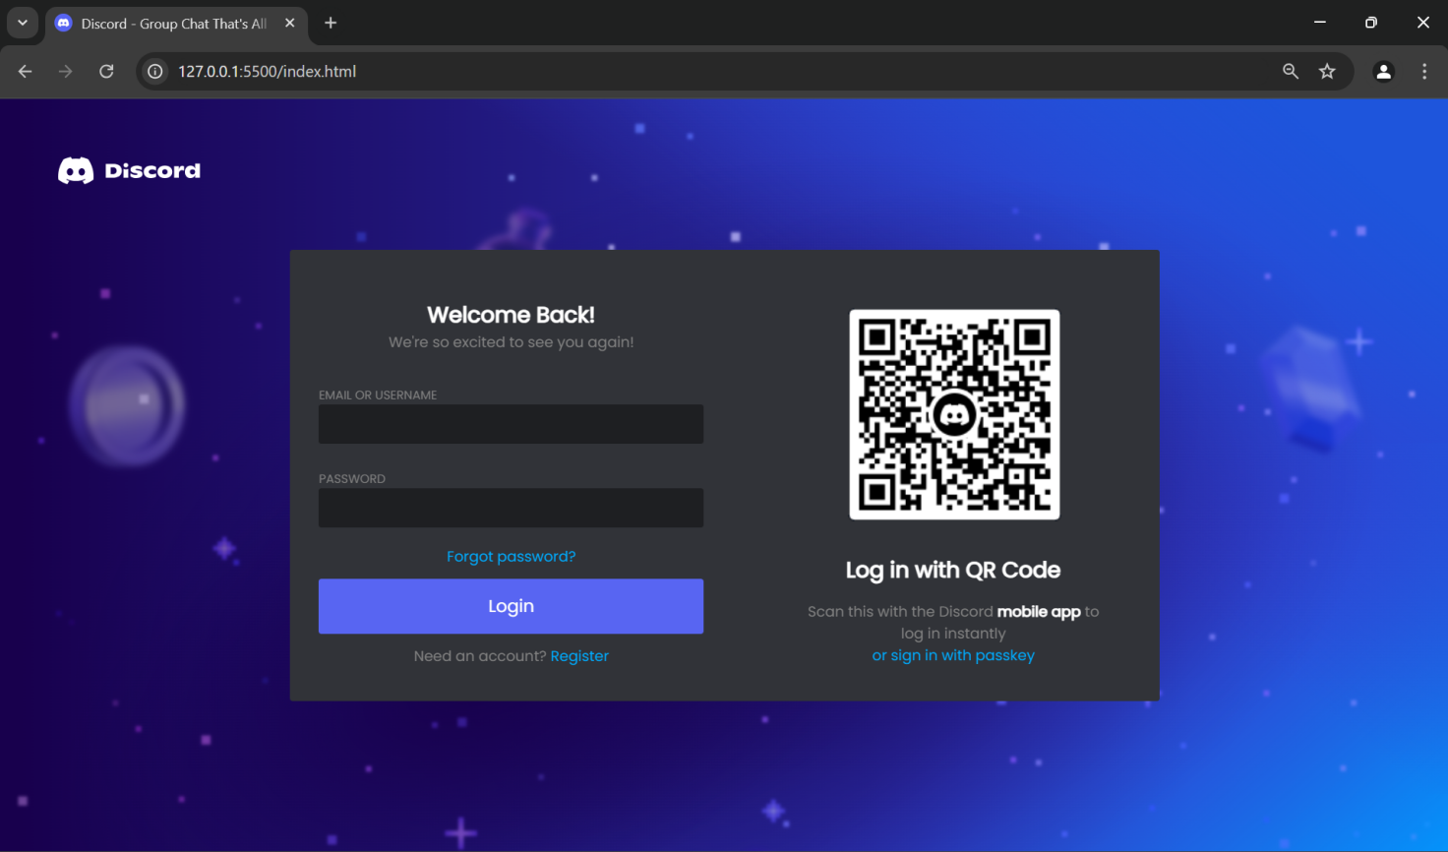

Log in - it contains the email and password input that takes the information of the user, it also has the authentic qr code of the discord official website.

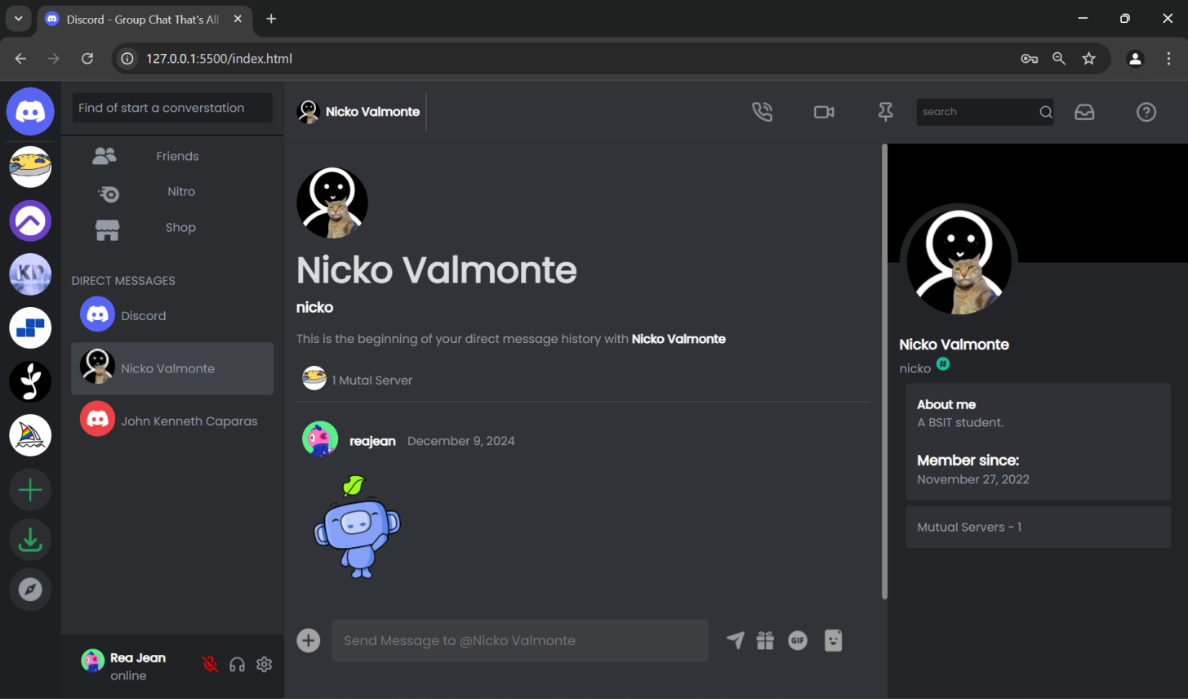

Home - this page contains the messages and contacts of the user, it also contain other resources such as receiver’s detail, navigation, and servers.

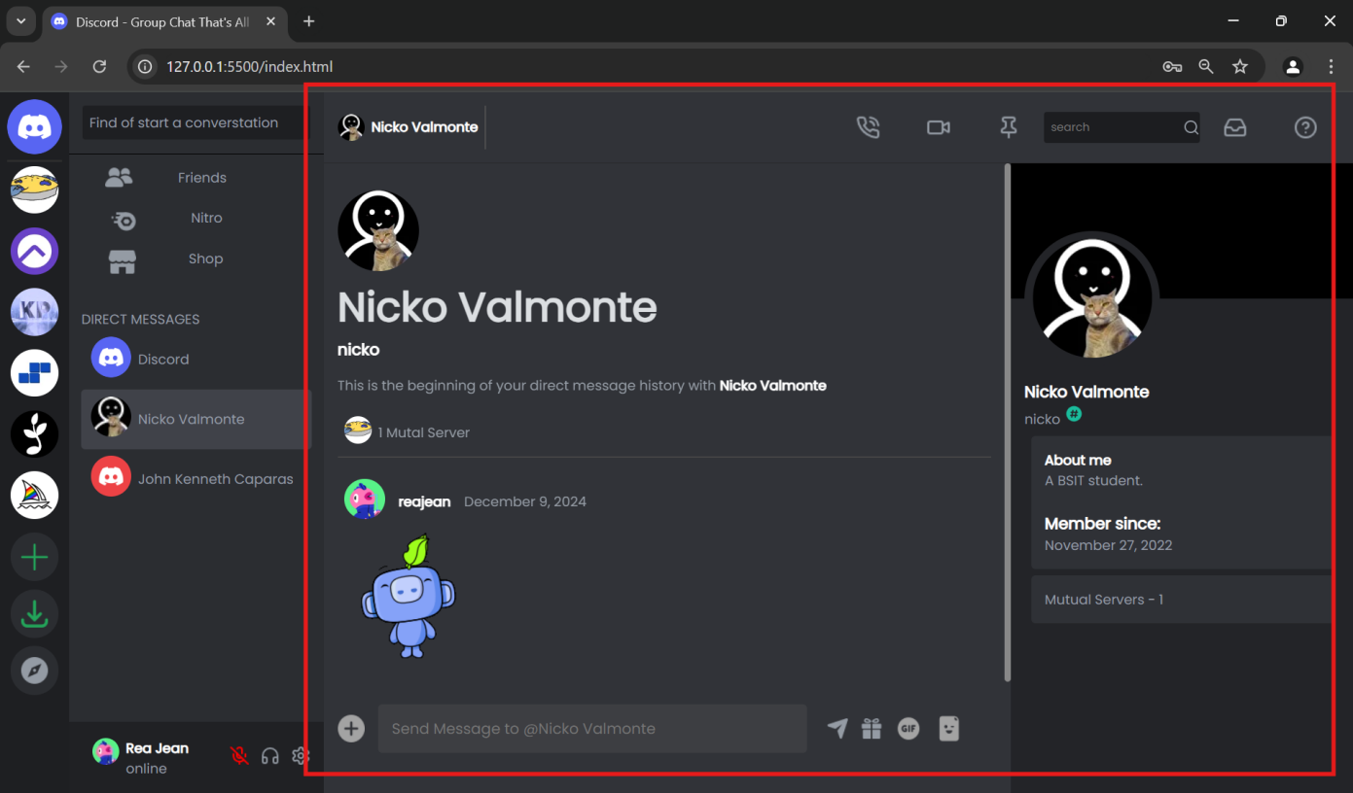

Message section - the section that has the history of the user and the receiver conversation, this also shows the detail of the message receiver.

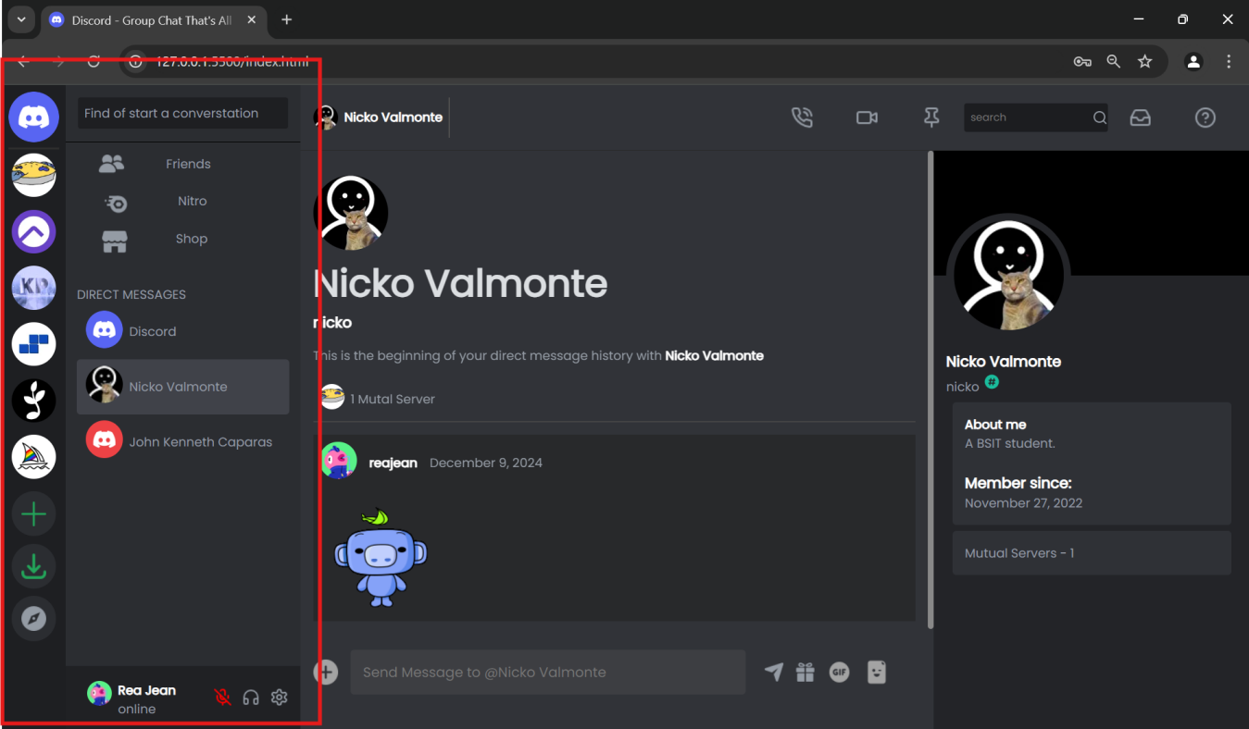

Nagivation menu -this shows the menu or the list of the server the user joined in the *server list*, the *conversation menu* that contains the people that user message directly.

1. References

(Lists of all links that you have used throughout your development (openai.com).)

Include all the JavaScript or CSS libraries that you used to build your web app.

<https://www.w3schools.com/> - this site contains the idea and lecture about the layout and structure of the code.

<https://icons8.com/icons/set/discord> - this site is used to take icon set similar to discord website.

<https://discord.com/> - this site serve as imitating reference of the project

<https://lucide.dev/icons/> - this site serve to get icons.

<https://stackoverflow.com/> - this site is used to get answers and efficient related codes.

<https://www.messenger.com/> - this site is used for team collaboration.

<https://drive.google.com/> - this is used to share and edit file remotely.