IT WS02 – Web Systems and Technologies 2

Spotify-Layout

Clone

Submitted by:

Stephanie Alarcon

Submitted to:

Mr. Edgen Dy M. Gavino

Instructor

1. Application Functionality

(Explain the overall functionality and importance of the web application)

The single-page Spotify clone serves as a visually engaging and interactive prototype of the Spotify web application. While it currently lacks backend functionality and data-driven features, its layout and page-switching mechanics are significant for the following reasons:

User Interface (UI) Design Showcase

Your website demonstrates the ability to replicate the look and feel of a professional music streaming application. This includes visual components like a navigation bar, playlists, album thumbnails, and other UI elements similar to Spotify.

Single-Page Navigation

The use of JavaScript for switching between pages highlights your knowledge of creating a seamless single-page application (SPA). This type of navigation offers a smooth and modern user experience.

Design Demonstration:

The layout provides a visual representation of how a Spotify-like application might look and feel.

It showcases core UI components, such as a navigation bar, music player section, and playlist.

Early testing ensures that the visual structure aligns with user expectations.

User Interface (UI) Design Showcase

The website demonstrates the ability to replicate the look and feel of a professional music streaming application. This includes visual components like a navigation bar, playlists, album thumbnails, and other UI elements similar to Spotify.

Single-Page Navigation

The use of JavaScript for switching between pages highlights your knowledge of creating a seamless single-page application (SPA). This type of navigation offers a smooth and modern user experience.

Importance:

This project serves as a valuable stepping stone in your learning journey, allowing you to understand web design principles while creating something visually compelling. It can also be added to your portfolio as a demonstration of your skills.

Although the project is currently non-functional, it demonstrates the value of front-end design and interaction principles. It’s a critical step in web development as it lays the groundwork for turning static concepts into interactive, user-friendly applications. By refining this prototype, the project can inspire future iterations and help transition toward a complete Spotify-like application.

Even without dynamic functionality, your Spotify clone has significant value as a learning exercise and a visually impactful showcase of your skills.

1. Application Views

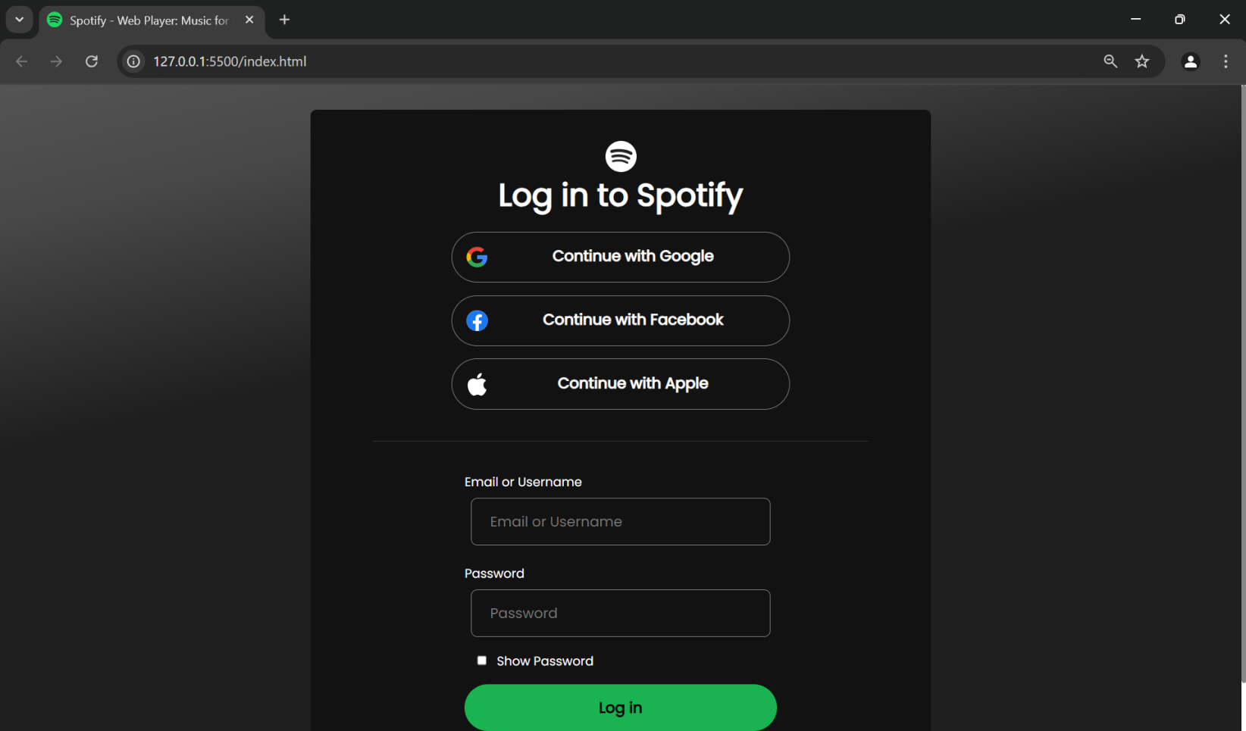

Log-in page - this page is the first thing you’ll see when you go to spotify, same thing here in the single-page website, you’ll land first in the log in page; this login only takes the *username* “pane” and *password* “pane”.

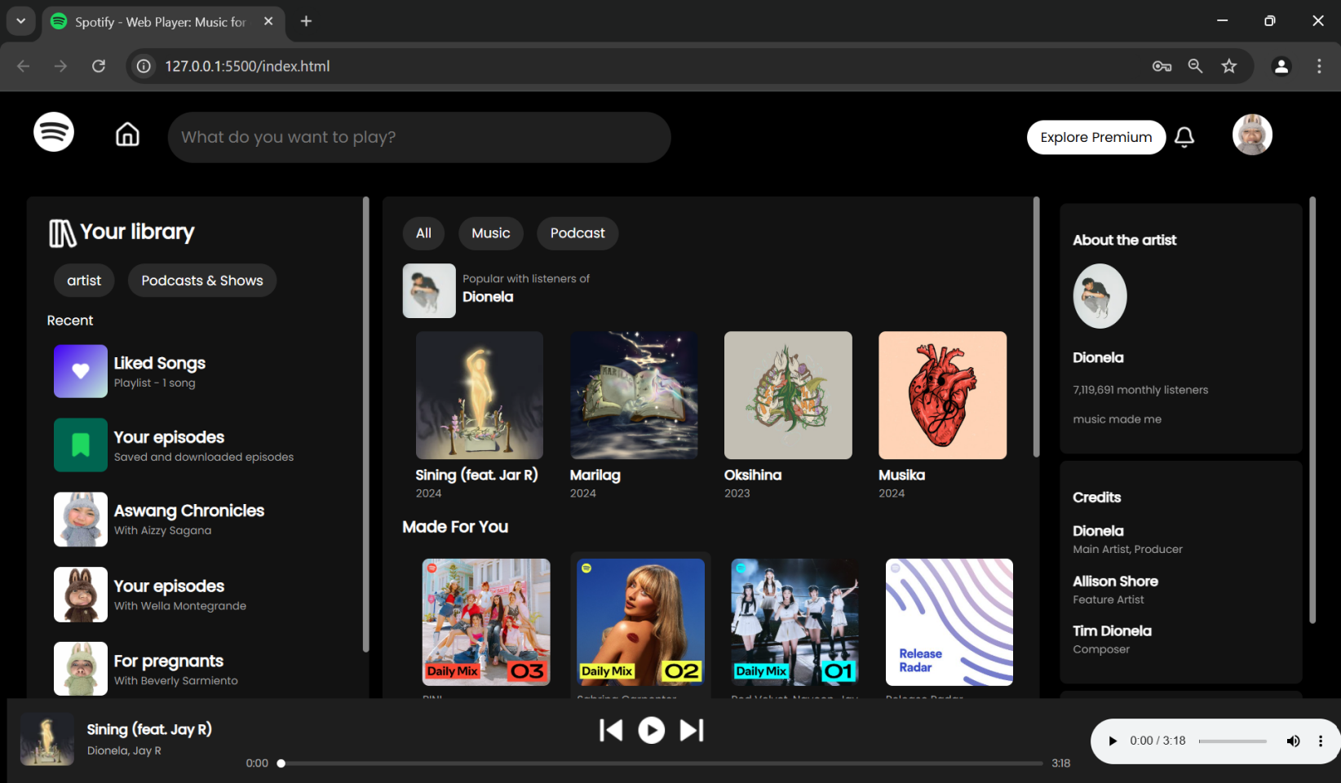

Main page - after you logged in you’ll see the main page; this page contains the library, the library contains menu items like *Liked Songs, Your episode, and the playlist.*

Next in Main page is the *Song/Music section* which shows the suggested music and also a navigation menu that has *All* and *Music,* the current shown section is the *All* section while the *Music* section contains more other music available.

Next in the Main page is the *about the artist* section, this contains the artist of the current song playing, and the next song in queue.

Last is the *Audio player*, it shows the current song playing and the audio controls.

1. References

(Lists of all links that you have used throughout your development (openai.com).)

Include all the JavaScript or CSS libraries that you used to build your web app.

<https://stackoverflow.com/> - used to ask questions for styling audio player controls

<https://open.spotify.com/> - Used to replicate spotify as reference to the project.

<https://lucide.dev/icons/> - Used to get icons.

<https://www.w3schools.com/> - used as learning material for other principle of the html and css.