Homework 3

1. Modeling Length vs Midrange Price

a)

Intercept = -41.525
Slope = 0.333

b)

MidrangePrice = 0.333(Length) - 41.525

c)

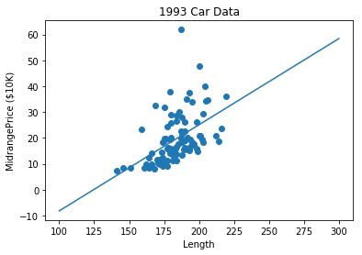

d)

SSE = 6406.756

e)

R-squared = 0.254

2. I found horsepower to be the best indication of median price, with the following measurements.

omega0 (intercept) = -1.399
omega1 (slope) = 0.145
SSE = 3250.881
R-squared = 0.621

3. I selected the attributes Length, Horsepower, and Midrange Price to predict Highway MPG.

a.

omega0 (intercept) = 54.261
omega1(slope) = -0.101
omega2(slope) = -0.036
omega3(slope) = -0.078

b.

HighwayMPG = -0.101(Length) – 0.036(Horsepower) – 0.078(Midrange Price) + 54.261

c.

SSE = 1440.574

d.

R-squared = 0.44917682144560667

4. Hot Hands Data:

00000001100011010000001110110100101101111101101101111110001100111101100000111110
00001001010110110010

5.

I felt that I improved at making baskets as the experiment progressed. I seemed to have more streaks of misses towards the beginning of the experiment. To analyze the validity of this claim I will use an alpha level of p=0.05

6.

The slope was 0.00158. Here is a graph of my results and the linear fit.

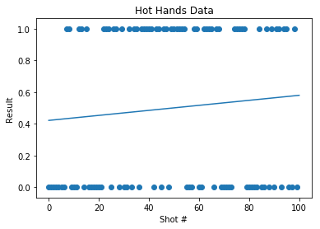

7.

a.

Null hypothesis: There was no improvement in my accuracy during the hot hands experiment.
Alternative hypothesis: There was an improvement in my accuracy during the hot hands experiment.

b.

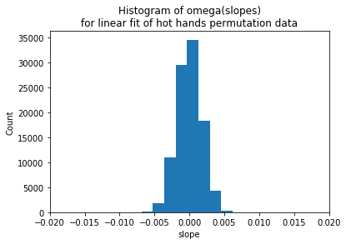

c.

cutoff = 0.00287

d.

p-value = 0.182

e.

Based on these results, there was no improvement to my shots during the hot hands experiment. My p-value was 0.182, which is not under the desired confidence level of 0.05, so we do not have enough evidence to reject the null hypothesis.

8.

An alternative approach would be to separate the results into chunks, say 10 or 20 baskets each, and compare the ratio of hits and misses of each chunk of data. If the ratio of hits/misses is significantly higher for the last portion of the data compared to the first portion, than you could demonstrate that there was an improvement in accuracy during the experiment.

