LearnQuest: An Adaptive Learning Management System Powered by Artificial Intelligence for STEM Students of
Kapitolyo High School

A Capstone Project proposal presented to the
College of Computer Studies of
Pamantasan ng Lungsod ng Pasig

In partial fulfillment of the requirements for the degree of
Bachelor of Science in Information Technology

by:
Mendoza, Rashid N.
Nebasa, Harlene G.
Valiente, Aaron Mark D.

Rebecca R. Fajardo, DIT
Adviser

October 2026

ADVISER’S RECOMMENDATION SHEET

This Capstone Project entitled

LearnQuest: An Adaptive Learning Management System Powered by Artificial Intelligence for STEM Students of Kapitolyo High School
by:
Mendoza, Rashid N.
Nebasa, Harlene G.
Valiente, Aaron Mark D.

And submitted in partial fulfillment of the requirements of the
Bachelor of Science in Information Technology degree
has been examined and is recommended for acceptance and approval

Rebecca R. Fajardo, DIT Adviser

October 2026

CAPSTONE PROJECT COORDINATOR AND
DEAN’S ACCEPTANCE SHEET

This Capstone Project entitled

LearnQuest: An Adaptive Learning Management System Powered by Artificial Intelligence for STEM Students of Kapitolyo High School
by:
Mendoza, Rashid N.
Nebasa, Harlene G.
Valiente, Aaron Mark D.

After having been recommended and approved is hereby accepted by
the College of Computer Studies of
The Pamantasan ng Lungsod ng Pasig
Riegie Dy. Tan, DIT
Capstone Project Coordinator
Riegie Dy. Tan, DIT
CCS Dean
October 2026

CERTIFICATION
This capstone project entitled LearnQuest: An Adaptive Learning Management System Powered by Artificial Intelligence for STEM Students of Kapitolyo High School, prepared and submitted by Mendoza, Rashid N., Nebasa, Harlene G., and Valiente, Aaron Mark D., in partial fulfillment of the requirements for the degree of Bachelor of Science in Information Technology (BSIT), has been examined and recommended for ORAL EXAMINATION.
Rebecca R. Fajardo, DIT
Adviser

APPROVAL SHEET
Approved by the Panel for Oral Defense on October 25, 2026, with a rating of___.
Randy R. Otero, MIT
Chairman
Noreen Arcangel-Perez, DIT
Panel Member

Accepted in partial fulfillment of the degree of Bachelor of Science in Information Technology.
Riegie Dy. Tan, DIT
CCS Dean

ACKNOWLEDGEMENT
Paste Here Paste Here Paste Here Paste Here Paste Here Paste Here
Paste Here Paste Here Paste Here

R.N.M
H.G.N
AM. D.V

TABLE OF CONTENTS
List of Appendices viii
List of Figures ix
List of Tables xi
Abstract xiii
CHAPTER 1: Introduction
The Problem and Its Background 01
Review of Related Literature 07
Significance of the Study 31
Statement of the Problem 33
General Problem 33
Specific Problems 33
Scope and Limitation of the Study 35

CHAPTER 2: Methodology
Introduction 41
Research Design 42
Population and Sampling 83
Data Collection Methods 84
Ethical Considerations 87
Summary 89
CHAPTER 3: Results and Discussions
Introduction 91
Project Capabilities and Testing Process Details 92
Test Plan
Results of the System Evaluation
Summary of the System Evaluation Results
Discussion
Project Testing Results 130

CHAPTER 4: Conclusions and Recommendations
Introduction 132
Conclusions 133
Recommendations 135

References 138
Plagiarism Check Results
Curriculum Vitae

LIST OF APPENDICES
Appendix A: Operational Definition of Terms 156
Appendix B: Evaluation Sheets 160
Appendix C: Project Timeline 166
Appendix D: Work Assignments 167
Appendix E: Certificate of Appreciation 170
Appendix F: Source Code 171
Appendix G: Plagiarism Check Results 200
Appendix H: AI-Generated Content Check Results 201
Appendix I: IMRaD compressed version 202

LIST OF FIGURES
Figure 1: Architectural Framework of the Study 44
Figure 2: Level 0 Data Flow Diagram (Context Diagram) of LearnQuest 59
Figure 3: Level 1 Data Flow Diagram of LearnQuest 62
Figure 4: Level 2 Data Flow Diagram of Process 3.0: Process
Documents and Summarize Lessons 66
Figure 5: Level 2 Data Flow Diagram of Process 4.0: Generate and
Validate Quiz Bank 68
Figure 6: Level 2 Data Flow Diagram of Process 5.0: Conduct
Adaptive Quiz Attempts 70
Figure 7: Level 2 Data Flow Diagram of Process 6.0: Update
Competency Mastery (BKT) 72
Figure 8: Level 2 Data Flow Diagram of Process 7.0: Provide
Personalized Learning Support 74
Figure 9: Agile Software Development Diagram 76
Figure 10: Users Landing Page 94
Figure 11: User Login and Sign-up Page 95
Figure 12: Teacher Guided System Tour 96
Figure 13: Teacher Homepage 97
Figure 14: Teacher Dashboard Page: Analytics and Monitoring
Interface 98
Figure 15: Teacher Class Details and Content Creating Modal 99
Figure 16: Teacher Module Management Page 100
Figure 17: Teacher Subject Level Modules: Materials Repository Page 101
Figure 18: Teacher Archived Classes Page 102
Figure 19: Teacher Quiz and AI Setup Page 103
Figure 20: Teacher QuestAI Coach Page 105
Figure 21: Student Home Page 106
Figure 22: Student Analytics Dashboard Page 107
Figure 23: Student Enrolled Class Page 108
Figure 24: Student Lesson Details Page 109
Figure 25: Student Quiz Assessment Page 110
Figure 26: Student QuestAI Study Assistant 111
Figure 27: User Profile Settings Page 112
Figure 28: Distribution of Responses per Evaluated Item

LIST OF TABLES
Table 1: Comparison of Adaptive Learning Algorithms 28
Table 2: Bayesian Knowledge Tracing (BKT) Variables Used 50
Table 3: Illustrative Example of BKT Implementation in LearnQuest 53
Table 4: Test Plan for the Major Functions of LearnQuest
Table 5: Interpretation Scale for the Weighted Mean
Table 6: Type of User 114
Table 7: Suitability 115
Table 8: Accurateness 116
Table 9: Compliance 117
Table 10: Security 11
Table 11: Fault Tolerance 118
Table 12: Recoverability 120
Table 13: Understandability 121
Table 14: Learnability 122
Table 15: Operability 123
Table 16: Attractiveness 124
Table 17: Time Behavior 125
Table 18: Resource Utilization 126
Table 19: Analyzability 130
Table 20: Testability 127
Table 21: Installability 128
Table 22: Replaceability 129
Table 23: Summary of the Weighted Means by ISO/IEC 25010 Characteristic

ABSTRACT
Title : LearnQuest: An Adaptive Learning Management System Powered by Artificial Intelligence for STEM Students of Kapitolyo High School
Researchers : Mendoza, Rashid N., Nebasa, Harlene G., Valiente, Aaron Mark D.

Degree : Bachelor of Science in Information Technology
School Year : 2026-2027

Project Description :
An abstract is a 150- to 250-word paragraph that provides readers with a quick overview of your thesis or capstone project and its organization. It should express your central idea and your key points.
“a concise summary of the entire paper.”
The function of an abstract is to describe, not to evaluate or defend, the paper.
The abstract should begin with a brief but precise statement of the problem or issue, followed by a description of the research method and design, the major findings, and the conclusions reached.
The abstract should contain the most important keywords referring to method and content: these facilitate access to the abstract by computer search and enable a reader to decide whether to read the entire document.

CHAPTER 1
INTRODUCTION

The Problem and its Background
Students in the field of Science, Technology, Engineering, and Mathematics (STEM) commonly find it difficult to keep their engagement, motivation, and consistency needed to succeed academically, especially in their science subjects. Students find it challenging to continue their interests and efficiently manage their productivity because the science subjects' content contains a lot of information and requires frequent analysis. Additionally, despite providing access to educational tools and standard instructional resources of traditional and online learning platforms, they are still unable to address the unique needs of the students.
In response to these learning challenges of the students, educational institutions are increasingly adopting innovative digital learning tools that could blend technology and the active participation of the students. Specifically, the embedding of artificial intelligence (AI) with learning management systems (LMS) has proven to be effective for students in creating more adaptive learning.
The advancements in digital technology have significantly reshaped the method of delivery and management of education. As stated by Hashemi-Pour et al. (2024), the utilization of Learning Management Systems (LMS) is one of the most important content management tools that teachers can easily use to organize and manage class lessons, communication, and test creation. Additionally,
Prahani et al. (2022) emphasized that the LMSs provide centralized control of learning materials and analytics by improving teaching efficiency and student participation.
Learning Management System (LMS) has become very important for convenient learning, progress monitoring, and effective teaching and learning by means of the education process. According to Lee D. (2023), the importance of implementing LMS in the secondary education sector is that the educational institutions that are making use of LMS can implement flexible learning and engaging means of education before and after the COVID-19 pandemic.
Therefore, there is an indication of the rise in usage of LMS through platforms that provide advanced features like flexible educational approaches, real-time assessments, analytics support, and Artificial Intelligence (AI). As Aljad et al. (2025) observe, this development is the result of the fast technological development of LMS platforms.
Despite advancements in digital technology, uses of online education continues to encounter many problems. Most students, especially senior high school students, find it difficult to concentrate while learning online. While Prahani et al. (2022) note that although Learning Management Systems (LMS) are extremely efficient in managing lessons and tests, students lack motivation due to the absence of personal interaction. The usage of artificial intelligence (AI) would be helpful as a solution to these problems because it provides personalized feedback and adaptive learning.
The significant contribution of Artificial Intelligence (AI) within the academic field seems to be growing tremendously because of its ability to observe student performance and learning processes. It is also capable of providing customized material according to the specific needs of students. AI technology is a very effective way to enhance the process of teaching and learning by integrating it into an LMS system.
Kapitolyo High School (KHS) was established in 2004 on 2nd of June, and was located on Barangay Kapitolyo, San Ignacio St., Pasig City. Since then, this institution has consistently worked hard to improve its instructional quality to provide an outstanding educational experience for its students. Currently, KHS has a total of approximately 1,700 senior high school students, comprising 844 Grade 11 students and 856 Grade 12 students, and a total of 40 faculty teachers who provide support to the students.
In addition, KHS provides students with three main options for their studies: Science, Technology, Engineering, and Mathematics (STEM), Accountancy, Business, and Management (ABM), and Humanities and Social Science (HUMSS). In addition to those main options, there are also Technical–Vocational–Livelihood (TVL) courses such as Animation, Computer Systems Servicing, and Home Economics. Hence, these diverse tracks enable students to develop their specialized skills while exploring their career interests.
Since the COVID-19 pandemic until the present, Kapitolyo High School has utilized Google Classroom as its primary Learning Management System (LMS) for
distributing learning materials, posting assignments, administering quizzes, and facilitating communication between teachers and students. The platform has supported the continuity of instruction by providing an organized digital environment where teachers can manage classroom activities and students can conveniently access learning resources anytime and anywhere.
However, despite these advantages, several instructional challenges remain, particularly in the teaching and learning of science subjects for STEM students. Science lessons often contain complex concepts that require continuous practice and better utilization of learning materials. While Google Classroom effectively manages classroom resources and assessments, learning activities are generally delivered in a uniform manner to all students, regardless of their individual learning progress. As a result, students who experience difficulties with specific concepts may require additional guidance before advancing to succeeding topics, while those who have already mastered the lessons receive the same learning experience.
Furthermore, monitoring student progress is commonly based on completed activities and numerical grades, making it challenging for teachers to identify specific competencies that require improvement. With large class sizes and multiple sections to manage, providing timely and individualized feedback for every learner also becomes increasingly demanding. Consequently, some students may continue experiencing misconceptions or learning gaps without receiving immediate instructional support.
These existing instructional challenges highlight the need for an enhanced learning management system that not only supports the organization of learning materials and classroom activities but also provides more personalized learning support and meaningful analysis of student progress. Such a system can assist both students and teachers by promoting continuous learning, identifying competency mastery, and providing timely learning interventions.
This study aims to develop LearnQuest, an adaptive Learning Management System powered by Artificial Intelligence for Grade 11 and Grade 12 STEM students of Kapitolyo High School. Similar to existing learning management systems, LearnQuest enables teachers to upload learning materials, create automatically generated quizzes, manage classes, and monitor student performance. However, the system extends these core LMS functionalities by incorporating intelligent features that enhance the learning experience.
The system includes AI-assisted generation of assessment questions from uploaded PDF and PowerPoint learning materials, automated lesson summarization, personalized learning feedback, and a student performance dashboard that presents learning analytics, competency mastery, and individualized study recommendations. These enhancements are designed to support students throughout the learning process while providing teachers with more informative insights into student performance.
To power these intelligent functionalities, LearnQuest integrates a Large Language Model (LLM), specifically Llama 3.3-70B-Instruct, which enables automatic question generation, lesson summarization, and personalized feedback based on teacher-uploaded instructional materials.
In addition, the system employs Bayesian Knowledge Tracing (BKT) as its adaptive learning algorithm to estimate students' mastery of individual competencies. Instead of relying solely on assessment scores, BKT continuously predicts students' probability of mastery, identifies competencies that require reinforcement, and recommends appropriate learning activities based on their progress. This adaptive approach enables a more personalized learning experience while helping teachers monitor mastery development more effectively.
For educators, LearnQuest also provides a comprehensive learning analytics dashboard featuring graphical visualizations such as radar charts that present competency mastery levels, assessment performance, completion rates, and BKT-based mastery probabilities. These analytics support data-informed instructional decisions and enable teachers to identify students who may benefit from additional learning interventions.
The proposed system would help students improve their motivation and engagement in learning through enjoyment. The capacity of the system to analyze the strengths and weaknesses of the students through artificial intelligence will help the students enhance their performance in science subjects. The system will also assist the teachers because it provides them with information on how the students are performing in real time. In addition, the school administration could
use this system to help manage learning as well as collect measured data about their development.
This study will emphasize the importance of technology in today’s education, as it will show that integrating a Learning Management System (LMS) and artificial intelligence (AI) could effectively enhance and assist learning experiences. Through monitoring engagement challenges and providing adaptive assistance, LearnQuest aims to improve the learning experience of STEM students in the science subject at Kapitolyo High School.

Review of Related Literature
This chapter presents a review of existing literature and researchers that constitute the theoretical background for designing LearnQuest: An Adaptive Learning Management System Powered by Artificial Intelligence. The purpose of this chapter is to give an in-depth analysis of existing technologies in the field of adaptive learning and artificial intelligence.

Learning Management System (LMS) and Evolving Role in Education
The learning management system (LMS) has become an essential part of modern education due to its capabilities in managing learning materials, facilitating communication, monitoring student progress, and overseeing educational tasks. The fast growth of educational technologies brought about the fact that the LMS evolved from being simply a digital repository of learning materials to becoming an intelligent, interactive learning environment.
One of the major strengths of modern learning management systems is their ability to promote learner engagement and accessibility. As Bonilla-Priego (2024) emphasized, the real success of the effectiveness of any LMS depends not only on its capacity to offer digital learning materials but also on its ability to increase availability and strengthen the interactions between teachers and students. A well-designed LMS facilitates the creation of an interactive environment where educators can seamlessly control their students' work. This kind of technological evolution of the platform indicates the increasing need for digital learning environments that would actively support adaptive educational and instructional purposes.
Beyond delivering content, modern LMS platforms generate valuable learner data that teachers can utilize to evaluate academic performance and improve their teaching methods. As mentioned by İskigöz (2024), the students' interaction monitoring, such as the quiz attempts, duration spent learning, and login frequency, can effectively be used to predict academic outcomes of the students. These learning analytics generated through a learning management system (LMS) can provide valuable information about students' learning habits that can assist teachers in pinpointing the problems in learning and implementing the targeted interventions for such problems.
Furthermore, the integration of learning analytics in the learning management systems has enabled the utilization of artificial intelligence (AI) in education. Through constant monitoring and analysis of learner interactions, artificial intelligence technology can detect learning trends, predict student performance, and suggest relevant learning tasks to learners based on their personal needs. Hence, modern platforms' LMS have become intelligent learning environments that support truly adaptive instruction and improve academic performance.
This body of literature illustrates that learning management systems (LMS) can act as the technological platform for developing intelligent educational solutions because the LMS platforms organize learning materials, gather data on students, and perform learning analytics, making them good platforms for incorporating intelligent learning solutions for an adaptive learning framework. All these features make it directly relevant to the proposed LearnQuest system, which will use an LMS with features that are integrated with artificial intelligence to track and measure the competencies of Grade 11 and Grade 12 STEM learners.
However, Learning Management Systems (LMS) provide all the required technical infrastructure for digital learning. Modern studies in education indicate that simply delivering the material is no longer enough to meet the diverse needs of learners. Modern educational environments need intelligent methods of continuous assessment of learners' achievements and personalized instructional pathways. Therefore, modern studies have focused on the application of Artificial Intelligence for student assessment and learning.

Artificial Intelligence in Student Assessment
Artificial Intelligence (AI) has brought a complete transformation in educational assessment due to its capability for continuous evaluation and personalized analysis of student learning. Unlike conventional methods of assessing student performance, which are limited to measuring performance at specific times, the use of an AI-powered assessment system continuously gathers and analyzes students' data throughout the learning process. Continuous assessment allows the teachers to pinpoint and understand the needs and strengths of learners. As educational technology advances, AI has been incorporated into modern education assessment to support adaptive learning.
The practical application of AI in students’ assessment involves the utilization of intelligent evaluation algorithms to evaluate the student outcomes and recommend a proper educational intervention. For instance, Shukla et al. (2021) suggest that AI-assessment frameworks evaluate the students’ response, establish patterns of comprehension, and propose the necessary instructional intervention depending on the learners’ mastery of knowledge. Unlike the typical approach to grading systems, this computing model allows not only personalization but also formative assessment. Additionally, the authors integrate Markov Decision Processes (MDPs) into their framework, which helps to choose the optimal learning activities for the students according to their current knowledge status.
In addition to AI advancements, there is another technology that allows estimating learner competency and mastery through their progress in learning tasks, called knowledge tracing techniques. According to Šarić-Grgić et al. (2024), Bayesian Knowledge Tracing (BKT) is a technique that estimates learner mastery based on learners' previous test scores and correct or wrong answers. Likewise, Zhou et al. (2025) concluded that Deep Learning Knowledge Tracing (DLKT) is a method that helps predict learners' progress more accurately through deep learning. Knowledge tracing has become an important element of AI-based adaptive learning environments.
Despite the many strengths AI provides in the field of educational assessments, there are several challenges associated with the implementation of such an assessment. According to Shukla et al. (2021), some of the challenges include issues related to computation, transparency of algorithms, privacy of data, and availability of enough learner data. It is important to address these challenges so that the AI-driven assessment system continues to be reliable and accurate. Despite these weaknesses, further developments in technology have helped enhance the accuracy and efficiency of AI-driven assessment systems.
With the constant advancements being made to AI assessment technologies, there is now a need for educational systems to have intelligent assessment content for use in continuously assessing learners. Adaptive learning systems need many assessment items to be able to assess the progression of the learners in their learning process. The need for such assessment content has prompted researchers to focus on finding ways to generate such assessments through artificial intelligence. Automatic generation of assessment questions eases the load of teachers and enables continuous assessment.

Automatic Question Generation Using Artificial Intelligence
The increasing usage of digital learning environments has resulted in an increase in the need for an efficient method of assessment. Traditionally, it takes a considerable amount of time and effort to create assessments, and the educator is supposed to have sufficient knowledge about the topic. Therefore, researchers have tried to find means through which they can use artificial intelligence (AI) to automatically generate questions.
As per Kurdi et al. (2020), Automatic Question Generation (AQG) means the process of creating assessment questions by employing computational methods from structured or unstructured educational material. This approach to question creation was introduced to cater to the challenges faced in developing questions manually and in performing different educational tasks like formative assessments, self-assessment, adaptive learning, and online teaching. The importance of AI-enabled question generation is that it helps educational organizations to consistently generate assessment questions and minimize the effort of teachers.
Apart from increasing efficiency, another benefit that AQG brings along is the improvement of the learning process through reinforcement and assessment. As stated by Kurdi et al. (2020), automatic generation of questions can be used in the retrieval of information, improvement of the concept, detection of misconceptions, and constant assessment in the learning process. Due to the increased application of e-learning systems, AQG has become increasingly important because of its ability to form large assessment databases.
In today's Automatic Question Generation (AQG) systems, the Natural Language Processing (NLP), machine learning, and semantics techniques are employed to convert educational material into valuable test questions. The use of these methods will help the AI to understand educational content, recognize relevant ideas and concepts, and produce tests in various formats, including multiple-choice questions, fill-in-the-blank questions, and short answers. As instructional materials are mostly available in text format, text-based AQG continues to be one of the most applicable methods of AQG.
These theories, provided by Kurdi et al. (2020), form a solid theoretical background for the application of Automatic Question Generation (AQG) in the educational environment. In the proposed LearnQuest system, it is intended to implement automatic generation of questions based on artificial intelligence that aligns with the educational content by the teacher. Using quiz automation, the system minimizes the burden of work on teachers while delivering the exams to the students on time. The responses obtained in the AI-generated quiz are used for Bayesian Knowledge Tracing, allowing the system to determine how well the student knows the subject matter. This achievement is the reason for making AQG one of the most important AI functions used in LearnQuest.
While there are many benefits associated with AI-based assessment tools, the education sector must ensure that these results are easily understood by both learners and educators. Visualization plays a key role in helping learners and educators make sense of learning analytics promptly. Consequently, recent studies have explored the use of radar charts as an effective tool for presenting multidimensional learner performance.

Radar Chart for Skill Visualization
Radar Charts are widely used in the educational field because they serve as a means of illustrating how students perform in different academic performances in a proper and easy to read and understand chart. Several studies by Jayaprakash et al. (2024), Kantabutra et al. (2025), Ramaswami et al. (2023), and Pinargote et al. (2024) illustrate that properly designed radar charts assist in detecting the weaknesses and strengths of students and learning tendencies.
This study employs radar charts in the LearnQuest system to show students' degree of mastery of competencies in science subjects. The assessment results will provide students with a perspective on how they perform because of the main science competencies and allow students to assess their own level of knowledge while helping teachers make evaluations of students' performance quickly.
Visualization methods have been quite successful in communicating learner performance, but there needs to be an intelligent system that can interpret learner performance information and make personalized recommendations based on their performance. All these requirements are achieved by embedding Artificial Intelligence services into Learning Management Systems using Application Programming Interfaces (APIs).

AI API Integration for Adaptive Learning and Intelligent LMS
The implementation of Artificial Intelligence (AI) Applications Programming Interface (APIs) has greatly improved the functionality of the current Learning Management Systems (LMS) by providing intelligent education capabilities without the need for institutions to create AI models from the beginning. The use of AI APIs allows educational systems to integrate into their operations such elements of advanced Artificial Intelligence as auto-generation of content, personalized feedback, assessment, and intelligent support of learners. According to Zawacki-Richter et al. (2020), the application of AI technologies into educational platforms make possible to automate various instruction-related procedures and supports provide personalized learning experiences due to the analysis of students' activities and learning materials. In the same way, Holmes et al. (2022) pointed out that AI-enabled systems can offer an adaptive learning experience, make better instructional decisions, and facilitate learning support for students through their unique requirements.
Additionally, the advancements made in Large Language Model (LLM) have also enhanced the abilities of the AI-powered educational system. According to Kasneci et al. (2023), the integration of LLMs through APIs into Learning Management Systems enables the provision of timely, scalable, and intelligent educational services, which involve content creation, automated evaluation, and personalized feedback that adapts to the performance of learners.
The literature above clearly shows that the use of artificial Intelligence (AI) APIs is a firm basis for the establishment of an intelligent adaptive learning management system (LMS). In the process of combining AI and learning analytics, one can automate student support, improve the generation of quality content, and ensure the customization of any learning process. This directly aligns with the goals of LearnQuest, an adaptive learning management system powered by Artificial Intelligence.
To achieve this, LearnQuest utilized a Llama 3.3-70B-Instruct model via an API to automatically provide lesson summaries, evaluation questions, and custom learning paths based on recent uploads. On the other hand, to justify the outputs, the AI system uses Bayesian Knowledge Tracing (BKT), which enables it to manage each student’s mastery and initiate the relevant adaptive actions. In the end, it has provided LearnQuest with a data-oriented service.

Synthesis
It clearly demonstrates in the review literature how educational technology has evolved extremely in the implementation of the Learning Management System (LMS), Artificial Intelligence (AI), Automatic Question Generation (AQG), learning analytics, Radar Charts, and AI Application Programming Interfaces (APIs). It can be concluded that all these improvements have changed the traditional digital learning platforms into an intelligent environment that can support the process of continuous assessment and evaluation of learners’ progress. In the modern educational system is not only about imparting knowledge; rather, it is a platform that can help to increase efficiency in teaching and improve the learning outcomes of the students.
The study of learning management systems (LMS) provides the technological foundation for digital learning since it highlights the significance of engaging the learner, ensuring accessibility, and using learning analytics to increase the quality of instruction (Bonilla-Priego, 2024; İskigöz, 2024). These abilities enable integration of AI to help achieve continuous assessment, competency tracking, and personalized feedback. At the same time, research conducted concerning AI-assisted assessment of students emphasizes the ability of intelligent systems to evaluate student performance, determine their level of competency mastery, and deliver instruction at the right time (Shukla et al., 2021; Šarić-Grgić et al., 2024; Zhou et al., 2025).
Additionally, the discussion on Automatic Question Generation (AQG) reveals the ways of employing artificial intelligence (AI) for the automation of assessment creation with the Natural Language Processing (NLP) methods, and machine learning can provide teachers with a way to lessen their difficulties and workload in conducting the assessment process (Kurdi et al., 2020). The effectiveness of these intelligent assessments is enhanced by employing visualization tools like radar charts to help teachers and students better understand the data about different types of competences (Jayaprakash et al.; Kantabutra & Tangmanee, 2025; Ramaswami et al., 2023; Pinargote et al., 2024). In addition, the use of AI through application programming interfaces (APIs) allows for the creation of platforms to provide smart services like lesson summaries along with customized feedback and suggestions, but ensuring that the system architecture is scalable and efficiency-compliant (Gupta et al., 2022; Holmes et al., 2022; Santos et al., 2021).
In summary, the reviewed literature supports both theoretically and technologically proposed LearnQuest: An Adaptive Learning Management System Powered by Artificial Intelligence for Grade 11 and Grade 12 STEM Students of Kapitolyo High School. The findings indicate that the use of an LMS combined with artificial intelligence assessment, automatic question creation, learning analytics, radar chart representation, and integration of AI APIs could help considerably enhance the process of competency monitoring and personalize the learning process. These ideas will form the basis for further discussion of adaptive learning algorithms such as Bayesian Knowledge Tracing (BKT), Deep Learning Knowledge Tracing (DLKT), and Markov Decision Processes (MDP).

Personalized Learning Using Artificial Intelligence
The application of AI in education has led to the development of personalized learning, considered one of its most important uses in the transformative application of AI in modern educational fields. Personalized learning enables the use of instructional methods that suit the learning requirements and capabilities of students based on their unique abilities, learning needs, and performance progress of the students. In contrast with traditional classroom instruction, where every student learns through uniform study materials and assessments, regardless of their knowledge levels, AI-based personalized learning examines students’ data on an ongoing basis and offers personalized recommendations on materials, assessments, and educational routes that facilitate the process of learning.
As pointed out by Khosravi et al. (2022), AI-based personalized learning systems use the information obtained from learner interactions, assessments, and behavior analysis to design personalized learning experiences for individuals. The intelligent systems under consideration can analyze students' academic performance, identify areas of weakness, and propose relevant learning sources appropriate for the students' level of knowledge. Hence, learners can learn at their own speed while teachers receive essential information that ensures effective support of students.
Likewise, Zawacki-Richter et al. (2020) elaborated that Artificial Intelligence improves personalized learning by offering adaptive learning materials, automatic feedback, learning suggestions, and learning analytics that meet the specific needs of learners. Such AI-based abilities solve the problems associated with the traditional one-size-fits-all approach to instructions by offering education that is adaptive, flexible, and personalized. By continuously analyzing the performance of learners, Artificial Intelligence can help educational systems in modifying instructional assistance as well as recommending suitable learning resources for the continuous improvement of outcomes.
In the recent educational studies (Khosravi et al., 2022; Zawacki-Richter et al., 2020), it must be highlighted that personalized learning outcomes are crucial for the development of self-regulated and independent learners. When educational content and activities are delivered in accordance with the students' level of competence, identify the strong and weak areas of the students and actively monitor their academic performance. Therefore, apart from enhancing learners’ academic performances, personalized learning helps to develop their autonomy, motivation, and lifelong learning skills.
A thorough analysis of the literature shows that Artificial Intelligence significantly contributes to the creation of personalized learning environments that adjust their teaching methods in accordance with actual student performance and progress in gaining skills (Khosravi et al., 2022; Zawacki-Richter et al., 2020). These findings strongly support the proposed LearnQuest: An Adaptive Learning Management System Powered by Artificial Intelligence, which uses AI to provide personalized learning experiences through summaries of lessons, AI-based assessments, personalized feedback, and competency-based learning suggestions. To make learning more adaptive, Bayesian Knowledge Tracing (BKT) is used in the system to predict the mastery level of the learners based on their performance in the assessments. The LearnQuest system will then recommend suitable learning materials and interventions to the students to meet their learning requirements. In this way, making the process more adaptive and learner-centric for Grade 11 and 12 STEM students of Kapitolyo High School.

AI-Based Lesson Summarization Using Artificial Intelligence
Utilization of Artificial Intelligence (AI) in the application of Large Language Model (LLM) has clearly reshaped the way of delivering and consuming in the online educational environment. AI is one of the crucial applications that can summarize the lessons that can automatically compress the length of educational materials into meaningful and easy to understand, while maintaining the original concept. As Zawacki-Richter et al. (2024) note, the artificial intelligence-driven technologies facilitate the development of intelligent content that improves the learning efficiency, accessibility, and personalization of students.
The new development of LLMs has enabled AI-generated content to improve the quality of summarization of lessons through understanding the context and creating meaningful content, rather than pulling out the important information. Xie et al. (2025) stated that AI-assisted lesson summarization provides students with the ability to concentrate on important aspects of lesson materials, thereby improving comprehension, the ability to recall the knowledge, and learning satisfaction. And with this outcome, AI summarization can support the progression of teaching and self-study.
Additionally, AI-based lesson summaries can help in personalized learning through the provision of educational content in an organized manner. According to Xie et al. (2025) and Zawacki-Richter et al. (2024), rather than being a replacement for teachers, AI is an important tool that can support the learning and students in reviewing their lessons in a better way while teachers concentrate on facilitating their learning.
According to the literature review (Xie et al., 2025), learning analytics plays an important role in monitoring the performance of students as well as helping in their education process. Considering these results, the proposed system is LearnQuest: An Adaptive Learning Management System powered by Artificial Intelligence, where the Llama 3.3-70B-Instruct model was implemented using an API for creating lesson summaries based on uploaded educational content. The summaries generated by AI are useful for Grade 11 and 12 Kapitolyo High School STEM students, allowing them to quickly review necessary concepts before assessments, thus ensuring that learners understand the study material and adding to the efficiency of the system.

Learning Analytics for Monitoring Student Performance
Learning Analytics has become basis elements of an intelligent educational system through empowering teachers to collect, analyze, and interpret the data of their students to improve their teaching effectiveness and student achievement. In their comprehensive review, Viberg et al. (2020) observed that the current Learning Management System (LMS) keeps tracking and recording the students' interactions, assessments, and participation outcomes, and the student behavior in the learning process, which can be easily used to make an educational decision based on the evidence and to identify the students who need specific intervention.
Focusing on the dashboard implementation, Matcha et al. (2022) found that the method of having good monitoring techniques using an analytics dashboard whereby students can be tracked in terms of their performance, engagement, and skill development. Technology helps teachers in identifying the learning gaps, determining the effectiveness of the learning process, and addressing individual students’ learning needs.

Looking at the advanced system, Ifenthaler et al. (2023) noted that learning analytics form the fundamental basis of adaptive learning technologies. Analytics systems provide the data that Artificial Intelligence needs to prepare personalized feedback, which checks proficiency and facilitates decisions regarding instruction analytics technology. Through combining the integration of learning analytics and artificial intelligence, it becomes possible for the educational system to move beyond performance measurement and provide intelligent, automated, and adaptive learning.
In conclusion, the combined perspectives of Viberg et al. (2023), Matcha et al. (2022), and Ifenthaler et al. (2023) indicate that learning analytics is crucial for tracking student progress and facilitating personalized education. These outcomes strongly support the proposed system, LearnQuest: An Adaptive Learning Management System Powered by Artificial Intelligence that harnesses learning analytics through AI to evaluate the learning results and assess the established competencies. LearnQuest provides these insights into performance through interactive dashboards that enable the students in Grades 11 and 12 of Kapitolyo High School to monitor their learning styles independently. Besides, these analytics also play a crucial role in the entire AI lesson summarization process and automated question generation performed by the system; as a result, every learning intervention is based on data and adjusted to the individual needs of students.

Competency-Based Learning and Mastery Learning
Competency-Based Learning (CBL) is a type of learning approach that focuses on students showcasing certain competencies in terms of knowledge and skills, with the students becoming the focus instead of time spent on learning. Under this approach, students are not allowed to move forward until the student mastered the necessary skills through continuous assessment and educational assistance. As per UNESCO (2021), competency-based learning includes defined learning outcomes, continuous tracking of students’ progress, and approaches to instruction that ensure that students can demonstrate the required skills before moving to advanced topics. In the same vein, Sturgis et al. (2021) maintain that mastery learning enables students to progress according to their own pace, along with timely assessments and support.
The use of competency-based learning has been shown by UNESCO (2021) and Sturgis et al. (2021) to be advantageous to the behavior of students. Through granting students concentrate entirely on gaining competencies instead of rushing through rigid course schedules, there will be increased ownership of their learning process by the students. Continuous assessment and competence monitoring offer teachers valuable, detailed information that helps in making active decisions about instruction and allows personalized intervention in real-time depending on the actual needs of learners.
In conclusion, the theories provided by UNESCO (2021) and Sturgis et al. (2021) make an excellent basis for the proposed system, LearnQuest, an adaptive learning management system powered by artificial intelligence. The system uses the basic principles of competency-based learning in that it incorporates the Llama 3.3-70B-Instruct model using the AI API to produce lesson summaries, automatic evaluation and feedback, and competency-based learning suggestions based on the uploaded educational content. Moreover, LearnQuest makes use of the Bayesian Knowledge Tracing (BKT) algorithm to dynamically assess the students’ competence in mastering the skills through these assessment tools. The intelligent features allow LearnQuest to precisely identify the gaps in learning, measure progress, and suggest appropriate learning interventions for achieving mastery learning among the STEM Grade 11 and 12 learners of Kapitolyo High School.
With an adaptive educational system using AI to personalize learning, it is important to select suitable algorithms that can estimate the mastery of competency. Hence, the succeeding section presents a comparative analysis of Bayesian Knowledge Tracing (BKT), Deep Learning Knowledge Tracing (DLKT), and Markov Decision Processes (MDP) to identify the most suitable algorithm for the adaptive learning model in LearnQuest.

Comparative Analysis of Adaptive Learning Algorithm of BKT, DLKT, and MDP
The adaptive learning management system depends on Artificial Intelligence (AI) algorithms for monitoring the progress of students, assessing the mastery of competencies, forecasting academic performance, and facilitating personalized instruction. The performance effectiveness of such systems depends on choosing a suitable learner modeling algorithm that effectively captures the process of learning by students. Some of the adaptive learning algorithms that have been extensively used include the Bayesian Knowledge Tracing (BKT), Deep Learning Knowledge Tracing (DLKT), and the Markov Decision Process (MDP), which could provide different strengths and limitations.
Bayesian Knowledge Tracing (BKT) assesses competence mastery of students through the pattern of correct and incorrect answers. As stated by Šarić-Grgić et al. (2024), BKT is quite efficient in working with limited student interaction of data and provides understandable and transparent probability values that can be interpreted easily by teachers. In contrast, according to Zhou et al. (2025), the Deep Learning Knowledge Tracing (DLKT) applies deep neural networks in order to detect intricate learning patterns and make accurate predictions about students’ performance in the future, provided enough educational data is available. However, it also highlighted that DKLT requires much more computing power and is less interpretable than BKT.
While BKT and DLKT aim at measuring the students' proficiency, MDP concentrates more on selecting the best instructional actions than estimating students' proficiency. Zhou et al. (2022) noted that MDP represents the learning process using states, actions, and rewards to suggest the best instructional intervention. Though useful in adaptive instructional planning, it requires enough student interaction data for successful applications, hence making it less appropriate during the initial phase of the system deployment.
Overall, the collective findings from Šarić-Grgić et al. (2024), Zhou et al. (2025), and Zhou et al. (2022) show that each of the algorithms for adaptive learning has specific advantages and is based on the objectives of the educational system. The BKT model is ideal for use in monitoring the competence of students due to ease of use, minimal data needs, and easy interpretability. While MDP is more suitable for long-term instruction decision-making and adaptive processes, these major differences can be seen in Table 1.

Table 1
Comparison of Adaptive Learning Algorithms
Features/ Algorithm | Bayesian Knowledge Tracing (BKT) | Deep Learning Knowledge Tracing (DKLT) | Markov Decision Process (MDP)
Primary Focus | Estimate competency mastery levels | Predict future performance | Selecting Optimal instructional actions
Data Requirement | Low -Suitable for early system use | High – Large  scale data | Moderate to High- Require extensive interaction logs
Interpretability | High | Low | Moderate
Best for | Real-time classroom adaptivity | Long-term forecasting | Adaptive instructional decision-making
According to the theories mentioned above, most literature supports the view that the Bayesian Knowledge Tracing (BKT) algorithm is best suited for LearnQuest, An Adaptive Learning Management System Powered by Artificial Intelligence. The uniqueness of BKT is to offer students precise, interpretable, and real-time measures of their competency, making it useful for the purposes of mastery tracking, personalized educational feedback, and adaptive learning for grade 11 and 12 STEM students in Kapitolyo High School.

Synthesis
The reviewed literature reveals that AI makes an important contribution to creating learner-oriented education systems through personalized learning, AI-based lesson summarization, learning analytics, competency-based learning, and adaptive learning algorithms. Collectively, these studies show that today’s education technologies extend further than delivering educational content, as they provide an intelligent tool that allows for continuous assessment of students' performance and develops appropriate assistance for learning.
In the literature regarding personalized learning, it is emphasized that artificial intelligence can monitor the learner and evaluate learning behavior to offer a customized learning experience, as well as give useful feedback on competency (Khosravi et al., 2022; Zawacki-Richter et al., 2020). Likewise, the studies on lesson summarization powered by AI technology demonstrate that large language models allow the generation of effective summaries from the learning materials, which contribute to better comprehension and memorization of information, as well as self-studying (Xie et al., 2025; Zawacki-Richter et al., 2024).
The research mentioned confirms the significance of learning analytics in determining student performance, as it helps in transforming learner behavioral data into useful information that can be utilized in decision making, competence evaluation, and personalizing learning (Ifenthaler & Schumacher, 2023; Matcha et al., 2022; Viberg et al., 2020) Learning analytics is made more significant by competency-based learning, which deals with an continuous assessment, reaching learning goals, and personalizing learning before moving learners to advanced competencies (Sturgis & Patrick, 2021; UNESCO, 2021). Moreover, the comparison between Bayesian Knowledge Tracing (BKT), Deep Learning Knowledge Tracing (DLKT), and Markov Decision Process (MDP) shows that each algorithm of adaptive learning has its own benefits according to the purpose of the system, available information about learners, and the implementation needs. Out of all the methods mentioned above, Bayesian Knowledge Tracing (BKT) is the most appropriate method due to the combination of all the mentioned factors (Šarić-Grgić et al., 2024; Zhou et al., 2025; Zhou & Wang, 2022).
In conclusion, the literature presented above offers a detailed theoretical and technological basis for the system being proposed, LearnQuest: An Adaptive Learning Management System Powered by Artificial Intelligence for Grade 11 and Grade 12 STEM Students of Kapitolyo High School, and the results highlight the importance of AI-based personalized learning, lesson summaries, learning analytics, competency-based-learning, and Bayesian Knowledge Tracing (BKT) in the context of monitoring student performance, providing recommendations, and improving their experiences. In this respect, all these concepts serve as the theoretical foundation for creating an intelligent and adaptive Learning Management System that supports competency-based education and enhances STEM students' academic performance.

Significance of the Study
The implementation of LearnQuest, an Adaptive Learning Management System Powered by Artificial Intelligence for STEM Students of Kapitolyo High School, is expected to be advantageous to the following parties:
Kapitolyo High School. The deployment of the LearnQuest will enable it to more efficiently organize, deliver, and manage the learning resources for its STEM strand. The use of artificial intelligence by schools can increase students’ engagement levels, improve learning, and help students achieve academic success. In addition, data-driven analytics will help the administrator at the school to gather useful insights concerning the performance of the curriculum and students.
Grade 11 and 12 students. These students stand to gain much from having an adaptive learning environment customized for them. Using the AI features in LearnQuest, students will be able to monitor their learning progress, receive personalized lesson summaries, and undergo automated testing based on their competencies. Through personalized feedback, the students will be able to recognize their strengths and weaknesses, thereby adopting good study habits.
The Teachers and Educators. The proposed system will help in mitigating the existing administrative and educational problems that teachers encounter using AI-based learning analytics. Through real-time tracking and performance reporting, the system will enable teachers to identify learners who are having difficulties in their studies and offer academic intervention. The question-generating feature will simplify the evaluation process for the teachers and allow them to make necessary changes to the instructional process.
The Researchers. Conducting this research gives student researchers an opportunity to use the theoretical knowledge of software engineering, database management, artificial intelligence, and user experience (UX) in solving a real-world problem. This presentation provides them with practical skills of technology, systems integration, and project management that are relevant for their future work in the sphere of information technologies.
Future Researcher. This study is meant to act as an empirical guide for researchers seeking knowledge about the subjects of adaptive learning systems and educational technology. These research methods and findings can be employed to investigate even more advanced uses of artificial intelligence, apply the same system in other subjects, or perform longitudinal research regarding the influence of artificial intelligence on students' results.

Statement of the Problem
To develop LearnQuest, an adaptive learning management system powered by artificial intelligence for STEM students at Kapitolyo High School, it is essential to identify the issues encountered in the teaching and learning of Science subjects that the proposed system aims to address.

General Problem
How can the learning engagement, competency mastery, and academic performance of Grade 11 and Grade 12 STEM students in Science subjects at Kapitolyo High School be enhanced through a more adaptive and personalized learning approach?

Specific Problems
- What system features and functionalities should be developed for the LearnQuest to help students in science subjects in material handling, processing of materials using AI technologies, quizzes and assessments, progress tracking, and personalization of learning experiences?
- How can a Large Language Model (LLM), specifically the Llama 3.3-70B-Instruct model, be integrated into the LearnQuest system to generate science-related quiz questions, summarize instructional materials from PDF documents and PowerPoint presentations, and provide personalized feedback to students?

- How can Bayesian Knowledge Tracing (BKT) and learning analytics be applied in the LearnQuest system for estimating students’ level of mastery, recognizing learning gaps, and facilitating adaptive learning methods in science competencies?
- What learning analytics and dashboard features can be implemented in the LearnQuest system to monitor student performance, visualize mastery level, identify at-risk students, and assist the teacher in decision-making?
- How acceptable is the developed LearnQuest system as evaluated by students and teachers based on the ISO/IEC 25010 Software Quality Model in terms of:
- Functional Suitability;
- Performance Efficiency;
- Compatibility;
- Usability;
- Reliability;
- Security;
- Maintainability; and
- Portability?

Scope and Limitations of the Study
This study focuses on the design, development, implementation, and evaluation of LearnQuest: An Adaptive Learning Management System Powered by Artificial Intelligence for Grade 11 and Grade 12 STEM Students of Kapitolyo High School. The proposed system is designed to enhance the teaching and learning process by integrating Artificial Intelligence (AI) and adaptive learning technologies into a web-based Learning Management System (LMS).

Scope of the Study
Learning Management Features
The study covers the development of LearnQuest, a web-based Learning Management System that enables teachers to manage classes, upload and organize instructional materials, create and administer assessments, and monitor students' learning progress. The system integrates Artificial Intelligence (AI) to automatically generate quizzes and assessment questions from uploaded learning materials, summarize lesson content, provide personalized feedback and AI-powered learning insights, recommend learning activities based on students' competency mastery, and present learning analytics through interactive dashboards for both teachers and students.
Supported Learning Materials
The system is designed to process instructional content resources in PDF documents and Microsoft PowerPoint presentations. These documents will be used as the basis for AI-enabled production of learning content.
Artificial Intelligence Integration
The study includes the integration of the Llama 3.3-70B-Instruct Large Language Model (LLM) through an inference API to support intelligent learning features. The AI component is designed to:
- Analyze uploaded instructional materials;
- Generate lesson summaries;
- Automatically generate quizzes and assessment questions;
- Provide personalized feedback; and
- Generate learning recommendations based on students' learning progress and competency mastery.

Adaptive Learning and Mastery Tracking
The system implements Bayesian Knowledge Tracing (BKT) to estimate students' competency mastery levels, identify learning gaps, and support adaptive learning. Based on students' assessment performance and estimated mastery levels, the system provides personalized learning recommendations to assist students in improving their understanding of the lessons.
- P(L₀)- Initial Probability of Mastery: The probability of knowing the competency before answering the first question.
- P(T)- Probability of Learning: The probability of moving into a state of mastery after trying to answer a question.
- P(G)- Probability of Guessing: The probability of answering correctly without mastering competency.
- P(S)- Probability of Slipping: The probability of answering wrongly even though the student is in a state of mastery.
Learning Analytics and Report
The system includes learning analytics and reporting features that enable teachers to monitor student progress through dashboards and graphical visualizations. These features include student performance analytics, competency mastery reports, radar chart visualizations, learning progress monitoring, and the identification of students who may require additional learning support.

System Evaluation
The developed system will be evaluated by selected Grade 11 and Grade 12 STEM students and Science teachers of Kapitolyo High School using the ISO/IEC 25010 Software Quality Model based on the following software quality characteristics:
- Functional Suitability
- Performance Efficiency
- Usability
- Reliability
- Security
- Maintainability
- Portability
- Compatibility

Limitations of the Study
The study is subject to the following limitations:
Academic Scope
The study is limited to Grade 11 and Grade 12 STEM students and Science teachers of Kapitolyo High School. Consequently, the findings of the study are applicable only to the selected respondents and may not be generalized to other schools, academic programs, or student populations without further validation.
Subject Coverage Limitation
The implementation and evaluation of LearnQuest are limited to the Science subjects offered to Grade 11 and Grade 12 STEM students at Kapitolyo High School. This limitation is based on the instructional materials and learning data provided by the client for system development and testing. Although the system is designed with a flexible architecture that allows additional subjects to be incorporated in the future, the present study focuses exclusively on Science subjects within the defined scope of the research.

Artificial Intelligence Limitation
The AI capabilities of LearnQuest are limited to the functionalities of the Llama 3.3-70B-Instruct model accessed through an inference API. The quality and accuracy of AI-generated lesson summaries, quizzes, assessment questions, personalized feedback, and learning recommendations depend on the completeness, relevance, and quality of the instructional materials uploaded by teachers. Since the AI features rely on an internet-based API service, the response time of AI-generated outputs may vary depending on the stability and speed of the internet connection. Therefore, a reliable internet connection is recommended to ensure optimal system performance. Additionally, AI-generated outputs should be reviewed and validated by teachers before classroom implementation.

Mastery Estimation Limitation
Students' competency mastery levels are estimated using Bayesian Knowledge Tracing (BKT) based on their assessment performance and recorded learning interactions within the system. As mastery levels are generated through a probabilistic model, their accuracy depends on the quantity and quality of learner assessment data collected during system use.

System Scope Limitation
The study is limited to the implementation of a web-based Learning Management System. It does not include mobile application development, speech-based learning interfaces, virtual or augmented reality learning environments, automated grading of essay-type or other subjective assessments, or adaptive learning algorithms beyond Bayesian Knowledge Tracing (BKT).

CHAPTER 2
METHODOLOGY

Introduction
This chapter provides information on the research methods and processes used in developing LearnQuest: The Adaptive Learning Management System Powered by AI for STEM Students of Kapitolyo High School. It provides the processes that were followed in the research, including the design, respondents, methods of collecting data, development methodology of the system, instruments used for evaluation of the system, and methods of analysis.
The methodologies used in this study have been chosen to address the issues mentioned in Chapter 1, such as the absence of adaptive feedback, personalized assessment, and learning analytics from existing Learning Management Systems (LMS). The use of these methodologies ensures an organized process of creation, implementation, development, and evaluation of the proposed artificial intelligence-based adaptive learning management system.
In addition to this, this chapter provides information about the way that the developed system would be evaluated because of its functionality, usability, software quality, and acceptance. By systematically describing the research procedure, this chapter ensures that the research follows well-established principles of developmental research.

Research Design
This study employed a developmental research design using a descriptive research approach to design, develop, implement, and evaluate LearnQuest: An Adaptive Learning Management System Powered by Artificial Intelligence for Grade 11 and Grade 12 STEM Students of Kapitolyo High School. A developmental research design was considered appropriate because the primary objective of the study was to develop an educational software solution that addresses the instructional needs of STEM students while integrating Artificial Intelligence (AI) and adaptive learning technologies. The descriptive research approach was utilized to determine the acceptability and software quality of the developed system based on the evaluation of its intended users.
The development of LearnQuest followed the Agile Software Development Methodology, which emphasizes iterative planning, system design, development, testing, evaluation, and continuous improvement. Through the Agile approach, system functionalities were progressively refined based on testing results and user feedback gathered during each development iteration. This methodology ensured that the developed system remained aligned with the functional requirements and learning needs of Grade 11 and Grade 12 STEM students and their Science teachers.
Following the development phase, the proposed system was implemented and evaluated to determine its overall software quality and acceptability. The evaluation was conducted using the ISO/IEC 25010 Software Quality Model, which
served as the basis for assessing the quality characteristics of the developed system. Specifically, LearnQuest was evaluated in terms of Functional Suitability, Performance Efficiency, Usability, Reliability, Security, Maintainability, and Portability.
The primary evaluation instrument used in this study was a researcher-made questionnaire adapted from the ISO/IEC 25010 Software Quality Model. The questionnaire consisted of statements corresponding to each software quality characteristic and utilized a four-point Likert scale to measure the respondents' level of agreement regarding the quality and acceptability of the developed system. Before its administration, the questionnaire was subjected to validation to ensure that the evaluation items were appropriate, clear, and aligned with the objectives of the study.
The respondents of the study consisted of selected Grade 11 and Grade 12 STEM students and Science teachers of Kapitolyo High School. They evaluated the developed LearnQuest system after using its core functionalities, including learning material management, AI-assisted lesson summarization, automatic quiz generation, personalized feedback, competency mastery monitoring, and learning analytics. The responses gathered from the evaluation were analyzed to determine the overall acceptability, usability, and software quality of the system.
As emphasized by Aljad et al. (2025), the development of modern Learning Management Systems requires a user-centered and iterative development process that supports continuous system improvement, performance evaluation, and the integration of emerging technologies such as Artificial Intelligence. This supports the use of a developmental research design and the Agile Software Development Methodology in the present study, as both approaches facilitate continuous refinement based on user feedback while ensuring that the developed system effectively addresses the instructional needs of its intended users. Furthermore, evaluating the developed system through the ISO/IEC 25010 Software Quality Model provides a systematic and internationally recognized framework for determining the software quality and acceptability of LearnQuest.

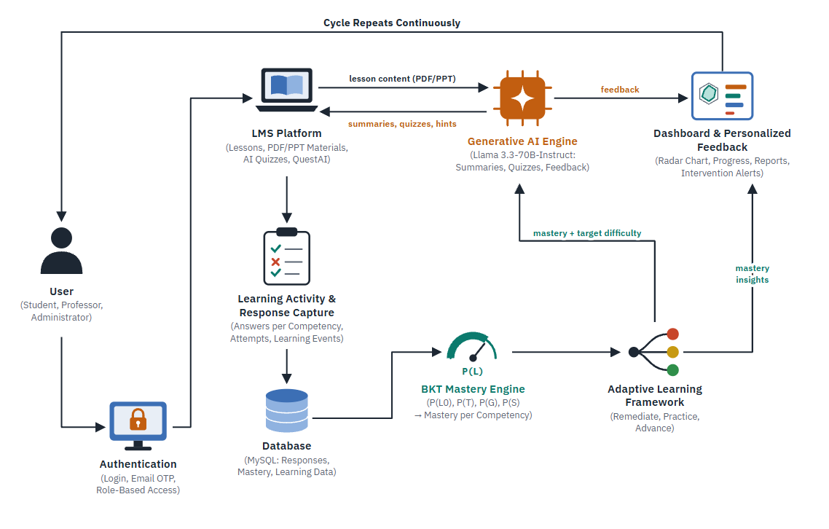
Figure 1
Architectural Framework of the Study

Architectural Framework
LearnQuest is an adaptive learning management system designed for Grade 11 and Grade 12 STEM students at the Kapitolyo High School which starts with Science 1, Chemistry. The architectural framework begins when the user signs in until when the user gets a new lesson or quiz. There are two AI components at the core of it, and one does a distinct job. The Bayesian Knowledge Tracing estimates what the student knows, and Llama 3.3-70B-Instruct writes the content the student sees. All the answers that the student inputs go back to the system and affect what comes next and form a loop.
User and Authentication. There are three types of users: students, professors, and administrators. Each logs in using a password, then a one-time password (OTP) sent to their email. Once the account is verified by the server, it identifies the user’s role and allows them to access only the page relevant to their role so that they can only see the feature and data relevant to their role. These verification and security features are done on the server and are not exposed in the browser to prevent unauthorized access to student’s grades and mastery.
LMS Platform. Most operations happen in the LMS Platform. Professors upload their lessons in PDF or PowerPoint and organize them by subject and lesson. Students open lessons, read summaries, take quizzes, and ask QuestAI, the learning assistant, for help. Administrators manage accounts, roles, and settings. Professors do not write quizzes. The quizzes are generated by the Generative AI Engine using the lessons uploaded by the professors in the LMS.
Generative AI Engine. The Generative AI Engine runs on Llama 3.3-70B-Instruct, accessible through the Routeway API. Thus, all requests go through the server, and the API key is not exposed to the browser. The engine is fed with text extracted from lessons uploaded to the LMS. This way, the summaries and questions it generates are relevant to what the teacher made the students learn rather than what the model knows. It creates lesson summaries, quiz questions, hints, explanations, feedback, and recommendations but does not share them directly with the students. The system evaluates the output before it is used in the LMS. A question must have multiple choices, a choice that is a correct answer, a competency, and a difficulty level before it is approved to be used as a quiz item. Professors can review the generated questions and approve or reject them.
Learning Activity and Response Capture. When students respond to quizzes, the system stores all their answers individually instead of giving a score when they finish. Each response is a record containing the student, the question, the competency, if the answer was correct, and the timestamp. The start of a quiz, a question, and the end of a quiz also generate events that are stored as records. The order of the answers is relevant to the mastery calculation that the Bayesian Knowledge Tracing will perform.
Database. Everything is stored in a MySql database. It stores users, subjects, lessons, uploaded materials and extracted text, competencies, quizzes, and records of attempts, individual answers, mastery, summaries, feedback, and chats with QuestAI. The dashboards and charts are powered directly by this database, except for the mastery values, which they do not store separately, so the value displayed is the same mastery that the system uses to decide what activities the student will do next.
BKT Mastery Engine. The BKT Mastery Engine estimates the probability that the student has mastered each competency. It uses four values. P (L0) is the probability that the student has mastered the skill before practicing. P(T) is the probability that he learns the skill after a practice attempt. P(G) is the chance the student can guess the correct answer if they have not practiced and P(S), the chance they make a mistake and do not master the skill even if they have practiced. For each student’s answer, the engine updates their probability of mastery for the competency the question is about. Mastery is tracked per competency; thus, a student can have a high mastery of one competency and a low mastery of another, and the system can distinguish between them. A quiz score is not the same as a mastery score. A student can get 10 out of 20 questions right and have a mastery lower than 50%. Using BKT, mastery is not calculated from the percentage of questions the student answered correctly since it tracks if, when, and how the student practices and considers their mistakes and guesses. Llama does not calculate mastery; the BKT does.
Adaptive Learning Framework. The Adaptive Learning Framework uses the mastery estimate to decide what the student should do next. It classifies a student’s mastery as low, medium, or high based on thresholds defined in the system configuration, adjustable by the research team. Students with low mastery are sent back to review the lesson with more practice focused on the same competency that the quiz was about at a lower difficulty. Students with a moderate mastery receive further practice but at a higher difficulty, along with hints and explanations relevant to their mistakes. Students who achieved a high mastery move on to more difficult questions and are introduced to the next interconnected competency. What the student should do next, with what difficulty, and their mastery level are sent to the Generative AI Engine to prepare the next activities and feedback, which can be questions or explanations based on the student’s answers. Everything the system does is based on the student’s responses, so the professor always knows why an action was taken.
Dashboard and Personalized Feedback. Students and professors can see results in the Dashboard. The student can see a mastery radar showing their level in each competency, their progress, quiz results, feedback, and recommendations. The professor can see the class’s mastery, progress, competencies where most students struggle, reports, and notifications for students with low mastery that need assistance. The attention is on what the students really need, and it is up to the professor to act on that information.
Continuous Cycle. The cycle continues; new activities generate new responses that update mastery, which updates recommendations, which change the content Llama generates. The more the student interacts with LearnQuest, the more it learns and understands the student and provides better recommendations.
LearnQuest is a learning management system that combines learning management, AI-generated content, mastery tracking, adaptive learning, learning analytics, and personalized feedback. BKT tracks student mastery, and Llama generates content, so every recommendation is based on what the student does, and the professor can act accordingly. Students get the learning support they need, and teachers get the information they need.

Artificial Intelligence Algorithms Used in the System
The Learning Management System (LMS) integrates Artificial Intelligence (AI) to provide adaptive learning pathways, personalized feedback, and real-time analysis of student knowledge. The system intentionally uses a hybrid AI approach composed of: (1) Bayesian Knowledge Tracing (BKT) for mastery estimation and adaptive learning progression, and (2) Large Language Model (LLM)-based generative AI for dynamic question creation and individualized feedback. These two components work together to personalize assessments and adjust difficulty levels according to each learner’s performance and learning needs.

1. Bayesian Knowledge Tracing (BKT)
The Bayesian Knowledge Tracing (BKT) algorithm models how students acquire specific skills or concepts over time by estimating the probability that a learner has mastered a topic based on their observable performance (Corbett & Anderson, 1995). BKT assumes that learning is not directly visible and must be inferred from correct or incorrect responses. BKT treats each learning objective as binary (either known or unknown) and updates mastery based on four probabilistic parameters:

Table 2
Bayesian Knowledge Tracing (BKT) Variables Used
Symbol | Meaning
P(L₀) | The initial probability that the student knows the skill before any practice
P(T) | The probability that learning occurs after an opportunity to practice
P(G) | The probability that the student guesses correctly without knowing the skill
P(S) | Probability that the student slips (answers incorrectly despite knowing)

Mathematical Model
If the learner’s response is correct:
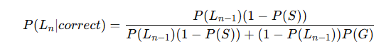
If the learner’s response is incorrect:
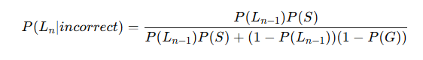
Accounting for learning after each observation:
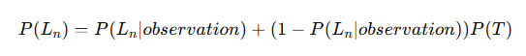
In the LMS, BKT processes quiz interactions, responses, and practice attempts to compute mastery levels in real time. If mastery is low, the LMS recommends remedial content or lowers the difficulty.

Implementation of BKT in the LearnQuest System
In the proposed LearnQuest system, Bayesian Knowledge Tracing (BKT) is implemented to continuously estimate the mastery level of students for individual Science competencies based on their interactions with learning materials and assessments. Each AI-generated quiz question is associated with a specific Science competency or learning concept. When a student answers a quiz question, the system records the student's response as either correct or incorrect and uses this observation as input to the BKT algorithm. The algorithm then updates the student's probability of mastery for the corresponding competency using the BKT parameters: initial knowledge probability (P(L_0)), learning probability (P(T)), guess probability (P(G)), and slip probability (P(S)). The updated mastery probability is stored in the system and becomes the student's current estimated mastery level for that competency.
For example, suppose a student begins a lesson on Newton's Laws of Motion with an initial mastery probability of 20% ((P(L_0)=0.20)). The student then takes an AI-generated quiz consisting of questions mapped to the competency. If the student answers a question correctly, BKT increases the estimated probability that the student has mastered the competency while accounting for the possibility that the student may have guessed the correct answer. If the student answers incorrectly, BKT decreases the estimated mastery probability while considering the possibility that the student may have made a slip despite knowing the concept. After each response, the system updates the student's mastery estimate. The following table illustrates an example of how LearnQuest processes student interactions and adapts the learning experience based on the estimated mastery level.

Table 3
Illustrative Example of BKT Implementation in LearnQuest
Steps | Student Activity | Student Response | Illustrative BKT Mastery Estimate | LearQuest System Action
1 | Student begins the lesson on Newton's Laws of Motion | No response yet | 20% initial mastery | Student is provided with the lesson and introductory learning materials
2 | Student answers the first AI-generated question | Incorrect | Mastery estimate is updated | System identifies the possibility of a competency gap and provides an explanation or additional practice
3 | Student answers another question targeting the same competency | Correct | Mastery estimate increases | System continues monitoring the student's understanding
4 | Student answers another question | Correct | Mastery estimate increases further | Llama 3.3-70B-Instruct generates questions appropriate to the student's updated mastery
5 | Student demonstrates consistent understanding | Mostly correct responses | Higher mastery estimate | System may provide more challenging questions or recommend the next related competency
6 | Students continue answering questions | New responses recorded | Mastery continuously updated | The new responses are processed by BKT to update the student's mastery estimate

Note. The mastery percentages shown in the table are illustrative examples only. Actual mastery estimates are calculated by the BKT algorithm based on the student's sequence of responses and the selected values of (P(L_0)), (P(T)), (P(G)), and (P(S)).
The mastery percentages produced by BKT do not simply represent the student's raw quiz score. Instead, they represent the estimated probability that the student has acquired or mastered a particular Science competency based on a sequence of observed responses. For example, a student who obtains 10 out of 20 questions correct may have a 50% raw quiz score, but the BKT mastery estimate may differ depending on the student's previous performance, the sequence of correct and incorrect responses, and the selected BKT parameters. This allows LearnQuest to evaluate mastery at the competency level rather than relying solely on the overall percentage score of a single assessment.
The updated mastery estimate is then used by LearnQuest to determine the student's next learning activity. When the estimated mastery of a competency is low, the system may recommend reviewing the relevant lesson, provide additional practice questions, or instruct the Llama 3.3-70B-Instruct model to generate simpler questions that target the student's identified learning deficiency. As the student's mastery increases, the system may provide questions of greater difficulty or recommend the next related competency. The Llama 3.3-70B-Instruct model uses the student's current BKT mastery estimate as contextual information when generating adaptive questions, explanations, personalized feedback, and learning recommendations. In this process, BKT functions as the mastery estimation mechanism, while the Llama 3.3-70B-Instruct model functions as the generative AI component that responds to the learner's estimated knowledge state.
The implementation of BKT therefore creates a continuous adaptive learning cycle within LearnQuest. Student responses collected from AI-generated quizzes and learning activities are processed by the BKT algorithm to update the estimated mastery of each Science competency. These mastery estimates are then used to guide the generation of subsequent learning activities, feedback, and recommendations. As students continue interacting with the system, their mastery estimates are continuously updated, allowing LearnQuest to adapt learning content according to their demonstrated performance. This process enables the system to identify competency gaps, provide targeted remediation, and progressively increase learning difficulty as students demonstrate greater mastery.
For instance, a student may demonstrate an estimated mastery of 80% in Newton's Laws of Motion but only 40% in Energy and Momentum. Rather than assigning the same learning materials or quiz difficulty to both competencies, LearnQuest can use these individual mastery estimates to recommend study techniques for Energy and Momentum while providing more advanced questions related to Newton's Laws of Motion. In this manner, BKT enables LearnQuest to establish a competency-specific learner profile that supports the generation of individualized adaptive learning pathways.

2. LLM AI Question & Feedback Engine (Llama 3.3-70B-Instruct)
The system integrates a generative Artificial Intelligence component powered by Llama 3.3-70B-Instruct Large Language Model, accessed through the Proxies API, to produce personalized learning materials and adaptive feedback. Unlike Bayesian Knowledge Tracing (BKT), which focuses on tracking mastery, the Large Language Model (LLM) serves as the system’s content generation engine. It uses natural language generation to create questions, explanations, hints, and motivational prompts that are tailored to each learner’s needs. When a student interacts with lessons or learning activities, the AI analyzes their responses in relation to their mastery status estimated by BKT. Based on this analysis, the Large Language Model (LLM) generates questions at appropriate difficulty levels, ensuring that learners are neither overwhelmed with advanced content nor bored with overly simple tasks.
Large Language Model (LLM) also produces detailed explanations after assessments, allowing students to understand why their answers were correct or incorrect. This supports meaningful learning by guiding students to reflect on their reasoning process rather than merely presenting the right answer. Additionally, the AI provides personalized recommendations on what lessons to review, what skills to practice, and how to improve performance. It can even offer motivational feedback that encourages persistence and engagement, especially in an adaptive learning environment. Through this integration, the system achieves a dynamic instructional process where generated questions, reinforcement strategies, feedback, and lesson suggestions are continuously aligned with the learner’s real-time performance profile.

Synergistic Interaction Between BKT and Large Language Model (LLM)
The adaptive capability of the system emerges from the complementary interaction between Bayesian Knowledge Tracing (BKT) and the Llama 3.3-70B-Instruct Large Language Model (LLM) generative engine. BKT functions as the system’s cognitive monitoring mechanism by estimating a student’s mastery level for each concept in real time. Every interaction within the LMS, such as answering a question or responding to a quiz item, updates the probability that a specific skill has been learned. These evolving mastery estimates serve as the foundation for personalized decision-making. Instead of merely categorizing learners as “high performers” or “low performers,” BKT provides a nuanced and continuously updated understanding of what each student knows and how likely they are to succeed in subsequent tasks.
Large Language Model (LLM) uses these mastery insights to produce personalized learning experiences. When the system detects that a student has difficulty mastering a concept, the AI generates additional questions with simplified difficulty or provides scaffolded explanations that target the observed weaknesses. In contrast, when the mastery probability is high, Large Language Model (LLM) responds by creating more challenging questions or advanced learning tasks that prevent stagnation and promote deeper understanding. This interplay ensures that students receive neither repetitive remedial content nor tasks that exceed their current learning capacity. In addition to adjusting difficulty, the AI explains errors, recommends specific lessons to revisit, and delivers motivational feedback that encourages learners to continue engaging with the material.
Together, BKT and Llama 3.3-70B-Instruct Large Language Model (LLM) establish a continuous feedback loop where performance data is analyzed, interpreted, and translated into actionable learning interventions. The student’s responses inform BKT’s mastery estimation, the mastery estimation guides Large Language Model (LLM) in generating personalized content, and the new content prompts further interaction that feeds back into the system. This closed cycle allows the LMS to remain responsive, personalized, and goal-oriented, enabling the development of an individualized learning pathway that supports the strengths and addresses the weaknesses of each learner. Through this synergy, the system moves beyond static instruction and becomes an adaptive environment capable of supporting the varied learning trajectories of senior high school STEM students.
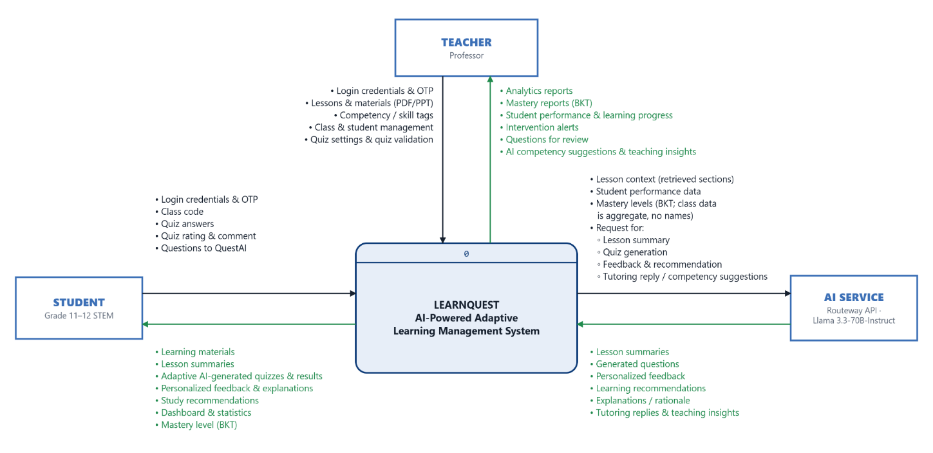
Figure 2
Level 0 Data Flow Diagram (Context Diagram) of LearnQuest

Level 0 Data Flow Diagram
Figure 2 illustrates the Level 0 Data Flow Diagram (Context Diagram) of LearnQuest: An AI-Powered Adaptive Learning Management System. The diagram presents the overall flow of information between the system and its three external entities: the Teacher, the Student, and the AI Service. At the center of the diagram is LearnQuest, represented as a single process (Process 0), which is responsible for receiving, processing, storing, and generating learning-related information.
The Teacher acts as one of the primary external entities of the system. Teachers provide login credentials and one-time password (OTP) codes for secure access, lesson materials in PDF and Microsoft PowerPoint (PPT) formats, competency or skill tags, class and student management information, quiz settings, and quiz validation decisions. These inputs are used by the system to organize learning resources, generate AI-assisted educational content, and manage classroom activities. In return, LearnQuest provides teachers with learning analytics reports, Bayesian Knowledge Tracing (BKT)-based mastery reports, student performance and learning progress information, intervention alerts, AI-generated questions for review, and AI-assisted competency suggestions and teaching insights. These outputs enable teachers to monitor student achievement, validate AI-generated assessments, and identify competencies that require further instructional intervention.
The Student serves as the second external entity. Students interact with the system by submitting their login credentials and OTP codes, class codes for joining a class, quiz answers, quiz ratings and comments, and questions addressed to QuestAI, the system's AI learning assistant. These data are processed by LearnQuest to evaluate student performance and estimate competency mastery levels. After processing, the system provides students with learning materials, AI-generated lesson summaries, adaptive AI-generated quizzes and their results, personalized feedback and explanations, study recommendations, dashboard statistics, and BKT-based mastery levels. Through these outputs, students are able to monitor their academic progress and receive personalized learning support based on their performance.
The AI Service, accessed through the Routeway API integrating the Llama 3.3-70B-Instruct Large Language Model (LLM), functions as an external intelligent service that enhances the capabilities of LearnQuest. The system sends lesson context retrieved from the uploaded materials, student performance data, BKT mastery levels, and requests for lesson summarization, quiz generation, personalized feedback, learning recommendations, tutoring replies, and competency suggestions to the AI Service. Class-level data sent for teacher reports is aggregated and does not include student names. In response, the AI Service returns lesson summaries, generated assessment questions, personalized feedback, learning recommendations, explanations or rationales, tutoring replies, and teaching insights, which are integrated into the LearnQuest platform to support adaptive learning. The AI Service does not compute mastery; mastery levels are estimated within LearnQuest using BKT and are passed to the AI Service only as context.
Overall, the Level 0 Data Flow Diagram illustrates how LearnQuest acts as the central processing system that facilitates the exchange of information among teachers, students, and the AI Service. By integrating Artificial Intelligence and Bayesian Knowledge Tracing (BKT), the system supports personalized learning, competency mastery monitoring, adaptive assessment generation, and learning analytics, thereby enhancing the teaching and learning experience for Grade 11 and Grade 12 STEM students of Kapitolyo High School.

Figure 3
Level 1 Data Flow Diagram of LearnQuest
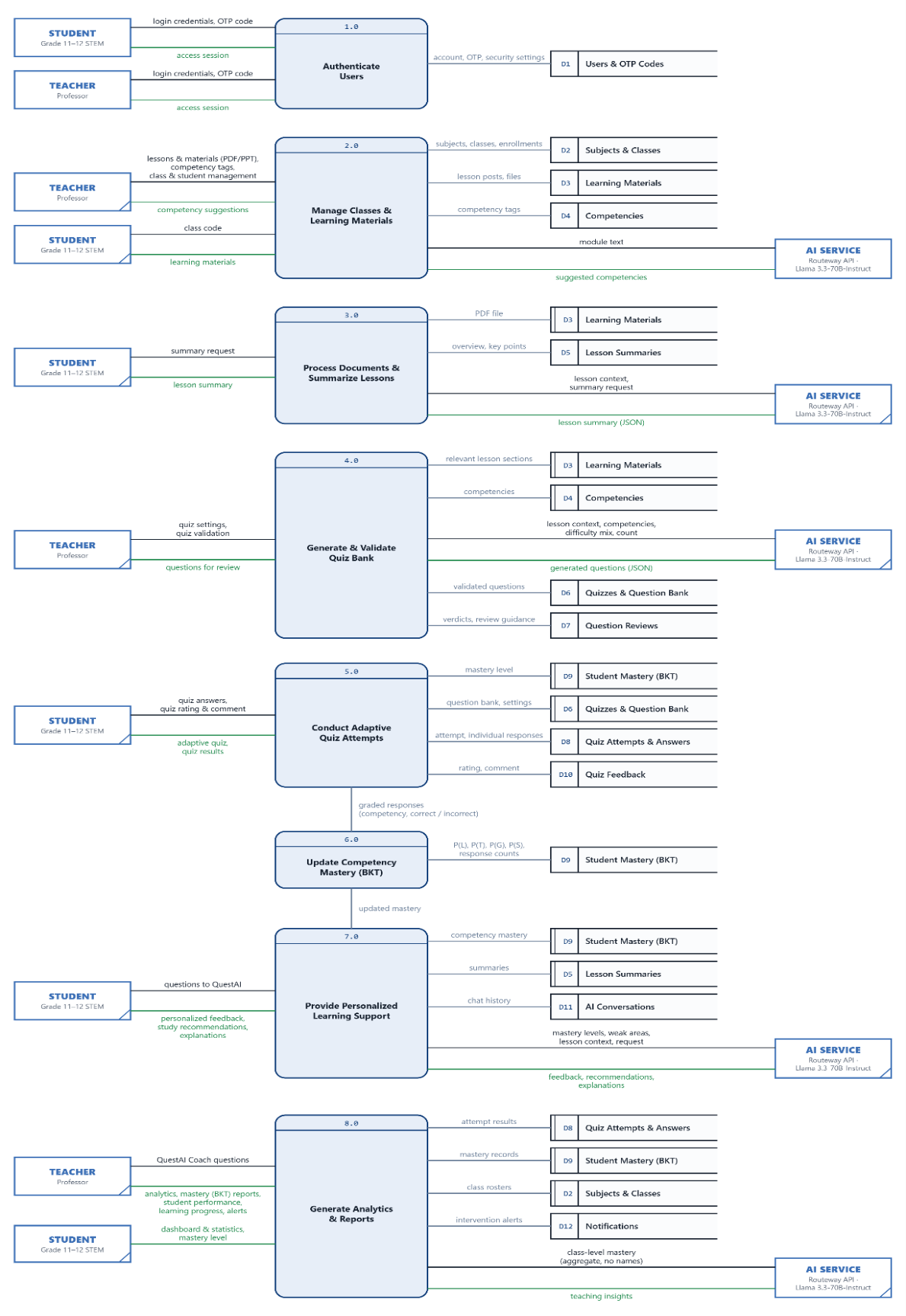
Figure 3 presents the Level 1 Data Flow Diagram of LearnQuest, which decomposes the single process of the Context Diagram into eight major processes: (1.0) Authenticate Users, (2.0) Manage Classes and Learning Materials, (3.0) Process Documents and Summarize Lessons, (4.0) Generate and Validate Quiz Bank, (5.0) Conduct Adaptive Quiz Attempts, (6.0) Update Competency Mastery using Bayesian Knowledge Tracing (BKT), (7.0) Provide Personalized Learning Support, and (8.0) Generate Analytics and Reports. These processes exchange data with twelve data stores (D1 to D12) and with the same three external entities shown in the Context Diagram. The processes are arranged in the order in which a lesson moves through the system, from the upload of learning materials to the generation of reports. Entities and data stores that appear more than once are duplicates included only to keep the data flows short and readable.
Process 1.0, Authenticate Users, verifies the login credentials and OTP codes submitted by students and teachers against D1 Users and OTP Codes and grants an access session to authorized users. Process 2.0, Manage Classes and Learning Materials, receives lessons and learning materials, competency tags, and class and student management information from the teacher, as well as class codes from students who join a class. This information is stored in D2 Subjects and Classes, D3 Learning Materials, and D4 Competencies. The process also sends module text to the AI Service to obtain suggested competencies, which the teacher reviews before they are saved, and provides learning materials to enrolled students.
Process 3.0, Process Documents and Summarize Lessons, retrieves the uploaded file from D3, extracts and prepares the lesson context, and requests a lesson summary from the AI Service. The validated summary is stored in D5 Lesson Summaries and delivered to students. Process 4.0, Generate and Validate Quiz Bank, retrieves relevant lesson sections from D3 and competencies from D4 and sends a structured request, including the teacher's difficulty mix and question count, to the AI Service. The generated questions are validated before they are stored in D6 Quizzes and Question Bank and are presented to the teacher for validation. The teacher's verdicts are recorded in D7 Question Reviews and serve as guidance for future quiz generation.
Process 5.0, Conduct Adaptive Quiz Attempts, reads the student's mastery level from D9 Student Mastery and the question bank from D6 to deliver an adaptive quiz whose difficulty matches the student's current mastery. The quiz attempt and each individual response are recorded in D8 Quiz Attempts and Answers, while the student's quiz rating and comment are stored in D10 Quiz Feedback. The graded responses, each identified by competency and marked as correct or incorrect, are passed to Process 6.0, Update Competency Mastery (BKT). This process applies the BKT parameters P(L0), P(T), P(G), and P(S) to estimate the probability that the student has mastered each competency and stores the result in D9. The updated mastery is then passed to Process 7.0.
Process 7.0, Provide Personalized Learning Support, uses the student's competency mastery from D9, lesson summaries from D5, and conversation history from D11 AI Conversations. It sends mastery levels, areas of weakness, and lesson context to the AI Service and returns personalized feedback, study recommendations, and explanations to the student, including replies from QuestAI. Process 8.0, Generate Analytics and Reports, compiles data from D8, D9, and D2 into analytics reports, BKT mastery reports, student performance information, and learning progress reports for the teacher, and into dashboard statistics and mastery levels for students. It records intervention alerts in D12 Notifications and sends aggregated class-level mastery, without student names, to the AI Service to obtain teaching insights.
Overall, the Level 1 Data Flow Diagram shows the clear separation of responsibilities within LearnQuest. Mastery estimation is performed only by Process 6.0 through Bayesian Knowledge Tracing, while the Llama 3.3-70B-Instruct model, accessed through the Routeway API, is used only for generative tasks in Processes 2.0, 3.0, 4.0, 7.0, and 8.0. This design keeps every adaptive decision traceable to recorded student performance and estimated competency mastery.

Figure 4
Level 2 Data Flow Diagram of Process 3.0: Process Documents and Summarize Lessons
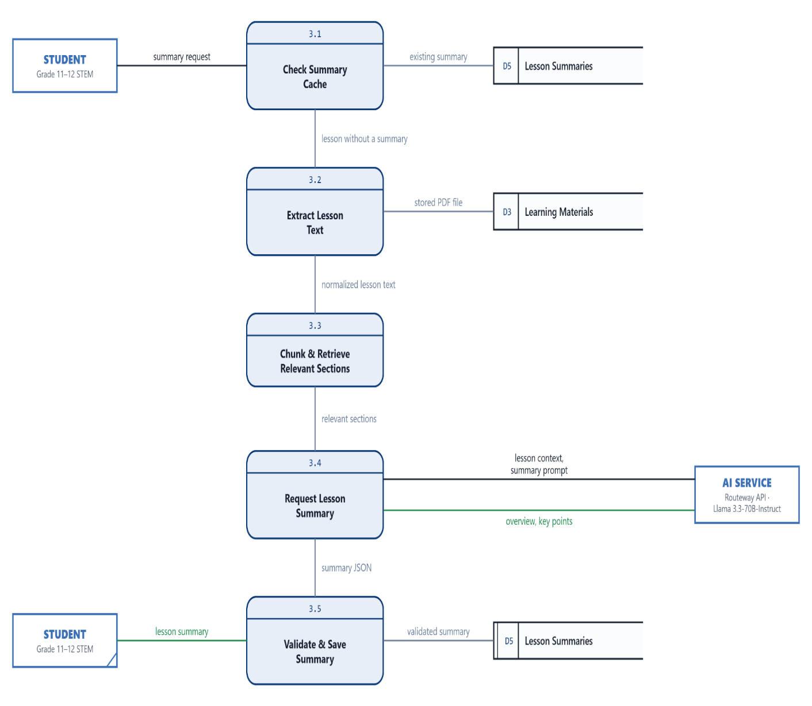
Figure 4 presents the Level 2 Data Flow Diagram of Process 3.0, Process Documents and Summarize Lessons. This process transforms an uploaded learning material into a concise, student-appropriate lesson summary generated by the AI Service and grounded in the teacher's own material. It is decomposed into five subprocesses.
Process 3.1, Check Summary Cache, receives the student's summary request and checks D5 Lesson Summaries for an existing summary of the lesson so that a summary is not generated again unnecessarily. If no summary exists, the lesson is passed to Process 3.2, Extract Lesson Text, which retrieves the stored file from D3 Learning Materials and converts its content into normalized lesson text. Process 3.3, Chunk and Retrieve Relevant Sections, divides the normalized text into smaller sections and selects the sections most relevant to the lesson, which avoids sending an impractically large document to the AI model in a single request.
Process 3.4, Request Lesson Summary, sends the selected lesson context together with a summarization prompt to the AI Service, which returns an overview and key points in a structured JSON format. Process 3.5, Validate and Save Summary, checks that the generated summary is complete and non-empty before storing it in D5 and presenting it to the student. Through this process, AI-generated summaries remain grounded in the materials uploaded by the teacher rather than in the general knowledge of the model.

Figure 5
Level 2 Data Flow Diagram of Process 4.0: Generate and Validate Quiz Bank
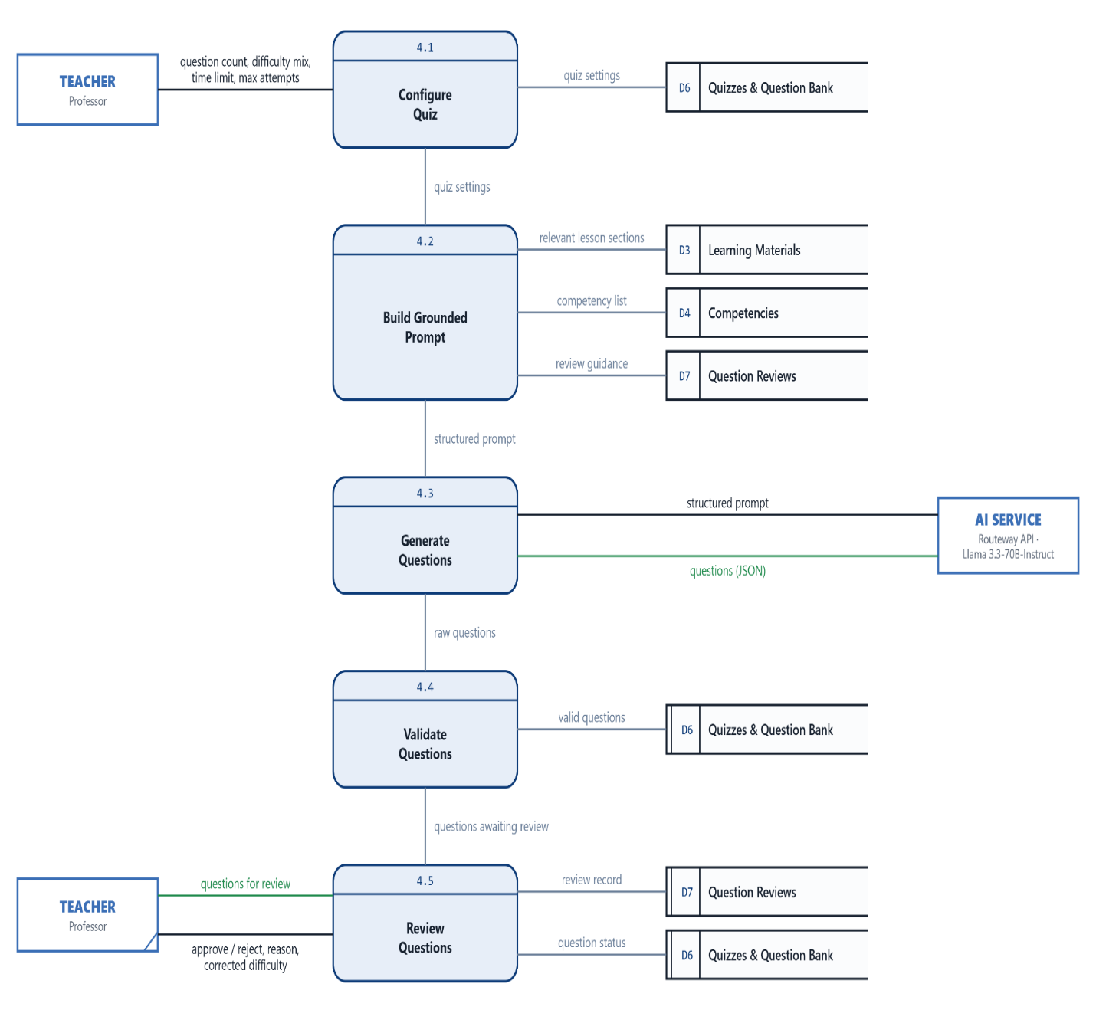
Figure 5 presents the Level 2 Data Flow Diagram of Process 4.0, Generate and Validate Quiz Bank. In LearnQuest, teachers do not write quiz questions manually; instead, the questions are generated by the AI Service from the lesson materials and are subsequently validated by both the system and the teacher. The process is decomposed into five subprocesses.
Process 4.1, Configure Quiz, receives the quiz settings from the teacher, including the number of questions, the difficulty mix, the time limit, and the maximum number of attempts, and stores them in D6 Quizzes and Question Bank. Process 4.2, Build Grounded Prompt, prepares a structured prompt by combining the relevant lesson sections from D3 Learning Materials, the list of competencies from D4 Competencies, and review guidance from D7 Question Reviews, which reflects the teacher's previous approvals and rejections. Process 4.3, Generate Questions, sends this prompt to the AI Service, which returns the generated questions in a structured JSON format.
Process 4.4, Validate Questions, verifies that each generated question contains a question stem, answer choices, a correct answer that matches one of the choices, a valid competency, a valid difficulty level, and an explanation. Only valid questions are stored in D6; invalid output is discarded. Process 4.5, Review Questions, presents the stored questions to the teacher, who approves or rejects each question, provides a reason for rejection, and may correct its difficulty level. The review is recorded in D7, and the status of the question is updated in D6. These reviews are used as guidance in future prompts for the same subject, allowing the quality of generated questions to improve without retraining the AI model.

Figure 6
Level 2 Data Flow Diagram of Process 5.0: Conduct Adaptive Quiz Attempts
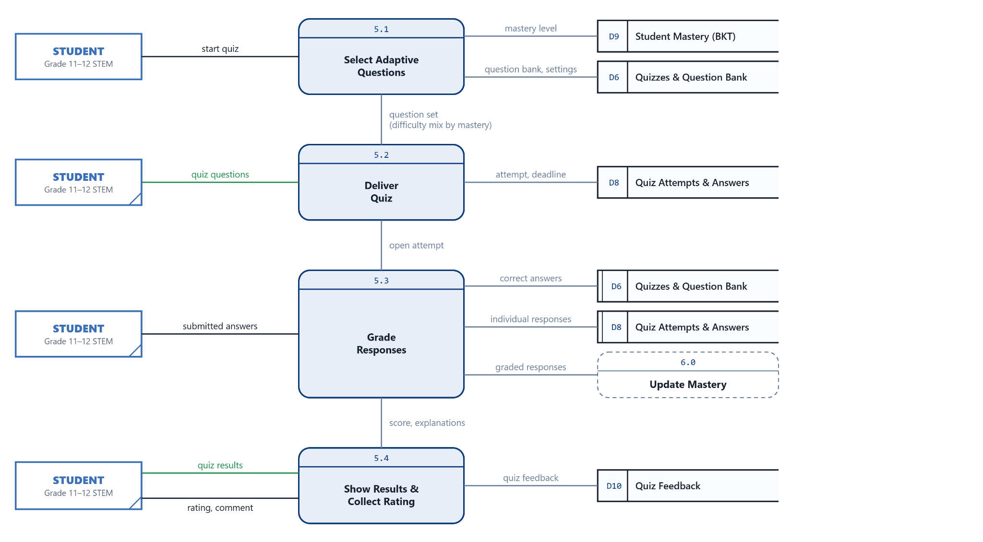
Figure 6 presents the Level 2 Data Flow Diagram of Process 5.0, Conduct Adaptive Quiz Attempts. This process delivers a quiz adapted to each student's current mastery, records every response individually, and forwards the graded responses to the mastery tracking process. It is decomposed into four subprocesses.
Process 5.1, Select Adaptive Questions, is initiated when the student starts a quiz. It retrieves the student's mastery level from D9 Student Mastery and the question bank and quiz settings from D6 Quizzes and Question Bank. Based on the mastery level, the difficulty mix of the selected questions is adjusted: students with low mastery receive more easy questions, students with developing mastery receive the teacher's configured mix, and students with high mastery receive more difficult questions. Process 5.2, Deliver Quiz, presents the selected questions to the student and records the opened attempt and its deadline in D8 Quiz Attempts and Answers.
Process 5.3, Grade Responses, receives the student's submitted answers and compares them with the correct answers stored in D6. Each response is stored individually in D8, together with its competency and whether it is correct, so that the sequence of responses is preserved. The graded responses are then sent to Process 6.0 for the BKT mastery update. Finally, Process 5.4, Show Results and Collect Rating, presents the quiz results and explanations to the student and receives the student's rating and comment on the quiz, which are stored in D10 Quiz Feedback. The raw quiz score shown in the results is kept separate from the BKT mastery estimate.

Figure 7
Level 2 Data Flow Diagram of Process 6.0: Update Competency Mastery (BKT)
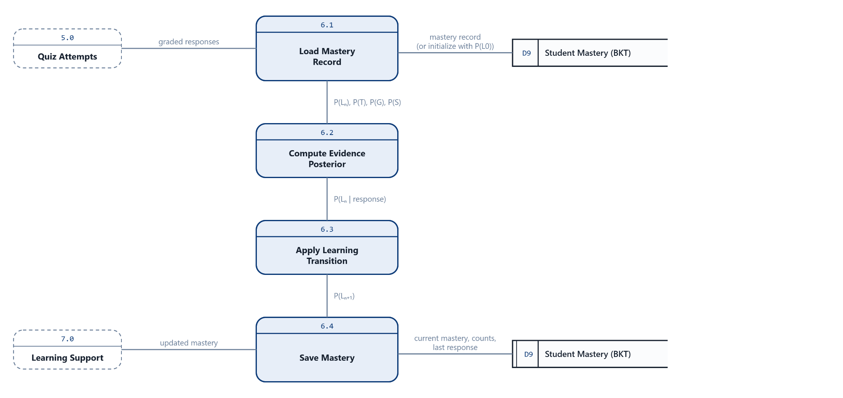
Figure 7 presents the Level 2 Data Flow Diagram of Process 6.0, Update Competency Mastery, which implements Bayesian Knowledge Tracing (BKT). BKT estimates the probability that a student has mastered a specific competency based on the sequence of the student's correct and incorrect responses. The process is decomposed into four subprocesses that are repeated for every graded response, in the order in which the responses were answered.
Process 6.1, Load Mastery Record, receives a graded response from Process 5.0 and retrieves the student's mastery record for the corresponding competency from D9 Student Mastery. If no record exists yet, the record is initialized using the initial knowledge probability P(L0). The current mastery probability P(Ln), together with the learning probability P(T), the guess probability P(G), and the slip probability P(S), is passed to Process 6.2, Compute Evidence Posterior. This subprocess updates the mastery probability based on the observed response: a correct answer increases the estimate while accounting for the possibility of a lucky guess, and an incorrect answer decreases the estimate while accounting for the possibility of a slip.
Process 6.3, Apply Learning Transition, adjusts the updated probability by the learning probability P(T) to account for the learning that may have occurred during practice, producing the new mastery estimate P(Ln+1). Process 6.4, Save Mastery, stores the current mastery, the number of observations, the counts of correct and incorrect responses, and the last response in D9, and passes the updated mastery to Process 7.0. Through this process, LearnQuest estimates mastery for each competency rather than relying on the raw quiz score; for example, a raw score of 50 percent does not automatically correspond to a mastery estimate of 50 percent.

Figure 8
Level 2 Data Flow Diagram of Process 7.0: Provide Personalized Learning Support
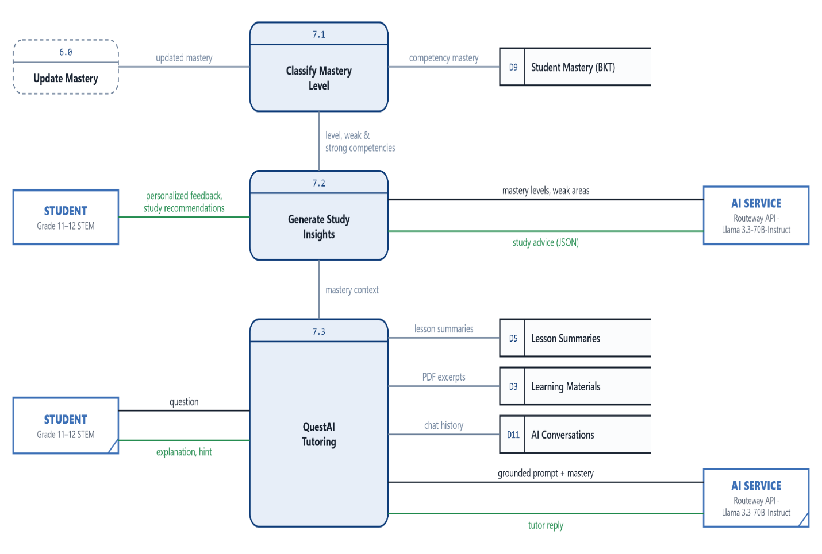
Figure 8 presents the Level 2 Data Flow Diagram of Process 7.0, Provide Personalized Learning Support. This process converts the student's BKT mastery estimates into personalized learning support. The adaptive decision is made by rule-based logic using mastery thresholds, while the AI Service is used only to express that decision as feedback, recommendations, and explanations. The process is decomposed into three subprocesses.
Process 7.1, Classify Mastery Level, receives the updated mastery from Process 6.0 and the student's competency mastery from D9 Student Mastery. Using configurable thresholds, it classifies each competency as low, developing, or high mastery and identifies the student's weak and strong competencies. Process 7.2, Generate Study Insights, sends these mastery levels and areas of weakness to the AI Service, which returns study advice in a structured format. The validated advice is presented to the student as personalized feedback and study recommendations. If the AI Service is unavailable or returns invalid output, the system provides rule-based recommendations derived from the same BKT data.
Process 7.3, QuestAI Tutoring, receives a question from the student and builds a grounded prompt using the lesson summaries from D5 Lesson Summaries, relevant excerpts of the learning materials from D3 Learning Materials, the conversation history from D11 AI Conversations, and the student's mastery context. The AI Service returns a tutoring reply, which is presented to the student as an explanation or hint and is saved to D11 to preserve the conversation. Through this process, the AI-generated support remains grounded in the teacher's lessons and adapted to the student's estimated mastery.

Figure 9
Agile Software Development Diagram
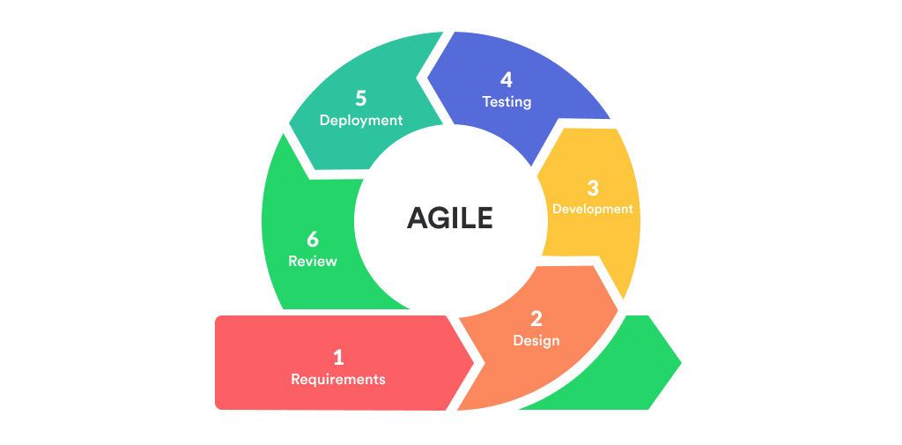

Software Engineering Paradigm
This study adopts the Agile Software Development Paradigm, particularly the iterative and incremental model, as the directing paradigm for the development and improvement of the LearnQuest: An Adaptive Learning Management System Powered by Artificial Intelligence for STEM Students of Kapitolyo High School.
The Agile method puts strong emphasis on flexibility, teamwork, feedback, and continuous improvement. This approach is different from traditional linear procedures such as the Waterfall method. It emphasizes user focus and flexibility. Agile can adapt based on stakeholder feedback and changing needs.
Agile development, as per Highsmith (2002), is such a development process that enables adaptation to change in a more efficient way, and it involves continuous interaction between developers, users, and all stakeholders. This approach focuses on developing functional software through iterations, during which new features are added to the software. This is an excellent alternative for initiatives that use new technologies, including Artificial Intelligence (AI), which frequently require evaluation and improvement by getting people engaged.
In this research study, the use of the Agile method means that the teacher, student, and administrator are all involved in every stage of the LMS system development process. This involvement means that the LMS will remain relevant and effective in serving its learning purpose. The paradigm's repeat cycles let the researchers quickly find usability issues, change AI algorithms, and make learning better overall.

Agile Development Process
In this study, the agile methodology involves an iterative and incremental development approach consisting of multiple iterations of development. Each iteration results in the production of a prototype that is tested, improved upon, and then moved forward to the next phase. The different stages involved in the Agile development process have been explained below.
Planning Phase. In this phase, the researchers work together with teachers and learners to determine the requirements of the system, learning goals, and core functionalities of the LMS. The user stories are then collected and prioritized in order to develop a product backlog that will be used as a guide during each development iteration. These are some of the features identified: AI-generated feedback, competency mastery tracking, adaptive assessments, and user access management.
Design and Prototyping Phase. Based on the requirements that have been gathered, plans are made for the system architecture and interface designs. Wireframes and data flow diagrams are made to show how users (teachers and students) would interact with the system. AI data pipelines are being planned to make the system adaptable and scalable.
Sprint Implementation: The Development Phase. During this phase, the development team will develop the system functionalities as per the planning done. The initial iterations will concentrate on the basic functionalities of the learning management system that include authentication, course management, uploading of learning materials, and quiz management. In subsequent stages, the other functionalities like integration of AI, Bayesian knowledge tracing, feedback mechanism, learning recommendation engine, and learning analytics will be included in the system. The developers validate the code's functionality repeatedly while they keep track of different versions.
Testing and Feedback Phase. During the completion of each sprint, the developed prototype is tested through the collaboration of the researchers and the selected teachers and learners. Some of the tests carried out include:
- Functional Testing – Ensuring the system does what it was supposed to do.
- Usability Testing – Checking the navigability, interface design, and user experience in general.
- AI Output Testing – Ensuring the quality, relevance, accuracy, and suitability of the outputs generated by AI, including summary, quiz questions, feedback, and recommendations, by evaluating these with teachers and subject matter experts.
During this phase, feedback collected from users and evaluators is noted down, analyzed, and incorporated into the further development process.
Review and Evaluation Phase. The team meets with the stakeholders to assess the completed iteration and address the issues raised, as well as figure out how to improve the process for the next iteration. Feedback from the stakeholders allows the team to make improvements to the system, optimize the AI-generated results, fine-tune the Bayesian Knowledge Tracing parameters, and optimize adaptive learning.
Deployment and Maintenance Phase. The LMS is ready for use in classrooms when the final version has been checked. The Agile methodology, on the other hand, stays in place after deployment. Maintenance and improvements are done as ongoing iterations. To make it last and work well in the long run, bugs, new features, and performance enhancements are added in later cycles.

The Advantages of Using Agile in this Study
The process of development of LearnQuest: an Artificial Intelligence-Powered Adaptive Learning Management System for Grade 11 and Grade 12 STEM Students of Kapitolyo High School, follows the Agile Software Development method as it is flexible, iterative, and learner-focused. The Agile process allows for the continual creation and improvement of the system via feedback from teachers, learners, and researchers throughout the development process.
As LearnQuest integrates artificial intelligence, adaptive learning, Bayesian knowledge tracing (BKT), and learning analytics, the agile methodology helps in implementing and testing each of these elements incrementally. With every iteration of software development, changes can be implemented considering user feedback to ensure that the content produced by the system, assessment capabilities, dashboarding, and recommendations provided serve the educational requirements of teachers and learners. Moreover, Agile methodology facilitates the quick identification of problems and their resolution to improve the system.

Retrieval-Augmented Generation (RAG)
To increase the accuracy of the content generated by AI, LearnQuest uses the Retrieval-Augmented Generation (RAG) strategy. This involves teachers feeding the system with their educational materials in the form of PDF files, Microsoft PowerPoint presentations, lectures, learning modules, worksheets, and lab manuals. Before generating educational content, the system extracts and retrieves relevant information from these uploaded learning materials and provides it as contextual input to the Llama 3.3-70B-Instruct model.
The probability of AI hallucination, consistency of facts, and alignment of the lesson summary, quiz, and learning suggestions to the required science competency and lesson objectives is achieved by ensuring that the responses of the AI system are based on instructional materials from the teacher and not only the prior knowledge of the model.

AI Output Validation
The quality of the Artificial Intelligence component is evaluated through AI output validation. The generated lesson summaries, quizzes, personalized feedback, and learning recommendations are reviewed by science teachers to determine their educational quality and suitability before they are used by students.
The output generated is evaluated based on the following criteria:
- Accuracy of scientific concepts
- Alignment with the intended Science competencies
- Relevance to the uploaded learning materials
- Clarity and comprehensibility of generated content
- Educational appropriateness of assessment items and feedback
In case the outputs provided by artificial intelligence are wrong, confusing, and not consistent with the objectives of the lesson, teachers will have an option to change, refuse, or create new material. Through this process, teachers ensure that artificial intelligence is just used as a means of a decision-making tool, not to replace the professional judgment of the teacher.

User Acceptance Testing (UAT)
The LearnQuest system will undergo User Acceptance Testing (UAT) to assess the usability and functionality of the system as well as the overall user satisfaction. A selected number of Grade 11 and 12 Science STEM students and Science teachers from Kapitolyo High School will participate for testing purposes.
These participants will test the LearnQuest system according to its ease of use, the effectiveness of AI-generated lesson summaries, the quality of the adaptive quiz, the importance of personalized feedback, and the clarity of learning recommendations and dashboards. The results obtained from the user acceptance testing will be used to find out the necessary changes to be made before the final deployment of the system.

Radar Charts for Learning Analytics
LearnQuest utilizes radar charts as part of its learning analytics dashboard to visualize student competency mastery across multiple Science learning competencies. Instead of presenting only overall assessment scores, radar charts display mastery levels estimated through Bayesian Knowledge Tracing (BKT), enabling both teachers and students to identify strengths and areas requiring improvement.
In the form of radar charts, there is learning data presented multi-dimensionally, which consists of proficiency levels achieved, progress made, assessment performance, and learning gaps. Giving a visual depiction of learner performance, it aids in making evidence-based decisions regarding instructional decisions, personalized intervention, and adaptive learning pathways that are tailored to the needs of each learner.

Population and Sampling
This research will focus on the students and faculty members from Kapitolyo High School STEM academic Strands, who impacted the adaptive learning management system that is powered by artificial intelligence. The number of STEM students is 60 students in Grade 11, 50 students are in Grade 12, for a total of 110 students in the academic school year 2025-2026. These learners represent the primary intended users of the system and therefore serve as the primary focus of this study. The initial implementation of the LMS focuses specifically on their engagement with Chemistry subjects to ensure a controlled and discipline-specific analysis. Additionally, the teacher population consists of STEM faculty members, particularly those teaching Chemistry, who play a role in handling instructions and managing student participation within the LMS environment.
The participants of this study were selected using purposive sampling methods. This is a suitable sampling method because the system should be evaluated by users who have had direct interaction with the system and can provide meaningful observations about the usability and effectiveness of the system, as well as the overall learning outcomes. By sampling students who are specifically studying Chemistry, the data collected in this study will accurately reflect the true experience of users in the academic setting in which they participate.
A total of fifty-five (55) respondents participated in the system evaluation, consisting of forty-five (45) Grade 11 and Grade 12 STEM students, five (5) Science teachers from Kapitolyo High School, and five (5) Information Technology experts. The respondents evaluated the developed LearnQuest system using a researcher-made questionnaire based on the ISO/IEC 25010 Software Quality Model. Their responses served as the basis for assessing the system's software quality and identifying areas for further improvement.

Data Collection Methods
The researchers utilized two primary data collection instruments: a structured questionnaire and the LearnQuest Adaptive Learning Management System prototype. Prior to the conduct of the study, permission to administer the system evaluation was secured from the administration of Kapitolyo High School. After obtaining approval, the selected Grade 11 and Grade 12 STEM students and Science teachers were identified as the respondents of the study.
Before participating in the evaluation, the respondents were informed about the objectives of the research, the procedures to be followed, the confidentiality of their responses, and their right to withdraw from the study at any time. After providing their consent, the respondents were given an orientation on the features and functionalities of the LearnQuest system, including its AI-assisted lesson summarization, AI-generated quizzes, mastery tracking, learning analytics dashboard, and personalized learning recommendations.
Following the orientation, the respondents accessed the LearnQuest system using their assigned accounts. Teachers uploaded instructional materials in PDF or Microsoft PowerPoint format, assigned competency or skill tags, and managed learning activities. Students accessed the uploaded learning materials, completed AI-generated quizzes and assessments, viewed lesson summaries, received personalized feedback and study recommendations, and monitored their learning progress through the dashboard.
As respondents interacted with the system, LearnQuest continuously collected system-generated (floating) data in real time. These data included quiz responses, assessment scores, question-level correctness, quiz completion records, time spent on assessments, interaction logs, and engagement with AI-generated learning resources. The system also recorded competency mastery estimates generated through Bayesian Knowledge Tracing (BKT), which were automatically updated after every assessment attempt to reflect each student's current level of mastery. Furthermore, AI-generated outputs, including lesson summaries, personalized feedback, study recommendations, and adaptive learning pathways, were stored to support continuous learning and personalized instruction. All collected data were securely maintained in the system database and served as the basis for learning analytics, radar chart visualizations, mastery monitoring, and teacher reports.
After completing the required learning activities, the respondents answered a structured questionnaire administered through Google Forms. The questionnaire consisted of closed-ended questions measured using a four-point Likert scale. It was divided into two sections. The first section gathered information regarding the respondents' learning experiences, while the second section evaluated the LearnQuest system based on its usability, effectiveness, learning support, and overall user experience. Prior to its administration, the questionnaire was reviewed and validated by the research adviser to ensure its clarity, relevance, and suitability to the objectives of the study.
Upon completion of the questionnaire, the survey responses and the system-generated data were consolidated, organized, and securely stored for subsequent analysis. All collected information was treated with strict confidentiality and used solely for academic and research purposes. The combined data obtained from the questionnaire and the LearnQuest system were utilized to evaluate the usability, effectiveness, and acceptability of the proposed adaptive learning management system, as well as to analyze student performance, competency mastery, AI-generated assessments, learning analytics, and adaptive learning support.

Ethical Considerations
The researchers conducted this study at Kapitolyo High School while ensuring the protected rights and privacy of all participants throughout the research process. Appropriate ethical measures and intellectual property rights were observed to maintain confidentiality in data handling since the study involved the collection of student assessment data and learning modules.
Respondents were informed of the study and its purpose before beginning data collection. Participation was completely voluntary, with members of the study group being given a reasonable opportunity to contact researchers with questions before providing consent to participate in the study.
To protect participant privacy, only information necessary for the conduct of the study was collected. Personal identifiers such as student names were not included in the datasets used for analysis. Instead, unique codes were assigned to participants to ensure anonymity. Access to collected data was restricted to the researchers and the research adviser only.
The security of data is essential when developing and implementing a system. LearnQuest System security measures were an essential part of the design of this system. Security features to protect user information from being compromised include an authenticated login process and the use of encryption to store passwords. All access to the information found in the LearnQuest System was based on restricted user roles, allowing students to access only their individual records while allowing teachers to view all records associated with the classes they had been assigned. The approved researchers also adhered to the requirements of the Data Privacy Act of 2012, the Republic Act No. 10173.
Since the use of Artificial Intelligence (AI) in this system requires incorporating consideration, instructions were provided to teachers outlining their role as the main evaluators and decision-makers for assessment decisions. Teachers will use AI-generated assessments for reference only and will use their own professional judgement and classroom observations when evaluating AI-generated results. The researchers also acknowledged that AI-generated outputs may not be completely accurate immediately after deployment due to limited learner data; therefore, to address this concern, the system was tested before deployment, and user feedback was considered in improving its accuracy and reliability.
The research participants were informed that the purpose of the system was to help students learn and identify areas for improvement, rather than to monitor or punish students. Both assessment results, as well as system-generated analytics from the participants and their summative assessments or measurement results, were to be collected solely for educational and research purposes. All information gathered during the study was treated with strict confidentiality and was not disclosed to unauthorized individuals or organizations. Data retention and disposal procedures were to follow the procedures outlined by institutional policy, and consent was given by all participants.
Before conducting the study, the researchers sought approval from their research adviser at Pamantasan ng Lungsod ng Pasig by making a request letter and securing permission from the administration of Kapitolyo High School.
Upon completion of the study, the researchers committed to providing Kapitolyo High School with a summary of the findings and recommendations. Documentation and reporting of issues that occurred during the system implementation were completed as needed by the research adviser and the school administration for purposes of accountability.

Summary
This chapter presented the research methodologies employed in the development and evaluation of LearnQuest: An Adaptive Learning Management System Powered by Artificial Intelligence for STEM Students of Kapitolyo High School. The study utilized a developmental research design with a descriptive research approach, which was appropriate for developing the system and assessing its software quality and acceptability. The Agile Software Development Methodology was employed to support continuous development, testing, and improvement based on system requirements and user feedback.
The integration of the Llama 3.3-70B-Instruct model was appropriate for supporting automated lesson summarization, quiz generation, and personalized feedback, while Bayesian Knowledge Tracing (BKT) was selected to estimate students' competency mastery and identify learning gaps based on assessment performance. These technologies supported the research objectives of providing adaptive learning experiences and monitoring student progress.
Furthermore, purposive sampling was employed to select respondents with relevant experience in evaluating the system. Data were collected from forty-five (45) STEM students, five (5) Science teachers, and five (5) Information Technology experts using a researcher-made questionnaire based on the ISO/IEC 25010 Software Quality Model. This evaluation approach was appropriate for determining the software quality and acceptability of the developed system.
Overall, the selected research methods provided a systematic approach to developing and evaluating LearnQuest. These methodologies supported the research objectives of integrating Artificial Intelligence, implementing adaptive learning functionalities, monitoring student competency mastery, and assessing the system's overall software quality and acceptability.

CHAPTER 3
RESULTS AND DISCUSSION

Introduction
This chapter presents the findings of the development and evaluation of LearnQuest: An Adaptive Learning Management System Powered by Artificial Intelligence for STEM Students of Kapitolyo High School. The study aimed to develop a web-based learning management system that supports Grade 11 and Grade 12 STEM students in Science subjects through learning material management, AI-generated lesson summaries and quizzes, adaptive assessments, personalized feedback, Bayesian Knowledge Tracing (BKT)-based mastery estimation, and learning analytics dashboards. Specifically, the study sought to answer five problems: (1) the features and functionalities of the system; (2) the integration of the Llama 3.3-70B-Instruct model; (3) the application of BKT and learning analytics; (4) the learning analytics and dashboard features; and (5) the acceptability of the system based on the ISO/IEC 25010 Software Quality Model.
Fifty-five (55) respondents evaluated the system: 45 Grade 11 and Grade 12 STEM students, five (5) Science teachers, and five (5) IT experts. A Google Forms questionnaire with closed-ended items measured on a four-point Likert scale was used, and a Data Privacy Notice informed the respondents of the confidentiality and voluntary nature of their participation. The questionnaire covered seven of the eight ISO/IEC 25010 quality characteristics named in Specific Problem 5: functional suitability, security, reliability, usability, performance efficiency, maintainability, and portability. Compatibility was not included in the questionnaire; this is acknowledged in the results and in Chapter 4.
The chapter is organized according to the study's specific problems. It first presents the features and interfaces of the developed system (Specific Problem 1), followed by the results on the integration of the Llama 3.3-70B-Instruct model (Specific Problem 2), the application of BKT and learning analytics (Specific Problem 3), and the learning analytics and dashboard features (Specific Problem 4). It then presents the test plan and the results of the system evaluation (Specific Problem 5), a summary of the evaluation results, a discussion of the findings, and a summary of the project testing results.

Project Capabilities and Testing Process Details
This section presents the features, functionalities, and capabilities of the LearnQuest system, along with the testing procedures used to evaluate its performance. LearnQuest was developed to address the problems identified in Chapter 1 by providing AI-assisted learning support, assessment, and student competency tracking. The system's functionality and software quality are evaluated through testing based on its intended uses and the ISO/IEC 25010 Software Quality Model.
The system allows teachers to upload learning materials in PDF format, which the integrated AI service uses to generate lesson summaries and assessment questions. Students can use the generated summaries as supplementary learning resources and take AI-generated quizzes based on the uploaded lesson content. Teachers can review, approve, reject, and correct the difficulty or competency of generated questions.
LearnQuest uses Bayesian Knowledge Tracing (BKT) to estimate students' mastery of individual Science competencies based on their assessment responses. The system distinguishes between raw assessment scores and estimated mastery levels. These mastery estimates are presented on the student dashboard through numerical values and a radar chart, allowing students to monitor their progress and identify competencies that may require further study. LearnQuest also provides study recommendations based on students' mastery strengths and weaknesses. Additionally, the system adapts quiz difficulty according to the student's estimated mastery level by adjusting the distribution of easy, medium, and hard questions.
The system consists of integrated modules for user management, learning materials, AI-generated summaries and assessments, adaptive quizzes, mastery estimation, student analytics, dashboards, AI tutoring, and learning recommendations. These modules work together to support the learning process, from the upload and processing of lesson materials to assessment, competency mastery estimation, and the presentation of student and class performance insights.
Testing was conducted to verify the functionality of LearnQuest's major components, including user authentication, learning material management, AI-generated summaries and quizzes, assessment processing, adaptive quiz difficulty, BKT-based mastery estimation, dashboards, analytics, and learning recommendations. The system's software quality was also evaluated using the ISO/IEC 25010 Software Quality Model. These testing procedures were intended to determine whether the implemented features functioned according to the system's requirements and intended use.
Figure 10
Users Landing Page
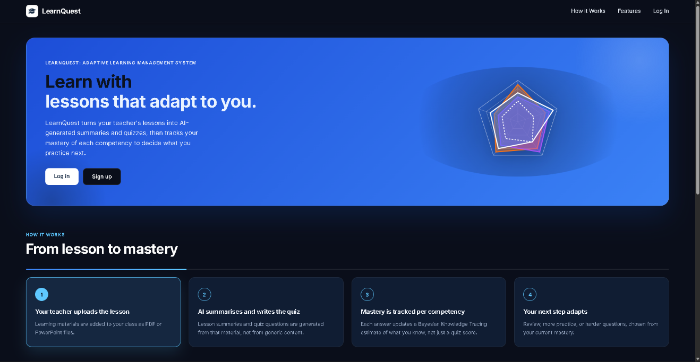
The Landing Page (Figure 10) was the first page users saw before signing in. It introduced the purpose of LearnQuest and provided Log In and Sign Up buttons. It also presented a sample mastery radar chart and a short explanation of how the lessons uploaded by teachers are used to generate AI summaries and quizzes. The chart on this page is illustrative and does not display actual student data.
Figure 11
User Login and Sign-up Page
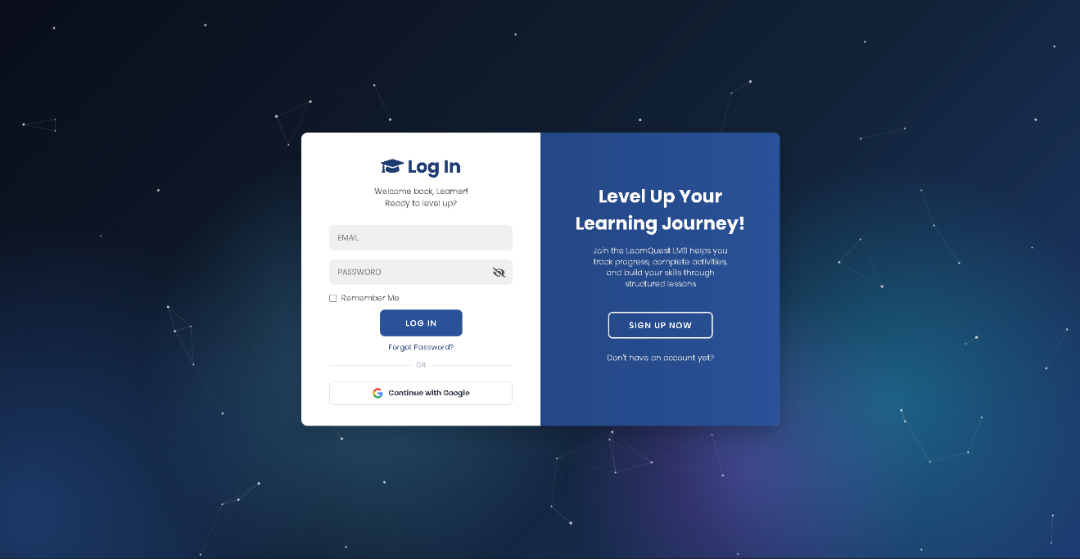
The Login and Sign-up Page (Figure 11) controlled access to the system. During registration, users entered their name, email address, and password and selected their role, either student or teacher. The account was activated only after the user entered a six-digit one-time password (OTP) sent to their email, which expired after 10 minutes and allowed at most three attempts. Users then signed in with their email and password, and could turn on an additional OTP check at every login in their security settings. The page also offered sign-in with a Google account. After a successful login, the system identified the user's role and directed the user to the corresponding home page. Passwords were stored in hashed form, and repeated login and OTP requests were rate-limited to prevent abuse.

Figure 12
Teacher Guided System Tour
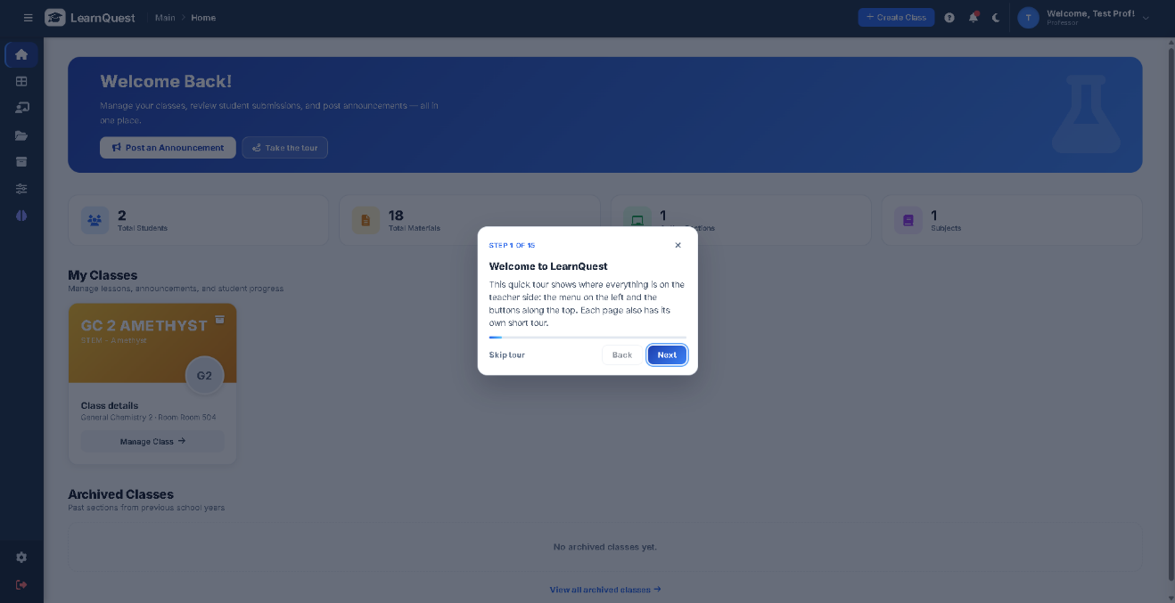
On the first login, a guided tour (Figure 12) launched automatically on the teacher dashboard. The 15-step tour highlighted the side navigation menu, the action buttons at the top of the screen, and the class management components, helping teachers who were less familiar with computers learn to navigate the platform. A similar tour was available to students. The completion of each tour was saved in the user's preferences so that it did not appear again on every login.

Figure 13
Teacher Homepage
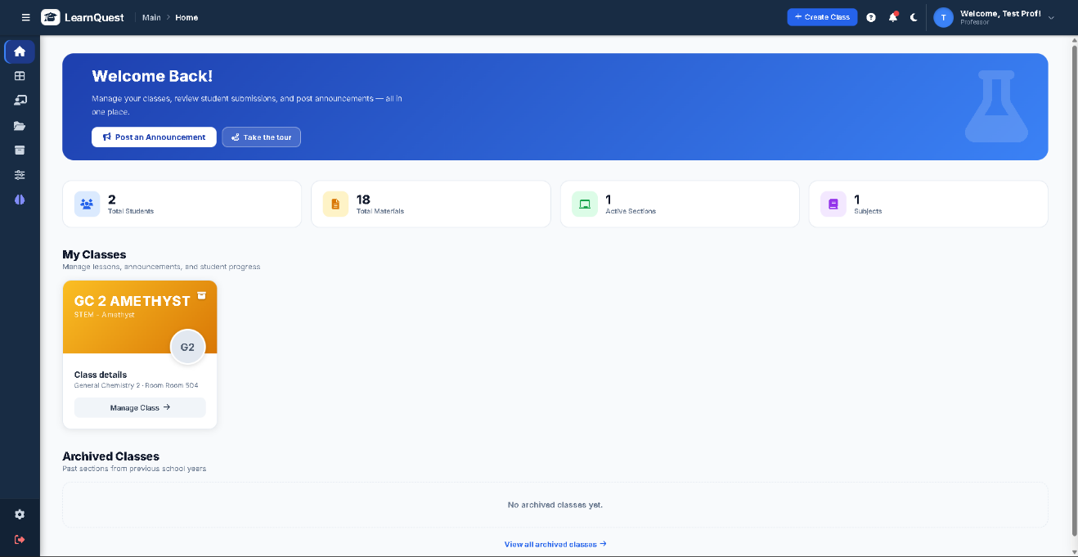
The Teacher Homepage (Figure 13) served as the teacher's starting point. It summarized the total number of students, uploaded materials, sections, and subjects handled by the teacher and provided shortcuts for creating a new class, posting an announcement, and opening active classes.

Figure 14
Teacher Dashboard Page: Analytics and Monitoring Interface
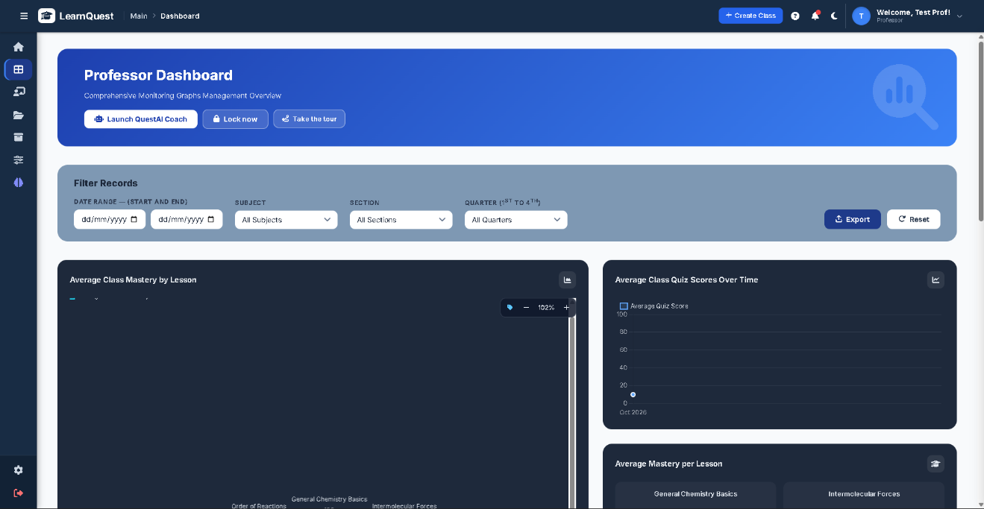
The Teacher Dashboard (Figure 14) presented class performance for all sections the teacher owned or collaborated on. It provided filters for date range, subject, section, and quarter, and the filtered data could be exported. The dashboard displayed a BKT mastery radar chart per competency, quiz performance trends, mastery per topic and per student, a ranking of student performance, and a list of students who may need intervention because of low mastery. It also included an AI-generated Strengths vs. Weaknesses analysis and access to the QuestAI Coach. This dashboard is discussed further under Specific Problem 4.

Figure 15
Teacher Class Details and Content Creating Modal
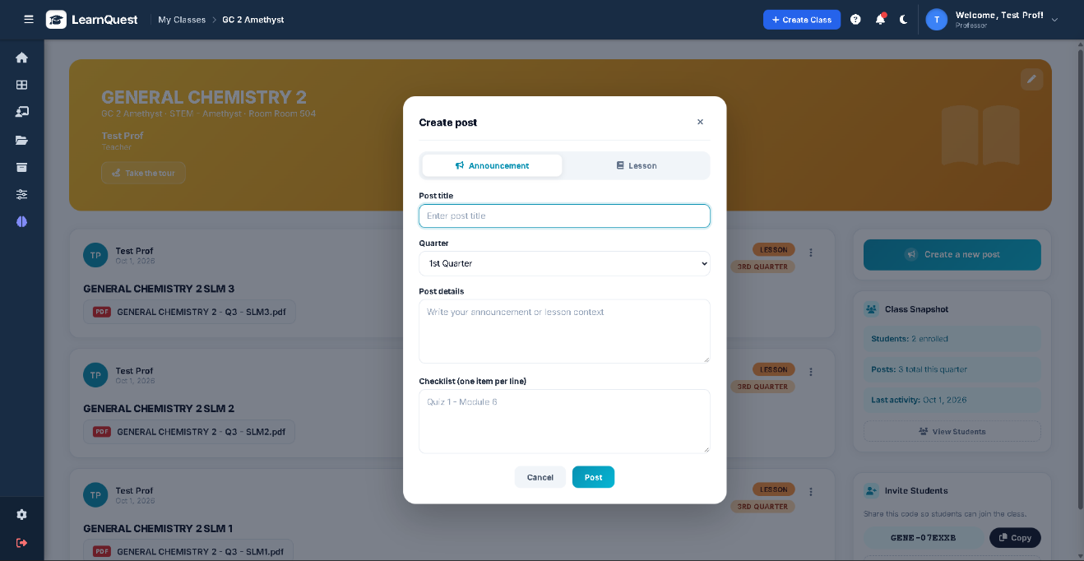
The Class Details page (Figure 15) allowed teachers to manage a section in one place. It showed the class banner, in this example for General Chemistry 2, a Class Snapshot with the number of enrolled students and recent posts, and the class code that students use to join the section. Through the Create Post feature, teachers could publish an announcement or a lesson by specifying the title, academic quarter, lesson details, an optional task checklist, and a PDF attachment. These features consolidated course information, enrollment, announcements, and lesson preparation in a single interface.

Figure 16
Teacher Module Management Page
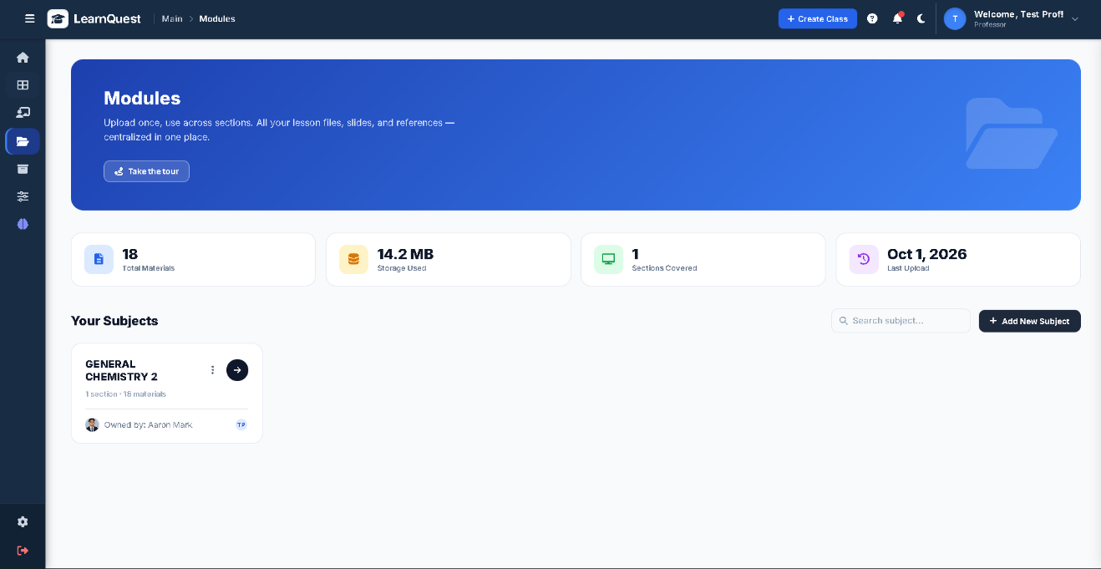
The Module Management Page (Figure 16) served as the teacher's repository of learning materials. Its header showed the number of materials uploaded, the storage space used, the sections covered, and the date of the most recent upload. Under Your Subjects, teachers could open an existing subject or create a new one with the Add New Subject button. Each subject card, such as General Chemistry 2, showed the number of sections and materials and the owner of the subject. Keeping all materials in one repository allowed the same file to be reused across sections without uploading duplicates.

Figure 17
Teacher Subject Level Modules: Materials Repository Page
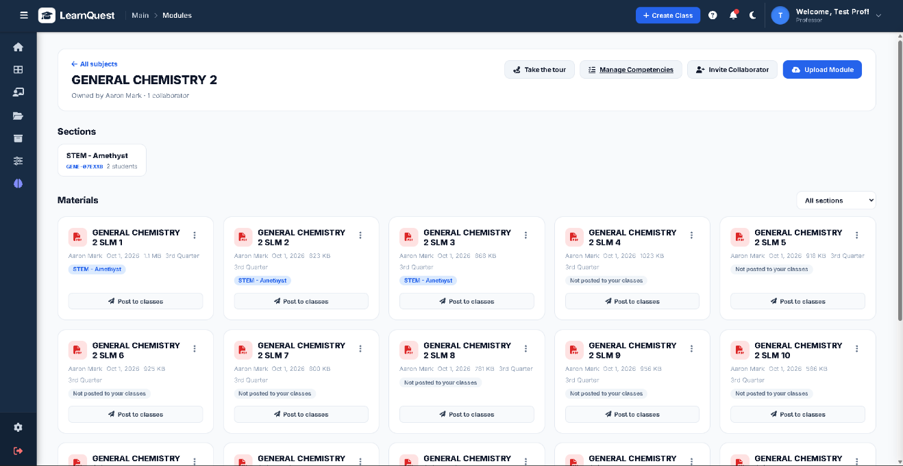
The Subject Modules page (Figure 17) organized the materials, competencies, and sections of a single subject. From its header, teachers could manage the subject's competencies, invite another teacher as a collaborator with co-owner access, and upload a module. Competencies could be entered manually or selected from competencies suggested by the AI from the text of the subject's modules; suggestions were saved only when the teacher chose them. Modules were uploaded as PDF files of up to 10 MB and tagged by quarter. The Sections area listed the class groups, such as STEM-Amethyst, with their student counts and join codes. Each module card showed the file name, file size, upload date, quarter, and publication status, and its Post to classes option created a lesson post in each selected section without uploading the file again. Collaborators who did not own a module could submit change requests instead of editing it directly.

Figure 18
Teacher Archived Classes Page
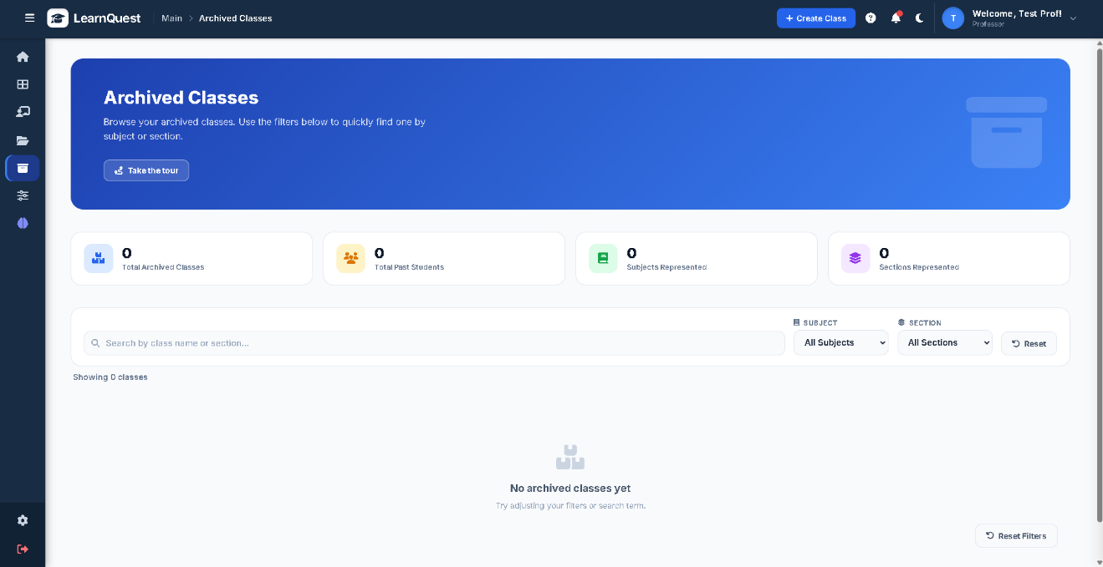
The Archived Classes page (Figure 18) kept a record of sections from past academic terms. Its summary showed the total number of archived classes, past students, subjects, and sections, and it provided a search box, subject and section filters, and a reset button. Archiving removed concluded classes from the active dashboard while preserving their records, and archived classes could be restored when needed.

Figure 19
Teacher Quiz and AI Setup Page
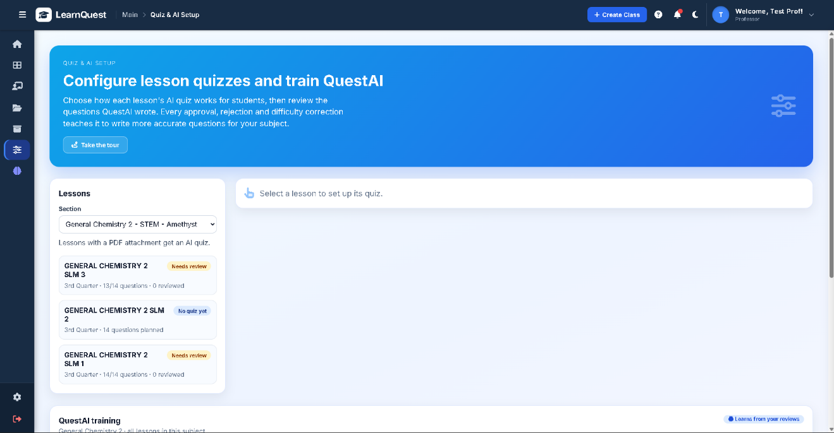
The Quiz and AI Setup page (Figure 19) was where teachers configured and reviewed AI-generated quizzes. Teachers did not write quiz questions. After selecting a section and a lesson, they set the number of questions (5 to 15), the difficulty mix of easy, medium, and hard items, the time limit, the maximum number of attempts, whether questions and choices were shuffled, whether answers were shown after submission, and whether the quiz adapted to each student's mastery. Lessons without saved settings used a default mix of 30% easy, 40% medium, and 30% hard. The page showed the review status of each lesson's quiz. Teachers approved or rejected each generated question with a reason and could correct its difficulty level or competency. Rejected questions were removed from the quiz and could be replaced through the top-up function.
The QuestAI Training panel on the same page summarized the teachers' reviews: the number of accepted and rejected questions, the acceptance rate, the agreement between teacher-assigned and AI-assigned difficulty, and the reasons for rejection. It also compared each question's actual percentage of correct student answers with the target for its difficulty level (80% for easy, 60% for medium, and 40% for hard, within 15 percentage points, after at least five responses) to flag questions whose difficulty may have been mislabeled. These reviews and calibration results were added as guidance to later quiz-generation prompts for the same subject. This training is in-context guidance only; the Llama model itself was not retrained or fine-tuned.

Figure 20
Teacher QuestAI Coach Page
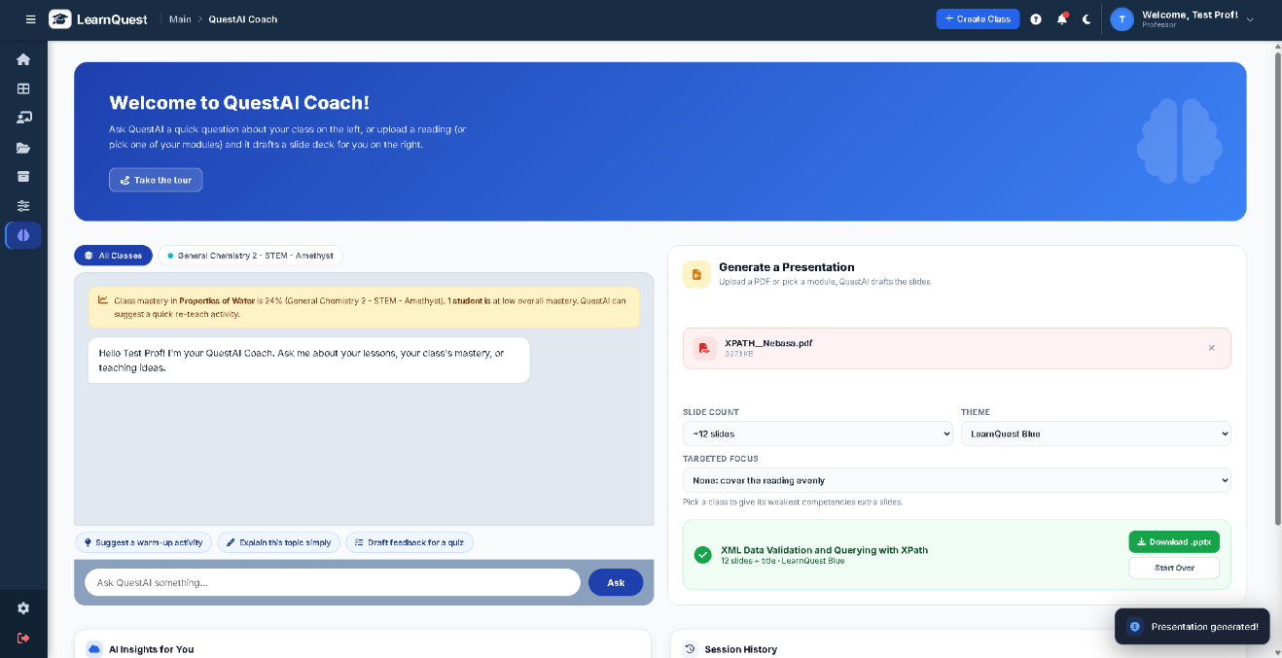
The QuestAI Coach (Figure 20) was an AI assistant for teachers. In the chat panel on the left, teachers asked class-specific questions and used prompt shortcuts for teaching strategies, warm-up activities, discussion topics, and quiz ideas. The Coach drew on the teacher's own materials and on class-level mastery figures; for example, it could point out a class's low mastery of the Properties of Water and suggest ways to address it. To protect student privacy, only aggregated class data, without student names, were sent to the AI service.
The Generate a Presentation tool on the right created a PowerPoint (.pptx) slide deck from an uploaded PDF or an existing module. Teachers set the number of slides, the visual theme, and the topics to emphasize, and could focus the deck on the class's weak competencies. This feature goes beyond those listed in the scope of the study and was added during development to support lesson preparation.

Figure 21
Student Home Page
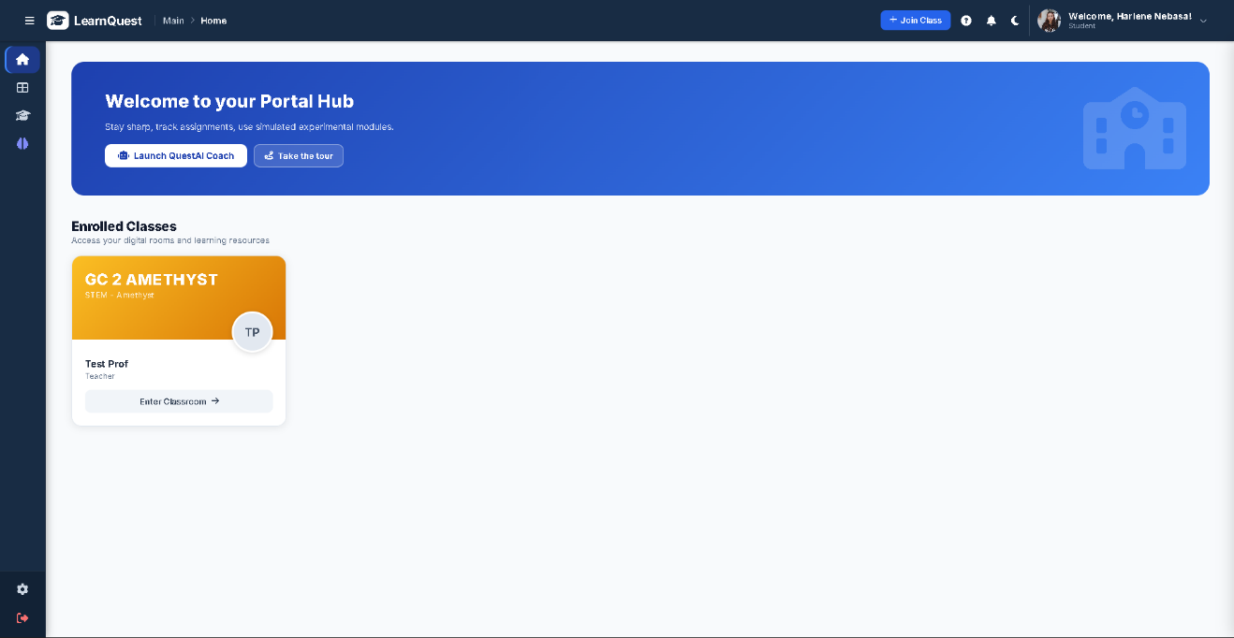
The Student Home Page (Figure 21) gave students access to their classes. Its welcome banner provided buttons for opening the QuestAI study assistant, taking a guided tour of the portal, and joining a class with a class code given by the teacher. The Enrolled Classes section listed each class with its section and teacher, and an Enter Classroom button opened the class's lessons, quizzes, and materials.

Figure 22
Student Analytics Dashboard Page
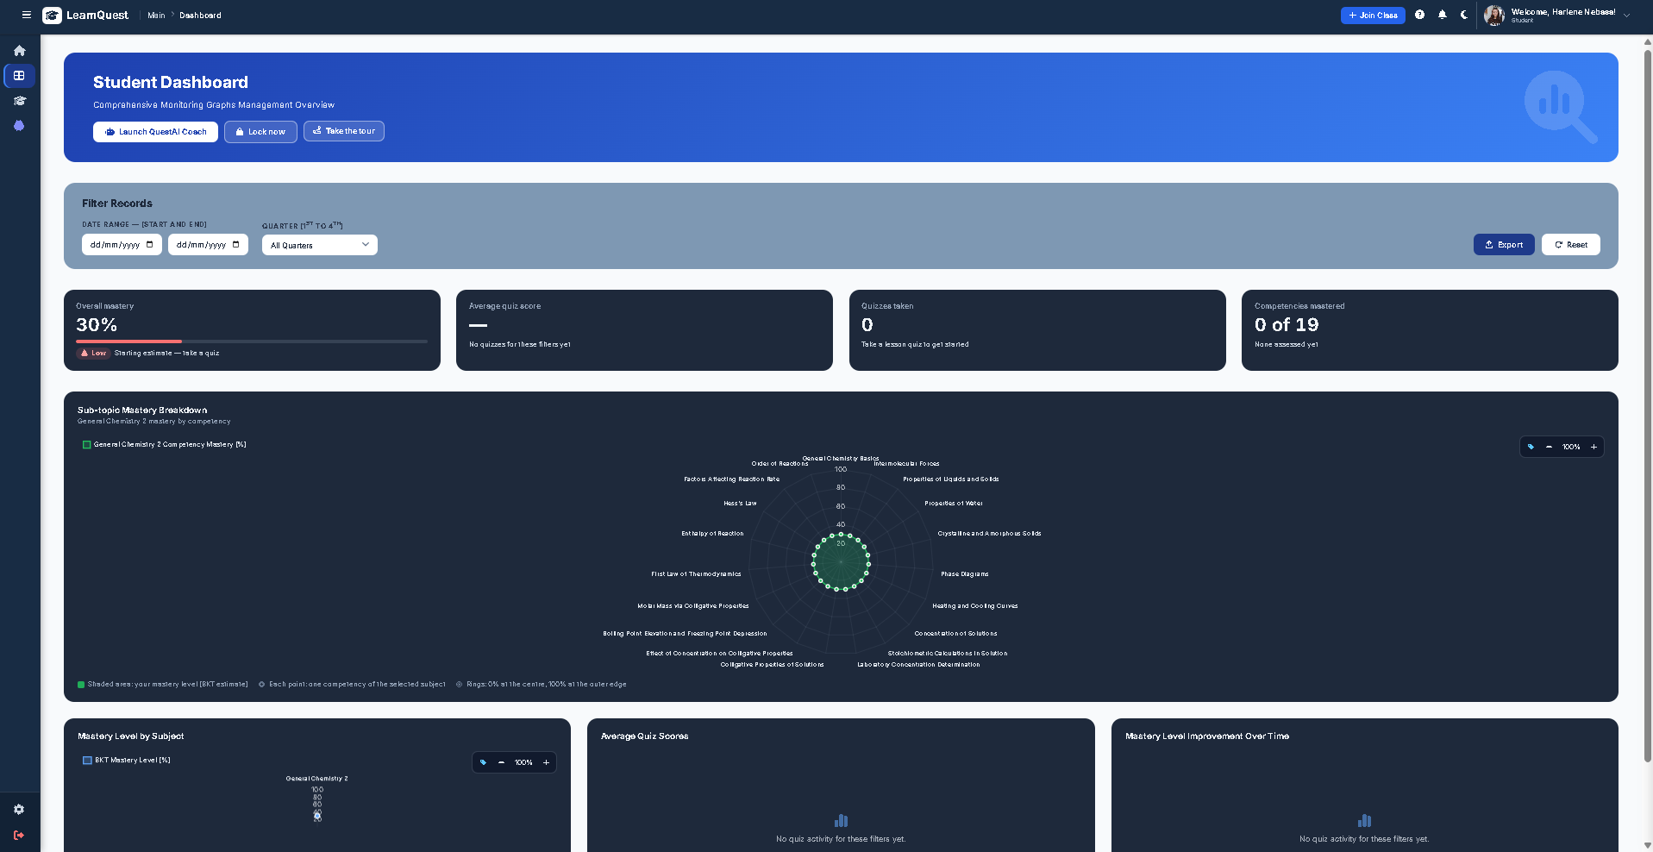
The Student Dashboard (Figure 22) showed each student's own performance. It could be filtered by date range and academic quarter, and a performance report could be downloaded. Summary cards displayed the overall mastery, average quiz score, number of quizzes taken, and competencies achieved. Mastery and quiz score were shown separately because they measure different things. A BKT radar chart showed mastery per competency, and further charts showed mastery per subject, quiz score history, and growth in competencies achieved. This dashboard is discussed further under Specific Problem 4.

Figure 23
Student Enrolled Class Page
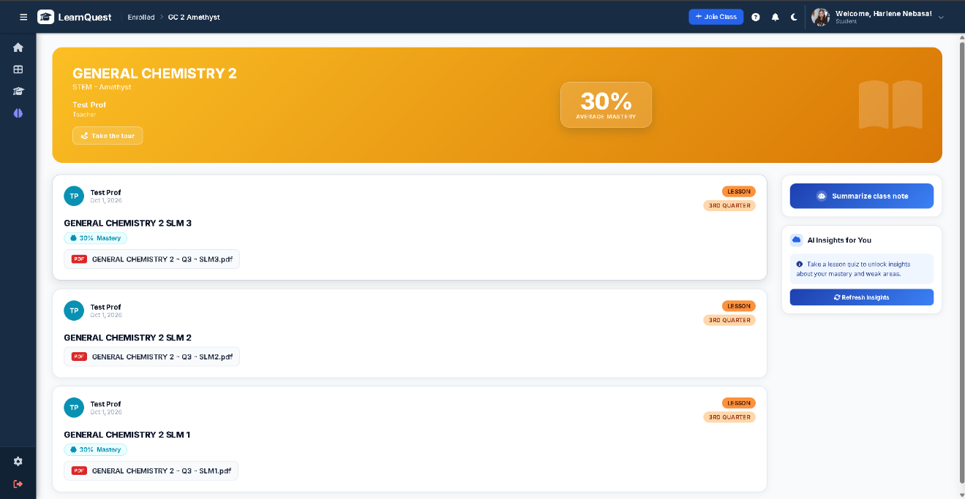
The Subject View page (Figure 23) showed a single enrolled class. Its header displayed the subject, the teacher, and the student's average mastery in the class. The main feed listed lesson posts, such as Self-Learning Modules, by quarter, with downloadable PDF attachments and the student's mastery for each topic. The side panel offered Summarize class notes and AI Insights for You. The insights became available only after the student had taken quizzes, because they are based on the student's BKT mastery.

Figure 24
Student Lesson Details Page
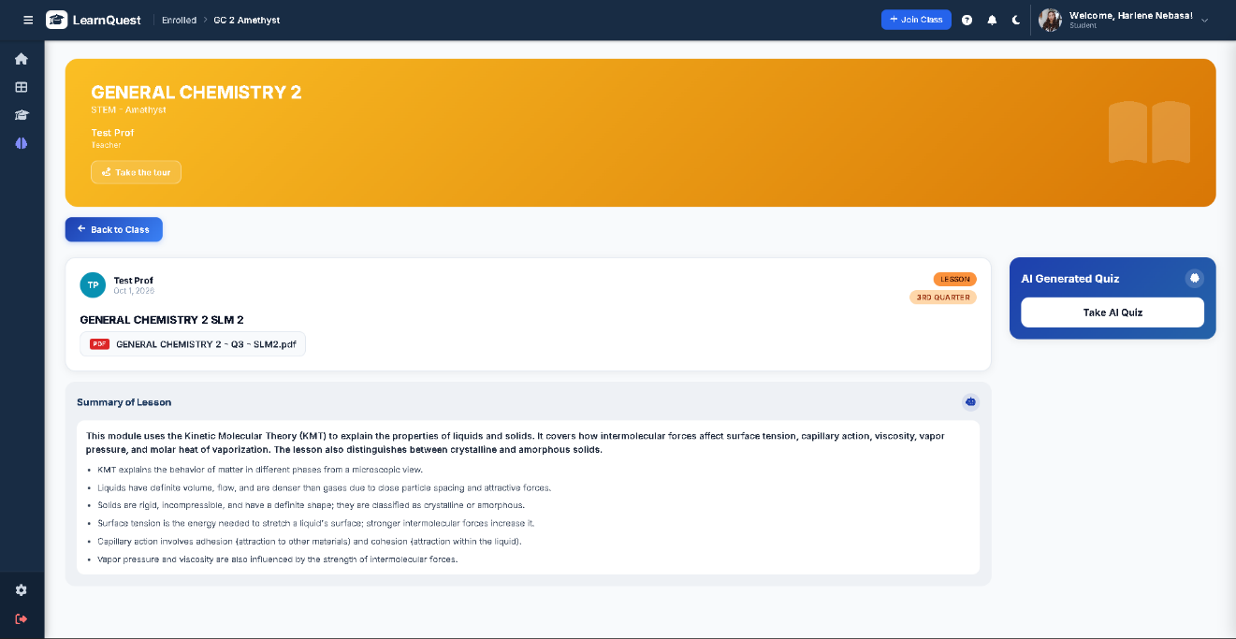
The Lesson Details page (Figure 24) presented a single lesson with its title, quarter tag, and PDF attachment, together with an Automatic Summary of Lesson box. The summary consisted of a short overview and up to six key points generated by the AI from the text of the attached PDF. It was generated the first time a student opened the lesson and was then stored, so later visits displayed it immediately. A Take AI Quiz button opened the lesson's quiz.

Figure 25
Student Quiz Assessment Page
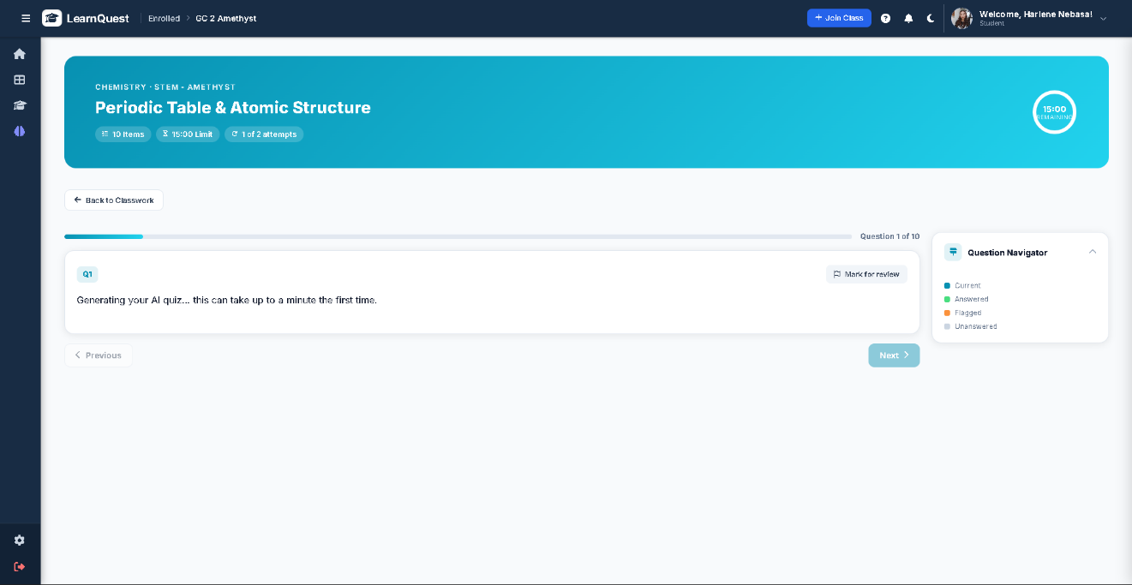
The Quiz page (Figure 25) presented the AI-generated quiz in a timed environment. The header showed the subject, topic, number of items, time limit, allowed attempts, and a countdown timer. Students moved through the questions with Previous and Next buttons and could mark questions for review, while the Question Navigator used colors to show the current, answered, flagged, and unanswered questions. The questions served to each student were selected according to that student's mastery level, as discussed under Specific Problem 3, and an attempt in progress resumed with the same questions and timer if the page was reloaded. After submission, the student saw the raw score, a review of each question with its explanation when the teacher allowed answers to be shown, and the change in mastery for each competency. The student could then rate the quiz and leave a comment.

Figure 26
Student QuestAI Study Assistant
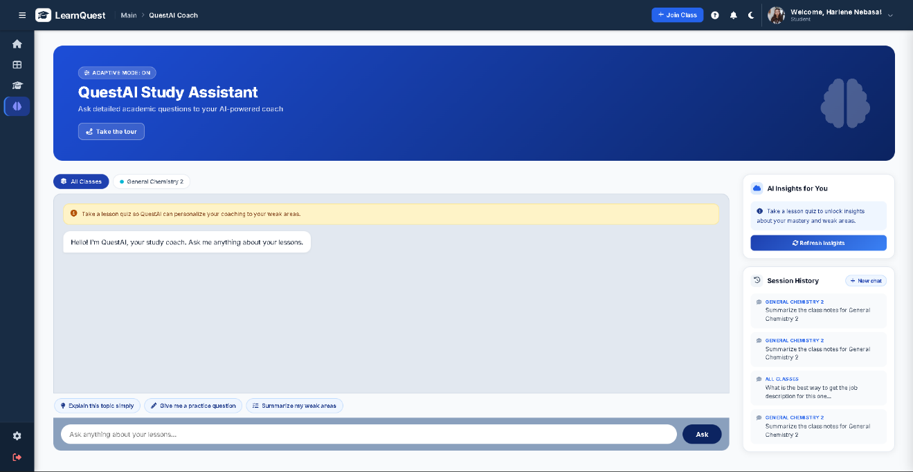
QuestAI (Figure 26) was the AI study assistant for students. Students typed questions or used prompt shortcuts such as Explain This Topic Simply, Give Me a Practice Question, and Summarize My Weakness. Replies were based on the class's lesson summaries and on passages of the lesson PDFs that matched the question, with the student's mastery used as context, and the lessons used as sources were recorded with each reply. Students could rate each reply. The right panel showed the AI Insights for You widget and previous conversations.

Figure 27
User Profile Settings Page
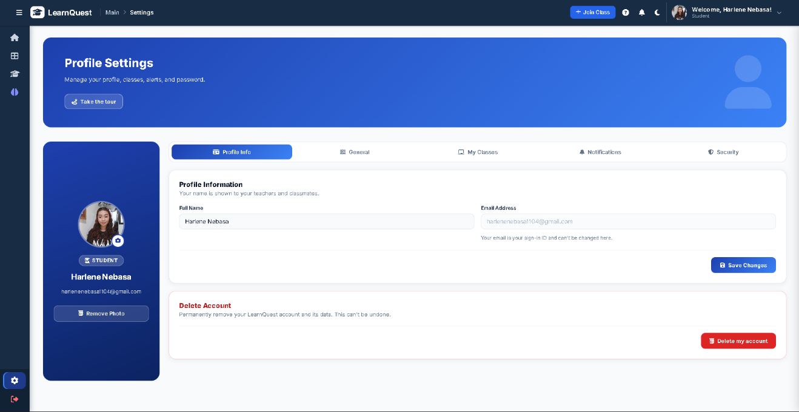
The Profile Settings page (Figure 27) let users manage their accounts. The left card showed the avatar, account information, and role. The Profile Info, General, My Classes, Notifications, and Security tabs allowed users to edit their name, view their sign-in email, set platform and notification preferences, review their classes, change their password, turn on OTP at login, and set the idle lock, which locks the session after a period of inactivity until an emailed code is entered. Users could also delete their own account.

Test Plan
A test plan was prepared to verify that LearnQuest meets the requirements that guided its design and development and to measure its software quality. The plan covers the objectives, scope, resources, procedure, and success criteria described below.
Objectives
The testing aimed to (1) verify that the major functions of LearnQuest operate as intended (Specific Problems 1 to 4); (2) determine the accuracy of the system's outputs, particularly the AI-generated summaries and quizzes (Specific Problem 2); and (3) evaluate the system's software quality as perceived by students, teachers, and IT experts using the ISO/IEC 25010 Software Quality Model (Specific Problem 5).
Scope and Resources
The test covered the user and system functions listed in Table 4. The AI components relied on the Llama 3.3-70B-Instruct model accessed through the Routeway inference API, and the evaluation questionnaire was administered through Google Forms to 55 respondents. The ISO/IEC 25010 model was selected because it evaluates the quality of the software itself, namely how well it performs, functions, and meets quality standards (International Organization for Standardization & International Electrotechnical Commission [ISO/IEC], 2011), which is the focus of the study. Behavioral acceptance models such as UTAUT, which explain why users adopt a technology, were outside the scope of this evaluation.
Functional testing combined the prepared test cases with the system's automated test suite (PHPUnit), which covers authentication and OTP verification, class and module management, competencies, lesson summaries, quiz generation and review, quiz attempts, adaptive quizzes, BKT mastery, dashboards and insights, QuestAI, slide deck generation, account settings, and notifications. In the automated tests, calls to the AI service were replaced with simulated responses. These tests therefore verified how the system handles and validates AI output, including malformed responses and invalid answer keys, but not the quality of the content produced by the model, which was assessed through teacher review.
Procedure
Each function was tested using prepared test cases containing the test condition, the expected result, and the actual result, and the tests were repeated to check consistency. Issues found during testing were documented and corrected before the formal evaluation. The respondents then used the system and answered the system evaluation questionnaire.
Success Criteria
A function was considered successful when its actual result matched the expected result in Table 4. A quality characteristic was considered acceptable when its weighted mean fell at least within the Agree range of the interpretation scale in Table 5.
Table 4
Test Plan for the Major Functions of LearnQuest
Feature / Module | Test Condition | Expected Result | SOP | Actual Result
User authentication | Register and log in as student and as teacher | Account is created and the user is directed to the role-based home page | 1 | Passed. The account was created after email OTP verification, and the user was directed to the home page for their role.
Learning material management | Upload a PDF lesson and open it as a student | Material is stored and accessible to the assigned class | 1 | Passed. The PDF was stored and posted as a lesson to the selected sections; files other than PDF were rejected.
AI lesson summary | Generate a summary from an uploaded lesson | A summary of the lesson content is produced | 2 | Passed. A validated overview and key points were generated, stored, and shown to the student.
AI quiz generation | Generate questions from an uploaded lesson | Science questions based on the lesson are produced for teacher review | 2 | Passed. Valid questions were stored for teacher review; malformed items were discarded.
Assessment scoring and feedback | Submit a quiz attempt | Answers are scored and feedback is displayed | 1, 2 | Passed. Answers were graded, and the score, question review, and mastery changes were displayed.
Adaptive quiz difficulty | Take consecutive quiz attempts | Question difficulty adjusts to the student's mastery level | 3 | Passed. The difficulty mix shifted toward easy questions for low mastery and toward hard questions for high mastery.
BKT mastery estimation | Complete assessments for a competency | Mastery estimate is updated after each response | 3 | Passed. Mastery matched the hand-computed BKT values after each response.
Dashboards and analytics | Open the teacher and student dashboards | Performance, mastery, and at-risk indicators are displayed | 4 | Passed. Mastery, trends, and students with low mastery were displayed.
Personalized recommendations | View recommendations after an assessment | Learning recommendations based on mastery gaps are shown | 3, 4 | Passed. Study advice based on weak competencies was shown, with rule-based advice when the AI was unavailable.
Note. Actual results are based on the automated test suite at the final build, in which all 318 tests (2,157 assertions) passed.

The results of the system evaluation were interpreted using the four-point scale in Table 5. The weighted mean of each item was computed as the sum of the frequency of each response multiplied by its scale value, divided by the total number of respondents.
Table 5
Interpretation Scale for the Weighted Mean
Scale Value | Range | Response Option | Verbal Interpretation
4 | 3.26 – 4.00 | Strongly Agree | Strongly Agree
3 | 2.51 – 3.25 | Agree | Agree
2 | 1.76 – 2.50 | Disagree | Disagree
1 | 1.00 – 1.75 | Strongly Disagree | Strongly Disagree

Accuracy of the System
System accuracy was examined through the accurateness item of the evaluation questionnaire and through the teachers' review of AI-generated questions in the QuestAI Training module. In the questionnaire, 40 of 55 respondents (72.73%) strongly agreed and 14 (25.45%) agreed that the system provides accurate information, while 1 respondent (1.82%) disagreed (Table 8). Because the questionnaire measured perceived accuracy, the teachers' reviews of AI-generated questions provide a more direct measure of the quality of generated content. [Insert from the QuestAI Training module: number of AI-generated questions reviewed, accepted, and rejected, and the acceptance rate]

Results of the System Evaluation
This section presents the respondents' ratings of LearnQuest by ISO/IEC 25010 quality characteristic. Each table gives the frequency and percentage of responses, the weighted mean, and its verbal interpretation. The profile of the respondents is shown first.
Several item labels used in the questionnaire, namely suitability, accurateness, and compliance under functional suitability and understandability and attractiveness under usability, follow the terminology of ISO/IEC 9126, the predecessor of ISO/IEC 25010. In ISO/IEC 25010, suitability and accurateness correspond to functional appropriateness and functional correctness, understandability to appropriateness recognizability, and attractiveness to user interface aesthetics, while compliance has no separate sub-characteristic. Compatibility, one of the eight characteristics named in Specific Problem 5, was not included in the questionnaire, so no rating is reported for it. Each sub-characteristic was measured by one questionnaire item.
Table 6
Type of User
Responses Option | Frequency | Percentage
Grade 11 and 12 STEM Students | 45 | 81.82%
Science Teachers | 5 | 9.09%
IT Experts | 5 | 9.09%
Total | 55 | 100%

Of the 55 respondents, 45 (81.82%) were Grade 11 and Grade 12 STEM students, 5 (9.09%) were Science teachers, and 5 (9.09%) were IT experts.
Functional Suitability
Functional suitability is the degree to which the system provides functions that meet stated and implied needs (ISO/IEC, 2011). It was measured through suitability, accurateness, and compliance.
Table 7
Suitability
Scale | Frequency | Percentage
Strongly Agree | 42 | 76.36%
Agree | 13 | 23.64%
Disagree | 0 | 0%
Strongly Disagree | 0 | 0%
Total | 55 | 100%
Weighted Mean | 3.76 | Strongly Agree

Table 7 shows the ratings on whether the functions of LearnQuest are appropriate for its intended learning-management tasks. Of the 55 respondents, 42 (76.36%) strongly agreed and 13 (23.64%) agreed. No respondent selected Disagree or Strongly Disagree. The weighted mean was 3.76, interpreted as Strongly Agree.
Table 8
Accurateness
Scale | Frequency | Percentage
Strongly Agree | 40 | 72.73%
Agree | 14 | 25.45%
Disagree | 1 | 1.82%
Strongly Disagree | 0 | 0%
Total | 55 | 100%
Weighted Mean | 3.71 | Strongly Agree

Table 8 shows the ratings on whether LearnQuest provides accurate information and performs its functions correctly. Of the 55 respondents, 40 (72.73%) strongly agreed and 14 (25.45%) agreed. 1 respondent (1.82%) disagreed, and no respondent selected Strongly Disagree. The weighted mean was 3.71, interpreted as Strongly Agree.
Table 9
Compliance
Scale | Frequency | Percentage
Strongly Agree | 41 | 74.55%
Agree | 13 | 23.64%
Disagree | 1 | 1.82%
Strongly Disagree | 0 | 0%
Total | 55 | 100%
Weighted Mean | 3.73 | Strongly Agree

Table 9 shows the ratings on whether LearnQuest conforms to the standards and requirements set for it. Of the 55 respondents, 41 (74.55%) strongly agreed and 13 (23.64%) agreed. 1 respondent (1.82%) disagreed, and no respondent selected Strongly Disagree. The weighted mean was 3.73, interpreted as Strongly Agree.
Security
Security is the degree to which the system protects information and data so that users have access appropriate to their authorization (ISO/IEC, 2011).
Table 10
Security
Scale | Frequency | Percentage
Strongly Agree | 42 | 76.36%
Agree | 12 | 21.82%
Disagree | 1 | 1.82%
Strongly Disagree | 0 | 0%
Total | 55 | 100%
Weighted Mean | 3.75 | Strongly Agree

Table 10 shows the ratings on the protection of user accounts and data in LearnQuest. Of the 55 respondents, 42 (76.36%) strongly agreed and 12 (21.82%) agreed. 1 respondent (1.82%) disagreed, and no respondent selected Strongly Disagree. The weighted mean was 3.75, interpreted as Strongly Agree.
Reliability
Reliability is the degree to which the system performs its functions under specified conditions (ISO/IEC, 2011). It was measured through fault tolerance and recoverability.
Table 11
Fault Tolerance
Scale | Frequency | Percentage
Strongly Agree | 37 | 67.27%
Agree | 15 | 27.27%
Disagree | 3 | 5.45%
Strongly Disagree | 0 | 0%
Total | 55 | 100%
Weighted Mean | 3.62 | Strongly Agree

Table 11 shows the ratings on the ability of LearnQuest to continue operating when errors or interruptions occur. Of the 55 respondents, 37 (67.27%) strongly agreed and 15 (27.27%) agreed. 3 respondents (5.45%) disagreed, and no respondent selected Strongly Disagree. The weighted mean was 3.62, interpreted as Strongly Agree.
Table 12
Recoverability
Scale | Frequency | Percentage
Strongly Agree | 36 | 65.45%
Agree | 16 | 29.09%
Disagree | 3 | 5.45%
Strongly Disagree | 0 | 0%
Total | 55 | 100%
Weighted Mean | 3.60 | Strongly Agree

Table 12 shows the ratings on the ability of LearnQuest to recover from errors or interruptions. Of the 55 respondents, 36 (65.45%) strongly agreed and 16 (29.09%) agreed. 3 respondents (5.45%) disagreed, and no respondent selected Strongly Disagree. The weighted mean was 3.60, interpreted as Strongly Agree.
Usability
Usability is the degree to which users can use the system effectively and satisfactorily (ISO/IEC, 2011). It was measured through understandability, learnability, operability, and attractiveness.
Table 13
Understandability
Scale | Frequency | Percentage
Strongly Agree | 41 | 74.55%
Agree | 14 | 25.45%
Disagree | 0 | 0%
Strongly Disagree | 0 | 0%
Total | 55 | 100%
Weighted Mean | 3.75 | Strongly Agree

Table 13 shows the ratings on how clearly the features, functions, and information of LearnQuest can be recognized. Of the 55 respondents, 41 (74.55%) strongly agreed and 14 (25.45%) agreed. No respondent selected Disagree or Strongly Disagree. The weighted mean was 3.75, interpreted as Strongly Agree.
Table 14
Learnability
Scale | Frequency | Percentage
Strongly Agree | 40 | 72.73%
Agree | 14 | 25.45%
Disagree | 1 | 1.82%
Strongly Disagree | 0 | 0%
Total | 55 | 100%
Weighted Mean | 3.71 | Strongly Agree

Table 14 shows the ratings on how easily users can learn to use LearnQuest. Of the 55 respondents, 40 (72.73%) strongly agreed and 14 (25.45%) agreed. 1 respondent (1.82%) disagreed, and no respondent selected Strongly Disagree. The weighted mean was 3.71, interpreted as Strongly Agree.
Table 15
Operability
Scale | Frequency | Percentage
Strongly Agree | 39 | 70.91%
Agree | 14 | 25.45%
Disagree | 2 | 3.64%
Strongly Disagree | 0 | 0%
Total | 55 | 100%
Weighted Mean | 3.67 | Strongly Agree

Table 15 shows the ratings on how well LearnQuest can be operated and how its functions respond to user actions. Of the 55 respondents, 39 (70.91%) strongly agreed and 14 (25.45%) agreed. 2 respondents (3.64%) disagreed, and no respondent selected Strongly Disagree. The weighted mean was 3.67, interpreted as Strongly Agree.
Table 16
Attractiveness
Scale | Frequency | Percentage
Strongly Agree | 42 | 76.36%
Agree | 13 | 23.64%
Disagree | 0 | 0%
Strongly Disagree | 0 | 0%
Total | 55 | 100%
Weighted Mean | 3.76 | Strongly Agree

Table 16 shows the ratings on the visual appeal of the LearnQuest interface. Of the 55 respondents, 42 (76.36%) strongly agreed and 13 (23.64%) agreed. No respondent selected Disagree or Strongly Disagree. The weighted mean was 3.76, interpreted as Strongly Agree.
Performance Efficiency
Performance efficiency is the performance of the system relative to the resources it uses (ISO/IEC, 2011). It was measured through time behavior and resource utilization.
Table 17
Time Behavior
Scale | Frequency | Percentage
Strongly Agree | 38 | 69.09%
Agree | 17 | 30.91%
Disagree | 0 | 0%
Strongly Disagree | 0 | 0%
Total | 55 | 100%
Weighted Mean | 3.69 | Strongly Agree

Table 17 shows the ratings on the response and processing time of LearnQuest functions. Of the 55 respondents, 38 (69.09%) strongly agreed and 17 (30.91%) agreed. No respondent selected Disagree or Strongly Disagree. The weighted mean was 3.69, interpreted as Strongly Agree.
Table 18
Resource Utilization
Scale | Frequency | Percentage
Strongly Agree | 37 | 67.27%
Agree | 18 | 32.73%
Disagree | 0 | 0%
Strongly Disagree | 0 | 0%
Total | 55 | 100%
Weighted Mean | 3.67 | Strongly Agree

Table 18 shows the ratings on the use of system resources by LearnQuest while performing its functions. Of the 55 respondents, 37 (67.27%) strongly agreed and 18 (32.73%) agreed. No respondent selected Disagree or Strongly Disagree. The weighted mean was 3.67, interpreted as Strongly Agree.
Maintainability
Maintainability is the degree to which the system can be analyzed and verified (ISO/IEC, 2011). It was measured through analyzability and testability.
Table 19
Analyzability
Scale | Frequency | Percentage
Strongly Agree | 39 | 70.91%
Agree | 16 | 29.09%
Disagree | 0 | 0%
Strongly Disagree | 0 | 0%
Total | 55 | 100%
Weighted Mean | 3.71 | Strongly Agree

Table 19 shows the ratings on the availability of information that can be used to analyze student learning progress and system performance. Of the 55 respondents, 39 (70.91%) strongly agreed and 16 (29.09%) agreed. No respondent selected Disagree or Strongly Disagree. The weighted mean was 3.71, interpreted as Strongly Agree.
Table 20
Testability
Scale | Frequency | Percentage
Strongly Agree | 40 | 72.73%
Agree | 14 | 25.45%
Disagree | 1 | 1.82%
Strongly Disagree | 0 | 0%
Total | 55 | 100%
Weighted Mean | 3.71 | Strongly Agree

Table 20 shows the ratings on how readily LearnQuest can be tested and verified. Of the 55 respondents, 40 (72.73%) strongly agreed and 14 (25.45%) agreed. 1 respondent (1.82%) disagreed, and no respondent selected Strongly Disagree. The weighted mean was 3.71, interpreted as Strongly Agree.
Portability
Portability is the degree to which the system can be installed in, or transferred to, an environment (ISO/IEC, 2011). It was measured through installability and replaceability.
Table 21
Installability
Scale | Frequency | Percentage
Strongly Agree | 40 | 72.73%
Agree | 15 | 27.27%
Disagree | 0 | 0%
Strongly Disagree | 0 | 0%
Total | 55 | 100%
Weighted Mean | 3.73 | Strongly Agree

Table 21 shows the ratings on whether LearnQuest can be installed and set up in its intended environment. Of the 55 respondents, 40 (72.73%) strongly agreed and 15 (27.27%) agreed. No respondent selected Disagree or Strongly Disagree. The weighted mean was 3.73, interpreted as Strongly Agree.
Table 22
Replaceability
Scale | Frequency | Percentage
Strongly Agree | 38 | 69.09%
Agree | 17 | 30.91%
Disagree | 0 | 0%
Strongly Disagree | 0 | 0%
Total | 55 | 100%
Weighted Mean | 3.69 | Strongly Agree

Table 22 shows the ratings on whether LearnQuest can serve as an alternative to existing learning management systems for its intended purpose. Of the 55 respondents, 38 (69.09%) strongly agreed and 17 (30.91%) agreed. No respondent selected Disagree or Strongly Disagree. The weighted mean was 3.69, interpreted as Strongly Agree.

Summary of the System Evaluation Results
Table 23 summarizes the weighted mean and verbal interpretation of the 16 evaluated items, and Figure 28 shows the distribution of responses for each item. The overall weighted mean was 3.70, interpreted as Strongly Agree.
Table 23
Summary of the Weighted Means by ISO/IEC 25010 Characteristic
Characteristic | Item | Weighted Mean | Verbal Interpretation
Functional Suitability | Suitability | 3.76 | Strongly Agree
Functional Suitability | Accurateness | 3.71 | Strongly Agree
Functional Suitability | Compliance | 3.73 | Strongly Agree
Security | Security | 3.75 | Strongly Agree
Reliability | Fault Tolerance | 3.62 | Strongly Agree
Reliability | Recoverability | 3.60 | Strongly Agree
Usability | Understandability | 3.75 | Strongly Agree
Usability | Learnability | 3.71 | Strongly Agree
Usability | Operability | 3.67 | Strongly Agree
Usability | Attractiveness | 3.76 | Strongly Agree
Performance Efficiency | Time Behavior | 3.69 | Strongly Agree
Performance Efficiency | Resource Utilization | 3.67 | Strongly Agree
Maintainability | Analyzability | 3.71 | Strongly Agree
Maintainability | Testability | 3.71 | Strongly Agree
Portability | Installability | 3.73 | Strongly Agree
Portability | Replaceability | 3.69 | Strongly Agree
Overall | All 16 items | 3.70 | Strongly Agree

The weighted mean by characteristic was Functional Suitability 3.73; Security 3.75; Reliability 3.61; Usability 3.72; Performance Efficiency 3.68; Maintainability 3.71; Portability 3.71. Across the 16 items, 13 Disagree responses were recorded: three each for fault tolerance and recoverability, two for operability, and one each for accurateness, compliance, security, learnability, and testability. No respondent selected Strongly Disagree.
Figure 28
Distribution of Responses per Evaluated Item
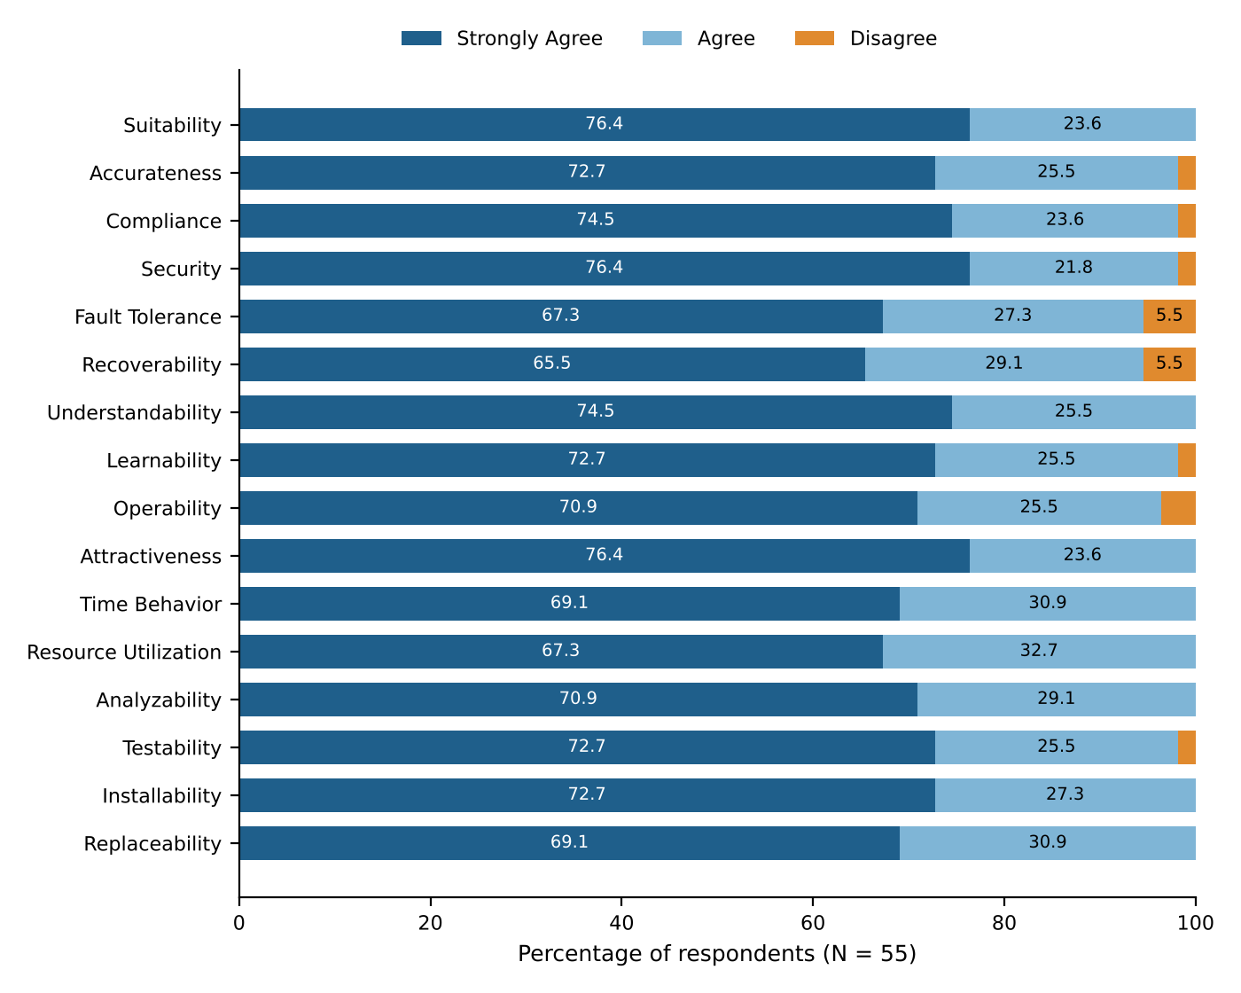

Discussion
All 16 evaluated items obtained weighted means between 3.60 and 3.76, within the Strongly Agree range, with an overall weighted mean of 3.70. The respondents therefore perceived LearnQuest as meeting the quality expectations for a school-based learning management system. These are user perceptions of software quality, and they indicate acceptability of the system; they do not by themselves show improvement in learning outcomes. Evaluations of learning management systems commonly consider user perception alongside other indicators of success (Bonilla-Priego, 2024).
Fault tolerance (3.62) and recoverability (3.60) had the lowest means and were the only items with three Disagree responses each. A likely factor is the system's dependence on an external AI service. Lesson summaries and quizzes are generated while the user waits; although the system retries failed requests and falls back to alternative models, generation can take noticeably longer while this happens, and a summary or quiz cannot be produced when none of the models responds. In contrast, study insights fall back to rule-based output, and a quiz attempt in progress resumes with the same questions after a page reload. These two items therefore point to AI generation under poor network conditions as the area that most needs further testing.
Functional suitability was rated highly (suitability, 3.76), and only one respondent disagreed on accurateness. The quality of AI-generated content depends on the instructional materials uploaded by teachers, and the literature on automatic question generation emphasizes reviewing generated questions before use (Kurdi et al., 2020). This supports the teacher review process in the Quiz and AI Setup page, where teachers can reject questions and correct their difficulty or competency. Lesson summaries and study advice, however, are shown to students without a teacher review step.
Understandability (3.75) and attractiveness (3.76) were among the highest-rated items. Clear presentation of learner data is a recurring concern in the design of learning analytics dashboards (Ramaswami et al., 2023), and the ratings suggest that the dashboards were understandable to the respondents. Analyzability (3.71) indicates that respondents found the information provided useful for analyzing learning progress. Because BKT produces probabilistic estimates of mastery (Šarić-Grgić et al., 2024), this rating reflects the perceived usefulness of the information and does not confirm the predictive accuracy of the estimates.
Two limitations of the evaluation should be noted. First, compatibility was not measured, so the study draws no conclusion on that characteristic. Second, each sub-characteristic was measured by a single questionnaire item, so the results reflect the respondents' overall impression of each quality rather than a multi-item scale.

Project Testing Results
The testing of LearnQuest covered its user authentication, learning material management, AI-generated summaries and quizzes, assessment scoring and feedback, adaptive quiz difficulty, BKT-based mastery estimation, dashboards, and personalized recommendations. Every function in Table 4 met its expected result. The automated test suite at the final build contained 318 tests with 2,157 assertions, all of which passed. Because the AI service was simulated in the automated tests, the quality of AI-generated content was assessed separately through teacher review.
In the system evaluation by 55 respondents, every item received a weighted mean in the Strongly Agree range (3.60 to 3.76; overall 3.70). The highest weighted means were obtained by suitability and attractiveness (3.76 each), and the lowest by recoverability (3.60) and fault tolerance (3.62). Thirteen Disagree responses were recorded across the 16 items, and no respondent selected Strongly Disagree.

CHAPTER 4
CONCLUSIONS AND RECOMMENDATIONS

Introduction
This chapter presents the conclusions and recommendations of the study. The conclusions are based on the results presented in Chapter 3 and follow the order of the specific problems stated in Chapter 1. The recommendations trace to the conclusions and are intended to guide the improvement of LearnQuest and further research.

Conclusions
The study developed and evaluated LearnQuest, an adaptive learning management system powered by artificial intelligence for Grade 11 and Grade 12 STEM students of Kapitolyo High School. It was evaluated by 55 respondents: 45 STEM students, five Science teachers, and five IT experts. The instrument was a researcher-made system evaluation questionnaire based on the ISO/IEC 25010 Software Quality Model, rated on a four-point Likert scale. The conclusions answer the five specific problems of the study in the order they were stated.
Specific Problem 1 (features and functionalities). LearnQuest was developed as a web-based learning management system with role-based access for teachers and students. Teachers can organize subjects, sections, competencies, and PDF learning modules, post lessons and announcements, configure and review AI-generated quizzes, and monitor class performance. Students can join classes, read AI-generated lesson summaries, take adaptive quizzes, consult the QuestAI study assistant, and track their own mastery. Respondents rated these functions as suitable (weighted mean = 3.76, with all 55 respondents agreeing or strongly agreeing) and compliant with requirements (3.73). Two planned features were not completed: PowerPoint upload, since materials are accepted in PDF format only, and the administrator role, which exists in the database but has no pages of its own.
Specific Problem 2 (integration of the Llama 3.3-70B-Instruct model). The Llama 3.3-70B-Instruct model was integrated on the server side through the Routeway API to generate lesson summaries, quiz questions with explanations, competency suggestions, study advice, and tutoring replies grounded in the teacher's uploaded PDFs. Every output is validated before it is saved, and teachers can review and reject generated questions. Respondents rated the accuracy of the system favorably (3.71, with 54 of 55 agreeing or strongly agreeing) and its response time favorably (3.69, with all respondents agreeing or strongly agreeing). These ratings reflect perceived accuracy and do not establish the factual accuracy of every generated output. Because fallback models respond when Llama is unavailable, not every stored output was necessarily produced by Llama.
Specific Problem 3 (application of BKT and learning analytics). BKT was applied to estimate each student's mastery of each competency from the sequence of quiz answers, using P(L₀) = 0.30, P(T) = 0.15, P(G) = 0.25, and P(S) = 0.10. The estimates classify each competency as low, developing, or high mastery, which the system uses to adjust the difficulty of the next quiz, identify weaknesses, generate study advice, and alert students and teachers. Mastery is kept separate from raw quiz scores throughout the system. All 55 respondents agreed or strongly agreed that the system provides information that can be used to analyze learning progress (analyzability, 3.71). The study did not test the predictive accuracy of the BKT estimates, and the parameters are working values rather than values fitted to student data.
Specific Problem 4 (learning analytics and dashboard features). Student and teacher dashboards were implemented with BKT radar charts, mastery per topic and per student, quiz performance trends, filters by quarter, date, section, and subject, a list of students who need intervention, and an AI-generated strengths-and-weaknesses analysis. Respondents found these interfaces understandable (3.75), easy to learn (3.71), easy to operate (3.67), and attractive (3.76), for a usability mean of 3.72.
Specific Problem 5 (acceptability based on ISO/IEC 25010). LearnQuest was rated Strongly Agree on all seven characteristics evaluated, with an overall weighted mean of 3.70. Security (3.75), portability (3.71), and maintainability (3.71) were rated highly, while reliability had the lowest mean (3.61), with three of 55 respondents (5.45%) disagreeing on each of fault tolerance and recoverability. No respondent strongly disagreed on any item. Compatibility, the eighth characteristic named in the problem, was not evaluated, so no conclusion is drawn on it. LearnQuest is therefore acceptable to its evaluators as a learning management system for its intended school setting.
Overall, this study shows that an adaptive learning management system that brings learning materials, AI-assisted assessments, mastery tracking, and analytics into one platform can be built and is acceptable to the students, teachers, and IT experts who evaluated it, giving Kapitolyo High School a basis for supporting personalized Science learning.

Recommendations
Based on the conclusions, the following recommendations are offered.
Recommendations for Action
• The school's Science teachers should review AI-generated questions in the Quiz and AI Setup page before opening a quiz to students, and check the generated lesson summaries, since the quality of generated content depends on the uploaded materials (Conclusion 2).
• The school should schedule a short orientation for new student and teacher users, using the system's guided tour, to support learnability and operability (Conclusion 4).
• Teachers should upload text-based PDF files rather than scanned documents and divide very long lessons into shorter modules, because scanned PDFs cannot be processed and summaries use only the first 12,000 characters of a lesson (Conclusion 2).
Recommendations for System Improvement
• The developers should add testing for fault tolerance and recoverability, such as interrupted sessions, temporary network failures, and recovery after unsuccessful operations, and should consider generating summaries and quizzes in the background so that slow AI responses do not keep users waiting, because these items had the lowest ratings (Conclusion 5).
• The developers should improve error messages and task guidance, particularly for features that received Disagree ratings for operability and learnability (Conclusion 4).
• The developers may extend teacher review, which is currently available for quiz questions, to lesson summaries and AI-generated study advice so that teachers can validate this content before it reaches students (Conclusion 2).
• The developers may display BKT mastery estimates together with the competency assessed and a short note that the values and mastery levels are estimates based on configurable thresholds, not raw scores (Conclusion 3).
• The developers should implement PowerPoint upload by adding a PowerPoint text extractor, add text recognition (OCR) for scanned PDFs, and build the administrator module for managing accounts and roles (Conclusion 1).
Recommendations for Future Research
• Future researchers should evaluate LearnQuest with a larger group across more classes or schools, measure each quality characteristic with several questionnaire items, and include compatibility, which was named in the study's problems but not evaluated (Conclusion 5).
• Future researchers should measure learning outcomes using pretests, posttests, and longer-term usage records to determine the effect of the system on competency mastery and engagement. They should also estimate the BKT parameters from the collected response data and validate the accuracy of BKT estimates and AI-generated content against independent measures (Conclusions 2 and 3).
• Before extending LearnQuest to other grade levels or subjects, future developers should validate its content and user experience with those users (Conclusion 1).
References

Aljad, T., Muratov, M., & Kuznetsova, E. (2025). Analysis of development trends and experience of using LMS in modern education. Education and Information Technologies, 30(1), 87–104. https://www.researchgate.net/publication/382432746_Analysis_of_Development_Trends_and_Experience_of_using_LMS_in_Modern_Education_An_overview
Amazon Web Services. (2023). Amazon SageMaker: Machine learning for developers.
https://docs.aws.amazon.com/sagemaker
Barab, S., & Squire, K. (2004). Design-based research: Putting a stake in the ground. Journal of the Learning Sciences, 13(1), 1–14. https://doi.org/10.1207/S15327809JLS1301_1
Bonilla-Priego, M. (2024). Evaluating the success of a learning management system. Taylor & Francis Online. https://www.tandfonline.com/doi/full/10.1080/09639284.2024.2424269
Bousboula, A., Khamlichi, S., & El Kabtane, H. (2025). Intelligent learning management systems in higher education: A review of adaptive models. Journal of Educational Technology & Society, 28(1), 44–59.
Chrysafiadi, K., & Virvou, M. (2021). Adaptive e-learning systems based on student knowledge and learning style: A review of recent developments. Expert Systems with Applications, 173, 114658. https://doi.org/10.1016/j.eswa.2021.114658
Dignum, V., Baldoni, M., Baroni, P., Bentahar, J., & van der Torre, L. (2021). Ethics and Artificial Intelligence: Balancing innovation and responsibility. AI Communications, 34(3), 211–228.
https://doi.org/10.3233/AIC-210017
Google Cloud. (2023). Vertex AI: Unified machine learning platform. Google LLC.
https://cloud.google.com/vertex-ai
Gupta, A., Bansal, D., & Bhushan, B. (2022). Integrating Artificial Intelligence in e-learning: A systematic review of adaptive models. Education and Information Technologies, 27(9), 12215–12238.
https://doi.org/10.1007/s10639-022-11143-8
Hashemi-Pour, C., Kirvan, P., & Brush, K. (2024, October 22). What is a learning management system (LMS)
https://www.techtarget.com/searchcio/definition/learning-management-system
Highsmith, J. (2002). Agile software development ecosystems. Addison-Wesley. https://www.scirp.org/reference/referencespapers?referenceid=1706156
Holmes, W., Porayska-Pomsta, K., & Holstein, K. (2022). Ethics of AI in education: Towards responsible implementation. Computers and Education: Artificial Intelligence, 3, 100071.
https://doi.org/10.1016/j.caeai.2022.100071
Ifenthaler, D., Schumacher, C., & Kuzilek, J. (2023). Investigating students' use of self-assessments in higher education using learning analytics. Journal of Computer Assisted Learning, 39(1), 255–268. https://doi.org/10.1111/jcal.12744
International Organization for Standardization & International Electrotechnical Commission. (2011). ISO/IEC 25010:2011 Systems and software engineering — Systems and software Quality Requirements and Evaluation (SQuaRE) — System and software quality models. ISO.
İskigöz, E. (2024). Do learning management system activities in online pedagogical education significantly predict academic performance? https://files.eric.ed.gov/fulltext/EJ1416060.pdf
Jayaprakash, S., Moody, E., Lauría, E., Regan, J., & Baron, J. (2024). Benchmarking student performance and engagement in an early alert predictive system using interactive radar charts. In Proceedings of the Sixth International Conference on Learning Analytics & Knowledge. ACM. https://dl.acm.org/doi/10.1145/2883851.2883891
Kantabutra, S., & Tangmanee, C. (2025). Perceptual bias in mobile radar chart visualization: Untangling the effects of radial axes, data series, and screen refresh. International Journal of Analysis and Applications. https://www.etamaths.com/index.php/ijaa/article/view/3943
Khosravi, H., Sadiq, S., & Gasevic, D. (2021). Learning analytics and adaptive feedback: Integrating models and APIs for student success. Computers & Education, 168, 104211.
https://doi.org/10.1016/j.compedu.2021.104211
Kurdi, G., Leo, J., Parsia, B., Sattler, U., & Al-Emari, S. (2020). A systematic review of automatic question generation for educational purposes. International Journal of Artificial Intelligence in Education, 30(1), 121–204. https://doi.org/10.1007/s40593-019-00186-y
Lee, D. (2023). Impact of learning management systems (LMS) on students during the COVID-19 pandemic. *International Journal of Educational Development, 43(2), 122–131.
https://doi.org/10.1016/j.ijedudev.2023.102751
Microsoft. (2023). Azure Machine Learning: Cloud AI services overview. Microsoft Corporation.
https://azure.microsoft.com/en-us/products/machine-learning
Pinargote, M., et al. (2024). Student performance visualization in dashboards: AdESMuS system (bar, radar, violin plots in comparative context). ScitePress. https://www.scitepress.org/publishedPapers/2025/132656/pdf/index.html
Prahani, B. K., Alfin, J., Fuad, A. Z., Saphira, H. V., Hariyono, E., & Suprapto, N. (2022). Learning management system (LMS) research during 1991–2021: How technology affects education. International Journal of Emerging Technologies in Learning, 17(17), 28–49.
https://doi.org/10.3991/ijet.v17i17.30763
Ramaswami, G., Susnjak, T., Mathrani, A., et al. (2023). Use of predictive analytics within learning analytics dashboards: A review of case studies. Technology, Knowledge and Learning, 28(4), 959–980. https://link.springer.com/article/10.1007/s10758-022-09613-x
RSIS International. (2025). Comparative study between Moodle, Canvas, and Google Classroom. International Journal of Research and Innovation in Social Science (IJRISS).
https://rsisinternational.org
Santos, O., de Lima, L., & Neto, F. (2021). Agile-based AI integration in educational software development. Journal of Systems and Software, 177, 110955.
https://doi.org/10.1016/j.jss.2021.110955
Šarić-Grgić, I., Pavlović, D., & Kovačević, A. (2024). Bayesian knowledge tracing models for adaptive learning environments: A systematic review (arXiv:2406.11847).
https://arxiv.org/abs/2406.11847
Shukla, N., Perianayagam, K. S., & Sinha, A. (2021). AI-based evaluation to assist students studying through online systems. In Artificial Intelligence and Machine Learning in Business Management: Concepts, Challenges, and Case Studies (pp. 145–158). CRC Press. https://books.google.com.ph/books?id=wJBDEAAAQBAJ
Xie, T., Kuang, Y., Tang, Y., Liao, J., & Yang, Y. (2025). Using an LLM-supported lecture summarization system to improve knowledge recall and student satisfaction. Expert Systems with Applications, 269, 126371. https://doi.org/10.1016/j.eswa.2024.126371
Zawacki-Richter, O., Bai, J. Y. H., Lee, K., Slagter van Tryon, P. J., & Prinsloo, P. (2024). New advances in artificial intelligence applications in higher education. International Journal of Educational Technology in Higher Education, 21(1), 32. https://doi.org/10.1186/s41239-024-00464-3
Zhou, J., Lin, Y., & Zhao, L. (2025). Advances in deep knowledge tracing for personalized learning analytics (arXiv:2503.04752). https://arxiv.org/abs/2503.04752
Zhou, Y., & Wang, X. (2022). Reinforcement learning frameworks for adaptive learning path optimization. Computers and Education: Artificial Intelligence, 3, 100071.
https://doi.org/10.1016/j.caeai.2022.100071

