**Instagive: A Platform for all Donations utilizing Progressive Web Application approach** Joshua Michael Jabor 1,2,3, Aaron Joshua Pangan 1,2,3, Michelle Biag 1,2,3, Jan Carlos Dizon 1,2,3

1 College of Computer Studies

2 Research Development and Innovation Center

3 Our Lady of Fatima University

October 2020

Table of contents

Title Pagei

Endorsementii

Certificate of Originalityiii

Acknowledgementiv

Table of Contentsv

List of Tablesvii

List of Figuresix

List of Appendicesx

Executive Summaryxi

1.0 Introduction1

1.1 Objectives of the Study2

1.1.1 General Objective2

1.1.2 Specific Objectives2

1.2 Significance of the Study3

1.3 Scope and Limitation3

1.3.1 Scope3

1.3.2 Limitation4

2.0 Review of Related Literature and Studies5

2.1 Technical Background5

2.2 Related Literature5

2.2.1 Local Literature5

2.2.2 Foreign Literature5

2.3 Related Studies5

2.3.1 Local Studies5

2.3.2 Foreign Studies6

2.4 Definition of Terms6

3.0 Methodology7

3.1 Conceptual Framework7

3.2 Project Development Approach9

3.2.1 Planning Phase9

3.2.2 Analysis Phase10

3.2.3 Design Phase10

3.2.4 Implementation Phase10

3.2.5 Testing & Integration Phase10

3.2.6 Maintenance Phase10

3.3 Requirement Analysis11

3.3.1 Visual Table of Contents11

3.3.2 Use Case Diagram12

3.3.3 Activity Diagram13

3.3.4 Data Flow Diagram14

3.3.4.1 Context Diagram14

3.3.4.2 Diagram 015

3.3.5 Class Diagram16

3.3.6 Entity Relationship Diagram16

3.3.7 System Architecture17

3.4 Testing18

3.5 Design Analysis19

3.5.1 Evaluation Procedure19

3.6 Data Gathering Procedures20

3.7 Research Ethics21

3.8 Statistical Procedure21

4.0 Results and Discussion23

4.1 Analysis of the Existing System23

4.2 Project Technical Description30

4.2.1 Hardware Specification30

4.2.2 Software Specification31

4.3 Project Structured Organization33

4.4 Project Evaluation39

4.4.1 Project Evaluation of the end-users39

4.4.2 Project Evaluation of the IT Experts44

5.0 Summary, Conclusion and Recommendation49

5.1 Summary49

5.2 Conclusion49

5.3 Recommendation49

References51

1. **Introduction**

Charities have a major role to play in contemporary communities, not only by offering resources to those in need but also by raising awareness and making the public think about critical social issues. So far, the candidate for election, the non-governmental agency, the non-profit organization, and the charity are to be considered the key sources of donation to the fund. Nonprofits – particularly small local ones –compete for donations on an ongoing basis. [1] Traditionally, charities are provided via media such as fundraisers, checks, and online through personal computers (PCs), but there is now a new alternative in the form of mobile devices. Specifically, this study would look at charitable donations via smartphones, which continue to be more efficient and popular for internet browsing and online transactions. [2] For this paper, a smartphone will be described as a mobile phone capable of performing many of the same functions as a computer, such as browsing the Internet.

Technology has been a great tool for donation and collaboration with donor bases. In our age, users or customers tend to use digital technologies for transactions and like donations. But several small non-profits do not use digital resources for several reasons, including lack of resources, lack of preparation, and little leadership support. [3]

In addition, to help the nature and the term of current technology, customers or users rely on the need for and use of applications that have been implemented in the cyber world, in particular mobile applications. [4] Mobile apps that are safe and manageable are more likely to be used. In designing and implementing an application, it must be protected to calculate the degree of protection offered efficiently. [5] To ensure that donations are made following the rules, protection is necessary at a certain time.

It has become increasingly popular for people to use smartphones for Internet activities instead of a desktop computer, and the phenomenal growth in users and goods is unparalleled. [6] Online activities have become a big deal for most people, it is a comfortable place for everyday transactions on the Internet, such as: selling or purchasing goods, online services on the Internet. Online shopping has become mainstream, and many people make online transactions regularly from a personal computer. [7] Although there is a lot of research on customer attitudes and actions, there is a gap in research on donor attitudes and behaviors about mobile donation.

In addition, mobile apps are the latest technology that can be used by the modern generation, and it is important to consider the quality of the data and the potential of donors&#39; attitudes towards charitable donations on mobile devices. [8] As mobile technologies become the standard, they represent a new and growing source of donations for non-profits.

* 1. *Objectives of the Study*
     1. *General Objective*

The objective of this project is to develop an online platform for donation drive. Also, to provide a convenient service to those people who are in need to have their needs provide by the help of the donors. Lastly to change the manual system into app-based computerized system which helps our fundraising system to be competitive in a way that will improve the quality, security and transparency for helping a person. This is easier and adaptable to modern living.

* + 1. *Specific Objectives*

The following are the specific objectives that the proponents want to achieve:

1. To develop a system that will do donation drive that is verified.
2. To create a system that will help donors to donate hassle-free using mobile phone.
3. To design an application that easy to access, just register and manage the user profile

and view all the donation drive and donate by just make few clicks.

1. To evaluate the acceptability of system in terms of:

5.1 Functional Suitability

5.2 Performance Efficiency

5.3 Compatibility

5.4 Usability

5.5 Reliability

5.6 Security

5.7 Maintainability

* 1. *Significance of the study*

*For Donors.* The Donors would have quick and easy access to donate and confirmed that the donation will be given accurately to the person in need. They can do this using their smart device that can go online, they could easily view and filter urgency of the donation drive. With the donation app, donors could have an insight on choosing and knowing the person in need. The system would also have a messaging platform for the donors and needy, promoting better communication at the same time it will promote the effortless and contactless donation.

*For Non-Profit organization.* The Non-Profit organization would have an easy way to identify each individual that is in need with our system they can easily verify the urgency and accuracy of the needed goods. This system would also promote contactless donation drive where non-profit organization can receive applications from someone in need.

*For the Government.* The Government can use this system to check all of the underprivileged needs and can provide the needed item with this platform, this system would also promote transparency with support provided from the government.

*For Someone in need.* For someone in need would have an easy way to apply for donation drive and get easily verified within our system. The system will promote legitimate and valid donation drive to prevent fraudulent activities.

*For future researchers.* This study could serve as a reference for future researchers who would like to develop and improve the existing system. They can use this study as a guideline in a project they want to make. This will allow them to further understand what a project needs and how this will benefit the community and such. They can further revise this study for advancement.

For others, the study can be a source of valuable up-to-dat**e** information which can be veryvaluable for their own similar studies for the given subject matter.

* 1. *Scope and Limitation*
     1. *Scope*

The system provides web application which clients can use; using their smart phone

or a computer. The system is a user-friendly environment where a non-profit organization or person can seek assistance by any terms of donations. The system as well will verify if the needed assistance is legitimate and will make transparent records about the donation drive.

* + 1. *Limitation*

The system requires an Internet Connection for the new donation drive to be available and it requires a smart device as well that can download an app.

1. **Review of Related Literature and Studies**

This chapter will cover related local and international studies and literature such as books, electronic materials, papers, articles, and recently published research papers. Such theories, observations, and methodologies are used to collect knowledge and develop our framework for better understanding.

* 1. *Technical Background*
     1. *Web Application*

# According to NETWORK ENCYCLOPEDIA, [9] web application is a collection of elements on a Web site that performs tasks over the internet and Web applications are designed to run on Web servers (such as Internet Information Services or Apache) and use Web browsers such as Microsoft Internet Explorer or Chrome as the user interface. Web applications are typically client/server applications. For example, the ordering mechanism on an electronic commerce site is a Web application.

* 1. *Related Literature*
     1. *Local Literature*

# CROPITAL it is a platform for social entrepreneurship and crowdfunding that

# connects all those who want to help and benefit from local farmers. Investors will have the ability to personally impact a small-scale farmer's production by increasing their cash through the company's scalable and sustainable financing scheme. Their system shows that it helps local farmers with their finances and helping them to grow their business also. While their business is growing you also benefiting from their growth which is your capital also increasing. [10]

* + 1. *Foreign Literature*

Mobile Blood Donor Tracker was proposed by Samy. S, is a mobile application that connects users with Blood Centers to facilitate the blood collection from donors during emergencies, facilitate the communication of blood donors with each other and facilitate the communication of blood donors with the Hospital blood center. It is an application developed by making use of the following technologies: MySQL database-used by the application to manage the low-level work of data by sending it commands, Service-based location-a software application for IP capable mobile devices, Android-the Linux based open source platform backed by Google, and the Android System Architecture, among others. [11]

* 1. *Related Studies*
     1. *Local Studies*

# A 2018 study by Gil Platon Soriano was conducted to assess the intention of community members in Manila to donate blood and the factors affecting the intention to come up with motivational evidence-based campaigns to encourage blood donors. To collect the details, a descriptive cross-sectional study design was used and a survey using a structured questionnaire was used. To pick the 600 respondents from six Manila districts, stratified random sampling was used. 177(29.5%) of the 600 respondents have undergone blood donation. Most of the blood donors with experience were, 39-48 y/o and had completed at least secondary education. Family medical needs are the primary reason for donation blood; health problems (25.2%) and the lack of opportunities (21.5%) are the most common considerations for not donating blood. A slightly higher proportion of respondents were prepared in the future to donate blood. This can be motivated by the creation of an incentive through regular blood donation events and campaigns. [12]

* + 1. *Foreign Studies*

The Research of Qing Li, analyze the impact factors of donation behavior by customers of financial businesses. Donation through different financial institutions helps people in and has a huge impact on the social charity. Before the questionnaires for this research were created, customer interviews were first performed to develop successful questionnaires. 205 bank customers answered questionnaires. Correlation analysis, chi-square, and Bayesian networks were used to test consumers' online donations. The degree of income and online donation is defined by correlations. Meanwhile, the chi-square test and conditional probability are used to test whether there is a significant association between trust, online donation, and donation fields. There is a strong theoretical and realistic understanding of bank customers' online donations and the effects of the fields of donation. The results are that the relationship between average income and online donation as well as an underlying relationship between trust and online donation.[13]

* 1. *Definition of Terms*

**Progressive Web App** - a type of software that can convert website to mobile applications.

**ReactJS** - use to develop the user interface of the application.

**NodeJS** - refers to the operating environment of the application.

**MongoDB** - Refers to the place where the data will be stored.

**ExpressJS** - a tool that allows the program to connect to the database(MongoDB)

1. **Methodology**
   1. *Conceptual Framework*

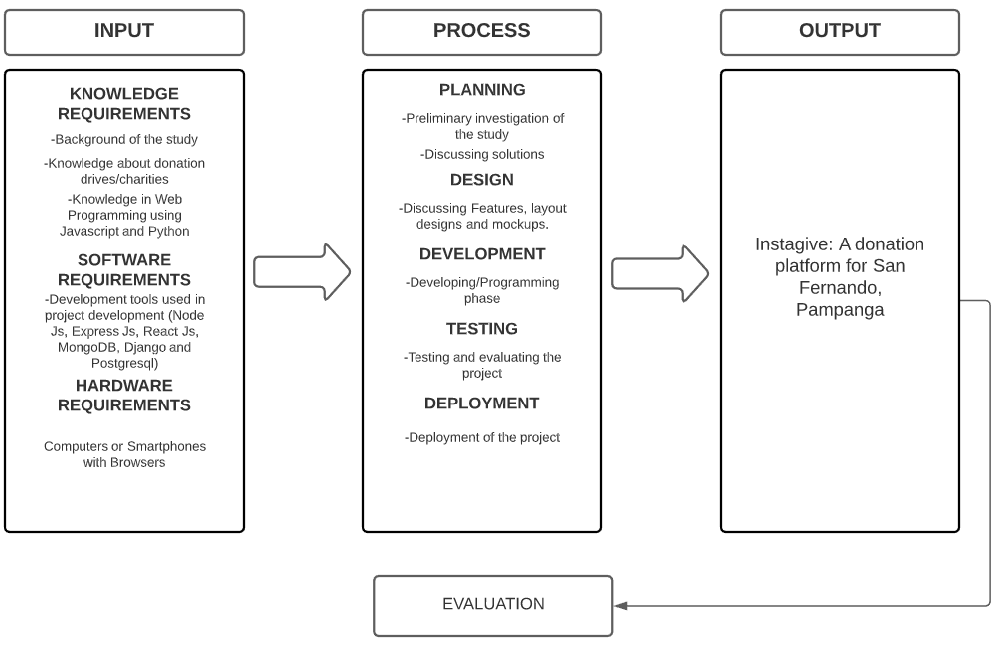

**Figure 1:** *Conceptual Framework of the Study*

The figure shows above addresses the system requirements and the development process. The inputs are all the required knowledge, software, and hardware to build the system. The Process is the procedures we used to develop the system and lastly, the result, which is the proposed system.

* 1. *Project Development Approach*

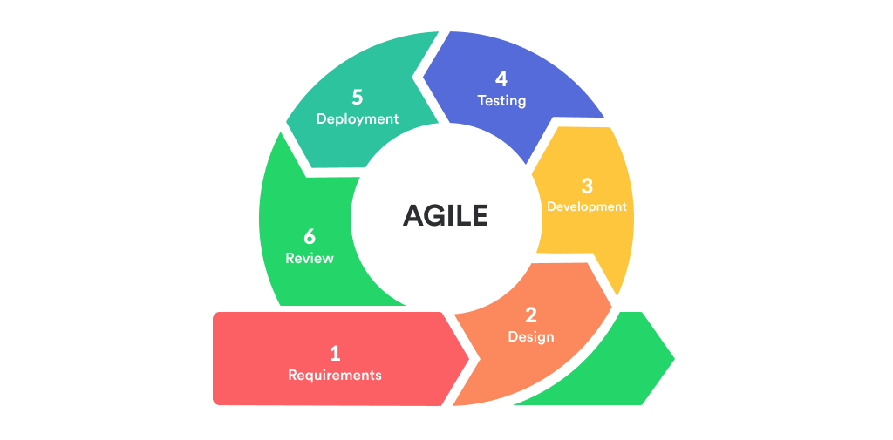

**Figure2:** *Project Development Approach for the Proposed System.*

The Proponents used the Agile Methodology as the System Development Life Cycle approach for the development of the proposed system. The proponents decided to use this approach because the proposed system will heavily depend on the suggestions of the end-users, In which we considered as the clients.

* 1. **Requirements Analysis**

*3.3.1 Visual Table of Contents*

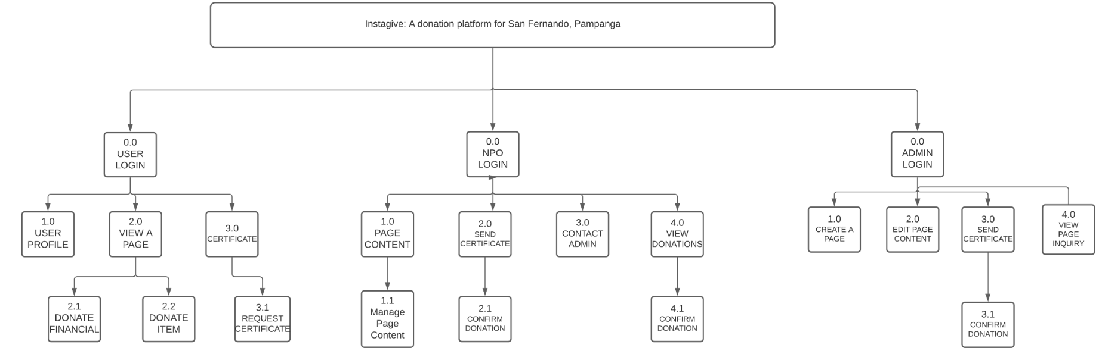

**Figure 3*:*** *Visual Table of Contents of the Proposed System*

The figure above shows the digital interface table of the proposed system. It shows what the user interface will be like in the proposed system.

*3.3.2 Use case Diagram*

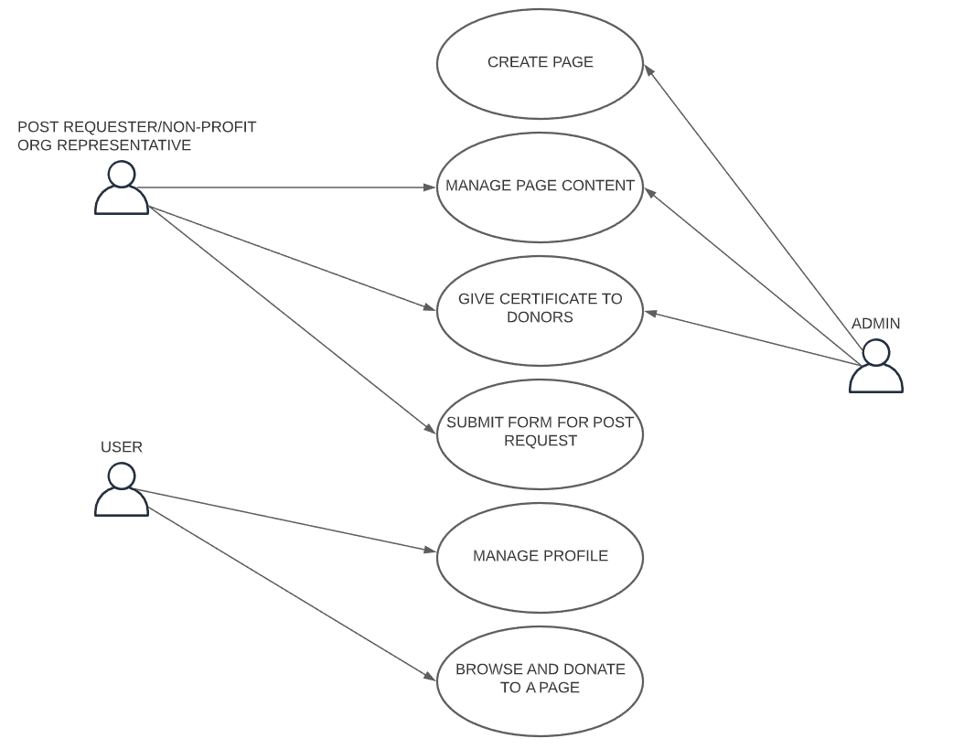

**Figure 4:** *Use case Diagram of the proposed System*

The figure above shows the graphical representation of what certain types of users can do in the proposed system.

*3.3.3 Activity Diagram*

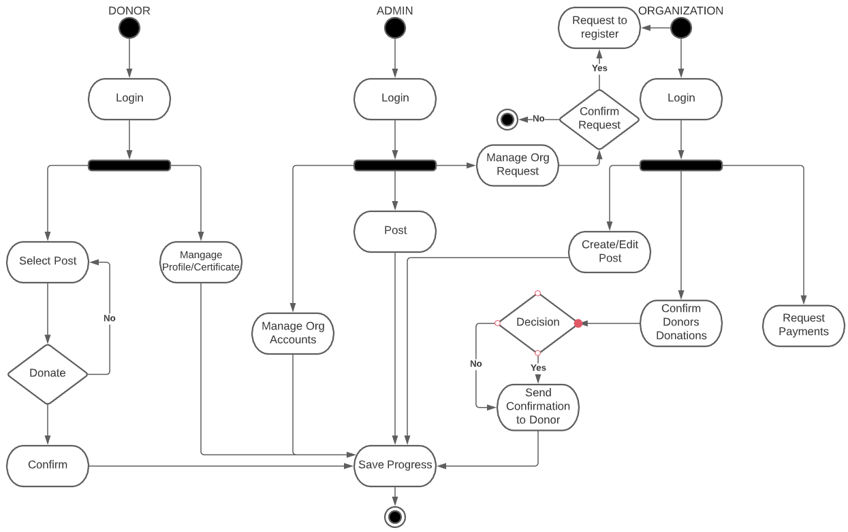

**Figure 5:** *Activity Diagram of the Proposed System*

The figure above shows the graphical representations of workflows of stepwise activities and actions. It illustrates the workflow between the users and the system from one activity to another.

*3.3.4 Data Flow Diagram*

*3.3.4.1 Context Diagram*

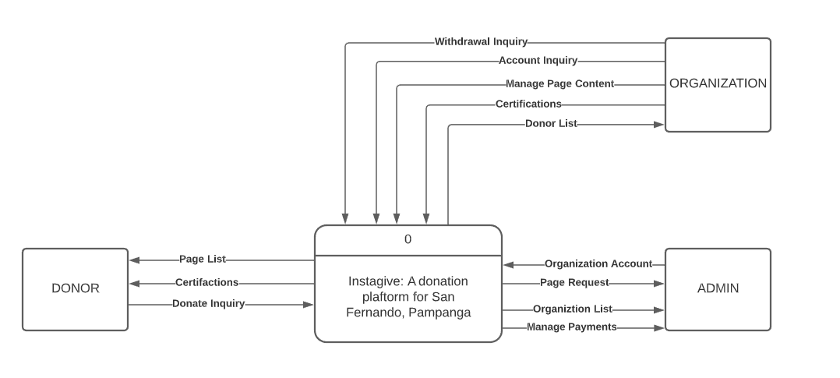

**Figure 6:** *Context Diagram of the Proposed System*

The figure above shows the relationship of the system with external entities. It also identifies the flow of information in the entire software system as a single process.

*3.3.4.1 Diagram 0*

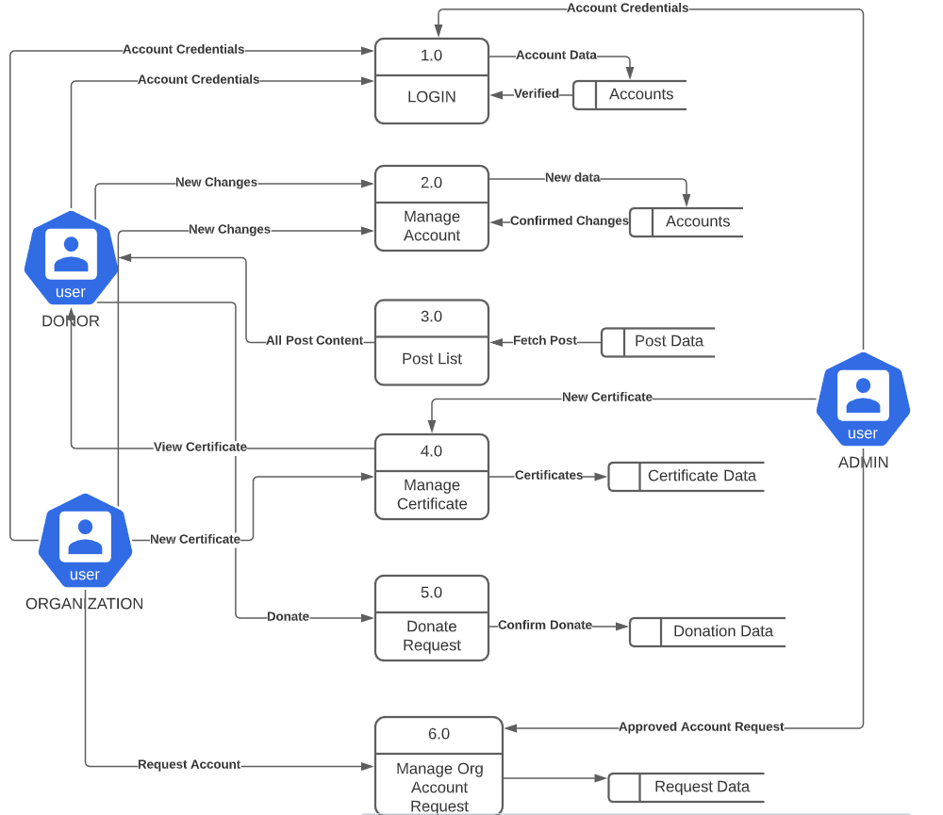

**Figure 7:** *Diagram 0 of the Proposed System*

The figure above shows each of the main sub-process that together form the complete system. It is also called the exploded view of the context diagram.

# *3.3.5 Class Diagram*

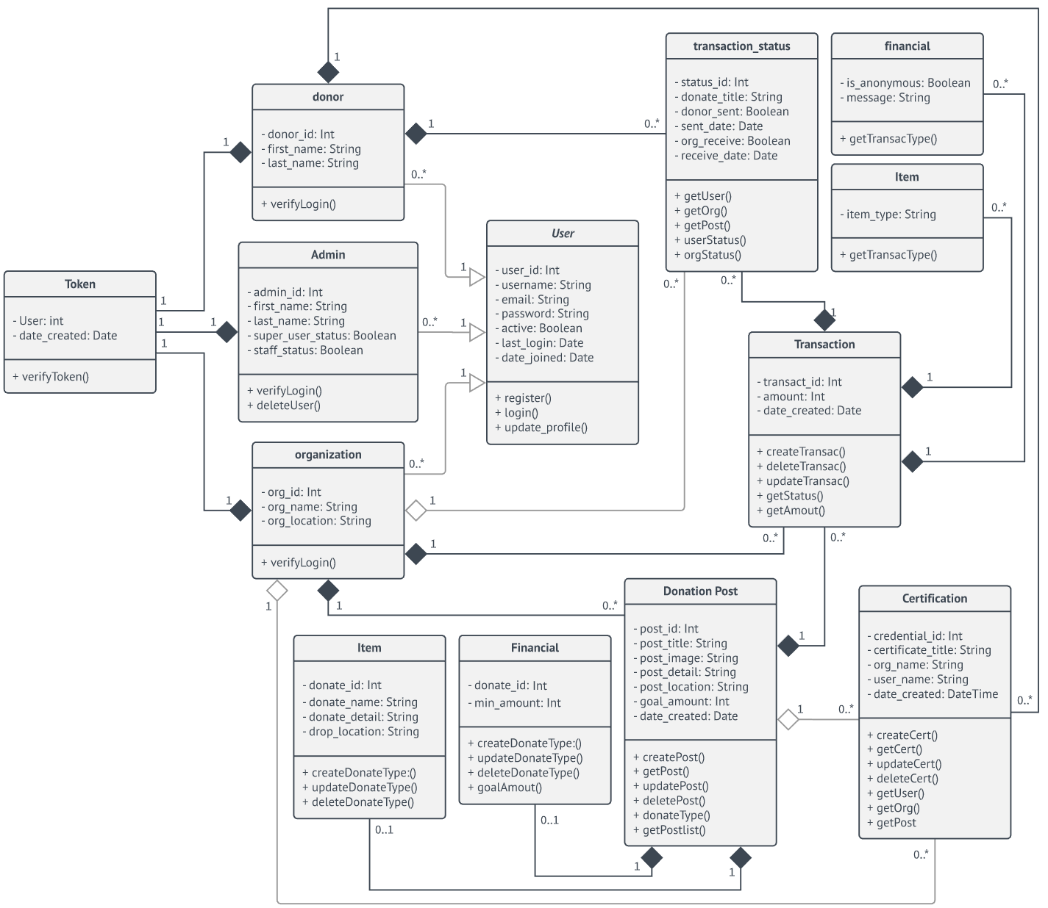

**Figure 9:** *Class Diagram of the Proposed System*

# The class diagram defines the classes of the software with their characteristics and their relationship as an person or an object. The admin, organization, and donors display their connections as classes and characteristics that determine their interaction defined in the application.

*3.3.6 Entity Diagram*

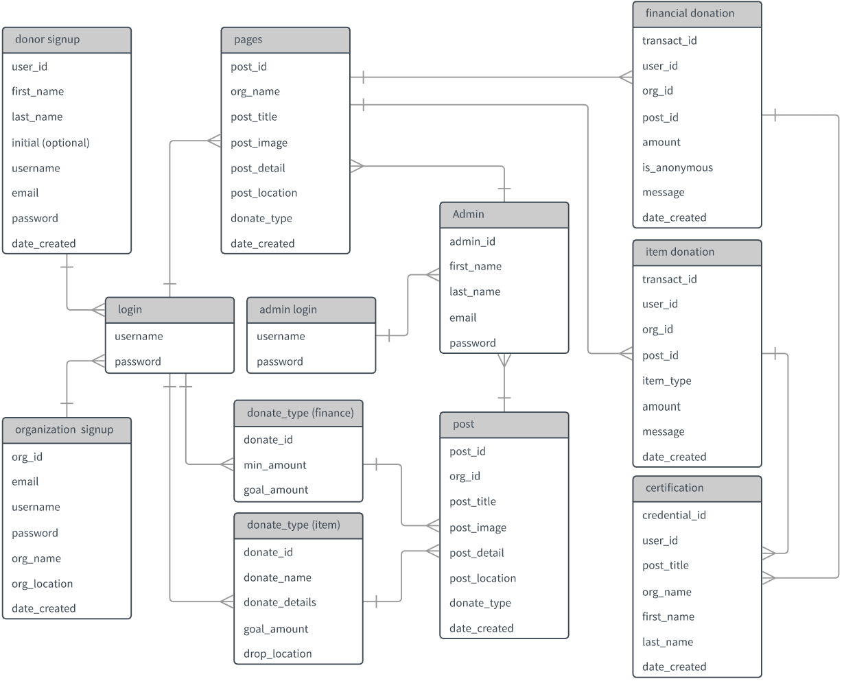

**Figure 10:** *Entity Diagram of the Proposed System*

The figure demonstrates how the basic form of the database is illustrated by the inclusion in the diagram of entities such as abstract concepts or individuals.

*3.3.7 System Architecture*

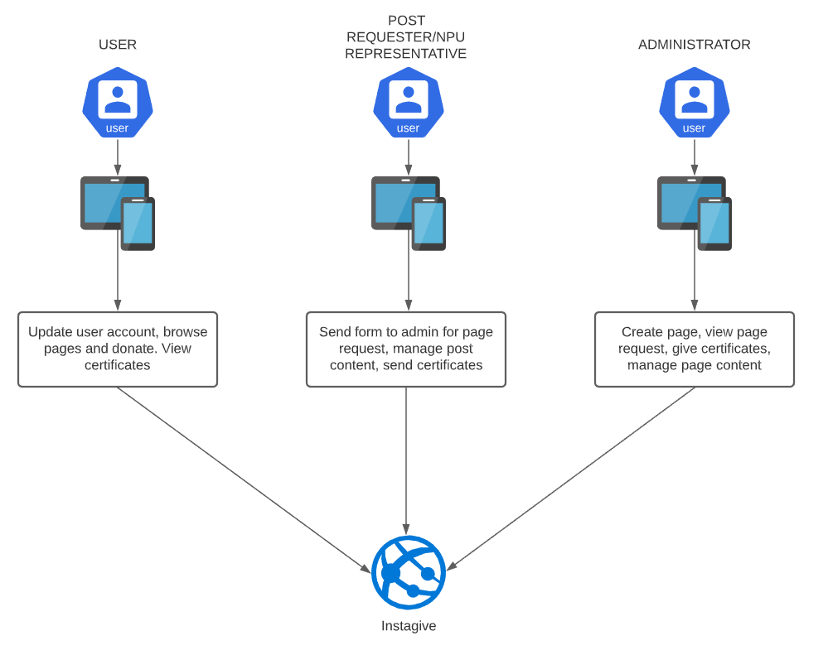

**Figure 8:** System Architecture of the Proposed System

# The figure above represents the entire architecture of the proposed system. It has an abstract overall outline and the relation, constraints, and boundaries between components.

**Appendix F**

1. Do you own a smartphone?

* Yes
* No

2. Have you donated to charity using a smartphone?

* Yes
* No

3. If yes, how did you donate on a smartphone?

* Using a website
* Using a mobile application
* Using text-to-give

4. How likely are you to donate using a smartphone?

* Very much
* More likely
* Not much

5. How easy or difficult was the process of donating online?

* Very easy
* Very difficult
* Neither easy nor difficult

6. How likely will you share/advertise this system to your friends, family or anyone to donate to us?

* Very much
* More likely
* Not much

7. If you'll rate a system like this, what would it be from 1-10, how interested will you be?

* 1
* 2
* 3
* 4
* 5
* 6
* 7
* 8
* 9
* 10

**3.6 Data Gathering Procedures**

The proponents give the details of the project that will be discussed thoroughly in the research. This part of the study encompasses the method to gather data that will be used to justify the satisfying conclusion.

**3.7 Research Ethics**

With regard to the research being done by the proponents and involving people, the proponents gave the respondents their consent. It helps them to reject answers when they feel uncomfortable in answering the survey. The proponents took account of the privacy of the respondent and maintained its information security.

A survey method was also carried out where the questionnaires were developed and carefully assessed to avoid disagreements between respondents. Those who answered in the survey had time to avoid mistakes and incorrect answers. The proponents have ensured the data collected are confidential and safe.

The advocates took those measures to finalize the report. The report was been cleared by Committee of Institutional Ethics at Our Lady of Fatima University.

**3.8 Statistical Procedure**

The research data was evaluated through statistical evaluation and the data was evaluated using mathematical formulas.

The percentage is the total of the respondents, with a percentage mark solved as the frequency of the respondents, divvied up by the total of the participants, and multiply to 100.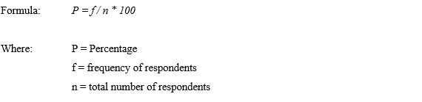

Mean is obtained by adding all scores in the set divided by number of the scores in the set. The formula for mean is

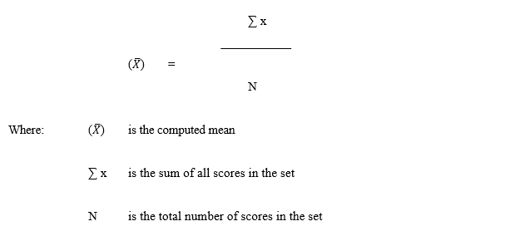

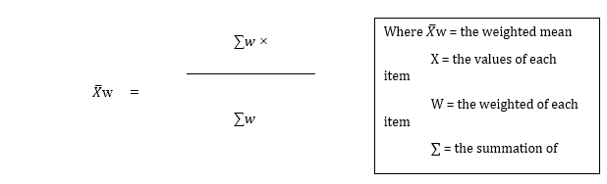To evaluate the classification of respondents, the weighted mean was used. There's been evaluation and each corresponds to the standard given by all the response. The assessment questions included a number of categories relating to flexibility, reliability, effectiveness and performance and sustainability.