


Citrix Access Gateway Installation Notes
Created November 2006 Graham Field
Table of Contents
Citrix Access Gateway Installation Notes 1
Introduction 1
Prerequisites 1
Installation 2
Configure the RADIUS server 2
Modify the logon page 3
Configure the logon page to use PINsafe 3
Configure RADIUS server authentication 4
Testing 5
Troubleshooting 6
Additional Information 6

Introduction
This configuration document outlines how to integrate PINsafe with Citrix using Active Directory authentication in addition to the PINsafe authentication.

Prerequisites
Citrix Access Gateway 4.5
Citrix Advanced Access Control 4.5
Citrix Access Management Console 3.0 with configured login points
Correct Citrix Licensing
PINsafe server
For Single Channel the PINsafe server IP needs to be reachable for authentication

Installation

Configure the RADIUS server
Right Click on the Access Gateway server farm and select Edit Farm Properties. Select the Authentication Profiles and for RADIUS profiles click on New. Enter a name and description for the server and then click on New. In the RADIUS server configuration enter the PINsafe server IP address, modify the Authentication and Accounting ports as required then click on OK.

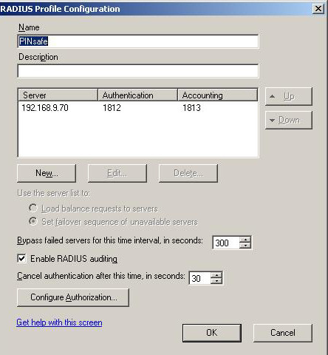

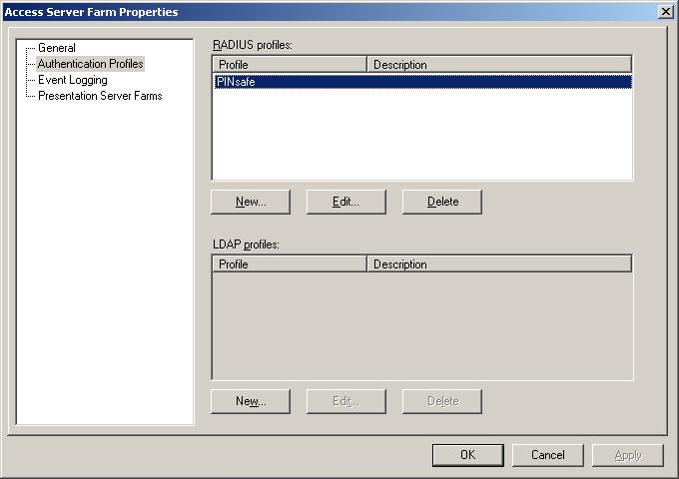

Modify the logon page
Skip this step if Single Channel authentication is not required
Locate the Logon page and then edit the Login.ascx
Example C:\Inetpub\wwwroot\CitrixLogonPoint\External
The following line needs to be edited to be the IP address of the PINsafe server, and if required to use https (normally on port 8443)

var sUrl="http://192.168.9.70:8080/pinsafe314/SCImage?username=";

The position of the displayed Turing button and Security String can also be modified by editing the following lines:

document.write("<input type=button name=btnTuring value=Turing onclick=ShowTuring() class='submitbutton' styleHIDDEN='visibility:hidden; position: absolute; left:250;top:302;width:75;'>");

document.write("<img id=imgTuring name=imgTuring style='visibility:hidden;position: absolute; left:100;top:350;'>");

where the values of left and top can be altered.

Configure the logon page to use PINsafe
Right click on the selected Logon Point and select Edit logon point.Select Authentication and ensure that the Active Directory Radio button is selected. Under Advanced Authentication select the RADIUS profile radio button and from the drop down menu select the PINsafe RADIUS server.
Under Authorization ensure that Group Authorization is set to Active Directory. Ensure that 'Authentication and group authority use the same password' is not selected.
Under Session Settings ensure that users have access to the Active Directory domain where their usernames and passwords are held, and this should be the same domain that PINsafe is using to read its usernames.
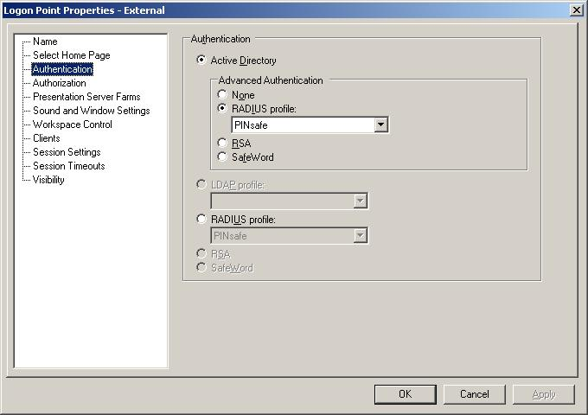

Configure RADIUS server authentication
This is configured from the Citrix Access Gateway Server Configuration. Select the Configured Logon Points and then click on the Logon Point required for PINsafe access, then click on the Authentication Credentials. RADIUS authentication can be configured by using either a Global secret or server specific secret, this needs to be the same as the shared secret on the PINsafe server. When complete select deploy to update the Citrix Access Gateway.

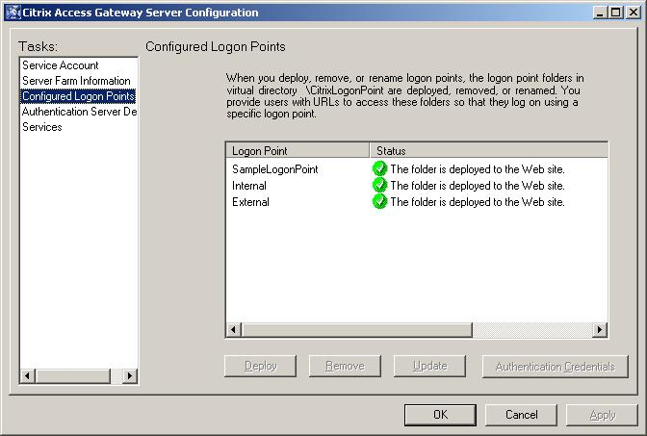
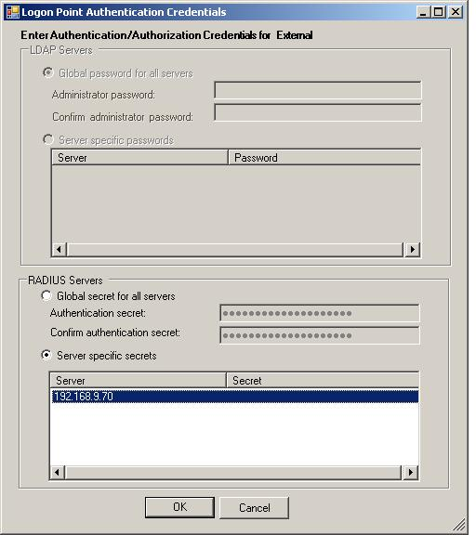

Testing
In a web browser load the logon page. The Single and Dual Channel should both function as required. For Dual channel enter the User Name, AD password, and the One Time Code in the RADIUS password field.

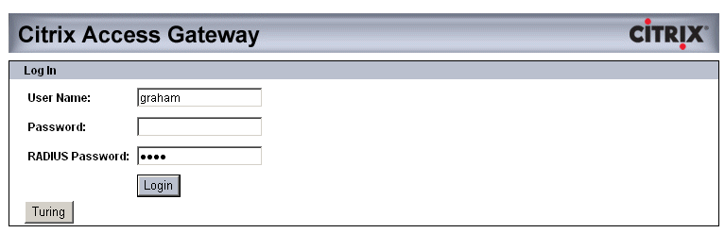

For Single Channel enter the User Name, AD password, then click on the Turing button to generate a single channel login image. Carry out a PIN extraction and enter the One Time Code in the RADIUS password field.
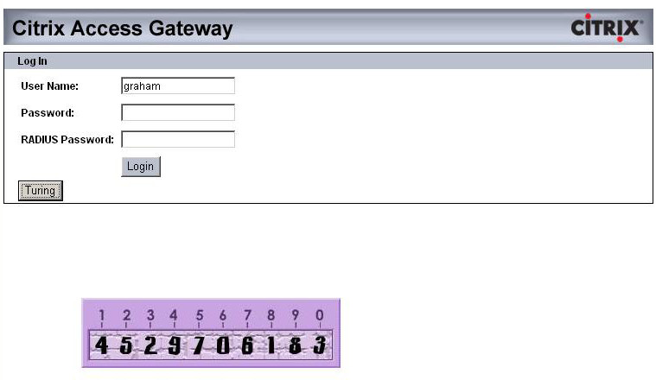

Troubleshooting
Check the PINsafe server logs and system event logs for any errors or lack of communication.

Additional Information
For assistance in the PINsafe installation and configuration please contact your reseller or email Swivel Secure support at support@swivelsecure.com

