Mycelium Contract  Supply of Goods and/or Services |  |  | 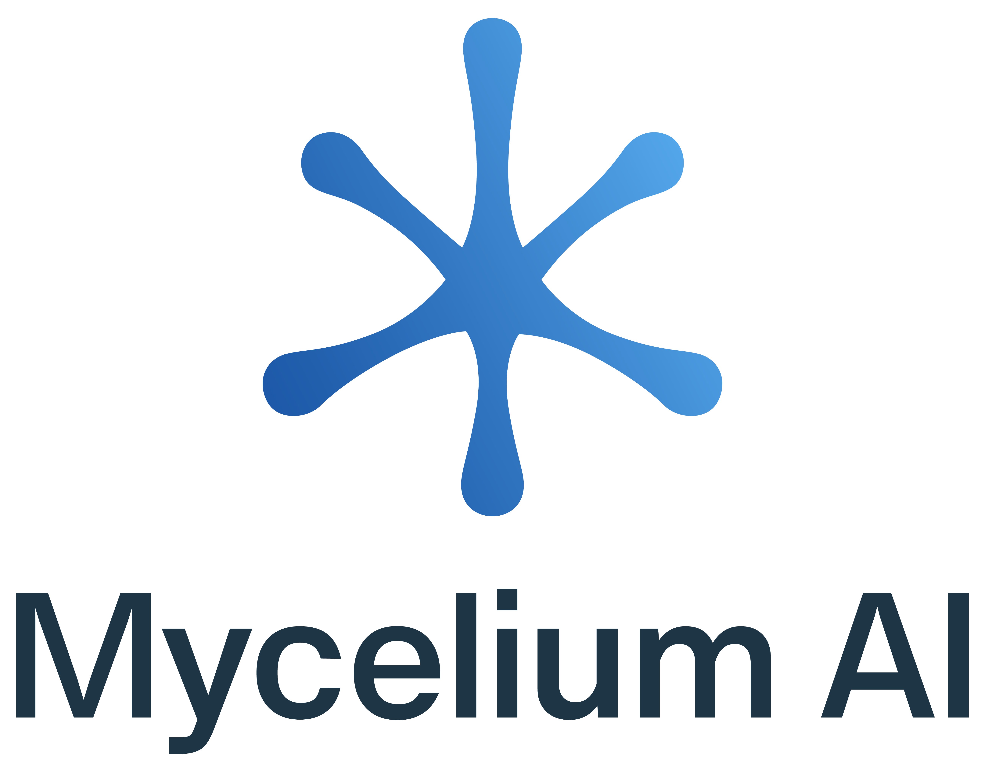
Contract Details
Contract Number | CW-01
Summary of Goods and Services | Development of a Power BI retention analytics dashboard ("the Dashboard") for Client's Pilates studio business, integrating with Momence CRM to provide actionable member retention insights, churn prediction, and engagement analytics.
Mycelium | Mycelium | MYCELIUM AI  Located at 15 Nelligan St, Dianella, Western Australia 6059.
 | ABN: | 30 520 399 153
 | ACN: | 520 399 153
 | Address for Notices: | 15 Nelligan St, Dianella, Western Australia 6059.
 | Representative name: | Aaron Parton
 | Representative title: | Founder & Automation Consultant
 | Email address: | aaron.parton@myceliumai.com.au
 | Telephone number: | 0498201788
Supplier | Supplier: | FORM SOCIETY PTY LTD  Located at Unit 8, 23-27 Scarborough Beach Rd, Scarborough WA 6019
 | ABN: | 89 681 925 860
 | ACN: | 681 925 860
 | Address for Notices: | Unit 8, 23-27 Scarborough Beach Rd, Scarborough WA 6019
 | Representative name: | Chloe Mackenzie
 | Representative title: | Director
 | Email address: | hello@formsociety.com.au
 | Telephone number: | 0408 909 330
Contract Start Date | 26/01/2026
Contract Finish Date | 01/12/2026

Execution Page

Acceptance by Supplier
Executed for Supplier by its authorized representative:
On behalf of FORM SOCIETY PTY LTD:

Signature | \sign1\ |  | Date | \signeddate1\
Print name | \fullname1\ |  | Position | \title1\

Acceptance by Mycelium

Executed for Mycelium by its authorized representative(s):

On behalf of Mycelium AI:

Signature | \sign2\ |  | Date | \signeddate2\
Print name | \fullname2\ |  | Position | \title2\

General Terms & Conditions of Supply

- Definitions
  - “Mycelium”, “we”, “us”, “our” means MYCELIUM AI (ABN 30520399153).
  - “Client”, “you”, “your” means the person or entity receiving the Services.
  - “Services” means AI and automation consulting, systems design, integration, testing, documentation, training, support, and related professional services described in a Proposal, SOW or Order Form.
  - “Deliverables” means outputs produced specifically for you under a Proposal/SOW (e.g., workflows, configurations, code, documentation).
  - “Client Materials” means data, content, credentials, systems, and other materials you provide or grant access to.
  - “Tools & Pre-Existing IP” means our pre-existing or general tools, prompts, templates, libraries, scripts, connectors, models, processes, know-how and improvements.
  - “Third-Party Services” means external platforms/vendors used or integrated (e.g., n8n, Google/Microsoft, CRMs, LLM providers, public clouds, payment gateways, schedulers).
  - “Confidential Information” means non-public business, technical and security information disclosed by either party.
- Agreement Structure, Term & Precedence
  - This MSA governs all Services and Deliverables. The parties may enter one or more SOWs/Order Forms and Change Orders under this MSA.
  - This Agreement includes Schedule 1 (Service Level Agreement and Project/SOW Details) and Schedule 2 (Data Processing Addendum).
  - Contract Term: Unless otherwise specified in the SOW, the term for a project starts on the Effective Date (or SOW start date) and ends upon the earlier of (a) acceptance of all Deliverables plus completion of any post-acceptance warranty window; or (b) termination under clause 19. Managed/retainer services continue month‑to‑month until ended under clause 19.
  - Precedence (highest to lowest): (a) signed Change Order; (b) applicable SOW/Order Form; (c) this MSA; (d) Schedule 1 (SLA & SOW details); (e) Schedule 2 (DPA, for personal information processing).
  - If a purchase order or vendor terms conflict with this Agreement, this Agreement prevails unless expressly agreed in writing

- Services & Statements of Work
  - We will deliver the Services with due skill and care and in accordance with applicable laws.
  - Each SOW states scope, assumptions, responsibilities, milestones, acceptance, pricing, billing, data locations (if any), security requirements, and support.
  - Each party will appoint a primary contact authorized to give and receive instructions.
  - Out‑of‑scope work requires a written Change Order before we proceed.

- Client Responsibilities
  - Provide timely access to Client Materials, systems, subject‑matter experts, environments, approvals and safe facilities (for on‑site work).
  - Ensure Client Materials are accurate, complete and lawfully collected/used with all required consents and notices (including for your end‑users).
  - Maintain upstream systems and licenses (identity/SSO, CRM, email, payment, firewalls).
  - Follow reasonable security requirements we specify (e.g., MFA, dedicated service accounts, credential rotation).
  - You are responsible for acts and omissions of your personnel and third‑party providers.

- Credentials & Security
  - Exchange credentials only via secure channels we approve; do not send passwords or API keys via plain email or unsecured chat.
  - Use least‑privilege, role‑based access. Secrets must be vaulted; tickets/logs must not contain raw secrets.
  - On request or termination, we will return or delete credentials within a reasonable period, subject to legal/backup retention.

- Third‑Party Services & AI Systems
  - The Services may rely on Third‑Party Services; you authorize us to configure and interact with them as needed to deliver the Services.
  - We are not responsible for availability or performance of Third‑Party Services and do not provide warranties beyond those providers’ commitments.
  - 6.3 AI outputs can be inaccurate or incomplete. You must review and validate outputs and make final decisions; we do not provide legal, financial, or regulatory advice unless a SOW states otherwise.

- Data Protection & Privacy (summary)
  - Each party will comply with applicable privacy laws (including Australia’s Privacy Act and APPs; and where applicable GDPR/UK GDPR/CCPA equivalents).
  - Roles: we act as controllers for our own business data and as your processor for end‑user personal information handled to deliver the Services, processing only on documented instructions.
  - AI training: by default, we do not permit foundation‑model providers to train their models on your data. We may use anonymized/aggregated data to improve prompts, templates and tools unless you opt out in writing.
  - International transfers may occur; we use reasonable safeguards with reputable vendors.
  - Client acknowledges that, for important reasons related to the provision of Services, Mycelium AI may need to input client data (including sensitive information) into public large language models (LLMs) such as OpenAI and Anthropic. Where possible, Mycelium AI will convert client data into dummy or anonymized data before inputting into public LLMs. However, in cases where anonymization is not feasible or would materially impact the Services, client data may be used as-is. The client expressly consents to such use and acknowledges the associated risks.
  - Suspected breaches will be investigated promptly; required notifications will be made per law and the DPA.
  - Audits & Information: On reasonable notice, Mycelium AI will make available information necessary to demonstrate compliance and allow audits no more than once per 12 months, subject to confidentiality and operational constraints.
  - Client agrees that Mycelium AI may use the client’s business name, logo, project description, and feedback (including paraphrased testimonials and success stories) in marketing materials and case studies, unless the client objects in writing.

- Intellectual Property
  - Tools & Pre‑Existing IP remain our property.
  - Subject to full payment, we assign to you the IP in Deliverables created specifically for you under a SOW, excluding Tools & Pre‑Existing IP and third‑party materials.
  - To the extent our Tools & Pre‑Existing IP are embedded in a Deliverable, we grant you a perpetual, worldwide, royalty‑free license (transferable to your affiliates and end customers who use the Deliverables) to use, modify and reproduce those elements as part of the Deliverables.
  - Open‑source components, if any, are licensed under their respective licences.
  - We may reference your name/logo and non‑confidential project descriptions for portfolio use unless you reasonably object in writing.

- Acceptance & Warranty
  - Acceptance testing criteria/periods will be stated in the SOW. Deliverables are deemed accepted on written acceptance, production use, or expiry of the acceptance period without a written rejection.
  - We warrant that Services will be performed with due skill and care; non‑conformities reported within the stated warranty period (or 30 days if none is stated) will be remedied at no additional charge.
  - Except as set out in this Agreement/SOW, all other warranties are excluded to the fullest extent permitted by law.

- Support, Maintenance & Availability
  - Support/maintenance scope and targets are defined in Schedule 1 (SLA) and/or the applicable SOW.
  - Managed hosting (if any) is governed by the SLA, including availability targets and service credits.
  - For Client‑hosted environments, only response/resolution targets apply; no uptime commitment.

- Change Orders
  - Any change to scope, assumptions, timelines or fees must be documented in a Change Order (email confirmation acceptable) before work proceeds.
  - A Change Order may adjust milestones, acceptance, fees, or resource allocations.

- Confidentiality
  - Each party must protect the other’s Confidential Information with at least reasonable care and use it only for the Services.
  - Confidential Information may be disclosed to need‑to‑know personnel, contractors, advisors, and vendors bound by confidentiality obligations, or as required by law (with notice where lawful).

- Non‑Solicitation & Non‑Circumvention
  - During the term and for 9 months after, neither party will solicit employment or contract any personnel of the other party with whom it had direct contact, except via bona fide public job ads.
  - During the term and for 12 months after, you will not bypass us to directly engage contractors we introduced for substantially similar services without our written consent; a reasonable buy‑out/referral fee may apply if consent is given.

- Compliance & Ethics
  - Each party will comply with applicable laws, including privacy, spam/marketing, consumer, modern slavery, anti‑bribery/anti‑corruption, sanctions/export controls, and WHS for any on‑site work.
  - You warrant that Client Materials and instructions will not cause us to violate law or third‑party rights.
  - You will not instruct us to deploy AI configurations that intentionally violate law or platform policies.

- Insurance
  - Mycelium AI will use reasonable efforts to obtain and maintain Professional Indemnity and Public Liability insurance appropriate for the services provided. Until such insurance is obtained, Mycelium AI’s aggregate liability under this Agreement will not exceed the total fees paid by the Client for the relevant Statement of Work, except to the extent required by law. Evidence of insurance coverage will be provided upon written request once obtained.

- Records, Audits & Reporting
  - We will maintain records reasonably necessary to substantiate invoices and compliance with security obligations; such records may be reviewed on reasonable notice up to once per 12 months during business hours, subject to confidentiality.
  - Security audits by you or your third party require reasonable notice, scope agreement, and must not unduly disrupt operations; you bear your own audit costs.

- Subcontractors & Personnel
  - We may use subcontractors; we remain responsible for their performance and will bind them to confidentiality and data‑processing obligations no less protective than this Agreement.
  - Access is restricted to need‑to‑know personnel; background checks may be applied where appropriate.

- Term, Termination & Suspension
  - This Agreement continues until terminated. Either party may terminate for material breach not cured within 14 days of written notice, or immediately if the other becomes insolvent. A SOW may also permit termination for convenience.
  - We may suspend Services for non‑payment, security risk, or legal requirement upon notice and will reinstate upon cure.
  - On termination/expiry of a SOW, you will pay for Services performed and approved expenses up to the effective date; we will deliver work‑in‑progress and assist with a reasonable handover on time‑and‑materials; each party will return or delete the other’s Confidential Information subject to legal/backup retention.
  - If requested within 30 days, we will provide reasonable transition assistance at SOW rates.

- Liability
  - To the maximum extent permitted by law, neither party is liable for indirect, special, incidental, consequential, punitive or exemplary damages, or loss of profit, revenue, goodwill, or data.
  - Aggregate liability of each party under this Agreement and any SOW will not exceed the greater of: (a) the fees paid or payable under the relevant SOW for the 6 months preceding the event; or (b) AUD $25,000.
  - The above limitations do not apply to death/personal injury caused by negligence, fraud, willful misconduct, breach of confidentiality, IP infringement by a party’s Deliverables/Tools (excluding Client Materials and Client‑mandated components), or amounts recoverable under an indemnity in clause 21.

- Indemnities
  - You indemnify us for third‑party claims, costs and losses arising from your breach; allegations that Client Materials or your instructions infringe IP or violate law; failure to obtain lawful consents/notices for end‑user data; and misuse or reliance on AI outputs without required review.
  - We indemnify you for third‑party claims that Deliverables created by us (excluding Client Materials, open‑source, or Client‑mandated components) infringe Australian IP rights, subject to prompt notice, our control of the defense, and your cooperation. We may modify/replace the Deliverables to avoid infringement or, if not commercially reasonable, refund fees paid for the affected Deliverable as your sole remedy.

- Price
  - The Price for Services is set out in Schedule 2 and is fixed unless otherwise agreed in writing. Any additional expenses or pass-through costs (e.g., cloud, SaaS, LLM usage) must be pre-approved in writing and will be charged at cost.

- Payment
  - Invoices are payable within 14 days of issue unless otherwise specified in the Statement of Work. Late payments may incur interest at the maximum lawful rate. Work may be suspended for non-payment after written notice. All invoices must be correctly rendered and specify the services provided, the amount due, and any applicable taxes.

- Force Majeure
  - Neither party is liable for delay or failure due to events beyond reasonable control (including outages by Third‑Party Services), provided the affected party uses reasonable efforts to mitigate.

- Notices
  - Formal notices must be in writing and sent by email to the addresses last notified by the parties’ contract contacts and are deemed received upon transmission unless a bounce‑back is received.

- Governing Law & Dispute Resolution
  - This Agreement is governed by the laws of Western Australia, and the parties submit to its courts.
  - Escalation: project leads → senior executives. If unresolved within 20 days, either party may refer the dispute to mediation in Western Australia. Nothing prevents urgent injunctive relief.

- General
  - Entire Agreement: this MSA (with Schedules) and each SOW constitute the entire agreement.
  - Assignment: neither party may assign without the other’s consent, except to a successor in interest upon notice.
  - Survival: clauses relating to IP, confidentiality, privacy, fees, liability, indemnities and dispute resolution survive termination.
  - Waiver: failure to enforce is not a waiver.
  - Severability: invalid terms are severed; the remainder continue.
  - Counterparts and e‑signatures are valid.

Schedule 1
Scope of Goods & Services

Section | Details
Scope of Goods | Not Applicable
Scope of Work | Development of a Power BI retention analytics dashboard ("the Dashboard") for Client's Pilates studio business, integrating with Momence CRM to provide actionable member retention insights, churn prediction, and engagement analytics.
In-Scope | - Executive Overview page with KPIs and churn insights  - Member engagement tier classification with smart upsells recommendations  - Personalized text scripts for member outreach  - Risk scoring and at-risk member identification  - Automated daily refresh via Power BI Service  - Secure credential management  - 12 months of historical analytics  - Month-over-month trend tracking
Out-of-Scope  (Additional fees apply) | The following work is not included in monthly maintenance and will be quoted separately:  Major Enhancements (quoted at $40/hour):  - New dashboard pages (e.g., additional reports or views)  - Complex new calculations or KPIs (>1 hour development time)  - Integration with additional data sources beyond Momence  - Custom drill-through pages or advanced interactivity  - Training sessions for additional users  - Exporting or scheduling features  Process:  - Client requests enhancement via email  - Developer provides time estimate and quote within 2 business days  - Client approves quote before work begins  - Billed separately from monthly maintenance/enhancement fee
Monthly Maintenance Services  (fixed monthly flat free - $50) | - Bug Fixes & Error Resolution:  - Fixing broken measures or visuals  - Resolving data refresh failures (not caused by Client's credentials/API access)  - Correcting calculation errors or unexpected behaviour  - CRM Compatibility Updates:  - Adapting queries if Momence API changes endpoints or data structures  - Fixing issues caused by Momence software updates  - Updating authentication if Momence changes OAuth requirements  - Minor Enhancements (estimated ≤2 hours/month):  - Adding one (1) new visual per month (e.g., chart, card, table)  - Cosmetic/aesthetic improvements (colours, fonts, layout tweaks)  - Minor text changes or formatting updates  - Filter or slicer additions  - Support & Monitoring:  - Email support for dashboard usage questions (48-hour response time)  - Monthly performance check-in (5-10 minutes)  Upon termination, monthly maintenance will be the sole responsibility of the client.
Dependencies & Client Inputs | To ensure successful delivery and ongoing enhancements, the Client agrees to provide:  - Access to Data Sources (Login credentials or API access for booking system, payment platform, and any CRM used. Permission to connect these systems to Power BI)  - Basic Business Information (Class schedule and instructor list. Pricing structure and membership types. Monthly revenue targets or KPIs)  - Branding Assets (Logo, color palette, and any preferred fonts for dashboard styling)  - Timely Feedback & Approvals (Respond to enhancement options within 3 business days. Approve visuals and KPIs promptly to avoid delays)  - Point of Contact (One primary contact for decisions and clarifications)  - Hardware & Software (A device with Power BI installed (or access to Power BI Service). Internet connection for dashboard refreshes)  - Change Notifications (Inform us of any changes to booking systems, payment platforms, or data sources at least 5 business days in advance)
Support Tier | ☐ Tier 2 – Extended (8:00–20:00, Mon–Fri).
Hosting Option | ☐ Client-Hosted (Mycelium Managed)

Schedule 2
Price of Goods & Services

Item | Amount / Details
Job Type | ☐ Build + Maintain + Enhance — Fixed Fee (100% Upon delivery) then Monthly Retainer. Enhancements will include future improvements (additional costs) to be negotiated.
Fixed Price | Upon Delivery AUD $700 excl GST
Retainer  (Covers monthly maintenance services) | AUD $50/ month.  - start: 01/02/2026  - end: 01/08/2026  Agreement continues month-to-month after initial 6 months unless terminated with 30 days’ notice
Usage/Pass-Through Caps | Not Applicable
Payment Terms Reminder | Invoices are due within 14 days; deposits/milestones as below; payment per clause 23.
Milestones | Not Applicable
Acceptance Criteria & Period | Acceptance Criteria:  The delivered dashboard will be deemed accepted if it meets all of the following:  - Core Features Delivered: Agreed features are present and functional.  - Data Loads Successfully: Dashboard refreshes data from Momence API without errors.  - No Critical Errors: No critical bugs or calculation errors are present in the main KPIs and visuals.  - Client Access: Client can log in and view all dashboard pages as described.  - Initial Training Provided: Developer has provided a brief walkthrough or written instructions for dashboard use.  Acceptance Process:  - Client will have 5 business days from delivery to review and report any material issues in writing.  - If no material issues are reported within this period, the dashboard is deemed accepted.  - Minor cosmetics or text changes requested during the review period will be addressed as part of the initial handover.
Communications & Updates | Client Response:  - Urgent – within 12 hrs.  - High Priority – within 24 hrs.  - General – within 48 hrs.  Supplier Response:  Status update at least weekly.  - Tier 1 – within 3 business days.  - Tier 2 & 3 – within 2 business days.

