**Movie Rental Database**

Introduction:

The Movie Rental Database serves as a robust and structured information management system designed to facilitate the operations of a movie rental service. This database is meticulously crafted to organize and store essential details related to movies, customer information, rental transactions, user accounts, and payment records. With an aim to streamline the processes of a movie rental business, the database provides a comprehensive framework that ensures data integrity, efficient retrieval, and scalability.

ER Diagram

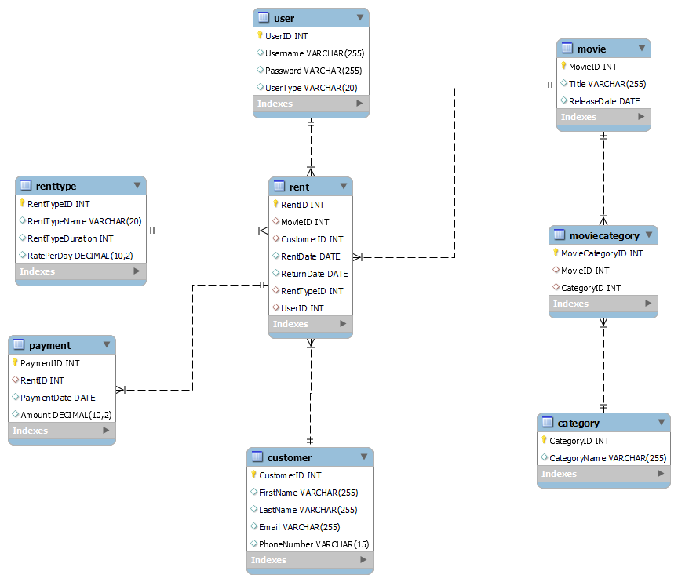

**Table Structures**

**Movie Table:**

|  |  |  |
| --- | --- | --- |
| **MovieID** | **Title (VARCHAR)** | **ReleaseDate (DATE)** |
| INT (PK) | Not Null | Not Null |

**Category Table:**

|  |  |
| --- | --- |
| **CategoryID** | **CategoryName (VARCHAR)** |
| INT (PK) | Not Null |

**MovieCategory Table:**

|  |  |  |
| --- | --- | --- |
| **MovieCategoryID** | **MovieID (FK)** | **CategoryID (FK)** |
| INT (PK) | INT (FK) | INT (FK) |

**Customer Table:**

|  |  |  |  |  |
| --- | --- | --- | --- | --- |
| **CustomerID** | **FirstName (VARCHAR)** | **LastName (VARCHAR)** | **Email (VARCHAR)** | **PhoneNumber (VARCHAR)** |
| INT (PK) | Not Null | Not Null | Not Null | Not Null |

**User Table:**

|  |  |  |  |
| --- | --- | --- | --- |
| **UserID** | **Username (VARCHAR)** | **Password (VARCHAR)** | **UserType (VARCHAR)** |
| INT (PK) | Not Null | Not Null | Not Null |

**RentType Table:**

|  |  |  |  |
| --- | --- | --- | --- |
| **RentTypeID** | **RentTypeName (VARCHAR)** | **RentTypeDuration (INT)** | **RatePerDay (DECIMAL)** |
| INT (PK) | Not Null | Not Null | Not Null |

**Rent Table:**

|  |  |  |  |  |  |  |
| --- | --- | --- | --- | --- | --- | --- |
| **RentID** | **MovieID (FK)** | **CustomerID (FK)** | **UserID (FK)** | **RentDate (DATE)** | **ReturnDate (DATE)** | **RentTypeID (FK)** |
| INT (PK) | INT (FK) | INT (FK) | INT (FK) | Not Null | Not Null | INT (FK) |

**Payment Table:**

|  |  |  |  |
| --- | --- | --- | --- |
| **PaymentID** | **RentID (FK)** | **PaymentDate (DATE)** | **Amount (DECIMAL)** |
| INT (PK) | INT (FK) | Not Null | Not Null |