CS 5610 Project

Aaron Carr & Daniel Reardon

4/8/2022

Cardiovascular disease is the number 1 leading cause of death in the world, accounting for 31% of all deaths (17.9 million people every year.) Four fifths of these deaths are due to sudden episodes of heart attack and stroke, and one third of these occur in patients under 70 years old. As such, constructing a model which can predict these events prior to their occurrence has wide ranging potential benefits in the medical field.

library(boot)  
library(MASS)  
library(e1071)  
library(caTools)  
library(dplyr)

##   
## Attaching package: 'dplyr'

## The following object is masked from 'package:MASS':  
##   
## select

## The following objects are masked from 'package:stats':  
##   
## filter, lag

## The following objects are masked from 'package:base':  
##   
## intersect, setdiff, setequal, union

library(tree)  
library(gbm)

## Loaded gbm 2.1.8

library(ggplot2)  
library(gridExtra)

##   
## Attaching package: 'gridExtra'

## The following object is masked from 'package:dplyr':  
##   
## combine

#library(randomForest)

The dataset which we use was constructed using 5 different datasets from Cleveland, Hungary, Switzerland, Long Beach California, and the Stalog Heart Data from the UCI Machine Learning Repository. It contains 918 different observations of which 11 common features are abstracted. These features are Age, Sex, Type of Chest Pain (Typical Angina, Atypical Angina, Non-Anginal Pain, and Asymptomatic), Resting Blood Pressure, Cholesterol, Fasting Blood Sugar (a binary measurement (1 if > 120 ml.dl, 0 otherwise), Resting Electrocardiogram Results (Normal, Having St-T wave abnormality, or showing at least probable left ventricular hypertrophy), Maximum Heart Rate achieved, Exercise Induced angina (yes or no), Oldpeak (as a numeric value), and ST-Slope (Up, down, or flat), and finally, the absence or presence of Heart Disease. The goal of our models is to predict the value of the Heart Disease variable using the values of the other variables as consistently and accurately as possible.

#Load Dataset  
heart <- read.csv("heart.csv")  
heart_copy = read.csv("heart.csv")  
#View(heart)  
heart <- mutate(heart, typical_angina = as.integer(ChestPainType == "TA")) %>%  
 mutate(atypical_angina = as.integer(ChestPainType == "ATA")) %>%  
 mutate(non_angina_pain = as.integer(ChestPainType == "NAP")) %>%  
 mutate(st_abnorm = as.integer(RestingECG == "ST")) %>%  
 mutate(left_vent_hypertroph = as.integer(RestingECG == "LVH")) %>%  
 mutate(ExerciseAngina = as.integer(ExerciseAngina == "Y")) %>%  
 mutate(stslope_up = as.integer(ST_Slope == "Up")) %>%  
 mutate(stslope_down = as.integer(ST_Slope == "Down")) %>%  
 mutate(male = as.integer(Sex == "M")) %>%  
 select(- c(ChestPainType, RestingECG, ST_Slope, Sex))  
  
summary(heart)

## Age RestingBP Cholesterol FastingBS   
## Min. :28.00 Min. : 0.0 Min. : 0.0 Min. :0.0000   
## 1st Qu.:47.00 1st Qu.:120.0 1st Qu.:173.2 1st Qu.:0.0000   
## Median :54.00 Median :130.0 Median :223.0 Median :0.0000   
## Mean :53.51 Mean :132.4 Mean :198.8 Mean :0.2331   
## 3rd Qu.:60.00 3rd Qu.:140.0 3rd Qu.:267.0 3rd Qu.:0.0000   
## Max. :77.00 Max. :200.0 Max. :603.0 Max. :1.0000   
## MaxHR ExerciseAngina Oldpeak HeartDisease   
## Min. : 60.0 Min. :0.0000 Min. :-2.6000 Min. :0.0000   
## 1st Qu.:120.0 1st Qu.:0.0000 1st Qu.: 0.0000 1st Qu.:0.0000   
## Median :138.0 Median :0.0000 Median : 0.6000 Median :1.0000   
## Mean :136.8 Mean :0.4041 Mean : 0.8874 Mean :0.5534   
## 3rd Qu.:156.0 3rd Qu.:1.0000 3rd Qu.: 1.5000 3rd Qu.:1.0000   
## Max. :202.0 Max. :1.0000 Max. : 6.2000 Max. :1.0000   
## typical_angina atypical_angina non_angina_pain st_abnorm   
## Min. :0.00000 Min. :0.0000 Min. :0.0000 Min. :0.0000   
## 1st Qu.:0.00000 1st Qu.:0.0000 1st Qu.:0.0000 1st Qu.:0.0000   
## Median :0.00000 Median :0.0000 Median :0.0000 Median :0.0000   
## Mean :0.05011 Mean :0.1885 Mean :0.2211 Mean :0.1939   
## 3rd Qu.:0.00000 3rd Qu.:0.0000 3rd Qu.:0.0000 3rd Qu.:0.0000   
## Max. :1.00000 Max. :1.0000 Max. :1.0000 Max. :1.0000   
## left_vent_hypertroph stslope_up stslope_down male   
## Min. :0.0000 Min. :0.0000 Min. :0.00000 Min. :0.0000   
## 1st Qu.:0.0000 1st Qu.:0.0000 1st Qu.:0.00000 1st Qu.:1.0000   
## Median :0.0000 Median :0.0000 Median :0.00000 Median :1.0000   
## Mean :0.2048 Mean :0.4303 Mean :0.06863 Mean :0.7898   
## 3rd Qu.:0.0000 3rd Qu.:1.0000 3rd Qu.:0.00000 3rd Qu.:1.0000   
## Max. :1.0000 Max. :1.0000 Max. :1.00000 Max. :1.0000

#There appear to be some gaps in the data, where Cholesterol and RestingBP are labeled as zero, which is obviously just missing information  
#We decided to construct small linear models to predict their values and replace them   
  
lm.chol_fit <- lm(Cholesterol ~ . - HeartDisease, data = dplyr::filter(heart, Cholesterol != 0))  
lm.bp_fit <- lm(RestingBP ~ . - HeartDisease, data = dplyr::filter(heart, RestingBP != 0))  
  
PredictedCholesterol <- predict(lm.chol_fit, dplyr::filter(heart, Cholesterol == 0))  
PredictedBP <- predict(lm.bp_fit, dplyr::filter(heart, RestingBP == 0))  
  
heart <- mutate(heart, Cholesterol = replace(Cholesterol, Cholesterol == 0, PredictedCholesterol))  
heart <- mutate(heart, RestingBP = replace(RestingBP, RestingBP == 0, PredictedBP))  
  
summary(heart)

## Age RestingBP Cholesterol FastingBS   
## Min. :28.00 Min. : 80.0 Min. : 85.0 Min. :0.0000   
## 1st Qu.:47.00 1st Qu.:120.0 1st Qu.:214.0 1st Qu.:0.0000   
## Median :54.00 Median :130.0 Median :240.1 Median :0.0000   
## Mean :53.51 Mean :132.5 Mean :244.2 Mean :0.2331   
## 3rd Qu.:60.00 3rd Qu.:140.0 3rd Qu.:268.0 3rd Qu.:0.0000   
## Max. :77.00 Max. :200.0 Max. :603.0 Max. :1.0000   
## MaxHR ExerciseAngina Oldpeak HeartDisease   
## Min. : 60.0 Min. :0.0000 Min. :-2.6000 Min. :0.0000   
## 1st Qu.:120.0 1st Qu.:0.0000 1st Qu.: 0.0000 1st Qu.:0.0000   
## Median :138.0 Median :0.0000 Median : 0.6000 Median :1.0000   
## Mean :136.8 Mean :0.4041 Mean : 0.8874 Mean :0.5534   
## 3rd Qu.:156.0 3rd Qu.:1.0000 3rd Qu.: 1.5000 3rd Qu.:1.0000   
## Max. :202.0 Max. :1.0000 Max. : 6.2000 Max. :1.0000   
## typical_angina atypical_angina non_angina_pain st_abnorm   
## Min. :0.00000 Min. :0.0000 Min. :0.0000 Min. :0.0000   
## 1st Qu.:0.00000 1st Qu.:0.0000 1st Qu.:0.0000 1st Qu.:0.0000   
## Median :0.00000 Median :0.0000 Median :0.0000 Median :0.0000   
## Mean :0.05011 Mean :0.1885 Mean :0.2211 Mean :0.1939   
## 3rd Qu.:0.00000 3rd Qu.:0.0000 3rd Qu.:0.0000 3rd Qu.:0.0000   
## Max. :1.00000 Max. :1.0000 Max. :1.0000 Max. :1.0000   
## left_vent_hypertroph stslope_up stslope_down male   
## Min. :0.0000 Min. :0.0000 Min. :0.00000 Min. :0.0000   
## 1st Qu.:0.0000 1st Qu.:0.0000 1st Qu.:0.00000 1st Qu.:1.0000   
## Median :0.0000 Median :0.0000 Median :0.00000 Median :1.0000   
## Mean :0.2048 Mean :0.4303 Mean :0.06863 Mean :0.7898   
## 3rd Qu.:0.0000 3rd Qu.:1.0000 3rd Qu.:0.00000 3rd Qu.:1.0000   
## Max. :1.0000 Max. :1.0000 Max. :1.00000 Max. :1.0000

#Give it a look over  
#View(heart)  
names(heart)

## [1] "Age" "RestingBP" "Cholesterol"   
## [4] "FastingBS" "MaxHR" "ExerciseAngina"   
## [7] "Oldpeak" "HeartDisease" "typical_angina"   
## [10] "atypical_angina" "non_angina_pain" "st_abnorm"   
## [13] "left_vent_hypertroph" "stslope_up" "stslope_down"   
## [16] "male"

dim(heart)

## [1] 918 16

summary(heart)

## Age RestingBP Cholesterol FastingBS   
## Min. :28.00 Min. : 80.0 Min. : 85.0 Min. :0.0000   
## 1st Qu.:47.00 1st Qu.:120.0 1st Qu.:214.0 1st Qu.:0.0000   
## Median :54.00 Median :130.0 Median :240.1 Median :0.0000   
## Mean :53.51 Mean :132.5 Mean :244.2 Mean :0.2331   
## 3rd Qu.:60.00 3rd Qu.:140.0 3rd Qu.:268.0 3rd Qu.:0.0000   
## Max. :77.00 Max. :200.0 Max. :603.0 Max. :1.0000   
## MaxHR ExerciseAngina Oldpeak HeartDisease   
## Min. : 60.0 Min. :0.0000 Min. :-2.6000 Min. :0.0000   
## 1st Qu.:120.0 1st Qu.:0.0000 1st Qu.: 0.0000 1st Qu.:0.0000   
## Median :138.0 Median :0.0000 Median : 0.6000 Median :1.0000   
## Mean :136.8 Mean :0.4041 Mean : 0.8874 Mean :0.5534   
## 3rd Qu.:156.0 3rd Qu.:1.0000 3rd Qu.: 1.5000 3rd Qu.:1.0000   
## Max. :202.0 Max. :1.0000 Max. : 6.2000 Max. :1.0000   
## typical_angina atypical_angina non_angina_pain st_abnorm   
## Min. :0.00000 Min. :0.0000 Min. :0.0000 Min. :0.0000   
## 1st Qu.:0.00000 1st Qu.:0.0000 1st Qu.:0.0000 1st Qu.:0.0000   
## Median :0.00000 Median :0.0000 Median :0.0000 Median :0.0000   
## Mean :0.05011 Mean :0.1885 Mean :0.2211 Mean :0.1939   
## 3rd Qu.:0.00000 3rd Qu.:0.0000 3rd Qu.:0.0000 3rd Qu.:0.0000   
## Max. :1.00000 Max. :1.0000 Max. :1.0000 Max. :1.0000   
## left_vent_hypertroph stslope_up stslope_down male   
## Min. :0.0000 Min. :0.0000 Min. :0.00000 Min. :0.0000   
## 1st Qu.:0.0000 1st Qu.:0.0000 1st Qu.:0.00000 1st Qu.:1.0000   
## Median :0.0000 Median :0.0000 Median :0.00000 Median :1.0000   
## Mean :0.2048 Mean :0.4303 Mean :0.06863 Mean :0.7898   
## 3rd Qu.:0.0000 3rd Qu.:1.0000 3rd Qu.:0.00000 3rd Qu.:1.0000   
## Max. :1.0000 Max. :1.0000 Max. :1.00000 Max. :1.0000

#Check to see if there's any missing values  
any(is.na(heart))

## [1] FALSE

set.seed(97)  
spl = sample.split(heart$HeartDisease, SplitRatio = 0.75)  
  
heartTrain = subset(heart, spl==TRUE)  
heartTest = subset(heart, spl==FALSE)  
  
dim(heartTrain)

## [1] 689 16

dim(heartTest)

## [1] 229 16

Our first task involves wrangling the dataset so that it optimal for use by the models. Glancing over the dataset, it is clear that the some of the variables are categorical and consist of three or more categories; in situations such as these, it is vital to split these categories into binary categories. For the sake of clarity, this is explicitly performed by the dplyr pipeline above and not left to the models themselves. The chest pain type, resting ECG type, exercised induced angina and patient sex have all been reformatted such that the baseline patient is a female with no resting chest pain, a standard ECG, and no exercised induced chest pain.  
Next, when looking over a summary of the original dataset, it becomes apparent that while there are technically no missing values, some Cholesterol values (and a single Resting Blood Pressure value) are listed as 0, which is clearly erroneous. In order to best address this without skewing the data or removing a large chunk of training data, toy linear regression models were constructed to predict the appropriate values for these variables. In situations where the data appeared to be erroneous, the erroneous value was replaced with the predicted value.

#Heart Disease by sex  
one = ggplot(data = heart_copy) +  
 geom_col(mapping = aes(x = Sex, y = HeartDisease, fill = Sex)) + labs(y = "Heart Disease")  
zero = ggplot(data = heart_copy) +  
 geom_col(mapping = aes(x = Sex, y = 1 - HeartDisease, fill = Sex)) + labs(y = "Non-Heart Disease")  
  
grid.arrange(one,zero, ncol= 2)

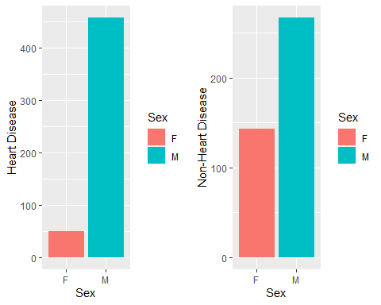

This dataset seems to suggest that Heart Disease is more common among men than women.

#Heart disease by chest pain type  
two = ggplot(data = heart_copy) +  
 geom_col(mapping = aes(x = ChestPainType, y = HeartDisease, fill = ChestPainType)) + labs(y = "Heart Disease")  
three = ggplot(data = heart_copy) +  
 geom_col(mapping = aes(x = ChestPainType, y = 1 - HeartDisease, fill = ChestPainType)) + labs(y = "Non-Heart Disease")  
  
grid.arrange(two,three, ncol= 2)

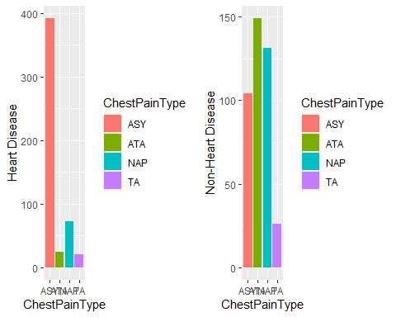

Asymptomatic individuals seem to dominate the heart disease group. There is a condition known as silent ischemia which restricts blood flow to the heart while the person feels no pain.

#Heart disease by age and cholesterol  
ggplot(data = heart) +  
 geom_point(mapping = aes(y = Cholesterol, x = Age, color = factor(HeartDisease, labels = c("No","Yes")))) +  
 scale_color_brewer(palette = "Set1") +  
 labs(color = "Heart Disease")

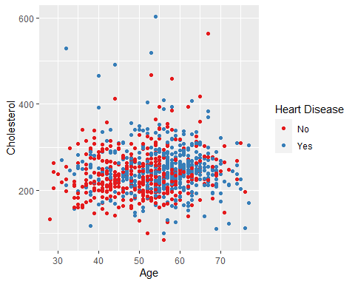

It is difficult to establish a relationship of age, cholesterol, and heart disease based on this scatterplot. It does appear that there that heart disease risk increases with age.

#Heart disease by Resting ECG  
four = ggplot(data = heart_copy) +  
 geom_col(mapping = aes(x = RestingECG, y = HeartDisease, fill = RestingECG)) + labs(y = "Heart Disease")  
five = ggplot(data = heart_copy) +  
 geom_col(mapping = aes(x = RestingECG, y = 1 - HeartDisease, fill = RestingECG)) + labs(y = "Non-Heart Disease")  
  
grid.arrange(four,five, ncol= 2)

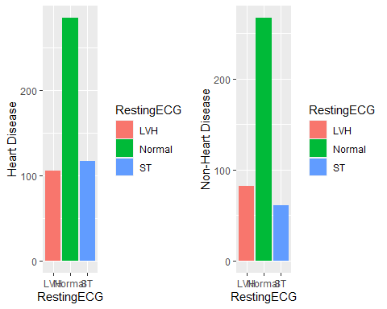

RestingECG seems to have no affect on heart disease risk.

#Heart Disease by ST_slope  
six = ggplot(data = heart_copy) +  
 geom_col(mapping = aes(x = ST_Slope, y = HeartDisease, fill = ST_Slope)) + labs(y = "Heart Disease")  
seven = ggplot(data = heart_copy) +  
 geom_col(mapping = aes(x = ST_Slope, y = 1 - HeartDisease, fill = ST_Slope)) + labs(y = "Non-Heart Disease")  
  
grid.arrange(six,seven, ncol= 2)

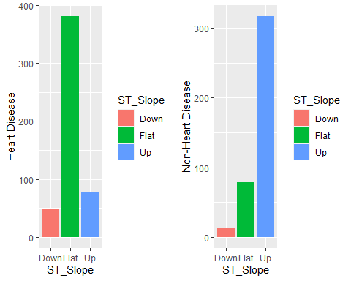

A flat ST_slope seems to be a risk factor for heart disease.

eight = ggplot(data = heart_copy) +  
 geom_col(mapping = aes(x = ExerciseAngina, y = HeartDisease, fill = ExerciseAngina)) + labs(y = "Heart Disease")  
nine = ggplot(data = heart_copy) +  
 geom_col(mapping = aes(x = ExerciseAngina, y = 1 - HeartDisease, fill = ExerciseAngina)) + labs(y = "Non-Heart Disease")  
  
grid.arrange(eight,nine, ncol= 2)

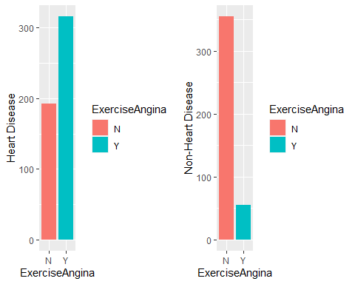

The presence of exercise angina appears to be an indicator of heart disease.

#Logistic Regression (87%)  
glm.fits <- glm(HeartDisease ~ .,  
 family = binomial, data = heartTrain  
)  
summary(glm.fits)

##   
## Call:  
## glm(formula = HeartDisease ~ ., family = binomial, data = heartTrain)  
##   
## Deviance Residuals:   
## Min 1Q Median 3Q Max   
## -2.8350 -0.4045 0.1933 0.5045 2.5901   
##   
## Coefficients:  
## Estimate Std. Error z value Pr(>|z|)   
## (Intercept) -0.788478 1.611022 -0.489 0.624539   
## Age 0.011393 0.014997 0.760 0.447443   
## RestingBP 0.004111 0.007047 0.583 0.559639   
## Cholesterol 0.002555 0.002384 1.071 0.283995   
## FastingBS 1.065646 0.302524 3.523 0.000427 ***  
## MaxHR -0.008234 0.005573 -1.477 0.139546   
## ExerciseAngina 0.938880 0.274380 3.422 0.000622 ***  
## Oldpeak 0.357433 0.130584 2.737 0.006197 **   
## typical_angina -1.192704 0.461671 -2.583 0.009782 **   
## atypical_angina -1.824644 0.365610 -4.991 6.02e-07 ***  
## non_angina_pain -1.611619 0.297733 -5.413 6.20e-08 ***  
## st_abnorm 0.267192 0.334449 0.799 0.424346   
## left_vent_hypertroph 0.221632 0.305032 0.727 0.467479   
## stslope_up -2.302289 0.273953 -8.404 < 2e-16 ***  
## stslope_down -1.346388 0.498025 -2.703 0.006862 **   
## male 1.654871 0.340736 4.857 1.19e-06 ***  
## ---  
## Signif. codes: 0 '***' 0.001 '**' 0.01 '*' 0.05 '.' 0.1 ' ' 1  
##   
## (Dispersion parameter for binomial family taken to be 1)  
##   
## Null deviance: 947.41 on 688 degrees of freedom  
## Residual deviance: 463.91 on 673 degrees of freedom  
## AIC: 495.91  
##   
## Number of Fisher Scoring iterations: 5

glm.probs <- predict(glm.fits, type = "response")  
glm.pred <- rep(0, 689)  
glm.pred[glm.probs > .5] = 1  
  
table(glm.pred, heartTrain$HeartDisease)

##   
## glm.pred 0 1  
## 0 253 42  
## 1 55 339

mean(glm.pred == heartTrain$HeartDisease)

## [1] 0.8592163

glm.probs <- predict(glm.fits, type = "response", newdata = heartTest)  
glm.predTest <- rep(0, 229)  
glm.predTest[glm.probs > .5] = 1  
  
table(glm.predTest, heartTest$HeartDisease)

##   
## glm.predTest 0 1  
## 0 86 13  
## 1 16 114

mean(glm.predTest == heartTest$HeartDisease)

## [1] 0.8733624

##Feature Selection algorithm  
i <- glm(HeartDisease ~ 1,  
 family = binomial, data = heartTrain)  
  
glm.new <- step(i, direction='both', scope=formula(glm.fits), trace=0)  
  
summary(glm.new)

##   
## Call:  
## glm(formula = HeartDisease ~ stslope_up + ExerciseAngina + male +   
## non_angina_pain + atypical_angina + FastingBS + typical_angina +   
## Oldpeak + stslope_down + MaxHR, family = binomial, data = heartTrain)  
##   
## Deviance Residuals:   
## Min 1Q Median 3Q Max   
## -2.8268 -0.4138 0.1946 0.5056 2.7572   
##   
## Coefficients:  
## Estimate Std. Error z value Pr(>|z|)   
## (Intercept) 1.376374 0.797648 1.726 0.084430 .   
## stslope_up -2.316734 0.270974 -8.550 < 2e-16 ***  
## ExerciseAngina 0.988086 0.270632 3.651 0.000261 ***  
## male 1.557620 0.332344 4.687 2.78e-06 ***  
## non_angina_pain -1.620591 0.293086 -5.529 3.21e-08 ***  
## atypical_angina -1.824558 0.362917 -5.027 4.97e-07 ***  
## FastingBS 1.130285 0.294911 3.833 0.000127 ***  
## typical_angina -1.152981 0.450237 -2.561 0.010442 *   
## Oldpeak 0.393905 0.127162 3.098 0.001950 **   
## stslope_down -1.406604 0.493726 -2.849 0.004386 **   
## MaxHR -0.010062 0.005077 -1.982 0.047503 *   
## ---  
## Signif. codes: 0 '***' 0.001 '**' 0.01 '*' 0.05 '.' 0.1 ' ' 1  
##   
## (Dispersion parameter for binomial family taken to be 1)  
##   
## Null deviance: 947.41 on 688 degrees of freedom  
## Residual deviance: 467.97 on 678 degrees of freedom  
## AIC: 489.97  
##   
## Number of Fisher Scoring iterations: 5

glm.probs <- predict(glm.new, type = "response", newdata = heartTest)  
glm.predTest <- rep(0, 229)  
glm.predTest[glm.probs > .5] = 1  
  
table(glm.predTest, heartTest$HeartDisease)

##   
## glm.predTest 0 1  
## 0 86 11  
## 1 16 116

mean(glm.predTest == heartTest$HeartDisease)

## [1] 0.8820961

The Logistic function models the probability of the outcome being a “success” (in this case success means that a patient has heart disease). The estimates return the log odds of a success given a value. For example, the estimate for the sex of the patient is 1.642. Meaning that a male has e^1.642 higher odds (or about 5 times higher odds) of having heart disease than a female.

For a continuous variable like cholesterol, the interpretation is similar except it relates to an increase of one unit. For example if a patient has one cholesterol unit higher than another patient, that patient with have an increase in odds of e^0.003597 (or about 1.0036 times higher odds).

The algorithm used to select the features used in the model was the stepwise regression algorithm. The algorithm begins with nothing in the model but the intercept, and adds the most significant variable. It continues this step until there are no more significant variables. However, at each step it also looks to see that no variables have been made insignificant by the addition of new variables. While this method is not foolproof, it does generally give a good idea of what features to include.

The model seems to agree that the variables we identified as significant in the visualization stage should be included in the model. It also agrees with not including RestingECG in the model as that seemed to have no effect when looking at the bar chart.

The feature selected model performs almost identically to the model which includes all features, each having an accuracy score of around 88%. (In fact, on the test data, the feature selection model performs slightly better).

#Linear Discriminant Analysis (87%)  
lda.fit <- lda(HeartDisease ~ ., data = heartTrain)  
lda.fit

## Call:  
## lda(HeartDisease ~ ., data = heartTrain)  
##   
## Prior probabilities of groups:  
## 0 1   
## 0.4470247 0.5529753   
##   
## Group means:  
## Age RestingBP Cholesterol FastingBS MaxHR ExerciseAngina Oldpeak  
## 0 50.72727 130.3442 240.4317 0.1201299 148.0227 0.1331169 0.4123377  
## 1 55.92388 135.3390 251.4317 0.3307087 128.2756 0.6246719 1.2958005  
## typical_angina atypical_angina non_angina_pain st_abnorm left_vent_hypertroph  
## 0 0.06493506 0.36038961 0.3344156 0.1493506 0.1948052  
## 1 0.05249344 0.04986877 0.1548556 0.2309711 0.2125984  
## stslope_up stslope_down male  
## 0 0.7889610 0.03246753 0.6623377  
## 1 0.1653543 0.09711286 0.9160105  
##   
## Coefficients of linear discriminants:  
## LD1  
## Age 0.007225944  
## RestingBP 0.001151866  
## Cholesterol 0.001079759  
## FastingBS 0.515764906  
## MaxHR -0.004872809  
## ExerciseAngina 0.554412550  
## Oldpeak 0.164861467  
## typical_angina -0.584059677  
## atypical_angina -1.020089731  
## non_angina_pain -0.903042790  
## st_abnorm 0.150132055  
## left_vent_hypertroph 0.101949823  
## stslope_up -1.510016605  
## stslope_down -0.595821588  
## male 0.718177361

plot(lda.fit)

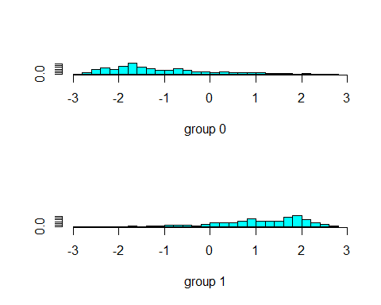

lda.pred <- predict(lda.fit, newdata = heartTest)  
lda.class <- lda.pred$class  
table(lda.class, heartTest$HeartDisease)

##   
## lda.class 0 1  
## 0 85 12  
## 1 17 115

mean(lda.class == heartTest$HeartDisease)

## [1] 0.8733624

The linear discriminant analysis model also displays a relatively high level of accuracy, at 87%.

#Quadratic Discriminant Analysis (86%)  
  
qda.fit <- qda(HeartDisease ~ ., data = heartTrain)  
qda.fit

## Call:  
## qda(HeartDisease ~ ., data = heartTrain)  
##   
## Prior probabilities of groups:  
## 0 1   
## 0.4470247 0.5529753   
##   
## Group means:  
## Age RestingBP Cholesterol FastingBS MaxHR ExerciseAngina Oldpeak  
## 0 50.72727 130.3442 240.4317 0.1201299 148.0227 0.1331169 0.4123377  
## 1 55.92388 135.3390 251.4317 0.3307087 128.2756 0.6246719 1.2958005  
## typical_angina atypical_angina non_angina_pain st_abnorm left_vent_hypertroph  
## 0 0.06493506 0.36038961 0.3344156 0.1493506 0.1948052  
## 1 0.05249344 0.04986877 0.1548556 0.2309711 0.2125984  
## stslope_up stslope_down male  
## 0 0.7889610 0.03246753 0.6623377  
## 1 0.1653543 0.09711286 0.9160105

qda.class <- predict(qda.fit, newdata = heartTest)$class  
table(qda.class, heartTest$HeartDisease)

##   
## qda.class 0 1  
## 0 83 16  
## 1 19 111

mean(qda.class == heartTest$HeartDisease)

## [1] 0.8471616

The quadratic discriminant model has an accuracy of only around 85%, close to the other models but slightly weaker. This might be an indication that the boundary between categories can be represented linearly.

#Naive Bayes (87%)  
#nb.fit <- naiveBayes(HeartDisease ~ ., data = heartTrain)  
#nb.fit  
  
#nb.class <- predict(nb.fit, newdata = heartTest)  
#table(nb.class, heartTest$HeartDisease)  
#mean(nb.class == heartTest$HeartDisease)

The Naive Bayes model performs about as well as the quadratic discriminant model, at around 84%.

#Classification Tree 85%  
tree.heart <- tree(as.factor(HeartDisease) ~ ., data = heartTrain)  
summary(tree.heart)

##   
## Classification tree:  
## tree(formula = as.factor(HeartDisease) ~ ., data = heartTrain)  
## Variables actually used in tree construction:  
## [1] "stslope_up" "MaxHR" "Oldpeak"   
## [4] "ExerciseAngina" "male" "Cholesterol"   
## [7] "left_vent_hypertroph" "atypical_angina" "non_angina_pain"   
## [10] "RestingBP"   
## Number of terminal nodes: 17   
## Residual mean deviance: 0.6075 = 408.2 / 672   
## Misclassification error rate: 0.1277 = 88 / 689

tree:::print.tree(tree.heart)

## node), split, n, deviance, yval, (yprob)  
## * denotes terminal node  
##   
## 1) root 689 947.400 1 ( 0.44702 0.55298 )   
## 2) stslope_up < 0.5 383 348.900 1 ( 0.16971 0.83029 )   
## 4) MaxHR < 140.5 260 145.900 1 ( 0.08077 0.91923 )   
## 8) Oldpeak < 0.05 59 0.000 1 ( 0.00000 1.00000 ) *  
## 9) Oldpeak > 0.05 201 134.600 1 ( 0.10448 0.89552 )   
## 18) Oldpeak < 1.65 101 97.660 1 ( 0.18812 0.81188 )   
## 36) ExerciseAngina < 0.5 23 31.490 1 ( 0.43478 0.56522 )   
## 72) male < 0.5 5 0.000 0 ( 1.00000 0.00000 ) *  
## 73) male > 0.5 18 21.270 1 ( 0.27778 0.72222 ) *  
## 37) ExerciseAngina > 0.5 78 55.790 1 ( 0.11538 0.88462 ) *  
## 19) Oldpeak > 1.65 100 19.610 1 ( 0.02000 0.98000 ) *  
## 5) MaxHR > 140.5 123 160.400 1 ( 0.35772 0.64228 )   
## 10) Cholesterol < 245.153 62 85.950 0 ( 0.50000 0.50000 )   
## 20) Oldpeak < 2.4 51 69.100 0 ( 0.58824 0.41176 ) *  
## 21) Oldpeak > 2.4 11 6.702 1 ( 0.09091 0.90909 ) *  
## 11) Cholesterol > 245.153 61 63.200 1 ( 0.21311 0.78689 ) *  
## 3) stslope_up > 0.5 306 311.200 0 ( 0.79412 0.20588 )   
## 6) Oldpeak < 0.45 233 163.000 0 ( 0.88841 0.11159 )   
## 12) left_vent_hypertroph < 0.5 196 105.900 0 ( 0.92347 0.07653 )   
## 24) atypical_angina < 0.5 112 84.400 0 ( 0.87500 0.12500 )   
## 48) non_angina_pain < 0.5 54 57.210 0 ( 0.77778 0.22222 ) *  
## 49) non_angina_pain > 0.5 58 17.400 0 ( 0.96552 0.03448 ) *  
## 25) atypical_angina > 0.5 84 10.850 0 ( 0.98810 0.01190 ) *  
## 13) left_vent_hypertroph > 0.5 37 45.030 0 ( 0.70270 0.29730 )   
## 26) non_angina_pain < 0.5 26 35.430 0 ( 0.57692 0.42308 ) *  
## 27) non_angina_pain > 0.5 11 0.000 0 ( 1.00000 0.00000 ) *  
## 7) Oldpeak > 0.45 73 101.200 1 ( 0.49315 0.50685 )   
## 14) male < 0.5 19 7.835 0 ( 0.94737 0.05263 ) *  
## 15) male > 0.5 54 68.740 1 ( 0.33333 0.66667 )   
## 30) MaxHR < 124.5 13 0.000 1 ( 0.00000 1.00000 ) *  
## 31) MaxHR > 124.5 41 56.230 1 ( 0.43902 0.56098 )   
## 62) RestingBP < 146.5 31 37.350 1 ( 0.29032 0.70968 ) *  
## 63) RestingBP > 146.5 10 6.502 0 ( 0.90000 0.10000 ) *

tree.pred <- predict(tree.heart, heartTest, type = "class")  
table(tree.pred, heartTest$HeartDisease)

##   
## tree.pred 0 1  
## 0 78 17  
## 1 24 110

(78+110)/229

## [1] 0.8209607

The single decision tree model was relatively inaccurate, at only 82% accuracy.

#Random Forest 84%  
#rf.heart <- randomForest(as.factor(HeartDisease) ~ ., data = heartTrain, importance = TRUE)  
#rf.pred <- predict(rf.heart, heartTest, type = "class")  
#table(rf.pred, heartTest$HeartDisease)  
(86 + 114)/229

## [1] 0.8733624

#importance(rf.heart)  
  
#varImpPlot(rf.heart)

But the random forest model pushed the accuracy back up to around 87%. The random forest model also seems to indicate that upward sloping ST region is overwhelmingly indicative of the absence of heart disease, in agreement with the logistic model.

In summary, we have decided that the logistic model is the best model to use to solve this problem. It performs at or above the level of the other methods we tried, but it has the added benefit of being the easiest model to understand for someone who is not statistically literate.