Capstone Report

Udacity Machine Learning Engineer Nanodegree

DonorsChoose.org Application Screening

Aaron Penne

2018-06-25

Table of Contents

1 Definition 4

1.1 Project Overview 4

1.2 Problem Statement 4

1.3 Metrics 5

2 Analysis 6

2.1 Data Overview 6

2.2 Data Exploration 6

2.2.1 “Resources” Dataset 6

2.2.2 “Training” and “Test” Datasets 7

2.3 Exploratory Visualization 9

2.4 Algorithms and Techniques 12

2.5 Benchmark 13

3 Methodology 15

3.1 Data Preprocessing 15

3.1.1 Basic Data Reading and Cleaning 15

3.1.2 Feature Engineering 15

3.1.3 Handling Text 15

3.2 Implementation 16

3.2.1 Model Selection and Data Cross Validation 16

3.3 Refinement 18

4 Results 19

4.1 Model Evaluation and Validation 19

4.2 Justification 19

5 Conclusion 20

5.1 Free-Form Visualization 20

5.2 Reflection 20

5.3 Improvement 20

6 References 21

# Definition

## Project Overview

Teachers in low income schools often find the school is unable to provide their students with adequate resources. This leads some teachers to purchase items with their own money to meet the students’ needs. To help solve this issue, Charles Best created the website DonorsChoose.org to allow philanthropic individuals the opportunity to selectively donate to various teacher projects. Teachers submit their applications to DonorsChoose.org, and if they are accepted then the project goes public and people may donate to it.

This charity has served as a Kickstarter for small public-school needs and provides a direct way to make an impact on young people’s lives. DonorsChoose.org has received top industry awards every year since 2005 and has fulfilled over 600,000 classroom projects. This impact can be made even greater by leveraging advanced technologies to actively utilize the datasets on hand.

DonorsChoose.org implements a screening process to ensure a high quality level of projects are listed on their site. This means hundreds of applications need to be read in detail by volunteers. This takes a lot of time and resources for the organization, and also adds delay to the teachers waiting for approval. The problem to be solved is a classification one, should the DonorsChoose.org accept or reject a given application. By automating a large segment of this process, applications that have an obvious classification can be accepted/rejected, while the more nuanced applications can be read more in depth by a volunteer.

## Problem Statement

The dataset is compiled from historical project applications that were submitted to DonorsChoose.org. These are presented on Kaggle in the form of comma separated variable files (CSV). These will be used as inputs to create a predictive classifier. In order to solve this problem, several steps must be taken: The data must be imported, cleaned, examined, and joined to other inputs. Various algorithms must be selected and cross validated to identify which model fits best, perhaps combining models into a customized ensemble. The chosen algorithm(s) must be selected and trained on the historical data. Finally, testing data will be run through the model(s) to create predictions which will be scored by Kaggle.

There are three data files available: training application data, test application data, and data on the resources requested. The application data contains some metadata about the application and the essays. The resources data includes one line item per resource requested, and may have multiple line items for a single application. Initially it seems that there will be predictive information in the resources categorical data and numerical data. It also is possible that the categorical and numerical data in the application metadata will be valuable for prediction. The essays and other text information will likely contain the most information gain, as there will be a deep and wide breadth of words used by the nationwide applicants.

These initial observations lead me to believe a two pronged approach will be needed from a high level perspective. One will be model(s) based on the categorical and numerical data. The other will be model(s) based on the text essays.

## Metrics

The confusion matrix shown in section 3.2.1 is used to calculate precision and recall. The confusion matrix shows the number of correct and incorrect predictions with the following numbers: True positives (TP), true negatives (TN), false positives (FP), and false negatives (FN). These numbers are eponymous counts of, for example, the number times a prediction was positive when the actual label was positive. These are valuable metrics, but it is difficult to identify superior models by comparing 4 values for each model. TP, TN, FP, and FN are typically combined into two metrics called precision and recall, defined as

$$Precision=\frac{TP}{TP+FP}$$

$$Recall=\frac{TP}{TP+FN}$$

While these are useful in their own right, two metrics are still difficult to use when comparing multiple models. Therefore, they are combined into a single metric known as the F1 score, defined as the harmonic mean of precision and recall

$$F_{1}=\frac{2TP}{2TP+FN+FP}=2*\frac{Precision* Recall}{Precision+Recall}$$

Another way to use the TP and FP values is to use a receiver operating characteristic (ROC) curve. This metric originated in radar detection to score a radar operator’s ability to correctly identify a target. Nowadays it is used to characterize algorithmic classification instead of human radar operators, but the principle is the same. ROC curves plot the FP rate (FPR) against the TP rate (TPR) for all decision thresholds. This form of plot is convenient to use as a metric because it is consistent across different models and methods.

A typical summary metric, which will be used for model selection and performance rating is the area under the ROC curve (AUC). This score essentially is the probability that a given prediction will be correct in predicting a positive result. For example, if the AUC score is 0.85, then there is an 85% chance that a positive prediction is correct.

Accuracy is a poor choice of a metric, although it is intuitive. When imbalanced datasets are used, accuracy gives a skewed result. Accuracy is intuitively based on a 50-50 random result being the baseline, but that is not the case with imbalanced datasets. This is where the benefit of AUC comes into play, the metric has the same meaning whether the dataset is imbalanced or not. As this dataset is imbalanced, the AUC metric will be the primary method of rating.

# Analysis

## Data Overview

Each request contains metadata such as the school’s state, class grade, teacher ID, categories, submission datetime, etc. The primary content of each request is essays filled out by the teacher, with 2-4 essays per request. Another resources dataset is provided that details the description, quantity, and price of each item in the applications. This resources dataset is tied back to the applications dataset using a unique id for each application.

The training set has 182k records and the testing set has 78k records. There are two class labels in this dataset, “accepted” and “rejected”. An interesting break in the data is that applications before a certain date had 4 questions to be answered. The latter applications had 2 questions. It will take some experimentation to determine how to properly handle this discrepancy, more information on this is in Section 2.2.2.

Many of the attributes are numerical in nature. These will be the simplest to model. Many attributes are also categorical, meaning they can be converted to numerical values and modelled in similar ways. The bulk of the potentially interesting data, however, is the essays written by the teachers. These provide both a challenge and an opportunity, as there is quite a bit of information encoded in these texts.

## Data Exploration

### “Resources” Dataset

Each application has a list of items requested where one application may have many requested resources. Further, the quantity of each resource varies. For each resource item the dataset contains the quantity and price of each item. Pivoting the data is a quick way to summarize the numerical values by summation, then multiplying the total unit cost and quantity to get a total cost for each application. Some questions that arise from a dive into the raw data lend themselves to answers via feature engineering.

* Do cheap or expensive applications tend to get approved?
  + Feature created: Highest/Lowest price of items (max/min of price)
  + Feature created: Total cost of request (sum of price*quantity for each application)
* Do applications with few or many items tend to get approved?
  + Feature created: Total number of items requested (sum of quantity)
  + Feature created: Total number of unique items requested (count of items per application)
* Does the type of item requested affect approval?
  + Feature created: Aggregation of all words from item descriptions (string join of description)

The possibility of information being gleaned from the list of descriptions means that text analysis will need to be used. This was obvious from the data descriptions but here it becomes apparent.

### “Training” and “Test” Datasets

The training and test datasets have the same features except the training data has class labels identified.

Notes on first pass of features

* id – unique id of the project application used to tie in resources.csv data
* teacher_id – ID of the teacher submitting the application can be disregarded because counts of submissions per teacher captured in other feature, teacher_number_of_previously_posted_projects
* teacher_prefix – title of the teacher's name (Ms., Mr., etc.) may be useful once encoded
* school_state – US state of the teacher's school may be useful once encoded
* project_submitted_datetime – application submission timestamp
* project_grade_category – school grade levels (PreK-2, 3-5, 6-8, and 9-12) may be useful once encoded
* project_subject_categories – category of the project (e.g., "Music & The Arts") but several records have 2 entries, needs to be split into 2 new columns. May be useful once encoded.
* project_subject_subcategories – sub-category of the project (e.g., "Visual Arts") but several records have 2 entries, needs to be split into 2 new columns. May be useful once encoded.
* project_title – title of the project in raw text
* project_essay_1 – Long form essay
* project_essay_2 – Long form essay
* project_essay_3 – Long form essay for applications before May 17, 2016
* project_essay_4 – Long form essay for applications before May 17, 2016
* project_resource_summary – summary of the resources needed for the project
* teacher_number_of_previously_posted_projects – number of previously posted applications by the submitting teacher
* project_is_approved – whether DonorsChoose application was accepted (0="rejected", 1="accepted") present in the training data only

There is a caveat with the long form essays. Only 3.5% of the applications contain essays 3 and 4. According to DonorsChoose.org the prompts changed after May 17, 2016. Prior to this the four prompts were:

* project_essay_1: "Introduce us to your classroom"
* project_essay_2: "Tell us more about your students"
* project_essay_3: "Describe how your students will use the materials you're requesting"
* project_essay_4: "Close by sharing why your project will make a difference"

This poses a problem, as it is typically a good idea to remove features that have a large number of nulls. However, this is not desired in this case because there is a large amount of information in the long form essays. Upon closer inspection, they may be aggregated with the other two essays. The two new prompts appear to be an aggregation of the four old prompts. Here are the prompts after May 17, 2016:

* project_essay_1: "Describe your students: What makes your students special? Specific details about their background, your neighborhood, and your school are all helpful."
* project_essay_2: "About your project: How will these materials make a difference in your students' learning and improve their school lives?"

Looking through the data confirms the initial hypothesis that a two-pronged approach will likely yield the largest amount of information gain from this data. Further questions answered with feature engineering approaches are described below.

* Do the categorical features independently have an effect on approval?
* Does the date of submission affect approval?
  + Feature created: Approval rates by year, month, day of year, day of week, hour
* Do new or experienced submitters get approved more?
* Does the title affect approval?
  + Feature created: Number of words in project_title
  + Feature created: Sentiment of project_title
* Do the essays affect approval?
  + Feature created: Number of words in each essay

For further insight, below is an overview of the data in the training dataset as well as full text examples from dataset:

|  |  |  |
| --- | --- | --- |
| **Feature Name** | **Value** | **Type** |
| id | p226941 | String (key) |
| teacher_id | 103cc1667cf9361bf1c58c8425e76e95 | String (key) |
| teacher_prefix | Mrs. | String (Categorical) |
| school_state | CA | String (Categorical) |
| project_submitted_datetime | 9/5/16 19:28 | Datetime |
| project_grade_category | Grades PreK-2 | String (Categorical) |
| project_subject_categories | Literacy & Language, Math & Science | String (Categorical) |
| project_subject_subcategories | Literacy, Mathematics | String (Categorical) |
| project_title | Technology Boost! | String |
| project_essay_1 | <See Essay 1 below> | String |
| project_essay_2 | With our new iPads, my students will… | String |
| project_essay_3 | Null | String |
| project_essay_4 | Null | String |
| project_resource_summary | My students need a projector and… | String |
| teacher_number_of_previously_posted_projects | 1 | Integer |
| project_is_approved | 1 | Integer |

Essay 1:

My children come to school everyday with the same expectations as any other children; they are eager to learn, excited about new discoveries, and want to feel like they have a place in this world. My challenge is to meet their expectations regardless of the fact that many of them face extremely difficult economic situations at home. \r\n\r\nAll children deserve access to educational tools, regardless of their family's economic standing! Most of my students come from working class families that are trying their best, but are unable to provide what many take for granted. The only exposure most of my students have to technology is at school, and our aging classroom equipment is barely limping along.

Note that the essays are stored as a single string, with escaped characters such as “\n” present. This means some string cleaning will be needed when reading this data in. More on the approach to processing this data can be seen in section 3.1.3.

The project_subject_categories and project_subject_subcategories features are categorical but many records contain multiple categories. For example, a project_subject_categories value may be a single entry such as “Applied Learning”, or it may have two entries such as “Music & The Arts, Health & Sports”. It will likely be a good idea to split these cases into multiple features. Using a string split it is possible to verify that the maximum number of categories in either feature is two. This anomaly initially points to splitting these features into 4 features. It is also intuitive that the subjects will give a good result if aggregated into a single feature.

## Exploratory Visualization

Exploratory Data Analysis (EDA) is frequently augmented by visualizations. This gives an intuitive understanding of the data beyond summary statistics. Most of the dataset contains categorical data, so the standard summary statistics of mean, quartiles, and outliers does not really apply. The most important factor here are what values are missing. This chart shows a high level view of the entire training dataset, with a single horizontal line representing a filled data point. The white space present represents null values or NaNs.

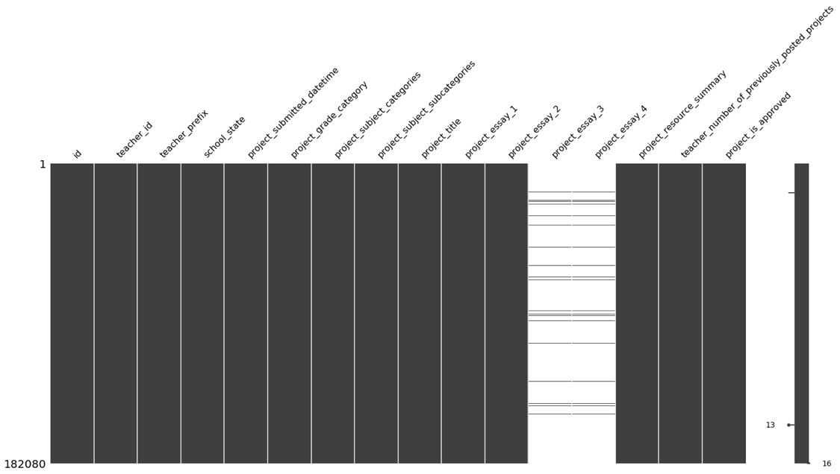

It is helpful when visualizing to dive into one feature in particular, or to do so repeatedly with all features. For this project, the following histogram was created for each feature to help determine if a particular state, etc. had a higher chance of getting accepted. This chart shows the counts of the teacher_prefix categories for accepted and rejected applications. While it is clear that more females submit, there is only a slight difference in the calculated rate of acceptance between Mr. (84.2%) and Mrs.+Ms. (84.9%).

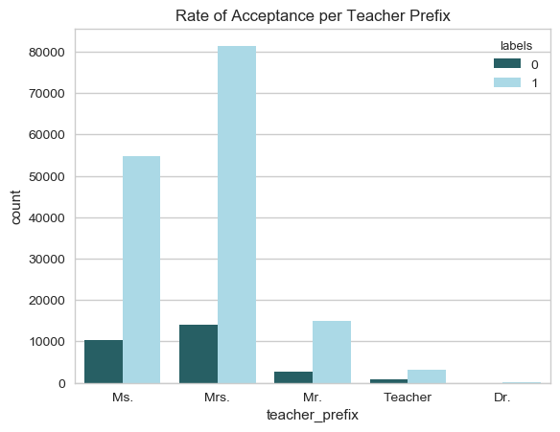

After doing some feature engineering and creating numerical values from text and encodings it is possible to probe the numerical data. Pairwise scatterplots are a great way to get a feel for numerical data quickly. They allow correlations to be spotted between variables as well as with the class labels. In this plot the right column and bottom row represent the class labels. The diagonal contains univariate histograms colored by the class value. The upper and lower off diagonal sections of the matrix are composed of bivariate scatter plots of the respective features.

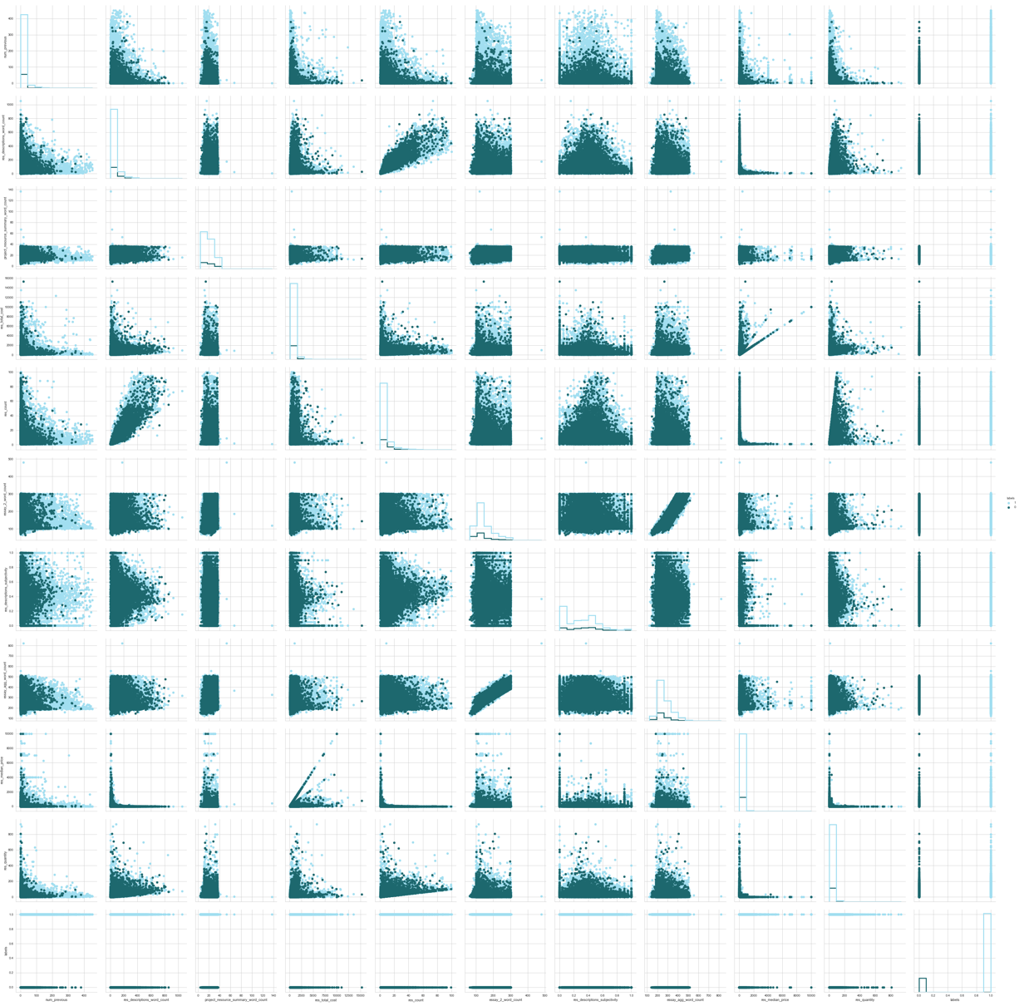

Unfortunately, this kind of plot is only useful for ‘eyeballing’ the data. To properly understand the inter feature correlation, a correlation matrix must be computed. These are also excellent to visualize as below.

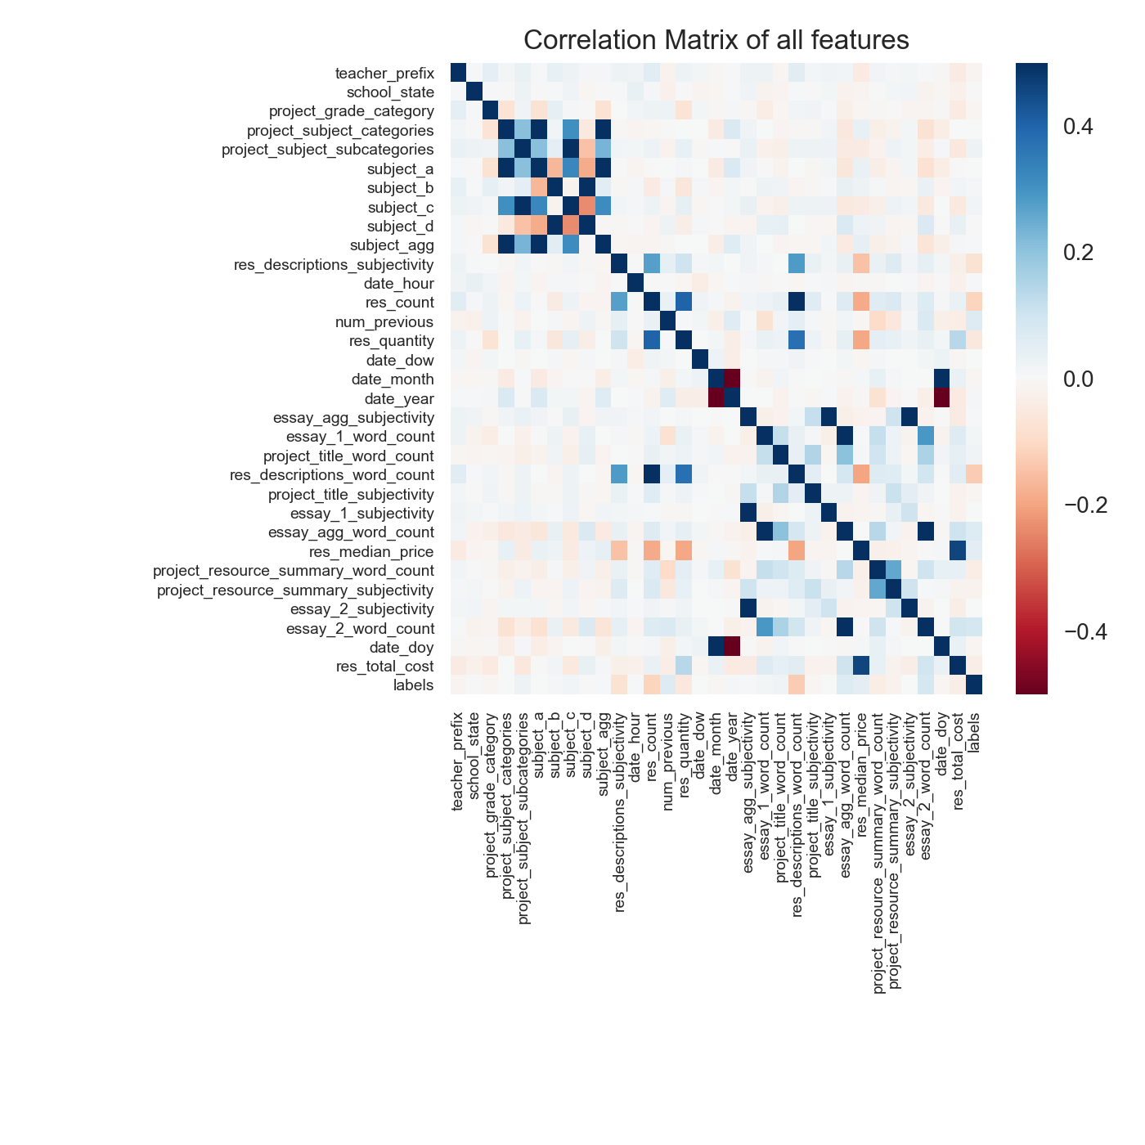

This dataset is difficult, as it is clear that no features are highly correlated with the class labels. Only two features had a correlation magnitude higher than 0.3, res_description_word_count and res_count. This is disappointing as it means our algorithms will have to work harder to predict correct values and that more work will need to be done with the text data to extract useable information.

## Algorithms and Techniques

There are three classifiers tested for use with both the numerical/categorical data and the text data. They are stochastic gradient descent, logistic regression, and support vector machine. The text data is converted to numerical features called term frequency inverse document frequency (TF-IDF).

Stochastic gradient descent (SGD) is performed by calculating the gradient of the current position, moving towards the largest negative gradient, and iterating that process until a minimum is found. SGD is sensitive to feature scaling, so it is appropriate to scale all feature values to a range such as [0,1] before training/testing the model. Logistic regression (LR) is actually a classifier in this case, where a sigmoid curve is applied to give the probability of a given point being in one of two binary classes. Overfitting is an issue with this classifier, as with the others, if there are too many features present. Support vector machines (SVM) operate by finding a plane that is furthest from the nearest point from either class label.

The dataset will be manipulated to fit into these models. All categorical features will be encoded to a one-hot matrix, where each possible category gets its own column filled with zeros, but is one where the original feature matches that column. Numerical data will be scaled to a given range, such as [0,1]. Text data will be normalized, tokenized, vectorized, then counted to give numerical TF-IDF values.

TF-IDF is a method used to weight words which occur frequently in a document, tempered by the amount that a word appears in all the documents. This protects the values from being affected more strongly by words that appear more often in general. The term frequency is simply a count of times the word appears in a given document, but this can be skewed as some documents are much longer than others. Therefore it is good practice to divide the term frequency by the document length. This term frequency is multiplied by the log of the quotient of the total number of documents divided by the number of documents with the particular term in it. This offsets the weight if it appears to frequently in all documents. By converting the text to numerical data the normal classifiers are able to fit and predict on this information in the same manner as the rest of the dataset.

To get the best of the text and numerical data, these will be predicted on separately and the results will be a custom ensemble approach. The probabilities of each class are summed with custom weights to ma

## Benchmark

The benchmark to use depends on the class balance, and from the training data it can be shown that the class balance is 84.76% approved and 15.24% denied. This means the zero rule for this problem is a baseline random model that randomly approve applications 84.76% of the time. Using this dummy classifier with kfold cross validation, the AUC scores range tightly around 50%. This means that if the predictive model performs well above 50% then it is doing well. If it performs under then there is a problem.

# Methodology

(approx. 3-5 pages)

## Data Preprocessing

The data is read in, cleaned, and the data types are converted to the appropriate types. For example, all escaped characters in text strings are removed, and integers are converted from strings to int32. There are several steps of the basic data cleaning and feature engineering outlined in the next sections.

### Feature Engineering

The questions posed in section 2.2 are answered here with feature engineering. This is the method of taking the few features provided in the original dataset and combining them or manipulating them to create new features.

The first of these involves the resources data. There are many lines per one application in the application data, so the resources data needs to be reduced to one line per application in order to be joined. First the quantity and unit price of each item are multiplied to get a total cost of each requested item. Then the resources related to a single application are grouped, the total cost is summed, and the text descriptions are joined into a single feature separated by commas. This new table can easily be joined to the application data table on the application ID.

### Handling Text

The resources dataset had some text data which may be useful. It contained one description for each record which was akin to a description that would exist on a purchase order, such as this example:

Dixon Ticonderoga Wood-Cased #2 HB Pencils, Box of 96, Yellow (13872)

For applications that had multiple resources requested, the descriptions were aggregated into a single record, separated by a comma. The new feature collecting all descriptions is title res_descriptions. This would allow the possibility of predicting on this row although not much information was expected to be gained from this feature.

The applications dataset contained six text features that had potential for natural language processing (NLP). They are project_title, project_essay_1-4, project_resource_summary, and res_descriptions.

According to the explanation in section XYZ, records with four essays were aggregated into two. The first and second essays were combined into essay_1 while the third and fourth were combined into essay_2. If the record had 2 essays they were mapped directly, the first to essay_1 and the second to essay_2. The essays are also aggregated into a single feature, essay_agg, along with the project_title to make a single blob of the entire submitted essay text. It is possible for this aggregated essay to yield good separation between records and possibly have high correlation with the class labels.

After the pivoted resources dataset is joined to the applications dataset it is possible to separate out the text data and perform NLP actions on it. First all NaN or null values in the text data are filled with ‘’, meaning an empty string. Then all escaped characters such as “\n” or “\r” are removed. Next all surrounding whitespace is stripped from each value of each feature. The project_subject_categories and project_subject_subcategories features are split into 4 new features: subject_a, subject_b, subject_c, and subject_d. Perhaps these features will yield more information if concatenated into a single feature, so they are joined in a new feature subject_agg.

Word count is extracted by tokenizing the strings in each essay and measuring the length of the resulting list. This is performed for all text features.

Subjectivity, polarity, and sentiment are computed on the non-normalized text. These produce numerical results which have meaningful ranges. The results are joined to the numerical data. The TextBlob library is able to perform these calculations directly using pretrained vocabularies and the VADER method.

Text normalization is a critical component of the NLP approach. The normalization section takes the longest time to run, even longer than training models. For each text value, the following steps are taken. All characters are converted to lowercase. All stopwords (according to the corpus XYZ) are removed, as well as any punctuation. Words are stemmed, split into single word members of a list, then joined with a single space between all words. Stemming is a process where words are reduced to their base form, allowing for more universal matching and less unique variants of a given word. For example, the words “reading”, “reader”, “readers”, and “read” may all be reduced to the root “read”. Some stemmed words are not actual words themselves (such as “forgiv”) but that is irrelevant as far as models are concerned. These normalized values are created in new features and given the suffix “_norm” to preserve the original text features in addition to the new normalized features. This allows flexibility when evaluating models.

## Implementation

### Model Selection and Data Cross Validation

The dataset had a large class imbalance, with 84% of applications being approved. Imbalanced datasets need to be handled appropriately before being used in models, otherwise the model is at risk of having skewed results. There are many methods to deal with imbalanced dataset, but the most straightforward is resampling the data. In this project the minority class was upsampled to match the number of samples of the majority class. Also, in different data frames, the majority class was downsampled to match the number of samples in the minority class.

In order to properly select a model, several were tested. These were

Repeated stratified Kfold cross val

Confusion Matrix !

Techniques

Looped through multiple classifiers

Looped through multiple parameters/settings/hyperparameters?

|  |  |  |  |  |
| --- | --- | --- | --- | --- |
| Classifier | Dataset Balance | AUC (median) | STD of AUC | Runtime (sec) |
| SGD | Imabalanced | 0.599 | 0.065 | 1.22 |
| SGD | Downsampled | 0.588 | 0.045 | 0.27 |
| SGD | Upsampled | 0.487 | 0.094 | 2.18 |
| Logistic Reg | Imabalanced | 0.649 | 0.003 | 5.92 |
| Logistic Reg | Downsampled | 0.654 | 0.005 | 0.98 |
| Logistic Reg | Upsampled | 0.654 | 0.001 | 5.61 |
| Linear SVM | Imabalanced | 0.524 | 0.093 | 150.37 |
| Linear SVM | Downsampled | 0.635 | 0.077 | 38.75 |
| Linear SVM | Upsampled | 0.574 | 0.055 | 304.92 |
| Naïve Bayes | Imabalanced | 0.653 | 0.003 | 0.67 |
| Naïve Bayes | Downsampled | 0.652 | 0.005 | 0.15 |
| Naïve Bayes | Upsampled | 0.652 | 0.001 | 0.97 |

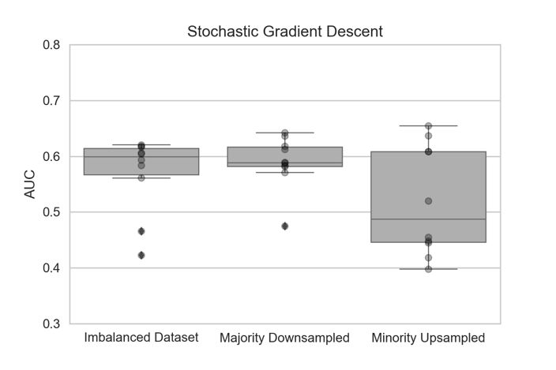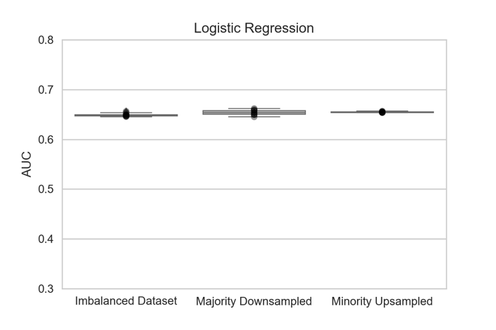

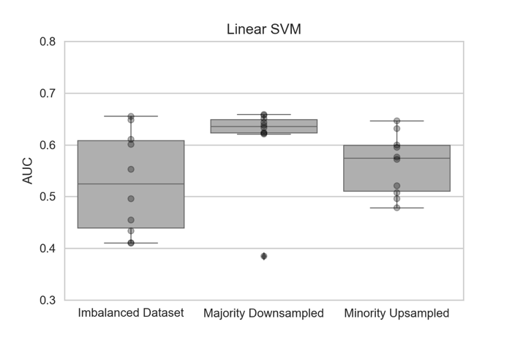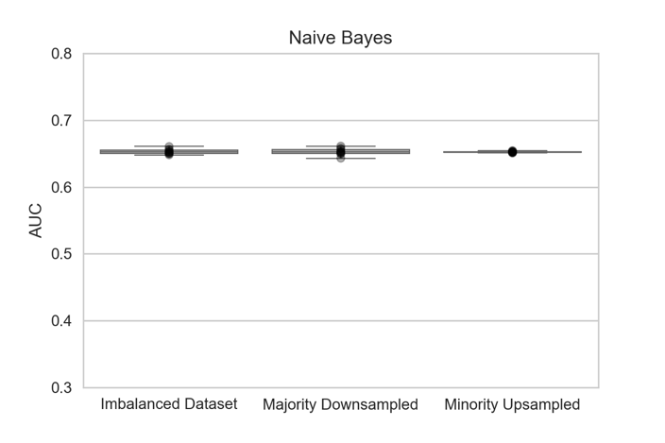

Partial dataset (filtered to 2 features)

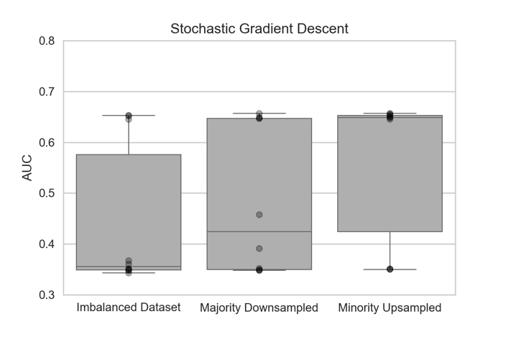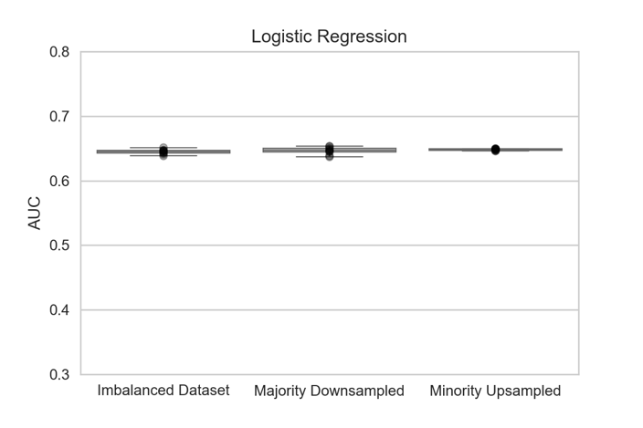

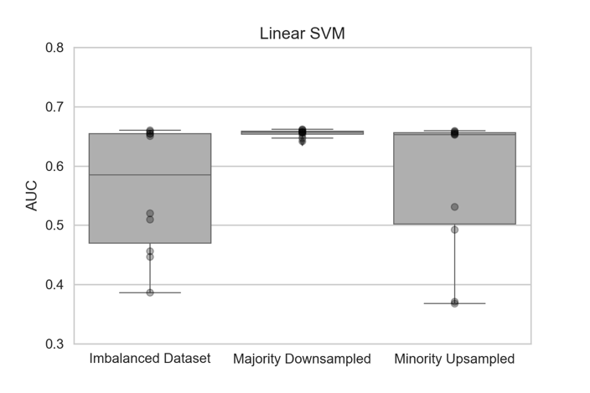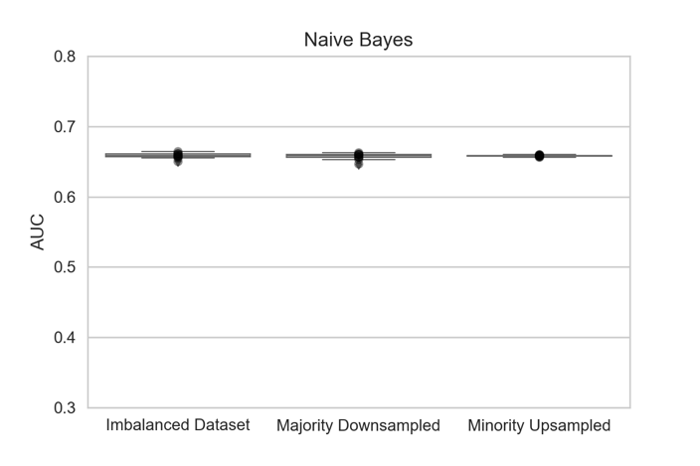

Selected Logistic Regression with Minority Upsampled

In this section, the process for which metrics, algorithms, and techniques that you implemented for the given data will need to be clearly documented. It should be abundantly clear how the implementation was carried out, and discussion should be made regarding any complications that occurred during this process. Questions to ask yourself when writing this section:

* Is it made clear how the algorithms and techniques were implemented with the given datasets or input data?
* Were there any complications with the original metrics or techniques that required changing prior to acquiring a solution?
* Was there any part of the coding process (e.g., writing complicated functions) that should be documented?

## Refinement

In this section, you will need to discuss the process of improvement you made upon the algorithms and techniques you used in your implementation. For example, adjusting parameters for certain models to acquire improved solutions would fall under the refinement category. Your initial and final solutions should be reported, as well as any significant intermediate results as necessary. Questions to ask yourself when writing this section:

* Has an initial solution been found and clearly reported?
* Is the process of improvement clearly documented, such as what techniques were used?
* Are intermediate and final solutions clearly reported as the process is improved?

# Results

(approx. 2-3 pages)

## Model Evaluation and Validation

In this section, the final model and any supporting qualities should be evaluated in detail. It should be clear how the final model was derived and why this model was chosen. In addition, some type of analysis should be used to validate the robustness of this model and its solution, such as manipulating the input data or environment to see how the model’s solution is affected (this is called sensitivity analysis). Questions to ask yourself when writing this section:

* Is the final model reasonable and aligning with solution expectations? Are the final parameters of the model appropriate?
* Has the final model been tested with various inputs to evaluate whether the model generalizes well to unseen data?
* Is the model robust enough for the problem? Do small perturbations (changes) in training data or the input space greatly affect the results?
* Can results found from the model be trusted?

## Justification

In this section, your model’s final solution and its results should be compared to the benchmark you established earlier in the project using some type of statistical analysis. You should also justify whether these results and the solution are significant enough to have solved the problem posed in the project. Questions to ask yourself when writing this section:

* Are the final results found stronger than the benchmark result reported earlier?
* Have you thoroughly analyzed and discussed the final solution?
* Is the final solution significant enough to have solved the problem?

# Conclusion

## Free-Form Visualization

Word clouds are a visual representation of word frequency. These are a favorite visualization among NLP practitioners, as they give a quick sense of what the underlying text contains. The first word cloud below is for the essay_agg features where the application was accepted. The second word cloud is for the applications that were rejected.

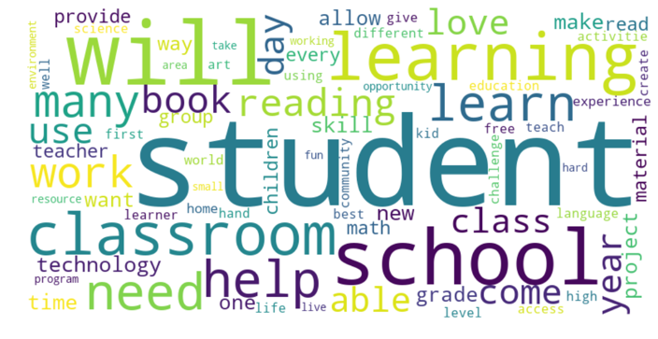 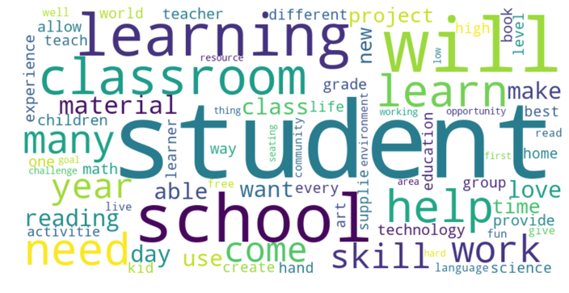

While these are interesting visualizations, it is clear that the primary words occur with approximately the same frequency in both classes. Words like “student”, “classroom”, and “learning” appear with similar weight. This highlights the primary difficulty with the classification problem using this dataset. The text contents of the applications are very similar, which makes extracting accurate predictions difficult. Words like “skill” appear to be present in different weights in the two classes, and further analysis may show that the numerical frequency is indeed greater in one over the other, allowing for some meaningful feature to be used there.

The non-normalized text was used to produce the word clouds displayed, but word clouds were also created for the normalized text (lower cased, stemmed, no stop words, etc.). The results were similar, with the same words appearing in both word clouds.

## Reflection

In conclusion the results using aggressive feature engineering and the straightforward application of well-known classifiers gave a satisfying result. The test data was scored on Kaggle and resulted in a 0.757 on the leaderboard. This is not bad considering the top score achieved 0.828 with a highly customized ensemble method containing several stacked algorithms. The direct approaches in this report show that great things are possible with machine learning if it is applied in the right way.

In this section, you will summarize the entire end-to-end problem solution and discuss one or two particular aspects of the project you found interesting or difficult. You are expected to reflect on the project as a whole to show that you have a firm understanding of the entire process employed in your work. Questions to ask yourself when writing this section:

* Have you thoroughly summarized the entire process you used for this project?
* Were there any interesting aspects of the project?
* Were there any difficult aspects of the project?
* Does the final model and solution fit your expectations for the problem, and should it be used in a general setting to solve these types of problems?

## Improvement

As always with machine learning problems, improvements can continuously be made. One area that stands to receive large information gain with small improvements is the text analysis. An option for improvement is to use neural networks via Keras with a TensorFlow backend on the text data, as that sort of complex approach is well suited to the text classification problem.

Future steps for this project involve tagging the parts of speech as noun, adjective, etc. to refine the text modeling. It seems completely possible to increase the performance of the basic predictors by refining the input text itself. More nuanced sentiment analysis could be possible if only certain word types were used. It would be interesting to also do topic modelling, find the strongest topics in each class, and only perform sentiment analysis on the sentences surrounding those terms. There is always room for improvement, which is what makes these kinds of problems exciting.

**Before submitting, ask yourself. . .**

* Does the project report you’ve written follow a well-organized structure similar to that of the project template?
* Is each section (particularly **Analysis** and **Methodology**) written in a clear, concise and specific fashion? Are there any ambiguous terms or phrases that need clarification?
* Would the intended audience of your project be able to understand your analysis, methods, and results?
* Have you properly proof-read your project report to assure there are minimal grammatical and spelling mistakes?
* Are all the resources used for this project correctly cited and referenced?
* Is the code that implements your solution easily readable and properly commented?
* Does the code execute without error and produce results similar to those reported?

# References

M. Fatourechi, R. K. Ward, S. G. Mason, J. Huggins, A. Schlögl and G. E. Birch, "Comparison of Evaluation Metrics in Classification Applications with Imbalanced Datasets," *2008 Seventh International Conference on Machine Learning and Applications*, San Diego, CA, 2008, pp. 777-782.

Tukey, John Wilder (1977). Exploratory Data Analysis. Addison-Wesley. [*ISBN*](https://en.wikipedia.org/wiki/International_Standard_Book_Number) [*0-201-07616-0*](https://en.wikipedia.org/wiki/Special:BookSources/0-201-07616-0).

Zweig MH, Campbell G (1993) Receiver-operating characteristic (ROC) plots: a fundamental evaluation tool in clinical medicine. Clinical Chemistry 39:561-577.

[Anscombe, F. J.](https://en.wikipedia.org/wiki/Frank_Anscombe) (1973). "Graphs in Statistical Analysis". [American Statistician](https://en.wikipedia.org/wiki/American_Statistician). **27** (1): 17–21. [doi](https://en.wikipedia.org/wiki/Digital_object_identifier):[10.1080/00031305.1973.10478966](https://doi.org/10.1080%2F00031305.1973.10478966). [JSTOR](https://en.wikipedia.org/wiki/JSTOR) [2682899](https://www.jstor.org/stable/2682899).

(<https://www.kaggle.com/c/donorschoose-application-screening>)